THE ROLE OF LEADERSHIP IN MANAGING ORGANISATIONAL CHALLENGES IN THE UK’S HOSPITALITY SECTOR DURING THE PANDEMIC

STUDENT NAME: Botanoiu Marilena Raluca
STUDENT NR. : 2019148

Acknowledgement
I express my heartfelt gratitude to my advisor for invaluable guidance and unwavering support throughout this dissertation journey. Special thanks to my family for their endless encouragement. I am also grateful to the research participants for their time and contributions, shaping this work.

Abstract
In the second chapter, the leadership strategies used by the hospitality sector during COVID-19 are examined. It examines the concepts of transformational and crisis leadership and how they affect organisational resilience. Leadership reactions and the disastrous effects of the COVID outbreak are highlighted through outlooks of different authors. It enables the researcher to identify the gaps existing in the literary context which act as the key motivation for conducting the study. In this exploration of the intricate dance between leadership and organizational hurdles in the UK's hospitality sector during the tumult of the COVID-19 pandemic, we embark on a journey to unravel the essence of effective leadership. The pandemic's impact on the hospitality realm, a linchpin in the UK's economic fabric, becomes the canvas on which leadership strategies are painted. The rationale behind this scholarly pursuit is grounded in the urgent need to comprehend how leadership becomes the compass guiding organizational vessels through the tempest. Moving beyond the introductory chapters, the literature review unfolds, weaving a narrative around the definition of leadership in the context of hospitality. It's not just about managing operations; it's a symphony of decision-making, communication, and adaptability, especially in the unpredictable melody of a pandemic. The theoretical underpinning, illustrated through transformational leadership and crisis leadership theories, paints a vivid picture of how leaders navigated the uncharted waters of a global crisis. The symbiosis of crisis response and visionary leadership emerges as the lifeblood of resilience. The real-life data, stark and unapologetic, reveals the true cost of the pandemic on an industry that thrived before the storm. Leadership challenges surface, like icebergs in the turbulent sea, forcing leaders to innovate, adapt, and sometimes, make painful decisions. The conceptual framework, a visual symphony of interconnected elements, encapsulates the essence of leadership in crisis management.

Table of Contents
Chapter 1: Introduction 6
1.1. Introduction 6
1.2. Background 6
1.3 Problem statement 6
1.4 Proposed Aim and Objectives 7
1.4.1 Aim 7
1.4.2 Objectives 7
Research questions 7
1.5.Rationale 8
1.6 Method 8
1.7 Scope of the study 8
1.8. Structure of the dissertation 8
1.9. Summary of chapter 1 9
Chapter 2: Literature Review 9
2.1 Definition 9
2.2 Theoretical Underpinning 10
2.3 The concept of leadership in Administering an organisation 12
2.4 The implication of leadership in the context of the hospitality sector 13
2.5 The impact of the pandemic on the global hospitality sector 14
Chapter 3: Research Methods and Methodology 19
1. 3.1 Research Philosophy 19
3.2 Research Paradigm 19
3.3 Research Approach 19
3.4 Research Methodology 20
3.5 Research Strategy 20
3.6 Sampling method 20
3.7 Data Collection 20
3.8 Interpretation of the data 21
3.9 Research Timeline 21
3.10 Ethical consideration 22
Chapter 4 Data Analysis 22
Chapter 4 Finding and discussion 22
4.1 Introduction 22
4.2 The concept of leadership for managing an organization 23
4.3 The variety of challenges that the Uk’s hospitality sector has faced during the pandemic 24
4.4 The part leadership had to play in the hotel industry in handling the challenges and difficulties encountered during the pandemic 26
4.5 Recommend various leadership strategies to the hospitality sector of the Uk to Manage organisational functioning during an uncertain situation. 27
Chapter 5 Conclusion, Limitation and Recommendation 28
5.1 Conclusion 28
5.2 Conclusion on each research issues 28
5.3 Conclusion on the research problem 28
5.4 Summary of the research finding and outcome 28
5.5 Original contribution of the research 29
5.6 Limitation of the research 29
5.7 Recommendation 29
5.8 Summary of chapter 5 29
References 31
Appendix 36

Table of Figures
Figure 2.1: Graphical representation of transformational leadership 5
Figure 2.2: Pictorial representation of Crisis leadership 6
Figure 2.3: The importance of leadership in administering an organisation 7
Figure 2.4: The implication of leadership in the hospitality sector 8
Figure 2.5: The impact of the pandemic on the global tourism sector 9
Figure 2.6: Leadership crisis during the pandemic 10
Figure 2.7: Conceptual Framework 12

Chapter 1: Introduction

1.1. Introduction
The dissertation explores the nexus between leadership and the mitigation of organisational challenges within the UK's hospitality sector amidst the COVID-19 pandemic. It aims to elucidate the concept of leadership in organisation management, appraise the myriad challenges encountered by the sector, and analyse how leadership dynamics navigated these challenges. Further, it delves into the implications of leadership strategies on the sector and suggests potential strategies to bolster organisational resilience during uncertain scenarios. Through a blend of theoretical and empirical lenses, this inquiry seeks to contribute a nuanced understanding of leadership's pivotal role in steering the hospitality sector through the pandemic-induced tumult.

1.2. Background
The pandemic has unveiled unprecedented challenges globally, with the UK's hospitality sector being significantly impacted. Pre-existing leadership paradigms were put to test as organisations navigated through operational, financial, and human resource hurdles. This research emerges from the critical need to understand how effective leadership can significantly influence the coping mechanisms of hospitality entities during adversities like the COVID-19 pandemic. The UK's hospitality sector provides a rich context given its substantial contribution to the economy and the severe implications it faced amidst pandemic restrictions. Examining the leadership strategies adopted during this period offers valuable insights into crisis management and organisational resilience (Bulińska-Stangreckaand Bagieńska, 2021).

1.3 Problem statement
Understanding the distinct challenges faced by this sector and evaluating the effectiveness of different leadership approaches during the pandemic provides a foundational basis for recommending robust leadership strategies. This, in turn, aims to equip the UK's hospitality sector with better preparatory and responsive measures for future uncertainties, enhancing its sustainability and resilience in the long term.

1.4 Proposed Aim and Objectives

1.4.1 Aim
The research aims to critically examine the role of leadership in managing organisational challenges within the UK's hospitality sector during the COVID-19 pandemic, analyse the effectiveness of the adopted leadership strategies, and recommend robust leadership approaches to enhance organisational resilience and preparedness for uncertain situations in the future.

1.4.2 Objectives
- To understand the concept of leadership for managing an organisation.
- To evaluate the variety of challenges that the Uk’s hospitality sector has faced during the pandemic.
- To analyse the role that leadership has played in the hospitality sector to manage the various complexities and issues that have been faced during the pandemic.
- To analyse the challenges faced by the hospitality sector of the Uk due to the follow-up of the leadership strategy
- To Recommend various leadership strategies to the hospitality sector of the Uk to manage organisational functioning during an uncertain situation.

Research questions
- What is the variety of challenges that the UK’s hospitality sector has faced during the pandemic?
- What is the role of leadership in the hospitality sector to manage the various complexities and issues that have been faced during the pandemic?
- What are the challenges faced by the hospitality sector of the UK due to the follow-up of the leadership strategy during the pandemic.
1.5.Rationale
The rationale behind this study lies in unpacking the critical role of leadership in navigating organisational challenges, particularly in crisis situations like the COVID-19 pandemic. The UK's hospitality sector, known for its economic vitality, was severely strained during this period, thus presenting a compelling case for investigation. Evaluating the leadership strategies employed helps in discerning effective measures for crisis management and organizational resilience (Gursoy, 2020). Moreover, by recommending adept leadership strategies, this research aims to better prepare the sector for future uncertainties, ensuring its sustainable growth.

1.6 Method
This study use Interpretive research philosophy, "Explanatory" research paradigm and conducting primary research methodology. In addition the research conduct “Quantitative research and make data collection through the google form.

1.7 Scope of the study
The insights derived could potentially extend to other sectors, contributing to a broader understanding of leadership efficacy in crisis mitigation and organizational sustainability.

1.8. Structure of the dissertation
Chapter 1: Introduction
Chapter: 2 Literature review
Chapter: 3 Methodologies
Chapter: 4 Discussions
Chapter: 5 Conclusions

1.9. Summary of chapter 1

This dissertation delves into the interplay between leadership and organisational challenges in the UK's hospitality sector during the COVID-19 pandemic. It aims to understand leadership's role, evaluate the sector's challenges, and recommend leadership strategies to bolster resilience and manage uncertainties, contributing to a nuanced understanding of crisis management.

Chapter 2: Literature Review

2.1 Definition
Leadership in the Hospitality Sector: Refers to the process of guiding, influencing, and managing individuals and groups in hospitality organizations. It involves strategic decision-making, effective communication, and the ability to adapt to rapidly changing environments. Leadership in this context is not just about managing operations but also about inspiring and motivating employees, ensuring guest satisfaction, and navigating through challenging situations like the COVID-19 pandemic (Huertas-Valdivia et al. 2019).
Organizational Challenges: Companies face several challenges that they must surmount in order to accomplish their goals. Amidst the pandemic, the hospitality sector encountered various obstacles such as adapting to mandatory health and safety protocols, dealing with financial constraints due to a decline in customer numbers, and ensuring operational effectiveness while safeguarding the well-being of both staff and patrons (Agostini and Filippini, 2019).
Hospitality Sector: Industries such as hotel, dining, entertainment, and recreation are included in this sector respectively. Customer satisfaction and overall experience are highly valued in this sector.

2.2 What we know so far about the roles of leadership in THE ROLE OF LEADERSHIP IN MANAGING ORGANISATIONAL CHALLENGES IN THE UK/Global/India/’S HOSPITALITY SECTOR DURING THE PANDEMIC
Leaders were crucial in managing organisational issues in the UK hotel sector throughout the pandemic. They had to rapidly adapt to changing regulations, implement stringent health and safety measures, and manage financial strains due to lockdowns and reduced customer flow. Effective communication, strategic planning, and employee support were key. Leaders had to balance operational efficiency with the well-being of staff and customers, often innovating to find new revenue streams. Their agility, decisiveness, and empathy were crucial in navigating these unprecedented challenges (Huertas-Valdivia et al. 2019).
The tourism industry has had a significant impact as a consequence of the COVID-19 outbreak. The essential function that leadership performs in assisting tourism organisations in overcoming the difficulties brought on by the global outbreak is examined in this particular section. It looks at many philosophies and methods of leadership and the issues that the hospitality industry had during the pandemic hit were investigated as well. Additionally, it assesses how business executives have handled the situation. The intention is to offer helpful tips and recommendations on how hospitality managers can improve their approaches to coping with ambiguous circumstances. The goal of this section is to deepen knowledge of why leadership is so significant for navigating organisations through challenging periods such as these by carefully evaluating current research and highlighting the major gaps in the study that served as the foundation for the current research.

2.2 Theoretical Underpinning
During the COVID-19 epidemic, “the transformational leadership” approach is extremely suitable for the hospitality sector as this philosophy emphasises empowering and inspiring employees to effectively navigate adversities. Encouraging creativity, instilling a sense of purpose in workers, and developing a common objective for the entire group are the key advantages of this framework. Positive shifts can be sparked by transformational leaders, who can also adjust strategies when necessary and boost morale all of which are crucial in times of crisis (Andriani et al., 2018). The fact that this strategy strongly relies on the magnetism of the person in charge and might not be effective in all situations or with every kind of manager is a possible disadvantage of this theoretical implication.
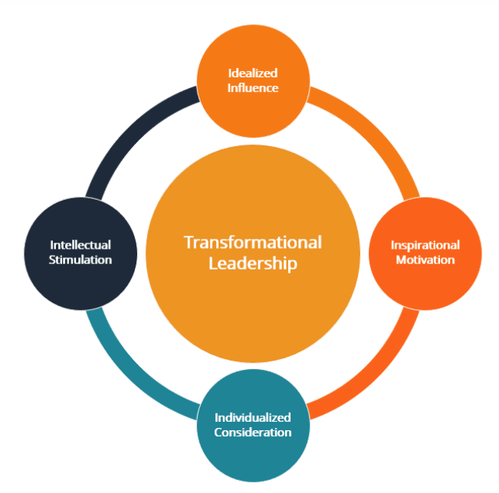
Figure 2.1: Graphical representation of transformational leadership
(Source: Andriani et al., 2018)

The COVID-19 pandemic is a prime instance of a crisis where the “crisis leadership theory”, which looks at how leaders react to and manage crises, is extremely important to the topic of the study. The focus on swift decision-making, straightforward interactions, and smart crisis leadership constitutes an attribute of this framework (Hertelendy, et al., 2022). Leaders in times of emergency can address urgent problems and put measures in place to safeguard the survival of the organisation. However, because crisis leadership is often reactive, it may be challenging for leadership to anticipate and prepare for unforeseen issues.
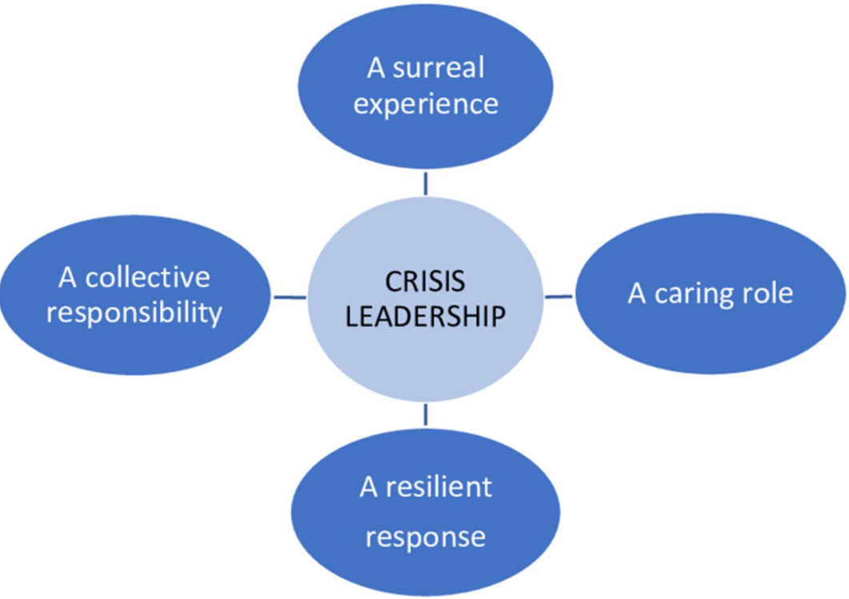
Figure 2.2: Pictorial representation of Crisis leadership
(Source: Luar and Incek, 2023)
Leading organisations in hospitality through challenging times of transition and disruption requires transformational leadership (Luar and Incek, 2023). Transformational leaders may drive ingenuity to address new challenges, maintain the motivation and engagement of staff members, and encourage cooperation to overcome barriers (Luar and Incek, 2023). The management of the pandemic’s immediate consequences on the hotel sector also requires crisis leadership. Leaders are more equipped to guide their organisations through unpredictability if they are able to react quickly, engage openly with stakeholders, and implement emergency management strategies (Urick et al., 2021). The fundamental concepts are that crisis leadership handles the immediate pandemic effects while transformational leadership promotes development during difficult circumstances. Both styles of management help hospitality businesses withstand adversity and prosper in the competitive spectrum.

2.3 The concept of leadership in Administering an organisation
Numerous academic articles highlight the importance of leadership in efficient organisational administration. Gazi et al. in this context (2020) highlight the significance of Islamic concepts of leadership in achieving organisational goals and looking for achievement after this existence. However, Mittal (2020) emphasises the important role that leadership performs in imparting dutiesin an organisation of practice participants. Saleh et al. (2018) put even more emphasis on how important it is for leaders to understand and negotiate the globe's intricacies, particularly in the manufacturing sector. Additionally, Lunenburg (2020) contends that organisations need a successful fusion of powerful leadership and outstanding management for the greatest efficiency. The findings indicate that leadership is a multifaceted concept involving the guidance and inspiration of individuals towards achieving organisational goals.

Recent research materials claim that the idea of leadership is multidimensional and encompasses a variety of competencies, traits of personality, and abilities to communicate. Effective leadership, according to Luar and Incek (2023), goes above simply assigning tasks and includes collaboration as well as interaction. On the other hand, Karnes and Bean (2021) suggest different terms and studies for formal and informal management, underlining the necessity to distinguish between these two categories. The most recent academic study emphasises the role of leadership in organisational management, highlighting the value of a variety of skills, character traits, and successful communications to administer the organisation effectively.

2.4 The implication of leadership in the context of the hospitality sector
Due to the importance of client engagement and execution of service features in the hotel industry, good leadership is essential (Qiu et al., 2019). Sustainability in the hotel industry requires a careful balancing act between functional proficiency and “soft skills” including mental agility and handling relationships, as per the opinion of Huang et al., (2021). They support a transformative management approach that inspires and challenges the minds of staff members. To be successful in the hospitality industry, sung et al., (2019) contend that transactional leadership behaviours, such as defining standards and offering incentives, must be combined with transformational leadership, despite its importance. Additionally, according to Jumah and Nthiga (2022), managers in hospitality should prioritise the empowerment of frontline workers and develop a customer-focused approach. Khan and Hossain (2018), on the other hand, criticise a purely service-centric strategy and stress the significance of promoting innovation through the adoption of novel technologies and business models.
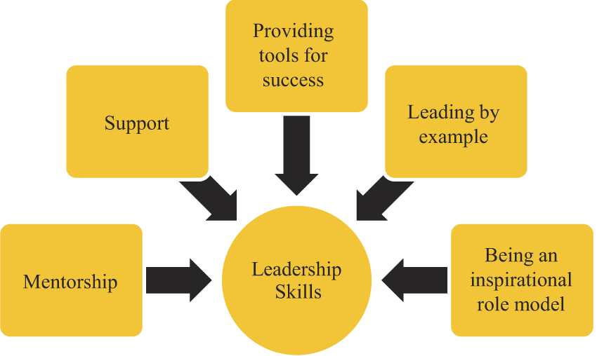
Figure 2.4: The implication of leadership in the hospitality sector
(Source: Mistry et al., 2022)

2.5 The impact of the pandemic on the global hospitality sector
Multiple studies claim that the COVID-19 epidemic has had a significant effect on the global tourism and hospitality sector. Both Gursoy (2020) and Robie (2020) highlight the business's previously unheard-of challenges, with Gursoy (2020) also urging further study to find solutions. Periasamy et al. (2020) point out that the lockdown has had a substantial influence on the availability of products and services in the Indian tourism sector, which has a knock-on effect on revenue from taxes. According to Malhotra (2021), these periodicals effectively show that the pandemic has significantly worsened logistical and economic problems within the hospitality industry, highlighting the immediate need for effective recuperation solutions.

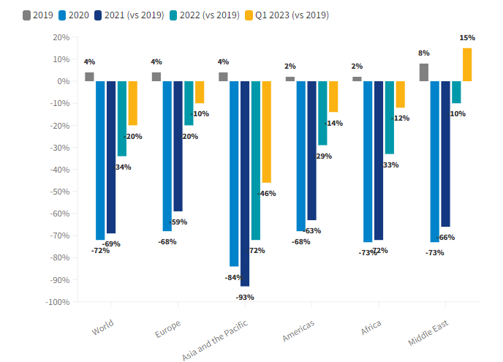
Figure 2.5: The impact of the pandemic on the global tourism sector
(Source: Unwto.org, 2023)
Some of the real-life data from the trusted organisation also demonstrate how severe the situation was. “The World Tourism Organisation” demonstrated that global tourism lost around $1.5 trillion in revenue during the pandemic (Unwto.org, 2023). As The hospitality sector accounts for 10 per cent of the global revenue, the impact of the pandemic on global GDP was enormous. The UNWTO also commented that 100 million jobs were jeopardised during the COVID outbreak (Unwto.org, 2023). Moreover, occupancy in Hotels diminished by 60 per cent while mitigating the revenue of the restaurant business by 40 per cent. It is a testament to the sheer terror the pandemic brought to the Hospitality sector (Iata.org, 2023).
2.6 Leadership challenges in the global hospitality sector during the pandemic
The COVID-19 epidemic presented leaders in the tourism industry with unprecedented challenges on a global scale. Consumption suddenly decreased very immediately as a result of limitations on travel and lockdown procedures (Shukla et al., 2022). According to Hahang et al., (2022), as a result, managers in hospitality were compelled to take drastic measures including initiating layoffs and furloughs while also changing the primary objective of the company's operations on service delivery and contactless payments. Nevertheless, during the time of emergency, an atmosphere of inventiveness and resiliency developed among numerous administrators who looked for novel answers. To maintain their enterprises, Kaushal and Srivastava (2020) observed that they looked into new opportunities including outdoor eating, online advertising, and strict health regulations. The epidemic served as a stimulus for development and transformation. According to Fenitra et al., (2022), organisational flexibility, effective communication, and sensitivity were crucial in assisting hospitality enterprises in effectively navigating through this environmental disruption. These traits not only helped them overcome the obstacles but also put them in an advantageous position for the “new normal” that would come after. There is no denying that the COVID outbreak brought about previously unheard-of difficulties for the hotel industry, however, it also sparked creativity and fortitude (Nisar et al., 2021). During this time, leaders in hospitality gathered up a few valuable lessons and realised how important interpersonal relationships, compassion, and adaptability were to their future prosperity.
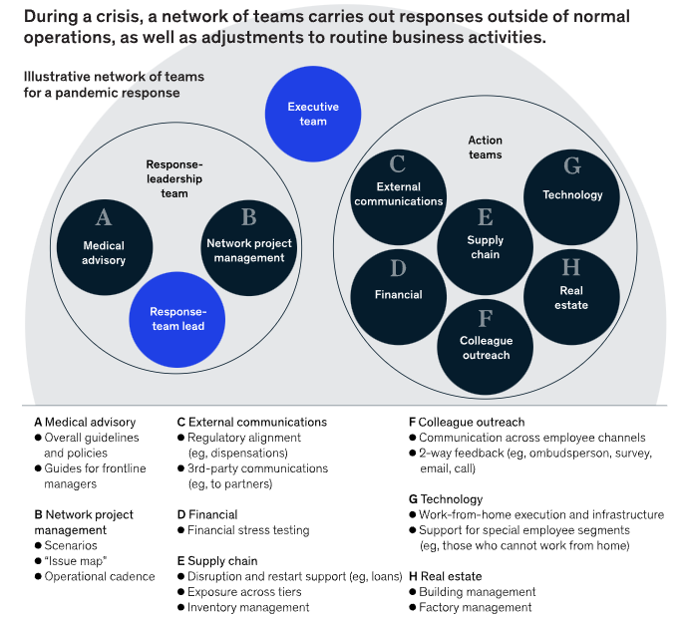
Figure 2.6: Leadership crisis during the pandemic
(Source: Mckinsey.com, 2023)
2.7 The strategies and leadership responses to manage volatility in the hospitality sector
Peer-reviewed research indicates that the global hospitality sector experienced significant leadership challenges as a result of the COVID-19 pandemic. To survive in the unstable environment, industry leaders implemented several intervention techniques. According to research by Hahang et al. (2022), qualities like a positive outlook, adept decision-making processes, adaptability, various perspectives, building confidence, and outstanding interpersonal talents were necessary for leading effectively throughout the pandemic. Meanwhile, Ardani and Harianto (2021) provided information on the precise strategies the hotel sector in Jakarta is employing to contain the outbreak. For the sector’s potential resilience, different research by Kaushal and Srivastava (2020) emphasised the significance of staff multitasking and professional growth, increased sanitation and hygiene regulations, greater crisis readiness, and the inclusion of technologies. Malhotra (2021) also explored the pandemic’s dramatic effects on the worldwide tourism sector, which collapsed as a result of a decline in tourism and travel which has forced industry-wide paradigm shifts and innovative strategies such as digital marketing and online advertising acted as the key surviving tools in the volatile scenario.
2.8 The Role of communication and employee satisfaction to manage a volatile scenario
Effective interpersonal interaction and excellent satisfaction among staff members are crucial in handling unpredictable and turbulent situations (Wang et al., 2021). Toscano and Zappalà (2020) assert that when a leader communicates in a straightforward and forthright manner, it promotes sustainability and integrates the workforce. Nemteanu et al., (2021) supported this finding by emphasising that periodic updates on shifting conditions and sympathetic acceptance of concerns from staff demonstrate care and participation, therefore improving morale and commitment, even under external instability. Bulińska-Stangrecka and Bagieńska (2021), on the other hand, warn against poor interaction that lacks empathetic thinking which may swiftly decrease morale among workers. In addition, Giménez-Espert et al., (2020) emphasise that ambiguous demands and leadership indifference can cause individuals to feel anxious and disconnected, which lowers their enthusiasm to take on novel responsibilities. Chanana and Sangeeta (2021) argue that unsatisfied workers might ultimately cease working for the company or disconnect. As stressed by Ninaus et al., (2021), engaged interaction and preserving satisfaction with work should be a top objective for the resilience of organisations. The research emphasises the need for communication and pleasure as key elements in effectively dealing with uncertainty.
2.09 Literature Gap
There is a dearth of thorough investigation within the specific confines of the sector in the existing research on leadership in the UK’s hospitality industry during the COVID outbreak. Although multiple studies have evaluated generic leadership strategies, there is a void in the research pool when it comes to examining the direct influence of managerial approaches on addressing the sector’s complexity during periods of uncertainty, particularly in the setting of the UK’s hospitality industry. In this particular arena, there has not been much research done on the relationship between leadership choices and the complications that emerge. For the UK hospitality industry to improve its organisational durability in the face of unprecedented circumstances, it is imperative to close this knowledge gap to offer insightful advice and suggest practical leadership measures.
2.10 Summary
The second chapter examines the body of knowledge on the leadership techniques employed in the tourism industry during the COVID-19 epidemic. It looks at the applicability of crisis and transformational leadership theories which forms the theoretical framework for the study. The devastating effects of the pandemic on the industry are examined, including decreased sales and employment layoffs. Moreover, leadership responses including employee multitasking, hygienic practices, and digital marketing were studied comprehensively. It was revealed that the need for efficient interaction and satisfaction among staff is emphasised as a means of managing the unpredictability of the scenario. There is a dearth of thorough investigation within the specific confines of the sector in the existing research on leadership in the UK’s hospitality industry during the COVID outbreak which form the connectome of the present study.

Chapter 3: Research Methods and Methodology

3.1 Research Philosophy
The Interpretivism research philosophy will be followed in order to conduct the research. This is because, according to Junjie and Yingxin (2022), the interpretivism philosophy aids the researcher in upholding the legitimacy of the data collecting and analysis process. It will also aid in the accomplishment of the study's main goals by assisting the researcher in comprehending and analysing the study's data while taking the particular study difficulty into account.

3.2 Research Paradigm
When brought together, the research philosophy and the research technique produce what is known as a research paradigm. In light of this fact, the researcher will be adhering to the "Explanatory" research paradigm in the course of carrying out the study. This is due to the fact that, in the view of Casula et al., (2021), the explanatory research paradigm provides the researcher with the ability to more flexibly conduct the study in accordance with the objectives of the research. In addition to this, the cost is significantly reduced, and it has the potential to assist in the establishment of a foundation for research, which in turn has the potential to assist in the long-term research of the subject.

3.3 Research Approach
The researcher will take into account the inductive research approach's follow-up when conducting this study's research. This is because the study's analysis will focus on how leadership in the UK's hospitality industry helped to handle the challenges during the COVID-19 pandemic. According to Vears and Gillam (2022), the inductive research technique aids in the analysis of research issues by the researcher through the study of theories. As a result, the study's general conclusions may be supported by the leadership theories that managers have applied to handle the complexity of the pandemic in the hotel industry.

3.4 Research Methodology
The study's findings and analysis will be conducted using "Secondary research methodology," according to the researcher. For the primary research, a survey will be conducted to gather all the information related to the research. The targeted people are staff of Hospitality sector

3.5 Research Strategy
The researcher will consider the follow-up of the "Quantitative research strategy" when they are doing the research for this study. This is because the Quantitative research technique provides the researcher with the opportunity to engage in more conjecture on the topics that they are investigating (Al-Ababneh, 2020). Because of this, establishing the dependability and validity of the conclusions of the research will be more simpler and more reliable.

3.6 Sampling method
In conducting this study, the researcher will employ the "Purposive sampling method" as a pivotal part of the research methodology. This decision is informed by the insights of Hew et al., (2019), who articulate that the purposive sampling method is instrumental in generalising data in alignment with the specific theoretical domain under exploration. Unlike other sampling techniques, purposive sampling allows for a targeted selection of participants or data sources based on predefined criteria, which in this case, corresponds to the intricacies of leadership dynamics within the UK's hospitality sector amidst the pandemic.

Moreover, an added advantage of this sampling method is its cost-effectiveness and time efficiency, which are crucial considerations in ensuring the smooth and timely progression of the research. By focusing on particular attributes or characteristics, purposive sampling facilitates a more in-depth understanding of the research problem, thus potentially yielding rich, context-specific insights. This method enables the researcher to draw pertinent conclusions and insights that are central to the theoretical underpinnings of leadership and organisational challenges, thereby significantly contributing to the holistic understanding of the research theme.

3.8 Interpretation of the data
The data will be deciphered utilizing “thematic analysis,” commencing with an inductive research approach adopted by the researcher. Following this, theoretical frameworks relevant to the study will be contemplated. Subsequently, the researcher will engage in the meticulous formation of themes, which will emanate from the comprehensive findings of the study. These themes will be intricately aligned with the research aims, objectives, and questions, ensuring a coherent and insightful analysis (Al-Ababneh, 2020). This methodical approach aims to provide a nuanced understanding of the data, thereby enriching the interpretation and the consequent conclusions drawn regarding the role of leadership in managing organisational challenges within the UK’s hospitality sector during the pandemic.

3.9 Research Timeline

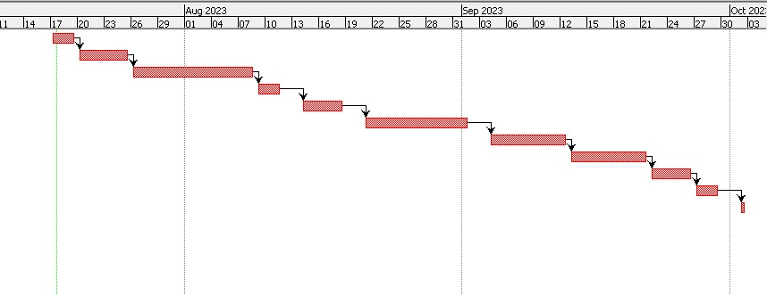
Figure 3.9: Gannt Chart
(Source: Created by the researcher)

3.10 Ethical consideration
The researcher will adhere to the "Data Protection Act of 2018" to uphold the ethical integrity and principles of the study. This adherence ensures the responsible management of collected data, safeguarding the privacy and rights of individuals or entities represented within the data. It also underscores the commitment to conducting a study that is not only rigorous in its analytical approach but also principled in its treatment of sensitive information. By aligning with the stipulations of the Data Protection Act, the research exemplifies a balanced confluence of ethical mindfulness and academic diligence, thereby bolstering the credibility and ethical standing of the study.

Chapter 4 Data Analysis

Chapter 4 Finding and discussion

4.1 Introduction
In the labyrinth of challenges posed by the pandemic, leadership emerged as the compass steering the UK's hospitality sector. Navigating uncharted waters, leaders faced multifaceted organizational hurdles. The intricacies of managing staff, adapting to ever-changing guidelines, and balancing financial tightropes demanded astute decision-making. Amidst chaos, leaders, akin to conductors orchestrating a symphony, fostered resilience (Li et al., 2022). A blend of simple directives, collaborative strategies, and empathetic communication became their arsenal. Through our analysis, patterns of effective leadership surfaced, intertwining the threads of adaptability and employee well-being. In this narrative, the role of leadership becomes not just a managerial duty but a beacon illuminating the path through adversity.

4.2 The concept of leadership for managing an organization
Leadership, the cornerstone of organizational efficacy, transcends the confines of a mere managerial role. It is an intricate dance, a delicate balance between guiding the ship through turbulent waters and inspiring the crew to weather the storm. At its essence, leadership embodies a nuanced understanding of human dynamics, a skill set that extends beyond the rigidity of flow charts and spreadsheets. In the tapestry of organizational management, simplicity often conceals profundity. Leaders, akin to maestros orchestrating a symphony, must master the art of clear and concise communication. Simple directives, unencumbered by convoluted jargon, resonate more profoundly with the diverse ensemble of individuals within an organization (Cortellazzo et al., 2019). A leader's ability to distill complex ideas into understandable nuggets is the alchemy that transforms confusion into clarity. However, the landscape of leadership is not a monochromatic canvas. It is painted with the hues of varied sentence structures the straightforward simplicity of a lone seagull gliding over calm waters, the intricate dance of compound sentences weaving multiple threads of thought, and the elaborate complexity of sentences akin to a bustling city intersection, where ideas intersect and diverge. Consider the leader as the lighthouse keeper, not just guiding ships safely to harbor but illuminating the way forward. The compound responsibilities they shoulder involve not just task delegation but the delicate art of motivation. Encouraging collaboration, fostering innovation, and navigating the dynamic currents of workplace relationships these are the skills that transform a manager into a leader. The ebb and flow of leadership mimic the rhythm of life itself. Sometimes, a leader must wield simplicity as a calming balm, offering straightforward solutions to immediate challenges (Griffin et al., 2020). At other times, the leader's role demands the complexity of strategic thinking, where decisions ripple through the organization, impacting its very foundation.
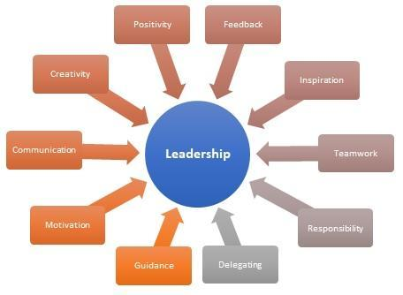
Figure 4.2 : Leadership
(Source: Stone and Patterson, 2023)

4.3 The variety of challenges that the Uk’s hospitality sector has faced during the pandemic
From the analysis above, five challenges were found. They are: 1, 2, 3.
First, the first challenge, 1, … (discuss)

In the turbulent wake of the pandemic, the UK's hospitality sector found itself navigating a labyrinth of challenges, each as diverse as the patrons it once warmly welcomed. From the onset, the sector grappled with the abrupt cessation of footfall, a haunting silence settling where laughter and chatter once thrived (López-Cabarcos et al., 2022). The immediate challenge, clear in its simplicity, lay in ensuring the safety of patrons and staff alike. Implementing health protocols, from the seemingly mundane sanitization rituals to the more complex task of redesigning spaces for social distancing, became imperative. Compound challenges emerged as financial uncertainties loomed large. The hospitality sector, once a vibrant tapestry of cafes, restaurants, and hotels, now resembled a puzzle missing crucial pieces. Leaders grappled with the complexities of budgetary constraints, a delicate dance of cost-cutting measures without compromising the quality that defined their establishments. Navigating government support programs added another layer of intricacy to the financial juggling act. In the heart of this complexity, the sector confronted a deeply human challenge the well-being of its workforce. The simple act of going to work became fraught with anxiety and uncertainties. Leaders found themselves in the delicate position of not just managing tasks but also nurturing the mental and emotional resilience of their teams. In this endeavor, the complexity lay in acknowledging the unique struggles of each individual, crafting support systems beyond the scope of traditional managerial roles (Ntounis et al., 2022). This multifaceted evaluation of challenges reveals a narrative where simplicity and complexity interlace like threads in a tapestry. Each challenge, whether a straightforward safety protocol or the intricate dance of financial restructuring, contributed to the sector's resilience.The hospitality industry's response to hardship became a story of survival and evolution, demonstrating the constantly changing relationship of simplicity and complexity.

4.4 The part leadership had to play in the hotel industry in handling the challenges and difficulties encountered during the pandemic
The hospitality industry's leadership proved to be the steady captain amongst the pandemic's choppy waters, guiding the ship though a storm of intricate details and unheard-of difficulties. A thorough examination demonstrates the complex role that leaders play, going beyond traditional managerial responsibilities to incorporate flexibility, empathy, and strategic vision. The analysis of leadership in the hospitality sector during the pandemic unravels a dynamic interplay between simplicity and complexity (Shukla et al., 2023).
Leadership as the Guardian of Well-being
At its most fundamental level, leadership took on the role of a guardian, ensuring the safety of patrons and staff. Implementing health protocols, from the straightforward deployment of sanitization routines to orchestrating social distancing measures, showcased the simplicity inherent in safeguarding the well-being of all stakeholders (Ho et al., 2023).
The Strategic Acumen of Leadership
However, the challenges were far from simple. The financial intricacies resembled a complex puzzle, demanding leaders to employ strategic acumen. The decisions to cut costs while preserving the core identity of each establishment revealed a leadership role akin to a financial architect, balancing the books with finesse and ingenuity.
Leadership as Empathetic Mentor
Beyond the fiscal challenges, leadership in the hospitality sector during the pandemic became profoundly human-centric. The workforce faced not only health concerns but a myriad of emotional and mental strains. Leaders found themselves in the role of empathetic mentors, acknowledging the personal challenges faced by their teams. The complexity here lay in fostering an environment that went beyond the transactional employer-employee relationship, addressing the fears and anxieties of a workforce grappling with unprecedented challenges (Cai et al., 2023).
Leadership in a Constant State of Flux
Adaptability emerged as the cornerstone of effective leadership. The ability to pivot, evident in the transformation of traditional sit-down establishments into agile takeout hubs, showcased leadership's role as architects of innovation. This required leaders to embrace the simplicity of unconventional ideas while navigating the complexities of execution and adaptation to a rapidly changing landscape.

4.5 Recommend various leadership strategies to the hospitality sector of the Uk to Manage organisational functioning during an uncertain situation.
In the ever-shifting landscape of uncertainty, the UK's hospitality sector requires a nuanced blend of leadership strategies to not only weather the storm but also to steer the ship toward calmer waters.
Embrace Open Communication Channels
Leaders should champion a culture of transparent communication, creating a bridge that connects all levels of the organizational hierarchy. It's not just about conveying information but fostering an environment where diverse voices are heard, creating a collective wisdom that guides decision-making (Chowdhury et al., 2023).
Foster Organizational Agility
In the face of unpredictability, leaders must cultivate an agile mindset within the organization. This involves not only creating flexible operational frameworks but also empowering teams to pivot swiftly in response to evolving circumstances. Adaptability becomes the cornerstone of organizational resilience.
Prioritize Employee Well-being
Beyond superficial gestures, leaders need to intricately understand the challenges employees face. This complex strategy involves tailoring support mechanisms that acknowledge and address the diverse needs of the workforce. The emphasis here is on fostering a workplace culture that values and safeguards the well-being of every team member (Okoli et al., 2023).

Chapter 5 Conclusion, Limitation and Recommendation

5.1 Conclusion
In the intricate tapestry of challenges posed by the pandemic, leadership in the UK's hospitality sector emerged as a guiding force, akin to conductors orchestrating a symphony. Leaders faced multifaceted hurdles, from managing staff and adapting to evolving guidelines to balancing financial tightropes. Amidst this chaos, effective leadership patterns surfaced, weaving adaptability and employee well-being into the fabric of organizational resilience.

5.2 Conclusion on each research issues
The variety of challenges faced, from the abrupt cessation of footfall to financial uncertainties, showcased the sector's resilience and transformative response. As the stalwart captains navigating this tumultuous sea, leaders played a multifaceted role, transcending traditional managerial duties with adaptability, empathy, and strategic foresight.

5.3 Conclusion on the research problem
Simple pleasures, like a shared meal or a night out, became complex endeavors fraught with health concerns and logistical intricacies. As the industry faced this unprecedented disruption, leaders found themselves at the helm of an organizational ship tossed by tempestuous waves

5.4 Summary of the research finding and outcome
The finding success lies in seamlessly transitioning between these roles, addressing each challenge with a blend of simplicity and strategic depth. In this dance of leadership, the sector not only weathered the storm but emerged transformed, a testament to the pivotal role played by those at the helm during unprecedented times.

5.5 Original contribution of the research
Evidently, there are different viewpoints on the best management stance and priorities for the tourism industry. Successful managers are inclined to use an integrated strategy, fusing a commitment to service excellence and the well-being of staff with a creative, forward-thinking outlook as the variety of this industry calls for adaptable, dynamic leadership.

5.6 Limitation of the research
The business was thriving prior to the pandemic, however, things drastically altered as a result of flight cancellations and limitations on travel, bringing the sector to a cease the practice.

5.7 Recommendation
Recommendations for the future involve embracing open communication channels, fostering organizational agility, prioritizing employee well-being, and investing in continuous training programs.

5.8 Summary of chapter 5
In summary, Leaders should consider a straightforward yet powerful strategy – investing in ongoing training programs. This not only equips the workforce with the skills needed to navigate uncertainty but also instills a culture of continuous learning, fostering resilience and adaptability.

References
Al-Ababneh, M.M., 2020. Linking ontology, epistemology and research methodology. Science & Philosophy, 8(1), pp.75-91.
Andriani, S., Kesumawati, N. and Kristiawan, M., 2018. The influence of the transformational leadership and work motivation on teachers performance. International journal of scientific & technology research, 7(7), pp.19-29.
Ardani, E.G., and Harianto, A. (2021). Surviving Strategy of Hospitality Sector in Pandemic Situation. E-Journal of Tourism.
Bulińska-Stangrecka, H. and Bagieńska, A., 2021. The role of employee relations in shaping job satisfaction as an element promoting positive mental health at work in the era of COVID-19. International journal of environmental research and public health, 18(4), p.1903.
Cai, Z., Mao, Y., Gong, T., Xin, Y. and Lou, J., 2023. The Effect of Servant Leadership on Work Resilience: Evidence from the Hospitality Industry during the COVID-19 Period. International Journal of Environmental Research and Public Health, 20(2), p.1322.
Casula, M., Rangarajan, N. and Shields, P., 2021. The potential of working hypotheses for deductive exploratory research. Quality & Quantity, 55(5), pp.1703-1725.
Chanana, N. and Sangeeta, 2021. Employee engagement practices during COVID‐19 lockdown. Journal of public affairs, 21(4), p.e2508.
Chowdhury, S., Rodriguez-Espindola, O., Dey, P. and Budhwar, P., 2023. Blockchain technology adoption for managing risks in operations and supply chain management: evidence from the UK. Annals of operations research, 327(1), pp.539-574.
Cortellazzo, L., Bruni, E. and Zampieri, R., 2019. The role of leadership in a digitalized world: A review. Frontiers in psychology, 10, p.1938.
Eliyana, A. and Ma’arif, S., 2019. Job satisfaction and organizational commitment effect in the transformational leadership towards employee performance. European Research on Management and Business Economics, 25(3), pp.144-150.
Fenitra, R.M., Abbas, A., Ekowati, D. and Suhairidi, F., 2022. Strategic intent and strategic leadership: A review perspective for post-COVID-19 tourism and hospitality industry recovery. The Emerald handbook of destination recovery in tourism and hospitality, pp.23-44.
Gazi, M.A.I., 2020. Islamic perspective of leadership in management; foundation, traits and principles. International Journal of Management and Accounting, 2(1), pp.1-9.
Giménez-Espert, M.D.C., Prado-Gascó, V. and Soto-Rubio, A., 2020. Psychosocial risks, work engagement, and job satisfaction of nurses during COVID-19 pandemic. Frontiers in public health, 8, p.566896.
Griffin, R.W., Phillips, J.M. and Gully, S.M., 2020. Organizational behavior: Managing people and organizations. CENGAGE learning.
Gursoy, D., and Chi, C.G. (2020). Effects of COVID-19 pandemic on hospitality industry: review of the current situations and a research agenda. Journal of Hospitality Marketing & Management, 29, 527 - 529.
Hahang, E., Bayraktar, S. and Jiménez, A., 2022. Early evidence of leadership skills and strategies in managing the impact of COVID-19 pandemic in the hospitality industry. Cross Cultural & Strategic Management, 29(3), pp.493-515.
Hahang, E., Bayraktar, S.,and Jiménez, A. (2022). Early evidence of leadership skills and strategies in managing the impact of COVID-19 pandemic in the hospitality industry. Cross Cultural & Strategic Management.
Hertelendy, A.J., Chekijian, S., McNulty, E., Mitchell, C.L., Grimes, J.O., Durneva, P., Ranse, J., Voskanyan, A., Nazarian, V., Rawaf, S. and Tabche, C., 2022. Crisis leadership: a case for inclusion in accredited Master of Public Health program curricula. Public health, 209, pp.14-18.
Hew, K.F., Lan, M., Tang, Y., Jia, C. and Lo, C.K., 2019. Where is the “theory” within the field of educational technology research?. British Journal of Educational Technology, 50(3), pp.956-971.
Ho, G.K., Lam, C. and Law, R., 2023. Conceptual framework of strategic leadership and organizational resilience for the hospitality and tourism industry for coping with environmental uncertainty. Journal of Hospitality and Tourism Insights, 6(2), pp.835-852.
Huang, A.Y., Fisher, T., Ding, H. and Guo, Z., 2021. A network analysis of cross-occupational skill transferability for the hospitality industry. International Journal of Contemporary Hospitality Management, 33(12), pp.4215-4236.
Iata.org, (2023). 2020 Worst Year in History for Air Travel Demand. https://www.iata.org/en/pressroom/pressroom-archive/2021-releases/2021-02-03-02/#:~:text=International%20passenger%20demand%20in%202020,down%2048.8%25%20compared%20to%202019.[ Accessed on 25th July, 2023]
Jumah, L. and Nthiga, R., 2022. Relationship between Behavioural Empowerment and Employee Commitment in selected Star Rated Hotels in Kisumu City, Kenya. Human Resource and Leadership Journal, 7(2), pp.49-66.
Junjie, M. and Yingxin, M., 2022. The Discussions of Positivism and Interpretivism. Online Submission, 4(1), pp.10-14.
Karnes, F.A., and Bean, S.M. (2021). Defining Leadership. Leadership for Students.
Kaushal, V., and Srivastava, S. (2020). Hospitality and tourism industry amid COVID-19 pandemic: Perspectives on challenges and learnings from India. International Journal of Hospitality Management, 92, 102707 - 102707.
Khan, Y.H. and Hossain, A., 2018. The effect of ICT application on the tourism and hospitality industries in London. SocioEconomic Challenges, (2, Iss. 4), pp.60-68.
Li, S., Wang, Y., Filieri, R. and Zhu, Y., 2022. Eliciting positive emotion through strategic responses to COVID-19 crisis: Evidence from the tourism sector. Tourism management, 90, p.104485.
López-Cabarcos, M.Á., Vázquez-Rodríguez, P. and QuinoA-Pineiro, L.M., 2022. An approach to employees’ job performance through work environmental variables and leadership behaviours. Journal of Business Research, 140, pp.361-369.
Lunenburg, F.C. (2020). LEADERSHIP VERSUS MANAGMENT: A KEY DISTINCTION—At LEAST IN THEORY.
Lužar, K., and Šincek, A. (2023). THE ROLE OF LEADERSHIP IN DESIGNING AND CONSTRUCTING A SUCCESSFUL ORGANIZATION. Medicinske sestre in babice skupaj za zdravje ljudi. Zbornik povzetkov in recenziranih prispevkov.
Malhotra, M. (2021). PARADIGM SHIFT IN THE GLOBAL HOSPITALITY INDUSTRY - IMPACT OF PANDEMIC COVID-19. International Journal on Recent Trends in Business and Tourism.
Malhotra, M. (2021). PARADIGM SHIFT IN THE GLOBAL HOSPITALITY INDUSTRY - IMPACT OF PANDEMIC COVID-19. International Journal on Recent Trends in Business and Tourism.
Mckinsey.com, (2023). Leadership in a crisis: Responding to the coronavirus outbreak and future challenges. https://www.mckinsey.com/capabilities/people-and-organizational-performance/our-insights/leadership-in-a-crisis-responding-to-the-coronavirus-outbreak-and-future-challenges
Mistry, T.G., Hight, S.K., Okumus, F. and Terrah, A., 2022. Managers from heaven: how do hospitality employees describe good managers?. International Hospitality Review, 36(1), pp.2-24.
Mittal, Kirti. “A Study of Common Leadership and Management Methods in Organizational Management.” TEST Engineering & Management (2020): n. pag.
Nemteanu, M.S. and Dabija, D.C., 2021. The influence of internal marketing and job satisfaction on task performance and counterproductive work behavior in an emerging market during the COVID-19 pandemic. International Journal of Environmental Research and Public Health, 18(7), p.3670.
Ninaus, K., Diehl, S. and Terlutter, R., 2021. Employee perceptions of information and communication technologies in work life, perceived burnout, job satisfaction and the role of work-family balance. Journal of Business Research, 136, pp.652-666.
Nisar, Q.A., Haider, S., Ali, F., Naz, S. and Ryu, K., 2021. Depletion of psychological, financial, and social resources in the hospitality sector during the pandemic. International Journal of Hospitality Management, 93, p.102794.
Ntounis, N., Parker, C., Skinner, H., Steadman, C. and Warnaby, G., 2022. Tourism and Hospitality industry resilience during the Covid-19 pandemic: Evidence from England. Current Issues in Tourism, 25(1), pp.46-59.
Okoli, J., Arroteia, N.P. and Ogunsade, A.I., 2023. Failure of crisis leadership in a global pandemic: some reflections on COVID-19 and future recommendations. Leadership in Health Services, 36(2), pp.186-199.
Periasamy, P., Dinesh.N, and Vedantan, K. (2020). Impacts of Covid-19 Pandemic on Indian and World Hospitality Industry: An Overview. Solid State Technology, 63, 4474-4480.
Qiu, S., Alizadeh, A., Dooley, L.M. and Zhang, R., 2019. The effects of authentic leadership on trust in leaders, organizational citizenship behavior, and service quality in the Chinese hospitality industry. Journal of Hospitality and Tourism Management, 40, pp.77-87.
Robie, R. (2020). The SARS Pandemic and its Impact on the Hospitality Industry for Crisis Mitigation.
Saleh, R.M.M., Nusari, M., Ameen, A. and Alrajawy, I., 2018. Leadership in the organization: A Conceptual Review. International Journal of Management and Human Science (IJMHS), 2(4), pp.52-59.
Shukla, B., Sufi, T., Joshi, M. and Sujatha, R., 2022. Leadership challenges for Indian hospitality industry during COVID-19 pandemic. Journal of Hospitality and Tourism Insights.
Shukla, B., Sufi, T., Joshi, M. and Sujatha, R., 2023. Leadership challenges for Indian hospitality industry during COVID-19 pandemic. Journal of Hospitality and Tourism Insights, 6(4), pp.1502-1520.
statista,2022, coronavirus-hospitality-footfall-united-kingdom-uk Available at: https://www.statista.com/statistics/1110280/coronavirus-hospitality-footfall-united-kingdom-uk/ [Accessed on 30.11.2023]
statista,2022,covid-19-impact-on-hospitality-industry-footfall-uk Available at: https://www.statista.com/statistics/1168471/covid-19-impact-on-hospitality-industry-footfall-uk/ [Accessed on 30.11.2023]
Stone, A.G. and Patterson, K., 2023. The history of leadership focus. Springer Books, pp.689-715.
Sung, T.P., Joo, L.W., Rahim, I.H.A. and Sondoh, S., 2019. Transformational and transactional leadership styles towards organizational commitment in the hotel industry. Journal of Tourism, 4(17), pp.34-45.
Toscano, F. and Zappalà, S., 2020. Social isolation and stress as predictors of productivity perception and remote work satisfaction during the COVID-19 pandemic: The role of concern about the virus in a moderated double mediation. Sustainability, 12(23), p.9804.
Unwto.org, (2023). 2020: WORST YEAR IN TOURISM HISTORY WITH 1 BILLION FEWER INTERNATIONAL ARRIVALS. https://www.unwto.org/news/2020-worst-year-in-tourism-history-with-1-billion-fewer-international-arrivals [ Accessed on 25th July, 2023]
Unwto.org, (2023). Impact assessment of the COVID-19 outbreak. https://www.unwto.org/impact-assessment-of-the-covid-19-outbreak-on-international-tourism [ Accessed on 25th July, 2023]
Urick, A., Carpenter, B.W. and Eckert, J., 2021, March. Confronting COVID: Crisis leadership, turbulence, and self-care. In Frontiers in education (Vol. 6, p. 642861). Frontiers Media SA.
Vears, D.F. and Gillam, L., 2022. Inductive content analysis: A guide for beginning qualitative researchers. Focus on Health Professional Education: A Multi-disciplinary Journal, 23(1), pp.111-127.
Vuong, Q.H., Nguyen, M.H. and La, V.P. eds., 2022. The mindsponge and BMF analytics for innovative thinking in social sciences and humanities. Walter de Gruyter GmbH.
Wang, B., Liu, Y., Qian, J. and Parker, S.K., 2021. Achieving effective remote working during the COVID‐19 pandemic: A work design perspective. Applied psychology, 70(1), pp.16-59.

Appendix

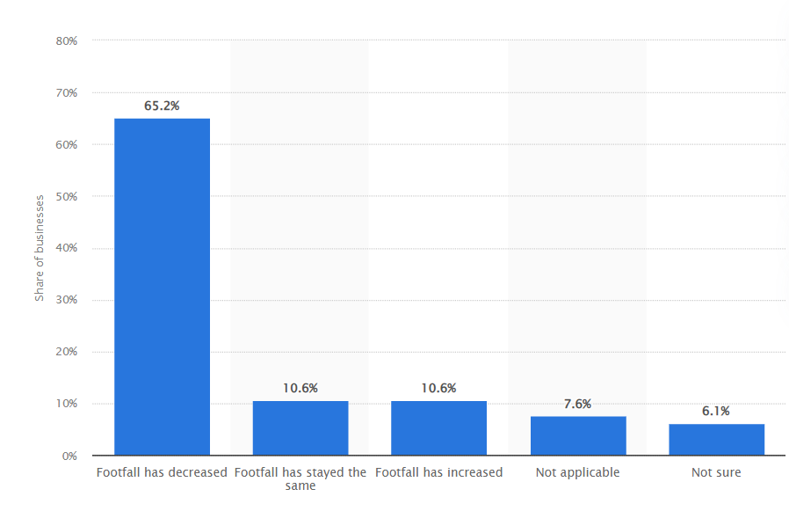
Figure 1: Covid 19 impact in UK hospitality
(Source: statista,2022)

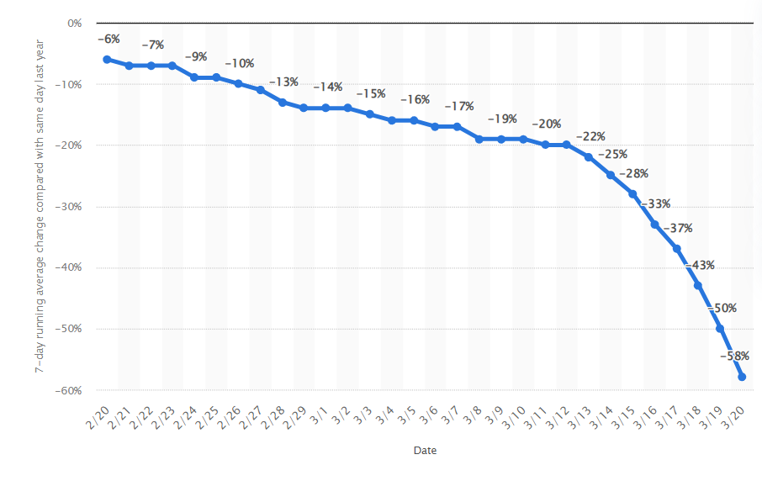
Figure 2: Covid-19 decline in Uk Hospitality
(Source: statista,2022)

APPLICATION FOR ETHICAL APPROVAL

In order for research to result in benefit and minimise risk of harm, it must be conducted ethically. A researcher may not be covered by the University’s insurance if ethical approval has not been obtained prior to commencement.

The University follows the OECD Frascati manual definition of research activity: “creative work undertaken on a systematic basis in order to increase the stock of knowledge, including knowledge of man, culture and society, and the use of this stock of knowledge to devise new applications”. As such this covers activities undertaken by members of staff, postgraduate research students, and both taught postgraduate and undergraduate students working on dissertations/projects.

The individual undertaking the research activity is known as the “principal researcher”.

Ethical approval is not required for routine audits, performance reviews, quality assurance studies, testing within normal educational requirements, and literary or artistic criticism.

Please read the notes for guidance before completing ALL sections of the form.

This form must be completed and approved prior to undertaking any research activity. Please see Checklist for details of process for different categories of application.

SECTION A: About You (Principal Researcher)
1 | Full Name: |  | Botanoiu Marilena Raluca
2 | Tick all boxes that apply: |  | Member of staff: | ☐ | Honorary research fellow: | ☐
 | Undergraduate Student | x | Taught Postgraduate Student | ☐ | Postgraduate Research Student | ☐

3 | Institute/Academic Discipline/Centre:
4 | Campus:
5 | E-mail address:
6 | Contact Telephone Number:
 | For students:
7 | Student Number: | 2019148
8 | Programme of Study:
9 | Director of Studies/Supervisor:

SECTION B: Approval for Research Activity
1 | Has the research activity received approval in principle?  (please check the Guidance Notes as to the appropriate approval process for different levels of research by different categories of individual) |  | YES | x | NO | ☐
 |  |  |  |  | Date
2 | If Yes, please indicate source of approval (and date where known): Approval in principle must be obtained from the relevant source prior to seeking ethical approval | Research Degrees Committee |  | x | Supevisor
2 |  | Institute Research Committee |  | ☐
2 |  | Other (write in) |  | ☐

SECTION C: Internal and External Ethical Guidance Materials
 | Please list the core ethical guidance documents that have been referred to during the completion of this form (including any discipline-specific codes of research ethics, location-specific codes of research ethics, and also any specific ethical guidance relating to the proposed methodology). Please tick to confirm that your research proposal adheres to these codes and guidelines. You may add rows to this table if needed.
1 | UWTSD Research Ethics & Integrity Code of Practice | x
2 | UWTSD Research Data Management Policy | x
3 | [List any other relevant documents here] | ☐

SECTION D: External Collaborative Research Activity
If there are external collaborators then you should gain consent from the contact persons to share their personal data with the university. If there are no external collaborators then leave this section blank and continue to section E.
1 | Institution
2 | Contact person name
3 | Contact person e-mail address
4 | Is your research externally funded? |  | YES | ☐ | NO |  | x
5 | Are you in receipt of a KESS scholarship? |  | YES | ☐ | NO |  | ☐
6 | Are you specifically employed to undertake this research in either a paid or voluntary capacity? | Voluntary | YES | ☐ | NO | ☐
7 |  | Employed | YES | ☐ | NO | ☐
8 | Is the research being undertaken within an existing UWTSD Athrofa Professional Learning Partnership (APLP)? | If YES then the permission question below does not need to be answered. | YES | ☐ | NO |  | ☐
9 | Has permission to undertake the research has been provided by the partner organisation? | (If YES attach copy)  If NO the application cannot continue | YES | ☐ | NO |  | ☐

Where research activity is carried out in collaboration with an external organisation
10 | Does this organisation have its own ethics approval system? | YES | x | NO | ☐
 | If Yes, please attach a copy of any final approval (or interim approval) from the organisation (this may be a copy of an email if appropriate).

SECTION E: Details of Research Activity
1 | Indicative title: | THE ROLE OF LEADERSHIP IN MANAGING ORGANISATIONAL CHALLENGES IN THE UK’S HOSPITALITY SECTOR DURING THE PANDEMIC
2 | Proposed start date: |  | Proposed end date:
Introduction to the Research (maximum 300 words per section)
Ensure that you write for a Non-Specialist Audience when outlining your response to the points below:
- Purpose of Research Activity
- Proposed Research Question
- Aims of Research Activity
- Objectives of Research Activity
Demonstrate, briefly, how Existing Research has informed the proposed activity and explain
- What the research activity will add to the body of knowledge
- How it addresses an area of importance.
3 | Purpose of Research Activity  The main goal of the study is to find out how important leadership is in helping the hotel business in the UK deal with the tough issues caused by the COVID-19 spread. By looking at the effects of various leadership types, sector-specific issues, effective solutions, and basic leadership principles, this study aims to make the sector stronger and better prepared for unplanned events. With a focus on crisis management and the long-term health of businesses, it aims to teach good leadership skills that will make the industry stronger and help it stay alive when problems come up out of the blue.  (this box should expand as you type)
4 | Research Question  What is the variety of challenges that the UK’s hospitality sector has faced during the pandemic?  What is the role of leadership in the hospitality sector to manage the various complexities and issues that have been faced during the pandemic?  What are the challenges faced by the hospitality sector of the UK due to the follow-up of the leadership strategy during the pandemic?  (this box should expand as you type)
5 | Aims of Research Activity  The research aims to critically examine the role of leadership in managing organisational challenges within the UK's hospitality sector during the COVID-19 pandemic, analyse the effectiveness of the adopted leadership strategies, and recommend robust leadership approaches to enhance organisational resilience and preparedness for uncertain situations in the future.  (this box should expand as you type)
6 | Objectives of Research Activity  To understand the concept of leadership for managing an organisation.  To evaluate the variety of challenges that the Uk’s hospitality sector has faced during the pandemic.  To analyse the role that leadership has played in the hospitality sector to manage the various complexities and issues that have been faced during the pandemic.  To analyse the challenges faced by the hospitality sector of the Uk due to the follow-up of the leadership strategy  To Recommend various leadership strategies to the hospitality sector of the Uk to manage organisational functioning during an uncertain situation.  (this box should expand as you type)
Proposed methods (maximum 600 words)
Provide a brief summary of all the methods that may be used in the research activity, making it clear what specific techniques may be used. If methods other than those listed in this section are deemed appropriate later, additional ethical approval for those methods will be needed. You do not need to justify the methods here, but should instead describe how you intend to collect the data necessary for you to complete your project.
7 | This study looked at how leadership affected how issues were treated in the UK hotel industry during the COVID-19 pandemic. Here are some important parts of the research method one should know about. For this study, interpretivism is used to make sure the data is correct and simple to understand. This makes it easier to collect and look at info. This way helps the study meet its goals while also recognising how hard it is, which is in line with what scholars said. According to research theory, the study uses a "explanatory" research method. This method helps to build a good study base, saves money, and gives better data choices. While studied, it helps stay on track with goals and encourages learning more about the subject.  The inductive method of the study looks at how hotel business leaders in the UK dealt with problems during the pandemic. This method, lets apply the study's findings to other situations by looking at the leadership theories that managers used to handle the complexity of the pandemic. Reading books, papers, and blogs that have already been written is a big part of the study. This is called secondary research. This way of secondary study makes it easy to find peer-reviewed material that has already been written and helps people fully understand the subject.  Qualitative research methods are used in the chosen study method. This qualitative way lets people guess and learn more about the things being studied. The study's results are more likely to be true because it is easy to check their truth and trustworthiness.  A way of choosing people for the study is known as "purposeful sampling." which lets certain people or data sources be picked out based on certain rules. This fits with how hard it was to be a star in the UK hotel business during the spread. It will make the best use of time and resources and make sure that the review is focused and complete. Aside from reading books, papers, and articles carefully, data is also gathered from other websites and platforms, such as Google Scholar, ProQuest, and others. Through careful selection of reliable academic sources, this way aims to improve the study's findings and make them more general.  "Theme analysis" is what is used to make sense of the data. Once the researcher has an idea of how to do the research, they carefully think about appropriate theoretical theories and come up with themes that fit with the study's goals, aims, and questions. If you follow these steps, readers will be able to better understand the information, which will help to learn more about how leadership helped the UK hotel business deal with management problems during the pandemic. A Gannt chart plan helps researchers keep track of how the times they studied changed over time. When it comes to morals, the Data Protection Act of 2018 is used. This law keeps private rights safe and makes sure that data is treated properly. This makes the work more honest and moral.  (this box should expand as you type)
Location of research activity
Identify all locations where research activity will take place.
8 | United Kingdom  (this box should expand as you type)
Research activity outside of the UK
If research activity will take place overseas, you are responsible for ensuring that local ethical considerations are complied with and that the relevant permissions are sought. Specify any local guidelines (e.g. from local professional associations/learned societies/universities) that exist and whether these involve any ethical stipulations beyond those usual in the UK (provide details of any licenses or permissions required). Also specify whether there are any specific ethical issues raised by the local context in which the research activity is taking place, for example, particular cultural and/or legal sensitivities or vulnerabilities of participants. If you live in the country where you will do the research then please state this.
9 | (this box should expand as you type)

10 | Use of documentation not in the public domain: Are any documents NOT publicly available? | NO | ☐
10 |  | YES | ☐
11 | If Yes, please provide details here of how you will gain access to specific documentation that is not in the public domain and that this is in accordance with the current data protection law of the country in question and that of England and Wales.  (this box should expand as you type)

 | Does your research relate to one or more of the seven aims of the Well-being of Future Generations (Wales) Act 2015? | YES | NO
12 | A prosperous Wales | ☐ | x
13 | A resilient Wales | ☐ | x
14 | A healthier Wales | ☐ | x
15 | A more equal Wales | ☐ | x
16 | A Wales of cohesive communities | ☐ | x
17 | A Wales of vibrant culture and thriving Welsh language | ☐ | x
18 | A globally responsible Wales | ☐ | x
19 | If YES to any of the above, please give details:
 | (this box should expand as you type)

SECTION F: Scope of Research Activity
 | Will the research activity include: | YES | NO
1 | Use of a questionnaire or similar research instrument? | ☐ | x
2 | Use of interviews? | ☐ | x
3 | Use of focus groups? | ☐ | x
4 | Use of participant diaries? | ☐ | x
5 | Use of video or audio recording? | ☐ | x
6 | Use of computer-generated log files? | ☐ | x
7 | Participant observation with their knowledge? | ☐ | x
8 | Participant observation without their knowledge? | ☐ | x
9 | Access to personal or confidential information without the participants’ specific consent? | ☐ | x
10 | Administration of any questions, test stimuli, presentation that may be experienced as physically, mentally or emotionally harmful / offensive? | ☐ | x
11 | Performance of any acts which may cause embarrassment or affect self-esteem? | ☐ | x
12 | Investigation of participants involved in illegal activities? | ☐ | x
13 | Use of procedures that involve deception? | ☐ | x
14 | Administration of any substance, agent or placebo? | ☐ | x
15 | Working with live vertebrate animals? | ☐ | x
16 | Procedures that may have a negative impact on the environment? | ☐ | x
17 | Other primary data collection methods. Please indicate the type of data collection method(s) below. | ☐ | x
 | Details of any other primary data collection method:  (this box should expand as you type) | ☐ | x
If NO to every question, then the research activity is (ethically) low risk and may be exempt from some of the following sections (please refer to Guidance Notes).

If YES to any question, then no research activity should be undertaken until full ethical approval has been obtained.

SECTION G: Intended Participants
If there are no participants then do not complete this section, but go directly to section H.

 | Who are the intended participants: | YES | NO
1 | Students or staff at the University? | x | ☐
2 | Adults (over the age of 18 and competent to give consent)? | x | ☐
3 | Vulnerable adults? | ☐ | x
4 | Children and Young People under the age of 18? (Consent from Parent, Carer or Guardian will be required) | ☐ | x
5 | Prisoners? | ☐ | x
6 | Young offenders? | ☐ | x
7 | Those who could be considered to have a particularly dependent relationship with the investigator or a gatekeeper? | ☐ | ☐
8 | People engaged in illegal activities? | ☐ | x
9 | Others. Please indicate the participants below, and specifically any group who may be unable to give consent. | ☐ | x
 | Details of any other participant groups:  (this box should expand as you type) | ☐ | x

Participant numbers and source
Provide an estimate of the expected number of participants. How will you identify participants and how will they be recruited?
10 | How many participants are expected? | (this box should expand as you type)
11 | Who will the participants be? | (this box should expand as you type)
12 | How will you identify the participants? | (this box should expand as you type)

 | Information for participants: | YES | NO | N/A
13 | Will you describe the main research procedures to participants in advance, so that they are informed about what to expect? | ☐ | ☐ | ☐
14 | Will you tell participants that their participation is voluntary? | ☐ | ☐ | ☐
15 | Will you obtain written consent for participation? | ☐ | ☐ | ☐
16 | Will you explain to participants that refusal to participate in the research will not affect their treatment or education (if relevant)? | ☐ | ☐ | ☐
17 | If the research is observational, will you ask participants for their consent to being observed? | ☐ | ☐ | ☐
18 | Will you tell participants that they may withdraw from the research at any time and for any reason? | ☐ | ☐ | ☐
19 | With questionnaires, will you give participants the option of omitting questions they do not want to answer? | ☐ | ☐ | ☐
20 | Will you tell participants that their data will be treated with full confidentiality and that, if published, it will not be identifiable as theirs? | ☐ | ☐ | ☐
21 | Will you debrief participants at the end of their participation, in a way appropriate to the type of research undertaken? | ☐ | ☐ | ☐
22 | If NO to any of above questions, please give an explanation
 | (this box should expand as you type)

 | Information for participants: | YES | NO | N/A
24 | Will participants be paid? | ☐ | ☐ | ☐
25 | Is specialist electrical or other equipment to be used with participants? | ☐ | ☐ | ☐
26 | Are there any financial or other interests to the investigator or University arising from this study? | ☐ | ☐ | ☐
27 | Will the research activity involve deliberately misleading participants in any way, or the partial or full concealment of the specific study aims? | ☐ | ☐ | ☐
28 | If YES to any question, please provide full details
 | (this box should expand as you type)

SECTION H: Anticipated Risks

Outline any anticipated risks that may adversely affect any of the participants, the researchers and/or the University, and the steps that will be taken to address them.

If you have completed a full risk assessment (for example as required by a laboratory, or external research collaborator) you may append that to this form.
1 | Full risk assessment completed and appended? |  | Yes | ☐
1 |  |  | No | ☐
2 | Risks to participants  For example: sector-specific health & safety, emotional distress, financial disclosure, physical harm, transfer of personal data, sensitive organisational information
 | Risk to participants:  (this box should expand as you type) | How you will mitigate the risk to participants:  (this box should expand as you type)
3 | If research activity may include sensitive, embarrassing or upsetting topics (e.g. sexual activity, drug use) or issues likely to disclose information requiring further action (e.g. criminal activity), give details of the procedures to deal with these issues, including any support/advice (e.g. helpline numbers) to be offered to participants. Note that where applicable, consent procedures should make it clear that if something potentially or actually illegal is discovered in the course of a project, it may need to be disclosed to the proper authorities
 | (this box should expand as you type)
4 | Risks to the investigator  For example: personal health & safety, physical harm, emotional distress, risk of accusation of harm/impropriety, conflict of interest
 | Risk to the investigator:  (this box should expand as you type) | How you will mitigate the risk to the investigator:  (this box should expand as you type)
5 | University/institutional risks  For example: adverse publicity, financial loss, data protection
 | Risk to the University:  (this box should expand as you type) | How you will mitigate the risk to the University:  (this box should expand as you type)
6 | Environmental risks  For example: accidental spillage of pollutants, damage to local ecosystems
 | Risk to the environment:  (this box should expand as you type) | How you will mitigate the risk to environment:  (this box should expand as you type)

 | Disclosure and Barring Service
 | If the research activity involves children or vulnerable adults, a Disclosure and Barring Service (DBS) certificate must be obtained before any contact with such participants. | YES | NO | N/A
7 | Does your research require you to hold a current DBS Certificate? | ☐ | ☐ | ☐
8 | If YES, please give the certificate number. If the certificate number is not available please write “Pending”; in this case any ethical approval will be subject to providing the appropriate certificate number.

SECTION I: Feedback, Consent and Confidentiality

1 | Feedback  What de-briefing and feedback will be provided to participants, how will this be done and when?
 | (this box should expand as you type)
2 | Informed consent  Describe the arrangements to inform potential participants, before providing consent, of what is involved in participating. Describe the arrangements for participants to provide full consent before data collection begins. If gaining consent in this way is inappropriate, explain how consent will be obtained and recorded in accordance with prevailing data protection legislation.
 | (this box should expand as you type)
3 | Confidentiality / Anonymity  Set out how anonymity of participants and confidentiality will be ensured in any outputs. If anonymity is not being offered, explain why this is the case.
 | (this box should expand as you type)

SECTION J: Data Protection and Storage

 | Does the research activity involve personal data (as defined by the General Data Protection Regulation 2016 “GDPR” and the Data Protection Act 2018 “DPA”)? | YES | NO
1 | “Personal data” means any information relating to an identified or identifiable natural person (‘data subject’). An identifiable natural person is one who can be identified, directly or indirectly, in particular by reference to an identifier such as a name, an identification number, location data, an online identifier or to one or more factors specific to the physical, physiological, genetic, mental, economic, cultural or social identity of that natural person. Any video or audio recordings of participants is considered to be personal data. | ☐ | ☐
 | If YES, provide a description of the data and explain why this data needs to be collected:
2 | (this box should expand as you type)
 | Does it involve special category data (as defined by the GDPR)? | YES | NO
3 | “Special category data” means sensitive personal data consisting of information as to the data subjects’ –  (a) racial or ethnic origin,  (b) political opinions,  (c ) religious beliefs or other beliefs of a similar nature,  (d) membership of a trade union (within the meaning of the Trade Union and Labour Relations (Consolidation) Act 1992),  (e) physical or mental health or condition,  (f) sexual life,  (g) genetics,  (h) biometric data (as used for ID purposes), | ☐ | ☐
 | If YES, provide a description of the special category data and explain why this data needs to be collected:
4 | (this box should expand as you type)

 | Will data from the research activity (collected data, drafts of the thesis, or materials for publication) be stored in any of the following ways? | YES | NO
5 | Manual files (i.e. in paper form)? | x | ☐
6 | University computers? | ☐ | x
7 | Private company computers? | ☐ | x
8 | Home or other personal computers? | x | ☐
9 | Laptop computers/ CDs/ Portable disk-drives/ memory sticks? | ☐ | x
10 | “Cloud” storage or websites? | ☐ | x
11 | Other – specify: | ☐ | x
12 | For all stored data, explain the measures in place to ensure the security of the data collected, data confidentiality, including details of backup procedures, password protection, encryption, anonymisation and pseudonymisation:
 | (this box should expand as you type)

 | Data Protection
 | Will the research activity involve any of the following activities: | YES | NO
13 | Electronic transfer of data in any form? | ☒ | ☐
14 | Sharing of data with others at the University outside of the immediate research team? | ☐ | x
15 | Sharing of data with other organisations? | ☐ | x
16 | Export of data outside the UK or importing of data from outside the UK? | ☐ | x
17 | Use of personal addresses, postcodes, faxes, emails or telephone numbers? | ☐ | x
18 | Publication of data that might allow identification of individuals? | ☐ | x
19 | Use of data management system? | ☐ | x
20 | Data archiving? | ☐ | x
21 | If YES to any question, please provide full details, explaining how this will be conducted in accordance with the GDPR and Data Protection Act (2018) (and any international equivalents, where appropriate):
 | (this box should expand as you type)
22 | List all who will have access to the data generated by the research activity:
 | (this box should expand as you type)
23 | List who will have control of, and act as custodian(s) for, data generated by the research activity:
 | (this box should expand as you type)
24 | Give details of data storage arrangements, including security measures in place to protect the data, where data will be stored, how long for, and in what form. Will data be archived – if so how and if not why not.
 | (this box should expand as you type)
25 | Please indicate if your data will be stored in the UWTSD Research Data Repository (see https://researchdata.uwtsd.ac.uk/ ). If so please explain. (Most relevant to academic staff)
 | (this box should expand as you type)
26 | Confirm that you have read the UWTSD guidance on data management (see https://www.uwtsd.ac.uk/library/research-data-management/) | YES | x
27 | Confirm that you are aware that you need to keep all data until after your research has completed or the end of your funding | YES | x

SECTION K: Declaration
The information which I have provided is correct and complete to the best of my knowledge. I have attempted to identify any risks and issues related to the research activity and acknowledge my obligations and the rights of the participants.

In submitting this application I hereby confirm that I undertake to ensure that the above named research activity will meet the University’s Research Ethics and Integrity Code of Practice which is published on the website: https://www.uwtsd.ac.uk/research/research-ethics/
1 | Signature of applicant: | Botanoiu Marilena Raluca | Date:  27.12.2023

For STUDENT Submissions:
2 | Director of Studies/Supervisor: | Dr.Hoang Dang Nguyen | Date:  28.12.2023
3 | Signature: | Hoang Dang Nguyen | Date:  28.12.2023

For STAFF Submissions:
4 | Academic Director/ Assistant Dean: |  | Date:
5 | Signature: |  | Date:

Checklist: Please complete the checklist below to ensure that you have completed the form according to the guidelines and attached any required documentation:
x | I have read the guidance notes supplied before completing the form.
x | I have completed ALL RELEVANT sections of the form in full.
x | I confirm that the research activity has received approval in principle
x | I have attached a copy of final/interim approval from external organisation (where appropriate)
x | I have attached a full risk assessment (where appropriate) ONLY TICK IF YOU HAVE ATTACHED A FULL RISK ASSESSMENT
x | I understand that it is my responsibility to ensure that the above named research activity will meet the University’s Research Ethics and Integrity Code of Practice.
x | I understand that before commencing data collection all documents aimed at respondents (including information sheets, consent forms, questionnaires, interview schedules etc.) must be confirmed by the DoS/Supervisor, module tutor or Academic Director.

RESEARCH STUDENTS AND STAFF ONLY
All communications relating to this application during its processing must be in writing and emailed to pgresearch@uwtsd.ac.uk , with the title ‘Ethical Approval’ followed by your name.
You will be informed of the outcome of your claim by email; therefore it is important that you check your University and personal email accounts regularly.
STUDENTS ON UNDERGRADUATE OR TAUGHT MASTERS PROGRAMMES should submit this form (and receive the outcome) via systems explained to you by the supervisor/module leader.

This form is available electronically from the Academic Office web pages: https://www.uwtsd.ac.uk/academic-office/appendices-and-forms/

