  Component One:  What are the key skills required when working in the housekeeping team? 750 words (+/- 10%)  Contribution to Overall Module Assessment: 25% | Student No: | 1818298
 | Module Title: | Operating Hotel Facilities
 | Module Code: | BMIH4006
 | Lecturer: | Lola Villard
The housekeeper is referred as the maintenance and the cleaning employees who used to work at homes or hospitality industry. There is various key that is considered by the housekeeper to make the proper cleanliness and hygiene in hotels. The housekeeping skills allows the housekeeper to perform their job skill fully. As working in housekeeping team, I have found that it is difficult to perform this task and to hectic. The skills required for performing this task is to change the bed sheets and clean the beds, recycle, and remove the garbage from the room, cleaning the cutlery, clean the furniture’s of the rooms and other skills. The other soft skill that is used to perform the job is managing the time. The housekeeper must complete their task of everyday in the time. Also, they must give proper attention on the details. They must follow their supervisor's order. And if any clients call them for cleaning they have to go and clean they area. Moreover, they must possess the interpersonal and communication skills in order to interact with guest. Also, they have to keep interaction with their team members to make sure about the completing of their task. Further, they must be flexible to effectively work and have the ability to provide customer services. As working in a Trinity hotel as an employee in the housekeeping team. The experience was not so good. But on other hand I learned a lot, as I used to enhance my communication skill and interpersonal skill. This helps me to easily get engaged with the guest. I get top learn more about the hygiene and cleanliness. The worst thing I faced when the client leaves the wash rooms area very dirty which smells awful. Along with this they used to not treat well with the workers. As for them we are kind of workers or servant, so they used yell on us. But I get to learn about various things. Such as I get flexible for working, learned how to compromise and tackle the guest. Also, anytime the client can call us for the cleaning, so we have to go their due to which sometimes I didn't get proper rest. I worked for almost 8 months in the hotel. And I didn't like the job position as well as their work due to which I left the job. Based on theoretical knowledge I have applied my learnings in my work. As I have learned more about proper use of better solutions and powder for proper cleaning. I get to learn during my courses about the coordination, social perception, speaking and monitoring. This all I have applied in my practical knowledge when I was working in the hotel. Moreover, I had a fun in this experience as my team members were supporting and encourages me. They also make me learn more things about the housekeeping department. My manager of the department was also supportive and taught us many things. They try to provide us flexibility for working also. But there are sometimes when I lack out the confidence and feels to leave the working. This is because of behaviour of customers. Their rude behaviour de motivates me to work in this hotel. Further, working in the prime and luxury hotel I upgrade my standard and able to maintain the hotels standard too. The housekeeping plays an important role in the hospitality. As this ensures about the safe and hygiene environment. As in hotel various clients are check in on every other day so it is necessary to clean the rooms and change the bedsheet. The cleanliness and hygiene are the factor which holds the customer and marks the impression. The department of housekeeping in the hotels are recognised for creating a home which is away from the home. It is the duty of housekeeping team to maintain the standard of quality and cleanliness in the hotel. This department is only responsible for cleaning in the hotels. It is necessary for the hospitality as this.
- Helps to make sure about the comfort of clients as well as for the smooth work of guest stay' s.
- Helps to establish the soothing and comfort atmosphere and ensures the reliable services for the staff.
- Make sure about the hygiene and cleanliness in the hotel.
- Ensures about the safety and security guidelines which met the consumer satisfaction.
- They used to cater the requirement of laundry maintain the décor of room in accordance with their standard.
Make sure about the working relationship with the departments.

Component Two:
Contribution to Overall Module Assessment: 25%
In this scenario – You have just been promoted to team leader for a floor within the hotel. A guest complains that on their arrival, their room had not been properly cleaned. Create an action plan and answer the following questions.

Problem | Why did it happen? | What are you going to do? | How will you prevent this from happening in the future? | What measures would you introduce to improve team effectiveness?
Unclean rooms that is lack of hygiene in the hotels, at the arrival time of guests. | As they don't have effective housekeeping team due to which their rooms are not cleaned. Also, the workers who used to clean the rooms they are not doing it properly (Alcalde-González, Mozo, and Bustos, 2021). Further, they don't have effective knowledge about cleaning the rooms with help of effective cleaning solutions. May be, the workers are being lazy in doing the work so they are not giving their best results. Another reason is that I have the shortage of workers due to which it is not able to clean each and every room daily. | Being a team leader, I will try to provide more knowledge to my team about the cleaning. Also, I will guide them to use various solutions and powders to do proper cleaning of rooms. Further, I will appoint more expertise and experienced person for cleaning the rooms and floors. I will ask the team members again and again to clean the rooms and floor. To produce the best output, I will provide them effective training and the practical knowledge about how to use the products for proper cleaning. Moreover, I can keep the fresheners in wash rooms of every room to reduce the foul smell. I can try to conduct meeting on regular basis to ensure that they are doing cleaning minimum 2 times in a day. | For future aspect, at the time of hiring a new employee for team I will check their skills. Also, I will provide them induction in which I will tell about effective cleaning of the rooms. This will give them snapshot about cleaning and to keep the hygiene. Also, I will ask the front desk to hold the clients until the room get cleaned. Don't provide them unclean rooms. Moreover, I will make in-charge and sub groups to lead three four members under them. And they will ensure about proper cleaning. Also, the numbers for cleaning will be given in every room and front desk so that client can call and ask for immediate cleaning. | In order to enhance the team effectiveness, I will motivate and encourage them to clean the rooms on daily basis. Along with this, when the customer leaves the room, just check the room and clean it again. Further, I will take meetings and seminars to guide them about cleaning of rooms. Moreover, I can give them responsibility for the area, for which they are accountable to keep it clean. The employees who are lazy and not giving their productive result, I can fire them from the team or provide them training (Tavitiyaman, and et. al, 2022). The expertise can help to make sure about the proper cleaning.

Component Three:
Contribution to Overall Module Assessment: 50%
Your task is to create and prepare a presentation following the detailed scenario provided below.

As the floor housekeeping manager and given the recent guest complaints you need to put together a basic training presentation for your colleagues within the housekeeping team to get the best out of them, ensure that brand standard is being achieved and that Health and Safety procedures are also being followed.

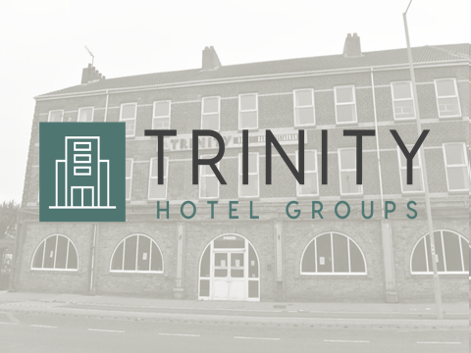

Training Notes: Title page
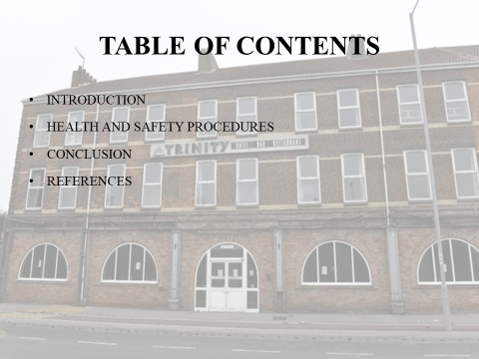

Training Notes: Content
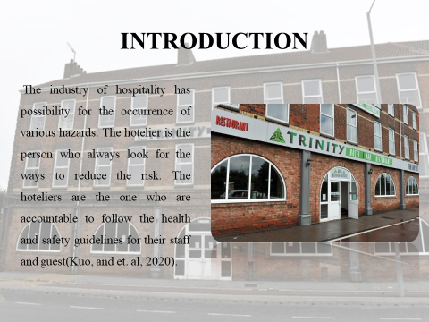

Training Notes: The industry of hospitality has possibility for the occurrence of various hazards. The hotelier is the person who always look for the ways to reduce the risk. The hoteliers are the one who are accountable to follow the health and safety guidelines for their staff and guest (Kuo, and et. al, 2020). This can be done by forming up the effective protocols in order to protect this. The success of hotel is linked with the health and safety protocols in order to protect the staff and guest from unfavourable consequences. In this presentation the opted hotel is trinity which follows the health and safety guidelines to protect their client and staff. This hotel is located at Marfleet, Kingston UK. The presentation will provide health and safety procedures by using the employee engagement model.
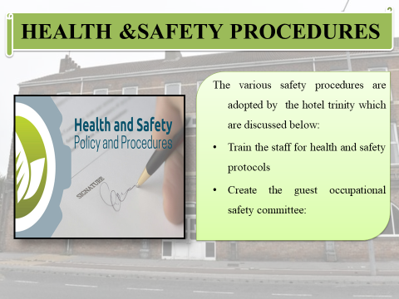

Training Notes:
The various safety procedures adopted by housekeeping department of hotel trinity are discussed below:
Train the staff for health and safety protocols: The manager of the housekeeping department can provide the safety measures for the guest and the staff in hotel. The manager must provide training to their staff in order to prevent injuries which can occur due to the fire, slips, exposure to chemicals and many more (Abu Aisheh and et.al., 2022).
Create the guest occupational safety committee: The manager must create the committee for the safety of guest. This group is only accountable for safety procedures taken by the hotel to protect the guest. Furthermore, they support in addressing deficiencies that may occur in the hotel’s safety protocol (Bitzas, and et. al, 2022).
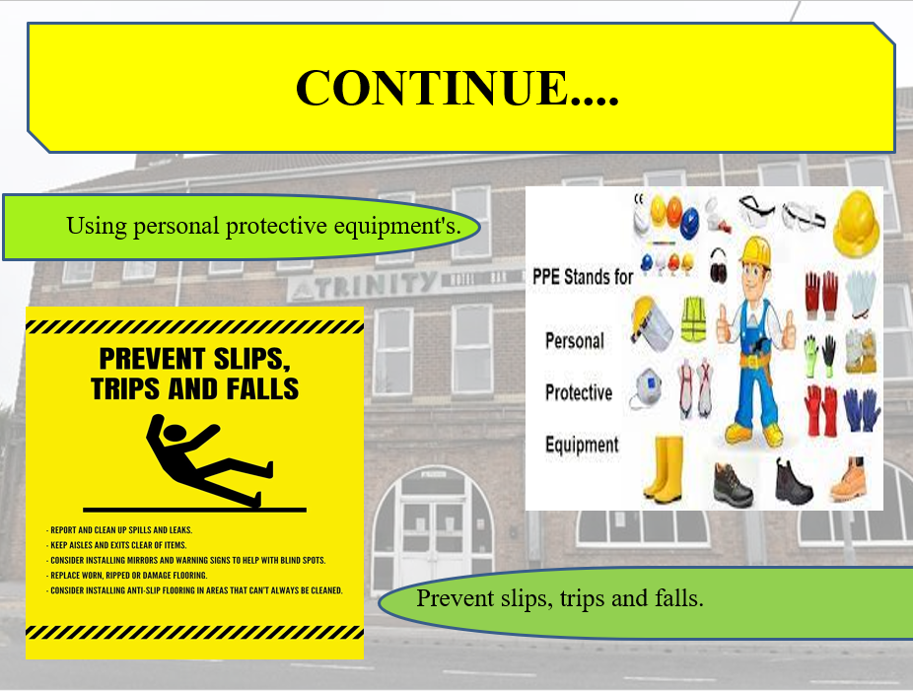

Training Notes:
Using personal protective equipment and tools: The wearing of necessary protective items like closed toe shoes along with safety glasses can play integral role in protecting workers while doing housekeeping activities. The PPE should be chosen consciously which may differ based on potential risks. In order to continue smooth usage and reduce dirtiness, the used tools should be inspected and cleaned on day-to-day manner (Gupta and Sahu, 2021).
Prevent slips, trips and falls: The workplace conditions of housekeeping department can be positively enhanced by keeping it in top sanitary conditions and orderly manner. The place is good for employees if there are proper arrangements in the form of proper passageways, storerooms as well as service rooms. In addition to this, the floors also need to be cleaned and then dried in fastest manner (Dela Cruz and Ortega-Dela Cruz, 2022). The housekeeping worker are requested to report to managers when any negative conditions arise like damaged floors, mats, spillage and many more.

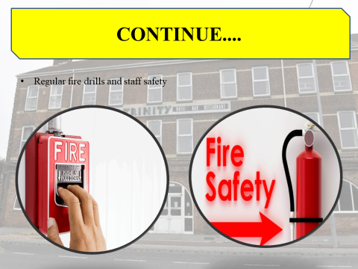

Training Notes:
Instalment of fire drills and staff safety: The protocol and some safety measures are being undertaken by the group of members, as to implement in the fire event. Through the employee engagement model these protocols have been decided by the hotels. The employee engagement model is used in creation of health and safety procedures (Sun, and Bunchapattanasakda, 2019). As this model help to make the members of staff satisfied. The training is provided to the employees for ensuring safety and checking effectiveness of fire drills on regular manner. In order to prevent fire, the usage of combustible materials within work area should be within fixed amounts needed for job. The fire extinguisher equipment’s must be installed where the chance of catching fire is very high (Mejia, Ciarlante and Chheda, 2021).
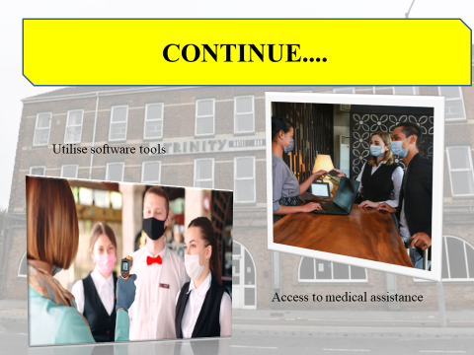

Training Notes:
Utilise software tools: The EHS management can be used to track the record keeping of customers. Also, this can be used to provide the content of training and employees documentation training in order to analyse the safety hazards in more effective manner (Kuo and et.al., 2020). This software can allow the employee to keep their record in safe and secure manner.
Access to medical assistance: The trinity hotel must form the teams to assure about the wellbeing and safety of everyone (Nimri, and et. al, 2020). They must put efforts in order to help the guest for the relaxed stay. As well as the hotel must provide the medical assistance to their guest and services in the form of keeping first aid box as well as pressing emergency alarm (Gurmu, 2019).
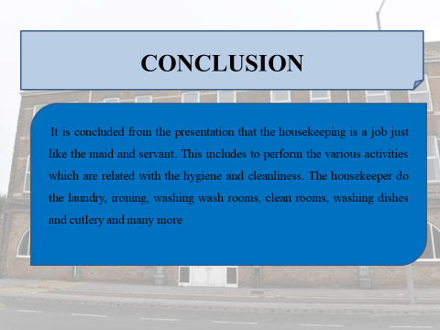

Training Notes:
It was concluded from the presentation that the housekeeping is a job just like the maid and servant. This includes to perform the various activities which are related with the hygiene and cleanliness. The housekeeper does the laundry, ironing, washing wash rooms, clean rooms and many more. In this presentation the skills required for housekeeping are mentioned. Along with this the health and safety procedures in context to hotel are being written. The health and safety protocols are adopted by the hotels to provide security and safety to staff as well as consumer.
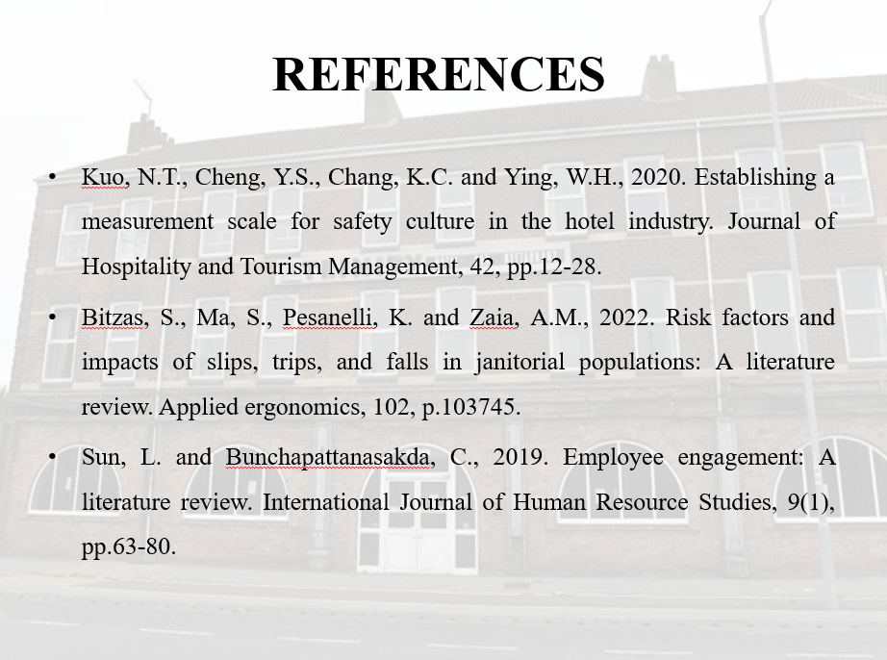
References

Mejia, C., Ciarlante, K. and Chheda, K., 2021. A wearable technology solution and research agenda for housekeeper safety and health. International Journal of Contemporary Hospitality Management.
Gupta, V. and Sahu, G., 2021. Reviving the Indian hospitality industry after the Covid-19 pandemic: the role of innovation in training. Worldwide hospitality and tourism themes, 13(5), pp.599-609.
Dela Cruz, R.Z. and Ortega-Dela Cruz, R.A., 2022. Facilities technology management framework for public health-care institutions in a developing country. Journal of Facilities Management, 20(5), pp.609-628.
Abu Aisheh and et.al., 2022. Health and safety improvement in construction projects: a lean construction approach. International journal of occupational safety and ergonomics, 28(4), pp.1981-1993.
Kuo and et.al., 2020. Establishing a measurement scale for safety culture in the hotel industry. Journal of Hospitality and Tourism Management, 42, pp.12-28.
Gurmu, A.T., 2019. Identifying and prioritizing safety practices affecting construction labour productivity: An empirical study. International Journal of Productivity and Performance Management, 68(8), pp.1457-1474.
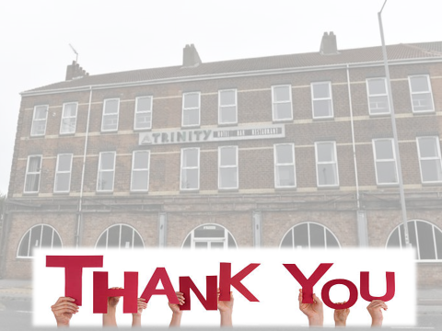

Training Notes:

References

Alcalde-González, V., Mozo, A.G. and Bustos, A.V., 2021. No clean rooms, no hotel business: Subversion tactics in Las Kellys’ struggle for dignity in hotel housekeeping. Annals of Tourism Research, 91, p.103315.
Nimri, R., Kensbock, S., Bailey, J., Jennings, G. and Patiar, A., 2020. Realizing dignity in housekeeping work: Evidence of five-star hotels. Journal of Human Resources in Hospitality & Tourism, 19(3), pp.368-387.
Tavitiyaman, P., Tsui, B., Chan, C.L.F. and Miu, H.W., 2022. Employee Productivity of Hotel Room Attendants: An Input–Output Perspective. International Journal of Hospitality & Tourism Administration, 23(5), pp.959-986.
Kuo, N.T., Cheng, Y.S., Chang, K.C. and Ying, W.H., 2020. Establishing a measurement scale for safety culture in the hotel industry. Journal of Hospitality and Tourism Management, 42, pp.12-28.
Bitzas, S., Ma, S., Pesanelli, K. and Zaia, A.M., 2022. Risk factors and impacts of slips, trips, and falls in janitorial populations: A literature review. Applied ergonomics, 102, p.103745.
Sun, L. and Bunchapattanasakda, C., 2019. Employee engagement: A literature review. International Journal of Human Resource Studies, 9(1), pp.63-80.

