ASSIGNMENT NO 2 FOR MARKETING FUNDAMENTALS
LECTURER TUSHARA BALENDRAN
UWTSD APRIL 2021 BUSINESS MANAGEMENT
DANIEL ANTONESCU STUDENT NUMBER 1914798

ADIDAS

TABLE OF CONTENTS

INTRODUCTION……………………………………………………………………………….3
ROLE OF MARKETING IN CREATING VALUE FOR CUSTOMERS……………………...3
MARKETING CONCEPT………………………………………………………………………3
ADVANTAGES OF MARKETING TO THE CONSUMER…………………………………..4
BRANDING……………………………………………………………………………………..4
ANSOFF MATRIX…………………………………………………………………………...…5
STAKEHOLDER ENGAGEMENT AND THEIR IMPACT ON THE MARKETING ACTIVITIES OF AN ORGANIZATION………………………………………….……………7
DEFINITION OF STAKEHOLDERS……………………………………………………….….7
THE POWER MATRIX…………………………………………………………………………8
CONCLUSION AND RECOMMENDATION………………………………………………….9
REFERENCES…………………………………………………………….…………………….10

- Introduction

The chosen company for this assignment is Adidas, which is a global known sportswear company, and, the biggest one in Europe, it has been on the market for over 70 years and, been founded in Germany by Adi Dassler. Adidas is very popular along younger people because they produce trendy items for affordable prices and also their products last very well through time. The German brand employs over 62.200 employees worldwide according to their 2020 report.

- Role of marketing in creating value to the customer

Adidas has always come up with innovative ideas and technology was used to promote and manufacture their products. For the sports fans and David Beckham fans, the collection between Adidas and David Beckham for instance, brings value to the customer. The customer is into sports and a certain celebrity and he wants a certain product to remind him of that. The collaboration brings value as well and because the celebrity is promoting a certain product, the consumer tends to think that the product is good, this way the image of the brand is implemented. The collaboration from 2019 between Adidas and David Beckham has brought on the market a pair of sports shoes UltraBOOST which costed around $210, the higher the price, the better the consumer think it is and the higher the expectations. (Leung,2019)
- The marketing concept
As stated by Kotler (2000) the marketing concept is made of four aspects: target market, customer needs, integrated market, and profitability. The marketing concept challenges the three business orientations: the production concept, the product concept, and the selling concept. By doing so, the organizational goals of the company can be achieved. The marketing concept focuses on the needs of the consumer. Adidas uses differentiated targeted strategy for mainly younger people between 15-40 that are passionate about sports and they wish to own good quality sportswear. (Bhasin,2017)
As stated by Bhasin (2018) the aim of Adidas is to give the best footwear to consumers with a combination of technology and great design, but these products are not need based, they are definitely wants and desires. The products even though are made for sportswear and athletes mostly, the targeted age group (15-40) uses Adidas products as statements as the brand image is highly valued.
- Advantages of marketing to the consumer
Marketing that is accurately researched and targeted will bring new consumers, opinions and feedback of consumers will bring ways for improvement, the brand awareness is rising, market share is increasing, a more personal relationship between the consumer and the brand is possible. (BBC,2020) Adidas marketing is relating on technology, the brand use digital marketing spending 90% of their marketing budget on digital campaigns and social media, as well as they thrive to manufacture and sell the products quickly for the comfort of the customers, the interaction with the customer is crucial, trying to build relationships with them and making the consumers feel valued, also the collaborations with different celebrities bring a boost of sales and it is a great marketing idea to attract customers. (Dan,2020)
- Branding
The branding is the sum of the characteristics which gives personality to the brand itself, its uniqueness and the thing that makes it different to other brands. The branding is the sum of the customers perceptions and experiences. (Brandocracy,2020) Adidas creates a distinctive image in the mind of the consumer by emphasizing the value of the quality of their products, Adidas is a trusted brand which manages to keep their brand essence, also they own Reebok, another sportswear brand. (Bhasin,2017) Adidas Original image is a striped three leaf, Adidas Performance is an image with three stripes, Adidas Neo is a ball with three stripes as well as Adidas Style, each of these logos implement the brand in the customer mind.
The advantages of branding stated by Brandocracy (2020) are: customer recognition, the opportunity to keep the employees happy in the company, the relationship between the brand and customers, the occasion to attract more talent into the company, gives credibility, makes the customers more loyal, gives consistency. Branding is the key to a healthy relationship between employees, customers, and business and also it helps to create value to the consumers.
- Ansoff matrix
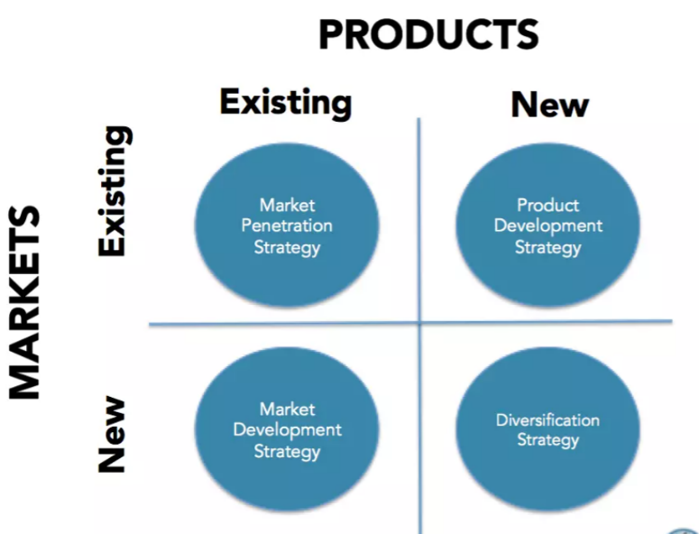
Fig. 1 Ansoff (1960)
The Ansoff matrix is a core business strategy tool used in business all around the world, which helps CEO’s, managers, and marketers to elaborate strategies of business growth. (OCM,2020)
Market penetration strategy – is a measure of how much a product or service is used by consumers compared to the total estimated market for that product or service. (Kenton,2020) The market Adidas on is retail, the brand sells sportwear clothing and accessories and, there is a huge demand for this kind of products. This is the era of comfort and people are looking for durable and comfortable clothing products and shoes, brands can easily enter the market and offer similar products, but Adidas is in top of the market still and their products are in demand.
Market development strategy – the brand enters a new market with their existing products. Adidas was born in Germany and the brand extended to Europe and then to America. In the first half of 2020, sales in Europe have brought Adidas 2.270 million euros and because they expanded to Asia the brand gained 2.756 million euros. (Statista,2020)
Product development strategy – the development of an original product, product improvements, or modifications and new brands through the firm’s own product development efforts. (Kotler & Armstrong p.280, 2018) Adidas was selling sports shoes at the beginning and now they are offering more than that, the brand offers clothing and accessories which gives the consumer more variety and brings more interest to the brand.
Diversification strategy – is used to expand the company’s operations by adding markets, products, or services to the existing business, when the brand has a powerful well-known name it can expand to other products or services. (Oluwakemi,2018) For example Adidas acquired the company Reebok in 2006 for $3.8billion and expanded their product and services. Reebok is a sportswear company as well and in 2019 their women sportswear was the most successful of part of their line. (Hensel,2020) Adidas has brought to the market perfumes and body cosmetics a few years ago, expanding the market to their men and women consumers which want to smell like a celebrity.
Advantages of the Ansoff matrix its simple to understand, it gives the company all the potential alternatives which helps with the decision-making also it helps with risk analysis. (Parikh, 2019) On the other hand, the disadvantages are the competitors are not taken into account, its tough to predict the effect of implementing some of the strategies and it points out the strategies, but it doesn’t consider the cost-benefit analysis.
The customer relationship management is the overall process of building and maintaining profitable customer relationships by delivering superior customer value and satisfaction. (Kotler & Armstrong p.38, 2018) Adidas is connecting with the customers to a whole new level, from the customer service experience, to the buying experience to the personalized products they provide. The brand offers an app called Adidas Confirmed which gives the opportunity to consumers to reserve products in the store for easy and fast pick-up and also sends online the latest news and releases from the brand, this strategy builds a relationship with customers. (Gilliland,2017) Adidas offers customer service before, during and after the customer places an order.
Adidas uses price skimming, like other companies, when a new product is released it comes out at a bigger price and later on the price is dropping. As Kotler & Armstrong states (p.333,2018) when the product comes out the quality and image must support the higher price and enough consumers must want the product for that price. If Adidas would use penetrative pricing, this could affect the brands’ equity.

- Stakeholder engagement and their impact on the marketing activities of an organization

- Stakeholder – definition
A stakeholder can be defined as any individual, group or organization that will have a substantial impact on or will be substantially impacted by the quality of a specific product/service. A stakeholder can be a member, customer, supplier, member of staff, investors, regulators, etc. (ASQ,2020) According to Adidas (2019) some of their stakeholders are AFIRM Group, Better Cotton Initiative, European Outdoor Group, German Partnership for Sustainable Textiles, International Chemical Secretariat Business Group, Fair Factories Clearinghouse, Fair Labor Association, Leather Working Group, Parley for the Oceans.
The German brand engages with their stakeholders in a number of ways meetings with socially responsible investment analysis, responding to feedback and comments from their customers and media, formal stakeholder consultation meetings, with employees through internal reporting and induction programs, collaborating with other brands for different initiatives, outreach the academic community. (Adidas,2008)
An internal stakeholder is a person whose interest in the company comes through a direct relationship, such as employment, ownership as stated by Fernando (2021) or investment, for example, investors are internal stakeholders. Adidas engages with their employees, donors, volunteers, partners through meetings, emails, conference calls, online meetings, and newsletters. In the COVID-19 era the online meetings are prefer as face-to-face meetings are not as safe and time efficient.
The internal stakeholders have a huge impact on the company, for example employees need to be trained and need to be aware of the news regarding the company, according to the 2007 report, the German brand is investing in training the employees in Europe, Asia, and America, this helps the growth of the company and the satisfaction of the employee, this satisfaction will reflect on the consumers which take contact with the employees. The employees represent the face of the brand.
An external stakeholder is the person who does not work directly with the company but is somehow affected by the actions of the business, for example suppliers and creditors are external stakeholders. (Fernando,2021) Customers are external stakeholders of Adidas, the brand communicates with their external stakeholders mostly through social media, websites like Facebook, Twitter, Instagram, Tik Tok are preferred nowadays as they are easy to access and the targeted audience to their brand is younger people, younger people tend to spend more time online, and they can be more up to date with the trends and news of the brand. Also, the brand communicates with its external stakeholders through events and emails.
The external stakeholders have a great impact in the brands sales and reputation, for example, the customers are the ones demanding and buying the products, if they are unsatisfied the company’s reputation will have to suffer. Also, celebrities that are involved in collaboration with Adidas can have an impact on sales and reputation, for instance the collaboration with Pharell Williams has brought Adidas a sale increase by 12%, the gross revenue coming to 13.9 billion euro in 2015. (Karsen,2016)
Adidas (2019) states that the brand has relationships with manufacturers in countries all over the world. The brand has high level standards when it comes to labor and expects their stakeholders and partners to comply to this matter. Adidas expects their suppliers, contractors, subcontractors, and others to treat staff fair, honest and respectful, the brand is engaged in organizations worldwide to stop child labor, forced labor, unsustainable sourcing. Along with the Cambodian government they fight against prison labor in Cambodia and also fights against child labor in Uzbekistan, the brand its on a path to recycle and reuse raw materials for a greener more sustainable future.
- The power matrix
Mendelow (1991) suggested that the stakeholders need to be analyzed accordingly to on power and interest, power means the influence the stakeholder has on the company and by interest means how interested the stakeholder really is in the company.
On the Mendelew matrix the stakeholders can be categorized in 4 groups: a) high power/high interest, b) high power/low interest, c) low power/high interest, d) low power/ low interest. (IS,2020)
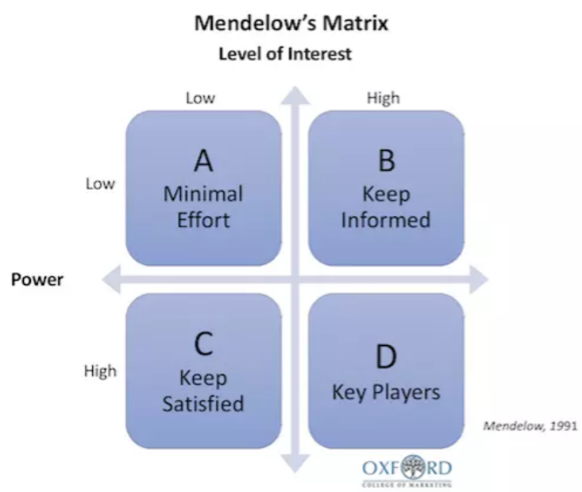
Fig 2. Mendelow (1991)
On the category of high power/high interest there can be found Adidas’ business partners, supplier, business provides etc. which need to be kept informed and engaged at all times, as well as employees which come in contact with the company at all times.
On the category of high power/low interest there are: the authorities and governments which can heavily impact Adidas and also opinion formers such as journalists and customers are in this category.
On the low power/high interest are other brands, donors, other multinationals etc.
On the low power/low interest are the celebrities and collaborations with the Adidas brand.

Conclusion and recommendations

In conclusion Adidas is one of the most leading sports brands at the moment, the German brand managed to be in top for a few years now by investing mostly in online advertising, as we are in the technology era and people are spending more time shopping online than offline. Even though there is competition on the market, Adidas knows where to invest – marketing, celebrities’ collaborations, sustainability, and transparence. My personal recommendations would be for the brand to continue putting on the market good quality products and invest more in the healthy lifestyle as people are concerned about their wellbeing. Adidas could expand to markets like fitness appliances and healthy food like cereals, drinks, shakes etc. Most of their consumers are into healthy lifestyle so this may bring some interest to the brand.

References:

Adidas (2021) Global employee population. Available at: https://report.adidas-group.com/2020/en/group-management-report-our-company/our-people/employee-population.html (Accessed on 12/03/2021)
Adidas (2019) Partnership approach. Available at: https://www.adidas-group.com/en/sustainability/managing-sustainability/partnership-approach/#/2006/kooperationen-und-mitgliedschaften/ (Accessed on 12/03/2021)
Adidas (2008) Corporate sustainability report 2007. Available at: http://sustainabilityreport.adidas-group.com/en/SER2007/pdf/adidas_SER2007_online.pdf (Accessed on 12/03/2021)
ASQ (2020) What are stakeholders? Available at: https://asq.org/quality-resources/stakeholders (Accessed on 11/03/2020)
BBC (2020) Marketing advantages and disadvantages. Available at: https://www.bbc.co.uk/bitesize/guides/zfcjbdm/revision/5 (Accessed on 11/03/2021)
Bhasin H., (2017) Marketing strategy of Adidas. Available at: https://www.marketing91.com/marketing-strategy-of-adidas/ (Accessed on 12/03/2021)
Bhasin H., (2018) Marketing mix of Adidas. Available at: https://www.marketing91.com/marketing-mix-adidas/ (Accessed on 12/03/2021)
Brandocracy (2020) Ce este brandul si cum te poate ajuta sa-ti cresti afacerea. Available at: https://brandocracy.ro/ce-este-brandingul-si-cum-te-poate-ajuta-sa-ti-cresti-afacerea/?lang=ro (Accessed on 11/03/2021)
Dan (2020) Digital marketing strategy of Adidas. Available at: https://digitalagencynetwork.com/digital-marketing-strategy-of-adidas/ (Accessed on 12/03/2021)
Fernando J. (2021) Stakeholder. Available at: https://www.investopedia.com/terms/s/stakeholder.asp (Accessed on 11/03/2021)
Fig. 1 Ansoff (1960) Using the Ansoff matrix to develop marketing strategy. Available at: https://blog.oxfordcollegeofmarketing.com/2016/08/01/using-ansoff-matrix-develop-marketing-strategy/ (Accessed on 11/03/2021)
Fig. 2 Mendelow (1991) What is Mendelow matrix and how is it useful? Available at: https://blog.oxfordcollegeofmarketing.com/2018/04/23/what-is-mendelows-matrix-and-how-is-it-useful/ (Accessed on 23/03/2021)
Gilliland N. (2017) How Adidas uses digital to enable powerful experiences. Available at: https://econsultancy.com/how-adidas-uses-digital-to-enable-powerful-experiences/ (Accessed on 12/03/2021)
Hensel A. (2020) Why Adidas was unable to resurrect of Reebok brand. Available at: https://www.modernretail.co/retailers/why-adidas-was-unable-to-resurrect-the-reebok-brand/ (Accessed on 12/03/2021)
IS (2020) Introduction to the power/interest grid. Available at: https://www.improvementservice.org.uk/business-analysis-framework/consider-perspectives/powerinterest-grid (Accessed on 23/03/2021)
Karsen S. (2016) How Pharrell led Adidas to its most profitable year yet. Available at: https://www.hollywoodreporter.com/news/pharrell-leads-adidas-profitable-year-874224 (Accessed on 12/03/2021)
Kenton W. (2020) Market penetration. Available at: https://www.investopedia.com/terms/m/market-penetration.asp (Accessed on 12/03/2021)
Kotler P. (2000) The marketing concept. Available at: https://www2.nau.edu/~rgm/ha400/class/professional/concept/Article-Mkt-Con.html (Accessed on 11/03/2021)
Kotler P. & Armstrong G (2018) Principles of marketing 17th edition p.38,p.280,p.333. Available at: http://rezakord.com/uploads/91b0c5c8c158421fa332a449c435e1b4.pdf (Accessed on 12/03/2021)
Leung A. (2019) David Beckham and Adidas release UltraBOOST 2019. Available at: https://hypebeast.com/2019/10/david-beckham-adidas-ultra-boost-2019-release (Accessed on 12/03/2021)
OCM (2020) Using the Ansoff matrix to develop marketing strategy. Available at: https://blog.oxfordcollegeofmarketing.com/2016/08/01/using-ansoff-matrix-develop-marketing-strategy/ (Accessed on 11/03/2021)
Oluwakemi O. (2018) Diversification strategy and organization market in the Nigerian manufacturing industry. Available at: https://www.researchgate.net/publication/327105966_Diversification_strategy_and_organization_market_share_in_the_Nigerian_manufacturing_industry (Accessed on 12/03/2021)
Statista (2020) Adidas revenue from H1 2017 to H1 2020, by region. Available at: https://www.statista.com/statistics/268445/revenue-of-the-adidas-group-by-region/ (Accessed on 12/03/2021)

