

Faculty of Applied Design and Engineering/Cyfadran Dylunio Cymhwysol a Pheirianneg
School of Applied Computing/Ysgol Cyfrifiadureg Gymhwysol

MSc Computer Networks
Implementing IP Routing & Switching Practical Assessment

Name :
Student ID :
Date & Time :

This is an individual practical lab-test, held under examination conditions. You will be assigned four Switches, you should configure these Routers based on the following specifications.

The routers that you will configure are: DLS1, DLS2, ALS1, and ALS2.

This paper is marked out of 100.

You will have 3 hours to complete this task.

Network Topology

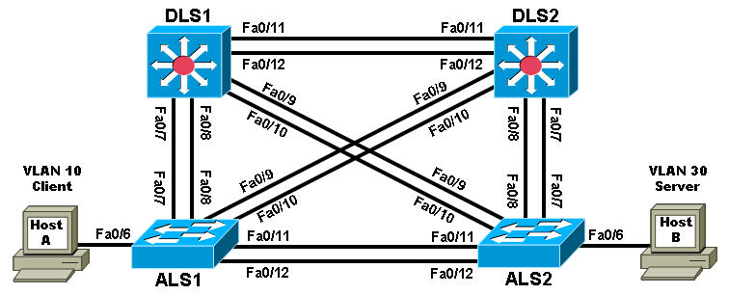

Requirements:

Task 1 – Network Connections (15 marks)

Physically cable the network as shown in the topology diagram.

Configure the router with hostname, Passwords (Console, Vty and privilege EXEC), line description, banner, disable DNS lookup, and synchronous logging.

Task 2 – Configure the network according to specifications (60 marks)

- Use multiple class C 192.168.20.0/24 networks as required for this practical exam.
- Configure the Fa0/11 link between DLS1 and DLS2 as a Layer 3 link and assign a network to it.
- Configure the Fa0/12 link between DLS1 and DLS2 as an ISL trunk, and statically set all other inter-switch links as 802.1q trunks.
- Bind the links between DLS1 and ALS1 in an EtherChannel and configure the two switches to actively negotiate a PAgP link.
- Place all switches in the VTP domain CISCO with DLS1 as the VTP server using VTP version 2. Configure all other switches as VTP clients.
- On DLS1, create VLAN 10 named CLIENT, VLAN 20 named VOICE, VLAN 30 named SERVER and VLAN 99 named MGMT. Choose a 192.168.X.0/24 network for each VLAN for use in subsequent steps.
- Ensure that the VLAN 1 interface on all switches is not used for administrative management or user traffic.
- Configure the Rapid PVST (PVRST+) protocol on all switches. Ensure that DLS1 becomes the spanning tree root of VLANs 10 and 20 and DLS2 becomes the backup. Ensure that DLS2 becomes the spanning tree root of VLANs 30 and 99 and DLS1 becomes the backup.
- On DLS1 and DLS2 configure SVIs and HSRP to provide gateway redundancy for access layer clients in VLANs 10, 20, 30 and 99. Create an SVI in VLANs 10, 20, 30 and 99, each with an IP address and mask from their respective networks chosen in Step 7.
- Configure DLS1 as the active HSRP router for VLANs 10 and 20 and configure DLS2 as backup. Configure DLS2 as the active router for VLANs 30 and 99 and configure DLS1 as backup.
- On ALS1 and ALS2 create an SVI for MGMT VLAN 99 with an IP address from the VLAN 99 network assigned in Step 7.
- For ALS1 and ALS2, specify the HSRP gateway address of VLAN 99 as the default gateway.
- Enable PortFast on all access layer switch ports.
- Permit the links between DLS2 and ALS2 to carry traffic only for the VLANs created in Step 7.
- Enable QoS globally on all switches.
- On ALS1 configure Fa0/6 as an access port in CLIENT VLAN 10 and to trust Cisco IP phones CoS using AutoQoS. Use VOICE VLAN 20 as the voice VLAN.
- On ALS1, configure port Fa0/6 with port security. Allow up to two MAC addresses to be learned for IP phone support. Enable sticky learning. Shut down the port if a violation occurs.
- On ALS2 configure port Fa0/6 as an access port in SERVER VLAN 30.
- Configure IP routing on DLS1 and DLS2, and use EIGRP to advertise 192.168.0.0/16 with automatic summarization disabled.
- Configure client PC-A with an IP address in the VLAN 10 network and specify the VLAN 10 HSRP virtual address as the default gateway. Configure server PC-B with an IP address in VLAN 30 and specify the VLAN 30 HSRP virtual address as the default gateway

Task3: Test network connectivity and path control (25 marks)
- Create a Tcl script and test connectivity from each distribution layer switch to the addresses you assigned in the topology.
Note: The IOS for the access layer switches used in this exam does not support Tcl scripting.
tclsh

foreach address {
192.168.10.1
192.168.10.2
192.168.10.254
192.168.10.101 (PC-A IP address)
192.168.11.1
192.168.11.2
192.168.20.1
192.168.20.2
192.168.20.254
192.168.30.1
192.168.30.2
192.168.30.254
192.168.30.101 (PC-B IP address)
192.168.99.1
192.168.99.2
192.168.99.3
192.168.99.4
192.168.99.254
} {
ping $address }

- Verify that the correct VLANs exist on all switches and contain the correct ports.
- Verify that the EtherChannel between DLS1 and ALS1 is configured correctly.
- Verify the spanning tree configuration and that the root bridge (DLS1 or DLS2) is correct for each VLAN.
- Verify that the correct SVIs exist and that the correct HRSP routers are primary and standby for each VLAN.
- Verify that Auto-QoS VoIP support is configured for port Fa0/6 on ALS1.
- Verify that client PC-A can ping server PC-B.
- Verify the traced route from client PC-A to server PC-B.

Submission Requirements:

All documentation for your solution should be submitted. Your name should be clearly printed on the documents, and signed.

At the end of the test a flash memory will be given to you, the configuration files for all routers should be copied to the media and handed in to your instructor.

The file name should be studentname_ID_devicename.txt

Show running-configuration
Show ip interface brief
Show vlan
Show vtp status
Show standby
Show etherchannel summary

