
Student Name: Thomas Clarke
Student ID: 2437137
Module Code: LCLM4005_LON
Lecturer: Sukhpreet Grewal
Module: Employability and Career Development
Date: 26/04/2026

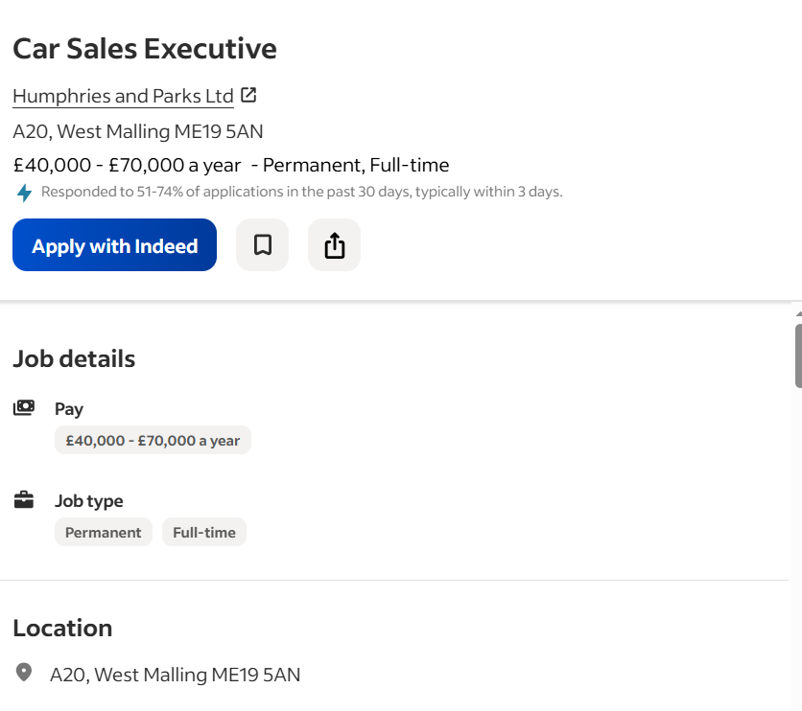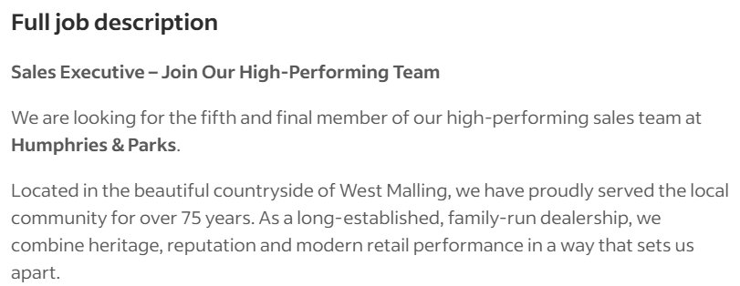

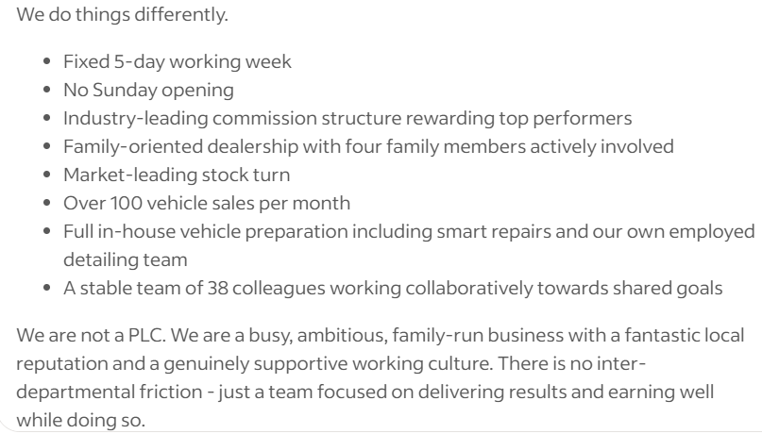

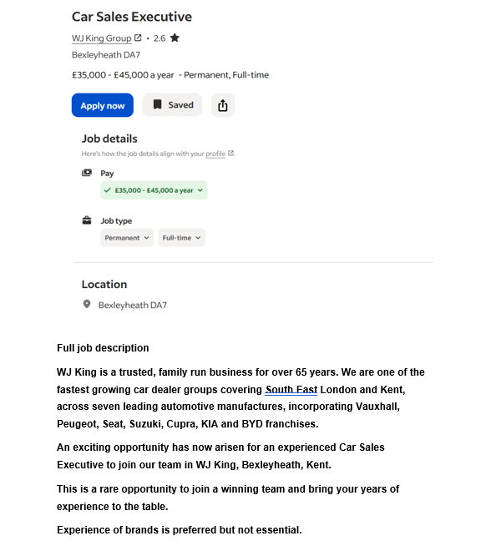
Task 1: Compare Job Adverts
The two job adverts above are for the position of Car Sales Executive at WJ King Group in Bexleyheath and Humphries & Parks Ltd in West Malling (Indeed, 2026a; Indeed, 2026b). Both vacancies are full-time, permanent roles within the car sales industry, but each company highlights slightly different expectations and benefits. The WJ King Group advert offers a salary of £35,000–£45,000 per year and requires people to have at least two years of automotive and sales experience. The company talks about being part of a strong team, delivering a high volume of vehicle sales, and maintaining customer satisfaction (Indeed, 2026a). Employees must also hold a driving licence with fewer than six penalty points and be able to travel within 30 minutes of the workplace, but in comparison Humphries & Parks Ltd offers a higher salary of £40,000–£70,000 per year, supported by the chance of earning money through a leading commission structure for top performers, the advert also highlights a friendly family-run company, a five-day working week along with not having to work on Sunday’s. It also has employee benefits such as a pension, company car, discounts, and additional leave (Indeed, 2026). The role focuses heavily on relationship building, handling enquiries and delivering results on a customer focused sales role and earning well whilst doing so. Both job adverts share several key skills and knowledge areas. Firstly, sales ability is essential in both roles. Candidates must be confident in selling vehicles, meeting targets and generating revenue also, customer service skills are strongly looked for, as both employers expect staff to deliver high customer satisfaction and provide a professional buying experience. The job advert also highlights that communication skills are important for dealing with enquiries, negotiating deals, and building trust with customers. Finally, teamwork is highlighted, as both companies require employees to work with colleagues to achieve shared goals (National Careers Service, 2024). One important shared skill that both the adverts show is customer service; this skill is vital in the car sales industry because purchasing a vehicle is a important financial decision for most customers. Buyers need guidance, trust, and reassurance throughout the process. A sales executive with strong customer service skills can understand customer needs, recommend suitable vehicles, and create a positive experience that encourages repeat business and referrals. In a competitive automotive market, excellent customer service can help a dealership build its reputation and maintain long-term success (Brown, 2021). Overall, both adverts show that a successful Car Sales Executive must use sales performance along with excellent customer service skills, professionalism, and the ability to work effectively in a team in a fast-paced environment.
Task 2: Self-Assessment and Evidence of Readiness
Self-Assessment (SWOT Analysis)
A SWOT analysis has been conducted to assess my strengths, weaknesses, opportunities, and threats in relation to becoming a Car Sales Executive (Armstrong and Taylor, 2023).
Strengths: One of my main strengths is strong communication skills, I am confident speaking with all types of personalities, and I can explain information clearly and effectively. This is important in the car sales industry because customers need advice about vehicle features, finance options, and after-sales products. Another strength is my ability to build positive relationships. I think that I am approachable, polite, and patient, which helps create trust with customers. Strong relationships are essential in sales because satisfied customers are more likely to return and recommend the dealership to others (Kotler and Keller, 2022). I’m also very motivated and I have target-focused mindset. I enjoy working towards goals and challenging myself to improve my performance. In a sales environment, motivation is important because being successful is often measured through targets and commissions. Finally, I am adaptable and willing to learn. The automotive industry is always changing due to new technology, electric vehicles, and digital sales systems. Being open to learning will help me stay focused and competitive.
Weaknesses: One weakness that I have is a limited experience in the car sales industry. Although I understand the importance of sales and customer service, I need more practical experience in handling real customers, negotiations and closing deals. Another weakness that I have is product knowledge. To be successful in car sales, I need a deeper understanding of vehicle specifications, finance packages, warranties and I need to know the differences between brands. I also need to improve on my confidence when dealing with difficult customers or problems that may occur in that environment. Sometimes customers may be uncertain, frustrated or comparing other experience’s that they’ve had in other dealerships, so I need stronger persuasion and conflict-handling skills.
Opportunities: There are many opportunities available to support my career development, as the automotive industry continues to grow, especially with increased demand for hybrid and electric vehicles, this creates new career opportunities for motivated sales professionals. Training programmes offered by dealerships can help me improve product knowledge, sales techniques, and customer service skills. Online learning platforms and my studies at university are also valuable learning resources. In addition, progression opportunities exist within the industry. starting as a Sales Executive can lead to roles such as Senior Sales Executive, Business Manager, Sales Manager, or Branch Manager.
Threats: One threat is the competition from experienced candidates who already have proven sales records and product knowledge. This means I need to stand out through my enthusiasm, professionalism, and willingness to learn. Another threat is the cost of living continuing to rise with each year. During periods of rising costs or reduced consumer confidence, customers may delay the purchasing vehicles for other things of more importance, which can affect sales performance and the automotive industry. Another threat is the growth of online car-buying platforms, customers are increasingly researching and purchasing vehicles online, meaning traditional sales roles are evolving and require digital skills.
Evidence of Readiness: My readiness for employment as a Car Sales Executive can be demonstrated through my academic achievements, transferable skills, and my personal development. My studies have helped me develop communication, teamwork, and problem-solving skills through group projects and presentations. They have taught me how to share ideas clearly, listen to others, and work in a team. These skills are directly relevant in a dealership environment where teamwork and customer interaction are essential (CIPD, 2023). I have developed time management and organisational skills by balancing my coursework, deadlines, and personal life responsibilities. In car sales, employees often manage multiple customers, appointments, follow-ups, and administrative tasks, so being organised is very important also I have customer service awareness, through everyday experiences and previous job roles, I understand the importance of being polite, helpful, and professional. Customers expect excellent service, especially when making an expensive purchase such as a car (Brown, 2021). I am also very motivated to learn more about the automotive industry, I regularly research vehicles, market trends, and the growth of electric cars and the current climate of today’s economy. This shows enthusiasm and genuine interest, which I think employers value highly. Feedback from tutors and peers has shown that I am reliable, hardworking, and able to communicate effectively. However, I have also been encouraged to continue building confidence and gaining practical experience, which I recognise as key areas for my personal development. Overall, although I still need to gain more direct industry experience, I believe I have the right attitude, transferable skills, and willingness to learn. These qualities show that I am ready to begin a career as a Car Sales Executive and continue developing into a high-performing professional (Sutton, 2020).
Task 3: Employment Goals and Personal Development Plan
Short-Term Goals: Based on the weaknesses shown in my SWOT analysis, my first short-term goal is to secure an entry-level Car Sales Executive role within the next 12 months. This will help me to gain practical experience and customer interaction, it will also help me with vehicle demonstrations, negotiations, and with closing sales. My second short-term goal is to improve my product knowledge by learning about vehicle brands, finance packages, vehicle warranties, and electric vehicle technology. This will help increase my confidence when advising customers and trying to gain sales.
Long-Term Goals: My long-term goal is to become a top-performing Sales Executive who consistently exceeds with meeting targets and earns strong commission. I also aim to progress into a management position such as Sales Manager, where I can lead a team and contribute to business growth. Eventually I would like town my own car dealership and have a career I can look back at and be proud of. These goals are important because they match my ambition to build a successful career in the automotive industry while developing professionally and financially.

Personal Development Plan
 | Short-Term Time Frame  What do I want to  accomplish in the next  three to six months? | Mid-Term Time Frame  What do I want to  accomplish in the next  six months to two years? | Long-Term Time Frame  What do I want to  accomplish in the next  two to three years?
Section 1 - My Goals  What are my overall goals that I want to accomplish in this time period?  Example: become a Student Affairs Officer; learn computer graphics | My overall goal in the next three to six months is to get an entry-level Car Sales Executive role or a trade plate driver in a dealership. I also want to increase my confidence when communicating with customers and increase my knowledge of vehicle brands and features. | The overall goal in the next six months to two years is to become a confident Car Sales Executive who meets sales targets, builds strong customer relationships, and earns commission through strong performance. | My overall goal in the next two to three years is to progress into a senior role such as Senior Sales Executive or Sales Manager. I also want to develop leadership skills and take on more responsibility within the dealership.
Section 2 - Skills and Knowledge to be  Learned  What specifically do I need to learn? What project do I need to work on?  Example: Student advising;  Banner; Dreamweaver; develop a procedures manual | I need to learn the basics of vehicle sales, customer service, product knowledge, and communication. I also need to understand how dealerships operate and how to handle customer enquiries professionally. | I need to develop negotiation skills, dealing with customer complaints, finance and warranty knowledge, selling techniques, and stronger sales closing skills. I also need to improve on working under pressure. | I need to learn leadership, team management, staff motivation, target setting, and advanced business management skills. I also need to understand dealership strategy and long-term customer relations.
Section 3 - Next Steps  How am I going to acquire the skills and knowledge? How am I going to do this project?  Example: take Dreamweaver class; do an  informational interview; set up a project outline | I will apply for dealership jobs, attend interviews, practise communication skills, research car brands, and complete online customer service or sales courses. I will also practise sales conversations. | I will gain practical experience in the workplace, ask managers for feedback, attend manufacturer training programmes, set monthly targets, and continue learning through courses and mentoring. | I will apply for promotion opportunities, complete management training, take on leadership responsibilities, and work closely with managers to gain experience in supervising staff and improving business performance.
Adapted from: http://www.hr.ucdavis.edu/sdps/forms/IDP%20Final%2010.14.11.pdf

 | Short-Term Time Frame  What do I want to  accomplish in the next  three to six months? | Mid-Term Time Frame  What do I want to  accomplish in the next  six months to two years? | Long-Term Time Frame  What do I want to  accomplish in the next  two to three years?
Section 4 - Resources  What resources do I need?  Example: free time; funding | Resources needed include free time, internet access, job websites, CV support, interview preparation, and online learning platforms. | Resources needed include employer training, support from managers, feedback from colleagues, sales data, and professional development courses. | Resources needed include leadership training programmes, mentoring from senior managers, management workshops, and opportunities for promotion.
Section 5 - Time Schedule

What is my time schedule?

When will I start? | 8 August 2026 | 9 February 2027 | 9 August 2028
When do I expect to finish? | 8 February 2027 | 8 August 2028 | 8 August 2029
Section 6 - Completion  When have I completed each  step? | □Applied for jobs  30/09/2026  □Completed sales course 15/12/2026  □Secured job 08/02/202027 | □ Achieved sales targets  30/062027  □Completed training 31/01/2028  □Received positive feedback 08/08/2028 | □ Applied for promotion 30/11/2029  □Completed leadership training 30/04/2029  □Promoted to senior role 08/08/2029

References
Armstrong, M. and Taylor, S. (2023) Armstrong’s Handbook of Human Resource Management Practice. 16th edn. London: Kogan Page.
Brown, D. (2021) ‘The importance of customer service in automotive sales’, Journal of Retail and Consumer Services, 58, pp. 102–110.
CIPD (2023) Employability skills factsheet. Available at: https://www.cipd.co.uk (Accessed: 8 August 2026).
Indeed (2026a) Car Sales Executive – WJ King Group, Bexleyheath. Available at: https://uk.indeed.com (Accessed: 8 August 2026).
Indeed (2026b) Car Sales Executive – Humphries & Parks Ltd, West Malling. Available at: https://uk.indeed.com (Accessed: 8 August 2026).
Kotler, P. and Keller, K.L. (2022) Marketing Management. 16th edn. Harlow: Pearson Education.
National Careers Service (2024) Sales executive: Job profile. Available at: https://nationalcareers.service.gov.uk (Accessed: 8 August 2026).
Sutton, D. (2020) Career Development and Employability Skills. Oxford: Oxford University Press.

