Generating a program for a specified embedded requirement in C.

ACDA4013

By Charles H, 2420823

Table of Contents
Abstract 3
1 Introduction 3
2 Proteus simulated circuit 3
2.1 Circuit design 3
2.2 I/O pin selection 4
3 Program sequence 4
4 Firmware design 5
4.1 Setup 5
4.2 Printing functions 6
4.3 Shutdown function 6
4.4 Main function 6
4.5 Main loop 7
5 Testing and debugging 9
5.1 Test planning 9
5.2 Terminal printing on the same line 9
5.3 Fan not activating 10
5.4 LCD screen not displaying 11
6 Potential changes 13
8 Conclusion 13
References 14
Appendices 15
A: First code iteration 15
B: Functional code 19
C: Final code 25

Abstract
This document presents a design and implementation of a C program which utilises a PIC16F877A microcontroller to simulate an automotive vehicle cooling system. It outputs using; three push-button inputs, three LEDs, an LCD display, a UART terminal and a DC motor. The circuit`s simulated in Proteus nine with firmware compiled in CCS C. The paper describes circuit design, operation, challenges during testing and solutions. Some potential modifications for future development are also covered.

1 Introduction

This assignment uses a PIC16F877A to replicate a vehicle cooling system [1]. There are three input buttons used to control the system in pre-defined sequence progressing through operating states. The outputs include; an LCD in four-bit mode, an RS232 terminal, three LEDs, and a fan.
The first button simulates starting the engine, the second button simulates checking the coolant and the third button starts the fan. There’s a small delay before simulating an issue and shutting down.
PICs are widely used in simulations of automatic systems such as controls for temperature [2] [3] and platforms [4].

2 Proteus simulated circuit

2.1 Circuit design
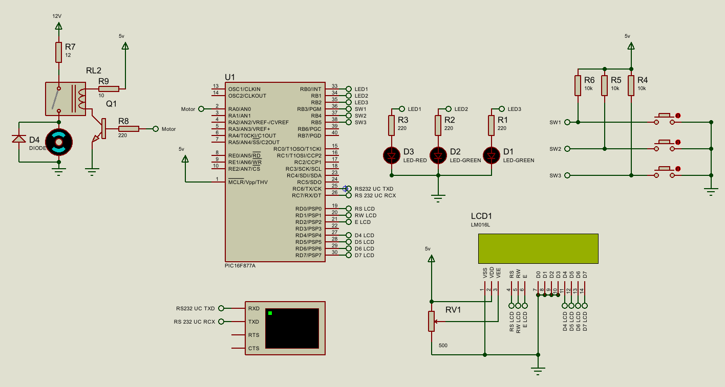
Fig. 1. Circuit diagram simulated in Proteus nine.
The PIC16F877A has a maximum output current of 25mA [1], which is not enough to drive a motor for a vehicle, which can draw Amps. Motors are noisy components and should not be connected to a microcontrollers circuit directly. A motor controller can be used, but a relay and transistor also function and are more common in high power situations. To prevent damage from back EMF, motors also have diodes across them [5].

2.2 I/O pin selection
The motor circuit is connected to port A as these I/O pins have no additional features [1, pp. 41,43], therefore best to power the motor. If it would be desirable to use PWM to vary the speed, a pin with PWM built in could be used such as C1.
The RS232 Terminal is connected to port C on pins C6/C7 as they have UART functionality built into the microcontroller [1, pp. 46-47].
The buttons are connected to pull-up resistors, as pull-down resistors are more sensitive to noise. Port B pins have software enabled internal weak-pullup resistors [1, pp. p44-45].
LEDs normally draw up to 20mA. They can be connected to any output on the PIC16F877A as all I/O pins source and sink 25mA [1, p. 173]. They can go anywhere so port B is chosen next to the buttons as they are likely wired in proximity.
The LCD is connected on port D. These pins have no additional features useful for this circuit and keeps them together. Port D is not available on a 28pin version [1, pp. 2-3,48,] so spare pins on other ports would need to be used.

3 Program sequence

The task has a guide for the order of operation for the circuit. Once the system is powered on and setup, it prints “System Ready” to the LCD and terminal. When SW1 is pressed it turns the Engine on along with a light. The system then stays idle until SW2 is pressed where the coolant is checked and turns the second LED on. When the third switch is pressed, the motor turns on and inform the user. After a short delay an alert is raised, blink the third LED and turn the system off.
Pseudocode is a way of writing in between code and standard written language which is designed to be understood by technical and non-technical audiences. Pseudocode for the brief is written below.

Algorithm 1. System Operation Sequence
Print through UART "System Ready"
Print to the LCD “System Ready”
When SW1 (Engine Start) is pressed {
Turn LED 1 ON
Print through UART “Engine Started”
Print to the LCD “Engine Started”
}
When SW2 (Coolant Sensor) is pressed {
Check SW1 has been activates successfully previously and continue if it has.
Turn LED 2 ON
Print through UART “Coolant OK”
Print to the LCD “Coolant OK”
}
When SW3 (Fan activation) is pressed {
Check SW2 has been activated successfully previously and continue if it has.
Print through UART “Fan activated”
Print to the LCD “Fan activated”
Active the DC Motor
Delay 3s
Print through UART “ALERT”
Print to the LCD “ALERT!”
Blink Red LED three times at 100ms intervals,
Deactivate the DC Motor
Print through UART “Shutdown done”
Print to the LCD “Shutdown Done”
}

4 Firmware design

4.1 Setup
The code, in appendix C, includes the header file for the PIC16F877A and allows setup for the microcontroller. The processor is set to 20MHz, without the watchdog timer and rs232 is setup at a baud rate of 9600.
The LCD library is setup, the std.io header file included and the pin definitions are set.
By using defines for constants, it allows set values to be changed easily when compiled and doesn’t use any additional resources during operation.
Global variables are then formed. One-bit integers forming flags are initialised as 0, and strings terminated immediately. These prevent any unwanted actions caused by previous states.

4.2 Printing functions
If every message was printed to the first line of the LCD, messages sent in quick succession could be missed. If the coolant wasn’t OK, this wouldn’t stop the engine from starting and users would be unaware. Alternating the lines which the messages are printing on would be confusing to the end user, so the most recent message is passed to the top line and the old message on the bottom.
The proper method for printing is passing strings directly into the function. This method causes issues in CCS C as it handles pointers in RAM and ROM differently [6]. To bypass this and work reliably on different systems, two functions were created in appendix B, one function was attempted however trying to pass one or two lines via variables for the same function became complicated, so they were split. Using one line using printing() and both lines uses printing2(). The Arrays toPrint and toPrint2 are used to pass strings indirectly, where they are saved in LCDLine1 and LCDLine2. These are 17 characters long, 16 characters for printing to the LCD and a null termination.

4.3 Shutdown function
A function should be used when repeating code or making it easier to work with by splitting it into smaller, more manageable sections [7] [8]. Although this doesn’t make the code easier to read when located in the main block, it becomes re-useable. If the system was expanded upon, more possibilities to require a shutdown would be possible so the function can be called anywhere. These are best used in addition with a physical cut off when critical. This also means as new components are added they only need to be added to one location and where specifically used. This avoids separate shutdowns being missed and not turning everything off. Writing all pins low is not ideal as a pin may sink current instead of sourcing depending on the circuitry [9].

4.4 Main function
The system starts by setting the I/O pin directions inside the main function. Any unused pins are set as outputs driven low which is more stable than floating [10]. This avoids any signals coming in which could interfere with the microcontroller. The LCD is setup and the system prints “System Ready”.
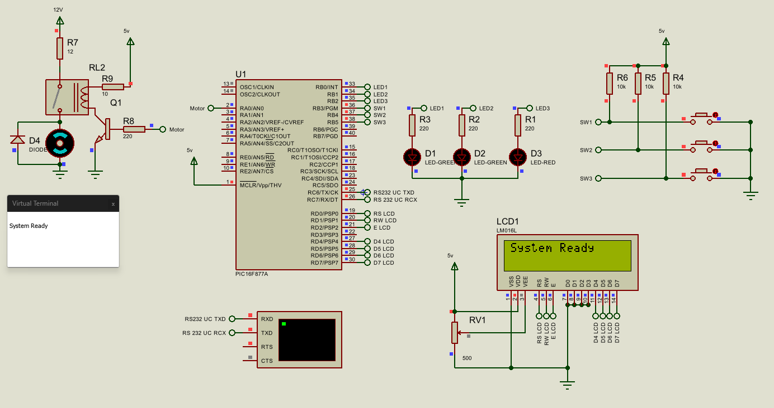
Fig. 3. Circuit when first powered

4.5 Main loop
The system then enters its loop through while(TRUE), where it checks for any of the button presses.
The circuit operation is linear with branching. While statements could be used to check when specific buttons are pressed such as in appendix A. This blocks other code from running that isn’t an interrupt, which could become a problem when expanding upon code [11]. If statements are used instead to avoid blocking which include an and check with flags, ensuring the previous button has also been pressed.
SW2 and SW3 will only activate when the flag for the button before has been raised, and their flag is not raised, and so will not function before SW1. When SW1 is pressed it turns LED1 on, prints “Engine started” and raises the SW1 flag, preventing it from actioning again and enables SW2 to action.
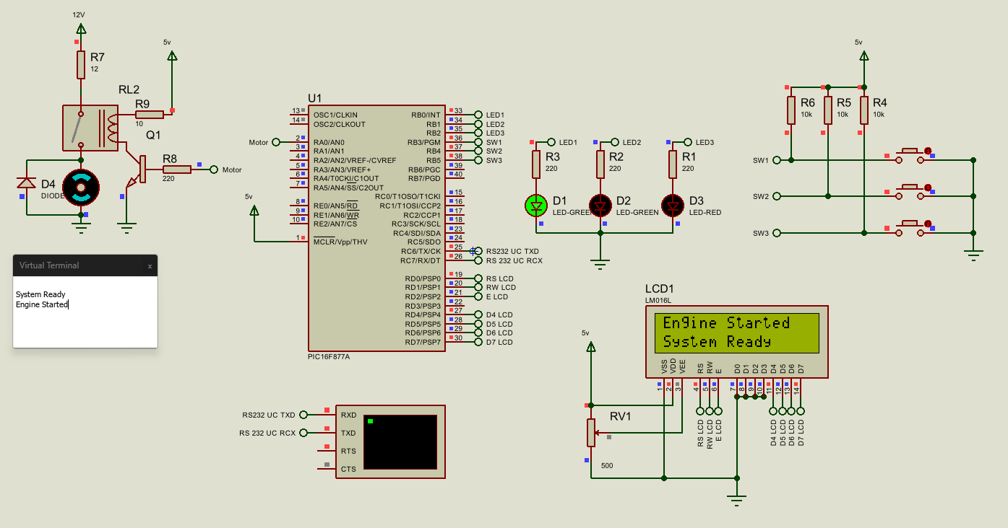
Fig. 4. Once SW1 is pressed.
SW2 turns the second LED on, prints “Coolant OK” and raises its flag. This disables SW2 from actioning again and enables SW3. When SW3 is pressed, it prints “Fan activated” and enables the fan. Theres a short delay before printing “ALERT!” and blinking the third LED three times. Theres then another short delay before shutting down.
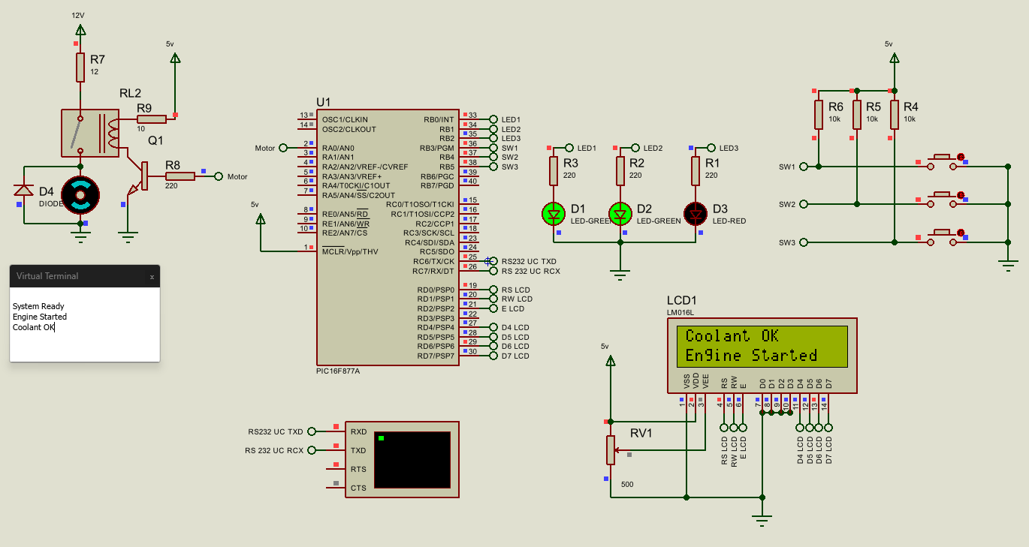
Fig. 5. Once SW2 is pressed.
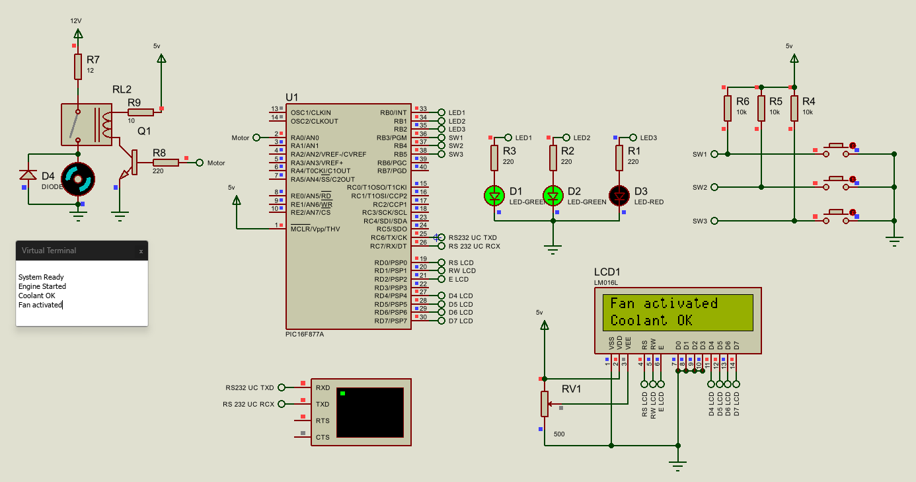
Fig. 6. Once SW3 is pressed.
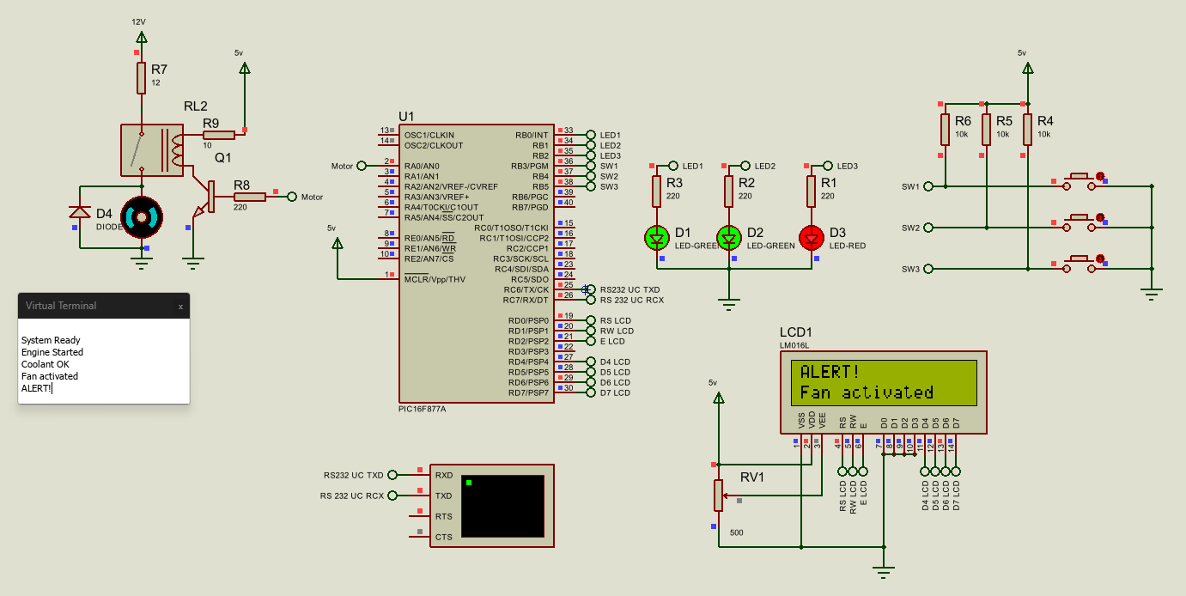
Fig. 7. During the alert with the blinking LED.
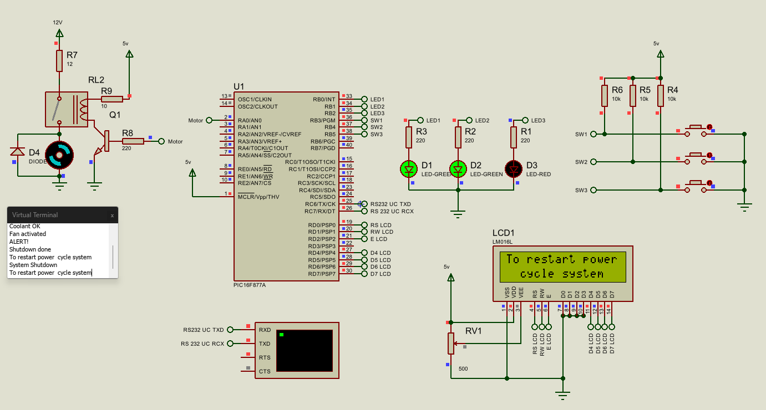
Fig. 8. System during shutdown.

5 Testing and debugging

5.1 Test planning
The program is small and has very little branching involved and can therefore be tested by exhaustion, comparing the result with the flowcharts in figures 9 and 10.
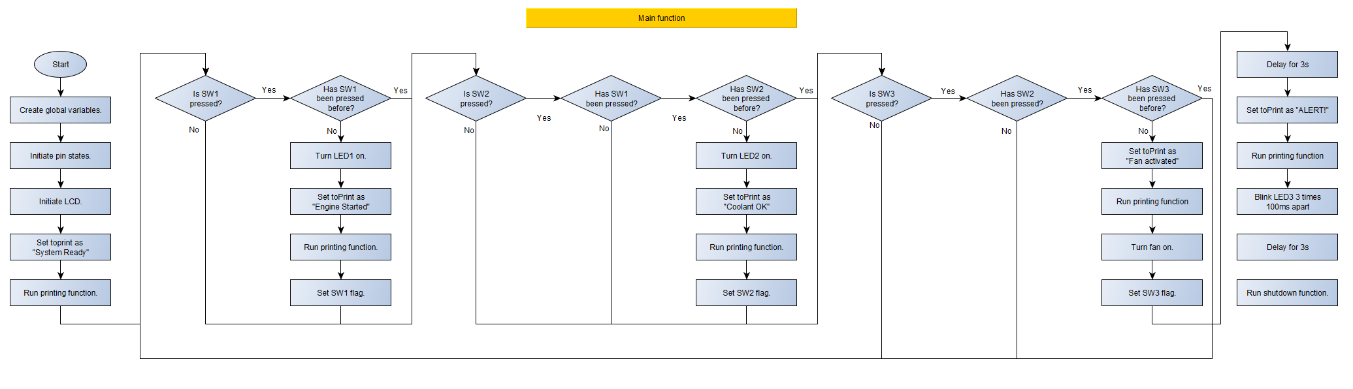
Fig. 9. Flowchart of the main block of code.
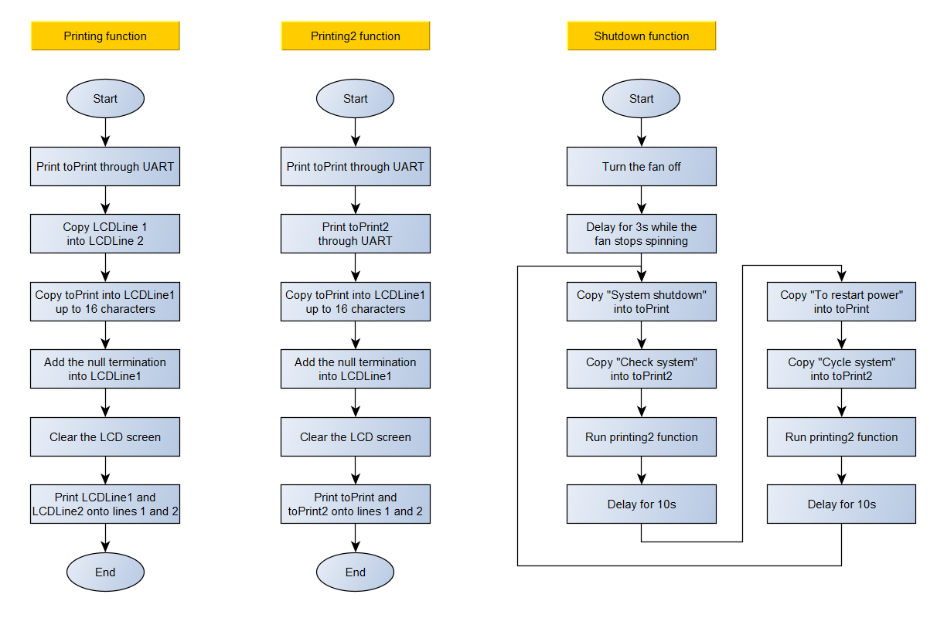
Fig. 10. Flowchart of the functions within the code.

5.2 Terminal printing on the same line
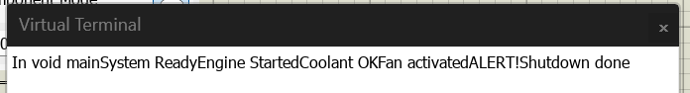
Fig. 11. Text printing on the same line in the terminal.
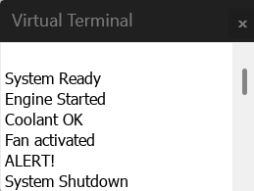
Fig. 12. Terminal printing on separate lines for each message.

TABLE I
TERMINAL PRINTING CODE
Original code | Updated Code | Changes
printf("\n%s",toPrint); | printf("\n\r%s",toPrint); | Added \r

Proteus uses ASCII control codes [12], and so \n only creates a new line. \r is also needed to move to the new line.

5.3 Fan not activating
Because Proteus is a simulation, the DC motor can be connected directly to the microcontroller for testing. This removes any issues with the rest of the circuit and proves remaining issues are in code.
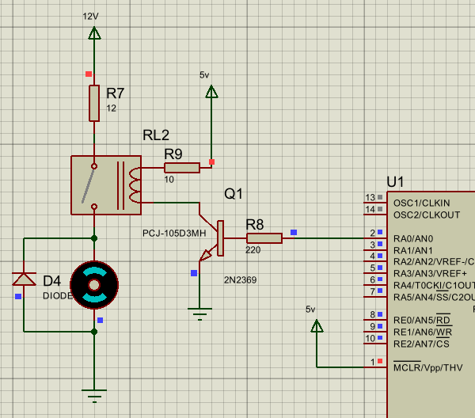
Fig. 13. Motor not working in the full circuit when running code.
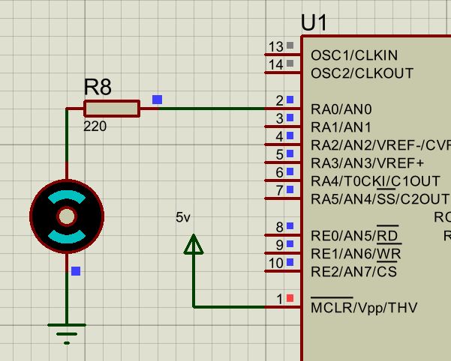
Fig. 14. Motor not working when running code without the full circuit.
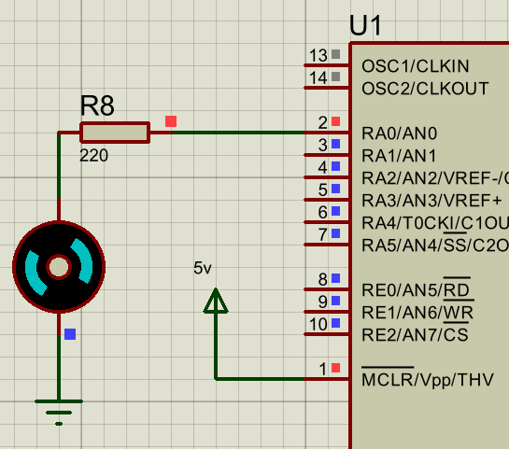
Fig. 15. The motor rotating after being powered.
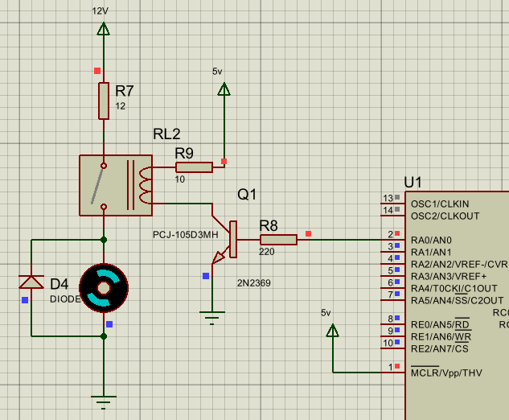
Fig. 16. Motor working in the full circuit.
TABLE II
MOTOR CODE
Original code | Updated code | Changes
#define Fan0 PIN_A0  output_high(FAN0); | #define FAN0 PIN_A0  output_high(FAN0); | Corrected the definition of the fan pin to match the code.

5.4 LCD screen not displaying
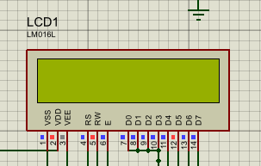
Fig. 17. LCD not printing.
The original code had ASCII commands and printing a string in the same line which isn’t possible in CCS C. They were split into two separate lines and the LCD remained empty as the LCD library was included before the pin definitions.
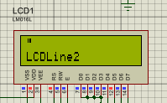
Fig. 18. LCD printing incorrectly.
When the LCD screen showed text, it printed LCDLine2 directly, and not the pointer destination, due to being in double quote marks inside lcd_putc().
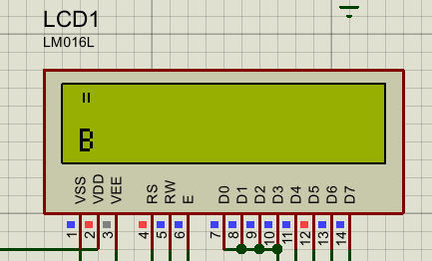
Fig. 19. LCD printing “ on line 1 and B on line 2.
“ and B are printed on the LCD because of how CCS C uses strings. In CCS C they point at a single location. This means those are the characters held at that location so printf() is used to pass the full string to lcd_putc().
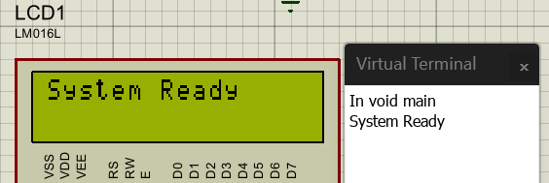
Fig. 20. Before SW1 is pressed
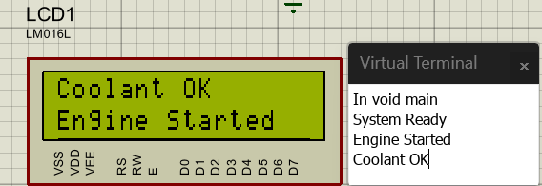
Fig. 21. After SW2 is pressed
TABLE III
LCD PRINTING CODE
Original code | Updated code | Changes
#include <lcd.c>  #define LCD_RS_PIN PIN_D0  #define LCD_RW_PIN PIN_D1  #define LCD_ENABLE_PIN PIN_D2  #define LCD_DATA4 PIN_D4  #define LCD_DATA5 PIN_D5  #define LCD_DATA6 PIN_D6  #define LCD_DATA7 PIN_D7  lcd_putc("\f%s",toPrint);  lcd_putc("\n%s",LCDLine2); | #define LCD_RS_PIN PIN_D0  #define LCD_RW_PIN PIN_D1  #define LCD_ENABLE_PIN PIN_D2  #define LCD_DATA4 PIN_D4  #define LCD_DATA5 PIN_D5  #define LCD_DATA6 PIN_D6  #define LCD_DATA7 PIN_D7  #include <lcd.c>  lcd_putc('\f');  printf(lcd_putc, "%s", LCDLine1);  lcd_putc(  printf(lcd_putc, "%s", LCDLine2); | Moved #include <lcd.c> to beneath the LCD definitions.  Split ASCII commands and printing strings into separate lines.  Used printf(lcd_putc) instead of lcd_putc for strings.

6 Potential changes

To use the internal pull-up resistors, the external pullup resistors need to be removed, and port_b_pullups(1) used.
If this was to be implemented in a real system the microcontroller would need to have many more connections to other features, such as additional buttons and displays. More sensors will be used so it may be suitable to offset these to other ICs such as GPIO extenders to reserve pins or additional microcontrollers communicating together.
The LEDs pins could be changed from source to sink. The LEDs would need to be reversed and connected to 5V, and logic in the code would need to be reversed for the LEDs from high to low.

8 Conclusion
The PIC16F877A microcontroller can be used for creating vehicle cooling systems. By simulating the circuit in Proteus nine using code written in C and compiled in CCS C. The code utilises if statements and flags to prevent an input actioning twice. Functions are used for repeating or important code. The motor is separated from the microcontroller by a relay, which is also powered by a transistor to prevent drawing excessive current from the I/O pins. The system functions as intended and does not allow an action to repeat or happen out of sequence, with some additional changes that could be made mentioned.

References

[1] | Microchip, “PIC16F87XA Datasheet,” 28 07 2003. [Online]. Available: https://ww1.microchip.com/downloads/en/devicedoc/39582b.pdf. [Accessed 02 12 2025].
[2] | R. A. N. J. R. S. I. M. Y. Z. I. R. H. Z. A. N. N. S. N. Dzulkefli, “DESIGN AN AUTOMATIC TEMPERATURE CONTROL SYSTEM BASED ON PIC CONTROLLER FOR SMART VENTILATION FAN,” 10 09 2017. [Online]. Available: https://libkey.io/libraries/1422/articles/393543163/full-text-file. [Accessed 05 12 2025].
[3] | G. O. T. C. P. R Rob, “Temperature controlling system using embedded,” 2017. [Online]. Available: https://libkey.io/libraries/1422/articles/69264881/full-text-file?utm_source=api_311&allow_speedbump=true. [Accessed 08 12 2025].
[4] | X. C. Jiang, J. Sun, K. Zhang, H. Guo and Y. H. Wu, “Research on Automatic Control System of Suspended Access Platform Based on PIC16F877A,” 06 12 2010. [Online]. Available: https://www.proquest.com/docview/1443625580/fulltextPDF?accountid=130472&sourcetype=Scholarly%20Journals. [Accessed 10 12 2025].
[5] | WatElectronics.com, “Connecting a Motor Driver to a Microcontroller : Basics, Precautions,” WatElectronics, 01 12 2020. [Online]. Available: https://www.watelectronics.com/connecting-a-motor-driver-to-a-microcontroller-basics-precautions/. [Accessed 08 12 2025].
[6] | Linux Code, “Passing a String to a Function in C: An In-Depth Guide for New C Programmers,” The Linux Code, 27 12 2023. [Online]. Available: https://thelinuxcode.com/pass-string-function-c-language/. [Accessed 18 12 2025].
[7] | Alex, “2.6 — Why functions are useful, and how to use them effectively,” learn c++, 25 01 2023. [Online]. Available: https://www.learncpp.com/cpp-tutorial/why-functions-are-useful-and-how-to-use-them-effectively/. [Accessed 08 12 2025].
[8] | O. A. Aktaa, “Mastering clean code part 3,” Medium, 21 02 2025. [Online]. Available: https://medium.com/@omair.alaktaa/mastering-clean-code-part-3-6ae6fa8d9aef. [Accessed 17 12 2025].
[9] | Warwick, “Current Sinking and Current Sourcing Explained in Easy Terms,” Starting electronics, 9 6 2025. [Online]. Available: https://startingelectronics.org/current-sinking-current-sourcing/. [Accessed 17 12 2025].
[10] | Microchip, “Configuring-unused-I-O-pins,” Microchip, 13 09 2019. [Online]. Available: https://support.microchip.com/s/article/Configuring-unused-I-O-pins. [Accessed 02 12 2025].
[11] | Google, “Blocking vs Non-blocking Code,” Google, [Online]. Available: https://sites.google.com/vt.edu/introduction-to-embeddedsystem/programming/blocking-vs-non-blocking-code. [Accessed 10 12 2025].
[12] | “ISO-8859-1,” Injosoft AB, 2025. [Online]. Available: https://www.ascii-code.com/ISO-8859-1. [Accessed 20 11 2025].

Appendices

A: First code iteration
/*Code for ACDA4013 by 2420823.
The system is linear, no branching depending on order of action.
Therefore the system can be hard coded on waiting for each button to be pressed.
====================================================

*/
//#include <strings.h>

//Libraries to include and settings for libraries.
#include <16F877A.h>
#fuses HS,NOWDT,NOLVP
#use delay(clock=20000000)
#use rs232(baud=9600, xmit=PIN_C6, rcv=PIN_C7, bits=8, parity=N, stop=1) //baud rte = Hz, xmit = transmit, rcv = recieve. parity N = No, Y = Yes, stop 1 = one bit to stop per frame.
//Use \r\n, or \n\r, to print to a new line AND return to the first column of that line. Otherwise continues printing on same line. (*true* behaviour.)

#include <stdio.h>

#include <lcd.c>
//LCD 4-bit connection pin definitions
#define LCD_RS_PIN PIN_D0
#define LCD_RW_PIN PIN_D1
#define LCD_ENABLE_PIN PIN_D2
#define LCD_DATA4 PIN_D4
#define LCD_DATA5 PIN_D5
#define LCD_DATA6 PIN_D6
#define LCD_DATA7 PIN_D7
//-------------------------------------------
//Pin Definitions

#define LED1 PIN_B0 //System on LED
#define LED2 PIN_B1 //Coolant OK LED
#define LED3 PIN_B2 //Red Alert LED

#define SW1 PIN_B3 //Engine Switch
#define SW2 PIN_B4 //Coolant Switch
#define SW3 PIN_B5 //Cooling Fan Switch

#define FAN0 PIN_A0 //Motor for Fan
#define FAN1 PIN_A1 //Motor for Fan
//-------------------------------------------
//Variables
char toPrint[16] = "";
char LCDLine1[16] = ""; //Save text printed to line 1
char LCDLine2[16] = ""; //Save text printed to line 2
//

void Printing() {
printf("\n\r%s",toPrint);
memmove(LCDLine1, LCDLine2, 16);
memmove(toPrint, LCDLine1, 16);
//lcd_putc("\f%s",toPrint);
lcd_putc("\f");
lcd_putc(toPrint);
//lcd_putc("\n%s",LCDLine2);
lcd_putc("\n");
lcd_putc("LCDLine2");
}

/*Save whether the text printed on the LCD is a message over both lines or not.
If 0, both lines are individual messages. The message from line 2 can be moved onto 1 and print a new message on line 2.
If value is 1 then the message carries over both lines. The lcd should be cleared with \f and the new message printed.*/
//================================================
void main() {//Setup code
printf("In void main");

//Initialise pin states
set_tris_a(0xFC); //A0-1 Motor outputs. 0b1111 1100
output_b(0x00); //clears outputs low
set_tris_b(0x38); //B0-2 Output Leds. B3-5 input switches. 0b0011 1000
output_b(0x00); //Clears outputs low
set_tris_c(0x3F); //C6-7 outputs 0b0011 1111
output_c(0x00); //Clear outputs from any previous state.
set_tris_d(0x00); //LCD Pins D0-D6 outputs.
output_d(0x00); //Clear outputs from any previous state.
//------------------------------------------------------------------------

//Start communication channels

//UART Begin
lcd_init();
toPrint = "System Ready";
Printing();
//printf("\r\nSystem Ready");
//lcd_putc("\fSystem Ready");

//============================================================================
while (TRUE){//Loop code

//Code happens in linear order, so delays and check loops will not cause issues for the intended process.

while (input(SW1)){ //Do nothing until SW1 is pressed.
}
//SW1 action

output_high(LED1);
toPrint = "Engine Started";
Printing();
//printf("Engine Started");
//LCD_Lineshift(Engine Started);
//lcd_putc("\nEngine Started");
//---------------------------------------------------------------------------------
while(input(SW2)){ //DO nothing until SW2 is pressed. Only runs once SW1 is pressed
}
//SW2 action

output_high(LED2);
toPrint = "Coolant OK";
Printing();
//printf("Coolant OK");
//LCD_Lineshift(Coolant OK);
//lcd_putc("Coolant OK");
//--------------------------------------------------------------------------------------
while(input(SW3)){ //DO nothing until SW3 is pressed. Only runs once SW2 is pressed
}
//SW3 action

toPrint = "Fan activated";
Printing();
//printf("Fan activated");
//LCD_Lineshift(Fan activated);
//lcd_putc("Fan activated");
//activate fan
output_high(FAN0); //??????
output_low(FAN0); //??????

delay_ms(3000); //Hard coded as linear code execution. Simulating time before problem.

toPrint = "ALERT!";
Printing();
//printf("ALERT!");
//LCD_Lineshift(ALERT!);
//lcd_putc("ALERT");

for(int i=0; i<3; i++) { //Blink LED3 3x 100ms. Linear code delays ok. total delay 600ms
output_high(LED3);
delay_ms(100);
output_low(LED3);
delay_ms(100);
}//end of blink loop

delay_ms(2400); //Total delay including blinking totals 3s before alert shuts down the fan.

output_low(FAN0);
output_low(FAN1);
delay_ms(1000); //delay of 1s for the fan to stop spinning before the system prints shutdown complete. To be replaced with a check as to whether its stopped spinning or not.
toPrint = "Shutdown done";
Printing();
//printf("\nShutdown done");
//LCD_Lineshift(Shutdown done);
//lcd_putc("Shutdown done");

while (TRUE) {//Shutdown loop. Stops any code from execuiting by entering with no exit. System has to be turned off and on again.
}//end of shutdown loop

}//end of code loop
}//End of main()

B: Functional code
/*Code for ACDA4013 by 2420823.
==========================================================
Intended circuit function:
Inputs:
SW1. Engine start
SW2. Coolant sensor
SW3. Fan activation
-------------------------------
Outputs:
Led1. Start signal
LED2. Coolant confirmation
LED3 (red). Alert indicator
DC Motor. radiator fan (controlled through 2 output pins)
UART Terminal
LCD (Port D 4 bit parallel)
--------------------------------
System Flow:
Power On
UART+LCD : "System Ready"
SW1 (Engine Start) pressed:
LED 1 ON
UART+LCD "Engine Started"
SW2 (Coolant Sensor) pressed:
SW1 Must have been pressed
LED 2 ON
UART+LCD "Coolant OK"
SW3 (Fan activation) pressed:
SW2 must have been activated successfully
UART+LCD "Fan activated"
DC Motor activated
Delay 3s
UART+LCD "ALERT!"
LED Blink 3x 100ms delay
System turn off
LCD+UART "Shutdown Done"

The system is linear, no branching depending on order of action.
Therefore the system can be hard-coded on waiting for each button to be pressed.
Since a button is never checked a second time, Debounce is not needed.
====================================================

*/
//#include <strings.h>

//Libraries to include and settings for libraries.
#include <16F877A.h>
#fuses HS,NOWDT,NOLVP
#use delay(clock=20000000)
#use rs232(baud=9600, xmit=PIN_C6, rcv=PIN_C7, bits=8, parity=N, stop=1) //baud rte = Hz, xmit = transmit, rcv = recieve. parity N = No, Y = Yes, stop 1 = one bit to stop per frame.
//Use \r\n, or \n\r, to print to a new line AND return to the first column of that line. Otherwise continues printing on same line. (*true* behaviour.)

#include <stdio.h>

//LCD 4-bit connection pin definitions
#define LCD_RS_PIN PIN_D0
#define LCD_RW_PIN PIN_D1
#define LCD_ENABLE_PIN PIN_D2
#define LCD_DATA4 PIN_D4
#define LCD_DATA5 PIN_D5
#define LCD_DATA6 PIN_D6
#define LCD_DATA7 PIN_D7

#include <lcd.c>
#define LCD_Length 16
//-------------------------------------------
//Pin Definitions

#define LED1 PIN_B0 //System on LED
#define LED2 PIN_B1 //Coolant OK LED
#define LED3 PIN_B2 //Red Alert LED

#define SW1 PIN_B3 //Engine Switch
#define SW2 PIN_B4 //Coolant Switch
#define SW3 PIN_B5 //Cooling Fan Switch

#define FAN0 PIN_A0 //Motor for Fan
#define FAN1 PIN_A1 //Motor for Fan
//-------------------------------------------
//Variables
char toPrint[LCD_Length] = "";
char LCDLine1[LCD_Length+1] = "";
char LCDLine2[LCD_Length+1] = "";
//

void Printing() {
printf("\n\r%s", toPrint);

strcpy(LCDLine2, LCDLine1);
strcpy(LCDLine1, toPrint);
LCDLine1[LCD_Length] = '\0'; //Terminates the string at the length +1, first character past the LCD Display limit due to starting at 0.

lcd_putc('\f');
//lcd_gotoxy(1,1);
printf(lcd_putc, "%s", LCDLine1);
lcd_gotoxy(1,2);
printf(lcd_putc, "%s", LCDLine2);
}

/*Save whether the text printed on the LCD is a message over both lines or not.
If 0, both lines are individual messages. The message from line 2 can be moved onto 1 and print a new message on line 2.
If value is 1 then the message carries over both lines. The lcd should be cleared with \f and the new message printed.*/
//================================================
void main() {//Setup code
printf("In void main");

//Initialise pin states
set_tris_a(0xFC); //A0-1 Motor outputs. 0b1111 1100
output_b(0x00); //clears outputs low
set_tris_b(0x38); //B0-2 Output Leds. B3-5 input switches. 0b0011 1000
output_b(0x00); //Clears outputs low
set_tris_c(0x3F); //C6-7 outputs 0b0011 1111
output_c(0x00); //Clear outputs from any previous state.
set_tris_d(0x00); //LCD Pins D0-D6 outputs.
output_d(0x00); //Clear outputs from any previous state.
//------------------------------------------------------------------------

//Start communication channels

//UART Begin
lcd_init();
strcpy(toPrint, "System Ready");
Printing();

//============================================================================
while (TRUE){//Loop code

//Code happens in linear order, so delays and check loops will not cause issues for the intended process.

while (input(SW1)){ //Do nothing until SW1 is pressed.
}
//SW1 action

output_high(LED1);
strcpy(toPrint, "Engine Started");
Printing();
//printf("Engine Started");
//LCD_Lineshift(Engine Started);
//lcd_putc("\nEngine Started");
//---------------------------------------------------------------------------------
while(input(SW2)){ //DO nothing until SW2 is pressed. Only runs once SW1 is pressed
}
//SW2 action

output_high(LED2);
strcpy(toPrint, "Coolant OK");
Printing();
//--------------------------------------------------------------------------------------
while(input(SW3)){ //DO nothing until SW3 is pressed. Only runs once SW2 is pressed
}
//SW3 action

strcpy(toPrint, "Fan activated");
Printing();
output_high(FAN0);
output_low(FAN1);

delay_ms(3000); //Hard coded as linear code execution. Simulating time before problem.

strcpy(toPrint, "ALERT!");
Printing();

for(int i=0; i<3; i++) { //Blink LED3 3x 100ms. Linear code delays ok. total delay 600ms
output_high(LED3);
delay_ms(100);
output_low(LED3);
delay_ms(100);
}//end of blink loop

delay_ms(2400); //Total delay including blinking totals 3s before alert shuts down the fan.

output_low(FAN0);
output_low(FAN1);
delay_ms(1000); //delay of 1s for the fan to stop spinning before the system prints shutdown complete. To be replaced with a check as to whether its stopped spinning or not.
strcpy(toPrint, "Shutdown done");
Printing();

while (TRUE) {//Shutdown loop. Stops any code from execuiting by entering with no exit. System has to be turned off and on again.
}//end of shutdown loop

}//end of code loop
}//End of main()

C: Final code

/*Code for ACDA4013 by 2420823.
!!!WHEN ADDING COMPONENTS, ENSURE THEY ARE TURNED OFF IN THE SHUTDOWN FUNCTION!!!
==========================================================
Intended circuit function:
Inputs:
SW1. Engine start
SW2. Coolant sensor
SW3. Fan activation
-------------------------------
Outputs:
Led1. Start signal
LED2. Coolant confirmation
LED3 (red). Alert indicator
DC Motor. radiator fan (controlled through 2 output pins)
UART Terminal
LCD (Port D 4 bit parallel)
--------------------------------
System Flow:
Power On
UART+LCD : "System Ready"
When SW1 (Engine Start) pressed:
LED 1 ON
UART+LCD "Engine Started"
When SW2 (Coolant Sensor) pressed:
SW1 Must have been pressed
LED 2 ON
UART+LCD "Coolant OK"
When SW3 (Fan activation) pressed:
SW2 must have been activated successfully
UART+LCD "Fan activated"
DC Motor activated
Delay 3s
UART+LCD "ALERT!"
LED Blink 3x 100ms delay
System turn off
LCD+UART "Shutdown Done"
====================================================

====================================================*/
//Libraries to include and settings for libraries.
#include <16F877A.h>
#fuses HS, NOWDT, NOLVP
#use delay(clock = 20000000)
#use rs232(baud = 9600, xmit = PIN_C6, rcv = PIN_C7, bits = 8, parity = N, stop = 1)
//baud rate = Hz, xmit = transmit pin, rcv = recieve pin. parity N = No, Y = Yes, stop 1 = one bit to stop per frame.
//====================================================
//Customiseable settings
#define LCD_Length 16 //# of characters on each LCD Line. 2 Lines supported.
#define Alert_Delay 3000 //Time before the ALERT warning begins in ms
#define Blink_Amount 3 //Number of times LEDs will blink before stopping
#define LED_Blink_Time 100 //Time that LEDs blinking are on and off in ms
#define Shutdown_Delay 3000 //Time to allow moving parts to stop before printing shutdown complete in ms. In a real system replace with a real check.
#define Repeat_Time 10000 //Time between rotating messages within cycles in ms.
//====================================================

#include <stdio.h> //used for: strcopy().

//LCD 4-bit connection pin definitions
#define LCD_RS_PIN PIN_D0
#define LCD_RW_PIN PIN_D1
#define LCD_ENABLE_PIN PIN_D2
#define LCD_DATA4 PIN_D4
#define LCD_DATA5 PIN_D5
#define LCD_DATA6 PIN_D6
#define LCD_DATA7 PIN_D7
#include <lcd.c>
//====================================================
//Pin Definitions

#define LED1 PIN_B0 //System on LED
#define LED2 PIN_B1 //Coolant OK LED
#define LED3 PIN_B2 //Red Alert LED

#define SW1 PIN_B3 //Engine Switch
#define SW2 PIN_B4 //Coolant Switch
#define SW3 PIN_B5 //Cooling Fan Switch

#define FAN PIN_A0 //Motor for Fan relay input
//====================================================

//Bools
int1 SW1pressed = 0;
int1 SW2pressed = 0;
int1 SW3pressed = 0; //flag not needed due to shutdown loop, but present as backup.
//Variables
char toPrint[LCD_Length] = "\0";
char toPrint2[LCD_Length] = "\0";
char LCDLine1[LCD_Length + 1] = "\0";
char LCDLine2[LCD_Length + 1] = "\0";

//====================================================

//Custom Functions
/* printing function (just one line)
Prints text on both LCD and UART. Additional message methods can be added into this function using the string toPrint.
Takes text from string toPrint, and sens it to the UART terminal and the top LCD line.
Takes the previous top LCD line and moves it down to the next line.
*/
void printing() {

//UART Terminal
printf("\n\r%s", toPrint);

//LCD
strcpy(LCDLine2, LCDLine1); //Copy LCDLine 1 to LCDLine 2, to be printed on the second line. LCDLine1 is already terminated.
strncpy(LCDLine1, toPrint, LCD_Length); //Move the string toPrint into LCDLine1, up to the length of the LCD lines. Dont copy any more as they wont be displayed.
LCDLine1[LCD_Length] = '\0'; //Terminates the string at the LCDlength +1, first character past the LCD Display limit due to starting at 0.

//Display to LCD
lcd_putc('\f'); //clear LCD
printf(lcd_putc, "%s", LCDLine1); //print the top line
lcd_putc('\n'); //go to the second line
printf(lcd_putc, "%s", LCDLine2); //print the second line
}//end of function printing

/*printing2 for printing two lines
copy the message to print on the top line into toPrint, and the bottom line into toPrint2.
Both lines are printed into UART first
the top line is then saved as the next use for the lcd may be a single line print (not in the assignment).
the bottom line doesnt need saving.
*/
void printing2(){

//UART Terminal
printf("\n\r%s",toPrint);
printf("\n\r%s",toPrint2);

//LCD
strncpy(LCDLine1, toPrint, LCD_Length); //Move the string toPrint into LCDLine1, up to the length of the LCD lines. Dont copy any more as they wont be displayed.
LCDLine1[LCD_Length] = '\0'; //Terminates the string at the LCDlength +1, first character past the LCD Display limit due to starting at 0.
//No need to save LCDLine 2 as 2 line LCD used, and will not be re-used.

//Display to LCD
lcd_putc('\f');
printf(lcd_putc,"%s", toPrint);
lcd_gotoxy(1,2);
printf(lcd_putc,"%s", toPrint2);
}

/* shutdown function
Ensure everything is turned off, acts as a global shutdown and do not restart without a power cycle. Should be used in addition with a physical cut off.
Turn off motors/moving parts then lights. Do not affect LCD screen/UART.
Once everything is turned off, enter a forever loop to prevent an accidental restart.
Seperate function so that it can be implemented in multiple places if the system was to be made larger.
*/
void shutdown(){

// Turn eveything off first
output_low(FAN); //Turn fan off.

//Artificial delay to ensure moving parts stopped. Should be replaced with a real check for a real system.
delay_ms(Shutdown_Delay);

//Forever shutdown loop. Will need to be turned off and on again to prevent an accidental restart.
while (TRUE) {

strcpy(toPrint, "System Shutdown"); //Line 1
strcpy(toPrint2, "Check system"); //Line 2
printing2(); //Print to both lines

delay_ms(Repeat_Time); //Hold previous message

strcpy(toPrint, "To restart power"); //Line 1
strcpy(toPrint2, "Cycle system"); //Line 2
printing2(); //Print to both lines

delay_ms(Repeat_Time); //Hold previous message
}//end of shutdown loop, repeating two messages.
}//end of shutdown function

//================================================

void main() {

//Initialise pin states. Best to set any unused pins to low outputs.
set_tris_a(0x00); //Set port A. A0-1 Motor outputs. 0b00 0000
output_a(0x00); //clears outputs low
set_tris_b(0x38); //Set port B. B0-2 Output Leds. B3-6 input switches. 0b0011 1000
//port_b_pullups(1); //Use internal port pullup resistors.
output_b(0x00); //Clears outputs low
set_tris_c(0x00); //Set Port C. C6-7 outputs 0b0000 0000
output_c(0x00); //Clear outputs low.
set_tris_d(0x00); //Set port D. LCD Pins D0-D2, D4-D7 outputs.
output_d(0x00); //Clear outputs from any previous state.
set_tris_e(0x00); //Set port E.
output_e(0x00); //clear outputs

//====================================================

//Start communication channels
lcd_init(); //Start LCD
//UART does not need to be started seperately.

strcpy(toPrint, "System Ready"); //Print that the system is ready
printing();

//============================================================================
while (TRUE) { //Looping code

//Input 1 is pressed and has not been pressed before.
if ((input(SW1) == 0) && (SW1pressed == 0)){
//SW1 action. Turn led 1 on, raise the flag and print engine started.
output_high(LED1);
strcpy(toPrint, "Engine Started");
printing();
SW1pressed = 1;
}//end of SW1 action

//Input 2 is pressed, has not been activated before, and 1 has been activated.
if ((input(SW2) == 0) && (SW2pressed == 0) & (SW1pressed == 1)){
//SW2 action. Turn LED2 on, raise flag and print coolant ok.
output_high(LED2);
strcpy(toPrint, "Coolant OK");
printing();
SW2pressed = 1;
}//end of SW2 action

//if SW3 is pressed, and not run before, and SW2 (and therefore) SW1 have run
if ((input(SW3) == 0) && (SW3pressed == 0) && (SW2pressed == 1)){
//SW3 action. Dont turn any LED on, raise flag for consistency, print fan activated.
strcpy(toPrint, "Fan activated");
printing(); //Print Fan activated first to prevent fan being on without the text
output_high(FAN);
SW3pressed = 1;

//Hard coded as linear code execution. Simulating time before problem.
delay_ms(Alert_Delay);

strcpy(toPrint, "ALERT!");
printing();

//Blink LED3 3x 100ms. Linear code delays ok. total delay 600ms
for (int i = 0; i < Blink_Amount; i++) {
output_high(LED3);
delay_ms(LED_Blink_Time);
output_low(LED3);
delay_ms(LED_Blink_Time);
} //end of blink loop

delay_ms(Alert_Delay); //Delay between the Alert and shutting down.

shutdown(); //Use global shutdown loop. Stop the entire system.
}//end of SW3 action
} //end of main while()
} //End of main()

