Module BMSW6102
Module: Developing Innovation and Creativity for Business Advantage
Student: Andrea Nankova Eduardo Barros dos Santos
Student number: 2019914
Lecturer Name: Dr. Abdullah Ijaz

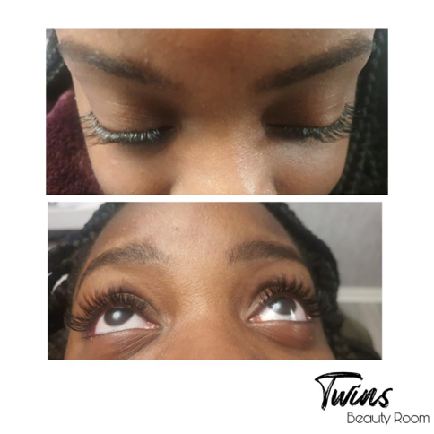

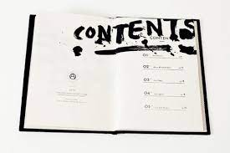

- Introduction………………………………………….3
- Company description………………………………...4
- Business structure……………………………………….5
- Advantages and disadvantages of opening an aesthetic centre……………………….6.
- Business objectives/ Marketing plan……………………………………………………………….7
- Management Team…………………………………………………………………………………………….8,9
- Products and services……………………………………………………………………………………….10
- Planning and operations plan………………………………………………………………………………11
- Financial Plan ………………………………………………………………………………………………….12
- Conclusion ……………………………………………………………………………………………………………….13

Innovative service plan

The present work studied the planning of the opening of an aesthetic centre and, as an innovation, an application to take my professionals as a way of delivering the available services that are in the physical store to my customers. To conduct this project, it was necessary to conduct a field survey to identify competitors and potential customers. To achieve the goal, I conducted market research with the target audience and what kind of application would be needed to achieve the final goal.

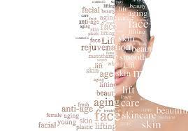

Company description
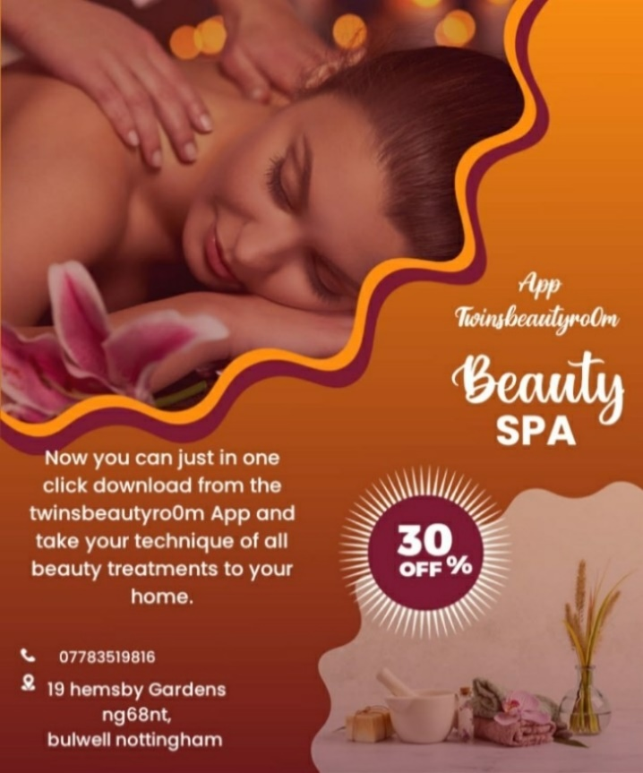
This business consists of a spa with all kinds of aesthetic treatments. Having a physical store, an online website, social media such as Instagram and Facebook and, as an innovation, it brought to the business an app for delivering professionals for all services included from the beauty salon to the customer's home. This will undoubtedly be the planning that I will elaborate with satisfaction, because in this module I learned and have some bases to do it.

Business structure
This company will be registered as a limited company at https://www.gov.uk/set-up-limited-company and will have the name "Twinsbeautyro0m".
For the structure of "Twinsbeautyro0m" to be an aesthetic centre, I will have to have an area with flexibility for expansion as the business develops. The environment can be divided into individual offices for service, bathrooms, reception, waiting room and office. I will plan the structure of this aesthetic centre well in advance so that all the activities and professionals that are both on the website and in the app, itself are available to my clients. Every aesthetic centre must be planned down to the smallest detail and mine will be no different, because I will be working with a physical space and a virtual one and I will have to have rules and practices with great security to promote the well-being of my clients and employees. For this reason, I believe it will be a business that will expand rapidly. My space will have electrical and plumbing facilities in particularly good condition, lots of lighting. Clear, washable walls and floors. The "Twinsbeautyro0m" beauty centre will provide a clean place with a calm and peaceful atmosphere.
My structure of my aesthetic centre will be composed of:
Reception – There must be a service counter with computer equipment that allows the registration of clients and the control of the services performed. It should have a telephone number for assistance and various contacts. Great care is needed with the look, location, and functionality, because this is where the first contact with the customer takes place. The reception service must be agile and efficient, directing the client to the place where the chosen service will be conducted, without creating unnecessary locomotion. The cashier can be at the reception, where the centre enters, where it will be the customer's first and last contact at the beauty centre. It will be at the reception that you will have control of requests for appointments from the app and new registered employees, as well as where they are at the time and time.
Waiting room – will offer convenience to customers and, preferably, have water, coffee, up-to-date magazines, newspapers, television, and background music. It will be located close to the reception and with easy access. A specific place for children to stay while their parents are dealt with and will be a differential to please my clients,
Service Rooms/Common Spaces – will be large enough to accommodate the furniture and equipment needed for each type of service. The ambient lighting will be serene and pleasant, providing tranquillity. Likewise, the colour of the walls and floor will be discreet. The environment will be airy and the temperature pleasant. If necessary, I will install air conditioners.
Individual service offices – will be large enough to accommodate the necessary equipment for each type of service. In general, they will have a minimum area of 5m², separated by partitions with a minimum height of 2m. I will use screens to divide larger spaces and create restricted areas for individual service, giving privacy and comfort to customers.
Bathroom Structure – will be close to the service areas to meet the flow of people who attend the beauty centre.
Parking – it will be especially important to have a parking space or an agreement with nearby parking lots, which can translate into a favourable differential for the business.

Advantages of opening an aesthetic centre.
• Distribution of expenses and costs (property leasing costs)
• Profits divided into two parts, however, there is a greater possibility of earnings.
• Management of the office under the direction of two professionals, where decisions do not matter to anyone.
• When hiring other professionals to join the
• Make a company cashier, where profits and cash outflows to pay bills and expenses will be listed.

There are disadvantages to all forms of creating something from scratch, whether in partnership or not. The point is to analyse each possibility and choose the one that best fits your reality.
One of the disadvantages of creating the office in society are:

- To risks, since another person in the business means exchanging ideas and often disagreeing with opinions
- In decisions, which cannot come from a single person.
- If one of the parties does not have the knowledge to manage it, this can be a burden for the other party to have to deal with everything.
- Difficulties in managing finances in society, without mapping the income that comes in and money outflows.
E-commerce:
I will use the e-mail system in my business to promote services, promotions, exchange of interactions with my clients, payments, purchase of material, among other benefits.
Key channels:
Facebook, Instagram, TikTok
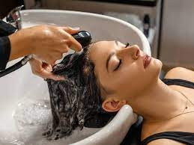

Industry
In today's times, to reach the standard of beauty imposed by the media, the market offers several resources. Cosmetic products, specialized clinics, surgical procedures, beauty salons, gyms and media spaces illustrating the universe created to meet the pursuit of beauty. So desired and "perfect". Regardless of sex or social class, there is always a solution for everyone, to meet the ever-increasing demand.

Business objectives
The purpose of creating this app is to make it practical for me as a businesswoman to have more control over my employees, the resources that come in and out, the employees themselves who sometimes pay to rent a chair so that they can exercise their profession, thus having total autonomy and my clients who will have different choices of treatments to meet the comfort of their home.
And with everything there are more and more people who don't like to leave the house and prefer a home service already exists but for the owner of the business it is often difficult to have a large number of employees to do this type of service so I to renew and to have more control of my workers I thought of creating an app with my aesthetic services such as home service delivery in which both qualified people in the field of aesthetics, duly certified, can access in my app which they will go to instead of paying for renting a chair they will go pay 5% to 10% of a fee and have products all provided by the establishment and uniforms and my permanent employees will have a monthly salary because sometimes they may be working in the physical store as they are going to deliver a specific service.

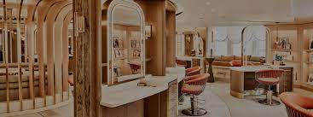

Management Team
Business objectives: ​
•Increase revenue by 10%
•Grow market share by 5%
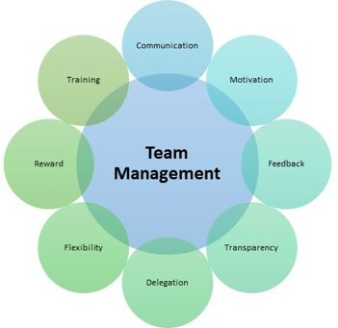

Marketing plan
• Marketing plan: It is a plan that is based on all the respective marketing efforts that I want to use so that my company has a future period and with that it outlines the marketing strategy, promotion, and advertising activities in record time.
• Product: The business is based on all kinds of aesthetic treatments of basic services provided by "Twinsbeautyro0m".
• Location: The company is located at 19 hemsby gardens, Nottingham. It is a place that is being selected so that many of the public's attention is attracted for the lucrative change to be altered in a respective way.
• Process: "Twinsbeautyro0m" guarantees the management of the operation and work practice in a brief period and therefore provides service from Monday to Sunday
Marketing focus:
- Acquire more customers.
- Grow revenue from existing customers.
- Innovation plan
Marketing goals:
•Increase average lifetime value by 5%
•Try to achieve new five hundred clients per month
•Make sure they are fully satisfied with your services

Marketing strategy:
•Making good discount
•Promote your services on everywhere
•Invest in your products
Dependencies:
•Budget
•High quality products
•development resources
•Taking care of our customers
•coming with extensive ideas to every meeting

Products and services
lip filler | Botox
lashes | modelling massages
eyebrows | nutritionist
facial treatments | hairdresser
laser hair removal | body massages
waxing | manicure
gel nails and designer | pedicure

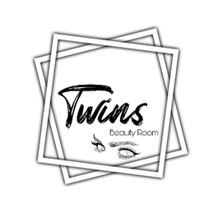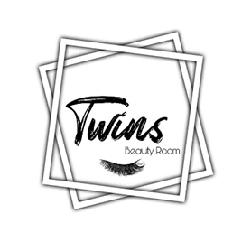

Coordination and operations plan
Here are some images of the app I made for the company's innovation structure, which, as I mentioned, will have the benefit of having more employees, having control over them, and taking my service to my customers in a comfortable and safe way.
https://bubble.io/page?name=index&id=twinsbeautyro0m&tab=tabs-1

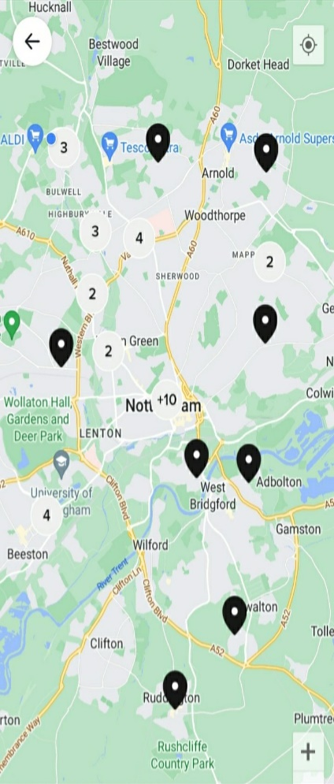
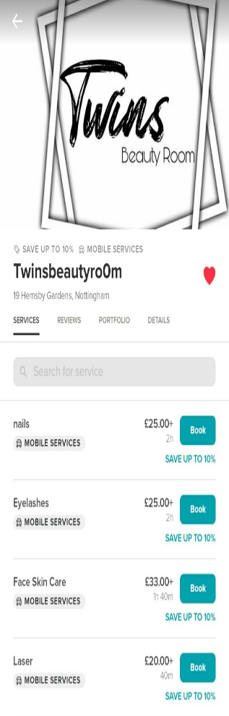
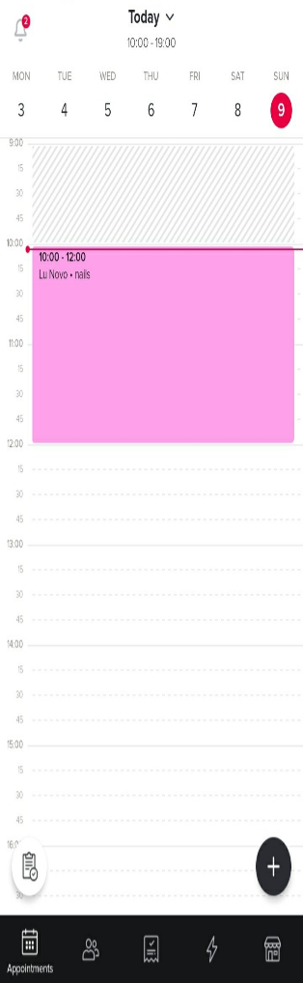
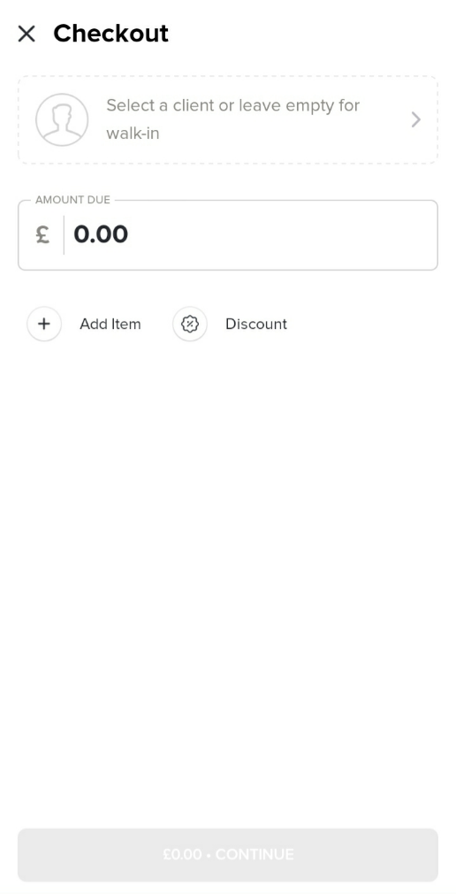

Ref. “(App Booksy Biz)”

Financial Plan
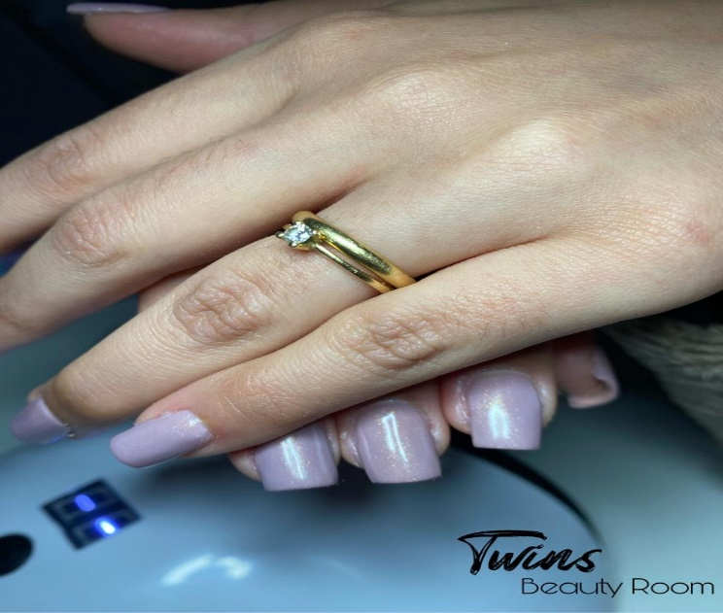

Financial Plan | Total Income: | Total Expenses: | Gross Profit: | Net Profit: | Cashflow forecast

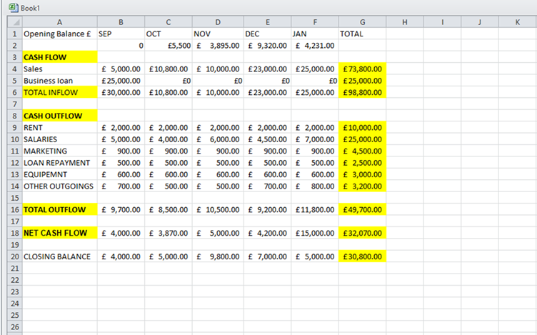

Conclusion
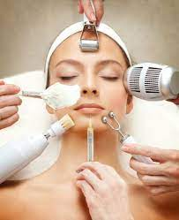

Through the knowledge I gained in the Developing Innovation and Creativity for Business Advantage module, I learned the importance of planning activity in our business decisions and how to have a better breadth of vision. Developing a plan, both professionally and personally, allows me to have a greater opportunity in the choices made during my career and to have a smaller number of appropriate problems without this planning because the whole business undergoes changes at all times because the market is very wide and we need to innovate all the time. To develop this business plan and structure it with some innovation was not at all easy because the market is full of innovations and the competition is only increasingly distributed and in quantity and quality, the activity was very well structured and worked on, elaborating all the details that exist in reality of an aesthetics sceptre with an app that allows me to have autonomy both for myself and for employees and customers with quality and speed and theoretically earning profit. I had some operational needs and with the learning I took through this module I found that innovation in the field of any business is particularly important for it to be at the same level as the competition. According to the research acquired in this project, the aesthetic sector is expanding in the city of Nottingham, as well as in society in general, with a large part of the services being of high quality, since it is an essential branch for the daily maintenance of individuals. and there is both the female and the male gender, the search for beauty is vast, and thus providing calm and welcoming services for the client. To complete, I elaborated the structure of the business, with strategic plan, marketing plan, operational plan, human resources plan and financial plan, all conducted in a theoretical forecast reality. Through this planning, the company operated in the aesthetic services market with a wide variety of certified and competent professionals and with a forecast of excellent future financial results. After viewing the competitors' data, the possible financial results were projected, considering a period of five years, going through the introduction, growth, and maturity phases of the business. Having the great certainty that the business only has and is growing both in terms of estimated profit and the increase in employees and, in turn, customers and everyone is satisfied.

References

- Al Mamun, C.A., and Hasan, M.N., 2017. Factors affecting employee turnover and sound retention strategies in business organization: A conceptual view. Problems and Perspectives in Management, (15, Iss. 1), pp.63-71.
- Arrondel, L., Debbich, M. and Savignac, F., 2014. Financial literacy and financial planning in France.
- App: Booksy Biz https://bubble.io/page?name=index&id=twinsbeautyro0m&tab=tabs-1
- Goh, S.H. and Eldridge, S., 2019. Sales and Operations Planning: The effect of coordination mechanisms on supply chain performance. International Journal of Production Economics, 214, pp.80-94.
- Hult, G.T.M., 2011. Market-focused sustainability: market orientation plus!. Journal of the Academy of Marketing Science, 39, pp.1-6.
- Parry, G., Newnes, L. and Huang, X., 2011. Goods, products and services. In Service design and delivery (pp. 19-29). Boston, MA: Springer US.
- Tulung, J.E. and Ramdani, D., 2016. The influence of top management team characteristics on BPD performance. International Research Journal of Business Studies, 8(3), pp.155-166.
- Wang, T.C., Tang, T.W. and Cheng, J.S., 2018. Art-oriented model of hotel service innovation. International Journal of Contemporary Hospitality Management, 30(1), pp.160-177.



