Outline and critically assess the supposed justifications for either the practice of factory farming or the use of animals in research.
In this essay I will explore the use of animals in research, looking at various aspects of the practise including animal research into cosmetics, medical animal research for human medicine both in modern and historic contexts. I’ll be looking at the justifications of each aspect, trying to see if any hold to criticism to see if any part of using animals in research is justifiable.
Before we get to the main part of the essay, however, I want to touch briefly on factory farming to explain what it is and why I chose not to focus the essay on it.
Factory farming is an intensive farming of livestock that produces industrial amounts of produce (1). Animals are kept in their thousands in small spaces and fed corn, wheat and soy that are also grown in using intensive, industrial methods. Growing the feeds also often use large amounts of pesticides which cause many problems of their own, but that’s for a different essay. The main aim of factory farming is to produce the maximum amount of produce for minimum amounts of costs. This aim is also linked to the main justifications of factory farming, the idea that it is linked thoroughly to the economy and the food production market in ways that make it near impossible to go back to farming livestock in more humane ways. It’s because most of the justifications are linked to economics that I chose to focus my essay on animals in research since I find the debate surrounding it far more interesting than those about money.
Animals are used in so types of research and there are many different ways to look at the topic. First we’ll begin with the use of animals in cosmetic research. Many cosmetics brands test their products on animals (2) before selling them. Most agree that “it is despicable and cruel to use animal life merely so that humans can advance their beauty technology” (Kabene & Baadel, 2019) and such experimentation is banned in the UK as well as most of the EU. However, some countries such as America and China still use animals to test cosmetic products. For America, products must meet certain safety regulations but it’s not specified how those must be tested so while using animal testing isn’t required, it isn’t banned. In China however, it is law for products to be tested on animals before it can be sold (although it’s not required if the product is only being made in China, only if it’s to be sold in China). Recently amendments have been made to the laws to exempt some products from this but it’s still required by most (Vy, 2021).
Despite it being legal or legally required in some countries, there is little actual benefit of using animals in cosmetics research. The methods are “inhumane, outdated, potentially misleading, and are no longer accepted in many countries in the world” (Humane Cosmetics Act, n.d.), with many alternative tests now available there is little room to argue that the tests can be justified through the safety the tests provide for the consumer. The alternative tests are both cheaper and more accurate. This leaves another justification as being able to sell the products in China, however this is a weak justification since the motivations are money which shouldn’t be more valuable than all the animal lives it costs to test the products.
So, I don’t think it’s justifiable to use animals in cosmetics research. A different type of research animals are often used for is medicine which we’ll look at next.
We have used animals in scientific and medical research for thousands of years with it still being done today. Each drug is tested on animals every 5-10 years to make sure they are still safe for human use, and any new drug on the market is put through animal testing before it goes to human trials. I think there is a difference between the testing on animals we did 100 years ago to the testing we do now. This creates the question: was animal testing morally right to do 100 years ago?
For an example we’ll use penicillin (3) since it was a massive breakthrough and still widely used today. The drug was discovered in 1928 but wasn’t available commercially until the mid to late 1940s, which was after it was shown not to be toxic to animals. Back when penicillin was being tested they didn’t yet have any of the alternative methods that we now have, they also were testing a completely new substance that was derived from mould. Because of this, I think it was justifiable for animals to be used in the testing of penicillin back in the 1940s since they didn’t have the alternative methods we have today and it’s derived from mould, as a completely new substance for us it was important to make sure it wasn’t toxic before commercial use. On top of this, penicillin has saved countless human lives and can also be used to help treat animals. Overall, I think for cases such as this animal testing was justified, although the fact that it cost animal lives and caused suffering means it wasn’t necessarily right.
The next thing to ask then, is if it’s justifiable to be using animal testing for medicine today.
One argument that it is justifiable is that it can tell us if a substance is toxic to humans. This is important to know for medicine and it’s been reasoned that a couple hundred animal lives are worth the countless human lives that the drug will save, or at least prevent from the harm that can potentially be caused by a toxic substance in a medicine. Furthering this line of argument “Badyal and DesaI (5) note that these treatments are as beneficial to humans as they are to animals, since some human diseases are found in animals too” (Kabene & Baadel, 2019) this strengthens the argument that animal testing for medicine is justifiable through the drugs it helps assure the safety of since it isn’t just humans using animals for our benefit as the results will also help other animals.
A counter claim to this however is that animals can’t predict how humans will react to a drug nor chemical. An example of this argument is Thalidomide. Thalidomide was a drug that was developed in the 1950’s and used for many conditions as well as treating the flu, nausea and morning sickness. During testing, scientists found that they could give large amounts of the drug to animals without it being fatal, using this they deemed it safe for humans to use and was advertised to pregnant women as completely safe for both the mother and child. The drug however caused a great range of changes in the foetus which included organs, eyesight and hearing, by the time the link between this and Thalidomide was made “it’s estimated that over 10,000 babies were effected worldwide” (science museum, 2019) (4). The reason that Thalidomide was allowed to become so available and widely used, that it was deemed harmless, was because of animal testing. Animal testing made the developers believe the substance was harmless when in fact it wasn’t, this gives strength to the counter argument since we can’t justify the use of animal testing for safety purposes if it doesn’t work to prove that anything is actually safe.
However, I don’t think it is possible to rule animal testing out based solely on one example of it going wring considering there is also a history of it going right and saving many lives; although, the argument that animal testing isn’t indicative of human reactions and so isn’t justifiable is still quite strong. Further evidence used for this is that most drugs that make it past animal testing never make it onto the market. This isn’t a very strong argument though since animal testing is usually good at telling us if something is toxic to humans, it’s that they can fail to tell us the effectiveness of the drugs on humans which isn’t something that is really being tested on animals most of the time. The majority of the time, animal tests are able to accurately predict if a substance is toxic to humans (Magee, 2019) therefore we can justify them by saying that they do give us the results needed to ensure the safety of our medicines.
A similar justification of animal experimentation is that “scientists note that significant medical breakthroughs have only been made possible through drug testing on animals” (Kabene & Baadel, 2019). The lives saved through animal experiments justify the use of them. There was a BBC2 documentary based on animal experimentation called ‘Monkeys, rats and me: animal testing’ in which this matter of a few animal lives being an acceptable cost for thousands of human lives (5). In the documentary, Tipu Aziz a professor of neuroscience, had been conducting experiments on monkeys to create a treatment for Parkinson’s and dystonia with Sean Gardner being an example of someone given their life back through Aziz’s work. Aziz had experimented on 100 monkeys to create a treatment that helped over 40,000 people, and Peter Singer responded that he “could see that as justifiable” (Mangan, 2006). In his book Animal Liberation, Singer expresses the same view that animal experimentation is justifiable if it saves many human lives, despite his ideals of all species having equal consideration.
In modern medicine we now have alternative ways to test toxicity and efficacy rather than on animals (6). These weren’t an option 100 years ago so they can’t be used to make animal testing back then unjustifiable but as we have them now is that the case? Animal-free alternative tests, if just as effective, would surely make testing on animals unjustifiable as there’d be a readily available method that doesn’t involve the harm of any living creature but assures the same results of saving lives. In some cases, this is exactly the case; alternative tests are being used instead of testing on animals which would strengthen the idea that animal-free testing makes any continuation of tests that harm animals unjustifiable. However, there are some areas of medical research such as that of treatments for arthritis where currently we have no alternatives that can give accurate data about the efficacy of new drugs. This creates a situation where some areas of medicine can use the justifications that we had 100 years ago, that there wasn’t an alternative method to develop the life-saving treatments (and as Singer has said, it’s justifiable to sacrifice the lives of some animals for the benefit of many humans), but at the same time there are areas where alternatives are possible so animal testing in those instances wouldn’t be justified (Katsnelson, 2013).
In conclusion, animal testing can be justified if it saves lives and there are also no better alternatives. Testing cosmetics on animals isn’t justifiable, however it can be justified to test life-saving medicines on animals if there are no alternative methods in that area of medicine available yet.

Bibliography
Humane Cosmetics Act. (n.d.). Retrieved from Animal Welfare Institute: https://awionline.org
Kabene, S., & Baadel, S. (2019). Bioethics: a look at animal testing in medicine and cosmetics in the UK. Journal of medical ethics and history of medicine, Vol.12 p. 15.
Katsnelson, A. (2013, June 10th). Will we ever… eliminate animal experimentation? Retrieved from BBC: https://www.bbc.com
Magee, C. (2019, March 13th). Did animal tests delay penicillin by 10 years? Retrieved from Understanding animal research: https://www.understandinganimalresearch.org.uk
Mangan, L. (2006, November 28th). Last night's TV. Retrieved from The Guardian: https://www.theguardian.com
science museum. (2019, December 11th). Retrieved from Thalidomide: https://www.sciencemuseum.org.uk
Vy. (2021, May 22nd). China’s Animal Testing Laws May 1, 2021 – What You Need To Know! Retrieved from Ethical elephant: https://ethicalelephant.com

Image appendix
1)
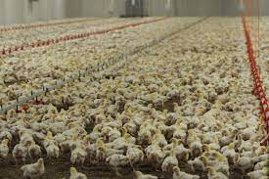
Farm sanctuary – factory farming
2)
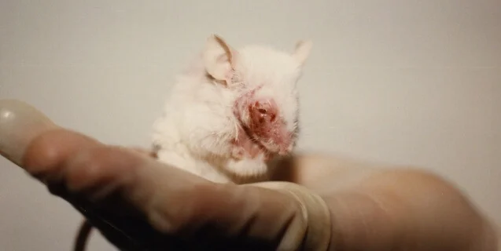
Peta.org Cruelty in Animal Testing Laboratories

3)
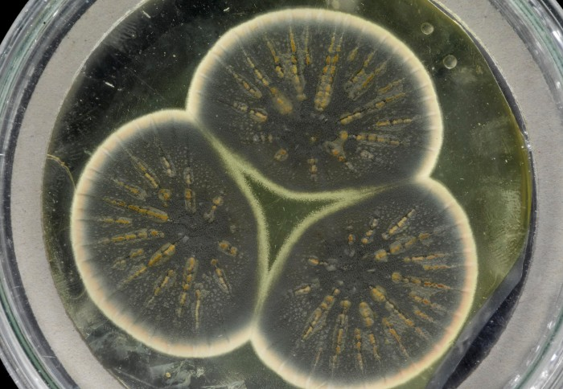
Genome of Alexander Fleming’s original penicillin-producing mould sequenced – Imperial college London
4)
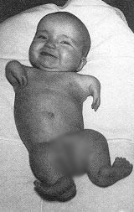
https://thalidomide.ca What is Thalidomide?
5)

https://bearmarketreview.wordpress.com - Utilitarianism in Hollywood
6)
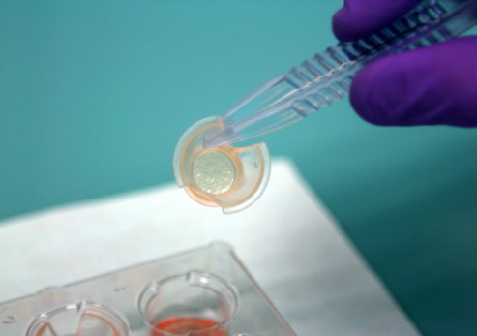
https://crueltyfreeinternational.org - Alternatives to animal testing

