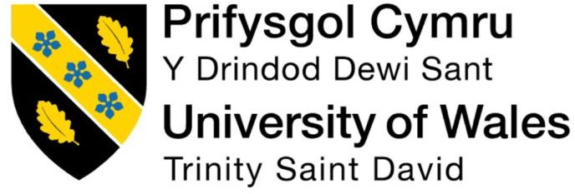

University of Wales Trinity Saint David (UWTSD)
Module Name: Employability and Career Development
Module code: LCLM4005
Assessment Title: Mock Interview
CertHE Business Skills for the Workplace
Submitted by: Amina Darr
Student ID: 2522455
Lecturer: Ibrahim Rufai
Submission Date: 19/10/2026

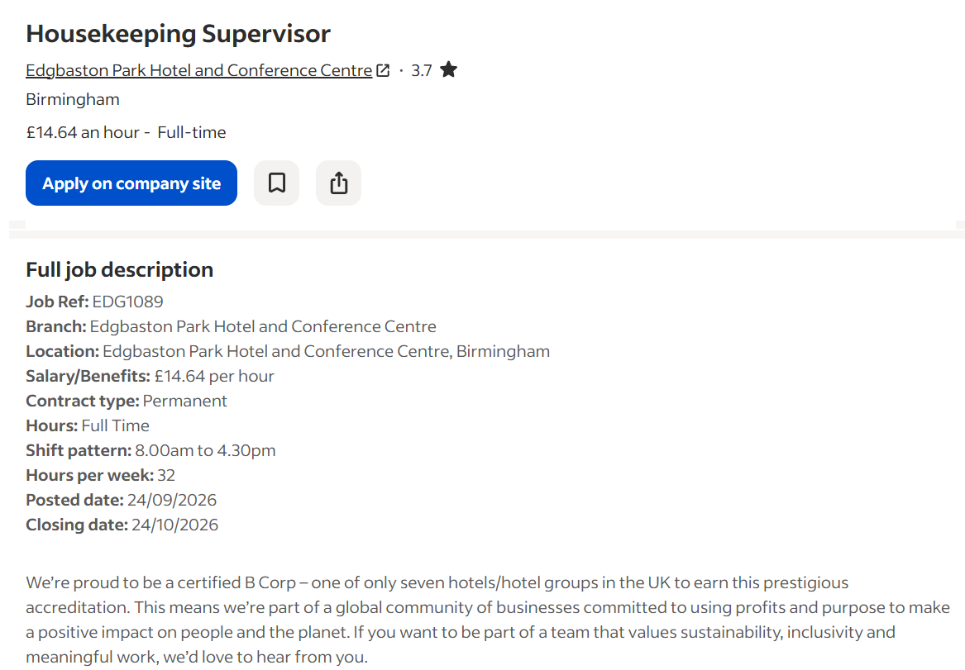

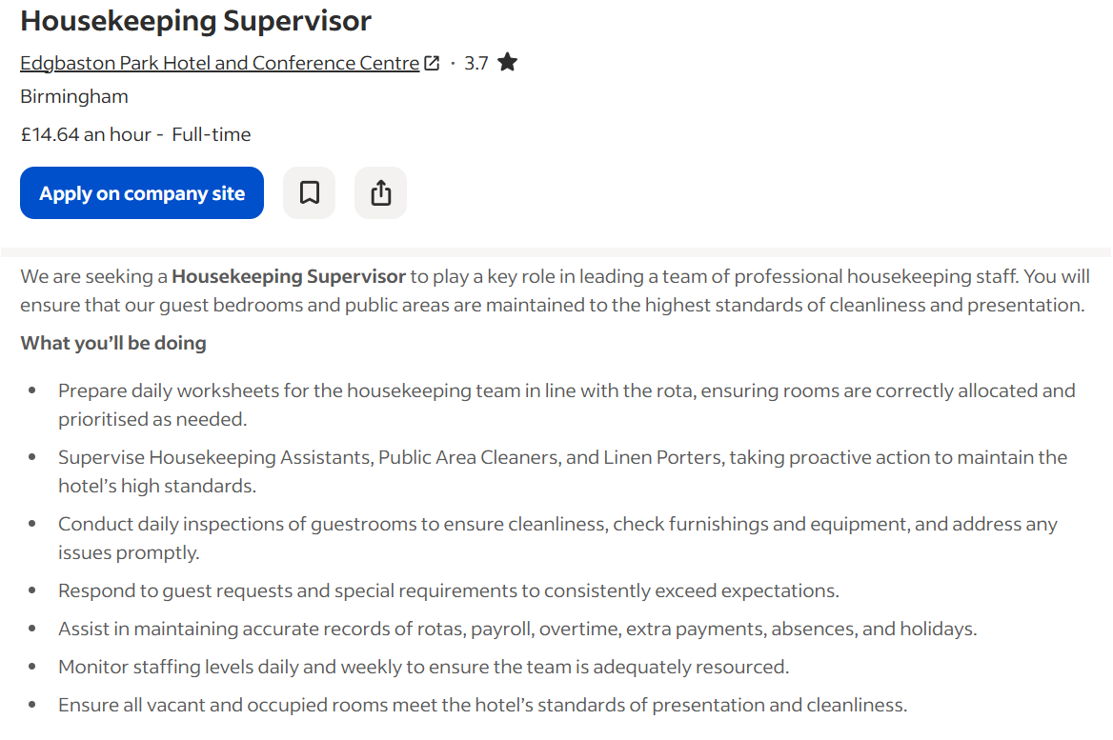

AMINA DARR

Telephone: 07882202371
Email: aminadarr2019@outlook.com

Personal profile

I am an experienced housekeeping professional with 25 years of experience in the hotel and hospitality industry. I have worked as a Housekeeping Manager and Assistant Head Housekeeping Manager, gaining valuable experience in managing housekeeping duties, maintaining high standards of cleanliness and supporting the smooth running of hotel operations.

I am hardworking, reliable and organised, with a strong commitment to cleanliness, teamwork and good customer service.

Key Skills

  - Housekeeping and hotel management
  - Maintaining high standards of cleanliness
  - Organising daily housekeeping duties
  - Supervising and supporting housekeeping staff
  - Checking room cleanliness and presentation
  - Teamwork and communication
  - Time management and organisation
  - Attention to detail
  - Guest service and satisfaction

Employment History

Housekeeping Manager
Campanile | 2004–2025

  - Managed housekeeping duties to maintain high standards of cleanliness throughout the hotel.
  - Organised daily housekeeping work and ensured tasks were completed on time.
  - Supported housekeeping staff and helped maintain a professional working environment.
  - Ensured guest rooms and hotel areas were clean, tidy and ready for use.
  - Maintained standards of presentation and contributed to guest satisfaction.
  - Worked with colleagues to support the smooth running of hotel operations.
  - Took responsibility for maintaining housekeeping standards.

Assistant Head Housekeeping Manager
Campanile | 1999–2004

  - Assisted the Head Housekeeper with the daily running of the housekeeping department.
  - Helped organise cleaning duties and staff workloads.
  - Supported housekeeping staff in maintaining cleanliness and presentation standards.
  - Helped ensure hotel rooms were prepared to the required standard.
  - Worked with colleagues to complete daily tasks efficiently.
  - Helped maintain a clean, tidy and welcoming environment for guests.

Education

GCSEs
  - English
  - Mathematics

Computer Skills

  - Microsoft Word
  - Microsoft Excel

Languages

  - English
  - Punjabi
  - Urdu

Amina Darr
Telephone: 07882202371
Email: aminadarr2019@outlook.com

Recruitment Team
Edgbaston Park Hotel and Conference Centre
Birmingham

13 October 2026

Re: Application for Housekeeping Supervisor

Dear Recruitment Team,

I wish to apply for the role of Housekeeping Supervisor at Edgbaston Park Hotel and Conference Centre in Birmingham. Please find my CV enclosed for your consideration.

As you can see from my CV, I have 25 years of experience in the hotel and hospitality industry. I believe my experience in housekeeping management, maintaining high standards of cleanliness and supporting staff makes me a suitable candidate for this role.

During my time at Campanile, I worked as an Assistant Head Housekeeping Manager from 1999 to 2004 and as a Housekeeping Manager from 2004 to 2025. These roles gave me valuable experience in managing housekeeping duties, maintaining cleaning standards and helping the housekeeping department run smoothly.

Throughout my career, I have understood the importance of keeping guest rooms and hotel areas clean, tidy and welcoming. I also understand the importance of organising daily duties, supporting staff, checking standards and making sure guests receive good service.

I am a hardworking, reliable and organised person who takes pride in my work. My years of experience have helped me develop a good understanding of hotel housekeeping and the importance of teamwork, communication and attention to detail.

I am confident that I can use my knowledge and experience to make a positive contribution to your housekeeping team and help maintain the high standards expected by your hotel. I would welcome the opportunity to bring my skills and experience to your organisation and continue working in the hospitality industry.

Thank you for considering my application. I look forward to the opportunity to discuss my experience and suitability for this position at an interview.

Yours faithfully,
Amina Darr

