

MODULE CODE: Digital Skills for Personal Development and Business Growth BMSW4008

ASSESSMENT COMPONENT: PORTFOLIO

STUDENT NAME: Kera Ahmed
STUDENT NUMBER: 2441883
LECTURER: Philippa Fitzgerald
DATE:12th of December

AI Acknowledgement
I confirm that I have not submitted any AI-generated material as my own work.
I confirm that I have copies of my drafts, notes, and other resources that I have used, which I may be asked to provide as evidence.
I acknowledge using Grammarly (https://www.grammarly.com/) to check my work using the following prompt(s):
’’Please check the following text for readability, grammar, and syntax.’’
I acknowledge using ChatGPT (https://chatgpt.com/) / Gemini (gemini.google.com/app) to check my work and check my grammar as well

Contents
Task 1 3
Assessment of Digital Skills 3
References 3
Task 2 4
LinkedIn Learning Certificates for Office365 4
Task 3 5
Essay on Relevance of Excel in professional and personal life. 5
References 5
Task 4 6
7 Minute Reflective Presentation 6
References 6

Task 1

Assessment of Digital Skills
.
Staying connected in the modern world requires more than just basic proficiency in using electronic devices. It also demands digital literacy—the knowledge and skills necessary to use technology safely, responsibly, and effectively (Carretero et al., 2017). To understand my current capabilities in this complex area, I analyzed my performance by completing the JISC Digital Literacy Test. The test provided a clear picture of the skills I already possess and the areas where I need to improve. According to research, digital literacy encompasses not only technical skills but also critical thinking, communication, and problem-solving in digital environments (Van Laar et al., 2020).
In this essay, I will focus on two skills I am confident in and two I need to develop to enhance my digital literacy and prepare for future advancement. As Carretero et al. (Carretero et al, 2017; van Laar et al., 2020), students need to understand their digital capabilities to thrive in the future.
One of my personal strengths, as noted in the JISC report, is my confidence in using basic digital communication tools such as email, Microsoft Teams, Outlook, and other online platforms. An academic study (Peter, 2025) underscores the importance of this skill, demonstrating that effective use of digital platforms increases student engagement and collaboration in educational activities. My ability to use these tools helps me create what the study calls a "collaborative learning environment," which supports digital transformation and improves access to communication and teamwork tools. Therefore, to further develop this skill, I plan to practice using communication platforms more extensively by writing more messages, sending photos, and other forms of communication.
Another one of my strengths is my proficiency in digital skills. My ability to confidently use digital devices and platforms shows that I have the essential skills needed for learning in a digital environment. Studies such as (Getine et al, 2024) suggest that proficiency in digital skills has a positive effect on students’ self-confidence, helping them feel more capable and prepared when learning online. This increased confidence leads to better engagement and performance. Similarly, (Yuan et al, 2025) explain that strong digital skills can improve learning outcomes because they allow students to feel more in control of their digital tasks. For these reasons, I consider my digital skills to be an important asset to my academic success. This proficiency also benefits me outside the classroom, as it enables me to access information, communicate effectively, and handle challenges in both academic and professional settings. Therefore, I plan to continue developing my digital skills by using digital tools more regularly, seeking help from experts when needed, and ensuring that gaps in my understanding do not hold me back.
My main weakness, however, is digital creativity. My confidence in this area is still developing, and I need more training in digital content creation. This includes creativity in tasks such as image design, creating clear presentations, and building simple web pages. At the moment, I often use simple designs and layouts, so I need to improve these skills to make my digital work more creative, engaging, and professional.

Another significant weakness is digital wellbeing. I am still learning how to manage my online activities in a healthy and safe way, which is important for maintaining my psychological wellbeing. This includes monitoring my online time, taking regular breaks from screens, and being more mindful of online communication. Sometimes, spending too much time online makes me feel stressed or unfocused, so I need to develop strategies to maintain balance and avoid negative digital experiences. Improving my digital wellbeing will help me function better and more comfortably in both academic and professional digital tasks.
In conclusion, reflecting on my JISC Digital Test results has helped me gain a clearer understanding of my current digital strengths and weaknesses. My confidence in digital communication and general digital skills plays an important role in supporting my academic performance and enabling me to interact effectively in digital learning environments. At the same time, recognising my weaknesses—particularly in digital creativity and digital wellbeing—has shown me where I need to focus my efforts to grow further. By actively developing these areas through practice, training, and healthier digital habits, I can enhance my overall digital literacy. Strengthening these skills will not only support my success at university but also prepare me for future opportunities in digital world.

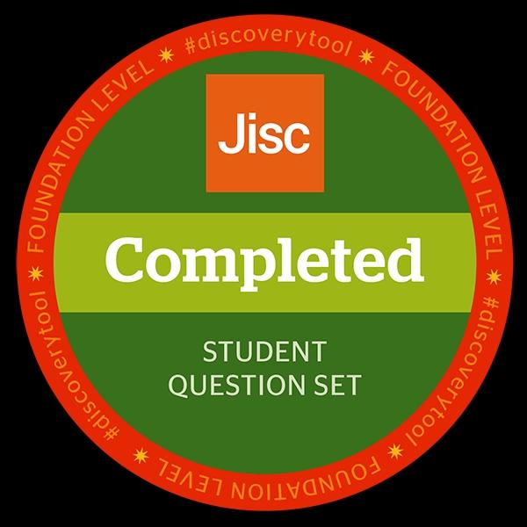

References
​​Carretero, S., Vuorikari, R. & Punie, Y. (2017). DigComp 2.1: The Digital Competence Framework for Citizens. Joint Research Centre, European Commission. Available at: https://publications.jrc.ec.europa.eu/repository/bitstream/JRC106281/jrc106281_digcomp_2.1__online_version.pdf
​Getenet, S., Cantle, R., Redmond, P. And Albion, P. (2024) ‘Students’ digital technology attitude, literacy and self-efficacy and their effect on online learning engagement’, International Journal of Educational Technology in Higher Education, 21(3). Doi: https://doi.org/10.1186/s41239-023-00437-y.
​Petre, I.L., Hristache, D.A., Dobrescu, M.M., Constantin, A., Dumitra, E.-C. And Radu, C.-G. (2025) ‘Digital Communication in Higher Education Settings: A Pilot Study on Students’ Behavioural Trends’, Sustainability, 17(7), p.3038. doi: https://doi.org/10.3390/su17073038.
​Van Laar, E., Van Deursen, A., Van Dijk, J. & de Haan, J. (2020). Determinants of digital skills in the workplace. Computers in Human Behavior, 108, p. 106253. Available at: https://doi.org/10.1016/j.chb.2020.106253.
​Yuan, N., Yu, Q. And Liu, W. (2025) ‘The impact of digital literacy on learning outcomes among college students: the mediating effect of digital atmosphere, self-efficacy for digital technology and digital learning’, Frontiers in Education, 10:1641687. Doi: https://doi.org/10.3389/feduc.2025.1641687.

Task 2

LinkedIn Learning Certificates for Office365


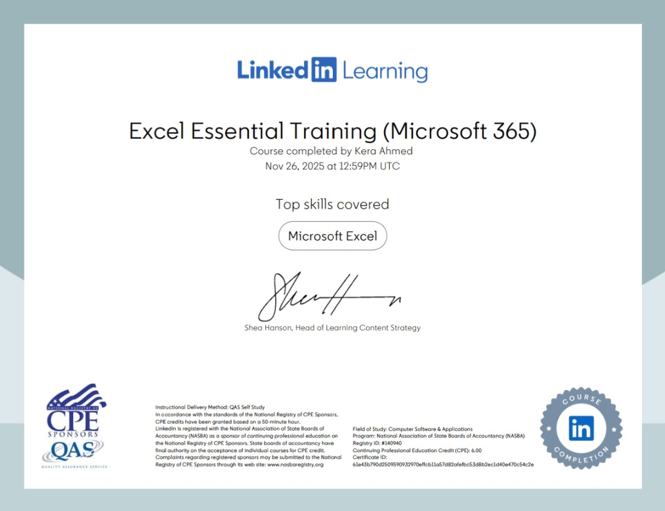

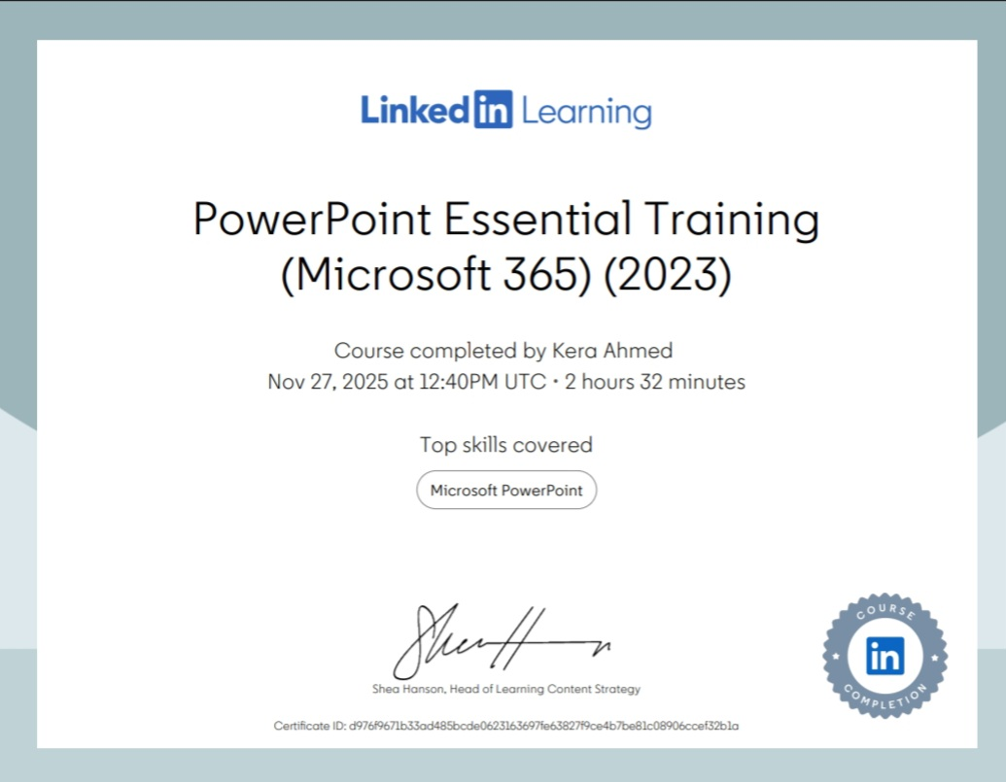

Task 3

Essay on Relevance of Excel in professional and personal life.
Historically, spreadsheet programs have played an essential role in the development of modern computing, mainly because of their importance in supporting decision-making and managing business operations. Microsoft Excel is one of the most prominent and widely used spreadsheet programs. It first appeared in the mid-1980s, specifically in 1985 for Macintosh computers, as a natural extension of the evolution that started earlier with VisiCalc and then Lotus 1-2-3. Over time, Excel managed to solidify its position as a standard tool across many sectors. Several academic studies point out that Excel’s development came as part of a series of innovations in spreadsheet design, which enabled it to gradually outperform its competitors thanks to its advanced capabilities and its strong connection with the Microsoft ecosystem (Raković, 2014).
In addition, some recent studies by ( Zdilar, M. 2023) and others show that Microsoft Excel has become one of the most widely used tools in many fields, including business, education, research, and other platforms. This wide use is not limited to individual users, but also extends to multi-user environments, which highlights the growing dependence on Excel. It also shows how some institutions rely heavily on it in their daily operations.
It is worth mentioning that Excel is no longer seen only as a simple spreadsheet tool. It is now viewed as a form of simplified programming. It allows users, even those without enough programming background, to create advanced functional models using formulas and basic programming rules. For this reason, some experts describe Microsoft Excel as “the most widely used programming language in the world,” since millions of people use it to complete essential academic and professional tasks. As a result, gaining strong skills in Microsoft Excel is considered an important requirement for career development (Hatmaker, 2023), because it increases a person’s efficiency and abilities in both study and work.
Many users think that Microsoft Excel is only used for data analysis, but its use is much wider than that. Excel is used in many other fields, such as financial analysis, asset valuation, statistical modelling, and intelligent systems that support decision-making. Because Excel is flexible, it works as a platform that combines practical calculations with analytical thinking (Bon et al., 2024).
Microsoft Excel skills are among the most in-demand skills in the job market, especially for jobs that do not require advanced technical knowledge. People use Excel for tasks such as accounting, sales tracking, calculating return on investment, organizing spreadsheets, and doing daily analytical work. Research also shows that computer-based analytical tools—including Excel—are used more often by quantitative researchers than qualitative ones, which highlights Excel’s growing role in scientific research (Ngolobi, 2023).
From a software engineering point of view, the LAMBDA function allows Excel users to apply a component-based engineering method in their models. This method helps reduce common errors by using reusable parts instead of creating long and complex formulas from the beginning. In addition, using the LAMBDA function together with the LET function makes Excel formulas easier to read and understand, as they can be divided into clear and well-labelled sections (Hatmaker, 2023). Although Microsoft Excel has great capabilities, it still faces a major challenge. Studies and data show that Excel has a high error rate in large and complex spreadsheets. Research indicates that the error rate is between 80% - 94% in operational spreadsheets, and these mistakes can lead to financial losses or inaccurate decisions. This problem is likely caused by the common practice of end-user programming, where millions of non-specialist users build models without formal training in quality assurance. As datasets continue to grow, the need for automated tools that can detect errors becomes even more important, especially in spreadsheets based on longitudinal data, which require high accuracy (Zdilar, 2023; Poon et al., 2024; ​Powell, J. R, 2018; Panko, R. R. 2016; Bruni et al., 2024).
Despite the presence of some errors, Excel remains an essential and influential tool. It has gone beyond its traditional role as a spreadsheet program and has become a powerful platform that combines software engineering principles with advanced analytics. Its strong compatibility with cloud systems and business intelligence tools—especially Power BI—together with the continuous demand for Excel skills in the job market, shows that Excel will continue to play a key role in shaping the future of data analysis and decision-making (Rebman et al., 2023).
In conclusion, Excel has undergone a major transformation since its beginnings as a simple spreadsheet tool. Today, it is a flexible and powerful environment for modern data analysis. Recent innovations, such as the LAMBDA and LET functions, have helped turn Excel into a developer-friendly environment, allowing even non-programmers to build organized, reusable, and efficient analytical solutions. Academic and professional studies continue to show the wide use of Excel in business, education, and research, confirming its central role in managing complex information systems and supporting informed decision-making.
Even with the rise of more advanced analytical platforms, Excel is still the preferred choice for millions of users because it is easy to access and deeply integrated into the Microsoft ecosystem, especially with Power BI. This shows Excel’s ability to adapt to new technologies while keeping a balance between simplicity and effectiveness. However, the high error rates in large spreadsheets highlight the importance of improving error-detection methods and promoting better practices, especially among end users who depend heavily on Excel without specialized training. Still, Excel remains a fundamental tool in today’s digital environment. Its mix of analytical power, ease of use, and scalability ensures that it will stay at the front of data analysis, business intelligence, and decision-making for years to come.

My Excel.

References
Bruni, R., Daraio, C. And Di Leo, S. (2024) Flexible Techniques to Detect Typical Hidden Errors in Large Longitudinal Datasets. Symmetry, 16(5), p. 529. Available at: https://doi.org/10.3390/sym16050529
Hatmaker, C. (2023) Reducing Errors in Excel Models with Component-Based Software Engineering. Proceedings of the EuSpRIG 2023 Conference. Available at: https://arxiv.org/abs/2309.00650
Ngulube, P. (2023) Improving the quality of reporting findings using computer data analysis applications in educational rese.arch in context. Heliyon, 9(9), p. E19683. Available at: https://doi.org/10.1016/j.heliyon.2023.e19683
Panko, R. R. (2016) What We Know About Spreadsheet Errors. Journal of End User Computing (JEUC), 10(2), pp. 15–21. Available at: https://www.researchgate.net/publication/228662532_What_We_Know_About_Spreadsheet_Errors
Poon, P. L., Lau, M. F., Yu, Y. T. And Tang, S F. (2024) Spreadsheet quality assurance: a literature review. Frontiers of Computer Science, 18(2). Available at: https://doi.org/10.1007/s11704-023-2384-6
Powell, J. R., Baker, S. A. And Panko, R. R. (2018) The danger of spreadsheet errors. The CPA Journal, 88(3), pp. 24–30. Available at: https://www.cpajournal.com/2018/03/29/danger-spreadsheet-errors/
Rebman, C. M. Jr., Booker, Q. E., Wimmer, H., Levkoff, S., McMurtrey, M. And Powell, L. M. (2023) An Industry Survey of Analytics Spreadsheet Tools Adoption: Microsoft Excel vs Google Sheets. Information Systems Education Journal (ISEDJ), 21(5). Available at: https://files.eric.ed.gov/fulltext/EJ1409034.pdf
Zdilar, M. (2023) Towards Automated Detection of Qualitative Spreadsheet Errors in Multi-user Environments. Paper presented at the Proceedings of the Central European Conference on Information and Intelligent Systems. Available at: https://archive.ceciis.foi.hr/public/conferences/2023/Proceedings/QICT/QICT1.pdf

Task 4

7 Minute Reflective Presentation
My PowerPoint .

