
MARKETING MANAGEMENT
ASSIGNMENT 1
NIKE


SAHIL CHOUDHARY
STUDENT NO. 1906815
DATE- 28TH AUGUST 2020
LECTURER - Tushara Balendran

Contents
Introduction 2
Analysis of main body 2
Describe the current promotions used by Nike business foreground 5
Explaining new promotional strategies Nike can use to raise awareness of the brand 6
Defining branding and brand equity through Keller’s Brand Equity Model 8
Customer’s journey and customer touch points for Nike 10
Conclusion 12
References 14

Introduction
Within a business, customers are one of the most important components that an organization works for and aspires to provide them with great levels of satisfaction through their products and services. In order to ensure that they are able to satisfy their customers, organizations induce various modes of communication in order to provide them the knowledge about the company and the brand’s variation of products and services. Accordingly, organizations understand the importance of various touch-points of the customers that if addressed by the organization would ensure higher level of customer engagement with the brand. Organizations induce extensive marketing strategies while constantly merging innovations as a significant way to increase brand awareness among their target customers (Hänninen and Karjaluoto, 2017). Nike is an international brand of sports shoes that has great significance in the entire world with its extensive range of products in the market. Significantly, Nike has also ensured to expand the brand in the market by creating awareness and ensuring to reach to its customers through the extensive use of communication channels. The following report would highlight the innovative marketing strategies of Nike in terms of raising awareness of the brand while ensuring to evaluate through various communication channels, customers’ journey to fulfil their future expectations.

Analysis of main body
Definition of communication
Communication in business terms may be defined as an effective process of transferring of messages by the sender from one end and the receiving and interpreting of the message by the receiver on the other end and the vice-versa, while implying to endure the transfer of messages from both the ends (Verzano, 2017). Significantly, its importance in an organization to ensure that while it entitles is responsibility to satisfy the customers in the most effective manner, the first important aspect is to ensure that the company to induces great communication to generate effective messages.

Shannon and Weaver’s Communication Model
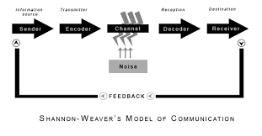
Shannon and Weaver Model of Communication provides an extensive understanding of the process of communication that takes place between the sender and the receiver while the model lays emphasis on an important aspect of Noise as a factor of communication. Following are the various factors included within the communication model:

Sender: the one who initiates a message containing important information to be sent out for the receiver (Wang, and Li, 2017).
Encoder: this is regarded as the transmitter in the communication process that converts the messages of the sender into specific signals.
Accordingly, the messages of the sender that contains important data is transmitted in the form of waves that helps in transferring the data through connections of cables or satellites.
Decoder: this is the step in the communication model whereby the encoded messages are decoded or reversed from signals to messages for the receiver (Soter, 2016). The receiver converts the signals into understandable language whereby it is able to understand the message appropriately.
Receiver: the message reaches the receiver and it could gain the information of the sender effectively. Significantly, the receiver may give back further messages to the sender as a feedback of the received message.
Noise: this is referred to the hurdle between the communication process or communication channel between the receiver and the sender. Accordingly, any sort of issue that affects the messages sent by the sender may lead to receiving of wrong messages by the receiver.
However, any sort of issues may significantly create the situation of noise that is created by an external force or signal that creates an issue of network between the sender and receiver (Onobrakpor, 2019). On the other hand, the sender that may not be understood by the receiver may also transmit incorrect messages with the wrong use of words. In case of the Nike, it can be understood that ensuring of effective communication between the brand and its customers requires the brand to ensure that the messages it leaves for its customers are understood significantly while their feedbacks are given due importance and resolving of queries take place effectively.
Integrated Marketing Communication (IMC)
Integrated Marketing Communication refers to the various modes of communication channels used by a business organization to transfer messages to its customers by linking all the tools of marketing effectively. IMC is the way to ensure that all the marketing tools connect with one another to spread the message of the brand significantly to ensure that they receive the messages across all channels. Among the 7Ps of marketing mix, Promotion is one of the important components that ensure effective communication between the organization and its customers (Finne, and Grönroos, 2017). Accordingly, various marketing channels like advertising, sales promotion, personal selling, direct marketing, public relations and social media are the effective ways through which organizations may communicate the information regarding their brand and their products and services effectively. Hence, integration of all the
channels of promotion together provides the company to ensure that through all the mediums of communication, organizations may reach their customers everywhere.

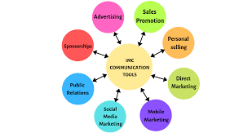
IMC has its own benefits for the organization in terms of enhancing the organizational culture by spreading out the message of sustainability that the brand follows while promoting their products and services. Integrated Marketing Communication benefits the organizations to communicate with their customers in the most effective way while ensuring to enhance consumer experience along the way. Nike being an international sports brand has provided extensive ways to integrate communication channels for marketing in order to ensure that it is able to provide its customers with extensive experiences by communicating with them through a combination of channels (Valos, et al., 2016). Sales Promotion and public Relations are the most focused channels of communication along with social media and advertising that Nike focuses on as a result of connecting with their customers on levels of both online and personal basis, ensuring to enhance their experiences while generating a stronger relationships with the customers through effective communication.

Describe the current promotions used by Nike business foreground
Nike as a leading sports brand in global context has been differentiated from its competitors in terms of adhering to their promotional techniques and messages that they enthral through their different applied marketing or promotional techniques. In various markets, it has been found that Nike has been sound in their promotional utility as it can be seen that as a sports brand they connect to the customers on an emotional note (Mikołajczyk, 2015). In the current context, Nike has been found to be promoting more over their products utility based over the athletic comfort and distinctiveness they has created as a brand. It can be seen that Nike for promoting their brand products in front of the customers uses upon amalgamation of traditional advertising, sales promotion, personal selling, direct marketing and different forms of public relations. With the combination of different promotional techniques, it can be found that Nike as a brand has been able to counter for a better promotional and brand value in front of the customers. Some of the promotions used by Nike are as follows:-
Advertising
This is probably the most dominated and largest promotional tactics applied by Nike and it can be seen that the company uses both traditional and digital media in terms of reaping the maximum promotional returns and sales from the advertisement they gear up. According to viewpoint of Bradshaw, and Scott, (2018), though it has been found that Nike propagates only 25% advertisements of their products; however, the company follows on traditional promotional platform like television, radio and print as the main medium of their promotion. Moreover, celebrity endorsement has also been a famous and vivaciously used promotional technique by Nike in current dimension. Nike is allured to endorse for famous athlete celebrities in their promotional content for propping up their brand in international context.
Personal Selling
Nike has been found to be profoundly concentrating over personal selling as a vehement promotional component in their own or franchisee based stores. The company entails for smart sales persons in their stores who persuade the customers for buying products through describing the product details and their unique features than other brand competitors in the market (Putra, and Ningrum, 2019). This tactic helps the customers to emotionally connect with the brand through the personal selling individual designated at different Nike stores and franchisees.
Sponsorships
This has been one of the most prominent promotional tactics used by Nike in the recent competitive world of marketing. It can be found that Nike approaches to be sponsoring different events and tournaments at local, regional, national and international sports level which helps them to establish stronger relation with the customers as a famous sports brand. In the year 2012-2019, Nike has been found to be sponsoring more than 185 sports events in Europe and UK as a part of their marketing promotional tactic (Pillay, 2019).

Sales Promotion
It is one of the most widely accredited promotional techniques used by Nike as they help in targeting the customer’s cognitive attachment with the brand and build up new customers base with additional discounts and rewards being offered to the end customers. Nike most usually persist upon distributing coupons and special offers to the customers so that it may feel to the customers that they are saving while buying Nike’s products on a discounted price than other brands (Sukram, 2017).

Explaining new promotional strategies Nike can use to raise awareness of the brand
The current global atmosphere of marketing is proclaiming for a vision where the platform of digital channels has been rightly served for promoting products in front of the customers. Nike as a authentic sports brand has always remained to be iconic in their usage of athletic apparel promotion so that it can reflect upon the pitching lifestyle of the customers. The promotion in today’s world is not only limited to the propagating for products feature detailing, but also to communicate with the customers and earn their feedback and response from the customers so that it can put forth value of the brand in front of the targeted customers. Therefore, for Nike, it can be mentioned that predictable traditional promotional technique may not earn for that much brand promotion amidst the various competitors in the market (Fontaine, 2020). The following promotion techniques can be useful for Nike to promote as a unique sports brand make them distinguish in contemporary market.
Partnering with eSports market
The eSports market is one of the most favourable market for promotion for sports brands as it can be seen that many sports celebrities, athletes and different brands are starting to get involved in partnering with eSports teams, tournaments leagues and players. In the current statistics, it can be seen that total revenue deposit for eSports market as per 2019 statistics has been $ 696 million and is estimated to reach to $ 5.5 billion by 2025 (Merikanto, 2019). It can be found that with growing popularity of the eSports Market, it can be seen that Nike as a brand can propel for channelling their promotion of brand through sponsoring various events and leagues as these are being frequently starting to take over the traditional league and broadcasting framework in this digital era.

Leveraging power of social media content
It has been found that Nike as a brand has improvised over their social engagement channel for promotional network as a part of their digital marketing strategy. However, with the growing penetration of the social media communicating platform and communication techniques being used by various sports brand, it is important for Nike that they leverage on mobile friendly app service in customer’s mobiles so that they can bring over maximum followers and users of their official site to be used among the various other brands (Kuang, K et al., 2017). It is important for Nike that they continue to improve upon local distribution and concentrate over local audience engagement through propagating for customer feedbacks and increasing customer conversation rate with their customer service assistance.
Running on local SEO campaigns
For Nike, it can be reflected that use of the Google keywords and AdWords can be a crucial promotional strategy as it can help the SEO channels and campaigns to be highly lucrative and at the same time attractive in front of the customers. According to the viewpoint of Do et al., (2015), it has been found that with the implication of the proper and local SEO content channel, the customers of a nation at regional and state level can align to the profound information level both at offline in-store service as well as online platform. Therefore, for Nike, it can be asserted that with the implication of the local SEO campaigns, Nike can drive traffic at an omnichannel platform. While opting for SEO campaigning or promotion, Nike can also adhere to the pay per click campaigns and this can help them to boost the sales of their apparels and brands in front of new customer segments in an existing or a new market.
Monetize for “video-on-demand”
In the early 21st century, the penetration of the video-on-demand has been an enormous opportunity for the sports brands who are directly related towards taking advantage of the promotion of their sports products in front of the customers. This is asserted to be one of the most mobilized platform of promotion offering service intended to be used by many sports brands and business organizations from different industrial sectors so that they can earn a greater benefit and earn upon bigger platform for promoting their brand testimony. Kornum et al., (2017), has argued that video-on-demand should reach a market value of 70 billion by the year 2021 and with the tenacity of different video animation, it is expected that most of the brands can expand their social testimonials and promotions more attractively in front of the customers. For Nike as a sports brand in international market,, it can be proclaimed that going for video-on-demand creation of content like videos, live streaming etc through various social media channels and official sites can help them to earn for greater value in their customer attention program while promoting their newer product lines and range in front of the customers

Defining branding and brand equity through Keller’s Brand Equity Model
The process of branding is a planned approach taken by a business firm to formulate strategies through which they can communicate with the customers and strengthen their firm’s brand value in front of the customers. It has been identified by Kristal et al., (2016), that branding is a long term strategy which helps a firm to build upon a brand perception of the company through its product features demonstration so that it can help the firm to build up sustainable advantage in the due course of time.
On the other hand, brand equity is a notion, which refers to the premium value which a business firm generates through their product line along with recognizable brand identity in comparison to their generic equivalence in the industrial market. From an apparent level, brand equity identifies the significance and value of the brand in eyes of the customers and thereby counting on how much the brand is worth in the eyes of the customers.

Keller’s Brand Equity Model
Keller’s Brand Equity Model also known as the CBBE model depicts for pyramid structure and consist of five stages through which business firm engages upon building up strong brand identity, meaning, response and resonance in front of the customers. One of the main concept behind the model is to find out how customers think about the brand and their opinions and beliefs make them differentiated from the competitors (Marques, 2018). The model itself depicts for different stages, which moves upwards towards summit and each of its stage define for the company’s standpoint as a brand in the pyramid. In many cases, the Keller’s Brand Equity Model depicts for identifying how a business company can virtually position themselves in higher pyramid order, which depicts their connectivity with the customers and effectiveness of creating brand resonance in front of the customers. However, the CBBE model also lacks in identifying the process of recognition by the customers for a brand and this can be followed over as a major weakness.
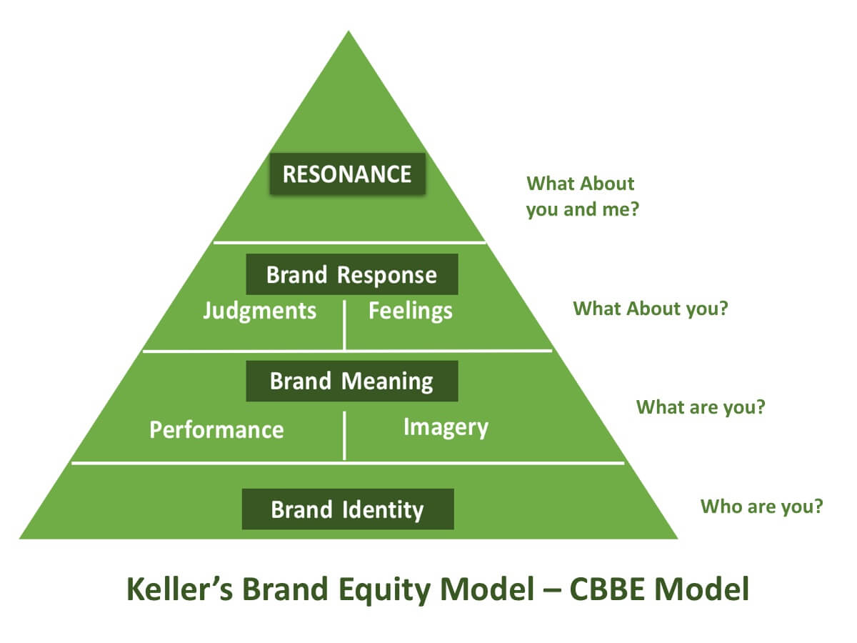
Nike as a core sports brand has more often adopted for different branding tactics and their directions for earning brand equity is aligned towards meeting the customer’s emotional resilience for creating long-term sustainability (Jaakkola, and Alexander, 2018). Following over the five steps of Keller’s Brand Equity Model, Nike’s brand equity in front of the customers can be judged.

Salience –In terms of brand salience or identity, Nike has been on top for making their brand identifiable through their logo and high-end products. In terms of brand identity, the logo and Nike’s punching tagline “Just Do it” creates a brand identity and propagation of their products portfolio as an athlete brand in front of the customers.
Brand meaning- the brand meaning denotes for ability and denotes for brand’s picture is created in front of the customers. Brand meaning is divided into two forms – performance and imagery. Brand performance for Nike denotes its design shoes and lightweight sports products, which mainly target the youths,and enriches their performance level through linking brand to their professional competition (Cataldo, 2020). On the other hand, the serviceability and diversity of their performance base also depicts for their brand performance in front of the customers the brand imagery for Nike is represented through the status which Nike represents as a part of lifestyle. In addition, its sustainability and environmental awareness as a brand creates a brand imagery in front of the competitors.
Brand Response –Brand response determines for the feelings customer have for a brand among other competitors in the market. the brand response are suggested by judgements and feelings of the customers towards the product deciphered by the brand. For Nike customers assume Nike to be a brand of high credibility because of their quality and endurance to customer service. On the other hand, as a part of brand feelings, Nike customers feel secured while buying Nike’s product and thereby providing inspiration to the customers.
Brand Resonance –Brand resonance determines for customer’s love for the brands there is already a steady relationship between customers and business firm. For Nike, brand resonance is determined by their provision to special offer to both offline and online customer base along with the different customization of services provided to the customers.

Customer’s journey and customer touch points for Nike
According to Kornum et al., (2017), customer’s journey from the point of view of marketing concepts define for the path or touch points which a customer passes while reaching on a purchase decision from their favourite brand. The portray of customer journey refers to the different process of interactions which a customer has encountered while becoming aware, investigating, buying and assimilating those thoughts for inspiring other buyers to purchase those products from the brand. For Nike, it can be entailed that the touch points have been a crucial course while identifying customer’s journey while buying their products.
Customer’s Journey and mapping for Nike
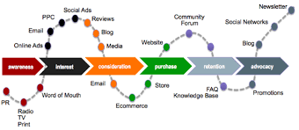
The customer’s journey consists of five stages like awareness, considerations, decision, retention and advocacy. In terms of customer’s journey, awareness by Nike has been quite influential since its inception as a brand as they set forth effective brand awareness campaigns, which act as a customer touch points before purchase. In current scenario, the messaging content, distinct colours, alluring designs, celebrity endorsements act as a first impression forming provision. The second stage of customer journey is considerations and evaluation and in this stage, the customers consider upon initial research and narrow down their buying options through collection of information (Kristal et al., 2016). Nike as a brand in contemporary scenario has incessantly persuaded upon in-store digital experience and their House of Innovation as an experiential store of retailing has been major pre and post purchase touch points for making the customers considers their products and in-store customization facility to be highly apprehensible in front of the customers.

The stage three of the customer journey for buying is decision making and according to this stage, Nike has been fruitful in making their customers think about their personalization and product design and quality appraisals so that it can help them improve the customer’s decision making process through both online and offline platform. In this stage, social media platforms and peer referrals have been the major touch points for Nike. The fourth stage is the retention stage and according to this stage, Nike has been found to be aligning to various digital marketing touch points as their major customer retention process as it increases the brand loyalty of the existing and new customers (Marques, 2018). The fifth stage is the advocacy stage and the customers of Nike are abided by the brand’s comprehensive customization of service and high product quality, which ensures their credibility to be high amidst the sustaining customer bases.

Evaluation through Total Engagement Model
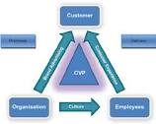
The Total Engagement Model defines for a business being driven by the key strategic elements for engaging the customers. These key elements are customer value proposition, branding, internal culture elements and customer experience. The model represents for the fact that there needs to be clarity and more importantly confrontation to these key elements so that they can retain customer engagement. Nike as a brand has created customer value proposition through accessibility, customization and innovation in their product designing. In terms of branding as a key strategic element, Nike refers to the core principle of connecting with customers on an emotional note and endorses celebrities to their promotional techniques which come out as a useful branding technique for the company (Jaakkola, and Alexander, 2018). The internal organizational culture of Nike contemplates for creativity and innovation so that it can suit to customer’s changing demands and choices while buying sports products. In terms of customer experience, Nike adheres to using omnichannel strategy so that it can provide the customers with personalized service and customize equipments to products distribution, which can uplift their customer experience standards.

Conclusion
Therefore from the following report, it can be analyzed that Nike as a brand can ensure upon rising brand awareness among the customers through applying appropriate marketing communication channels. With the help of various integrated marketing channels, the company can come out as a unique brand in sports goods market. In modern world, Nike promotional tactics need to be far more digitalized and based on engaging customer’s brand identity so that it can ensure their growth and fulfil the expectation of the stakeholders like the customers in international sports goods market.

References
Bradshaw, A. and Scott, L., 2018. Advertising Revolution: The Story of a Song, from Beatles Hit to Nike Slogan. Watkins Media Limited.
Cataldo, J., 2020. Just Post It: A Critical Discourse Analysis on Nike’s Instagram.
Do, H., Ko, E. and Woodside, A.G., 2015. Tiger Woods, Nike, and I are (not) best friends: how brand's sports sponsorship in social-media impacts brand consumer's congruity and relationship quality. International Journal of Advertising, 34(4), pp.658-677.
Finne, Å. and Grönroos, C., 2017. Communication-in-use: customer-integrated marketing communication. European Journal of Marketing.
Fontaine, S.P., 2020. Analyzing the Social Media Presence of Nike, Adidas, and New Balance Using Social Listening.
Hänninen, N. and Karjaluoto, H., 2017. The effect of marketing communication on business relationship loyalty. Marketing Intelligence & Planning.
Jaakkola, E. and Alexander, M., 2018, June. How does engagement affect customer journeys and experience?. In 10th SERVSIG Conference.
Kornum, N., Gyrd-Jones, R., Al Zagir, N. and Brandis, K.A., 2017. Interplay between intended brand identity and identities in a Nike related brand community: Co-existing synergies and tensions in a nested system. Journal of Business Research, 70, pp.432-440.
Kristal, S., Baumgarth, C., Behnke, C. and Henseler, J., 2016. Is co-creation really a booster for brand equity? The role of co-creation in observer-based brand equity (OBBE). Journal of Product & Brand Management.
Kuang, K., Jiang, M., Cui, P., Luo, H. and Yang, S., 2017. Effective promotional strategies selection in social media: A data-driven approach. IEEE Transactions on Big Data, 4(4), pp.487-501.
Marques, S.M.E., 2018. The disruption of retail through Gen Z: An exploratory study on the new customer journey and the impact of customer touchpoints on Brand Loyalty.
Merikanto, S., 2019. Controversal Marketing-A successful strategy to grow a brand or risky approach? Case study: Nike Inc.
Mikołajczyk, A., 2015. Product placement in brand promotion. Współczesna Gospodarka, 6(2), pp.11-19.
Onobrakpor, U.D., 2019. Information Transfer in Libraries and Information Centers: Role of Communication. Information Impact: Journal of Information and Knowledge Management, 10(2), pp.99-108.
Pillay, D.H., 2019. The impact of celebrity endorsements on consumers’ perceptions of the Nike sports brand (Doctoral dissertation).
Putra, P.Y. and Ningrum, S., 2019, February. The Influence of Celebrity Endorser, Brand Image, and Brand Trust on Consumer Purchasing Decisions of Nike Brand Sport Shoes In Surabaya. In Journal of World Conference (JWC) (Vol. 1, No. 1, pp. 208-218).
Soter, M., 2016. Theoretical Modelling of Intercultural Communication Process. Journal of Advocacy, Research and Education, (2), pp.87-92.
Su, J. and Tong, X., 2015. Brand personality and brand equity: evidence from the sportswear industry. Journal of Product & Brand Management.
Sukram, A., 2017. Perspectives on the effects of ambush marketing: the case of Nike, the global ambusher (Doctoral dissertation).
Valos, M.J., Habibi, F.H., Casidy, R., Driesener, C.B. and Maplestone, V.L., 2016. Exploring the integration of social media within integrated marketing communication frameworks. Marketing Intelligence & Planning.
Verzano, N., SAP SE, 2017. Managed device-to-device communication in business computing systems. U.S. Patent 9,781,189.
Wang, N. and Li, B., 2017. A Model of Deceitful Information Communication: Some Views on Theory and Practice of Semantic Information. In Multidisciplinary Digital Publishing Institute Proceedings (Vol. 1, No. 3, p. 127).



