How did the Normans use their physical environments to reinforce their conquests?
The Normans are perhaps best known for their ability to conquer various states across the Christian world. However, without their ability to consolidate their rule there is no way the Normans would have been as successful in their conquests. England has long been discussed as having the most obvious scars of the Norman conquest left, through the their building projects, most clearly castles and cathedrals. However, looking further afield from Normandy it becomes clear that these consolidation techniques were in fact commonplace in Norman states, Southern Italy, Sicily and the Holy Land, specifically Antioch and Edessa, all show signs of this attempt to gain and keep control of their conquests. While castle building is the most obvious way in which the Normans reinforced their conquests, they were also responsible for building cathedrals in order to legitimise themselves as successful Christian rulers and, in certain cases, as a sign of their oppression of the locals. All of these building projects were however, an attempt to not only reinforce and legitimise the conquering Normans’ rule but also to centralise their rule. In order to fully assess the extent to which the Normans used their physical environments it is important to assess all of their conquests in a number of ways, not only what they built but the ways in which they used them. The physical remains of the Normans are not the only sources that give an insight to the Normans’ ability to reinforce their rule. The written sources of both the conquerors and the conquered give the modern historian an insight into the effects of the Normans on society. As such, this essay will discuss the cultural assimilation and oppression that took place as a result of the Norman’s building efforts.
Castles were by far the best way in which the Normans could change the physical landscape to enforce and then reinforce their conquests across their territories. These castles were clearly a way of the Normans legitimising their control in the first instance. The original Norman castles of Normandy were built in the Romanesque style which they would continue throughout their building projects. These castles were developed in Normandy throughout the early years of Norman control, such as Château de Fécamp on the coast. This castle was built in the late 10th Century and would become the home to the Norman dukes, a clear sign that the Normans saw this coastal position as a strategic position from which to control their lands. This control was held through the castle as its walls were built to be defensible not only from potential French invasion but also from the local population, who did not all embrace the Norman invasion as Dudo of St. Quentin suggests. The castles of England follow this pattern in which the Normans built to defend from the local community as much as they did from invasion. For example, Dover Castle, although the current castle was built by Henry II in the late twelfth Century and is therefore not necessarily a Norman castle, given that Henry II was only in part Norman, was originally developed as a castle in the Norman sense, that is a motte and bailey, in 1066 following William the Conqueror’s taking of the area.
However, there is some debate about whether William was directly responsible for the fortress of Dover as a whole, as William of Poitiers states that he ‘spent eight days adding the fortifications that it lacked’ suggesting that Dover already had some form of fortifications, possibly an Iron-Age hillfort, prior to William’s invasion of England given that the word Dover is related to the Celtic Dwr, meaning water. Clearly then the Normans used the fortifications that were already in place in the first instance. On top of this, debate as to the level of which the Normans actually developed their own castles, their building projects also had a negative side in terms of the local population. Rougemont Castle in Exeter is a clear example of this, although built for Norman lords, the castle was in fact built by Anglo-Saxon labourers and as a result boasts a number of Anglo-Saxon features amongst the Romanesque architecture, such as the triangular-headed windows (see appendix one). Furthermore, Chepstow Castle was the first Norman Castle in England and Wales to be built in stone. The main keep, thought to have been used by William I as an audience chamber to receive homage from his Welsh subjects, the castle was clearly a symbol of the power and control William I held. Both of these examples were replicated across England and provide a clear suggestion that the Normans and therefore Normanitas refer to the leadership and not the whole population.
Furthermore, these castles are a clear example of the centralisation of the state which the Normans brought about. Given that the number of castles built by the Normans is believed to be around 1000, it is clear that the majority of these would be within a single day’s ride each other. Not only would this have made the odious task of travelling easier but it also allowed for garrisons to be moved to where they were needed at a moment’s notice in order to put down rebellion as well as allowing a communication link for the Norman lords. On top of this, the Normans are also responsible for moving England’s capital to London; before this point the capital was considered to be Winchester. This meant the rebuilding of the buildings that would house the cogs of government. This started with the Tower of London, which would become the most iconic symbol of the Norman takeover of England, a symbol of the Norman control given its status as the largest building in London at the time. Westminster would become the home to parliament in this period, although the palace is believed to have Anglo-Saxon origins, with King Cnut building a royal palace on the site. During the Norman period however, it would be developed into the centre for government with Westminster Hall being built from 1097 onwards so that by the time the Plantagenets were in power London ‘housed the emerging Inns of Court and, above all, the great departments of State: the Exchequer, or treasury… and the Chancery or great ‘writing office’. Clearly then, the Normans were able to take control of England by moving and redeveloping government whilst keeping its tax systems the same until 1089 and the writing of the Domesday Book.
This method of creating a new centre for government, however, was not a tactic used across the Normans’ ever growing lands. Palermo was already the capital for the Emirate of Sicily before the Norman take over by Roger of Hauteville in 1072. In this case the Normans appeared to be more willing to assimilate their style with the traditional Greek and Islamic styles of building that were already in place. The palace is believed to be built on the site of the Saracen palace which was at the centre of one of the wealthiest cities of the Mediterranean. Roger II took the capital city and its castle and developed it into his own personal seat of government. The Arab geographer al-Idrisi described Roger II’s palace at Palermo as being ‘notable in its architectural decorations’, referring to the mix of styles; Romanesque arches with Greek mosaics in the Cathedral of Palermo are one such example. As such, the castles of Sicily were a way in which the Normans were able to reinforce their conquests through being able to create a feeling of cultural assimilation in a state in which they were firmly in charge.
Castles were not the only building projects the Normans took on in order to control and legitimise their rule. Cathedrals were not only some of the biggest buildings in Europe but also some of the most important to the devout Christian community of Europe. In order to fit into this Christian world, Rollo, first Norman leader had converted to the faith in 912 following his gaining of Normandy from Charles the Simple of France. Given that they were new to the faith it was important for the Normans to legitimise themselves as faithful Christians, which would in turn legitimise their rule, and as such set about building a number of abbeys and cathedrals in Normandy. The most famous example is the Abbey of Mont Saint Michel, a Benedictine monastery founded originally by Richard I of Normandy in 966 and much loved by every following Norman leader. Although, again the site for the abbey appears to have originally held a church founded in 709. The Abbey Church of Saint-Etienne at Caen also became a centre for Norman legitimisation, following its foundation by William the Conqueror in c.1063. As the resting place for a number of Norman leaders including, William I of England and his wife Matilda, the church became a symbol of the Normans’ devout Christianity and thus their status as top Christian leaders. This building of cathedrals as a way to legitimise Norman control was also a key way in which they were able to reinforce their control through attempting to prove their faith and therefore fit into a wider Christian society. On top of this, cathedral building was another way in which the Normans could push for cultural assimilation between themselves and their new communities. Sicily is perhaps the best of example of this cultural assimilation, with the cathedrals boasting some of the best remaining Byzantine mosaics in southern Italy. Cefalù Cathedral shows a number of devotional images of Christ and multiple saints. Appendix two shows a number of saints as part of the mosaic in the apse and shows how the Normans took their religion to a state where not all the community followed the same religion, as is seen in the Greek lettering of the Latin name of each saint. Clearly this was the Normans way of suggesting that they were the legitimate rulers by Christ by creating cathedrals that were designed to show off their devotion through their architectural design. This creation of legitimising imagery was a tool used by the Normans to control their conquests as it would suggest to the population that the Normans were the rightful rulers.
However, cathedrals were not only signs of the good will of the Normans to creating a peaceful, culturally assimilated society. Oppression was a key feature of the building of these cathedrals. The clearest example of local builders from the society that had been taken over, that is Sicilian in Sicily or Anglo-Saxon in England, can be seen in the architectural styles of the locals that made their way into Norman buildings, such as Durham or Winchester in England which are thought to have been built under to guidance of an English master mason. Appendix three, shows the detail of both Durham and Winchester and shows the extent of the Anglo-Saxon influence though the more simplistic style of carving decoration, especially seen in Winchester Cathedral rather than the highly decorated cathedrals that would come later in the Norman period, such as the later Gothic additions to Winchester. Clearly therefore, the architecture of these two cathedrals was influenced by the building style of the Anglo-Saxons and as such shows how the Normans were not able to fully reinforce their conquests by commissioning building work that would support the local community as they only occupied the top few roles in society, that is to say they were the leaders not the whole.
Furthermore, while the cathedrals of Sicily may suggest a harmony of cultures between Normans, Greeks and Muslims but it could also suggest a darker side to the Norman rule of Sicily. Given the Norman tendencies for inserting themselves into the leadership of a state, it seems likely it was the Greek and Muslim communities who were the craftsmen directly responsible for the building of these structures and thus explains the Arabic and Byzantine influenced of the architecture. While this may well suggest that the three different cultures were living comfortably next to each other under Norman rule, it could also suggest that the Normans were actually using building projects as a form of oppression in order to keep control of society. This idea can be further evidenced through the building of Ely Cathedral in Norfolk. The Cathedral was built in 1109 after the rebellion of Hereward the Wake, who had hidden in the original Anglo-Saxon monastery on the site. By building on top of the original Anglo-Saxon site William I was in effect saying that he was the replacement for Anglo-Saxon rule and using construction to turn the Anglo-Saxon pilgrimage site of St. Etheldreda in to a Norman one. As such William I built the cathedral as a symbol of his power and as a reminder of his ability to put down any further rebellion of Anglo-Saxons. Although, to the monastic chroniclers of the time saw William I’s monastic building projects as beneficial to society, as the Anglo-Saxon Chronicle shows through the Peterborough manuscripts praise of this, the changes made to the physical environments by the Normans were in fact another way of them oppressing those whom they had conquered and so reinforcing their control.
Another way in which the Normans used the land to oppress the local population was through the destruction of the landscape which they knew and worked. One clear example of this is the Harrying of the North the occurred in the north of England, particularly around Yorkshire in the winter of 1069-70. The Harrying occurred as a result of a series of low level rebellions in the area by the local Anglo-Saxon population, which William I wanted to not only put down but also to make an example of the rebels so as to deter further rebellion. The Harrying involved the destroying of crops and livestock as well as physical infrastructure to such an extent that Symeon of Durham reported the land was still not fully habitable nine years following the event, as is evidenced by the entries for the area in the Domesday Book. Orderic Vitalis, although writing from Normandy, claims that 10,000 people died as a result of the Harrying; clearly in spite of his Anglo-Norman heritage Vitalis, chose to side with the Anglo-Saxon community in this case. Regardless of the intention of the Harrying of the North, it did not deter Anglo-Saxon rebellion as other rebels appeared throughout the reign of William I. The building of Ely Cathedral also shows how the Normans used their physical environments in order to insure rebellions were put down. Given that, Hereward had the support not only of the Danes in the original rebellion, who soon changed sides, but also a number of a number of the English nobility, including Earl Morcar and Bishop Aethelwine of Durham, it is not surprising that he had managed to keep his rebellion going for almost five years. As these two nobles were of Anglo-Saxon stock, it makes sense that they would support an anti-Norman rebellion, however, they must have supported the Normans in the first place to have defected from William’s side, thus suggesting that Norman behaviour had pushed them out in order to replace them with other Normans. Although early efforts to cross the fenland and get to Ely failed and siege weapons were burnt down by the rebels, Norman trickery did achieve the rebel’s downfall. William I had managed to persuade the monks of Ely to act as guides across the marshes of the fens and into the abbey through a back door. Not only is this an example of the trickery the Normans were famous for across Europe but also of the ability of the Normans to use the environment and exploiting the local population, who knew the land in order to consolidate their rule.
Once he had successfully consolidated his rule, William I then decided to set about changing the physical landscape through the development of a number of new towns in the later Norman period following the Domesday Book. Pembroke in Wales is an example of this development as the township was purpose built originally by Arnulf de Montgomery, a Norman lord in 1093, in order to serve the Marcher castle that the Normans had begun building in the same year. On top of this, Henry I granted the town a Royal Charter of Privileges in 1130 allowing the town tax exceptions in order to encourage people to populate the town, clearly the later Normans were determined to ensure the success of the Welsh Marches through developing a successful community. A number of other towns can be linked to this Norman ideal of creating new towns in order to serve a particular function in society such as the before mentioned development of London into England’s capital. The later Norman leaders were therefore, clearly, determined to make their mark on society and to develop it further into a flourishing society through the development of townships across the country.
The Normans were therefore responsible, in part, for the historical landscape left from the medieval as they exploited what was already in place in order to create their own society that was different from what had come before. Not only did they take what was already in place, such as the developing feudalistic system in England or the cultural assimilation in Sicily, in order to put themselves in place as the leaders, but they also used this as a means to legitimise their rule through the changes they made. The development, and re-building, of English cathedrals shows how determined the Norman nobility were to legitimise their Christian faith by taking the growing English monastic community and inserting themselves as the greatest donors of the time, through their building projects. On top of this the need to prove their right to rule lead the Normans to oppress the local population through the changes made to the physical environment in order to reinforce their rule. Not only were the local population directly responsible for the building of castles, cathedrals and towns but also they were also directly affected by the use of them to enforce Norman rule, for example, through the building of castles to allow garrisons to defend the local area from rebellion. These building projects allowed the consolidation of Norman rule to occur as they allowed for good communication links, through castle building, and through developing society so that it work for them, such as moving the English capital to London. Clearly therefore, the Normans used their physical environment to consolidate their rule as the leaders of a society rather than make the whole society Norman.
Appendices
Appendix one
Rougemont Castle, Exeter. Image available at https://www.travelblog.org/Photos/1904568 [accessed 23/12/2017].
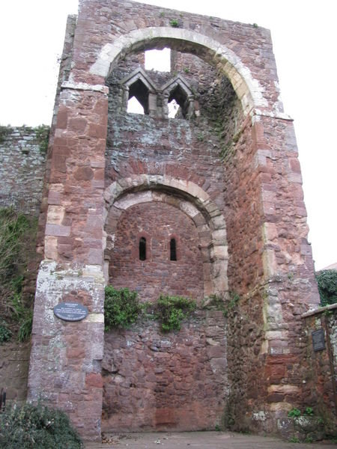

Appendix two
Image of apse mosaic, Cefalù. Image available at https://www.wga.hu/html_m/zgothic/mosaics/3cefalu/4cefalu.html [accessed 23/12/2017].
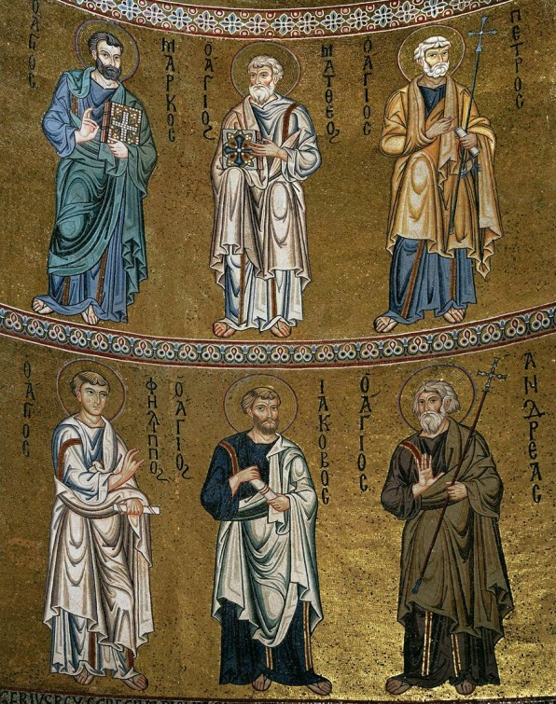

Appendix three
Detail Durham (left) and Winchester (right) Cathedrals. Image available at https://www.durhamworldheritagesite.com/architecture/cathedral/building-durham [accessed 23/12/2017].
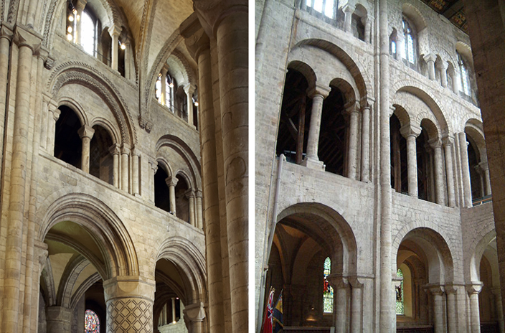

Bibliography
Albu, E., The Normans In Their Histories: Propaganda, Myth and Subversion (Woodbridge: The Boydell Press, 2001).
Allen Brown, R., The Normans and The Norman Conquest (Woodbridge: The Boydell Press, 1985).
Aitcheson, J., The Harrying of the North’, History Today (London: History Today, 2016). Available at http://www.historytoday.com/james-aitcheson/harrying-north [accessed 23/12/2017].
Anderson, N., ‘Medieval Pembroke’, Pembroke Story (Pembroke: Pembroke Story, 2017). Available at http://www.pembrokestory.org.uk/history_pages.php?page=MedievalPembroke [accessed 23/12/2017].
Bracewell, P., ‘Fécamp’, Medieval Histories (Denmark, Medieval Histories, 20170. Available at http://www.medievalhistories.com/fecamp/ [access 23/12/2017].
Cawthorne, E., ‘Castles of the Conqueror’, History Extra (London: History Extra, 2016). Available at http://www.historyextra.com/article/bbc-history-magazine/castles-william-the-conqueror-norman-conquest-1066 [accessed 23/12/2017].
City of London, ‘City Timeline’, City of London (London: City of London 2017). Available at https://www.cityoflondon.gov.uk/things-to-do/visit-the-city/our-history/Pages/timeline.aspx [accessed 23/12/2017].
Davis, P., ‘Exeter Rougemont Castle’, Gatehouse (Yorkshire: Philip Davis, 2016). Available at http://www.gatehouse-gazetteer.info/English%20sites/847.html [accessed 23/12/2107].

Doherty, P., Isabella and the Strange Death of Edward II (London: Robinson, 2004).
Gibson, J., ‘The Building of Durham Cathedral’, Durham World Heritage Site (Durham: Durham World Heritage Site, 2017). Available at https://www.durhamworldheritagesite.com/architecture/cathedral/building-durham [accessed 23/12/2017].

Gibson, J., ‘Winchester Cathedral’, Durham World Heritage Site (Durham: Durham World Heritage Site, 2017). Available at https://www.durhamworldheritagesite.com/architecture/romanesque/display/winchester-cathedral [accessed 23/12/2017].
Golding, B., Conquest and Colonisation: The Normans in Britain, 1066-1100 (New York: St. Martin’s Press, Inc., 1994).
Hanser, D.A., Architecture of France (London: Greenwood Press, 2006).
Haskins, C.H., The Normans in European History (New York: Frederick Ungar Publishing Co., 1959).
Krén E. and D. Marx, ‘Apse mosaic (detail)’, Web Gallery of Art (Budapest: Web Gallery of Art, 2017). Available at https://www.wga.hu/html_m/zgothic/mosaics/3cefalu/4cefalu.html [accessed 23/12/2017].
Martin, J., ‘The Story of Ely Cathedral’, Ely Cathedral (Ely: Ely Cathedral, 2017). Available at http://www.elycathedral.org/history-heritage/the-story-of-ely-cathedral [accessed 23/12/2017].
Mont Saint-Michel Tourist Office, ‘History’, Mont Saint-Michel (France: Mont Saint-Michel Tourist Office, 2010). Available at http://www.ot-montsaintmichel.com/en/histoire.htm [accessed 23/12/2017].
Morris, M., Castle: A History of the Buildings that Shaped Medieval Britain (London: Windmill Books, 2013).
Paliament.uk, ‘Anglo-Saxon Origins’, Parliament.uk (London: Parliament.uk, 2017). Available at http://www.parliament.uk/about/living-heritage/building/palace/estatehistory/the-middle-ages/anglosaxon-royal-palace/ [accessed 23/12/2017].
Paliament.uk, ‘The Palace and the Normans’, Parliament.uk (London: Parliament.uk, 2017). Available at http://www.parliament.uk/about/living-heritage/building/palace/estatehistory/the-middle-ages/palace-normans/ [accessed 23/12/2017].
Pembroke Castle, ‘Castle History’, Pembroke Castle (Pembroke: Pembroke Castle, 2017). Available at http://pembroke-castle.co.uk/pages/detailed-history [accessed 23/12/2017].
Zalapì, A., Palaces of Sicily (Venezia: Arsenale, 2004).

E. Cawthorne, ‘Castles of the Conqueror’, History Extra (London: History Extra, 2016). Available at http://www.historyextra.com/article/bbc-history-magazine/castles-william-the-conqueror-norman-conquest-1066 [accessed 23/12/2017].
B. Golding, Conquest and Colonisation: The Normans in Britain, 1066-1100 (New York: St. Martin’s Press, Inc., 1994) pp.159-161.
Ibid. p.127.
Cawthorne, ‘Castles of the Conqueror’.
Golding, Conquest and Colonisation: The Normans in Britain, 1066-1100, p.35.
P. Bracewell, ‘Fécamp’, Medieval Histories (Denmark, Medieval Histories, 20170. Available at http://www.medievalhistories.com/fecamp/ [access 23/12/2017].
E. Albu, The Normans In Their Histories: Propaganda, Myth and Subversion (Woodbridge: The Boydell Press, 2001) p.8.
M. Morris, Castle: A History of the Buildings that Shaped Medieval Britain (London: Windmill Books, 2013) p.29.
Ibid.
P. Davis, ‘Exeter Rougemont Castle’, Gatehouse (Yorkshire: Philip Davis, 2016). Available at http://www.gatehouse-gazetteer.info/English%20sites/847.html [accessed 23/12/2107].
Morris, Castle p.54.
Ibid.
Ibid, p.45.
Golding, Conquest and Colonisation: The Normans in Britain, 1066-1100, p.132.
City of London, ‘City Timeline’, City of London (London: City of London 2017). Available at https://www.cityoflondon.gov.uk/things-to-do/visit-the-city/our-history/Pages/timeline.aspx [accessed 23/12/2017].
Morris, Castle pp.52–53.
Paliament.uk, ‘Anglo-Saxon Origins’, Parliament.uk (London: Parliament.uk, 2017). Available at http://www.parliament.uk/about/living-heritage/building/palace/estatehistory/the-middle-ages/anglosaxon-royal-palace/ [accessed 23/12/2017].
Paliament.uk, ‘The Palace and the Normans’, Parliament.uk (London: Parliament.uk, 2017). Available at http://www.parliament.uk/about/living-heritage/building/palace/estatehistory/the-middle-ages/palace-normans/ [accessed 23/12/2017]. See also P. Doherty, Isabella and the Strange Death of Edward II (London: Robinson, 2004) p.4.
Albu, The Normans In Their Histories, p.108.
C.H. Haskins, The Normans in European History (New York: Frederick Ungar Publishing Co., 1959) p.241.
A. Zalapì, Palaces of Sicily (Venezia: Arsenale, 2004) p.30.
Ibid.
Albu, The Normans In Their Histories, p.17.
Mont Saint-Michel Tourist Office, ‘History’, Mont Saint-Michel (France: Mont Saint-Michel Tourist Office, 2010). Available at http://www.ot-montsaintmichel.com/en/histoire.htm [accessed 23/12/2017].
Ibid.
Ibid.
D.A. Hanser, Architecture of France (London: Greenwood Press, 2006) p.1.
Haskins, The Normans in European History, p.192.
E. Krén and D. Marx, ‘Apse mosaic (detail)’, Web Gallery of Art (Budapest: Web Gallery of Art, 2017). Available at https://www.wga.hu/html_m/zgothic/mosaics/3cefalu/4cefalu.html [accessed 23/12/2017].
J. Gibson, ‘The Building of Durham Cathedral’, Durham World Heritage Site (Durham: Durham World Heritage Site, 2017). Available at https://www.durhamworldheritagesite.com/architecture/cathedral/building-durham [accessed 23/12/2017].
J. Gibson, ‘Winchester Cathedral’, Durham World Heritage Site (Durham: Durham World Heritage Site, 2017). Available at https://www.durhamworldheritagesite.com/architecture/romanesque/display/winchester-cathedral [accessed 23/12/2017].
Zalapì, Palaces of Sicily, p.30.
J. Martin, ‘The Story of Ely Cathedral’, Ely Cathedral (Ely: Ely Cathedral, 2017). Available at http://www.elycathedral.org/history-heritage/the-story-of-ely-cathedral [accessed 23/12/2017].
Ibid.
Ibid.
Anglo-Saxon Chronicle quoted in, Haskins, The Normans in European History, pp.56-57.
J. Aitcheson, The Harrying of the North’, History Today (London: History Today, 2016). Available at http://www.historytoday.com/james-aitcheson/harrying-north [accessed 23/12/2017].
Ibid.
Ibid.
Ibid.
Golding, Conquest and Colonisation: The Normans in Britain, 1066-1100, p.42.
Ibid.
Ibid, p.43.
Golding, Conquest and Colonisation: The Normans in Britain, 1066-1100, p.42
Pembroke Castle, ‘Castle History’, Pembroke Castle (Pembroke: Pembroke Castle, 2017). Available at http://pembroke-castle.co.uk/pages/detailed-history [accessed 23/12/2017].
N. Anderson, ‘Medieval Pembroke’, Pembroke Story (Pembroke: Pembroke Story, 2017). Available at http://www.pembrokestory.org.uk/history_pages.php?page=MedievalPembroke [accessed 23/12/2017].
R. Allen Brown, The Normans and The Norman Conquest (Woodbridge: The Boydell Press, 1985) p.70.
Haskins, The Normans in European History, p.56.

