
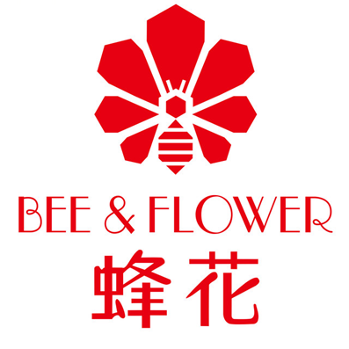
BMMB7012: Marketing Management
Student name: Jiangying Qu
Student ID:2001788

Executive summary
The present report sheds light on the marketing status quo of a Chinese haircare brand Bee & Flower with an overate aim to propose actionable recommendations for Bee & Flower in its future marketing efforts. The whole report includes several interconnected parts, respectively the macro and micro environment audit, the segmentation, targeting and positioning of Bee & Flower, the tailored 7P marketing mix, the primary marketing media suggested for the brand, as well as the measurement of marketing effectiveness.
The macro and micro environmental audit indicate the fact that there are several megatrends in the marketing landscape has not yet been noticed by Bee & Flower, such as the emerging social e-commerce, the popularity of live streaming, etc. At the same time, it revealed some inherent problems of Bee & Flower in its current marketing activities, including the obsolete packaging, bare engagement in marketing, etc.
The input from the environment audit has been used to develop STP. Bee & Flower is suggested to target female customers with low-to-middle income from relatively developed cities with an age range from 18 to 50 who are heavy users of haircare products. Bee & Flower is suggested to position itself as a domestic brand designed for Chinese customers with premium quality and high affordability.
7P marketing mix is used to develop the new marketing scheme for Bee & Flower. Some primary points include the diversification of the current product portfolio, the update of the outer package, the cost-plus pricing strategy, the adoption of online e-commerce as the direct-to-consumer distribution strategy, the and leverage of social e-commerce and live streaming to engage with customers, etc.
The effectiveness of the marketing scheme can be measured through the formulation of a set of specific key performance indicators that benchmark the current marketing performance with previous performance and with the competitors’ performance.
In a summary, the present report provides some implications for Bee & Flower on its future marketing efforts, based on a thorough analysis of the macro and micro environment.

contents
Executive summary
1. Introduction 1
2. Marketing evaluation of Bee & Flower 1
2.1 The marketing concepts 1
2.2 The macro & micro environment 2
2.2.1 The macro environment 2
2.2.2 The micro environment 3
2.3 Target market 4
2.3.1 Segmentation 4
2.3.2 Targeting 4
2.3.3 Positioning 5
2.4 The marketing mix 5
2.5 Marketing media 7
2.6 Measuring success 8
3. Conclusion 8
4. Recommendation 8
References 10

- Introduction
Founded in 1985, Shanghai Bee Flower Daily Products Co., Ltd. (as Bee & Flower) is a hair care company specializing in the production of "Bee & Flower" brand shampoo and conditioner (Bee & Flower, 2022). After decades of operation Bee & Flower is able to realize an annual production capability of haircare products of above 100,000 tons, and report an annual output value of 1.5 billion yuan (Bee & Flower, 2022). In 2014, "Bee & Flower" was recognized by the State Administration for Industry and Commerce as a "Chinese Famous Trademark" (China Economic, 2021). In the era of the planned economy in China (before 1992), Bee & Blossom's products did not need to worry about sales. With the advent of the market economy (after 1992) and the introduction of the open and reform policies, the sales of Bee & Flowers have been under the significant impact of international brands such as Procter & Gamble, Syoss, Schwarzkopf, etc. The inability to adapt to the new competitive environment and perform effective marketing communication has directly resulted in the consecutive loss of Bee & Flowers for almost two decades (Sohu, 2021).
The present report intends to dive into the marketing issues involved in Bee & Flower with an aim to propose some effective recommendations for its future marketing efforts. The whole report will include three interconnected parts, including the marketing evaluation of Bee & Flower, the concluding remark of the marketing analysis, and some recommendations tailored to deal with Bee & Flower’s current issues. In short, the present report suggests Bee & Flower could consider the following interventions: the leverage of a cost-plus strategy in terms of pricing, the exploitation of integrated marketing communication, and the adoption of emerging marketing methods in the Chinese market to shape brand image, etc.
- Marketing evaluation of Bee & Flower
  - The marketing concepts
Defined by Kotler et al. (2013), marketing is “a process by which businesses create values for their targeted customers, as well as develop sustainable customer relationships to capture value from customers in return”. The resource-based view of the firm developed from the strategy and economic literature around the 1950s highlights the importance of organizational resources in competitive advantage (Hooley et al., 2005). The view has significantly impacted the development of marketing theories and practices as emerging studies place attention on resources required to deliver effective marketing efforts. Adapted from the following framework developed by Hooley et al. (2005), the resources required for the marketing effectiveness in Bee & Flowers include the marketing support resources and market-based resources.
In terms of marketing support resources, Bee & flowers have to develop certain managerial capabilities, which mainly include effective human resource management, effective financial management, as well as other functional activities. In terms of marketing-based resources, Bee & Glower needs to have a marketing team who have know-how knowledge in hair care products marketing, and have business acumen in the domestic marketing landscape, have some reputational assets such as the brand name (Bee & Flower), have some market innovation capabilities such as the ability to develop and launch new products, as well as customer linking capabilities that sense the changing preferences and needs of customers. It has to be noticed that the above market-based resources are prerequisite for the marketing effectiveness, but they are enabled by the financial, physical, and human resources of Bee & Flower as these resources are fundamental to performing marketing activities
In recent years, as marketing activities are getting digitalized, the technological resources have received unprecedented attention (Ramaswamy and Ozcan, 2018; Robul, 2020; Cham et al., 2022), and Bee & Flower has not been able to keep pace with the trend in this regard. Also, the market-based resources, especially the customer linking capabilities and market innovation capabilities of Bee & Flower (especially unable to innovate according to the market, unable to interact with customers to develop strong relationships) has been perceived as the underlying rationale for its unsatisfactory marketing effectiveness and financial performance in recent years.
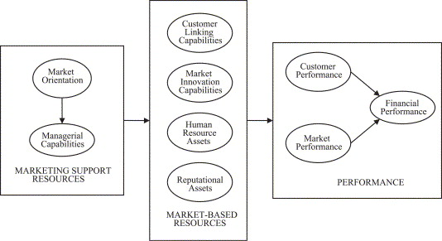
Figure 1: Conceptual model of marketing resources (Hooley et al., 2005)
  - The macro & micro environment

2.2.1 The macro environment
The macro environment analysis is performed through PEST analysis that synthesize the primary influential factors from the macro level. The PEST analysis here will focus on the Chinese market where Bee & Flower operates in.
Table 1: PEST analysis
Macro factors | Implications
Political | - In order to support the domestic business and stimulate domestic consumption, the Chinese government has issued a series of policies (Made in China 2025, Buy Chinese, etc.) (Global Times, 2021; Reuters, 2021). This has benefited the domestic business from the production side and from the consumption side.  - Chinese government has insisted on the ‘dynamic zero’ policies towards covid-19 control (‘find one, end one’) (Reuters, 2022), and this has resulted in several at-scale lockdowns in Shanghai, which in turn negative impacted the production capability of Bee & Flower (two major factories of Bee & Flowers) locates in Shanghai
Economic | - The economic downturn resulted from the covid-19 pandemic has resulted in an evident fact that the disposable income of customers has shrunk (Financial Times, 2022). However, over the long-term, under the new normal of the Chinese economies, it is expected there will be increasing middle class citizens with higher disposable income and consumption desire (CNBC, 2022).
Social | - Given the prevalence and penetration of the mobile devices and internet in China, consumers are showing an evident tendency to shop online (Liu et al., 2021). The prosperity of the e-commerce also resulted in emerging shopping trends, such as e-commerce live streaming, etc.
Technological | - Technological breakthroughs in terms of hair care product manufacturing, such as plant essence generation and integration, production chain automation, etc. has brought more possibilities for Bee & Flower in promoting production efficiency and innovation (Koike, 2019).
The above analysis indicates some necessary attention should be placed towards the key technological trends and social trends, such social media marketing, e-commerce streaming, etc. to reshape its current marketing strategies to better accommodate to the current competitive landscape.

2.2.2 The micro environment
The micro environment analysis is performed through SWOT analysis that focus on the internal environment where Bee & Flower operates.
Table 2: SWOT analysis
Micro factors | Implications
Strengths | - Domestic reputation: as a long-standing domestic brand, Bee & Flower has been well-known in the Chinese market  - High affordability: compared to other domestic brands and international brands, Bee & Flower has a high affordability, as the price is more than 60% lower than the international brands in average (Sohu, 2021)
Weaknesses | - Ignorance of marketing: Bee & Flower has rarely used any marketing methods to promote brand awareness and sales performance (Sohu, 2021).  - Simple product portfolio: there are limited choices under the brand  - Obsolete outer package: the external package of Bee & Flower’s product is obsolete and not preferred by younger consumers (Sohu, 2021).
Opportunities | - Buy Chinese: increasing young consumers shows the tendency to choose domestic brands due to multiple factors, such as premium quality, high affordability, Chinese characteristics, etc. (Global Times, 2021)  - Emerging marketing channels: social media marketing, live e-commerce streaming, etc. (Lin, Li and Wang, 2017; Liu, Yang and Ling, 2020)
Threats | - Fierce competition: direct competition with domestic and international brands
The above analysis some internal resources and competences that can be exploited by Bee & Flower in its future marketing, such as its domestic reputation, high affordability, etc., and also reveal some pitfalls that should be eliminated in the coming marketing efforts, such as the obsolete packaging, etc.

2.3 Target market

2.3.1 Segmentation
Marketing segmentation is the first step of the STP approach, and it involves dividing the mass market into small segments with different needs, characteristics and behaviors that might require the leverage of specific marketing strategies. The mass market of Bee & Flower can be divided as follows.
Table 3. Segmentation of Bee & Flower’s mass market
Criteria | Segmentation
Geographic | Locations: Relatively developed cities in China (tier 1, tier 2 and tier 3 cities), and less developed cities.
Demographics | Age: age under 18, age from 18 to 50, age above 50  Gender: male, female  Income level: low income (under 4000 RMB per month), middle income (4000 – 7500 RMB), high income (above 7500 RMB)
Psychographics | Lifestyle: lifestyle oriented and pay attention to personal care; not lifestyle oriented  Values: price sensitive; less price sensitivity
Behavioral | Purchase pattern: heavy online shopping users; physical shopping users  Purchase occasion: regular occasions; special occasions  Usage rate: light user, medium user and heavy user

2.3.2 Targeting
Compared to other international brands or domestic brands, affordability is one of the most prominent selling unique points of Bee & Flower. Compared to these brands which mostly targeting at middle to higher income consumers who are less sensitive to price and are more willing to pay price premium, Bee & Flower targets the lower to middle end consumers, especially females aging from 18 to 50 (as usually females at this age range pay more attention to hair care), who are more sensitive to price and but are heavy users of hair care products. Preferably, they will live in relatively developed cities in China, and would use different channels to access Bee & Flower’s products.

2.3.3 Positioning
Defined by Kotler et al. (2013), the last step of STP approach – positioning can be perceived as the act of designing the brand’s offering and image so that the brand can occupy a differentiated competitive position in the targeted market. indicated by the above analysis, Bee & Flower will position itself as a well-known and long-standing domestic brand with premium quality and with high price affordability for Chinese consumers.

2.4 The marketing mix
All above analysis feeds into the formulation of the marketing mix, in terms of 7P, of Bee & Flower.
Product: besides basic haircare product offerings, Bee & Flower should diversify its current product portfolio to keep pace with the latest trends. Some options can be considered include hair essence oil, hair bleach and dye products, etc. At the same time, the obsolete package of Bee & Flower should be updated with more trendy and aesthetic design to attract the customers’ attention.
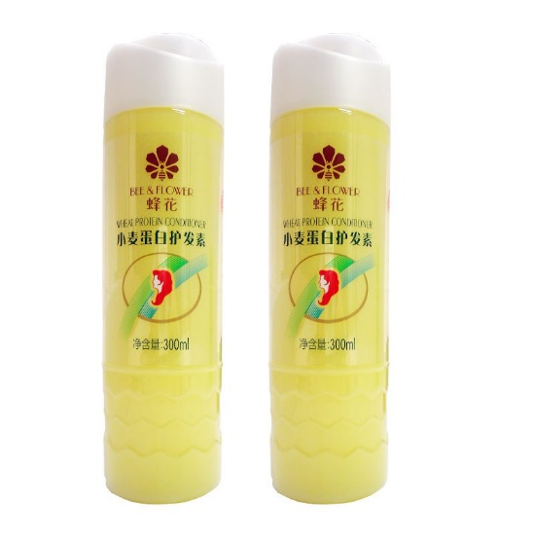
Figure 2: Basic haircare product by Bee & Flower with obsolete design
Pricing: in order to maintain the affordability, Bee & Flower can consider the adoption of the cost-plus pricing strategy which a mark-up is added to the overall costs of production and distribution (Lamb, Hair and McDaniel, 2012). The specific pricing strategy allows Bee & Flower to remain less pricy than other haircare brands, but also to maintain profitable by sustaining a certain profit margin. In the past ten years, Bee & Flower has not increase prices on any of its products (Sohu, 2021). However, due to the increase of direct and indirect costs, some mark-up on prices can be introduced to increase the profit margin while remain affordability.
Place: the omni-channel distribution should be adopted by Bee & Flower in distribution. This is to say, rather than focus on the collaboration with retailers to distribute products in physical stores, some emerging distribution places should be leveraged, such as the collaboration with leading e-commerce platforms in China (Tmall, JD, etc.), the development of official e-commerce platform by Bee & Flower, etc.
Promotion: the power of diversified marketing should be aware by Bee & Flower. Rather than solely relying on the word of mouth for marketing, Bee & Flower should consider the use of some cost-efficient marketing channels to promote brand awareness and increase direct-to-consumer sales. For instance, the e-commerce live streaming has been leveraged by Bee & Flower recently as a novel channel for promotion and distribution during the lockdown of Shanghai due to covid-19 (China Economic, 2021). Co-branding with other domestic brands can also be considered to result in at-scale network effects among Chinese consumers (Helmig, Huber and Leeflang, 2008). Collaboration with key opinion leaders with online influence can also be highly useful to stimulate purchase of followers (Lim et al., 2017).
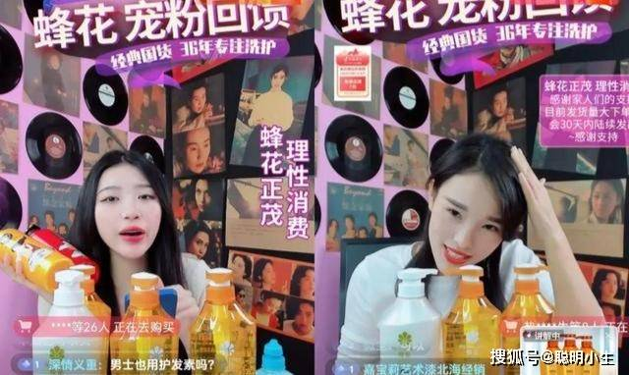
Figure 3: live streaming e-commerce of Bee & Flower (QQ News, 2021)
People: since direct-to-consumer sales is suggested to be prioritized by Bee & Flower in the future, more investment in trained human capital in online services is recommended too. Bee & Flower should, thereby, provide training and development schemes for employees who are in charge of different online service, such as order taking, after-sale services, etc. Preferably, they should be trained with in-depth understanding about the brand and products under the brand, and they should be developed with technical skills and interpersonal skills to serve customers with an orientation to optimize customer experience in every touch point (Lemon and Verhoef, 2016; Gao, Melero and Sese, 2020).
Process: with two big factories of Bee & Flower locating in Shanghai, Bee & Flower should use Shanghai as a centre hub to develop a robust distribution process. Besides the sound logistic chain, Bee & Flower should also be more engaged in the online direct-to-customer journey from making an enquiry online to make a purchase, this can be facilitated through the development and enhancement of Bee & Flower’s digital presence and capabilities.
Physical evidence: physical evidence, usually in the form of the online reviews, website layout, etc. provides a tangible cue to customers regarding the brand (Yelkur, 2000). The website design of Bee & Flower has been criticized for its obsoleteness and user unfriendliness. The update of the online website of Bee & Flower, as well as brand pages when collaborating with other third-party e-commerce platforms should be initiated to delivery a more trendy and aesthetic impression on potential users.

2.5 Marketing media
With the advancement of technology and digital media, social media has attracted massive users, many of whom have integrated the site into their daily lives and business practices, changing the way consumers and brands communicate with each other in a one-sided manner (Evans, Bratton and McKee, 2021). It is less capital intensive, more informative and faster than traditional marketing methods (Alves, Fernandes and Raposo, 2016). This can drive Bee & Flower to use this new marketplace to connect with consumers and find potential customers. Furthermore, the impact of social media on the market environment, although it has a great impact on the marketing activities of enterprises, but at the same time, its promotion effect should not be ignored. In the network environment, Bee & Flower have a channel to talk directly with the masses, and with the support of big data technology, Bee & Flower can grasp the mainstream psychology of the audience through different dimensions, so that it cannot only develop products more accurately, but also continuously improve the quality of its products and services according to consumers' opinions (Evans, Bratton and McKee, 2021). Therefore, in this process, not only to close the distance between the brand and consumers, but also to enable their direct participation in corporate marketing activities, not only to enhance the user's brand loyalty, but also to shape their own outstanding brand culture (Barker et al., 2012). Especially, it has been a quite evident trend that social media is combined with e-commerce to form a new platform known as social commerce (such as RED, WeChat, Tmall, etc.) that enable customers to engage in the social networking and direct purchase, and the emerging opportunity should be seized by Bee & Flower in its future marketing.
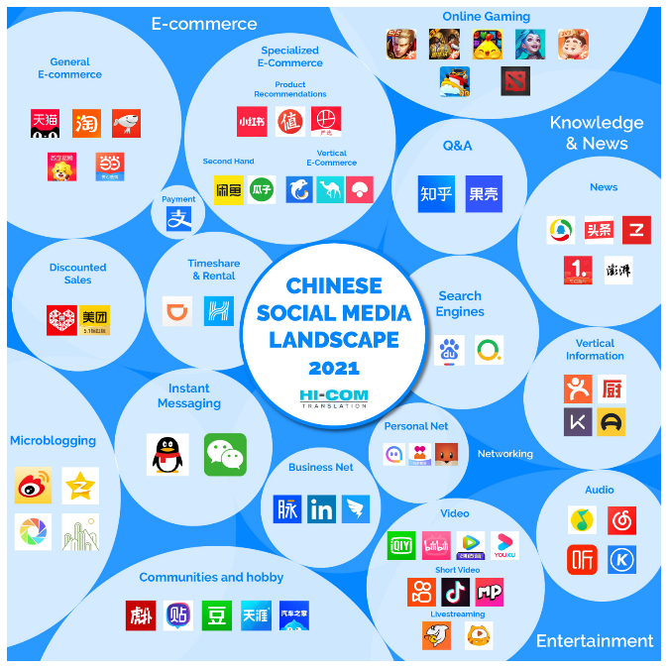
Figure 4. Chinese social media landscape in 2021 (HI-COM, 2022)

2.6 Measuring success
Based on the SMART principles (specific, measurable, actionable, relevant, and time-bound), the marketing objective set for Bee & Flower is to promote overall sales revenue by 20% in the next fiscal year (from January 1st 2023 till 31st December 2023). The overall objective here will be decomposed through work breakdown structure with detailed deliverables for the marketing team (Pride et al., 2006). Besides, a system of key performance indicators, such as the annual sales, monthly sales, regional sales, physical sales, online sales, profit margin, return on investment, etc. will be used to continuously evaluate, monitor and benchmark the marketing effectiveness. These key performance indicators are formulated based on the previous performance, the current marketing expectation, the industrial level, etc. Periodical communication should be arranged with across departments to discuss any deviations from the predetermined marketing plans, and think up the actionable remedies for Bee & Flower to stick up with the marketing plan (Jaworski, 1988; Armstrong, 2009; Mullakhmetov et al., 2016).
- Conclusion
Based on the macro and micro environment audit, the present report uses some interconnected marketing approaches to deliver a more effective marketing scheme for Bee & Flower, a domestic haircare brand in China. Using the STP approach, it is identified that Bee & Flower should target low-to-middle income female group in China with an age range of 18-50 who are heavy users of haircare products, and Bee & Flower should position itself as a well-known and long-standing domestic haircare brand with premium quality and high affordability Based on the insights gained from environment audit, a new 7P marketing mix is developed for Bee & Flower. Some points highlighted in the new marketing mix include the diversified product portfolio and more aesthetic and innovative packaging design in terms of product dimension, the cost-plus strategy to maintain affordability and profitability in terms of pricing dimension, the use of emerging marketing communication channels in the promotion dimension, the use of direct-to-customer channel in terms of place dimension, etc.
- Recommendation
Based on the above analysis, there are some corresponding recommendations proposed for Bee & Flower in its future marketing efforts. SOSTAC analysis has been covered in the above section, hereafter the section only highlights the most important recommendations.
- Enhance the proactivity in marketing activities: marketing has been all the time ignored by Bee & Flower as it perceives the word of mouth from previous users the most effective marketing approach. However, given the fierce competition in the marketing, Bee & Flower should actively and proactively embrace the emerging marketing and communication channels in the domestic market to promote the awareness of its brand, to cultivate strong relationship with its customers, and to promote profitability over the term. Some prominent marketing portals, such as live e-commerce streaming, social e-commerce, is cost-efficient and effective in terms of direct-to-customer interaction, and thereby should be adopted by Bee & Flower.
- Reshape the organizational structure: sole efforts and investment in marketing activities will not be effective over the long term without the support of other functional activities. This is indicated by the above marketing resource model (as shown in Figure 1). Therefore, the change in the marketing scheme should be complemented and supported by other changes within Bee & Flower, such as the digitalization of the organization to support online distribution and marketing, the technological advancements enabled by research and development to diversify the product portfolio and keep pace with the latest market trends, etc.

References
Alves, H., Fernandes, C. and Raposo, M. (2016) ‘Social media marketing: a literature review and implications’, Psychology & Marketing, 33(12), pp. 1029–1038.
Armstrong, G. (2009) Marketing: an introduction. Pearson Education.
Barker, M. et al. (2012) Social media marketing: A strategic approach. Cengage Learning.
Bee & Flower (2022) About us . Available at: http://www.beeflower-cn.com/blank0511.html (Accessed: 24 June 2022).
Cham, T.-H. et al. (2022) ‘Digitalization and its impact on contemporary marketing strategies and practices’, Journal of Marketing Analytics, 3(1), pp. 1–3.
China Economic (2021) Is Bee & Flower another Erke ？. Available at: http://www.ce.cn/cysc/newmain/yc/jsxw/202111/22/t20211122_37103196.shtml (Accessed: 24 June 2022).
CNBC (2022) Chinese official on China’s economy amid Covid pandemic. Available at: https://www.cnbc.com/2022/05/12/chinese-official-on-chinas-economy-amid-covid-pandemic.html (Accessed: 24 June 2022).
Evans, D., Bratton, S. and McKee, J. (2021) Social media marketing. AG Printing & Publishing.
Financial Times (2022) How are coronavirus lockdowns affecting China’s economic output? . Available at: https://www.ft.com/content/9e0c8fec-26b4-4b46-8493-fe165fa01a51 (Accessed: 24 June 2022).
Gao, L., Melero, I. and Sese, F. J. (2020) ‘Multichannel integration along the customer journey: a systematic review and research agenda’, The Service Industries Journal, 40(15–16), pp. 1087–1118.
Global Times (2021) Chinese prefer buying local brands due to improving quality: survey . Available at: https://www.globaltimes.cn/page/202103/1218329.shtml (Accessed: 24 June 2022).
Helmig, B., Huber, J.-A. and Leeflang, P. S. H. (2008) ‘Co-branding: The state of the art’, Schmalenbach Business Review, 60(4), pp. 359–377.
HI-COM (2022) A Guide to the Top 24 Chinese Social Media Apps, Platforms and Websites 2021 - HI-COM. Available at: https://www.hicom-asia.com/chinese-kol-top-10-social-media-platforms-they-use/ (Accessed: 24 June 2022).
Hooley, G. J. et al. (2005) ‘The performance impact of marketing resources’, Journal of business research, 58(1), pp. 18–27.
Jaworski, B. J. (1988) ‘Toward a theory of marketing control: environmental context, control types, and consequences’, Journal of marketing, 52(3), pp. 23–39.
Koike, K. (2019) ‘Special Issue “Recent Advances in Hair Science and Hair Care Technologies”’, Cosmetics, 6(4), p. 61.
Kotler, P. et al. (2013) ‘Principles of Marketing. 6th European edition’, Essex: Pearson Education Limited.
Lamb, C. W., Hair, J. F. and McDaniel, C. (2012) Marketing. Cengage Learning.
Lemon, K. N. and Verhoef, P. C. (2016) ‘Understanding customer experience throughout the customer journey’, Journal of marketing, 80(6), pp. 69–96.
Lim, X. J. et al. (2017) ‘The impact of social media influencers on purchase intention and the mediation effect of customer attitude’, Asian Journal of Business Research, 7(2), pp. 19–36.
Lin, X., Li, Y. and Wang, X. (2017) ‘Social commerce research: Definition, research themes and the trends’, International Journal of Information Management, 37(3), pp. 190–201.
Liu, M. et al. (2021) ‘The adoption and impact of E-commerce in rural China: Application of an endogenous switching regression model’, Journal of Rural Studies, 83, pp. 106–116.
Liu, Z., Yang, J. and Ling, L. (2020) ‘Exploring the influence of live streaming in mobile commerce on adoption intention from a social presence perspective’, International Journal of Mobile Human Computer Interaction (IJMHCI), 12(2), pp. 53–71.
Mullakhmetov, K. S. et al. (2016) ‘Control in marketing-based management’, Academy of Marketing Studies Journal, 20(2), pp. 13–19.
Pride, W. M. et al. (2006) Marketing: Core concepts and applications. John Wiley & Sons.
QQ News (2021) After implusive consumption . Available at: https://new.qq.com/omn/20211130/20211130A0ATD800.html (Accessed: 24 June 2022).
Ramaswamy, V. and Ozcan, K. (2018) ‘Offerings as digitalized interactive platforms: A conceptual framework and implications’, Journal of Marketing, 82(4), pp. 19–31.
Reuters (2021) Analysis: Chinese flock to home-grown brands in golden opportunity for investors . Available at: https://www.reuters.com/business/finance/chinese-flock-home-grown-brands-golden-opportunity-investors-2021-06-27/ (Accessed: 24 June 2022).
Reuters (2022) China’s ‘dynamic’ zero-COVID strategy will boost economy - watchdog . Available at: https://www.reuters.com/world/china/chinas-dynamic-zero-covid-strategy-will-boost-economy-watchdog-2022-02-18/ (Accessed: 24 June 2022).
Robul, Y. (2020) ‘Structure and constituents of digital marketing systems’, Olsztyn Economic Journal, 15(1), pp. 53–62.
Sohu (2021) Why Bee & Flower remains unknown among young generation? Available at: https://www.sohu.com/a/505161185_115386 (Accessed: 24 June 2022).
Yelkur, R. (2000) ‘Customer satisfaction and the services marketing mix’, Journal of professional services marketing, 21(1), pp. 105–115.

