Jasmine Thomas – 1902630
BMSP4003
Learning and Collaboration for Global Citizenship
Contribution to Advancing Sustainability
Dr Alex Bell

History
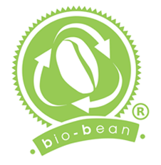
“We are the world’s largest recycler of coffee grounds.”
(Bio-Bean, 2019)
Bio-Bean has claimed themselves the world’s largest recycler of coffee grounds, as they’ve recycled used coffee grounds into sustainable products to sell all over the world. Arthur Kay the founder of Bio-Bean was a student when he found research to support his theory on how the waste from coffee grounds can be re-used as a fuel source. The company was then founded in 2013, where they began to collect coffee waste across the UK and took them to their newly built coffee recycling factory. In 2014 Bio-Bean released their first consumer retail product, coffee logs, Bio-Bean had also used the coffee grounds to then recycle into biomass pellets. By 2019 Bio-Bean has built three factories located in London, Enfield, and Huntingdon. (Bio-Bean,2019)
“Bio-bean is about creating change: at scale, with longevity and with real impact. Bold and ambitious, we are full-hearted, creating a real difference for our world by sustainably innovating through coffee waste.”
(Bio-Bean, 2019)
The Contribution Bio-Bean has made to advancing sustainability
Bio-Bean has already done a great many to be sustainable by themselves, the UK itself drinks 95 million cups of coffee every day, this meaning there are hundreds of thousand tonnes of coffee grounds waste each year. Bio-Bean is the first-ever company in the world to recycle coffee grounds waste to then convert into sustainable biofuels and biochemicals. It's known that coffee grounds go to landfill where they emit methane which is 28 times more potent than carbon dioxide. But Bio-Bean has figured out that coffee grounds are highly calorific and contains valuable compounds which ideally makes a feedstock, that produces advanced biofuels. (Edie.Net,2019)
“We work within the existing waste infrastructure to collect used coffee grounds from coffee shops, offices, transport hubs and coffee factories, recycling them into sustainable and high-performance products and saving 80% on CO2e emissions than if the grounds were sent to landfill.”
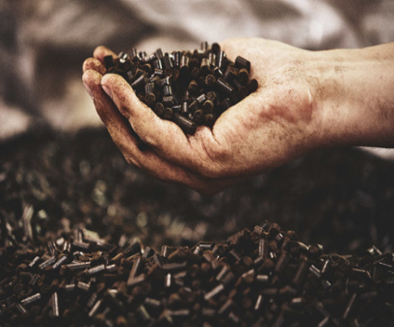
(Edie.Net,2019)
Shell a British-Dutch oil and gas company has collaborated with Bio-Bean to help turn coffee waste, coffee shops and offices into sustainable transport fuel. As stated, before Bio-Bean has recycled coffee grounds into biomass pellets which will be used as an alternative to carbon-heavy fuels, virgin timber, or imported pellets. Biomass pellets are a substantial idea Bio-Bean has come up with, because of our dependence on fossil fuels we are the cause of climate change. From burning, fossil fuels emit greenhouse gases such as carbon dioxide, carbon monoxide, methane, and Nitrous oxide it has caused air pollution. Carbon fuels release unburnt carbon particles into the environment which causes respiratory diseases, for example, asthma. This proves that carbon fuels do not only harm the environment, but also humanity. (Daily Sun,2019)
“With Shell’s support, bio-bean turned waste coffee grounds into an effective biofuel”
(Shell,2019)

It is estimated by The Intergovernmental Panel on Climate Change that annual greenhouses gases emission will double in the next 50 to 100 years. Carbon Dioxide, Methane, Nitrous Oxide, Halocarbons, Ozone, are gasses that don't disappear quickly. Carbon Dioxide alone is responsible for 60% of Greenhouse gases over the last 100 years. 70 to 90% of Carbon Dioxide emissions are from the combustion of fossil fuels, and 10 to 30% are from deforestation. Fossil fuels are the main reason for Greenhouse gasses emissions, fortunately, Bio-Bean is trying their best to tackle fossil fuels and help make other resources that won't harm the Earth. (Mohammed Quasserras,2016)
Bio-Bean has successfully already made 10 million kilogrammes of biomass pellets every year, which is enough to fuel 15,000 British homes. Bio-Bean is already planning on researching versatile biodiesel production, which will be used for transport uses. (Shell,2019).
“Our coffee pellets exploit the high calorific value of coffee, boasting a net calorific value ≥15% higher than standard timber pellets. They feature consistently low moisture content, high bulk density, a high ash melting point and good durability making them a high-performing alternative”
(Bio-Bean,2019)
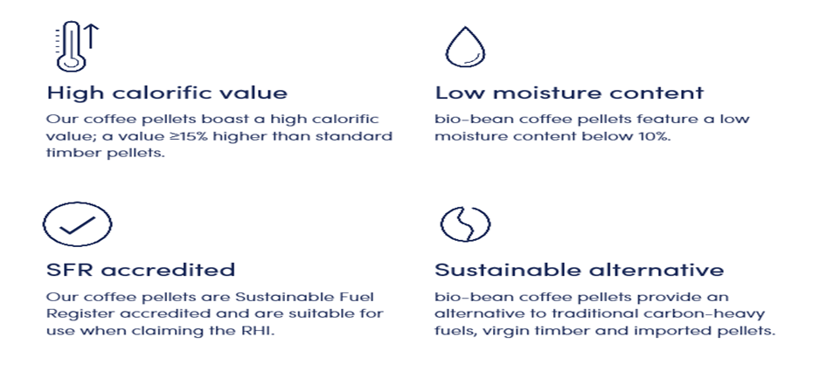

Bio-Beans coffee pellets efficient burn profile saves businesses money from requiring a reduced volume which then acquires fewer deliveries to have the same energy output as wood pellets.
Arthur Kay the CEO of Bio-Bean has done a significant amount of work to be sustainable, and it shows through him as he sits on a great many of boards that are associated with social enterprise green entrepreneurship, and the RSA.

“Arthur Kay has been appointed as a 'London Leader' by Mayor Boris Johnson, as an 'Emerging Innovator' by the Ellen MacArthur Foundation, and has been named as both "the UK's most Innovative Young Entrepreneur" by the Chairman of Shell UK and one of the "1,000 most influential Londoners by the Evening Standard".”
(Florian Singhoff journalist for Wired, 2014)

A significant amount of institutions has funded Bio-Bean for example, Shell, GLA, Berkeley Group, TSB, Santander, RBS, UKTI, and UCL. (Arthur Kay, 2014) This does not only prove how much companies believe in Bio-Bean’s step to sustainability, but it also proves that the previous companies are also trying to take a step to be more sustainable. Bio-Bean has expanded their team to 15 members including George May, Peter Griffiths, Barbara Walshe, Dianne Mitchell, Ben Millis-Lamptey, Callum Cottrell- Duffield, Matt Keniston, Ed de Moraville, John Casey, Jessica Folkerts, Jo Doyle, Nick Southam, Anna Kaminska, Shaun Kisby, and Kieth Riley. (Bio-Bean,2019) From all the hard work of the 15 team members, Bio-Bean has some pioneering technology which has been able to form partnerships with some of the largest coffee companies in the UK. (Arthur Kay,2014) By gaining partnerships with other coffee companies it's inspiring those companies to be more sustainable and innovative with their methods of wasting materials.
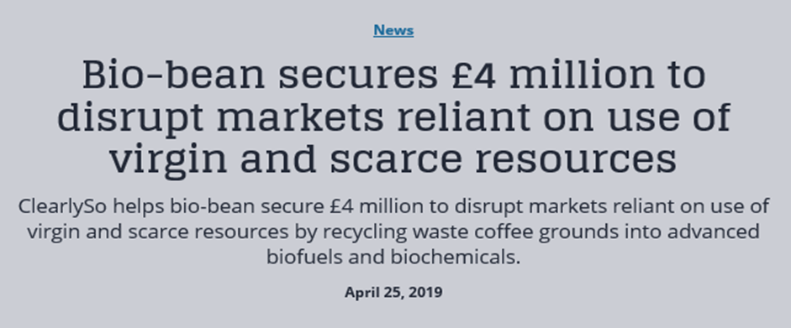
Bio-Bean has earlier this year secured £4 million with the help of ClearlySo, the leading impact investment bank in Europe. To disrupt the use of virgin and scarce resources which markets are reliant on using. Bio-Bean has always believed that there is no such thing as waste, only resources in the wrong place. By following that statement Bio-Bean is offering a coffee waste recycling service to businesses who produce a large number of spent coffee grounds, such as Cafes, Office buildings and transport hubs. Bio-bean will take the spent coffee grounds to their factory where they will transform the waste into a range of valuable bio-based products.
“This true circular economy business model has the potential to disrupt markets that are dependent on intensive use of virgin and scarce resources.”
(ClearlySo,2019)
This is another contribution Bio-Bean has made to advancing sustainability. The company is truly giving 100% effort on not only contributing themselves to help save the planet from climate change but also persuade other businesses to take the same footsteps as them.
Looking back at all that Bio-Bean has done I’m unable to see any evidence saying Bio-Bean hasn’t been contributing to advancing sustainability. With the earth today facing large threats from climate change and global warming, there are not enough companies trying to be sustainable or innovative. Bio-Bean has done years of research before being able to open a factory to start their work for the business. Coffee grounds waste from businesses and our homes all go to landfills where they emit methane, which is more potent than Carbon dioxide which says a great many when Carbon dioxide is responsible for 60% of greenhouse gases and global warming. Most of the carbon dioxides emissions are from the combustion of fossil fuels. We rely on fossil fuels to heat our homes, it's cheap for the economy, and because oil, natural gas, and coal are relied on as they are abundant and available. Bio-Bean is trying to tackle this crisis by recycling coffee ground waste to then converting them into sustainable biofuels and biochemicals.
Bio Bean has had a lot of support from other companies and boards. Shell has collaborated with Bio-Bean to make a sustainable transport fuel. Institutions such as GLA, Berkeley Group, TSB, Santander, RBS, UKTI, and UCL has shown support to Bio-Bean by funding them to help do research and have the right equipment to expand the company. Some of the largest coffee companies in the UK has even formed a partnership with Bio-Bean. This shows how many companies want to help to contribute to advancing sustainability by helping and supporting Bio-Bean.
Bio-Bean hasn’t even stopped there, in recent news this year Bio-Bean had secured £4 million with the help of ClearSo, a Europe impact investment bank. Bio-Bean's plan with the £4 million is to offer a coffee waste recycling service to businesses that produce a large number of coffee grounds. Bio-Bean is even offering to collect the waste of the coffee grounds and transporting them to their factories, where they will be transformed into a range of valuable Bio-Based products.
Bio-Bean has done a massive contribution to advancing sustainability, they are not only doing their best to help improve global warming, but they are inspiring other businesses to do so.

Reference List:
https://www.bio-bean.com/contact/
https://www.bio-bean.com/about/
https://www.shell.co.uk/make-the-future/cleaner-mobility/bio-bean.html
https://www.daily-sun.com/arcprint/details/443027/Effects-of-fossil-fuel-on-life-/2019-12-01
https://www.wired.co.uk/article/bio-bean
https://www.edie.net/67957/d/bio-bean-Ltd
https://www.clearlyso.com/insight/news-reports-and-think-pieces/bio-bean-secures-4-million-to-disrupt-markets-reliant-on-use-of-virgin-and-scarce-resources/
https://greentumble.com/the-impact-of-fossil-fuels-on-climate-change/
https://www.clearlyso.com
https://www.theperspective.com/debates/living/depend-fossil-fuels-renewable-energy/

