The use of technology in the modern healthcare workplace

Topic Name: Hospital
Module Name: Digital Skills and Research Methods
Module Code: (LCHS4002_LON)
Student Name: Anilda Aful
Student ID: 22250171
Lecture´s Name: Koushik Modak
University Name: London Campus
Submission deadline: 03/05/2023

Table of Contents
Introduction 3
How to find a research topic from an initial investigation. 4
The use of technology in the modern healthcare workplace 5
Qualitative, Quantitative and mixed methodologies 6
How to find a credible source for your research 7
Be Skeptical 7
Evaluate what sources are cited by the author 7
Check the endorsements and reviews that the source received 7
Check if the publisher of the source is reputable 7
Beware of bias 8
Credible Sources 9
Conclusion 12
Reference 13

Introduction
I will be writing a report about the use of technology in the modern healthcare workplace more specifically in Hospitals.
I chose this topic because is an interesting and very important topic to talk about as it is in the world's interest, assuming that every human being will need a hospital in some point in their life.
In a hospital, technology is used mainly to help doctor to save lives.
There are many technologies that are very important for us and I will be writing about some of them that are relevant for me.

How to find a research topic from an initial investigation.
Choosing an interesting research topic is your first challenge. Here are some tips:
Choose a topic that you are interested in and narrow your topic to something manageable.
Background reading can help you choose and limit the scope of your topic.
Review the guidelines on topic selection outlined in your assignment. Ask your professor or TA for suggestions.
Refer to lecture notes and required texts to refresh your knowledge of the course and assignment.
Talk about research ideas with a friend. S/he may be able to help focus your topic by discussing issues that didn't occur to you at first.
Think of the who, what, when, where and why questions:
WHY did you choose the topic? What interests you about it? Do you have an opinion about the issues involved?
WHO are the information providers on this topic? Who might publish information about it? Who is affected by the topic? Do you know of organizations or institutions affiliated with the topic?
WHAT are the major questions for this topic? Is there a debate about the topic? Are there a range of issues and viewpoints to consider?
WHERE is your topic important: at the local, national or international level? Are there specific places affected by the topic?
WHEN is/was your topic important? Is it a current event or an historical issue? Do you want to compare your topic by time periods?

The use of technology in the modern healthcare workplace
This is report about the use od technology in the modern healthcare workplace more specifically in Hospitals.
As I mentioned before I chose this topic because is an interesting and very important topic to talk about as it is in the world's interest, assuming that every human being will need a hospital in some point in their life.
In a hospital technology is used mainly to help doctor to save lives.
For example, connected inhalers are a smart technology in healthcare that saves lives by helping patients track usage and by reminding them when to take a dosage to maintain a healthy schedule. 66% of asthma deaths could have been prevented with smart technology monitoring like connected inhalers.
One of the most fascinate technology in hospital in my opinion is Xray.
X-rays are a form of electromagnetic radiation, similar to visible light. Unlike light, however, x-rays have higher energy and can pass through most objects, including the body. Medical x-rays are used to generate images of tissues and structures inside the body.
There are still several researches that need to be completed and others to be done on incurable diseases such as cancer or AIDS. One of my biggest dreams is that they manage to find a cure for these diseases that are very harmful to human beings.
This is one of the reasons I chose this topic.

Qualitative, Quantitative and mixed methodologies
Quantitative research is expressed in numbers and graphs. It is used to test or confirm theories and assumptions. This type of research can be used to establish generalizable facts about a topic.
Common quantitative methods include experiments, observations recorded as numbers, and surveys with closed-ended questions.

Qualitative research is expressed in words. It is used to understand concepts, thoughts or experiences. This type of research enables you to gather in-depth insights on topics that are not well understood.
Common qualitative methods include interviews with open-ended questions, observations described in words, and literature reviews that explore concepts and theories.

A mixed methods study combines quantitative and qualitative data collection and analysis in one study. Individually, these approaches can answer different questions, so combining them can provide you with more in-depth findings. In general, quantitative data is better at answering questions like ‘What is the effect of your digital product?’ and qualitative data can show how and why you got these results.

Because as the report is about the use of technologies in hospitals and as this research method is more about experiments and testing hypotheses to obtain a final product about something unproven and also because technology in hospitals is based on scientific experiences as for example the medicines that we use when we are sick, so I conclude that the quantitative method is the best option for my report.

How to find a credible source for your research
A source is credible when it is trustworthy. Sometimes it is hard to determine whether credible sources are trustworthy or not, as voicing an opinion or presenting false information as fact without any credentials or proof is easy for anyone, especially online.
Sources can often appear credible even when there is little evidence to support them - just think of the many pseudoscience-based articles that go viral on social media sites. Here are a few points to consider when evaluating sources for credibility:

Be Skeptical
Just because something is presented as a fact, it doesn't mean that it is. Question everything, books, articles, and websites can all be unreliable sources.

Evaluate what sources are cited by the author
Unless the author is analysing their own data, their information came from somewhere. Beware if the author doesn't list academic sources. Always review the type of sources listed and make sure they stand up to scrutiny.

Check the endorsements and reviews that the source received
You can read reviews of books printed or on the websites of online book retailers. You can find reviews of larger reputable websites. Some smaller sources, like journal articles, might not have reviews readily available, but you can check if the authors are authoritative sources in their field.

Check if the publisher of the source is reputable
Large publishers or reputable magazines and journals will thoroughly check the facts of the information they are distributing, which makes these sources pretty safe. This is especially true if the source in question comes from peer-reviewed journals or other scholarly databases.

Beware of bias
Always evaluate if the source presents clear and unbiased information, or if it aims at persuading, you to take on a specific point of view. A source written from a specific point of view may still be credible, but it can limit the coverage of a topic to a particular side of a debate. It's always better to make use of sources that show both sides of the story.
By following all these steps, I was able to find, through a lot of research on the internet, a credible and relevant source for my research.

Credible Sources
Matuszac about Cancer
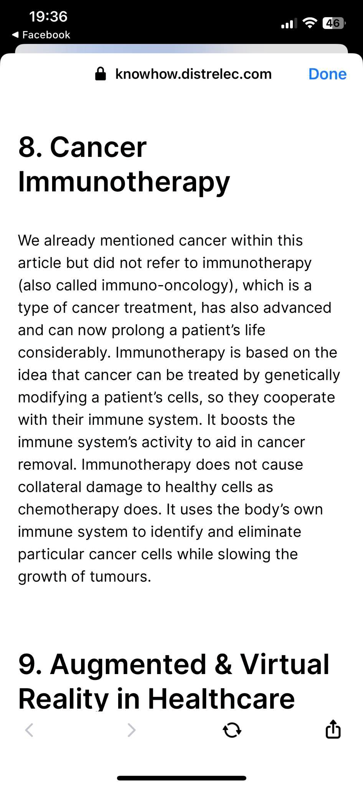

(Matuszak, 2022)
NIH about X-RAY
“What are medical x-rays?
X-rays are a form of electromagnetic radiation, similar to visible light. Unlike light, however, x-rays have higher energy and can pass through most objects, including the body. Medical x-rays are used to generate images of tissues and structures inside the body. If x-rays traveling through the body also pass through an x-ray detector on the other side of the patient, an image will be formed that represents the “shadows” formed by the objects inside of the body.
One type of x-ray detector is photographic film, but there are many other types of detectors that are used to produce digital images. The x-ray images that result from this process are called radiographs. When used appropriately, the diagnostic benefits of x-ray scans significantly outweigh the risks. X-ray scans can diagnose possibly life-threatening conditions such as blocked blood vessels, bone cancer, and infections. However, x-rays produce ionizing radiation a form of radiation that has the potential to harm living tissue. This is a risk that increases with the number of exposures added up over the life of an individual. However, the risk of developing cancer from radiation exposure is generally small” (National Institute of Biomedical Imaging and Bioengineering, 2022).

Medwiser about HIV
“Technology to fight AIDS
Technology exists today that can defeat HIV/AIDS without a vaccine. In order to accomplish this, we must efficiently scale up a combination of prevention, testing, and treatment. Using effective treatment can help individuals to live normal lives. We now know that it can also prevent transmission. Prevention by treatment can reduce the chances of infection by greater than 95%. The greatest challenge to this strategy is implementation.

HATS – the HIV AIDS Test Screening Software improves infrastructure for care.
HATS incorporates interactive elements that provide information to patients and providers. HATS automates reporting and can be used to improve delivery of HIV related care. An individual can benefit by easily finding out if they need a test. Institutions can also implement HATS to realize large savings while scaling up testing services. Without having to make large investments to grow testing programs including hiring and training new employees, HATS offers these organizations a rapid low-cost alternative. In addition, it can be used to increase the efficiency of existing programs” (Medwiser, 2022).

These are some quotes from research done by people or institutions about technologies used in hospitals and which, in my opinion, are essential and indispensable for human survival.

Conclusion
By doing this report I learnt more about technology used in hospital and how important they are for our lives and how they will affect us in the future.
The evidence suggests that in the future there will be a cure for some uncurable diseases that are affecting us right know and we will have more types of technologies to help save our lives.

Reference
Streefkerk, R. (2019). Qualitative vs. quantitative research | definitions, differences & methods. [online] Scribbr. Available at: https://www.scribbr.com/methodology/qualitative-quantitative-research/.
GOV.uk (2020). Mixed Methods Study. [online] GOV.UK. Available at: https://www.gov.uk/guidance/mixed-methods-study.
NIH (2022). X-rays. [online] www.nibib.nih.gov. Available at: https://www.nibib.nih.gov/science-education/science-topics/x-rays#:~:text=X%2Drays%20are%20a%20form.
PaperPile (2019). How can I find credible sources? - Paperpile. [online] Paperpile. Available at: https://paperpile.com/g/find-credible-sources/.
Thimbleby, H. (2013). Technology and the future of healthcare. Journal of Public Health Research, [online] 2(3), p.28. doi:https://doi.org/10.4081/jphr.2013.e28.
National Institute of Biomedical Imaging and Bioengineering (2022). X-rays | National Institute of Biomedical Imaging and Bioengineering. [online] Nih.gov. Available at: https://www.nibib.nih.gov/science-education/science-topics/x-rays.

