Question How Does the Concept of the 'Punctum' in Barthes' *Camera Lucida* Influence the Representation of Memory and Absence in Hauntological Photographic Artifacts

Table of Contents
Table of Figures 2
Introduction 3
Chapter 1 3
1.1 Memory, Absence and Hauntology. 3
1.2 The Hauntological Nature of Photographs 4
1.3 Punctum, Memory, and Absence 7
Chapter 2: Artist Case Studies 9
Conclusion 16
Bibliography 18

Table of Figures
Figure 1 untiled (Schofield 2018) 4
Figure 2 untiled (Schofield 2018) 5
Figure 3 Christian Boltanski Moment to the Lycee (1999) 9
Figure 4 Christian Boltanski moment to the lycee (1999) 10
Figure 5 ( Edgar Martins, Sliboques of death) 10
Figure 6 ( Edgar Martins sliboques of death) 11
Figure 7 ( Helen Rosemier Zones of possibility) 12
Figure 8 Disappearance at Sea (Tacita Dean, n.d.) 13
Figure 9 Untiled 1 (2024, Fulop) 14
Figure 10 untitled (2024 Fulop 15
Figure 11 untitled 3 (2024 Fulop) 15

Introduction
This essay explores how does the concept of the punctum in Barthe’s Camera Lucida influence the representation of memory and absence in hauntological photographic artifacts? The range of theory discussed in the thesis include Barthes, Sontag and Derrida. These theories will be applied to the work of photographic artists such as Christian Boltanski, Edgar Martins, Helen Rosemier and Tacita Dean. My own work will also the explored through this theoretical lens. In my own photographic practice, I am very interested in these themes of memory, hauntology and family archive. My current project is exploring the ontological nature of photographs, particularly how they capture a trace of the past that no longer exists, such as family photo albums. To delve into this idea, I have been using photographs of my deceased family members to examine how photographs outlive us. This Is where the punctum comes into my practice instead of using the full image I crop and focus on the details that I interpret as the punctum. This essay will explore if there is a link to the punctum and hauntology and if that is what takes a photograph hauntological.

Chapter 1

1.1 Memory, Absence and Hauntology.
The concept of hauntology is that the present is haunted by lost futures. In photography hauntology means that “all photographs are hauntological as they cannot exist without a trace of absent past” according to Jacques Derrida (Rosemier, 2021). This means that photography has no existence without the referral to something no longer in existence. Derrida also believes that we are the ghost of the future as we continue to haunt the future by the traces we leave from the past (Rosemier, 2021). According to Natalie Carstens, photographs are ownned memories as she suggests they bring loved ones that have passed away back to her for example “something very special about photography being printed and being able to hold them” (Carstens, 2022) . The theory of Barthes Camera Lucida and the punctum is interesting as it is trying to understand the role of memory in photography. According to Barthes the punctum can bring emotional rection to a photograph for example, when Barthes looks at a photograph of his mother at a time when he did not know her (Barthes, 1980) . “There I was, alone in the apartment where she had died, looking at these pictures of my mother, one by one, under a lamp, gradually moving back in time with her, looking for the truth of the face I had loved, and I found it” (Barthes, 1980, p.46). After learning about the punctum, it is useful to consider how the punctum influences memory and absence in hauntological photographic artifacts.

1.2 The Hauntological Nature of Photographs
This section is exploring how photographs function as ontological artifacts The theorist Schofield his exploring how photographs function as hauntological artefacts by using scanned archival images (Schofield, 2018). Some of the photos have been damage over time. In the hopes of creating new work that explore absence in a passage of time and how time influence hauntology. The outcome of the work raises question on the theory of hauntology in photographic artifacts? (Schofield, 2018). The theorist Derrida believed that photographs are intrinsically ‘spectral’, and that the archive is always under some form of erasure (Forsyth, 2023). This suggest that the archival images are a return of an element from the past. According to Derrida all mediums can be understood as a form of technological ghost rear haunting itself as a trace of the past returned in new forms (Forsyth, 2023). This implies that all new forms or mediums of work have this haunting attached to the work as it creating new forms and traces that will continue to haunt the future in a different format.
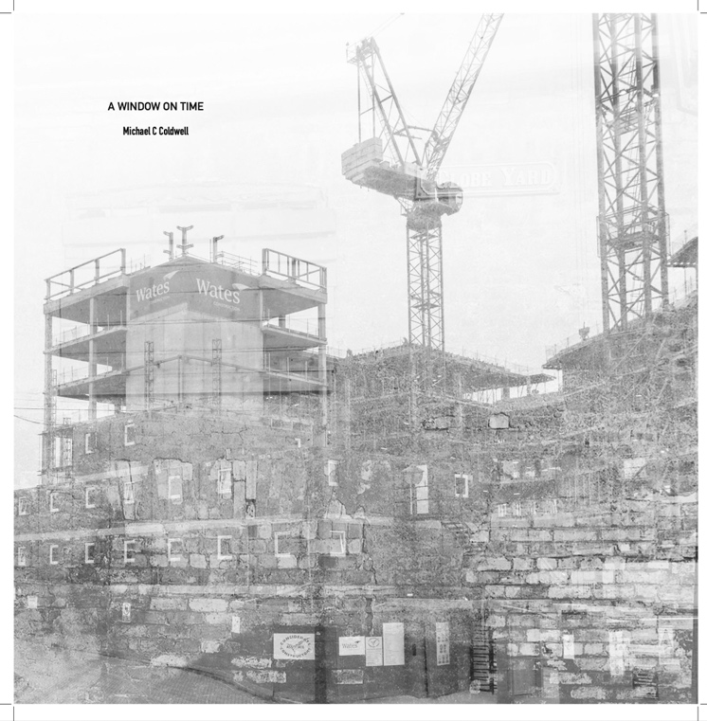
Figure 1 untiled (Schofield 2018)
In figure one this work by Schofield (2018) is exploring how photographs function as hauntological artefacts by using scanned archival images. The image is in black and white this suggested that the image is old as when we think of black and white images, we tend to think of the family photo album. By the photograph being in black and white we are able to pick up more details of the structure of the old buildings and the dust within the image. Some may argue photographs in black and white almost have this vintage and nostalgic effect. The dust and blur in the image can symbolises death because over time the image will slowly fade and become dustier where you cannot perceive any details within the photograph. This is a lot like humans over time we slowly fade away until there nothing left but traces from our past such as the old and dusty photograph. The structure of the buildings is interesting as we know this from the past, so it leaves one to think about a lot of questions such as has building been finished? Or has the site been destroyed and there is something new there. As we are aware photographs carry traces of our history and how things changed over time, this is an example of what makes the photograph hauntological as the place has changed and this photograph is carrying the traces with it.
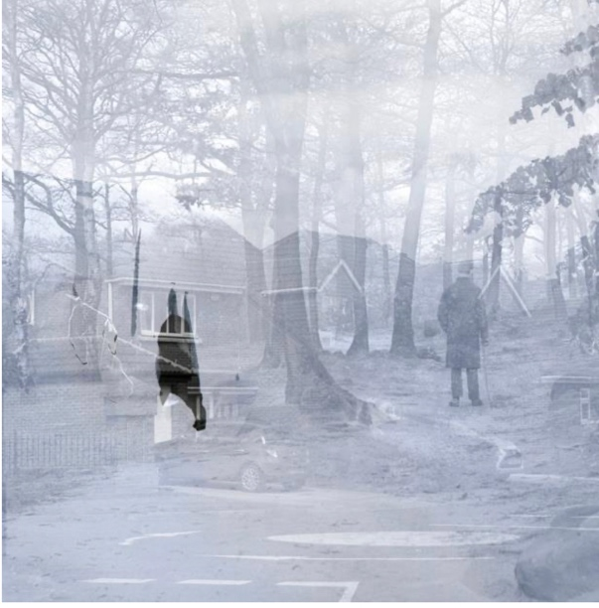
Figure 2 untiled (Schofield 2018)
In figure 2, as with the previous image this work is exploring how photographs function as hauntological artefacts by using scanned archival images. In the image it almost hard to see the details in the image it is creating this blur effect like there something being layered on top of the image. This suggests that the image is old and it almost creating this ghostly effect that plays into making the photograph hauntological. We cannot see the man’s face in photograph as he facing way form us this makes us question who he is. By having the man facing away from us it creates a silhouette effect. It is also hard to tell what is going on the image. The house has been layered on top of a forest with a man walking away. The blurriness of the image creates this unsettling atmosphere that adds to the hauntological element. There is spot on the image this darker compared to the blue and purple in photograph. The darker spot all most looks like a ghost or a spirit lurking in the shadows. Yet again this adds to the hauntological aspects as Derrida suggest that we haunt the future by are traces form the past. By creating the effect that a sprit is lurking in the photograph it adds to the narrative of Derrida theory.

The themes explored in this section are theory on photography and hauntology relationship with images. Derrida’s concept of hauntology is the idea of presences in foundation of being. In the concept of photography “all photography are hauntological, as they cannot exist without the traces form an absent past” (Rosemier, 2021). This brings the topic of fragmented past and present moment into discussion with photography. Rosemier explores the relationship hauntology has on photography. According to Derrida the spectral is the essence of photography and it acknowledges the ghostliness of photography. This can “neither image nor reality, a new being, really a reality one can no longer touch” (Rosemier, 2021). This shows that a photograph of a loved one that passed away is a reminder they are no longer here, and you cannot touch them anymore. This one of many things that make a photograph hauntological. Derrida also makes an interesting comment on “how photography has long been associated with certain ghostliness as it repeats what could never be repeated existentially” (Rosemier, 2021). This an interesting point, knowing that the photograph is repeating the existence of that person and that is what is left with.

The key aspect discussed in this section is exploring Barthes concept of the punctum to hauntology. Hauntology intersects with Barthes’ theory of the of the punctum as photographs is haunting viewers as they remember things from the past. Hauntology comes into play with the punctum as the punctum brings an emotional reaction to a photograph. In Barthes case seeing a photograph of his mother after she had died, from a time before he knew her made him emotional. This could be as Derrida refers to hauntology relationship with photography “all photographs are hauntological, as they cannot exist without the traces of an absent past ” (Rosemier, 2021). In this case the image becomes hauntological as Barthes knows his mother does not exist anymore which then brings the emotional reaction known as the punctum. Derrida also suggests that “how photography has long been associated with certain ghostliness as it repeats what could never be repeated existentially” (Rosemier, 2021). This an interesting concept to look at how it could play into the theory of the punctum and the emotional reactions come from knowing that the photograph is repeating the existence of that person and that is what is left with.

This section explores the discuses the ontological ideas in photography for instance absence, trace and present. Sontag describes photography as “usurp of reality because it is not only an image but an interpretation of reality that can be a trace of a footprint or death mask” (Sontag, 1977, 27). This is interesting in terms of hauntology’s relationship with photography, as a photography is capturing a trace something that is no longer there. It seems with Sontag’s theory that this is what photography’s role is with hauntology. According to Andre Bazin on hauntology is that “ontology is that a breach of philosophy connected with the study of being, and the different kinds of being entities might have” (Thomas, 2019, 32). This is an interesting theory to explore and what the role of photography is in this. Bazin believes photography role is the photography is to consider what kind of thing a photograph is.

1.3 Punctum, Memory, and Absence
This section we explore Barthes theory of the punctum and how a wound can evoke memory in an emotional response. The punctum is unique to are relationship with photography as he describes “the sensory, intensely subjective effect of a photograph on the viewer” (Frieze, 2010). As Barthes explores the theory of the punctum, he goes on to suggest that “The punctum of a photograph is that accident which pricks me (but also bruises me, is poignant to me)” (Barthes, 1980, 32). This suggest that there something in the photograph like hands or touch that brings this emotional reaction by accident. Barthes make an interesting comment on how he describes photographs “as the living of dead” (Barthes, 1980, page). This implies that photographs are capturing life, and they end up out living us and then bring the effect of photographs as living of dead.
Barthes looks back on many photos of his mother after she died but these did not move him. Until he comes across the winter photography that brings the punctum, he does say the punctum is a small detail a picture that brings emotional reaction for example hands (Barthes, 1980). Bathes says this after experiencing the emotional reaction “there I was, alone in the apartment where she had died, looking at these pictures of my mother, one by one, under a lamp, gradually moving back in time with her, looking for the truth of the face I had loved, and I found it” (Barthes, 1980, 48). This means that, for Barthes, the essence of his mother is in the photograph and in doing so it brought this emotional reaction that make him remember the memories of him and his mother.
The key aspects discussed is how the punctum relates to memory and absence. Barthes believes that a certain emotional connection to a photograph for instance the punctum is the immediate reaction to seeing the photo (Morgan & Morgan, 2012). “Barthes maintains that one must have personal connection to the moment in time and any photograph cannot simply move you” (Morgan & Morgan, 2012). This implies that the photographs must be personal and come from a family history to have an emotional reaction. This interesting because this means that punctum plays a role in memory and absence and the connection it has to photography.

This section explores can the punctum exist for a viewer if they do not have a personal connection to the contents of the image? In most case the punctum exists when looking at family archive of loved that have passed away, for example, according to Pierre Nora “family pictures play a highly complex role in the process of remembrance, as they are able not to only capture memory, but also the time, to stand in for” (Ban, 2010). This implies that photographs are not just able to create memory but also capturing history within that time frame. Lucress Van Groningen talks about the relationship with memory and photography by looking at family archives. then how the photograph of her grandmother had emotional reaction as she was filled with emotions and memories (Van Groningen, 2004). This suggest that the punctum plays huge role in absence and memories.
This raises the question on if absence is a key part of the punctum, is there a hauntological aspects to all images that achieve the punctum? We know that Barthes describes the punctum as “The punctum of a photograph is that accident which pricks me (but also bruises me, is poignant to me)” (Barthes, 1980). The punctum has this effect of absence of something that is no longer there in Barthes case his dead mother. This in lines with Jacques Derrida concept of hauntology as Derrida believes photography has no existence without the referral to something that no longer exists (Forsyth, 2023). This suggests that the punctum is the loss of something that is no longer there and therefore become hauntological as it the trace of an absent past.

Chapter 2: Artist Case Studies
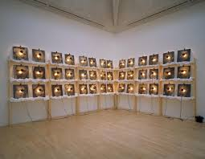
Figure 3 Christian Boltanski Moment to the Lycee (1999)
Boltanski is artist known for his photographic installations. His body of work explores the theme of life, death and memory. His works focus on the holocaust and the boundaries between truth and function (Price database, 2010). The practical element of his works is that he used photos from his family archives that lived in World War 2 ,as Jewish family (Price database, 2010). Then images are in large and printed on fabric with hanging lightbulbs. “Boltanski often has objects stand in for absent subjects, bringing spirituality and meditation to his practice” (Price database, 2010).
The work demonstrates the concept of the punctum by focusing on the small details for instance eyes, hands sensation of touch. This what Barthes suggest what is the punctum in a photograph small detail like hands and eyes that bring the emotional reaction. Boltanski work has an installation of eyes of his family members who have died. This explores the punctum well as it focusing on the small detail likes eyes so everyone can experience the emotions. This would be different if the image was in full, as it would only be personal to the artist as it not focusing on the punctum. Whereas the artist has chosen to focus on the punctum and the small details for his audience to experience the emotions as well.

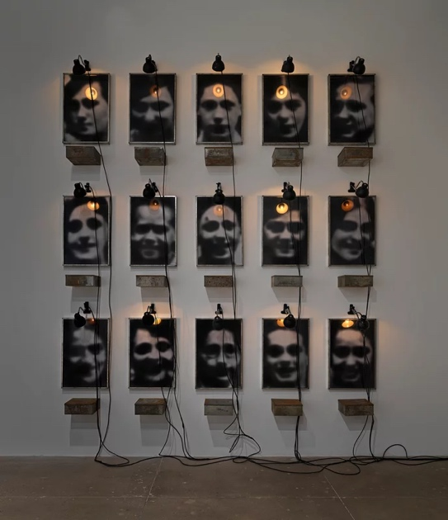
Figure 4 Christian Boltanski moment to the lycee (1999)
In figure 4, the images are in black and white which makes you think the images are of an older time and make you think of looking at family archives. You also cannot see the details of the eyes very well in the photographs. This symbolizes death as you cannot really pick out the details of the eyes as it almost looks as they been taken out of the persons face. This implies that the persons death was horrible and possible torture. This make sense to have this effect in the images as these were family members that did not survive the holocaust (Price database, 2010). It also brings this hauntological effect to the images as it carrying absence trace and it all most looks ghostly. In the installation there also a lightbulb hanging above the photographs which creates this weird tension between the work. This implies that the lightbulb symbolizes the essence and the spirit of the people that have passed in the photograph. It also can symbolize the light at the end tunnel when someone dies. All these elements that the artist has chosen to make the work like this works well with the contexts and the themes the work tries to explore. The work explores a range of themes and theories well such as memory hauntology and the punctum.

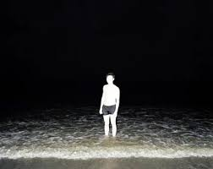
Figure 5 ( Edgar Martins, Sliboques of death)
The body of work explores the representation and imagination of death in practical suicide. In speaking about this work, Martin states the “Paradoxical role that photography – with its epistemological, aesthetes and ethical implications – has played in its intelligibility and perception (Martins, 2017). In the work Martins uses tension between omission and revelation to create hauntological aspects to the image which then challenges the audience to find meaning. This artist is a great example of how photography explores theme around death and people find the topic uncomfortable. The body of work explores how hauntology can be found in very day photographs as these are the last images of the person.
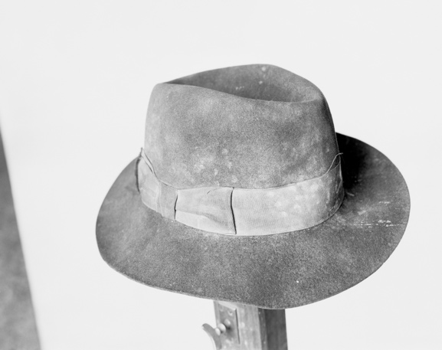
Figure 6 ( Edgar Martins sliboques of death)
The elements of this can be considered hauntological because the photo as outlived the person and is a reminder of his life which then brings ghostly effect on the image. Also, the image is hauntological as this is the last photograph of before the person ended his life. This linked in well to into Derrida theory of we are the ghost of the future as after we die, we leave traces of us behind for instance photographs and object left behind. In Sliboques of Death there are many elements that can be considered as hauntological, for instance the objects left behind after the person has taken their life for example the hat. In figure 6, the hat ends up become the ghost of the future as it carries the trace of the persons past which then ends up haunting the future. The last element that is hauntological as the artist photograph the place where the person killed themselves. The photography carries the essence of the person as that where he died again is carrying traces of past that his haunting the future. The book project and juxtaposition of the images create this hauntological effect greater than one single image.
In figure 6, the object of the hat in black and highlights the details of the dust and mould more so if the image was in colour. The image in black and white suggest that image was taken in a certain time for example in the olden days. This suggest when we look at an image in black, white we think of family archive and old family photographs. The hat is an object that is worn every day. In the object of the hat there is dust and mould which suggest that is old and that it has been worn and used. This implies that the hat belonged to someone, and the person is not there in the photograph. Then brings the feeling of absence within the photographs as the person is not there. The dust and the mould in the image symbolize death witch the life that is gone and discarded. Then with knowing the context of the work it adds another level of emotions to the work. The work then goes for someone owned the hat, to person who killed themselves owned that hat. This then leads to people asking question around the topic of death and suicide which is an uncomfortable topic. It can also be seen to add another level of emotions to the work as once you have the context you begin to understand the elements within the photograph that are consider hauntological.

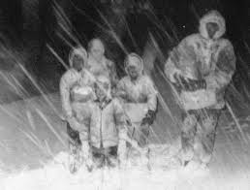
Figure 7 ( Helen Rosemier Zones of possibility)
The work of Helen Rosemier explores the presence of absent family members. That creates mythology based on fragments from the past (Rosemier, 2000). The work touches on the theme of grief throughout the project. The body of work is also being presented in the form of a book. The artist's work has the element of hauntology and memory. The work is hauntological as it explores the presence of absent family members. The photographs have outlived the people which carry the trace from an absent past according to Derrida. Also exploring how we are the ghost of the future as we have left traces from the past that haunt the future. This work is just an example photograph that has outlived them and is carrying the traces of them and haunting the present. It also has the element of the memory within as these are personal archives of loved ones and when looking back at photographs, we remember all the different memories of that person's life. Even though the photograph has this hauntological element to it, it is also exploring the theme on memory and photography.
In figure 7 you cannot see the faces and the details within the photographs, it is almost like a blur. This symbolizes that they are like ghosts as when a loved one dies you can never see them again like you did before, so it is like they do not exist. So, in the image it is like a ghost as people are like silhouettes because they are dead, and we cannot focus on the details of that person. It is exploring the traces of absent family members as if they are ghosts, and we cannot see them anymore. So, it makes sense to hide the details of the hand and face in the image to make them a blur. As when the loved one has died you will never see their faces again. In the photograph there are lines and marks all over the photos. This suggests that the photograph is old and has been touched and marked throughout the years. This then adds into the tension and emotions of the image as marks and lines and age can mean death. This then means the end of life and the photographs are the only thing left that carries the traces of them. The dust and the marks and not being able to see the details of the hands and face all add to the elements that make this work hauntological. Some may argue that memory and hauntology are part of a bigger thing that we do not understand. Therefore, we have different words to explain these concepts, as memory and hauntology are almost always linked together.

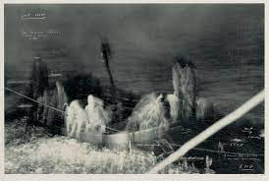
Figure 8 Disappearance at Sea (Tacita Dean, n.d.)
The Disappearance at Sea is a short film made by Tacita Dean. The film was filmed at St Abb’s Head on the cost of Scotland. The practical element of the work uses the light of a lighthouse and the surrounding landscape (Tate, 2019). The film shows rotting of the lighthouse that explores the conceptual themes of ghosts of the past in the present. The work shows the space between land and water and the traces of human presence interact with the natural world. The distortion of the images creates a dissociative feeling which disrupts the viewers perception of time (Tate, 2019).
The work Disappearance at Sea explores the concept of hauntology well by focusing on the details of the lighthouse rotting as it exploring that over time things will rot away and will become old and you cannot use it anymore. Then it is carrying the trace of the past into the present as the lighthouse is left to rot and not be used, there was a time where it was new and being used every day. The works explores Derrida’s theory well as he believes that we are the ghost of our future, and our traces continue to haunt the present. This works with this theme as lighthouse carries trace form the past that haunt the future, and Dean explores this concept well.
In figure 8 the still from the film is very blurred you cannot see the boat well or the people on the boat. This suggest the artist is trying to explore the hauntological nature of the lighthouse and the landscape around the area. The blurring of the boat and the people implies that they both suffer because of the lighthouse not being used. This captures the lost essence of the lighthouse without function. Having the image in black and white significantly adds to the narrative of the work. It creates this eeriness and tension in the work, as the sea looks different and the detail of it in black and white creates this hauntological effect that we get form the sea. The film uses a static camera which makes the shots similar to photography. This stillness works well with the hauntological element that the artist is trying to explore. The artist work realties to Derrida theory of we are the ghost of the future, and we haunt the present by continuing to carry traces form an absent past that is presented in a different form.

Figure 9 Untiled 1 (2024, Fulop)
In my own photographic practice, I am very interested in these themes of memory, hauntology and family archive. My current project is exploring the ontological nature of photographs, particularly how they capture a trace of the past that no longer exists, such as family photo albums. To delve into this idea, I have been using photographs of my deceased family members to examine how photographs outlive us. In doing so, I aim to investigate how memory and hauntology influence everyday photographs. The practical element of my work is crop out details of hands eyes and the sensation of touch to explore the hauntological aspect of trace and by doing so making my audience have an emotional reaction. This then brings the element of the punctum in my work as people could relate more to the cropped images than the original image. This means that the original images only had meaning to me and only I could pick out the punctum in the photograph and the hauntological traces that comes with the photo. So, I decide to only focus on the punctum to see how that would change how my audience interact with my project.
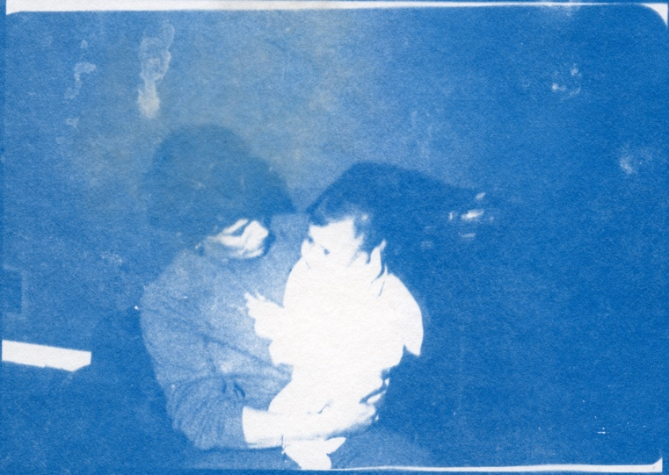
Figure 10 untitled (2024 Fulop
In figure 10, is the example the original image not cropped. The full image is still hauntological as it still has the ghostly effect as the photograph as outlived the person. The images as cyanotypes works well but other suggested lowering the exposure the images are more fade and cropping the images to focus on hands and the sensation of touch and longing of person. I did this because when showing the full image as a cyanotype that been exposed well people did not think the images was hauntological and it had no meaning behind it. People were more focus on the detail of the hands holding the baby, so it was suggested to crop the image and focused on that details to see how this cold make the image hauntological.
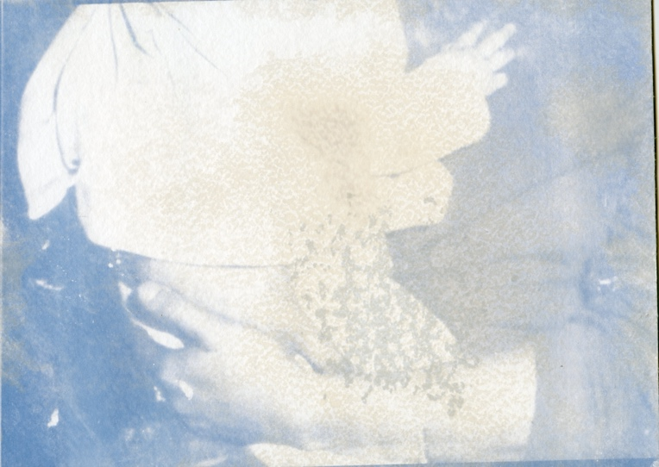
Figure 11 untitled 3 (2024 Fulop)
In figure 11, is the example of the cropped image. This image as more of an hauntological effect because the images is almost faded, and you can see hand of the baby is slowly fading away. This relates to death as overtime we as human slowly fade away to the point where we do not exist anymore. By removing the faces of the individuals, it creates this atmosphere who are these people witch some may argue make it more hauntological as we do not know these people and all we have is this photograph. The detail of the whiteness adds to the ontological element as it creates unusual effect that explores the traces left that haunt the future that then creates new forms.

Conclusion
This essay has explored the themes of hauntology and the punctum. The main theorist discuss in this thesis is Derrida and Barthes. Derrida theory on hauntology and photography are that all photographs are hauntological as they cannot exist without a trace from an absent past (Rosemier, 2021). Also suggests that we are the ghost of the future as we haunt the future by leaving traces form past in the present form the future. Barthes theory is on the essence of photography, where he talks about the punctum (Barthes, 1980). The punctum is a small detail in a photograph that brings this emotional reaction when seeing the punctum. In Barthes case seeing a photograph of his mother at time when he did not know her after she had passed away.
The artist that I have chosen to explore have the themes of hauntology or the punctum. The artist Christian Boltanski work from the moment to the lycee has the element of the punctum within his work he has taken focused on eyes of his loved ones that died in the holocaust and made insulation of the eyes in the exhibition. The work is also hauntological as the photographs have outlived the people witch then is carrying traces form an absent past. The work of Edgar Martins sliboques of death explore the theme of hauntology well. By creating a book with the last images of people before they committed suicide and also photographing the objects they left behind. This makes the work more hauntological as it exploring the traces we live behind when we die like the objects, we have not just the photographs.
Helen Rosmier work explores the theme of hauntology well by explore the presence of absent family members. this is different to Boltanski work as it has no element of the punctum within the photograph as you cannot see the details of the hand and face. We can’t see the punctum because in figure 7 you cannot see the people in the image or the face and hands as they all most look like a silhouette. We know the punctum is a small detail in photograph-like hand or eyes, but this image doesn’t have that as you cannot see any details within the image. Rosmier want to explore hauntological aspect of the photograph, so she decides to make the family a blur to focus on the fact they have died. The work by Tacita Dean disappearance at sea focuses on the lighthouse and how it not being used and it left to rot there which makes the work hauntological as it exploring how the site is being abandoned and is now carrying the traces of the past. All the artists explore hauntology in very different ways as there are a lot of elements that make a work hauntological. It was interesting to explores these different ways to help my understanding on the topic of hauntology better
The punctum cannot exist without referring to something hauntological. As the punctum is focusing on the small details of the hands and eyes that brings this emotional reaction. In most cases the reason as to why there is an emotional reaction is that that person is no longer with us. Therefore, the punctum is carrying a trace of that person which makes the punctum a part of all hauntological photographic artifacts. Contrastingly, a photograph can be hauntological without referring to the punctum. For example, having an image of a places that been abandoned makes that image hauntological as it carrying a trace of what that site was used for and now is being left to rot away. In my own work I use the theme of hauntology . in my previous project I was focusing on the abandoned places and using objects from that site and layer on top of the original images to explore the concept of traces we leave behind . In doing so I was exploring how these sites carry traces from the past that continue to haunt the future. I wanted my work to explore this concept through layering the objects left behind on top of the abandoned sites. I also use the punctum within my practice as I am exploring the family archive and what makes it hauntological an by using the punctum within my work has helped me explore hauntology with family archives. this method of exploring had come from my reading and how I develop my understanding of role hauntology within photographs and want to explore a different medium of how hauntology works within photographs.

Bibliography
Artnet (2010) Price database, Artnet. Available at: https://www.artnet.com/artists/christian-boltanski/ (Accessed: 04 November 2024).
Barthes, R. (1980) Camera lucida: Reflections on photography: Barthes, Roland: 9780374521349: Amazon.com: Books. Available at: https://www.amazon.com/Camera-Lucida-Reflections-Roland-Barthes/dp/0374521344 (Accessed: 28 October 2024).

Ban, Z. (2010) Exposed memories: Family pictures in private and collective memory on JSTOR. Available at: https://www.jstor.org/stable/10.7829/j.ctt2jbm8r (Accessed: 02 November 2024).
Carstens, N. (2022) Photographs are the keys to unlocking our memories, Natalie Carstens - The Hague Newborn & Family Photographer. Available at: https://www.nataliecarstens.com/blog/photographs-are-the-keys-to-unlocking-our-memories/ (Accessed: 05 December 2024).

frieze | 18 Oct 24, S. et al. (2010) ‘punctum. reflections on photography’ brings Barthes to the Digital age, Frieze. Available at: https://www.frieze.com/article/punctum-reflections-photography-2014-review (Accessed: 28 October 2024).

Forsyth, S.B. (2023) On the ghosts of Western Philosophy, Medium. Available at: https://medium.com/deterritorialization/jacques-derridas-specter-s-of-marx-and-the-concept-of-hauntology-reflections-on-deconstruction-2eb687322a69 (Accessed: 03 December 2024).

Morgan, H. and Morgan, H. (2012) Challenging Barthes’s punctum, Picture It: Literature, Photography, and Memory. Available at: https://memoryphotographyliterature.wordpress.com/2012/02/16/challenging-barthess-punctum/ (Accessed: 30 October 2024).

Martins , E. (2017) Siloquies and soliloquies on Death life and other Interludes @ Photo oxford 2017, Edgar Martins. Available at: https://edgarmartins.com/2017/09/08/siloquies-soliloquies-death-life-interludes-photo-oxford-2017/ (Accessed: 04 November 2024).

Rosemier, H. (2021) (PDF) photographic Hauntology in a time out of joint. Available at: https://www.researchgate.net/publication/361142854_Photographic_Hauntology_in_a_Time_Out_of_Joint (Accessed: 21 October 2024).

Rosemier, H. (2000) Zones of possibility, Pixelrights. Available at: https://helenrosemierphotography.co.uk/albums/0UE5/zones-of-possibility (Accessed: 12 November 2024).

Schofield, M.P. (2018) Aura and trace: The Hauntology of the rephotographic image, White Rose eTheses Online. Available at: https://etheses.whiterose.ac.uk/22615/ (Accessed: 21 October 2024).

Sontag , S. (1977) On photography Susan Sontag. Available at: https://writing.upenn.edu/library/Sontag-Susan-Photography.pdf (Accessed: 24 October 2024).

THOMAS, B. (2019) Ontology of photography, Beverley Thomas. Available at: https://beverleythomasphotographydotcodotuk.wordpress.com/2019/08/14/ontology-of-photography/ (Accessed: 24 October 2024).

TATE. (2019) ‘disappearance at sea’, Tacita Dean CBE, 1996, Tate. Available at: https://www.tate.org.uk/art/artworks/dean-disappearance-at-sea-t07455 (Accessed: 21 April 2024).

Van Groningen, L. (2004) Photography and memory: Lucrees van Groningen - photography, Photography, and memory | Lucrees van Groningen - Photography. Available at: https://www.lucreesvangroningen.nl/miscellaneous/photography-and-memory/ (Accessed: 16 March 2024).

