PPT Notes

BMIH4006
Operating Hotel Facilities

Component 3

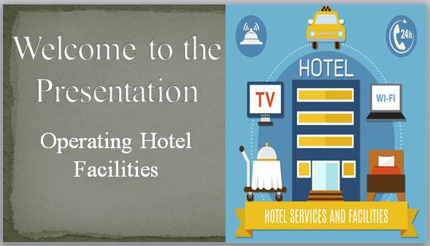

Table of Contents
Introduction 2
Guest complaints that need to put together basic training for colleagues within the housekeeping team as a floor housekeeping manager, to get the best out of them 2
Ensure that brand standard is being achieved and that health and safety procedures are also being followed 3
Employee engagement model to a best practice industry example (This would ultimately give the team a framework of which to follow) 4
Conclusion 6
References 6
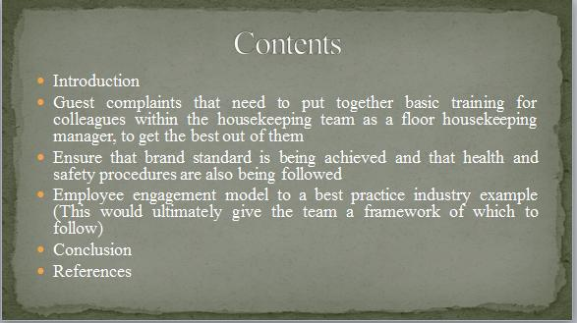

Introduction
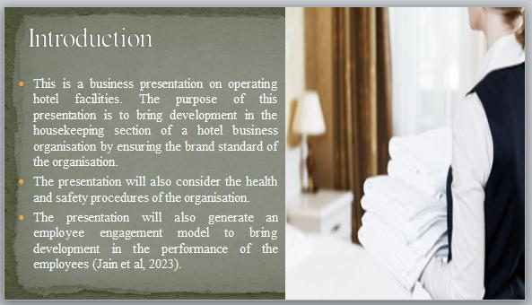
This is a business presentation on operating hotel facilities. The purpose of this presentation is to bring development in the housekeeping section of a hotel business organisation by ensuring the brand standard of the organisation. The presentation will also consider the health and safety procedures of the organisation. The presentation will also generate an employee engagement model to bring development in the performance of the employees (Jain et al, 2023).

Guest complaints that need to put together basic training for colleagues within the housekeeping team as a floor housekeeping manager, to get the best out of them
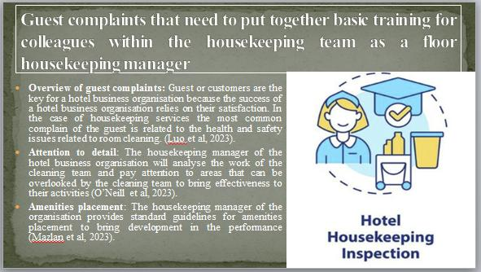
Overview of guest complaints: Guest or customers are the key for a hotel business organisation because the success of a hotel business organisation relies on their satisfaction. In the case of housekeeping services the most common complain of the guest is related to the health and safety issues related to room cleaning. The floor housekeeping manager of a hotel business organisation always ensures the best employees and cleaning materials in the rooms to satisfy the gust to solve their complaints (Luo et al, 2023).
To solve the Guest complaints the housekeeping manager will take some initiative to ensure the best outcome for the housekeeping team. They are presented below-
Attention to detail: The housekeeping manager of the hotel business organisation will analyse the work of the cleaning team and pay attention to areas that can be overlooked by the cleaning team to bring effectiveness to their activities. It will also support the housekeeping team to stay aware of their working and cleaning activities and in the upcoming days, thy will work on their mistakes to perform better (O’Neill et al, 2023).
Amenities placement: Hotel business organisations offer amenities services to the customers and guest in their rooms and bathroom so the housekeeping team need to focus on the proper organization of the amenities such as towels, toiletries essentials and other in-room facilities to ensure the best care of the customers in the organisation. The housekeeping manager of the organisation provides standard guidelines for amenities placement to bring development in the performance (Mazlan et al, 2023).
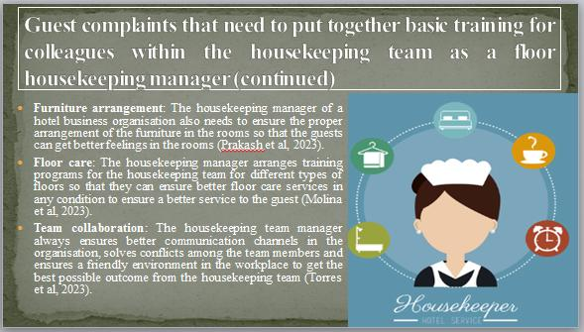
Furniture arrangement: The housekeeping manager of a hotel business organisation also needs to ensure the proper arrangement of the furniture in the rooms so that the guests can get better feelings in the rooms. The housekeeping team also always clean the furniture and solves issues in the furniture to perform better by providing the best services to the customers (Prakash et al, 2023).
Floor care: The housekeeping manager of a hotel business organisation always tries to keep the floor of the rooms neat and clean so that customers stay satisfied with the cleaning process of the organisation. The housekeeping manager arranges training programs for the housekeeping team for different types of floors so that they can ensure better floor care services in any condition to ensure a better service to the guest (Molina et al, 2023).
Team collaboration: housekeeping is a challenging task for every hotel business organisation so the housekeeping manager of the organisation tries to build a strong team in the organisation to perform better by supporting each other. The housekeeping team manager always ensures better communication channels in the organisation, solves conflicts among the team members and ensures a friendly environment in the workplace to get the best possible outcome from the housekeeping team (Torres et al, 2023).

Ensure that brand standard is being achieved and that health and safety procedures are also being followed
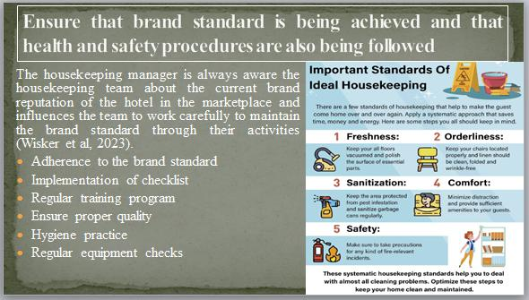
Adherence to the brand standard: Brand reputation is key for every hotel business organisation as it supports getting the attention of the potential customers in the organisation. The housekeeping manager is always aware the housekeeping team about the current brand reputation of the hotel in the marketplace and influences the team to work carefully to maintain the brand standard through their activities (Wisker et al, 2023).
Implementation of checklist: The housekeeping manager of a hotel business organisation make a checklist based on the brand standard of the hotel and implement the checklist in the organisation to achieve the brand standard by ensuring proper health and safety procedure. The housekeeping manager will divide the tasks in the checklist among the team members and give responsibilities to the team members to do their tasks perfectly to ensure the achievement of brand standards (Ulum et al, 2023).
Regular training program: The current hotel business system is very competitive and especially after the COVID-19 pandemic the condition gets complicated for hotel business organisations. The housekeeping manager of a hotel always tries to identify the safety measures in cleaning tasks and arrange regular training program for the team members to get them aware of new safety rules and regulations related to cleaning tasks so that the team can maintain the cleaning standard of the hotel to achieve brand standard (Jain et al, 2023).
Ensure proper quality: The housekeeping team of a hotel business organisation needs to be aware of the quality of their performance to ensure brand standard. The housekeeping manager always audits the workplace carefully and analyse the quality of work in the rooms to successfully satisfy the guest (Luo et al, 2023).
Hygiene practice: In hotel room different types of customers comes regularly and take services so it is a must for the housekeeping team of the organisation to practice proper hygiene to meet the brand standard of the organisation. The housekeeping manager ensures proper hygiene in the team by providing cleaning materials, uniform and necessary medicine in cleaning processes (O’Neill et al, 2023).
Regular equipment checks: The housekeeping manager of a hotel business organisation always monitors the cleaning equipment carefully to ensure better cleaning performance. It is important because if the equipment do not work perfectly the cleaning task will not be better that can make impact on the brand standard of the organisation (Mazlan et al, 2023).

Employee engagement model to a best practice industry example (This would ultimately give the team a framework of which to follow)
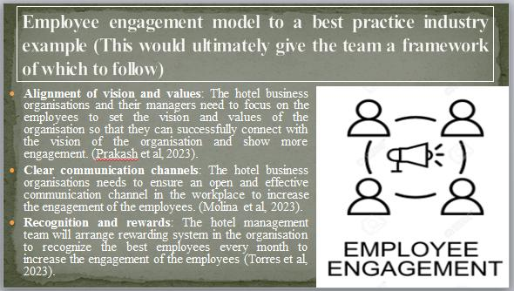
Alignment of vision and values: The hotel business organisations and their managers need to focus on the employees to set the vision and values of the organisation so that they can successfully connect with the vision of the organisation and show more engagement. The home tasks manager of a resort business enterprise makes a checklist primarily based on the logo preferred of the inn and puts into effect the tick list within the company to obtain the brand preferred by means of making sure the right fitness and protection process is followed. (Prakash et al, 2023).
Clear communication channels: The hotel business organisations needs to ensure an open and effective communication channel in the workplace to increase the engagement of the employees. This will support the employees to express their issues and emotions with the organisation that will support them to stay satisfied to the organisation (Molina et al, 2023).
Recognition and rewards: Employees always want to get recognition for their contribution in the organisation so the hotel management team will arrange rewarding system in the organisation to recognize the best employees every month. This will increase the engagement of the employees in the organisation and play a crucial role to bring development in their performance (Torres et al, 2023).
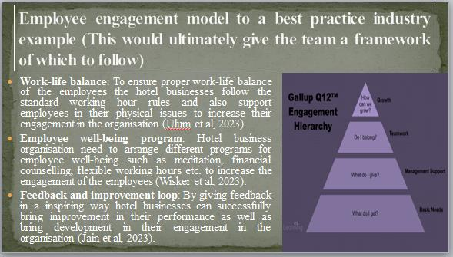
Work-life balance: Employees are human beings so hotel business organisations need to ensure proper work-life balance of the employees to take care of the employees. To ensure proper work-life balance of the employees the hotel businesses follow the standard working hour rules and also support employees in their physical issues to increase their engagement in the organisation (Ulum et al, 2023).
Employee well-being program: The housekeeping manager of the hotel commercial enterprise will analyse the work of the cleaning crew and be aware of areas that may be left out through the cleaning group to deliver effectiveness to their activities. Hotel business organisation need to arrange different programs for employee well-being such as meditation, financial counselling, flexible working hours etc. to increase the engagement of the employees (Wisker et al, 2023).
Feedback and improvement loop: Hotel business organisations and their managers need to provide regular feedback to the employees in the workplace to increase their engagement. Guest or customers are the keys for an inn enterprise company because the fulfilment of a hotel business company is based on their pride. By giving feedback in a inspiring way hotel businesses can successfully bring improvement in their performance as well as bring development in their engagement in the organisation (Jain et al, 2023).

Conclusion
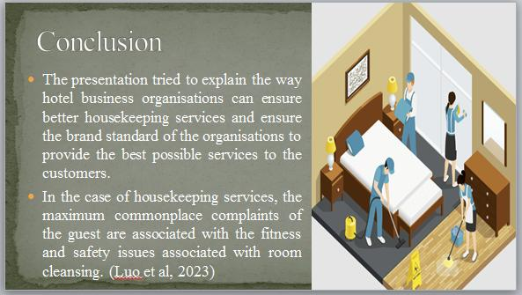
The presentation tried to explain the way hotel business organisations can ensure better housekeeping services and ensure the brand standard of the organisations to provide the best possible services to the customers. In the case of housekeeping services, the maximum commonplace complaints of the guest are associated with the fitness and safety issues associated with room cleansing. The house responsibilities supervisor will divide the responsibilities within the tick list many of the group participants and provide duties to the crew participants to do their duties perfectly to make certain the success of brand standards. (Luo et al, 2023)

References
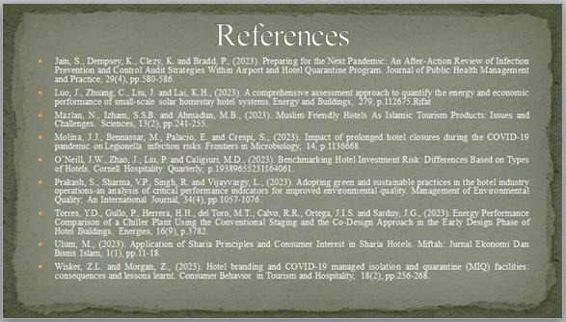
Bridger, E. (2018) Employee engagement: a practical introduction. 2nd ed. HR Fundamentals. London: CIPD and Kogan Page.
Cottrell, S. (2019) The Study Skills Handbook. 5th ed. London: Red Globe Press.
Jain, S., Dempsey, K., Clezy, K. and Bradd, P., (2023). Preparing for the Next Pandemic: An After-Action Review of Infection Prevention and Control Audit Strategies Within Airport and Hotel Quarantine Program. Journal of Public Health Management and Practice, 29(4), pp.580-586.
Leiter, M. P. and Bakker, A. B. (2010) Work Engagement : A Handbook of Essential Theory and Research. Hove [England]: Psychology Press.
Luo, J., Zhuang, C., Liu, J. and Lai, K.H., (2023). A comprehensive assessment approach to quantify the energy and economic performance of small-scale solar homestay hotel systems. Energy and Buildings, 279, p.112675.Rifat
Mazlan, N., Izham, S.S.B. and Ahmadun, M.B., (2023). Muslim Friendly Hotels As Islamic Tourism Products: Issues and Challenges. Sciences, 13(2), pp.241-255.
Molina, J.J., Bennassar, M., Palacio, E. and Crespi, S., (2023). Impact of prolonged hotel closures during the COVID-19 pandemic on Legionella infection risks. Frontiers in Microbiology, 14, p.1136668.
O’Neill, J.W., Zhao, J., Liu, P. and Caligiuri, M.D., (2023). Benchmarking Hotel Investment Risk: Differences Based on Types of Hotels. Cornell Hospitality Quarterly, p.19389655231164061.
Prakash, S., Sharma, V.P., Singh, R. and Vijayvargy, L., (2023). Adopting green and sustainable practices in the hotel industry operations-an analysis of critical performance indicators for improved environmental quality. Management of Environmental Quality: An International Journal, 34(4), pp.1057-1076.
Torres, Y.D., Gullo, P., Herrera, H.H., del Toro, M.T., Calvo, R.R., Ortega, J.I.S. and Sarduy, J.G., (2023). Energy Performance Comparison of a Chiller Plant Using the Conventional Staging and the Co-Design Approach in the Early Design Phase of Hotel Buildings. Energies, 16(9), p.3782.
Ulum, M., (2023). Application of Sharia Principles and Consumer Interest in Sharia Hotels. Miftah: Jurnal Ekonomi Dan Bisnis Islam, 1(1), pp.11-18.
Wisker, Z.L. and Morgan, Z., (2023). Hotel branding and COVID-19 managed isolation and quarantine (MIQ) facilities: consequences and lessons learnt. Consumer Behavior in Tourism and Hospitality, 18(2), pp.256-268.

