

Assessment 2

Student name:​Mayne Salcedo
Student ID: ​2118543
Module name: Mental Disorders and Psychopathology​
Module code: BMHP6006
Lecturer name: Bianca Sanfilippo ​
Date: 03-05-2024

Introduction
This report is about on the three mental health disorders from the ICD-10 Manual: General Anxiety Disorder, Schizophrenia and Autism. Correspondingly examine the causes, signs and symptoms, treatment, diagnosis, and measurements of rehabilitations as well provide recommendations.

1.General Anxiety Disorder (GAD)
According to Munir and Takov (2022) is defined as a mental and behavioural disorder It is characterized by excessive, uncontrollable, and often irrational worry about events or activities in life. This worry can significantly affect an individual's daily functioning and may cause them to excessively concern such as: health, finances, death, family, relationship concerns, etc.
Classification of GAD within Icd-10 Manual GAD is classified within ‘F40-F48 Neurotic, stress-related and somatoform disorders. GAD is under F41.1
Anxiety can be present in three levels of Severity: Mild, Moderate and Severe.
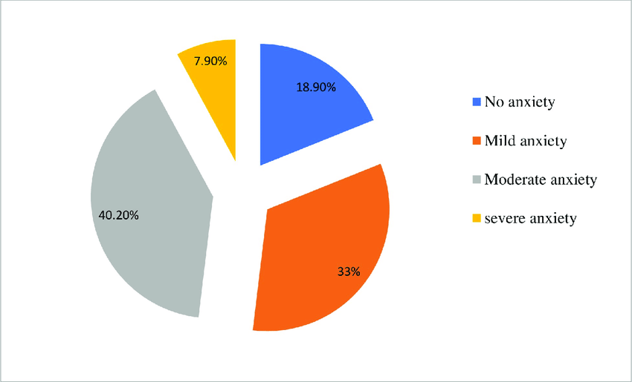

Statistics of people surfer from anxiety disorder in UK
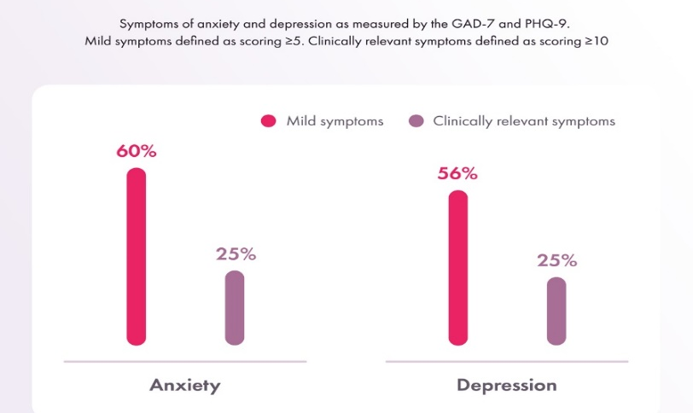

In England, a substantial number of individuals are diagnosed with generalised anxiety approximately six out of every one hundred people experiencing this condition. This can have a profound impact on people's lives causing them to feel excessively worried.
The prevalence of anxiety disorders in the United Kingdom is also a cause for concern, with more than eight million people living with form of anxiety disorder at any given time. This can include conditions such as panic disorder, among others.
Despite the availability of effective treatments, such as therapy and medication, individuals with generalised anxiety disorder do not seek help. This is a worrying trend, as untreated anxiety can lead to other mental health problems, such as depression.
In addition, work-related stress, depression, and anxiety are also prevalent in the UK, with an estimated 822,000 employees affected each year (Pindar J ,2023).

Causes of Anxiety Disorder (Aetiology)
(GAD) can be caused by a range of factors such as: genetic predisposition are the genes inherited from one's parents, experiencing a history of stressful or traumatic events such as domestic violence, child abuse, or bullying can also contribute to the development of GAD. Furthermore, having a long-term painful health condition, such as arthritis, can also trigger the disorder, History of drug or alcohol misuse. However, the individuals may develop GAD even in the absence of these factors. In such cases, the cause of the disorder may not be immediately apparent (Shri,2010 pp 101-102).

Signs and Symptoms of Anxiety Disorder
Anxiety disorder can have a profound impact on an individual's emotional and psychological well-being characterized by persistent and intense feelings of fear, worry or panic. Common symptoms of anxiety disorder include excessive worrying, trouble sleeping, restlessness, irritability, muscle tension, and difficulties with concentration. Physical symptoms such as sweating, trembling, rapid heartbeat, and shortness of breath are also typical manifestations of anxiety disorder. (National Institute of Mental Health 2024 p1).

Diagnosis of Anxiety disorder
The General practitioner will analyse the symptoms and personal situation to make an accurate diagnosis if the patient has been experiencing symptoms for at least six months, the GP may conduct a thorough physical examination or order blood tests to rule out other conditions that may be causing this symptom. Also, The GP use a questionnaire or standardized assessment tool to evaluate the severity of your symptoms. This assessment can help to determine the most appropriate treatment options for the patient and the Treatment options range from exercise, meditation, and relaxation techniques for mild anxiety, to medications or CBT for moderate anxiety. Severe anxiety may require hospitalization, antipsychotics, mood stabilizers, or Electroconvulsive therapy (Nhs,2022).
Anxiety treatment positive and negative effect of medication
Agent | Positive | Negative
SSRI | - Well, tolerated.  - Minimal risk of mortality in overdose when is use as a single agent | - Slow onset of effect (4-12 weeks)  - May worsen symptoms initially
Benzodiazepines | - Quick onset of effect  - Well tolerant | - Sedation  - Rebound anxiety on withdrawal.  - Risk of dependence
TAC | - Treats co-morbid depression | - Cardiotoxicity  - Risk in overdose
Anticonvulsants | - Quick onset of effect | - Low levels of evidence  - Sedation  - Pharmaceutical benefits scheme statues issues  (Anxiety testing,2024).

Measurement of the Rehabilitation Generalised anxiety disorder questionnaire.
To accurately determine the effectiveness of treatments, it is key to measure the rehabilitation progress. This helps in identifying if the current treatment plan is not working as expected, and modifications may be necessary over period of two weeks in the case of GAD (Robert et al.,1999).

Principles of care for people with Anxiety disorder
The principles in health care setting are: building and maintaining strong relationships with the patients such as involve friends and family to bring emotional support and to help reduce stress, understand the condition and develop effective coping strategies, Understand the person feeling without critical way, recognising the diagnosis of anxiety may lead to stigma and discrimination, Implement centred approach: treating patients with dignity and respect ,encourage in participation and decision- making, inform about their clinical conditions and treatment options and keep confidentially of each individuals(NICE,2011p1).

Recommendations
As suggested Zhao et al .,2023 said:Use the complementary therapies for example practicing yoga can help reduce stress and anxiety by promoting relaxation and improving overall mental health. At that point Mindfulness Meditation: This practice involves focusing on the present moment and accepting your thoughts and emotions without judgment. Studies have shown that regular mindfulness meditation can help reduce anxiety levels. Furthermore Acupuncture: This ancient Chinese practice involves inserting thin needles into specific points on the body to help regulate the flow of energy. Studies have shown that acupuncture may help.
Usefullinks:
https://www.mind.org.uk/information-support/types-of-mental-health-problems/anxiety-and-panic-attacks/self-care/
https://www.anxietyuk.org.uk/
https://www.mind.org.uk/

2.Schizophrenia
Schizophrenia is a serious long-term condition affects a person's thinking, emotions, and behavior characterized by a range of symptoms, including hallucinations, delusions, and unusual behaviors, which can significantly impair communication, socialization, and relationships. Usually, it develops during late teenage years or early adulthood (Hamd,2018 p77).
Statistics of people surfer with schizophrenia
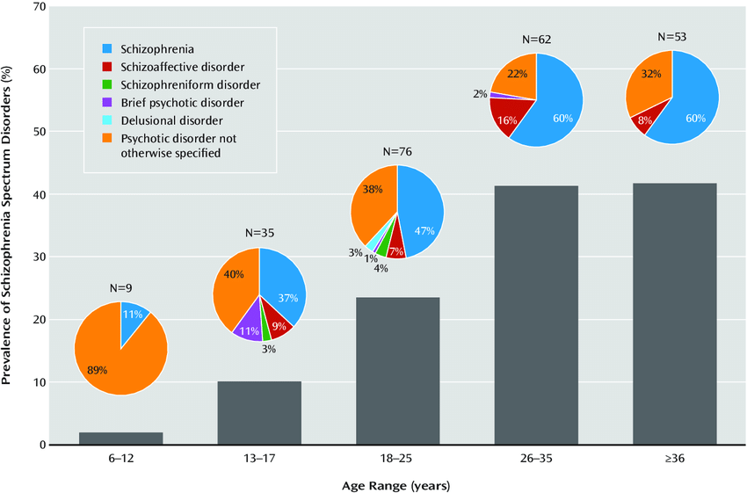
Schizophrenia is a severe mental disorder that can have a significant impact on a person's life. In the UK, it is estimated that 1% of the population will experience this condition in their lives, which translates to around 600,000 people.
Can affect anyone, regardless of age, gender, or ethnicity, although it typically develops in people between the ages of 15 and 35. However, despite the availability of effective treatments, statistics show that around 60% of people with schizophrenia do not receive the appropriate care they need.
This may be due to a lack of access to mental health services, stigma surrounding the condition, or a lack of awareness of the signs and symptoms of schizophrenia.
Classification of schizophrenia within the ICD-10 manual is classified as Schizotypal and Delusional disorders within (F20-F29).

Causes of Schizophrenia (Aetiology)
The aetiology of schizophrenia remains a subject of constant investigation is still not clearly. Nevertheless, current research suggests that a confluence of physical, genetic, psychological, and environmental factors predispose individuals to the development of the condition. While certain individuals may be inherently susceptible to schizophrenia, the manifestation of a psychotic episode can be precipitated by stressful or emotional life events (World Health Organization,2024).

Signs and symptoms of Schizophrenia
Schizophrenia symptoms are typically categorized into two groups: positive symptoms and negative symptoms. Positive symptoms refer to any changes in behavior or thoughts, such as hallucinations or delusions. Negative symptoms are characterized by a withdrawal from the world around them, other symptoms can include difficulty organizing thoughts and speaking coherently, known as disorganized speech, difficulty with tasks that require planning and organization, and engaging in behavior that seems unusual or inappropriate, known as disorganized behavior (National Health Service,2023).

Diagnosis of Schizophrenia
The mental health professional involves a thorough assessment that includes a physical examination, laboratory tests, and a detailed review of the patient's medical history and symptoms. The mental health professional will also conduct a clinical interview to evaluate the patient's thoughts, emotions, and behavior. To diagnose schizophrenia specific symptoms such as delusions, hallucinations, disorganized thinking, and abnormal motor behavior. It is important that schizophrenia is not diagnosed based on a single symptom but rather on a combination of symptoms that persist for at least six months (Guest et al.,2012 pp 66-68).

Current treatments of Schizophrenia (NHS)
The treatment for schizophrenia usually involves a combination of medication and therapy. Antipsychotic medication is often prescribed to reduce symptoms such as delusions and hallucinations. Cognitive behavioural therapy (CBT) may also be used to help patients manage their symptoms, improve communication and social skills, and enhance problem-solving abilities. Family therapy is another helpful intervention that provides support and education to the patient's family members. In addition to these interventions, patients may also benefit from community support services, such as vocational rehabilitation and housing assistance. Treatment plans are tailored to each individual's needs and may be adjusted over time based on their progress and response to treatment (National Health Service,2023).

Measurements of rehabilitation
In order to help individuals with schizophrenia is important to evaluate the quality of care and treatment the patients receive. As a health care provider, we will take necessary steps to effectively manage the condition and prevent any potential complications such as self-harm, neglect, lack of dignity, and violation of human rights. Additionally, we can assess the quality of life by utilizing indicators that are typically used for long-term mental disorders. By taking these measures, we can ensure that individuals receive the greatest possible care, support (Silverstein,2000 pp 6-8).
Quality indicator for rehabilitated care (QuIRC-SA): A tool for quality assessment of specialist mental health supported accommodation services is now available. Schizophrenia is a long-term condition. Supporting service users for an excellent quality of life is important. Indicators for rehabilitative care can assess care quality for all long-term mental health conditions (Killaspy et al.,2016 p1).

Principles when collaborating with people Schizophrenia
Provides comprehensive guidance and principles of care for individuals living with schizophrenia, including medication and psychological therapies, alongside regular monitoring for potential side effects of medication. In addition, NICE emphasizes the importance of involving family members or carers in the care planning process and offering support to help individuals manage their symptoms and maintain their independence. The principal objective of this guidance is to provide a holistic, person-centered approach to care that supports individuals with schizophrenia (NICE,2014 p 580).

Recommendations
Therapy: Psychological therapies such as cognitive-behavioural therapy (CBT) can help patients manage their symptoms and improve their quality of life; Support: People with schizophrenia need support from family, and mental health professionals. Encouraging social connections, education, and employment opportunities can help improve their overall well-being. Lifestyle changes: Eating a healthy diet, getting regular exercise, avoiding drugs, and reducing stress also Early intervention can help reduce the severity of symptoms.
Useful links:
https://www.mind.org.uk/information-support/helplines/https://www.nami.org/about-mental-illness/mental-health-conditions/schizophrenia/?tab=support#:~:text=NAMI%20and%20NAMI%20Affiliates%20are,or%20finding%20support%20and%20resources.

3. Autism spectrum disorder (ASD)
Autism is a condition that affects neurodevelopment, causing difficulties in social interaction, communication, behavior, and sensory processing. Referred to as a spectrum disorder because the symptoms and their severity can vary widely from person to person. Individuals with ASD usually experience challenges in social interaction and communication, engage in repetitive behaviors or routines, tend to focus intensely on specific interests or topics (Ousley and Cermak,2014 pp20-22).
Classification (F80-F89 Disorders of psychological development, ICD, 2010) F 84.0

Statistics people surfer with Autism Spectrum in UK.
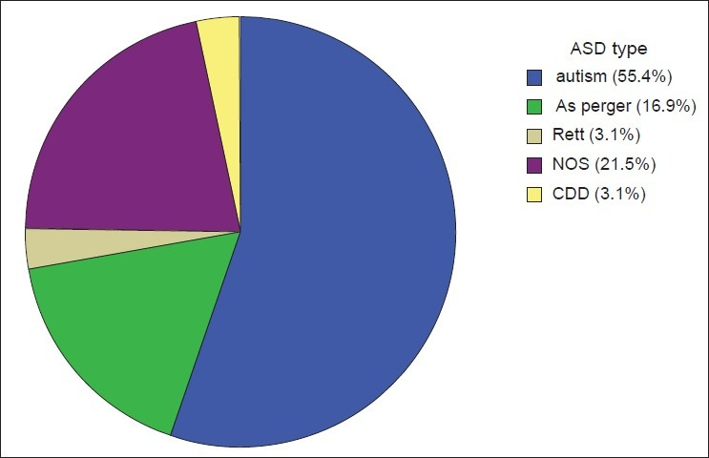

According to the World Health Organization (WHO), approximately 1 in 160 children worldwide has an autism spectrum disorder (ASD).
The researchers analysed anonymized data from over five million individuals registered at GP practices in England from 2000 to determinate the number of people diagnosed with autism.
In the UK, the National Health Service (NHS) estimates that around 1 in 100 people have an ASD.
However, it is important to note that these figures are only estimates, as accurate data on the prevalence of ASD can be difficult to obtain.

Causes of Autism (Aetiology)
According to The National Health Service (2022) said: the reasons behind autism spectrum disorder are still unknown, although it is assumptions that a combination of environmental and genetic factors plays a critical role. Research has indicated that certain genes can make people more vulnerable to autism, while environmental factors such as exposure to toxins or infections during pregnancy can also be contributing factors.

Signs and Symptoms of Autism
Restrepo et al. (2022, p431) suggested the most common symptoms of ASD are difficulty with social interactions. Individuals with ASD may struggle to understand social indications, make eye contact. Delayed language development is another symbol of ASD. The people may not speak at all, while others may develop language skills but have difficulty with social communication, such as understanding sarcasm or figurative language. Repetitive behaviors or movements. These behaviors may be used as a way to self-regulate or cope with sensory overload.

Diagnosis of Autism
Diagnosing autism is a complex process that requires a comprehensive evaluation by a healthcare professional, such as a paediatricians, neurologist, or psychologist. The evaluation may include assessments of developmental milestones, social communication skills, repetitive behaviors, and sensory processing. Diagnostic measures include The Autism Diagnostic Interview- Revised (ADI-R).
Sources:https://www.nhs.uk/conditions/autism/getting-diagnosed/how-to-get-diagnosed/

Autism Assessment
Firstly, if your child is showing signs of autism, the next step should be speaking with someone about it; consider talking to a GP, a health visitor (if your child is under 5 years old), any other healthcare professional you may be seeing, such as a doctor or therapist, or special educational needs (SENCO) staff at your child's school. You can ask them whether they think it would be an innovative idea to refer the child for an autism assessment.
If you or your child are experiencing any problems that may suggest autism, it is recommended to have an autism assessment. This involves a team of autism specialists who will evaluate you or your child to determine if autism is present. During the assessment, the team may ask questions, observe how you or your child interacts with others, and speak to people who know you or your child well, such as family, friends, GP, or teachers (National Institute of Mental Health,2024)

Current treatments for Autism (NHS)
The National Health Service (2023) offers various treatments for individuals with autism, which include medication to manage symptoms, also provides behavioural therapies such as cognitive behavioral therapy (CBT) and applied behavior analysis (ABA) to help individuals enhance their social and communication skills. Furthermore, speech and language therapy, occupational therapy, and sensory integration therapy are available to assist individuals with autism in improving their communication, motor, and sensory skills. It is essential to note that the treatment plans are personalized and tailored to an individual's specific requirements.

Measurement of rehabilitation Childhood Autism rating scale
The Childhood Autism Rating Scale (CARS) is a widely recognized tool utilized to evaluate the severity of autism spectrum disorder (ASD) symptoms in children, which encompasses various aspects of behavior such as social interaction, communication, and repetitive behaviors and to assess the effectiveness of various treatments and interventions for autism.

Recommendation for improvement of Autism
Yoga is a beneficial complementary therapy for individuals with autism. Practicing yoga can help to promote relaxation, reduce stress levels, improve motor coordination, and enhance social interaction skills in individuals with autism. Furthermore, yoga can also assist in improving focus and attention, which can be especially helpful for individuals with autism who experience attention deficits. While yoga is not a cure for autism, it is an excellent way for individuals with autism to enhance their overall well-being and improve their quality of life (Killic et al.,2023 pp 001-004).

Conclusion
The healthcare industry plays a crucial role in helping patients with mental health issues. Mental health care providers offer a wide range of services and treatments, such as therapy, medications, and support groups, which are aimed at helping patients manage their symptoms and improve their overall well-being. Health professionals are equipped to provide patients with coping mechanisms and resources that can aid them in navigating daily challenges.

References
Anxiety testing (2024) Anxiety treatment: All treatment for anxiety Available at: https://www.anxietytesting.com/anxiety-treatment.php (Accessed 09 April 2024).
Guest, P. et al.(2012) ‘Diagnosis schizophrenia’ European Biopharmaceutical Review January pp 66-68. Available at:https://www.researchgate.net/publication/266793800_Diagnosing_Schizophrenia (Accessed 11 April 2024).
Hamd, F. (2018) ‘schizophrenia-overview’ Asian Journal of Pharmaceutics 12(2):77 p77.
Killaspy, H. et al. (2016)’ Adaptation of the Quality Indicator for Rehabilitative Care (QuIRC) for use in mental health supported accommodation services (QuIRC-SA)’ p1.DOI: 10.1186/s12888-016-0799-4
Killic, L. et al. (2023) ‘The Efficacy of Yoga Interventions for Children with Autism: A systematic Review’ Journal of yoga and physiotherapy pp 001-004 DOI:10.19080/JYP.2023.10.555786
Munir S. and Takov V. (2022) Generalized Anxiety Disorder National Institutes of Health Available at: https://www.ncbi.nlm.nih.gov/books/NBK441870/ (Accessed 07 April 2024).
National health service (2022) Diagnosis-Generalised anxiety disorder in adults p1 Available at:https://www.nhs.uk/mental-health/conditions/generalised-anxiety-disorder/diagnosis/ (Accessed 09 April 2024).
National Health Service (2023) Treatment-Schizophrenia Available at:https://www.nhs.uk/mental-health/conditions/schizophrenia/treatment/ (Accessed 11 April 2024).
National Health Service (2023) Symptoms-Schizophrenia Available at:https://www.nhs.uk/mental-health/conditions/schizophrenia/symptoms/ (Accessed 11April 2024).
National health Service (2022) What is autism? Available at: https://www.nhs.uk/conditions/autism/what-is-autism/ (Accessed 13April 2024).
National health service (2023) Care Education and treatment review Available at: https://www.england.nhs.uk/learning-disabilities/care/ctr/ (Accessed 17 April 2024).
National Institute of Mental Health (2024) anxiety disorders p1 Available at: https://www.nimh.nih.gov/health/topics/anxiety-disorders (Accessed 12 April 2024).

National Institute of Mental Health (2024) Autism Spectrum Disorder Available at:https://www.nimh.nih.gov/health/topics/autism-spectrum-disorders-asd (Accessed 14 April 2024).
National Institute for Health and Care Excellent (2011) p1. Generalised Anxiety Disorder and panic disorder in adults: management. Available:https://www.nice.org.uk/guidance/cg113/chapter/Recommendations#principles-of-care-for-people-with-generalised-anxiety-disorder-gad (Accessed 10 April 2024).
National Institute for Health and Care Excellent (2014) Psychosis and schizophrenia in adults p 580. Available at:https://www.nice.org.uk/guidance/cg178/evidence/full-guideline-490503565 (Accessed 12 April 2024).
Ousley, O. and Cermak, T. (2014) ‘Autism Spectrum Disorder: Defining Dimensions and Subgroups’ Current Developmental Disorders Reports1(1) pp20-22.DOI:10.1007/s40474-013-0003-1.
Pindar, J. (2023) Anxiety Statistics UK :2023 Available at: https://championhealth.co.uk/insights/anxiety-statistics/#:~:text=In%20any%20given%20week%20in,access%20treatment%20(Mental%20Health%20Foundation)(Accessed 08 April 2024).
Restrepo, B. et al. (2022) SIGNS AND SYMPTOMS OF AUTISM SPECTRUM DISORDER. Developmental-Behavioral Paediatrics E-Book, p.431.
Silverstein, S. (2000) ‘Psychiatric rehabilitation of schizophrenia: Unresolved issues, current trends, and future directions’ Applied and Preventive Psychology 9(4):227-247 pp6-8. DOI:10.1016/S0962-1849(00)80002-5
Shri, R. (2010) ‘Anxiety: Causes and Management’ The Journal of Behavioural Science 5(1) pp101-102 Available at: ungsinun,+Journal+manager,+2205-4645-1-CE (Accessed 09 April 2024).

Robert, L. et al. (1999) GAD-7 Anxiety Available at:https://adaa.org/sites/default/files/GAD-7_Anxiety-updated_0.pdf (Accessed 10 April 2024).

World Health Organization (2024) Schizophrenia Available at:https://www.who.int/news-room/fact-sheets/detail/schizophrenia (Accessed 11 April 2024).

Appendix A: General Anxiety Disorder questionnaire
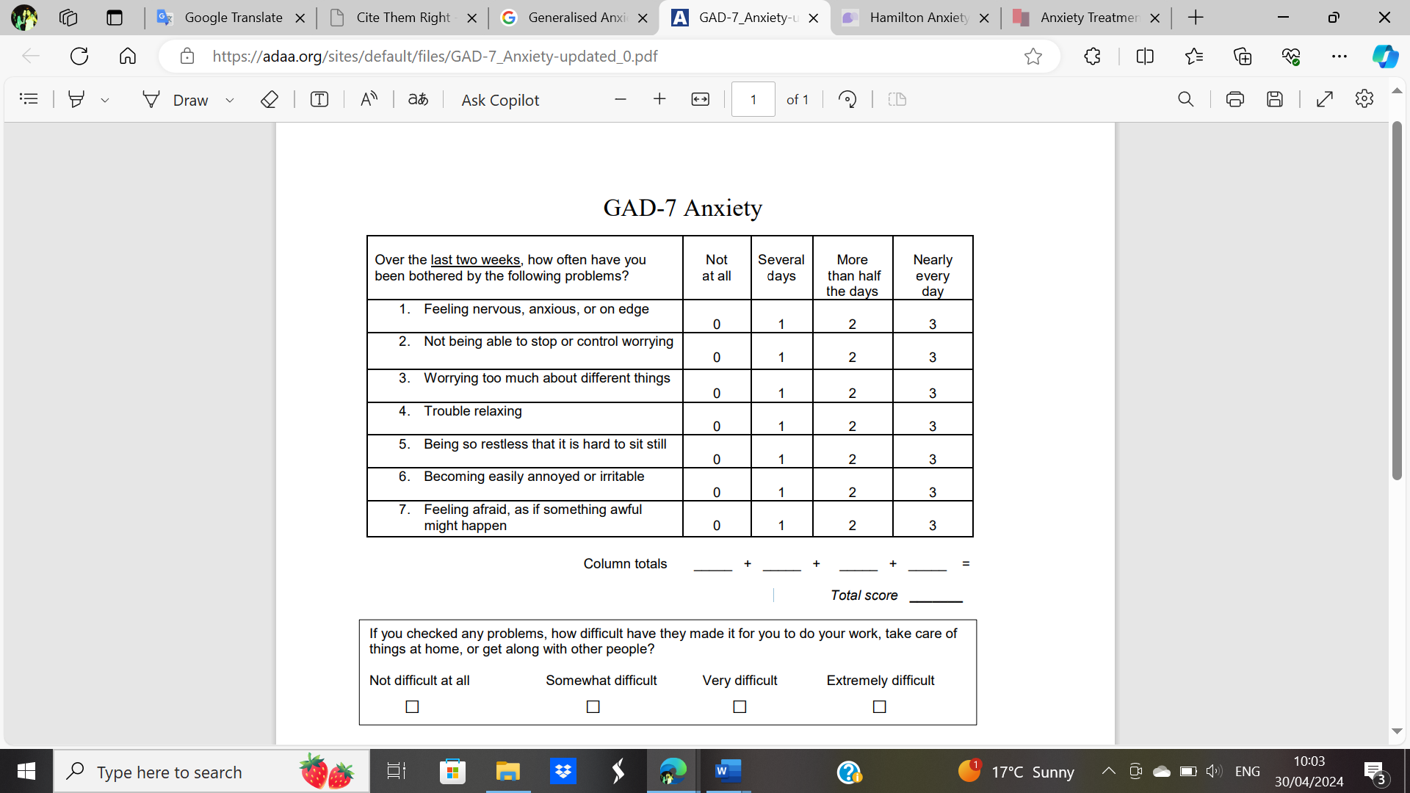
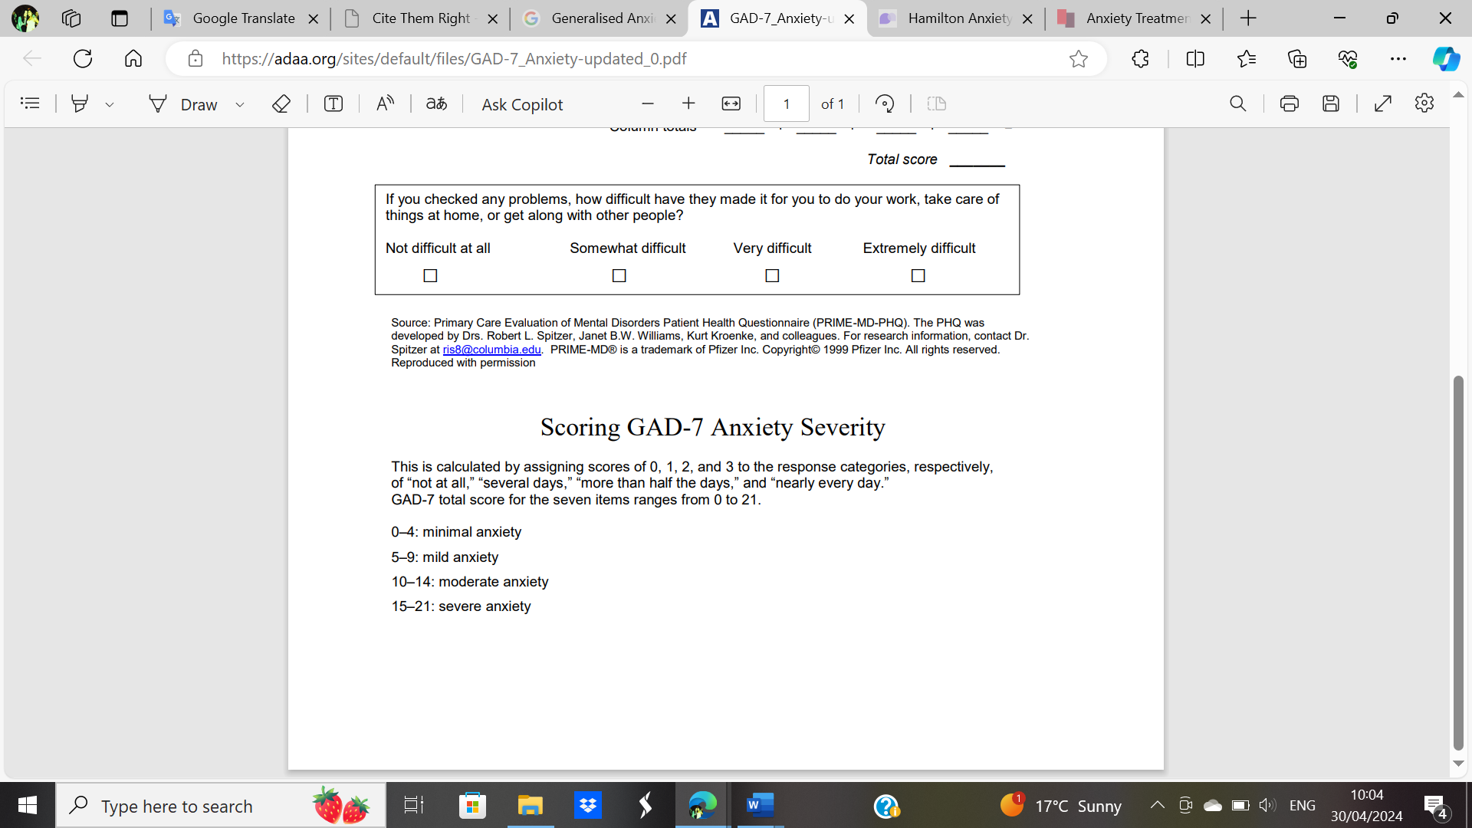

Appendix B: indicators for rehabilitative care Schizophrenia
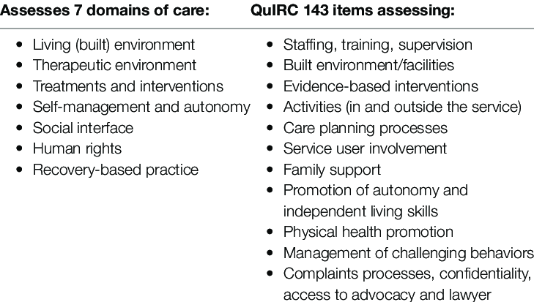
Appendix C: Autism Rating Scale (CARS)


