
A Critical Perspective Of Asda In relation to its crm, ethics, sustainability and quality policies and operations
Module Code: BMSW5103

March 27, 2020
University of Wales Trinity Saint David

Mamasir Miah
1805953

Executive Summary

This report analyses Asda in terms of its Ethics policy as well as other aspects such as sustainability, CRM and TQM. The report goes into depth with suggestions for suitable quality models that Asda may use to improve on its CRM and TQM. The report also provides a SWOT analysis for Asda and makes recommendations for Asda on how to improve its current position on these aforementioned issues.
In conclusion the report states that even though Asda is facing tough times like all other supermarkets, it is in a strong position of leadership and prestige to improve on its image for its customers and itself. Finally, the report makes some recommendations for Asda to allow for it to implement these standards and improve on its overall customer service.
The report uses credible sources of reference from journals, websites and popular YouTube videos.

Table of Contents
Executive Summary 1
Introduction 3
Main Findings 4
Conclusion 9
Recommendations…………………………………………………………………………………………………………………………….9
References 10

Introduction
Asda is a well loved British supermarket and continues to do well despite the challenges supermarkets face in light of competition and political and financial uncertainty. All businesses face challenges and need to adapt and implement policies and innovative ideas to retain customers and gain new ones. Businesses can use proven business models to improve its image and sense of customer satisfaction. They can do this using industry standards such as Customer Relationship Management, Total Quality Management, Sigma Six and Deming’s 14 Points. All this needs to be applied whilst implementing ethical and sustainability standards.
This report covers Asda’s attempt to follow through on these premises. The report lays out the importance of these standards, their benefits and in some cases their drawbacks.

Main Findings

Ethics
Ethics is a topic that more and more companies are looking into as part of their business ethos. The difference between ethics and morality is that morality is the broad understanding of the right thing to do and ethics is the finer rules, spoken or unspoken, governing peoples’ actions. Ethics concerns itself with trying to define right from wrong, (60Second Philosophy, 2015). A general understanding of ethical guidelines and responsibilities allows employees to conduct themselves with customers and employers in an agreeable manner. For employers it allows them to treat employees with respect and dignity. “Unethical workplace behaviour can vary from minor transgressions to illegal activity but are essentially actions that harm the legitimate interests of the organisation, its workforce, customers and wider society”, (CIPD, 2019).
Adherence to ethical standards and commonly accepted ideas are beneficial to all who are involved. This includes employees, employers, customers, suppliers and the general community. These standards will include things such as honesty, fair treatment and respect.
Asda’s ethical examples are:
- introducing purchasing limits on items due to the Coronavirus crisis, (Asda.com, 2020). This will help ensure that more people will have a fair chance of getting the essential supplies that they need.
- Working with local charities and community groups to help fund small projects (Asda.com, 2020). This gives a positive impression to customers that the company cares for the community and improves the brand image
- Offers staff extra training to help progress in career.
- Taking into consideration the mental health of employees. Asda claims “The Asda mental health policy gives practical guidance on how to support colleagues and manage mental health across our stores, home offices and distribution centres”, (Fisher, 2018)

It must be said that ethics is separate from legislation. Each serve a different purpose. Indeed, it is possible for an employer to be unethical in its practice and yet act within the boundaries of the law. An example of this could be how a certain airlines owner, who is worth billions, is now getting rid of staff due to the coronavirus crisis and yet is asking for government funding to continue to operate his business. This sort of thing is common in the world of big business. Similar scenarios occurred during the financial crisis of 2008.
Ethical behaviour could mean different things for different people. This would depend on the upbringing of the individual and their values, beliefs and attitudes. One persons’ ethical view could be completely alien to another’s. Therefore, it is essential that organisations make clear their ethical stance to employees through training, development and examples. To achieve this an organisation needs to put into place “best practice” policies. This needs to be followed by employees at all times and reviewed regularly to check results and improve. “Approaches, processes, and management methods that allegedly helped enterprises to achieve great results are often described as "Best Practice”, (Urban, 2018).
Trading between organisations and nations can be looked with the lens of ethical practices. When rich and powerful nations trade with nations that have a far weaker GDP they can tend to take advantage of the situation. As such the poorer nations would get much less benefit from this type of trading. This is a typical example of unethical practice. However, this practice seems to be on the decline, with poorer countries getting better and fairer trading deals in the modern world. At least this seems to be the case from a media point of view. With fairer and more ethical trading deals the general public looks at companies and governments in a better light. This also helps all sides of the trade. Customers would be more willing to interact with organisations with better ethical practices.
Any organisation will need to look at their finances and see how far they are willing to or can afford to implement ethical practices in terms of suppliers and customers. An example of this would be the recent years of devastating fires breaking out in factories in Bangladesh. These factories supply products to chains such as Primark. The health and safety practices in these factories are nothing short of negligent. However, trading with these suppliers continues to be done as it is cheap and the general public is quick to forget the consequences.
Sustainability
Sustainability is another big topic in modern business. This is due to the dwindling resources of the natural earth. Therefore, businesses need to be smart and practical in how to use their resources. According to Carbon Radio (2019), there are three types of sustainability: environmental, social and financial. A responsible organisation needs to consider all three aspects of sustainability as part of its operations. These aspects need to consider among other things:
- Pollution
- Recycling
- Communities
- Education
- Investments
- Growth
Lakshmi and Kennedy agree with these three categories:
Business sustainability from the point of view of human resource management (HRM) is a management and leadership philosophy about how people are most enable to contribute to success at their work by minimizing the negative impact of their work on the environmental and social factors and at the same time improving the financial factors in the organizations
(Lakshmi and Kennedy, 2017, pp. 70-85)

All of this will amalgamate to a business plan that prepares for the long term benefit of the company. It will foresee any changes and accommodate for that as best it can so that the business can adapt and survive.
Asda has a sustainability policy with regards to these three aspects. This will ensure that customers can continue to purchase their favourite shopping items and not be afraid of running out of these items. One of the ways that Asda is doing this is by removing as much unnecessary plastic from food packaging as it can, (Asda.com, 2020). Other ways include: reducing its carbon footprint, reduce food waste, improving and promise 100% recycling by 2025. (Asda.com, 2020).
All of this looks very attractive to the consumer who is very conscious of sustainable business practices. Consumers need to know that businesses are wary and looking at ways to improve sustainability. Many NGO’s are championing products and practices that improve sustainability and also take into consideration quality of the products.
CRM and TQM
Ethical trading and sustainability are part of the overall Customer Relationship Management (CRM) of any organisation. Trusov (2019) says, “The goal of having a Customer Relationship Management system (CRM) is simple: document the sales process, build a relationship with customers, and improve customer retention”.
CRM starts from the “touch Point” between customer and the business. Touch points are points of contact where the business receives some type of initial idea that a customer is interested in a product or service. This could be manifested through many avenues such as:
- Customer coming walking into a shop
- Email
- Phone call
- Online traffic and clicks
Businesses can increase the traffic and effectiveness of this by clever marketing and making available as many touch points as possible for the customer.
“Customer experience develops throughout all touch points and episodes encountered during the service delivery process”, Jüttner et al (2013, quoted in Stein and Ramaseshan, 2016, p. 8-19).
CRM needs to be regularly monitored and updated in response to societal developments and tastes. This will ensure that businesses don’t fall behind consumer trends and lose revenue and opportunities for business growth.
The drawback of CRM is that businesses may feel it takes up valuable resources and time to constantly review and update it’s policies. Also, any information that businesses collect from customers is liable to misuse. An example of this is the serious misuse of data which had been collected by Facebook which was then sold onto Cambridge Analytica. The latter organisation then used this data to persuade the general public to sway their voting decision in the 2016 United States election.
Businesses may use a range of theories or “Quality models” to help them improve CRM. It is vital for businesses to keep a check on the quality of its CRM as otherwise they may lose customers. When a business makes a continuous effort on improving quality, this is regarded as Total Quality Management (TQM). “Total Quality Management is a leadership tool that provides firms with a competitive strategy”, Nguyen and Nagase (2019). Furthermore, TQM “is a continually improving process aimed at providing a quality of service that meets or exceeds customer expectations”, Nguyen and Nagase (2019).
TQM covers many processes of any business. These include:
- Retaining relationships with customers and suppliers
- Checking for product or service quality
- Improving or optimising production processes
- Set standards for best practice
The main difference between TQM and CRM is that TQM is broader and cover the overall processes of any business whereas CRM is more customer focused.
Two particular models of TQM are The Sigma Six quality model and Deming’s 14 Points. Each model has its processes to ensure that quality is met through services and products.
The Sigma Six Model
“Six Sigma is a set of management tools and techniques designed to improve business by reducing the likelihood of error. It is a data-driven approach that uses a statistical methodology for eliminating defects”, Kumar (2020). It is a quality model introduced by Motorola in 1986. This model has five principles:
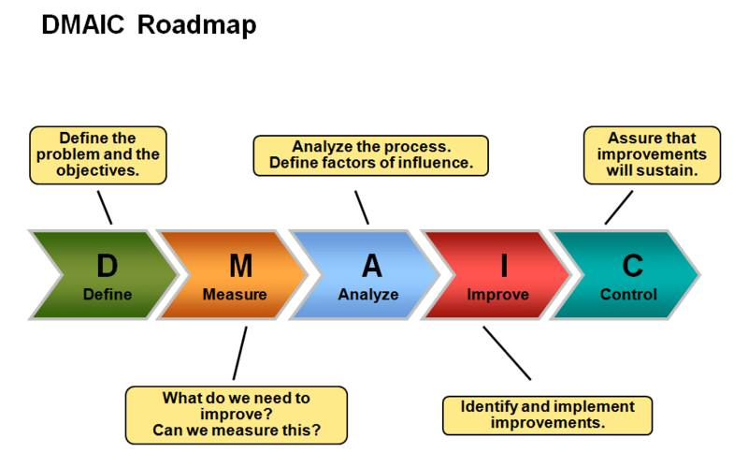
D – Define: Any problems that the business is facing must be defined before solution is put forward
M – Measure: the extent of the problem must be quantified with research data
A – Analyse: the data must be analysed to set goals and discover areas of weakness
I – Improve: analysis will reveal areas to improve
C – Control: maintain the previous processes to implement the improvements for long term success
The main drawback of this model may be that small companies would find it very costly and timely to implement these measures. Therefore, it may be only feasible for larger companies to implement.
Deming’s 14 Points
Dr Deming introduced his 14 Points system for TQM in the 1980’s. It also lays out processes for helping with managing quality of service. The image below shows an example of this:
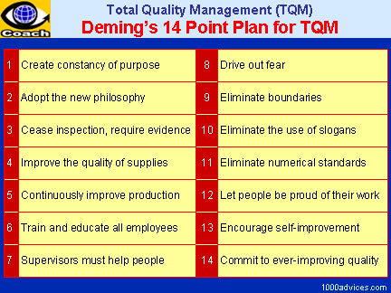
“Toyota and Sony are high-profile examples of companies that applied Deming's 14 points and helped Japan become a world manufacturing leader”, Lachance (2019).

SWOT
The table below is a SWOT analysis of Asda
Strengths | Weaknesses
- Part of Walmart Group  - Huge range of products  - Beloved British Institution  - Ethical and sustainable policies | - Uncertain financial climate  - Merger with Sainsbury’s blocked  - Not UK’s No1 supermarket
Opportunities | Threats
- Add more range of products  - Expand to new territories  - Improve CRM and TQM | - Tesco  - Budget supermarkets  - Brexit

The SWOT analysis shows that despite some uncertainties with Brexit and competition from other supermarkets, Asda has a huge amount of potential to implement new ideas, processes and policies to improve CRM and TQM.

Conclusion

Asda can adapt and use any one of these models to help it improve its CRM and TQM in the current financial and social climate. Asda is in a unique situation as it is a part of a larger organisation that operates internationally. It needs to continually monitor its TQM to remain in a position of competitive advantage.
Ethics, Sustainability, TQM and CRM are all susceptible to rapid and constant change. Indeed, these concepts are never static and change from time to time and place to place. What was once considered ethical in the United Kingdom two hundred years ago may not be looked at in the same light mow by the British public. However, this same thing may still be ethical in another country and to another demographic.
With Asda’s ethical and sustainability policies that are clear and helpful, these will have a hugely positive impression on the TQM and CRM.

Recommendations

The following are three recommendations for Asda to consider to further improve itself.
- Adapt a quality model. – whether it is the Sigma Six model or Deming’s 14 points model, each has its strengths and weaknesses. The Sigma Six model maybe the easier model to try and implement initially to see how and if things improve and can be maintained. This may also be the most cost effective
- Continue offering value – many UK customers see Asda as more value for money compared to Tesco and Morrisons. Asda needs to continue this trend and improve with new measures on CRM and TQM. This will come with implementation of a quality model.
- Start new marketing campaign – Asda can start a new marketing campaign highlighting to customers its values, ethics and sustainability policies. This will attract new customers who are more aware of these trends and ideas. These customers can then be retained with positive CRM and TQM strategies.

References

60Second Philosophy, (2015). What Is Ethics? https://www.youtube.com/watch?v=vnP1D7iL0Z4 (Accessed 20 March 2020)
Asda.com, (2020) https://www.asda.com/feeding-the-nation. (Accessed 25 March 2020)
Carbon Radio, (2019) What is Sustainability? https://www.youtube.com/watch?v=ez3KMZ9cp30 (Accessed 25 March 2020)
CIPD, (2019). Ethics At Work: An Employers Guide https://www.cipd.co.uk/knowledge/culture/ethics/ethics-work-guide. (Accessed 20 March 2020)
Fisher, K. (2018) Asda Rolls Out New Mental Health Policy, Occupational Health and Wellbeing. 70(5). Available at: https://search-proquest-com.ezproxy.uwtsd.ac.uk/docview/2136875287?accountid=130472&rfr_id=info%3Axri%2Fsid%3Aprimo (Accessed 25 March 2020)
Kumar, P. (2020) What Is Sigma Six: A Complete Overview. https://www.simplilearn.com/what-is-six-sigma-a-complete-overview-article (Accessed 26 March 2020)
Lachance, E. A. (2019) How Companies Have Applied Deming’s 14 Points In Manufacturing. https://blog.worximity.com/en/industry-4_0/how-companies-have-applied-demings-14-points-in-manufacturing (Accessed 26 March 2020)
Lakshmi, R. V. and Kennedy, H. (2017) “The Role of Business Sustainability in Human Resource Management: A Study on Indian Manufacturing Companies”, South East Asian Journal of Management, 11(1), pp. 70–85. [Online] Available at: https://web-a-ebscohost-com.ezproxy.uwtsd.ac.uk/ehost/detail/detail?vid=0&sid=d6848237-f4d4-4718-bc1e-e57b81186033%40sessionmgr4008&bdata=JnNpdGU9ZWhvc3QtbGl2ZQ%3d%3d#AN=123390597&db=bth (Accessed 25 March 2020)
Nguyen, T. and Nagase, K. (2019) “The Influence of Total Quality Management On Customer Satisfaction”, International Journal of Healthcare Management, 12(4). pp. 277-285. Available at: https://web-b-ebscohost-com.ezproxy.uwtsd.ac.uk/ehost/detail/detail?vid=0&sid=1b3508f2-51bb-4b81-8beb-6e1df9191cab%40sessionmgr101&bdata=JnNpdGU9ZWhvc3QtbGl2ZQ%3d%3d#AN=138278050&db=bth (Accessed 26 March 2020)
Trusov, A. (2019) “Modern Casting”, Des Plaines, 109(11). (p31-34). [Online] Available at: https://search-proquest-com.ezproxy.uwtsd.ac.uk/docview/2322344761?accountid=130472&rfr_id=info%3Axri%2Fsid%3Aprimo (Accessed 26 March 2020)
Stein, A. and Ramaseshan, B. (2016) “Towards the identification of customer experience touch point elements”, Journal of Retailing and Consumer Services. (30). pp. 8 – 19. Available at: https://www-sciencedirect-com.ezproxy.uwtsd.ac.uk/science/article/pii/S0969698915301855 (Accessed 26 March 2020)
Urban, J. (2018) Possibilities and limits of adopting successful managerial approaches: from "Best Practice" to "Best Fit", Studia Commercialia Bratislavensia. 11(39). pp118-127. Available at: https://web-b-ebscohost-com.ezproxy.uwtsd.ac.uk/ehost/detail/detail?vid=0&sid=9234c91a-b9d1-4500-b2e4-80fe3a677aa9%40pdc-v-sessmgr01&bdata=JnNpdGU9ZWhvc3QtbGl2ZQ%3d%3d#AN=131080439&db=bth (Accessed 27 March 2020)

