BMSW4008 Digital Skills for Personal and Professional Growth

Word Count: 2700 Words

Student Name: Helena Kandracova
Student ID: 2331019@student.uwtsd
Table of Contents
Task 1 Questionnaire Analysis 3
Task 2 Website Design and Marketing Material 5
Task 3 Importance of Microsoft Excel 6
Task 4 Short Advertising 10
References 11
Appendices 14
Appendix 1 Survey Questions 14
Appendix 2 Microsoft Excel 14
Appendix 3 Transcript for Video Presentation 14

Task 1 Questionnaire Analysis
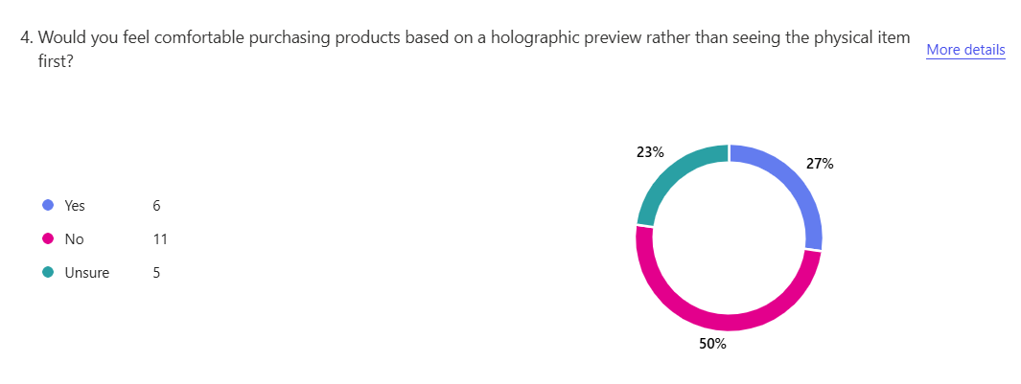
The above response recorded the intention of the customer to purchase the product using the holographic projection rather than the physical form, through the results it had been found that the respondents have stated that 6 respondents were willing to use this, while 11 respondents were more inclined towards the orthodox approach and the remaining are not sure. This might be because of the age gap among the respondents as they found that they belong to a relatively higher age group. This resulted in impacting the ability of the people to adapt to the new technological concepts (Kavitha, et al., 2022). Further influencing the ability of the customers, to purchase and learn new technology. As older respondents are less likely to purchase the technological innovation and accept the holographic presentation (Vinifa, et al., 2024).
According to the research the crucial aspects of technological trust and purchasing adaptability profoundly influence how consumers make their buying choices. The large group of consumers who neglect holographic previews holds its reservations primarily because they want reliable and physical items as well as authentic product experiences through virtual means. People who shop traditionally find reassurance when checking out products through physical interactions before completing their purchase. The uncertain respondents seem to exist between two categories as they might represent tech-savvy youth or tech-confident consumers who could support new technologies with adequate demonstrations and confidence-building. Businesses launching revolutionary products should begin by combining conventional and technological methods as this assists consumers who are transitioning to accept the new system.

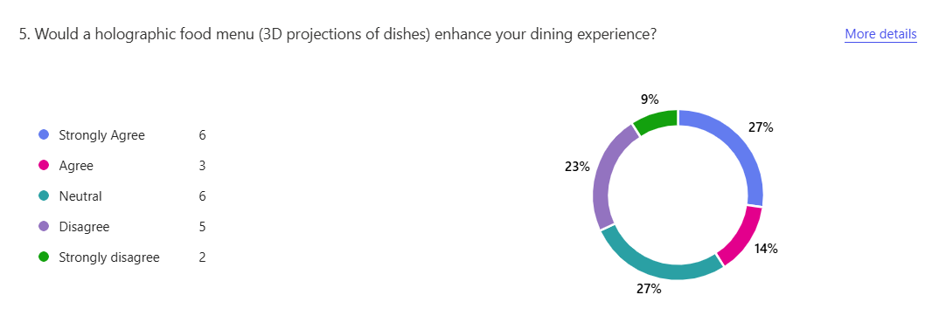
The above response states whether the holographic projection of the food menu could enhance the dining experience of the customers. Through the response, it was found that 6 respondents strongly agreed that the holographic food menu could aid in enhancing their experience. 3 respondents found that they agreed with the situation of the food menu 6 respondents were neutral on the perception as they found that the holographic menu could aid in improving the experience while the rest neglected the intention of accepting the holographic menu. It recorded the intentions of the customers to accept the menu that are necessary for building the customer experience and accepting the intentions for purchasing the product and even meeting the customer demand (Haleem, Arous and Amer, 2021; Surya, Sampathsree and Swetha, 2024).
The information demonstrates that some restaurant customers show enthusiasm for including 3D food projections yet others maintain reservations about the concept. Some customers who responded neutrally or disagreed possess doubts about 3D food projections because they lack exposure or worry about privacy issues or fear they will undermine traditional dining experience charm. The responses reflect different demographics of customers who include their age along with technology experience and their cultural values. Holographic menus should be implemented gradually by restaurants since they should offer standard options alongside virtual menu choices.

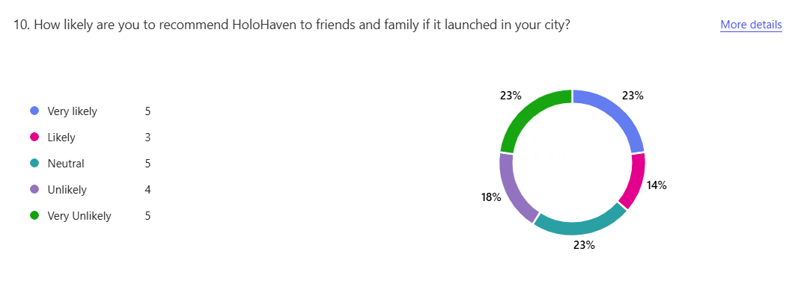
The above response recorded states whether the respondents would recommend the HoloHaven to friends and family if they were launched in the city. 5 respondents stated that they are more likely to recommend to their friends and family about the product. 3 are likely to recommend the services offered by the company to customers and friends. 5 respondents had a neutral approach to this. 4 respondents are less likely and the remaining 5 are very least likely to do so. This was possible because of the changing intentions of the customers and keeping strong intentions for building the customers. This is the reason for implications and promoting the product to a wider audience (Çöl, İmre and Yıkmış, 2023; Moya Ruiz, 2023; Dampage, et al., 2021).
The assessment of public perception needs both statistical data analysis and awareness of external elements which affect these results. Public perception and recommendation willingness depend heavily on multiple aspects including brand visibility and both pre- and post-service quality together with how users experience the services and powerful market competition. Survey participants frequently weigh their survey answers against their personal beliefs and previous dealings with other individuals. This level of public neutrality ABOUT HoloHaven indicates potential growth areas that can be improved by strategic market strategies along with better stakeholder engagement. Several users show resistance to endorsing HoloHaven because they have doubts about its trustworthiness and its unknown qualities as well as its actual worth. The solution of resolving these problems proves essential for boosting customer loyalty levels. Customer feedback together with continuous adaptation will make HoloHaven more appealing so it can strengthen its market position in this new market segment.

Task 2 Website Design and Marketing Material
URL of Website: https://holohaven.weebly.com/
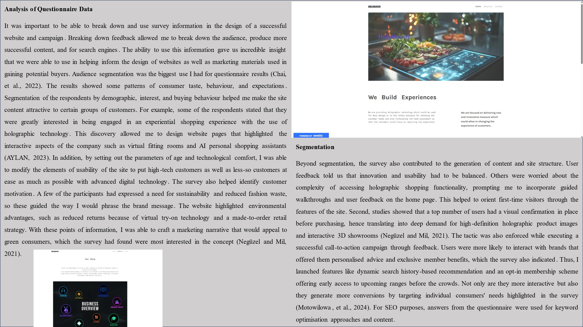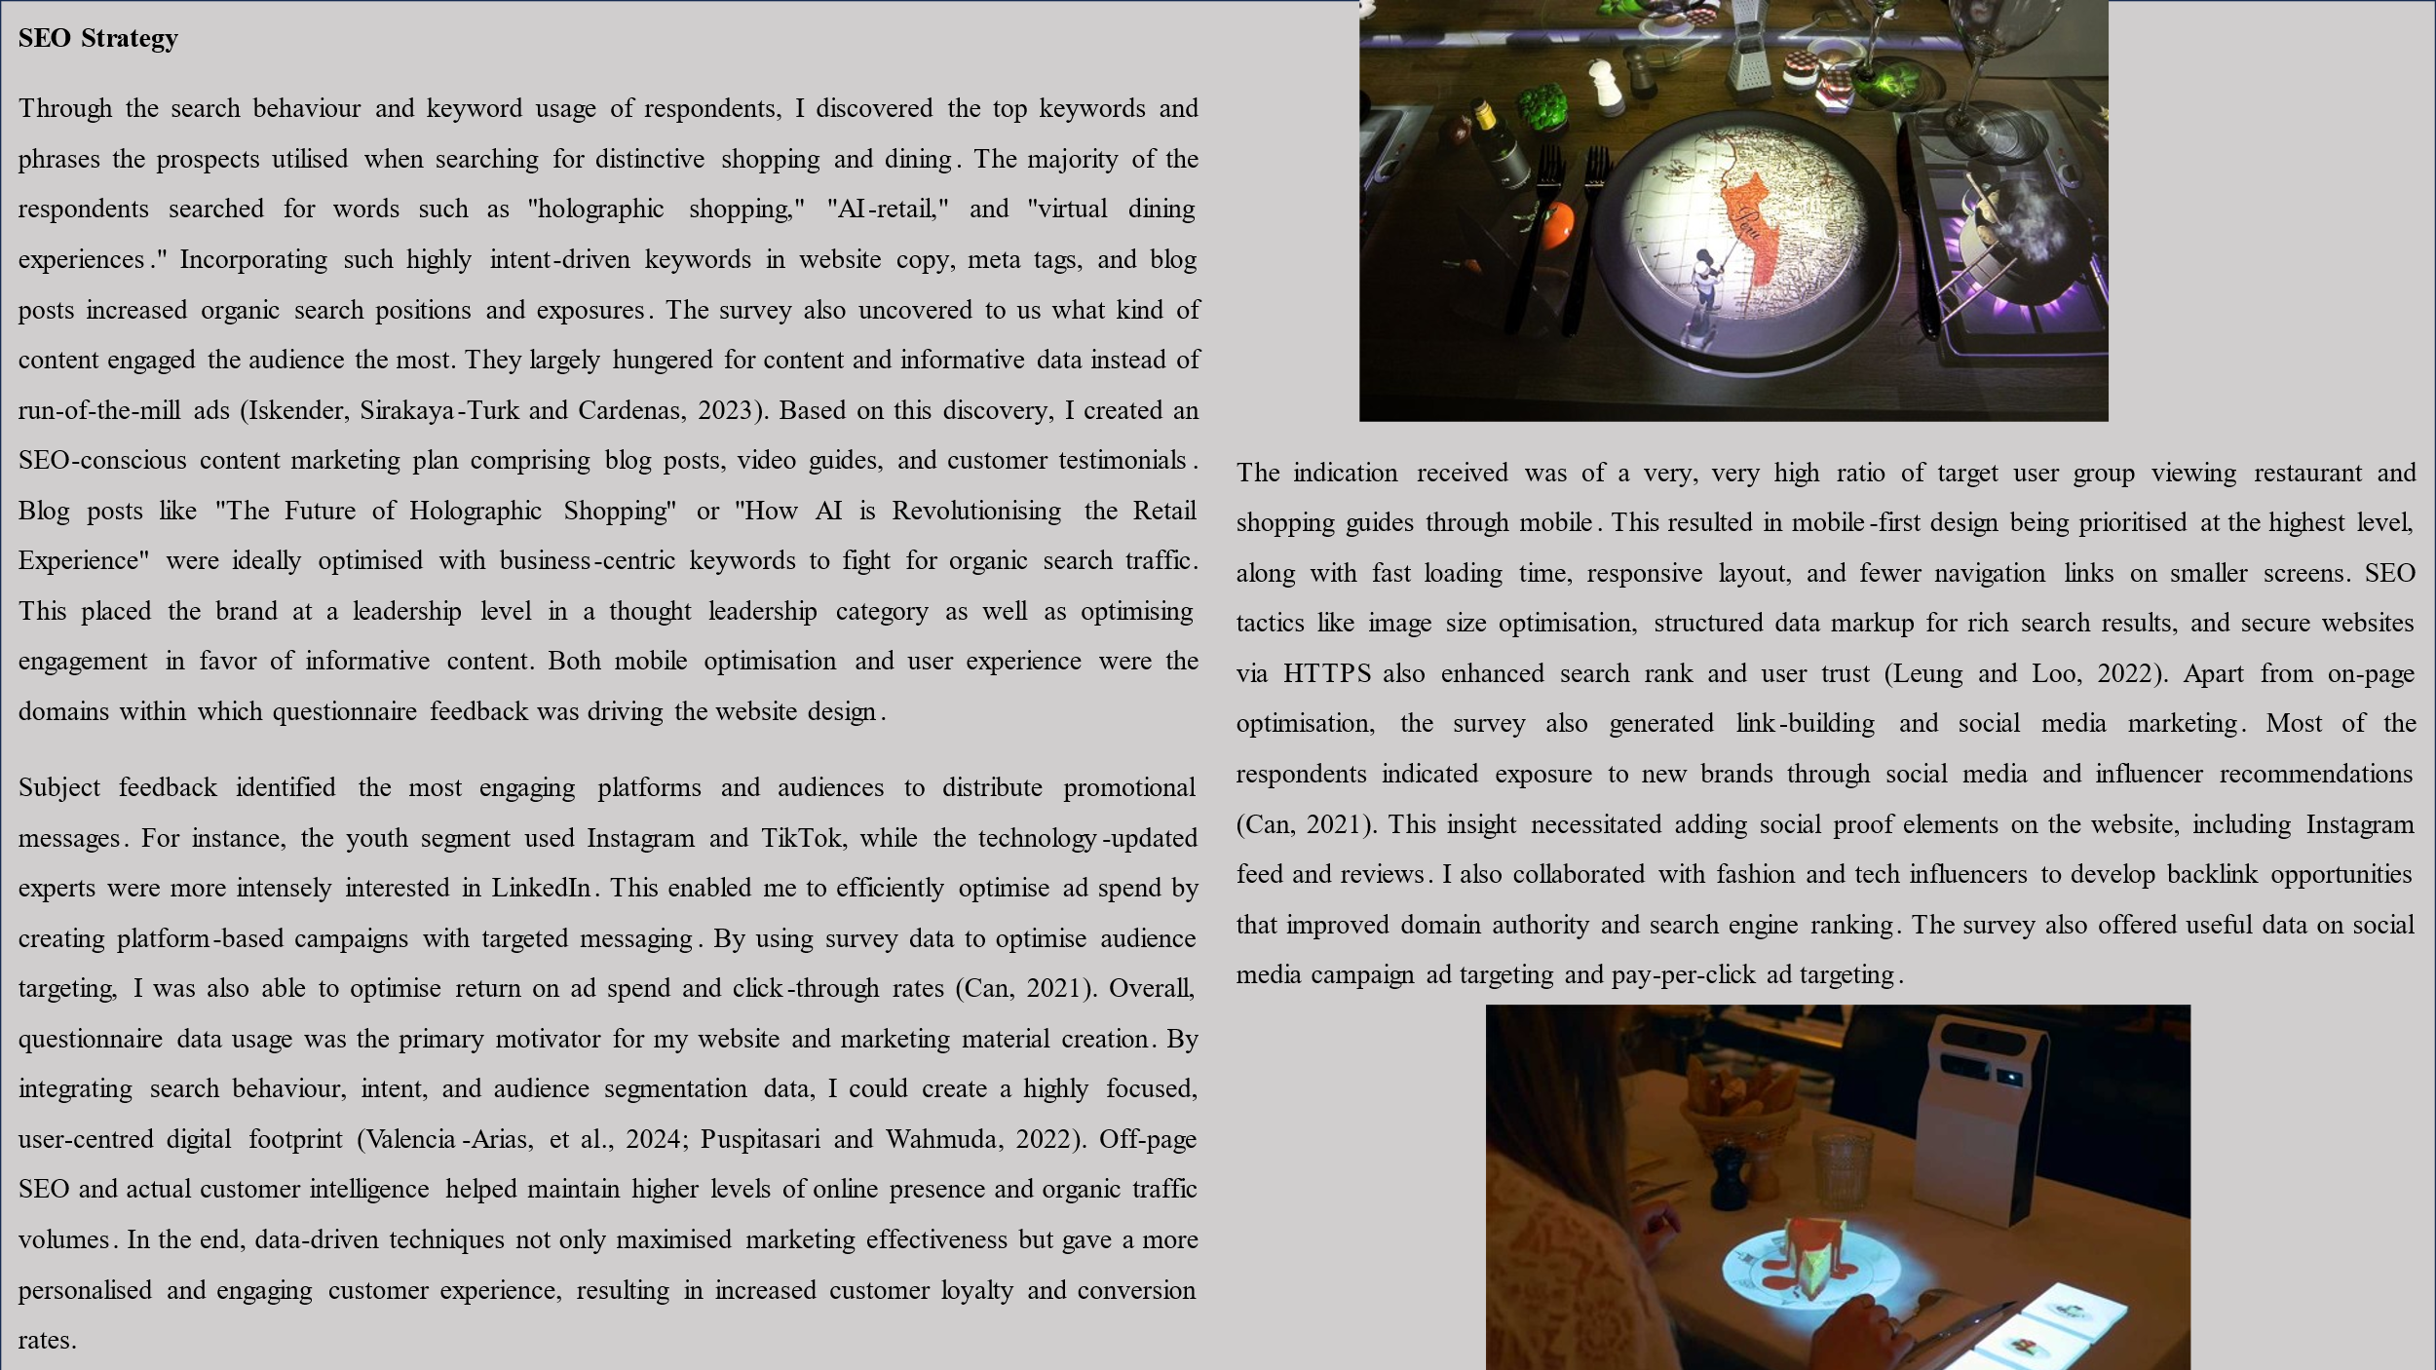

Task 3 Importance of Microsoft Excel
Category | Calculation | Amount (£)
Revenue Projection
Target Customers | 15,000 customers
Average Orders/Month | 3 orders per customer
Total Orders/Year | 15,000 × 3 × 12 | 540000
Revenue per Order | Fixed Price | £30
Total Revenue | 540,000 × £30 | 16200000
Cost of Goods Sold (COGS)
Ingredient Cost/Order | Fixed Cost | 16
Packaging Cost/Order | Fixed Cost | 2
Delivery Cost/Order | Fixed Cost | 6
Total COGS/Order | 16+2+6 | 24
Total COGS | 540000*24 | 360000
Gross Profit | Revenue - COGS | 15840000
Gross Profit Margin | (£1,800,000 / £5,400,000) × 100 | 10227.27%
Operating Expenses
Marketing & Advertising | Estimated Cost | 250000
Salaries & Wages | Staff & Management | 500000
Technology & Website | Maintenance & Updates | 300000
Rent & Utilities | Office & Storage Costs | 400000
Customer Service/Admin | Support & Administration | 250000
Miscellaneous Costs | Other Business Expenses | 100000
Total Operating Expenses | Sum of Above | 1800000
Net Profit | Gross Profit - Operating Expenses | 14040000
Net Profit Margin | (£550,000 / £5,400,000) × 100 | 1282.05%
Break-Even Analysis
Fixed Costs (Operating Expenses) |  | 2500000
Contribution Margin/Order | £30 - £20 | £10
Break-Even Orders | 2500000/10 | 2500000

Microsoft Excel, in the meantime, has with time continued to be the best and most viable tool of the new era. The most distinctive feature of Excel is its ability to offer management of money, management of information, decision-making, and automation. In the data era when data is the highlight in everything, having a basic proficiency in Excel has become a necessary skill to have among professionals of every trade (Remenyi, Onofrei and English, 2022). Businesses churn out humongous quantities of data that need to be sifted through, analysed, and interpreted. Excel is simple to sort, save, and play with data. With the help of functions such as VLOOKUP, pivot tables, and conditional formatting, Excel makes it easy to make conclusions from unpretty sets of data (Mount, 2024). It thus turns into a highly useful tool in data analysis and business intelligence where conclusions are drawn from firmly ensnared options.
Excel makes financial modelling, forecasting, and budgeting easy due to its advanced functions and formulas. Organisations utilise Excel to create expenses, cash flows, and financial statements. Automation of the calculation assists in removing the room for errors to be committed and improving the precision of the reports (Mount, 2024). Excel also assists firms in preparing for financial situations utilising the goal seek and scenario analysis tools, thus preparing them strategically. Another feature that is a testament to how much Excel is essential is how it is utilised in automation and improvement in productivity (Tu and Akhter, 2023). Functions that were formerly cumbersome to accomplish using the services of manual labour hours are now theoretically possible to automate using Excel's built-in functionality and macros. Visual Basic for Applications (VBA) enables the user to create tailored automation scripts, introducing even more ease into the process. Excel automation has extremely deep implications in business activities, particularly in business activities engaged in repetitive data entry, report generation, and activity tracking.
Excel is applied by scientists and students for analysing data, plotting data, and conducting research. Excel is an easy application in science and social studies by hypothesis testing, regression analysis, and correlation coefficient. Excel is also used by researchers as a teaching tool where they use it to illustrate mathematics concepts, analyse surveys, and develop problem-solving instructional aids (Tu and Akhter, 2023). Apart from its analytic potential, Excel is also an important utility to use while working with data visualisation. Providing charts, graphs, and dashboards, as it can do, is of greatest concern for reporting data to businesses and individuals. Data visualisation simplifies communication, and hence it becomes possible for the stakeholders to envision patterns and trends immediately (Tu and Akhter, 2023). The software allows reports and presentations where the data is utilised to make decisions. It is because of the ease with which Excel and other computer programs and technology are used that it is utilised today in the computer age.
It is highly compatible with business intelligence software, cloud computing environments, and databases and can be shared and collaborated on in real-time. The users can also edit and view their Excel sheets remotely using cloud-based services like Microsoft 365, which provides collaboration and remote working features. Excel's ability to support various types of files and its compatibility with tools such as Power BI, SQL database, and CRM applications optimise the use of Excel, and it is now integrated into business processes (Tu and Akhter, 2023).
While data analysis software and AI-based software have been designed innovatively, Excel remains a basic skill for every professional. Its ease, powerful list of functions, and regular updations make it an indispensable tool in the modern era. Organisations even put a lot of emphasis on Excel skills while recruiting employees as it is a representation of analytical brains, problem-solving skills, and hard work (Tu and Akhter, 2023). Whether novice or old, Excel has a learning curve that can be designed to fit the level of one's experience to help one gain useful technical knowledge in the long term. Since the nature of technology is always changing, so is Excel, and it is integrating artificial intelligence and machine learning capabilities into its operations.
Power Query, data analysis toolpak, and AI-insights are Revolutionising the way the world works with data. Since Microsoft is continuing to make Excel stay in the game for the future by keeping updated with the changing digital world, it is going to be part of the kit forever. In short, the role of Excel today cannot be exaggerated. Since it can handle data, do calculations on finances, automate things, boost productivity, and interface with other systems, it's a central system in all business sectors across the world. Business, learning, and academic research rely on Excel as part of decision-making and solving problems.

Task 4 Short Advertising
The advertising shows proper storytelling on how the products are being showcased. In the storytelling approach, the main thing which is shown using the advertising is the approach of how the technology is used for promoting the product in the market. Further, the storytelling is expected to identify the usability of the product by showcasing the non-tech-savvy people how the technology could be used so that the usability could be improved drastically. Moreover, it has been stated that advertising is required. Further, the advertising is designed the improve the knowledge of the customers and even focuses on providing an approach on how the technology could be used for promoting the approach for meeting the goals and even formulating the right knowledge that could allow in shaping the intentions for meeting the goals and even the future which the brand is seeing for developing the brand. Further, the storytelling approach has been used in the perspective storytelling in which the advertisement is focused on showing an elderly person going to a hologram restaurant and using the technology to order the dishes.

References
AYLAN, K.C. (2023) 'NEW TECHNOLOGIES IN EVENTS. SOCIAL, HUMAN AND ADMINISTRATIVE SCIENCE, p.1. https://www.researchgate.net/profile/Alihan-Celtek/publication/377078483_Electronic_Flight_Bag_EFB_Fat_Finger_Cases_In_The_Cockpit/links/6594663a6f6e450f19c48ae9/Electronic-Flight-Bag-EFB-Fat-Finger-Cases-In-The-Cockpit.pdf#page=9
Can, Ü. (2021) ‘A conceptual assessment of current trends in the restaurant industry accompanied with future forecasts’. Journal of New Tourism Trends, 2(2), pp.209-219. https://dergipark.org.tr/en/download/article-file/2086289
Chai, J.J., O'Sullivan, C., Gowen, A.A., Rooney, B. and Xu, J.L. (2022) ‘Augmented/mixed reality technologies for food: A review’. Trends in Food Science & Technology, 124, pp.182-194. https://www.sciencedirect.com/science/article/pii/S0924224422001509
Çöl, B.G., İmre, M. and Yıkmış, S. (2023) ‘Virtual reality and augmented reality technologies in gastronomy: A review’. Efood, 4(3), p.e84. https://iadns.onlinelibrary.wiley.com/doi/pdfdirect/10.1002/efd2.84
Dampage, U., Egodagamage, D.A., Waidyaratne, A.U., Dissanayaka, D.W. and Senarathne, A.G.N.M. (2021) ‘Spatial augmented reality based customer satisfaction enhancement and monitoring system’. IEEE Access, 9, pp.97990-98004. https://ieeexplore.ieee.org/iel7/6287639/9312710/09469789.pdf
Haleem, W.M.A., Arous, S. and Amer, T. (2021) ‘Potentials benefits of applying three dimensional hologram technology (3DHT) in the hotel industry’. J. Fac. Tour. Hotels-Univ. Sadat City, 18. https://mfth.journals.ekb.eg/article_172665_af09b61a9239a61688b5083e1fb1ecc2.pdf?lang=en
Iskender, A., Sirakaya-Turk, E. and Cardenas, D. (2023) ‘Restaurant menus and COVID-19: implications for technology adoption in the post-pandemic era’. Consumer Behavior in Tourism and Hospitality, 18(4), pp.587-605. https://www.researchgate.net/profile/Ali-Iskender/publication/373043271_Restaurant_menus_and_COVID-19_implications_for_technology_adoption_in_the_post-pandemic_era/links/64d7c88325837316ee09516a/Restaurant-menus-and-COVID-19-implications-for-technology-adoption-in-the-post-pandemic-era.pdf
Kavitha, M., Venkatesh, J., Salma, S.K. and Moosa, S.R. (2022, June) ‘Virtual reality (Hologram) based food supply system in smart restaurant based menu ordering system’. In 2022 7th International Conference on Communication and Electronics Systems (ICCES) (pp. 449-454). IEEE. https://ieeexplore.ieee.org/abstract/document/9835976/
Leung, R. and Loo, P.T. (2022) ‘Co-creating interactive dining experiences via interconnected and interoperable smart technology’. Asian Journal of Technology Innovation, 30(1), pp.45-67. https://www.academia.edu/download/65562521/Co_creating_interactive_dining_experiences_via_interconnected_and_interoperable_smart_tec.pdf
Motowilowa, J., Vergari, M., Kojić, T., Warsinke, M., Möller, S. and Voigt-Antons, J.N. (2024) ‘Exploring Augmented Table Setup and Lighting Customization in a Simulated Restaurant to Improve the User Experience’. arXiv preprint arXiv:2411.10230. https://arxiv.org/pdf/2411.10230
Mount, G. (2024) Modern Data Analytics in Excel: Using Power Query, Power Pivot, and More for Enhanced Data Analytics. " O'Reilly Media, Inc.".
Moya Ruiz, B. (2023) GlassFood: The holographic healthy smart recipe app. https://ddd.uab.cat/pub/tfg/2022/tfg_1334169/first_delivery_bruno_glassfood.pdf
Negüzel, F.K. and Mil, B. (2021) ‘cHaPTER XX VIRTUaL REaLITY In GaSTRonoMY: EVaLUaTIon of REaLITY THEoRIES’. The evaluations and researches in social sciences and humanities, p.378. https://www.academia.edu/download/102377926/The_20Evaluations_20and_20Researches_20in_20Social_20Sciences_20and_20Humanities.pdf#page=385
Puspitasari, R. and Wahmuda, F. (2022) ‘Penerapan Teknologi Sterilisasi dan Visualisasi Hologram pada Redesain Furnitur Ruang Publik Komersial’. Ars: Jurnal Seni Rupa dan Desain, 25(1), pp.79-84. https://journal.isi.ac.id/index.php/ars/article/viewFile/6439/2589
Remenyi, D., Onofrei, G. and English, J. (2022) An introduction to statistics using Microsoft Excel. UJ Press.
Surya, U., Sampathsree, N. and Swetha, M. (2024, June) ‘Virtual Reality For Eco-Conscious Customer Engagement’. In 2024 International Conference on Innovations and Challenges in Emerging Technologies (ICICET) (pp. 1-7). IEEE. https://ieeexplore.ieee.org/abstract/document/10616271/
Tu, J.J. and Akhter, S. (2023) ‘Exploring the role of entrepreneurial education, technology and teachers’ creativity in excelling sustainable business competencies’. Economic research-Ekonomska istraživanja, 36(1). https://hrcak.srce.hr/file/442397
Valencia-Arias, A., Cardona-Acevedo, S., Martínez Rojas, E., Ramírez Dávila, J., Rodriguez-Correa, P., Palacios-Moya, L., Teodori de la Puente, R., Agudelo-Ceballos, E. and Benjumea-Arias, M. (2024) ‘Trends in Smart Restaurant Research: Bibliometric Review and Research Agenda’. F1000Research, 13, p.1505. https://onlinelibrary.wiley.com/doi/pdf/10.1111/fcsr.12476
Vinifa, R., Prasad, N.V., Santhosh, A. and Amarnath, M. (2024, April) ‘Contact-less Food ordering System in Restaurants using hologram’. In 2024 10th International Conference on Communication and Signal Processing (ICCSP) (pp. 444-447). IEEE. https://ieeexplore.ieee.org/abstract/document/10544019/

Appendices

Appendix 1 Survey Questions

Appendix 2 Microsoft Excel

Appendix 3 Transcript for Video Presentation

