01/05/2025 – First Meeting – Shortlisting Task

Candidate Name: 001 Job Title:

ATTRIBUTES | ESSENTIAL | DESIRABLE | TOTAL
Qualifications | GCSE – C grade of above in core subjects e.g English, Maths | Food Standards Agency Certificate in food allergy and intolerance | 0
Experience |  | Previous experience in Hospitality or Customer Service | 1
Knowledge | Customer Service  Information about Allergy |  | 1
Skills | Attention to detail  Problem solving  Multi-Tasking |  | 1
Personal qualities | Ability to work as part of a team | Enthusiasm  Empathy | 1
Additional Requirements | Right to work in UK | Flexibility  Weekend Working | 1
TOTAL SCORE |  |  | 5
Interview – Y/N |  |  | N

Scoring:
- Does not meet criteria
- Partly meets
- Fully meets
- Exceeds

Candidate Name: 002 Job Title:

ATTRIBUTES | ESSENTIAL | DESIRABLE | TOTAL
Qualifications | GCSE – C grade of above in core subjects e.g English, Maths | Food Standards Agency Certificate in food allergy and intolerance | 2
Experience |  | Previous experience in Hospitality or Customer Service | 3
Knowledge | Customer Service  Information about Allergy |  | 3
Skills | Attention to detail  Problem solving  Multi-Tasking |  | 2
Personal qualities | Ability to work as part of a team | Enthusiasm  Empathy | 2
Additional Requirements | Right to work in UK | Flexibility  Weekend Working | 2
TOTAL SCORE |  |  | 14
Interview – Y/N |  |  | Y

Scoring:
- Does not meet criteria
- Partly meets
- Fully meets
- Exceeds

Candidate Name: 003 Job Title:

ATTRIBUTES | ESSENTIAL | DESIRABLE | TOTAL
Qualifications | GCSE – C grade of above in core subjects e.g English, Maths | Food Standards Agency Certificate in food allergy and intolerance | 0
Experience |  | Previous experience in Hospitality or Customer Service | 0
Knowledge | Customer Service  Information about Allergy |  | 0
Skills | Attention to detail  Problem solving  Multi-Tasking |  | 1
Personal qualities | Ability to work as part of a team | Enthusiasm  Empathy | 2
Additional Requirements | Right to work in UK | Flexibility  Weekend Working | 1
TOTAL SCORE |  |  | 4
Interview – Y/N |  |  | N

Scoring:
- Does not meet criteria
- Partly meets
- Fully meets
- Exceeds
This is a template that can be adapted as required. Examples should be removed from submission for assessment.

Interview Questions discussion via Teams: 01/05/2025

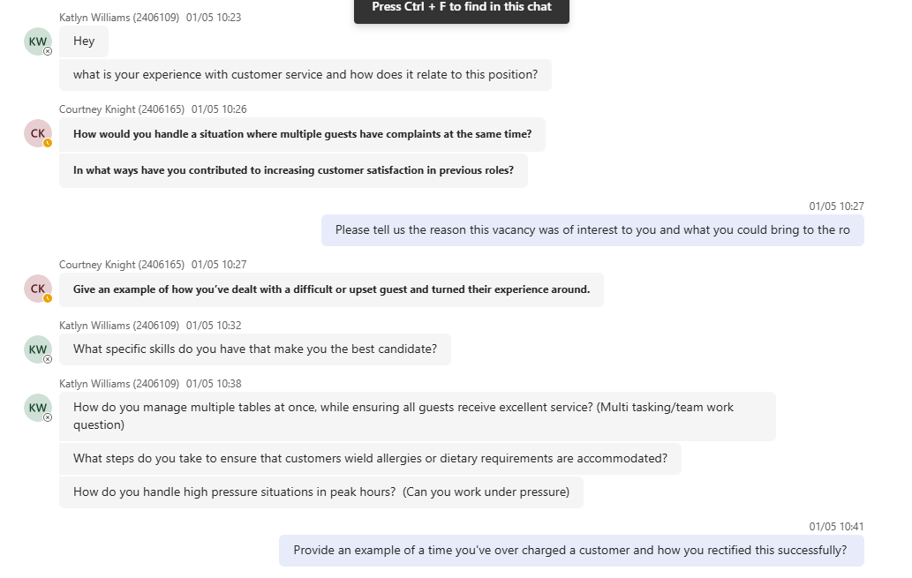

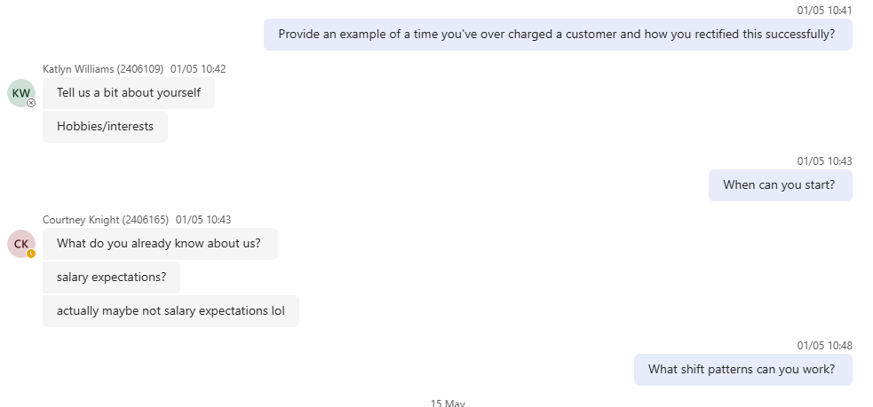

Interview date – 05/06/2025
Notes:

Food and Beverage Assistant Interview Pack

Interview Information
Candidate Name | Rhiannon
Interviewer Name | Dion Evans – Inter Lux Hotel Group – F&B Manager
Interview Date | 05/06/2025

Information Gathering

- Can you start by telling us a bit about yourself
- education
- qualifications
- Please can you explain why this vacancy was of interest to you
- What specific skills can you bring to the role that make you the best candidate? DE
- What is your experience with customer service and how does it relate to this position?
1.Vital qualifications for the role – Food hygiene L2
2.Want a greater change of role to current role within F&B.
3. Applicant is customer focused and can take instruction well. They prioritise what needs to be done and is proactive. Not worried about asking for help.
4.Great detail about their customer service experience. They explained that they customers always have unrealistic expectations and it happy to problem solve around this.

Test of Behaviour

- In what ways have you contributed to increasing customer satisfaction in a previous role?
- Give an example of how you have dealt with a difficult or upset guest and turned their experience around - DE
- What steps do you take to ensure that customers allergies or dietary requirements are accommodated?
- How would you manage multiple tables at once, while ensuring all guests receive excellent service?

1.Cusomer satisfaction is important, and applicant is proactive in providing a high level of service for customers
2/3. Applicant understands the allergy menu and dietary requirements needed. When the customer was upset, the applicant replaced the meal that the customer didn’t want.
4.When managing multiple tables, applicant explained that they are efficient and proactive when cleaning tables.

Starting information

- How soon would you be able to start? (Do you have a notice period, holidays booked etc?) DE
- What is your availability in terms of hours and days?
- Any questions?
- DE – Finish

- Applicant has given notice but not sure on their notice period / no holidays booked.
- They are looking for a part time vole, evening / during the week. Requestion no Sundays. They can drive to other sites.
- Question asked about progression – wants to become Team Leader.

Candidate Evaluation

Please evaluate the candidate as follows and score (X) accordingly.
 | Excellent | Strong | Average | Weak | N/A
Strength of the candidate’s  educational background: |  | X
Strength of the candidate’s prior  work experience: |  | X
Candidate’s communication skills: |  | X
Candidate’s job-specific skills: |  | X

Overall Impressions & Recommendation
Please describe your overall impressions of this candidate, as well as any traits or skills you believe would make them especially suitable for this role:
Great overall impression. Would hire due to experience and knowledge. Great specific responses to certain vital questions.

Final Recommendation
Please mark your recommendation (X) accordingly.
 | Hire | Hold | Do Not Proceed
Hire recommendation | X

