Virtual Learning Environment

Module: Digital Skills and Research Methods
Lecturer: Koushick Kodak

Student: Samuel Dias Domingues
Student ID: 1817913
Contents
1. Introduction Page 3
2. Literature Review Page 3
3. Rationale Page 4
4. Methodology Page 4
5. Findings and Analysis Page 4
6. Conclusion Page 5
7. References Page 5
8. Appendices Page 6

1. Introduction
In this report, it is shown a series of data which shows students interaction with Moodle, a virtual learning environment provided by the university that they are enrolled in, University of Wales Trinity Saint David. It goes into detail about some of the questions answered and how effective Moodle as a virtual learning environment is for students, their point of view on this platform and the suggestions they have to make this platform easier to use and more effective at meeting their needs as part time students, when most of their learning is done through the use of a virtual learning environment.
2. Literature Review
As technology has evolved, the tools that have come along with it have resulted in the implementation of some of these tools in the learning process of some students. Due to these advancements in technology some educational bodies have the need to apply Virtual Learning Environment, this platform of learning allows standard processes of these educational bodies to be conducted such as teaching, learning, and assessing. Along with all these changes came applications that would allow these virtual learning platforms to be managed (Oproiu, 2015).
Virtual learning platforms are currently being used to support standard teaching. With resources being available on these platforms, students are able to complete standard activities from institutions, these students are not only able to complete exercises and study content on their own, but also many other activities. Although these activities are possible and available to students, they do however require some determination, due to the fact that these activities would be accomplished unsupervised. Virtual learning platforms also have electronic means of communication which allows students to get in contact with staff members of the institution they are enrolled and vice versa. These platforms are also managed differently by staff members and students, with different controls for each of them (Oproiu and Chicioreanu, 2012).
Given this information Moodle is a Virtual Learning Environment system, which contains methods communication between students and university staff members, sources about in-class exercises and lectures, electronic library and many other resources at both students and university staff members disposal. Moodle is also a complimentary resource, meaning all you need to access its contents is a device that is connected to the internet, as well as it has a very easy to access interface that allows those with less experience with technology to use its content with little to no trouble.
The Moodle virtual learning environment is always being looked over and having updates done to keep up with both its users and improvements to technology, this keeps Moodle an easy to access platform. Being a worldwide system, Moodle supports over 120 languages, which allows for improvement suggestions to be done with little to no language barriers, it also provides resources such as support for the community and forums for community discussion. Moodle is not only focused on students but also teaching staff, with a tracking process, that allows for both teaching staff and students to keep up with activities done as well as resources. With the advancing of technology Moodle is also able to update its security, which allows for a safer online experience when using the platform, this feature also enables privacy for content to only be reviewed to a designated group of students or a specific class. Moodle has an assignment activity source that allows students to hand in assignments, receive feedback as well as receive grading, together with the ability to submit assignments as a group, this source also provides offline work to be completed (moodle.org, 2018).
3. Rationale
The aim of this report is to recognise students’ point of view and experience on virtual learning environment (Moodle) from the University of Wales Trinity Saint David and learn how the students manage to adapt to the learning platform provided.
Moodle is a requirement for the completion of the university`s courses, as the courses requires the students to complete assignments and submit them via Moodle`s assignment feature. This Virtual Learning Environment also provides a well organised method of interaction between lectures and students and other university staff members, allowing them to communicate with students and allowing students to respond in an efficient manner.
4. Methodology
The research done in the report used a questionnaire with a total of 10 items. Of those 10 items, 4 were closed-ended items. 20 copies of the questionnaire were given out to 20 students of the University of Wales Trinity Saint David. This questionnaire had the purpose of identifying the students` experience and point of view of the Moodle Virtual Learning Environment. It also aims to identify
As this university has many courses to offer and does not separate different courses through different facilities, rather allocate students of different courses in the same facility, this questionnaire was given to students of various courses. This would not differentiate the outcome of the questionnaire as it is focused on acquiring information on students` experience and point of view of this Virtual Learning Environment and would affect all students of all courses and not a specific targeted group of people or courses.
The research done with this questionnaire, was completed on students that are part timers, so most of their studying is done via the virtual learning platform provided (Moodle).
No other information on the student such as: sex, religion, ethnicity were not recorded as it was not relevant to this questionnaire, as it is solo aimed at the experience they are having while using this virtual learning environment.
5. Findings and Analysis
When asked which of the students uses the Virtual Learning Environment (Moodle) 100 percent of the students who participated in the questionnaire responded that they did use the platform (figure1). Although the number of students who answered the questionnaire is fairly small, the total percentage of those who use the Moodle platform within the questionnaire is a great number.
50 percent who answered the questionnaire stated that they have never used a Virtual Learning Platform before (figure2). This could be due to the fact that most students that are enrolled at the university are returning to study after a long period of time. This is also a good addition to previous mentioned question, given that 50 percent of the students had not used a Virtual Learning Platform before, and all 100 percent now use a platform. It goes to show how relevant and useful the platform can be.
85 percent of students who answered the questionnaire stated that they would recommend Moodle as a Virtual Learning Environment. 10 percent of the students had said that they would not recommend the platform and only 5 percent were not sure as to whether or not they would recommend or not the Moodle platform (figure3). These numbers show that students are happy with the service provided by this virtual learning platform, given that the majority would recommend that others also use it.
When it comes to answering how satisfied students were about the Moodle platform, 70 percent of the students stated that they were satisfied with the content found in Moodle, 20 percent stated that they were very satisfied with Moodle and only 10 percent stated that they were neither satisfied or not satisfied with this virtual learning platform (figure4). Here it is shown that there are still a few students who would like this the platform to be improved to meet their needs to navigate and enjoy the features provided by Moodle.
From the 20 students who participated in this questionnaire, 80 percent answered that they had no suggestions for improvement of Moodle as a virtual learning platform (figure5). The data acquired from this question suggests that students have little to no difficulty accessing and managing tasks when using the Moodle platform.
6. Conclusion
From the answers given by the students who participated in this questionnaire, students who have not used any form of virtual learning platform before and are now given the opportunity to experience this new tool of learning institutions, and those who have had some experience before, they all currently have access and use the provided platform Moodle. By the level of satisfaction with this virtual learning environment, which the questionnaire showed none of the students were not satisfied with Moodle, leaving a total of 90 percent of students either satisfied or very satisfied.
Another answered question which shows how well this learning platform is performing, is whether or not they had any suggestions for improvement within the system supplied by the University of Wales Trinity Saint David, and 80 percent of students had no suggestions to improve this platform, leaving only a few students with some suggestions such as online library improvement with 10 percent of the students who answered the questionnaire, 5 percent suggested improvements on the structure of the tasks and 5 percent which suggested making this platform more fun to use. Although the number of no suggested improvements is great, there are still comments about how this platform could be improved and made it easier and more pleasant to use, all of which that could be taken into consideration if appointed to the IT department. Given that the students presented with this questionnaire and answered it, were part timer students, the percentage of those who had no suggestions for improvements indicates that Moodle is a great show of how far technology has come with the advancements for virtual learning environments.
Altogether, with the information provided by the questionnaire, it is believed that students are quite happy with the addition of the Moodle virtual learning platform, and also have very little to suggest as improvement of the platform. With technology quickly developing and improving, this virtual learning platform and many others could be of even greater help for students currently using this platform or future students.
7. References
Moodle.org. (2018). Moodle - Open-source learning platform | Moodle.org. [online] Available at: https://moodle.org/ [Accessed 7 Jan. 2020].
Oproiu, G. and Chicioreanu, T. (2012). Using virtual learning environments in adult education. [ebook] Brasov. Available at: http://www.afahc.ro/ro/afases/2012/socio/2.2/Oproiu_%20Chicioreanu_en.pdf [Accessed 5 Jan. 2020].
Oproiu, G. (2015). A Study about Using E-learning Platform (Moodle) in University Teaching Process. Procedia - Social and Behavioral Sciences, [online] 180, pp.426-432. Available at: https://www.researchgate.net/publication/277935033_A_Study_about_Using_E-learning_Platform_Moodle_in_University_Teaching_Process [Accessed 5 Jan. 2020].
8. Appendices
Figure1

Figure2

Figure3

Figure4
figure5

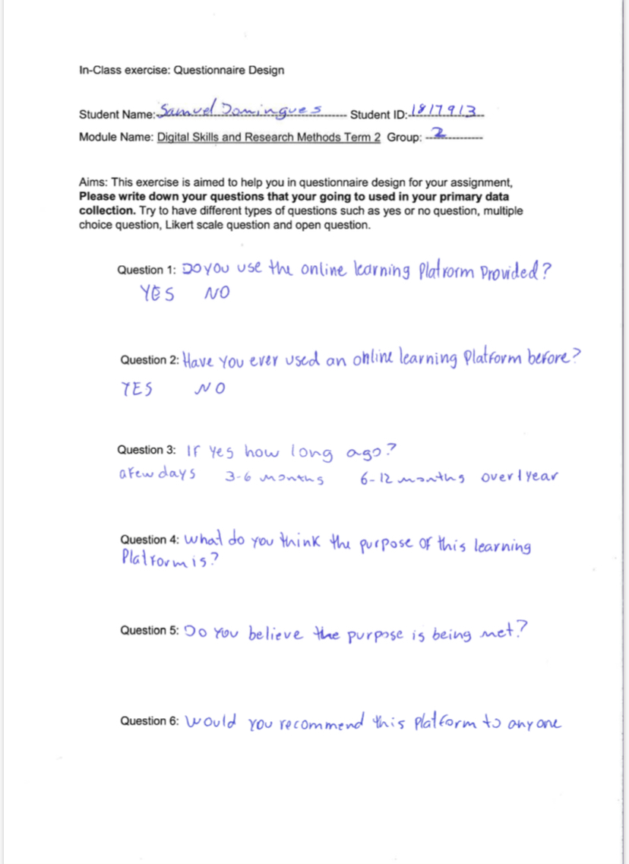
Figure6
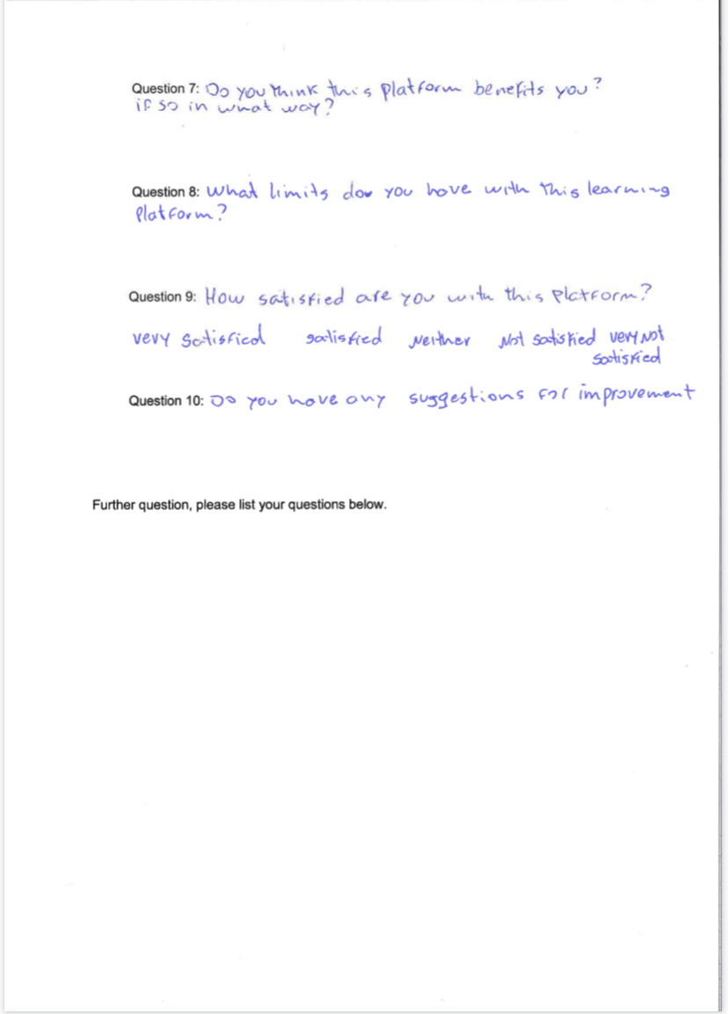
Figure7

