Sean Bamber
2320765
Abstract
This appraisal outlines the profitable, low-carbon retrofit of Lace House in Brighton, balancing heritage conservation with sustainable housing delivery. It demonstrates financial viability, ethical design, and replicability for future urban regeneration projects.
Report - development plan
Lace House
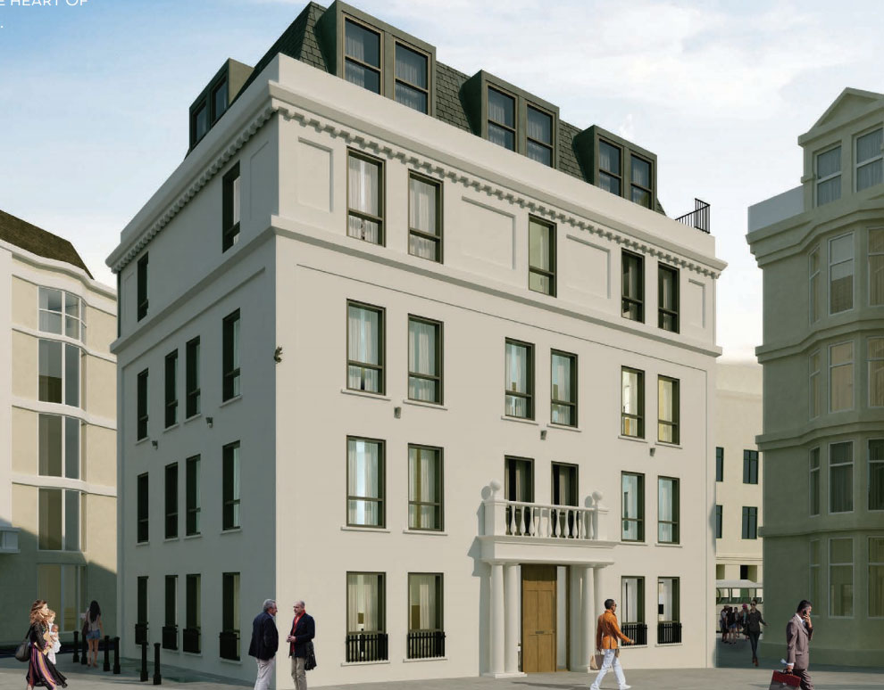

Table of Contents

1. Introduction 1

2. Site Description and Planning Context 2

3. Development Proposal 3

4. Financial Appraisal 4

5. Risk Assessment 6

6. Ethical and Sustainable Enhancements 7

7. Recommendations for Improvement 9

8. Conclusion 10

9. References 11

1. Introduction

This development appraisal assesses the financial viability, risk exposure, sustainability performance, and strategic potential of renovating and converting Lace House, a Grade II* listed office building in Brighton City Centre, into nine high-quality residential flats. The reconstruction intends to balance heritage preservation with modern housing needs while conforming to local planning standards and achieving at least a 10% return on investment (ROI). The plan is well-positioned to make a significant contribution to Brighton's critical housing shortage while incorporating adaptive reuse and climate resilience concepts.

The primary goal of this analysis is to determine the scheme's commercial feasibility and social utility from the standpoint of a construction firm shifting into property development. This work is predicated on an 18-month delivery timeline, a fixed land purchase cost of £1.5 million, a Gross Development Value (GDV) of £4.2 million, and phased investment drawdowns to optimise finance. To ensure accuracy, the appraisal refers to local authority planning policy, recent market intelligence (Savills, 2024; Knight Frank, 2024), and heritage retrofit best practice (RICS, 2023).

The aim is to appraise whether the development meets stakeholder expectations, planning obligations, and sustainable performance benchmarks, while achieving an ethically justifiable financial yield. The objective is to present a defendable strategy that balances profit with urban regeneration and heritage conservation.

2. Site Description and Planning Context

Lace House is located in a conservation area between the railway station and shopping centre, in the heart of Brighton's cultural and commercial districts. The location has excellent walkability, connection, and public realm integration, resulting in significant residential demand. As a Grade II* listed structure, it is subject to statutory heritage constraints, which require construction that adheres to architectural fabric and conservation area requirements, as mandated by Historic England and Brighton & Hove City Council.
The Brighton & Hove City Plan Part One (2023) outlines planning policies that aggressively favour brownfield regeneration and housing development. The design emphasises the reuse of underutilised commercial space to meet housing needs while conserving townscape character. These principles lend credence to the Lace House scheme's ethical and planning rationales. The idea also supports the National Planning Policy Framework's (2023) mandates on sustainable development, climate change adaptation, and urban densification.
The planning assumption is that the development will benefit from early-stage pre-application consultations, allowing for an iterative design approach in response to heritage and community feedback. The complete planning proposal will include a heritage statement, design-and-access report, daylight study, and lifecycle carbon assessment. Upgrades will concentrate on internal rearrangement, with little disruption to historic façades and structural aspects.

3. Development Proposal

The project comprises upgrading and converting an existing three-story office building into nine residential flats—six one-bedroom and three two-bedroom apartments. This plan is informed by evidence-based insights into Brighton's urban demographics, with a focus on young professionals, first-time buyers, and downsizing residents looking for accessible and sustainable homes in a central location.
The retrofit strategy prioritises fabric-first approaches. Internal wall insulation, high-efficiency secondary glazing, floor slab modifications, and airtightness enhancements are among the measures implemented. The building will be heated using an integrated air source heat pump system augmented by rooftop solar photovoltaics. Each unit will include MVHR systems to improve indoor air quality and reduce energy consumption. These systems are chosen based on their compatibility with heritage constraints and contribution to operational carbon savings.
The design meets the Nationally Described Space Standards (NDSS) and Lifetime Homes requirements. Internal layouts are optimised for daylight access, acoustic separation, and thermal comfort. Improved navigation and a reworked stair core help to improve circulation. Cycle storage is available at ground level. The internal finishes will prioritise recycled materials, long-lasting low-VOC paints, and water-saving fixtures. A conservation architect and historic expert will oversee the detailing and planning to protect heritage value.

4. Financial Appraisal
A thorough residual land value analysis was performed to thoroughly analyse the financial viability of the Lace House renovation, which included extensive lifespan cost estimates, carefully staged cash flow predictions, and clearly specified profit targets. This appraisal process is critical for assuring the project's economic viability throughout all stages, from land purchase to final sales. The financial assumptions were rigorously benchmarked against the Building Cost Information Service (BCIS) indices, which provide up-to-date and regionally appropriate cost data, as well as through an analysis of recent market comparable in Brighton's city centre residential conversion sector.
Development Cost Breakdown:
Land Acquisition (£1,500,000): The fixed-price land acquisition fee has been established to give predictability and eliminate exposure to market price volatility. This statistic shows the premium paid for a well-located, listed heritage asset, highlighting the site's intrinsic value and redevelopment possibilities.
Construction Costs (£1,350,000): Construction expenses are projected at £1,500 per square meter for a 900m² net internal area. This cost compensates for the added complexity of converting a Grade II* listed building, which necessitates specialised conservation skills, custom materials, and careful integration of current energy efficiency systems while preserving heritage elements.
Professional Fees (£202,500): These fees, which account for 15% of construction expenditures, cover the interdisciplinary team responsible for planning, design, heritage consulting, and project management. Their knowledge is crucial for reducing risk and ensuring compliance with severe conservation requirements.
Contingency Allowance (£135,000): A 10% contingency is prudently set aside to account for unforeseen construction obstacles and latent defects, which are typical in ancient building refurbishments.
Planning, Legal & Statutory Fees (£50,000): These expenditures involve planning applications, legal advice, and any essential statutory consents, ensuring that regulatory processes run smoothly.
Marketing and Disposal (£84,000): Marketing and sales expenses are calculated at 2% of the GDV and include commissions, advertising, and sales-related legal costs, which have been prudently calibrated for the competitive Brighton housing market.
Finance Costs (£165,000): Finance charges have been carefully adjusted to avoid excessive borrowing expenses and sustain profitability, using a 6% annual interest rate over an 18-month development period and staggered loan drawdowns aligned with project cash flow demands.
The total development cost is £3,486,500, with a gross development value (GDV) of £4,200,000. This results in a Net Profit Before Tax of £713,500 and a Developer Profit Margin of roughly 10.2%, which is somewhat higher than the average minimum return on investment (ROI) criterion of 10% for speculative urban historic conversions (RICS, 2023).
This financial outcome illustrates that the project is not only possible, but also provides a competitive return, which justifies the inherent risks associated with listed building conversion. To minimise over-optimism, the evaluation makes conservative sales price assumptions and uses fixed-price contracting procedures to keep costs under control. Efficient procurement processes, together with expected VAT collection on construction and professional costs, increase financial resilience and cash flow efficiency. Together, these criteria form a solid financial foundation that supports both lender confidence and developer appetite, ensuring the project's successful completion within budgetary and timeline constraints.

5. Risk Assessment
The development's risk profile has been examined in terms of planning, construction, financial, and market dimensions. Given the building's listed status, the most major threats are heritage and structural. Mitigation is integrated into the project through rigorous pre-construction surveys, consultation with statutory consultees, and generous contingency allowances. A Conservation Management Plan will guide any actions, ensuring that they are consistent with Historic England best practices.

Identified Risks and Mitigations:

Planning risk: was mitigated through early involvement, heritage assessments, and a complying design strategy, which included iterative interaction with Brighton & Hove City Council and Historic England. The involvement of a conservation specialist helps to decrease potential approval delays.

Structural Integrity Risk: Comprehensive surveys phased demolition experiments, and continual monitoring throughout construction have all helped to mitigate the problem. Where unknowns persist, risk is mitigated through preliminary estimates and flexible sequencing.

Cost Overrun: Managed with a 10% contingency, competitive tendering, and progressive drawdowns. Fixed-price subcontract packages will be prioritised to reduce vulnerability to inflationary pressures, and value engineering will be used post-tender to maintain budget discipline.

Market Demand Fluctuations: Offset by Brighton's lack of up-market housing, particularly centrally placed, low-carbon, and character-rich homes. Sales risk is further lowered by matching local housing demands and lifestyle preferences.

Finance Risk: Controlled through stable interest assumptions, limited borrowing exposure, and investor equity rather than speculative debt. Sensitivity analysis has been used to model interest rate fluctuations and ensure financial resiliency during stressful times.

Furthermore, reputational risk has been addressed, especially considering the site's significance and heritage status. Community participation and open communication tactics are offered as ways to retain public trust and avert opposition. Insurance coverage for latent faults and public responsibility will be in place.

Overall, the project is classified as medium risk. However, the controlled delivery technique, skilled professional staff, and predictable market environment limit exposure. The project's strategic location and conservation appeal serve as a powerful market hedge, protecting against larger economic cycles. By incorporating risk responsiveness into program design, contract structures, and stakeholder relations, the scheme is well-positioned to move forward with confidence.

6. Ethical and Sustainable Enhancements
The scheme's ethical and environmental policy ensures long-term viability and planning acceptance. Sustainability is approached in a holistic manner, including embodied and operational carbon, diversity, procurement ethics, and community benefit. According to the UKGBC (2024), retaining structural features results in an embodied carbon savings of around 450 tonnes CO₂e. This carbon-saving achievement aligns the development with LETI and RIBA guidelines for heritage retrofits and contributes to Brighton & Hove's climate action goals.
Air source heat pumps (ASHPs) and rooftop solar panels (PV) will cut operational carbon emissions by approximately 42% when compared to Part L 2013 norms. Passive design factors like sunshine optimisation, stack ventilation, and thermal mass exploitation improve energy efficiency even more. The project aspires for EPC B ratings across all units and BREEAM 'Very Good' certification, exhibiting above-average sustainability in energy, materials, and health parameters.
Inclusionary methods include lifetime adaptation elements, level thresholds, and neurodiverse-accessible signage created with disability access consultants' participation. The renovation will follow the Design Council's inclusive design principles to improve usability and dignity for all residents.
Ethical procurement is incorporated into the bidding documents, which require contractors to fulfil living wage criteria, implement equitable hiring practices, use FSC-certified timber, and prioritise material sourcing within a 500-mile radius. This technique saves carbon emissions from transit while also promoting localised economies and fair labour.
Social value delivery is a critical component of the sustainability agenda. Throughout the construction process, the developer will partner with local colleges and employment organisations to create apprenticeships and paid work opportunities. There is also a promise to work with Brighton housing trusts to offer a part of units at a lower market rent, helping to meet local affordability goals.
The sustainable strategy also considers long-term building performance and overall value. Improved insulation and mechanical systems will lower tenant energy expenditures, hence combating fuel poverty. Water-saving fixtures, rainwater harvesting systems, and smart meters will be installed to encourage responsible resource usage. Design for manufacture and assembly (DfMA), offsite prefabrication, and the reuse of existing components like timber joists and internal walls will all help to reduce construction waste. Site activities will adhere to a strict environmental management plan that aims to divert 95% of trash from landfills.
A post-occupancy assessment (POE) will be conducted after 12 months to assess operational energy performance, thermal comfort, acoustic quality, and resident satisfaction. This data-driven method enables for further refining in future schemes and strengthens the company's long-term commitment to ethical development standards.
Collectively, these ethical and sustainable improvements take the Lace House project beyond compliance, cementing its status as a paradigm for sensitive, low-carbon, and socially responsible urban renewal.

7. Recommendations for Improvement
The following tactics are proposed for increasing return on investment while being ethical and sustainable. Value engineering, specifically the use of standardised kitchen and bathroom components, can help to improve design efficiency. Prefabricated bathroom pods might cut M&E installation time by up to 30% while improving quality control. This technology not only speeds up the construction process, but it also eliminates on-site waste and minimises interruption to the existing fabric, which is critical in a listed building setting. Modular internal elements can help to streamline logistics and provide more predictable scheduling, facilitating procurement and subcontractor collaboration.
Battery storage systems linked to PV arrays should be installed to boost on-site energy consumption and lower communal energy expenditures. This upgrade is predicted to increase asset value by about 1.5%, hence increasing resale and rental performance. Smart metering and energy monitoring technologies can also help occupants better manage their consumption, improving the development's long-term viability and attracting environmentally conscientious tenants or buyers.
The development should include a Post Occupancy Evaluation (POE) process at six and twelve months after completion, which will provide vital performance data and allow for continual improvement. A POE report can also be utilised to supplement future investor communications and environmental certifications like the Home Quality Mark. In addition to monitoring environmental efficiency, POE can analyse occupant well-being, contentment, and comfort—critical information for future marketing and reputational value.
Partnering with local social entrepreneurs for interior fit-outs can improve community connectedness while lowering costs. This technique adheres to the project's ethical procurement policy and adds social value, which may be considered in future bids or planning presentations. Finally, encouraging households to join in vehicle-sharing programs rather than individual car ownership promotes the council's low-carbon mobility plan and may free up land for green amenity use. Replacing extra parking with green roofs or planted courtyards will boost biodiversity and microclimate control, enhancing the scheme's environmental benefits. These approaches, when done together, have the potential to improve the scheme's marketability, compliance, and community impact, as well as improve investor returns and strengthen ethical development principles.

8. Conclusion
The rehabilitation of Lace House demonstrates that lucrative, ethical, and environmental solutions may all be achieved within the complicated constraints of a listed urban site. By attaining a 10.2% profit margin, the proposal meets commercial expectations while also contributing to Brighton's housing ambitions, climate action strategy, and cultural preservation.
The appraisal validates that the development is financially viable, ethically sound, and environmentally responsible. It provides a reproducible blueprint for similar brownfield conversions and demonstrates the ability of small-to-medium construction enterprises to successfully transition into development roles that prioritise social value.
Additional investment in post-occupancy review, community benefit collaborations, and digital design efficiencies can help to improve performance, lower risk, and promote legacy value. Such forward-thinking techniques not only contribute to successful planning outcomes but also align with changing investor and occupier expectations for ESG (Environmental, Social, and Governance) criteria.
Furthermore, the use of sustainable technologies, community interaction, and inclusive design elements establishes a precedent for future urban retrofit projects. Lace House will become an example of best practice in listed building adaptation by proving measurable reductions in carbon emissions, increased energy efficiency, and active contributions to local social infrastructure.
With proactive management and ongoing stakeholder engagement, the scheme has the potential to become a landmark in Brighton's sustainable urban transformation, balancing commercial return with long-term social and environmental impact while reinforcing the importance of responsible development within the historic built environment.

9. References

Brighton & Hove City Council (2023). City Plan Part One. [online] Available at: https://www.brighton-hove.gov.uk/planning

Brighton & Hove City Council (2021). Biodiversity and Green Infrastructure SPD. [online] Available at: https://www.brighton-hove.gov.uk

Design Council (2023). Inclusive Environments: Design Guidance. [online] Available at: https://www.designcouncil.org.uk

Knight Frank (2024). UK Housing Market Update. [online] Available at: https://www.knightfrank.co.uk

RICS (2023). Heritage Retrofit Standards and Valuation Guidance. London: RICS.

Savills (2024). UK Residential Forecast. [online] Available at: https://www.savills.co.uk

UKGBC (2024). Whole Life Carbon Roadmap for the Built Environment. London: UK Green Building Council.

National Planning Policy Framework (2023). Department for Levelling Up, Housing & Communities.

