EXAMINATION SOLUTIONS
(to accompany the examination paper sent to the external examiner
but NOT to be seen by students)

Programme: | BSc/HND Motorsport Engineering  BSc/HND Automotive Engineering | Level: | 5
Module: | Industrial Placement and Team Management
Author: | Mark Sandford | Page:

Q 1 | Question | Marks
1a)  1b)  1c)  1d)  1e) | Candidates are required to calculate the break-even point.  Break-even point = $\frac{Fixed costs}{Selling price per unit-Variable costs per unit}$  Break-even point = $\frac{£500,000}{£20- £7}$  Break-even point = 38,462 units  Candidates are required to draw a break-even chart that shows the firms current position Sales revenue  Profit  Variable costs  Costs £ Break-even  Loss  500,000 Fixed costs  38,462  Output (units)  (3 marks) for labelling lines  (1 mark) for adding figures (fixed costs and output at break-even point)  (1 mark) for labelling axis  Candidates are required to calculate the margin of safety at 45,000 units.  Margin of safety = Current output – Output at break-even point  Margin of safety = 45,000 – 38,462  Margin of safety = 6,538 units  Candidates are required to calculate the profit if output falls to 75%  Output at 75% = 60,000 x 0.75 = 45,000 units  Now calculate the contribution and profit using the following formula  Contribution = Sales revenue – Variable costs  Profit = Contribution – Fixed costs  Contribution = 45,000 x £20 = 45,000 x £7  Contribution = £900,000 - £315,000  Contribution = £585,000  Profit = Contribution – Fixed costs  Profit = £585,000 - £500,000  Profit = £85,000  Candidates are required to discuss the limitations of using break-even analysis  - It depends on the quality and accuracy of the data used to construct cost and revenue functions. If the data is poor and inaccurate, the conclusions drawn on the basis of the data are flawed.  - It assumes that all output is sold and no stocks are held. Many businesses hold stocks of finished goods to cope with changes in demand  - The break-even chart is drawn for a given set of conditions. It cannot cope with a sudden increase in wages and prices or changes in technology  - Throughout the analysis it has been assumed that the total cost and total revenue functions are linear. This may not always be the case. | 4 marks  5 marks  4 marks  2 marks  3 marks  2 marks  5 marks

Q2 | Question | Marks
2 a | - Generate an RFQ for the autoclave. Briefly explain the reasoning behind the inclusion of each of your criteria.  Physical internal size – to ensure the biggest panel can fit or batches of panels can be accommodated  External dimensions and weight for shipping  Ex works and delivery charge  Warranty terms and conditions  Operational software  Software maintenance and support facilities  Power consumption/efficiency  Pressure & heat up / depressurize times  Additional service equipment supplied or required  Service contract conditions.  Sketty sports cars are concerned about the initial purchase price and operating costs for the autoclave. | 8 marks
2 b | - Explain the concept of life style costing. (2 marks)  The student should define/discuss life cycle costing  - The practice of obtaining over their lifetime the best use of the physical assets at the lowest cost to the organisation. This is achieved through a combination of management, financial, engineering and other disciplines.  - Discuss the advantages  Accurate comparison of competing options (broad options buy v lease days)  Good awareness of total costs (ref total cost of project)  Accurate forecasting of cost patterns (cash flow esp, running costs)  Allows assessment of performance trade off against cost  - Outline the main disadvantage of not really knowing what will happen in the future. | 2marks
2 c | - Critically evaluate the factors that should be considered to generate a life style cost for the Autoclave. (10 marks)  The students should analyse important factors, which could include:  - LCC gives two main costs  - Acquisition costs  - Initial cost  - Transports costs (i.e. ex works)  - Installation / commissioning costs,  - esp building changes, floor strengthening etc  - provision of electrical power  - Cost of necessary peripherials  - Cooling towers  - Special freezers for material storage etc  - Spares packages  - Training costs  - The time cost of money  - Running costs  - Operation, fill time, cycletime.  - Energy costs  - Material/consumable costs  - Insurance – pressure vessel  - Servicing  - Raw material availability.  - Maintenance and inspection costs,  - Disposal Costs or Residual Value  - Lifetime prediction, deprecation.  - Disposal – residual value (depreciation factors) or costs of removal and scrapping. | 10 marks

Q3 | Question | Marks
3 a | Explain the concept of Total Quality Management  The students should discuss:  Fitness for Purpose or use, (Dr. Joseph Juran)  Or Meeting (exceeding)the Customer’s Requirements  Requirements include:-  - Reliability  - Cost  - Function  - Delivery  - Life  - Aesthetics  Customers are both internal and external to an organistion  Total Quality Embraces  - BS/ISO – Quality accreditation  - Company Culture  - Individual Attitudes  - Continuous Improvement  - Commitment – ownership of problems  - Relationships (with suppliers and customers)  And applies to all parts of the organisation  “Quality is both thinking why something is done, and why it is done that  way: Then thinking differently to improve” Mr Ohno, Chairman of Toyota. | 5 marks
3 b | Outline a total Quality Management Strategy. Refer to Juran’s 10 steps.  The student should discuss:  - TQM Must be owned by senior management  - TQM requires continuous improvement  - TQM involves everybody  - TQM applicable to all parts of the company  design, production, purchase, finance  - TQM means satisfying your customers  Juran’s 10 steps  - Build awareness of the need and opportunity for improvement  - Set goals for improvement  - Organise to meet goals  - Promote training  - Carry out projects to solve problems  - Report progress  - Give recognition  - Communicate results  - Keep score  - Maintain momentum. Make annual improvement part of regular systems of company continuous improvement | 6 marks
3 c | What are the potential effects of not having a robust engineering quality system?  Cost arises from  - Error  - Eg. Scrap, rework, waste in any form  - Policing  - Loss of reputation  - Loss of market share  Costs can be as high as 40% of sales turnover, and are typically as high as 15-25% of sales. 80-85% of quality problems originate in areas other than manufacture.  Examples of waste:  - Service/warranty costs  FRACAS reporting/investgations  - Customer dissatisfaction – loss of reputation, leading to loss of market share.  - Redesign  - Shortages  - Incorrect deliveries  - Material handling damage  - Lack of information. Unclear communication  - Rework  - Excess inventory  - Time wasting | 3 marks
3 d | Many engineering organizations utilize Fault Reporting And Corrective Action Systems (FRACAS). Imagine that you are working for a volume motorcycle engineering manufacturer. It has been reported that some telescope damper fork seals are leaking regularly on a recently released motorcycle. (see below)  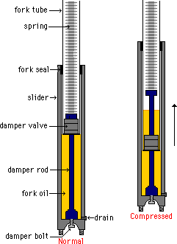  You have been asked to identlfy any possible causes of this failiure. Create an Ishikawa (herring bone) diagram of possible causes. Explain significant design error potential causes that may require more detail investigation. Use diagrams as required.  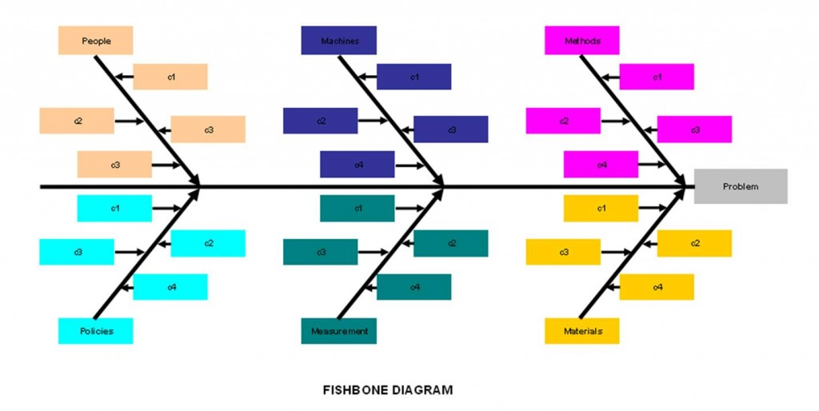  Check design intent, usage and life. Velocity and fluid pressures  The back bone (or trunk) is the error state eg leaking seal, branches and twigs off that.  Design branch  Limits and fits (identify critical dimensions) esp seal housing  Surface finish esp shaft.  Dimensional tolerances etc  Material selection, fluid compatibility, shore values  Lifing, recommended service intervals etc.  Environmental branch  Ingress IP rating, fluid and grit etc  Temp, humidity  Vibration  Manufacturing branch  Seal insertion, process, mandrels and tooling, lubrication  System assy procedure,  Training.  Material management branch.  Purchase systems, identification of critical items.  Supplier quality assessment.  Strorage, time . temp humidity, stock control etc. | 11 marks

Q4 | Question | Marks
4 a | The candidate should discuss the potential adoption these technologies:  The governing body – automotive relevance, interest from Vehicles Manufacturers, greenification of motorsport.  The business - advantages to teams, publicity, costs, potential sponsorship  The technology – size, relevance, safety and complexity. | 4 marks
4 b | The candidate should perform a PEST analysis on the marco environment. The list bellows is not exhaustive but provides examples.  Political  Supporting the political agenda  Seen to be green  Supporting government agendas  Green pressure groups  Emissions legislation CO2, noxious gasses  Economic  Expensive to design and develop  Extra spares required  Extra safety regulations  Potential new sponsorship avenues.  Additional staff & facilities required.  Social  Consumer buying patterns  Satisfying consumers green agenda  Fashion for performance upgrades  Fashion for vehicle downsizing  Increased use of KERS / hybridisation again for marketing and sales  Technological  Effect brake stability  Effect on vehicle mass  Effect on servicing requirements and safety  Ease of installation  OEM’s offering more base vehicles with hybrid capability – technology transfer  OEM’s providing more ‘niche’ vehicles  Competing technologies such as flywheels batteries, supercaps.  Improving vehicle stage performance (especially for restricted engines)  Possibilities to ‘down size’ IC engine.  Ever more complex donor vehicle engine management systems making KERS/hybrid integration  more complex | 16marks
4 c | An open question for the candidate, suggestions could include:  Improve the green credentials  Target for smaller engines, promote concept of downsizing  More potential sponsorship  Probably need market survey, sound out VM’s etc  Technical and cost impact on teams – study required  Safety considerations – study required.  Diversify within technology and equipment  What other markets could be addressed with similar technology?  What spin offs into road vehicle technology?  Consider maintaining entertainment spectacle. | 5 marks

