Distinctiveness and Regeneration BMSP4005
Assessment One - Learning Log Report

The main components that contributed to the development and the prosperity of Blaenavon (during the Industrial Revolution) were the formation of the ironworks and the growth of the coal mining industry.
In the late 1700s, Britain became the world leader in the Industrial Revolution, with Wales being at the forefront. Blaenavon is a town situated in the Torfaen county of South-East Wales, with part of its’ landscape sitting within the Brecon Beacons. The land in Blaenavon was rich in minerals and resources, that were used to fuel the industrial revolution, such as coal, limestone, and iron ore.
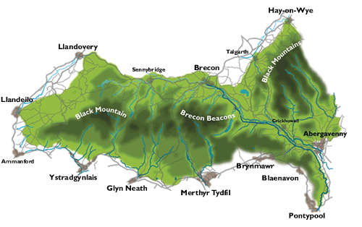
(Map showing Blaenavon in the Brecon Beacons National Park)
In November 1789, (through negotiations with the Earl of Abergavenny) a lease of extensive land was granted to three experienced entrepreneurs: Thomas Hill, Thomas Hopkins, and Benjamin Pratt. These industrialists went on to build an ironworks and they became the first partners of The Blaenavon Company. The ironworks was innovative for the period, being powered by steam. It was one of the largest ironworks in the world and had three blast furnaces. The Blaenavon Company was able to source its own raw materials, which contributed greatly to its’ productivity and output. Demand for iron continued to grow and The Blaenavon company increased its number of furnaces to five (1810-1815), this resulted in even greater production. 1796 saw a production of approximately 5000 tons of iron and by 1812 there was the capacity to make 14,000 tons of iron a year.
At the time, Blaenavon ironworks had a tremendous impact on the area. The works employed around 300 workers, some relocating to the area, resulting in increased population.
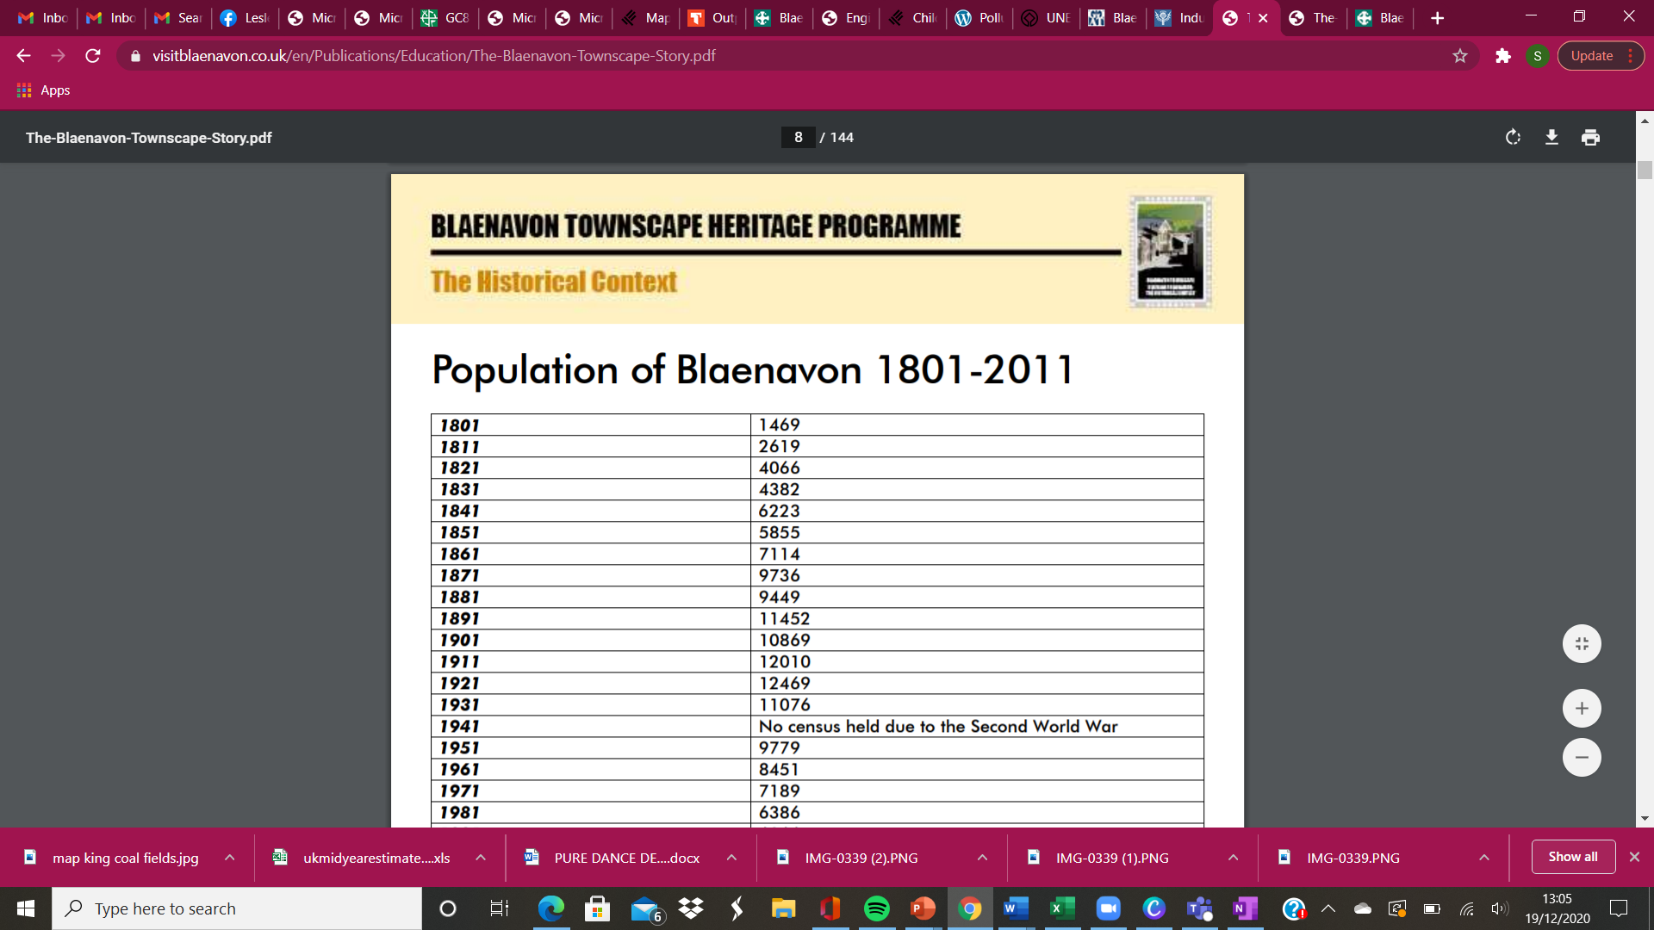

The company was responsible for building housing around the works for key workers, a tramroad that linked the ironworks to the Brecknock and Abergavenny canal and later the company also built a network of primitive railways, which were used for the movement of raw materials and to transport products to markets.
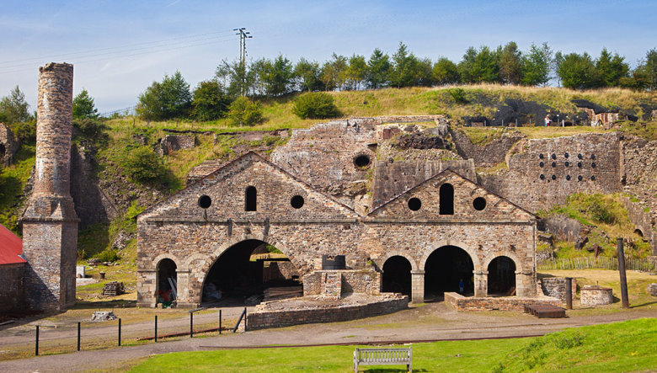
(Blaenafon ironworks as it stands today)
Coal mining also played a major role in the development of Blaenavon. Initially mines in South Wales were used mainly to support the ironworks, however, in addition to this, Blaenavon coal was mined to meet local demand. A few of the mines in Blaenavon and South Wales were joined to create one large colliery, named after its 300ft depth, as Big Pit. Big Pit had a positive effect on the local economy and the employment rate in Wales, it employed 1300 men, however with no health and safety laws or regulations, the work was dangerous for the miners, there were many fatalities and general health suffered. Coal mine conditions were damp, dark, and extremely dangerous. Child labour was also an issue during the industrial revolution. As part of The Commission of Enquiry into the State of Children in Employment, government inspectors interviewed child miners in the Welsh coalfields. These findings were then presented to Parliament. Evidence from the 1842 Mines Report shows that when asked how old the children were when they first went underground; Mr. William Stange, medical assistant, Lalnfavon replied '..children are employed as air-door keepers at 5 years of age; as horse drivers at 14, as colliers at 12 years of age.' Soon after, a new law was passed (The Mines Act 1842) which banned all females and boys under the age of ten from working in mines.
The discovery of a bituminous coal (better known as king coal) in the late nineteenth century resulted in growing demand for Welsh coal. The steam coal was plentiful in Blaenavon and the king coal coalfields in South Wales were mined to provide fuel for locomotives, steam ships, factories, and houses.
Nationally King Coal was great for the economy, with the year 1913 recording Wales’ highest ever output of coal! Nearly a quarter of a million miners in Wales produced 57,000,000 tons of coal! Blaenavon coal was used by the Great Western Railway as well as shipped around the world.
Big Pit had a positive effect on the local economy and the employment rate in Wales, it employed 1300 men and community spirit amongst the miners was strong. However, with no health and safety laws or regulations, the work was dangerous for the miners, there were many accidents and fatalities.
Both the ironworks and the coal mines had a negative effect on the local environment, causing air and water pollution. Often workers and people living near to the industrial sites would suffer with respiratory diseases through the inhalation of smoke, dark smog, and toxic fumes.
Along with the industrial development of Blaenavon came the building of other infrastructures. This was of great benefit to the community as it included the construction of a new church (St Peters Church 1804) followed by the building of St Peters School in 1815/16. These buildings would have both added a great sense of community spirit. The first vicar of St Peter’s was Welsh speaking, which added to the heritage of the area and gave the people of Blaenavon a sense of belonging.
The growth of Blaenavon was a direct product of the industrial revolution and had a large knock-on effect for many years after. Commercial development also came to the town during the nineteenth century, which provided further opportunities for employment.
In essence, the ironworks (Blaenavon Company) and the coal mines (Big Pit and king coal) did not only effect the prosperity of Blaenavon and it’s local area but also had a great effect on Wales and the rest of Great Britain.

Reference list
https://www.visit-brecon-beacons.co.uk/brecon-beacons-national-park.shtml
https://www.abergavenny.org/ironworks.html
http://www.ggat.org.uk/cadw/historic_landscape/blaenavon/english/Blaenavon_Features.htm#thetown

