Module Title: Accounting Fundamentals- Assessment 1
Name: Oana Florentina Dumitriu
Student number: 1909491
Module lecturer’s name: Dr. Rexon Nting
Table of Contents
Introduction 3
Task 1 4
Task 2 8
Task 3 13
Task 4 18
Task 5 22
Conclusion 25
Reference List 26

Introduction
There are differing business functions and compulsory activities that are needed being adopted within organisational contexts. Amongst these functions and activities, a compulsory activity of businesses is preparation, presentation and publishing of financial statements prepared within them. Within this report, there is a detailed analysis done on the fundamental concepts of accounting. It involves the application of the basic principles present in accounting for the presentation of financial statements. At the same time, the way in which financial statements of business entities can be prepared from initial data has been determined through dealing with non-routine and routine transactions. Lastly, the report discusses on revenue and capital expenditures and elucidates the differences existent between the two of these expenditures.

Task 1

(a) Write up, balance and close the relevant ledger accounts for the above transactions.
Date | Particulars | Notes | Amt (Debits) | Amt (Credits)
5-4-2019 | Cash Account:: |  | £300.00
 | Capital Account: |  |  | £300.00
7-4-2019 | Purchase Account: |  | £200.00
 | Cash Account: |  |  | £200.00
8-4-2019 | Tatiana Account: |  | £250.00
 | Loan Account: |  |  | £250.00
15-4-2019 | Motor Car Account: |  | £150.00
 | Cash Account: |  |  | £150.00
20-4-2019 | Cash Account: |  | £350.00
 | Sales Account: |  |  | £350.00
28-4-2019 | Rent Account: |  | £50.00
 | Cash Account: |  |  | £50.00
29-4-2019 | Loan Account: |  | £200.00
 | Tatiana Account: |  |  | £200.00
30-4-2019 | Drawings Account: |  | £60.00
 | Cash Account: |  |  | £60.00

Cash Account:
Date | Details | Amount | Date | Details | Amount
5-4-19 | Capital Account: | £300.00 | 7-4-19 | Purchase Account: | £200.00
20-4-19 | Sales Account: | £350.00 | 15-4-19 | Motor Car Account: | £150.00
28-4-19 | Rent Account: | £50.00 | 30-4-19 | Drawings Account: | £60.00
 |  |  | 30-4-19 | Bal. carried down: | £290.00
 |  | £700.00 |  |  | £700.00

Purchase Account:
Date | Details | Amount | Date | Details | Amount
7-4-19 | Cash Account: | £200.00
 |  |  | 30-4-19 | Bal. carried down: | £200.00
 |  | £200.00 |  |  | £200.00

Capital Account:
Date | Details | Amount | Date | Details | Amount
 |  |  | 5-4-19 | Cash Account: | £300.00
30-4-19 | Bal. carried down: | £300.00
 |  | £300.00 |  |  | £300.00

Tatiana Account:
Date | Details | Amount | Date | Details | Amount
8-4-19 | Loan Account: | £250.00 | 29-4-19 | Loan Account: | £200.00
 |  |  | 30-4-19 | Bal. carried down: | £50.00
 |  | £250.00 |  |  | £250.00

Motor Car Account:
Date | Details | Amount | Date | Details | Amount
15-4-19 | Cash Account: | £150.00 | 30-4-19 | Bal. carried down: | £150.00
 |  | £150.00 |  |  | £150.00

Loan Account:
Date | Details | Amount | Date | Details | Amount
29-4-19 | Tatiana Account: | £200.00 | 8-4-19 | Tatiana Account: | £250.00
30-4-19 | Bal. carried down: | £50.00
 |  | £250.00 |  |  | £250.00

Rent Account:
Date | Details | Amount | Date | Details | Amount
28-4-19 | Cash Account: | £50.00 | 30-4-19 | Bal. carried down: | £50.00
 |  | £50.00 |  |  | £50.00

Sales Account:
Date | Details | Amount | Date | Details | Amount
30-4-19 | Bal. carried down: | £350.00 | 20-4-19 | Cash Account: | £350.00
 |  | £350.00 |  |  | £350.00

Drawings Account:
Date | Details | Amount | Date | Details | Amount
30-4-19 | Cash Account: | £60.00 | 30-4-19 | Bal. carried down: | £60.00
 |  | £60.00 |  |  | £60.00

(b) Prepare the list of account balances at 30 April.
Items | Notes | Amt (Debits) | Amt (Credits)
- Cash Account: |  | £190.00
- Capital Account: |  |  | £300.00
- Purchases Account: |  | £200.00
- Tatiana Account: |  | £50.00
- Loan Account: |  |  | £50.00
- Motor Van Account: |  | £150.00
- Rent Account: |  | £50.00
- Drawings Account: |  | £60.00
- Sales Account: |  |  | £350.00
Total Amount |  | £700.00 | £700.00

(c) Prepare the statement of profit or loss for the month ended 30 April and a statement of financial position at that date.
In Maxim’s Books, Profit or Loss Statement, for month ended 30th April
Particulars | Amt
Revenues earned from sales proceeds (i) | £350.00
Less - Cost of products sold off (ii)
Level of beginning stock-in-hand £0.0
Purchase of stock or inventories £200.00
Level of closing stock-in-hand £100.00 | £300.00
Gross profit earned (i - ii) | £250.00
Less - Expenses on operations
Expenses on rent £50.00 | £50.00
Net profit earned | £200.00

In Maxim’s Books, Financial Position Statement, dated 30th April
Items | Amt
Assets
(A) Fixed assets
Motor van 150.00
(-) Depreciation 0.0 | £150.00
(B) Current and liquid assets
Cash & equivalents 290.00
Stock-in-hand 100.00 | £390.00
Total assets (A) + (B) | £540.00
Equity & Liabilities
(C) Short-term debts
Loan 50.00 | £50.00
(D) Long-term debts 0.0 | Nil
(E) Shareholders’ funds
Capital 300.00
(-) Drawings 60.00
(+) Net income 200.00 | £490.00
Total equity & liabilities (III) + (IV) + (V) | £540.00

Task 2

(a) Write up the ledger accounts for the above transactions, including dates, descriptions and balances.
Cash Account
Date | Details | Amount | Date | Details | Amount
January 1 | Capital Account: | £5,000.00 | January 2 | Motorcar Account: | £600.00
January 13 | Sales Account: | £300.00 | January 3 | Purchases Account: | £1,300.00
January 20 | Sales Account: | £500.00 | January 10 | Motorcar Expense Account: | £200.00
 |  |  | January 24 | Storage cost Account: | £150.00
 |  |  | January | Drawings Account: | £175.00
 |  |  | January 31 | Bal. carried down: | £3,375.00
 |  | £5,800.00 |  |  | £5,800.00

Capital Account
Date | Details | Amount | Date | Details | Amount
 |  |  | January 1 | Cash Account: | £5,000.00
January 31 | To Bal. carried down: | £5,000.00
 |  | £5,000.00 |  |  | £5,000.00

Purchases Account
Date | Details | Amount | Date | Details | Amount
January 3 | Cash Account: | £1,300.00 | January 31 | Bal. carried down: | £1,300.00
 |  | £1,300.00 |  |  | £1,300.00

Sergei Account
Date | Details | Amount | Date | Details | Amount
January 4 | Loan Account: | £1,000.00 | January 27 | Loan Account: | £350.00
 |  |  | January 31 | Bal. carried down: | £650.00
 |  | £1,000.00 |  |  | £1,000.00

Loan Account
Date | Details | Amount | Date | Details | Amount
January 27 | Sergei Account: | £350.00 | January 4 | Sergei Account: | £1,000.00
January 31 | Bal. carried down: | £650.00
 |  | £1,000.00 |  |  | £1,000.00

Motor Car Account
Date | Details | Amount | Date | Details | Amount
January 2 | Cash Account: | £600.00
 |  |  | January 31 | Bal. carried down: | £600.00
 |  | £600.00 |  |  | £600.00

Motorcar expense Account
Date | Details | Amount | Date | Details | Amount
January 10 | Cash Account: | £200.00 | January 31 | Bal. carried down: | £200.00
 |  | £200.00 |  |  | £200.00

Drawings Account
Date | Details | Amount | Date | Details | Amount
January | Cash Account: | £175.00 | January 31 | Bal. carried down: | £175.00
 |  | £175.00 |  |  | £175.00

Storage expenses Account
Date | Details | Amount | Date | Details | Amount
January 24 | Cash Account: | £150.00 | January 31 | Bal. carried down: | £150.00
 |  | £150.00 |  |  | £150.00

Sales Account
Date | Details | Amount | Date | Details | Amount
 |  |  | January 13 | Cash Account: | £300.00
January 31 | Bal. carried down: | £800.00 | January 20 | Cash Account: | £500.00
 |  | £800.00 |  |  | £800.00

(b) Prepare the trial balance at 31 January.
In Pendo’s Books, Trial Balance, dated 31st Jan
Items | Notes | Amt (Debits) | Amt (Credits)
Cash Account: |  | £3,375.00
Sergei Account: |  | £650.00
Purchases Account: |  | £1,300.00
Motorcar Account: |  | £600.00
Capital Account: |  |  | £5,000.00
Storage costs Account: |  | £150.00
Loan Account: |  |  | £650.00
Drawings Account: |  | £175.00
Sales Account: |  |  | £800.00
Motorcar expense Account: |  | £200.00
Total |  | £6,450.00 | £6,450.00

(c) Prepare the statement of profit or loss for the month ended 31 January and a statement of financial position at that date.
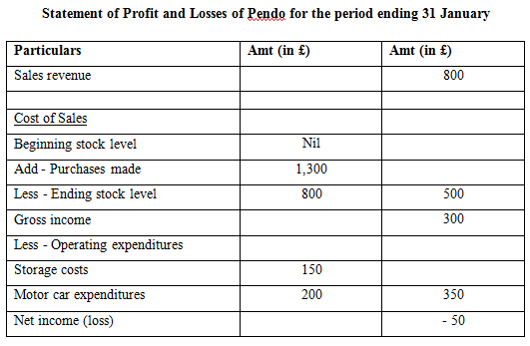
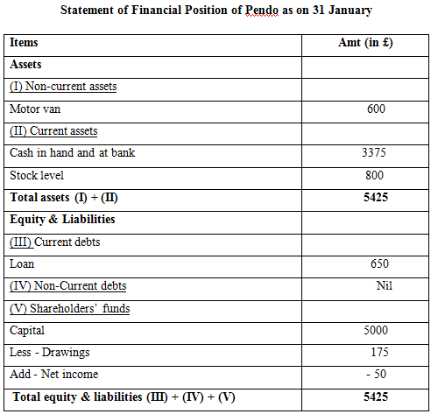

Task 3

(a) Write up and close the relevant ledger accounts.
Harvey Account:
Date | Details | Amount | Date | Details | Amount
January 1 | Bal. brought down: | £39.00
January 2 | Sales Account: | £124.00 | January 23 | Cash Account: | £25.00
 |  |  | January 31 | Bal. carried down: | £138.00
 |  | £163.00 |  |  | £163.00

Sales Account:
Date | Details | Amount | Date | Details | Amount
 |  |  | January 2 | Harvey Account: | £124.00
 |  |  | January 11 | Cash Account: | £64.00
 |  |  | January 21 | Cash Account: | £110.00
 |  |  | January 28 | Cash Account: | £84.00
January 31 | Bal. carried down: | £412.00 | January 31 | Cash Account: | £30.00
 |  | £412.00 |  |  | £412.00

Wages Account:
Date | Details | Amount | Date | Details | Amount
January 5 | Cash Account: | £12.00
January 14 | Cash Account: | £14.00
January 21 | Cash Account: | £17.00
January 28 | Cash Account: | £15.00 | January 31 | Bal. carried down: | £58.00
 |  | £58.00 |  |  | £58.00

Cash Account:
Date | Details | Amount | Date | Details | Amount
Bal. | Bal. brought down: | £343.00 | January 5 | Wage Account: | £12.00
January 7 | Smith Account: | £18.00 | January 9 | Max Account: | £21.00
January 11 | Sales Account: | £64.00 | January 14 | Wage Account: | £14.00
January 21 | Sales Account: | £110.00 | January 14 | Purchase Account: | £75.00
January 23 | Harvey Account: | £25.00 | January 15 | Rich Account: | £12.00
January 28 | Sales Account: | £84.00 | January 20 | Furniture & fitting Account: | £32.00
January 31 | Sales Account: | £30.00 | January 21 | Wage Account: | £17.00
 |  |  | January 23 | Office expense Account: | £3.00
 |  |  | January 28 | Wage Account: | £15.00
 |  |  | January 31 | Bal. carried down: | £473.00
 |  | £674.00 |  |  | £674.00

Office Expenses Account:
Date | Details | Amount | Date | Details | Amount
January 23 | Cash Account: | £3.00 | January 31 | Bal. carried down: | £3.00
 |  | £3.00 |  |  | £3.00

Purchases Account:
Date | Details | Amount | Date | Details | Amount
January 5 | Rich Account: | £150.00 | January 31 | Bal. carried down: | £225.00
January 14 | Cash Account: | £75.00
 |  | £225.00 |  |  | £225.00

Rich Account:
Date | Details | Amount | Date | Details | Amount
January 15 | Cash Account: | £12.00 | January 1 | Bal. brought down: | £12.00
January 31 | Bal. carried down: | £150.00 | January 5 | Purchase Account: | £150.00
 |  | £162.00 |  |  | £162.00

Smith Account:
Date | Details | Amount | Date | Details | Amount
January 1 | Bal. brought down: | £18.00 | January 31 | Cash Account: | £18.00
 |  | £18.00 |  |  | £18.00

Max Account:
Date | Details | Amount | Date | Details | Amount
January 9 | Cash Account: | £21.00 | January 21 | Bal. brought down: | £21.00
 |  | £21.00 |  |  | £21.00

Furniture & fittings Account:
Date | Details | Amount | Date | Details | Amount
January 1 | Bal. brought down: | £198.00
January 20 | Cash Account: | £32.00 | January 31 | Bal. carried down: | £230.00
 |  | £230.00 |  |  | £230.00

(b) Extract a trial balance at 31 January.
In Mafuta’s Books, Trial Balance, dated 31st Jan
Particulars | Notes | Amt (Debits) | Amt (Credits)
- Cash Account: |  | £473.00
- Smith Account: |  | Nil | Nil
- Harvey Account: |  | £138.00
- Purchases Account: |  | £225.00
- Office expense Account: |  | £3.00
- Sales Account: |  |  | £412.00
- Rich Account: |  |  | £150.00
- Wages Account: |  | £58.00
- Max Account: |  | Nil | Nil
- Moon Account: |  | £26.00
- Inventories Account: |  | £374.00
- Furniture and fittings Account: |  | £230.00
- Suspense Account: |  |  | £965.00
Total |  | £1,527.00 | £1,527.00

(c) Prepare a statement of profit or loss for the month ended 31 January and a statement of financial position at that date.
In Mafuta’s Books, Profit or Loss Statement, for month ended 31st Jan
Particulars | Notes | Amt
Revenues earned from sales proceeds (i) |  | £412.00
Cost of products sold off (ii)
Level of beginning stock-in-hand £0.0
Purchase of stock or inventories £225.00
Less - Level of closing stock-in-hand £374.00 |  | - £149.00
Expense made on wages (iii) |  | - £58.00
Gross profit earned (i - ii - iii) |  | £503.00
Less - Operating costs
Office expenditure |  | £3.00
Net profit earned |  | £500.00

In Mafuta’s Books, Financial Position Statement, dated 31st Jan
Particulars | Notes | Amount
Assets
- Furniture & fittings |  | £230.00
- Inventory level (at cost) |  | £374.00
- Cash and equivalents |  | £473.00
- Accounts receivable |  | £164.00
Total asset |  | £1,615.00
Equity & Liabilities
- Accounts payable |  | £150.00
- Net profit or loss |  | £500.00
- Suspense |  | £965.00
Total equity & liabilities |  | £1,615.00

Task 4

Prepare the relevant ledger accounts to record the above transactions, extract a trial balance at 27 June and close the relevant ledger accounts.
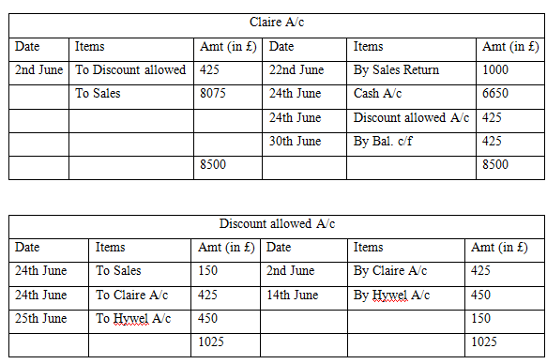
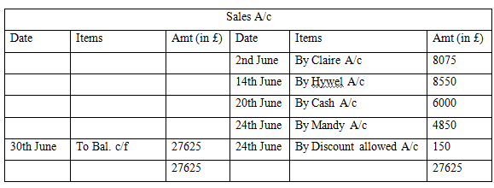
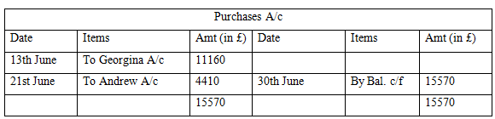
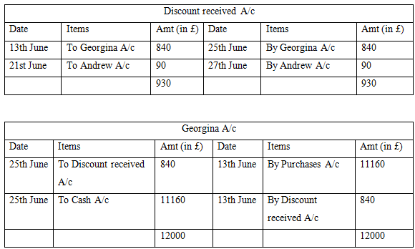
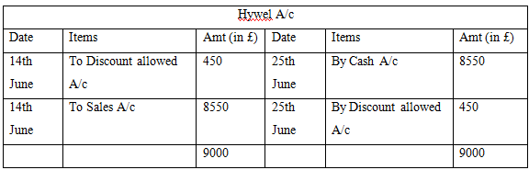

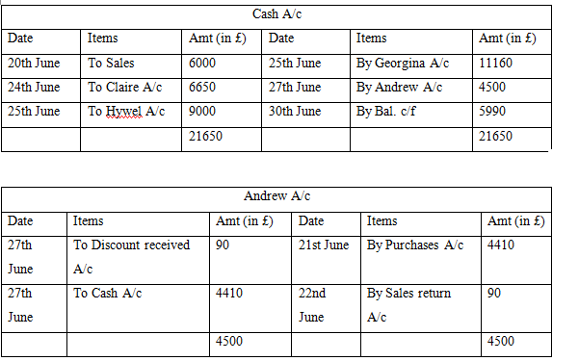
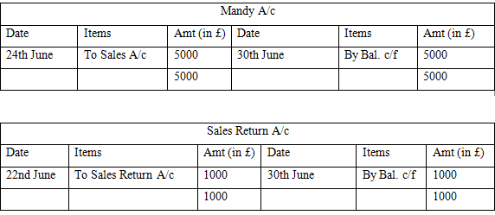

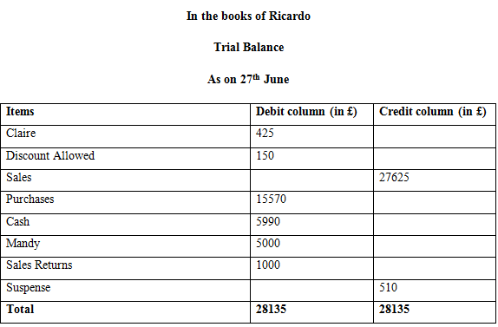

Task 5

Demonstrating your research, differentiate between revenue expenditure and capital expenditure with reference to International Accounting Standards
In the field of accounting, expenditure is one of the most relevant and widely used terms. In the words of Schroeder et al. (2019), expenditure relates to any sort of disbursement or payment. These expenditures might be made in order to buy any asset or for the decrease of any liability. They can also be incurred for the distribution to its owners. At the same time, expenditure can also be made in order to make payments within the same period of accounting, as the amount paid turns into an expense. Thus, in simple words, one can be explaining expenditure as the incurrence of any liability or payment of an amount for the exchange of products and services. All expenditures made within an organisational context can be done either in credit or in cash (Kieso et al., 2019).
All organisations have to make differing sorts of expenditure throughout the life of the business and they are necessary to be spent to ascertain improved organisational efficiencies. At the same time, expenditures assist a company so that they can be accomplishing further returns from their spending. However, expenditures made within organisations are classified into differing categories. The two broad categories or types, in which the field of financial accounting divides expenditure, include revenue expenditure and capital expenditure. These two expenditures made within organisations are largely different from one another. The capital expenditure indicates the expenditures incurred for the acquirement of assets or the enhancement of the asset’s capacity (Kitchen et al., 2019). These expenditures are incurred for acquirement of fixed assets within business that are expected on being productive assets for a long span of time. On the contrary, revenue expenditure relates to the routine expenditure, which is spent for the execution of their regular business activities (Muda and Naibaho, 2018). They are the costs associated to the particular transactions of revenue or the operating periods, for example, the expense on maintenance and repairs and the cost of sales.
As per the International Accounting Standards, there are a large number of ways in which revenue expenditure and capital expenditure can be classified. The basic ways in which the expenditures can be classified include the following -
- Timing - When an organisation makes it capital expenditures, they are charged to its expenses gradually through the medium of depreciation and throughout a long time span (Kraft et al., 2017). On the other hand, the revenue expenditures are charged as expense during the present time and shortly thereafter.
- Consumption - Based on consumption, the capital expenditures are assumed on being consumed throughout a relative non-current asset’s useful life (Ainsworth and Deines, 2019). However, whenever revenue expenditures are made, they are assumed on being consumed within a merely short time span.
- Size - The monetary amounts, which are spent within revenue expenditure and capital expenditure, are also one of the major differences amongst the two expenditures (Reid, 2018). It is since an expenditure that can be classified only as capital expenditure if it is successful in exceeding a particular threshold value. In case if the threshold value is not exceeded, it is categorised as revenue expenditure. However, there are particular large expenditures that can be still be divided into revenue expenditures, since long they are linked directly with the period costs or sales transactions.
These are the common differences, which are pointed out from the International Accounting Standards. At the same time, a few other differences are determined from these standards as well between the two expenditures. For instance, as per the IAS 18, recognition of revenue is remarkably significant for business entities (iasplus.com, 2019). This accounting standard also points out that the expenditures are recordable only with income statements of a business entity. At the same time, it is pointed out from the accounting standard that the matching concept is relevant to revenue expenditures, since revenue receipts are easily matched with revenue expenditure. However, as per IAS 38, the capital expenditures spent in organisations are the long-term ones and comprise of capitalisation, which does not exist when revenue expenditures are made (iasplus.com, 2019). These accounting standard points out that capital expenditure are involved in the profit and loss statements together with the balance sheets presented in entities. However, the matching concept is not applicable for these sorts of expenditures. None of the capital receipts of an organisation can be matched as per matching concept.
Similarly, the outlay of the capital expenditure in an entity takes place on a non-recurring basis. However, when outlay of an entity takes place for revenue expenditure, it is done in a recurring manner. Another difference between them is that the advantage or returns from capital expenditure are enjoyed for above one year (Nobes, 2015). However, in case of revenue expenditure, the outlay is recurring. Lastly, when a company makes a capital expenditure, it seeks the improvement of its capacity of earning. However, whenever an organisation makes revenue expenditure, it is done for the maintenance of its earning capacities.

Conclusion
Therefore, through the discussions of the report along with its findings, a basic knowledge has been gained on the primary underlying concepts within the field of accounting. It has helped in finding out how a business entity can be recording its financial transactions and how it can be writing up its ledger accounts. At the same time, the way in which financial statements can be drafted and presented in a company has been determined as well. In addition, the closing of ledger accounts for businesses have been seen and accounting both on accrual and cash basis has been understood. The report also helped in understanding the two differing expenditure made within businesses while pointing out the differences amongst these two categories of expenditure. The way in which the International Accounting Standards classify revenue and capital expenditure has been found out, which is required for recording them during the development of financial statements.

Reference List
Ainsworth, P. and Deines, D., 2019. Introduction to accounting: An integrated approach. Wiley.
iasplus.com, 2019. IAS 18 — Revenue. [online] Available at: https://www.iasplus.com/en/standards/ias/ias18 [Accessed 20 Dec. 2019].
iasplus.com, 2019. IAS 38 — Intangible Assets. [online] Available at: https://www.iasplus.com/en/standards/ias/ias38 [Accessed 20 Dec. 2019].
Kieso, D.E., Weygandt, J.J. and Warfield, T.D., 2019. Intermediate accounting. John Wiley & Sons.
Kitchen, H., McMillan, M. and Shah, A., 2019. Expenditure and Revenue Assignment: Practices. In Local Public Finance and Economics (pp. 81-126). Palgrave Macmillan, Cham.
Kraft, A.G., Vashishtha, R. and Venkatachalam, M., 2017. Frequent financial reporting and managerial myopia. The Accounting Review, 93(2), pp.249-275.
Muda, I. and Naibaho, R., 2018, March. Variables influencing allocation of capital expenditure in Indonesia. In IOP Conference Series: Earth and Environmental Science (Vol. 126, No. 1, p. 012066). IOP Publishing.
Nobes, C., 2015. Accounting for capital: the evolution of an idea. Accounting and Business Research, 45(4), pp.413-441.
Reid, W., 2018. The meaning of company accounts. Routledge.
Schroeder, R.G., Clark, M.W. and Cathey, J.M., 2019. Financial accounting theory and analysis: text and cases. John Wiley & Sons.

