Assignment 1
Wasim Saleem
Student id 2221253
Learning in digital ERA

Assignment 1
- Task 1 essential skills for study and employment
Digital marketing tool (such as automated marketing software)How the development of such skills will support you in your chosen Career after you graduate.
I have chosen this course because I want to improve my knowledge on computers I have always been a computer geek. Once I graduate from university I will have the skill and knowledge for most computer organizations one of the key skills that would be needed is team work and communication and being confident in my work and presentation. Having positive mindset and being confident around people communication is an essential for programmers. No programmer works alone there will always be other people affected by your work.[1]​
I will be doing a presentation on pdp personal development plan the key skill in my presentation will be communication, being confident around other students and being creative.[2] Many businesses want their employees to have good communication skills and share ideas. Once iv completed my course I want to get a degree in digital marketing. A digital marketing manager has many responsibilities such as market trends, organising campaigns and using web analytic tools to analyse the performance of marketing campaigns.[3]
However I also need to improve my time management skills and learn how to adapt in a new work environment as I have doing construction work for 10 years so working with computers is completely different Overall, time management is an essential aspect of many human activities, and it touches on various issues such as setting yourself goals, making a change self-management and decision making.
Having a positive attitude being calm when things go wrong working together or problem solving (thinking skills) where you can see something that wont work all these skills are key qualities in the work industry and will help you get far in your career [4]
Overall while im studying full time im looking to gain new skills everyday and work hard and stick to my goal to succeed as a digital marketer.

References for essential skills
[1]Springboard Blog. (2022). 19 Programming Skills to Start (or Grow) Your Career. [online] Available at: https://www.springboard.com/blog/software-engineering/programming-skills/.
[2] Davies, T. (2000). Confidence! Its Role in the Creative Teaching and Learning of Design and Technology. Journal of Technology Education, 12(1).
[3] Bala, M. and Verma, D., 2018. A critical review of digital marketing. M. Bala, D. Verma (2018). A Critical Review of Digital Marketing. International Journal of Management, IT & Engineering, 8(10), pp.321-339.
[4] careers.govt.nz (2019). Skills employers are looking for. [online] Govt.nz. Available at: https://www.careers.govt.nz/plan-your-career/get-ideas-for-your-career/skills-employers-are-looking-for/.
Time management
Today my research will be about time management. I will be writing about how to manage and save time. There are loads of different facts that may help you save time which can save you on a day to day basis.
The review shows that the time management behaviours relate positively to perceived control of time, job satisfaction, and health, and negatively to stress. The relationship with work and academic performance is not clear. Time management training seems to improve time management skills, but this does not automatically transfer to improved performance [1].
The reviewed research displays several limitations. First, time management has been defined and operationalised in a variety of ways.
The time management is worthy goal of many human activities. It concerns variety problems related to goals definition, assessment of available resources, control of management policies, scheduling of decisions. This book is an attempt to illustrate the decision making process in time management for different success stories, which can be used as reference models by the interested audience. [2]
Team work
Teamwork has many key qualities that can help you now and in the long term. There are so many different skills you can achieve as an independent person and as a member of group working together will always make life a little easier.
Employers value teamwork because effective teamwork can create a sustainable competitive advantage in the marketplace. Organizations are reporting that the expertise they desire in a candidate is the ability to work well in teams. According to survey data, students lack the necessary teamwork skills when they enter the workplace. Since students should be prepared to bring excellent teamwork skills into the market place. Student survey results indicate an overwhelming indication that they comprehend the stages of teamwork based on my process. Indications suggest they will be much better prepared to succeed in their interviews and careers. [3]

Communication skills
Communication is a key skill in life its to do with listening and taking in as much information as you can and responding and this does help you in a day to day life its something we do everyday without realising at home or work outside we have to communicate.
Where would we use communication skill?
Good doctors communicate effectively with patients—they identify patients' problems more accurately, and patients are more satisfied with the care they receive. But what are the necessary communication skills and how can doctors acquire them? [4]
Reference
[1] Claessens, B.J., Van Eerde, W., Rutte, C.G. and Roe, R.A., 2007. A review of the time man
[2] Stoilov, & Stoilov, T. (2012). Time Management (Stoilov, Ed.). IntechOpen.agement literature. Personnel review.
[3] Maguire, P. and Pitceathly, C., 2002. Key communication skills and how to acquire them. Bmj, 325(7366), pp.697-700.pp.697-700.

Task 1 b
Similarity check
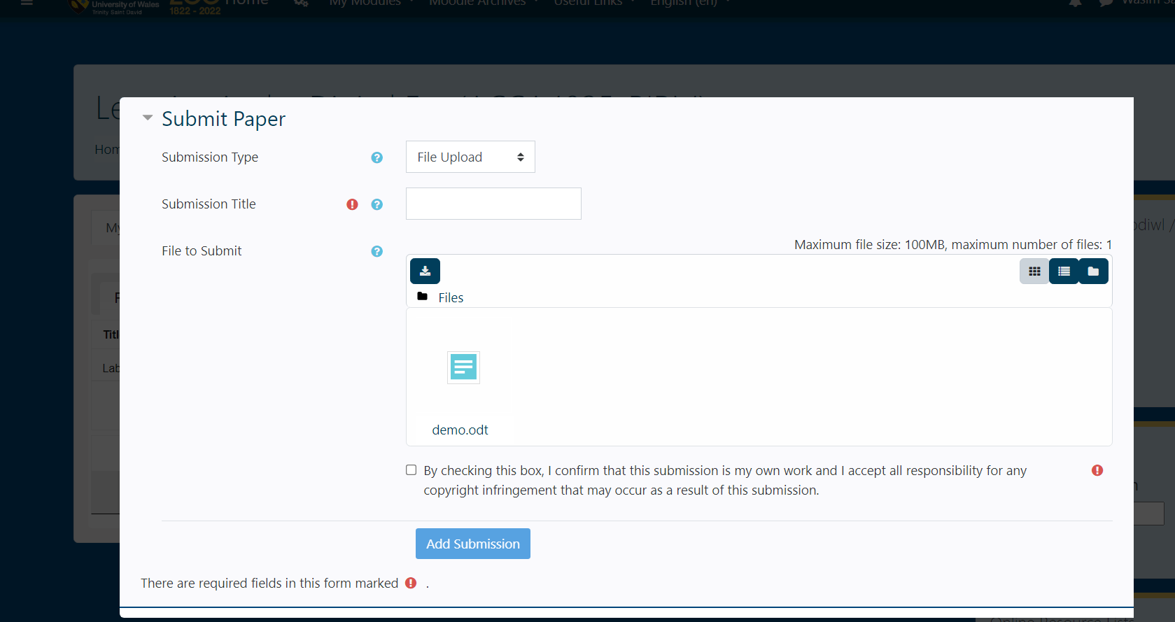
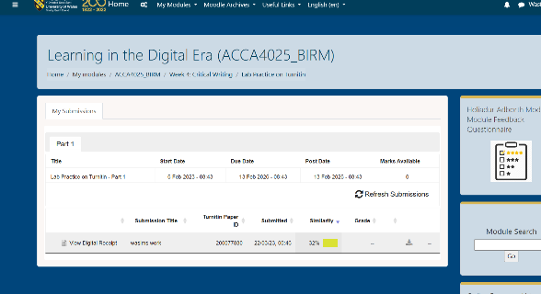
My similarity score is 32% which is not bad it shouldn’t be any more than 30% but I’m going to have read through what I have written and rephrase some of my words I haven’t copied or pasted anything that I have researched. Everything I have written is in my own words but similar to what I have been researching I’m going look online for a paragraph rewriter or a word rephrasing tool so I can improve my work and get a better mark. Any irrelevant text I will remove mainly there for referencing .
80% out of 100
I gave my self this score because I have understood what it expected in this assignment what I would like to improve on is my punctuality.
Task 2:
https://sway.office.com/lAizFGzw7SUBxBoi?login_hint=2221253%40student.uwtsd.ac.uk
Task 3:
Referencing Guide
Todays task is understanding the use of menedely. Mendeley is an self referencing tool which will help reference your information by who its author or creator.

Step 1: Download and Install Mendeley
Go on to any search engine and search up mendeley reference manager / or go on to moodle learning in digital era week 4 and it should have a link for Mendeley.


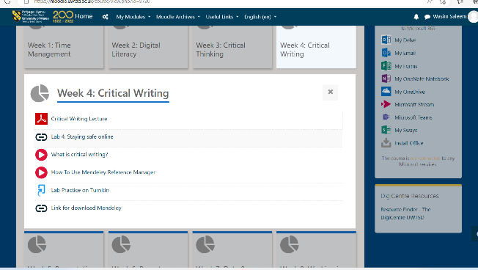
click on the link above and it will take you onto the mendeley website

Step 2: Create an account and sign in
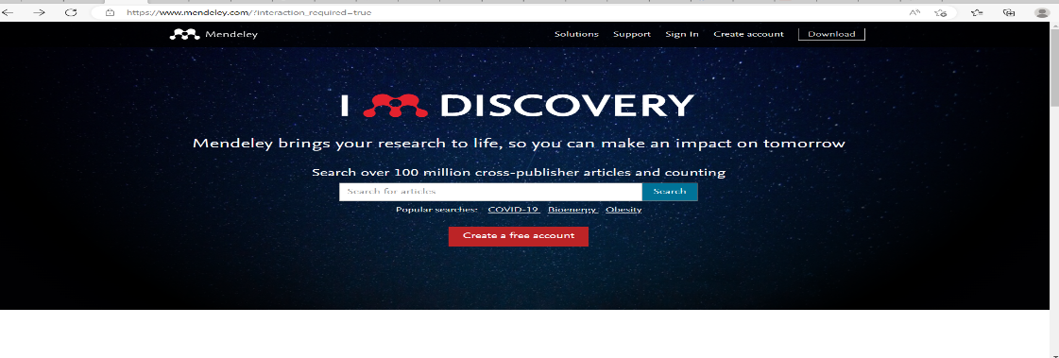
Once on this sight on the top right corner there is an option to create an account and sign in

Once on this page create an account and sign in.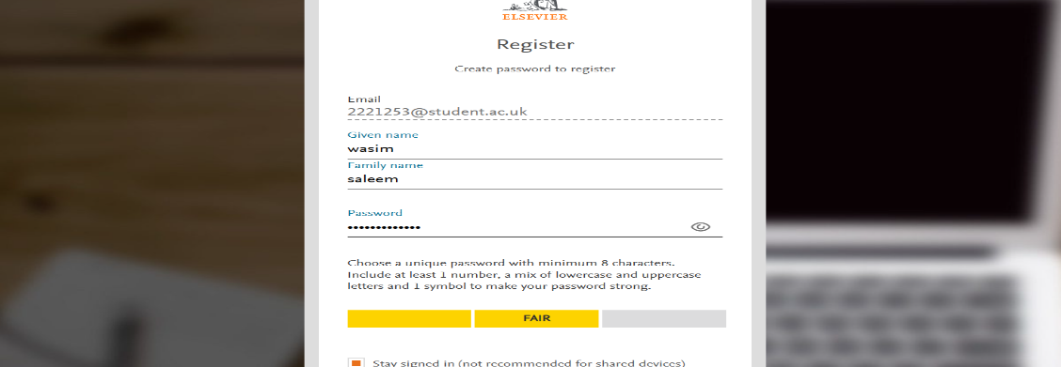

Step 3:upload a pdf on medeley
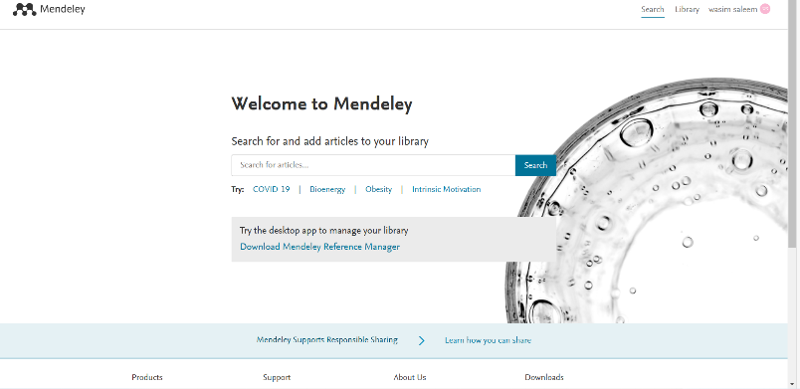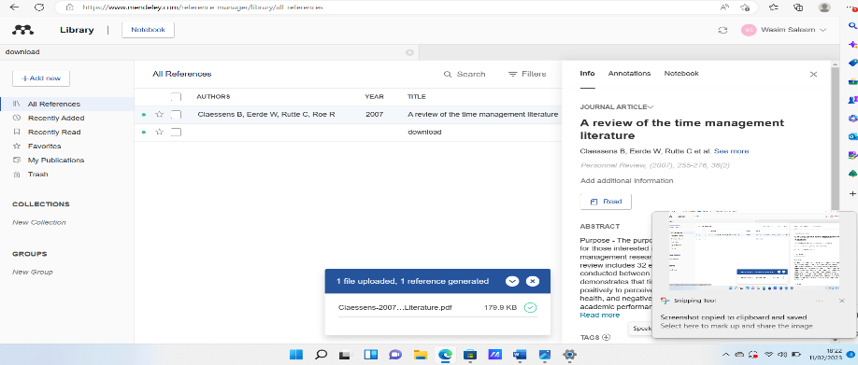
This is the best way to upload saved references that you have used in your writing. It makes your point given more believable by adding evidence to it.
Then click on add new to upload a pdf file from your saved files
Click on library

Step 4:

Task 4: Poster creation

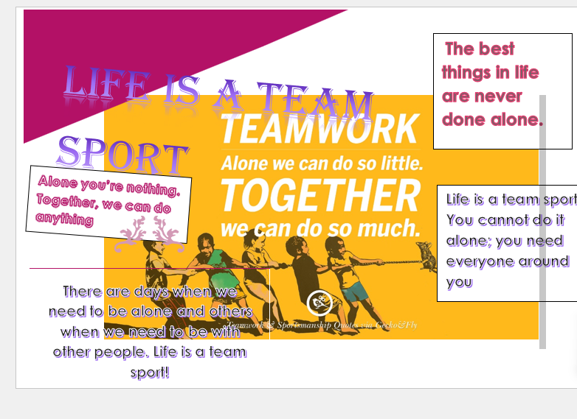
My task here was to create a poster to do with life is a team sport in this poster I have to have a open mind and be creative and making sure I catch my viewers attention I did that by adding a unique style of font and adding small quotes about teamwork and life. Alone we are nothing together we can do anything [1] there are days when we need to be alone and others when we need to be with other people [2] you cannot do this alone you need everyone around you [3]Best things in life are never done alone.[4]
References
[1] Nimble Quotes. (2021). ‘Alone We Can Do So Little; Together We Can Do So Much.’ Helen Keller. [online] Available at: https://nimblequotes.com/alone-we-can-do-so-little-together-we-can-do-so-much-helen-keller/.

[2] Psychology Today. (2019). Why You Want to Be Alone and Why That Matters. [online] Available at: https://www.psychologytoday.com/us/blog/living-single/201912/why-you-want-be-alone-and-why-matters.
[3] Samaritans. (n.d.). Signs you may be struggling to cope. [online] Available at: https://www.samaritans.org/how-we-can-help/if-youre-having-difficult-time/signs-you-may-be-struggling-cope/.
[4] Verywell Mind. (n.d.). 10 Things You Can Do Right Now If You’re Feeling Lonely. [online] Available at: https://www.verywellmind.com/things-to-do-if-you-feel-lonely-5081371.

Screen shots from sway
- 
 

