Lydia Greaves - 2304941
Julia Lockheart – ADAD5003
Word count - 2629
Question 2: Define skill in the context of your own practice and the work of two artists/makers/designers from the lecture series

This essay will discuss skill in the context of the craft of stained glass and the different skills required for traditional and modern stained glass techniques. It will also analyse the different skills used for quick sales crafts and for major art pieces. I will be looking predominantly at the work of Juliet Forrest as well as other makers.
“The word ‘craft’ means ‘skill’” (Walker, 1989, p38) there is an interlinking relationship between craft and skill. This framing suggests to craft is to apply skill. Corbett (2017) further shows this connection by describing craft as a verb meaning “to exercise skill in making an object typically by hand” and also as a noun, being “an activity involving skill in making things by hand” (p.11). These definitions highlight the skill involved with handmade crafts. Within this essay, these skills will be analysed by describing the different processes involved with making hand crafted items and evaluating the outcome of key pieces of work.

Regarding skill, stained glass largely emerged around the 12th century, particularly with the rise of the gothic architecture. Stained glass windows could be seen mainly in churches, cathedrals and monasteries. Medieval guilds and specific craft guilds for skilled artisans were formed around this time. Entry to the guilds was limited in order to maintain the high standards of skill of a particular profession i.e. stained glass (Cartwright, 2018). Stained glass panels helped church attendees to understand the stories from the bible, as they are “one of society’s most primitive methods of storytelling’ (Sheriff stained glass specialists, 2017). Creating the stained-glass window panels is a long and highly specialized craft that has distinct stages. These are: Designing, cutting, painting/firing, leading, cementing then framing. Making the glass was also quite complicated, requiring a lot of skill. It was achieved using sand and wood ash heated to a high temperature to turn the substance to liquid form. They then mix in powdered metals and colours to produce the required pattern and shade (Medieval History, 2017).

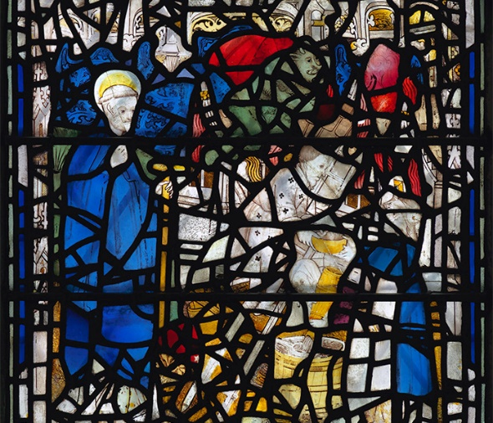
An example of this skill is The Great East Window of York Minster. It has 128 windows that some date back to the 12th century. All made with traditional methods but now being updated with modern techniques such as Uv- glazing that preserve and conserve the windows (Great East Window, 2018).

Figure 1 St Cuthbert Window
The traditional technique for making stained glass is vastly different to modern times. An example of the difference in technique is Tiffany lamps. These highly priced lamps are a commodity and could be labelled as a luxury craft. Stained glass has gone from something with a purpose; telling bible stories on windows, into items for the home. Stained glass lamps do have practical purpose, but the design is intended for adornment and decoration.
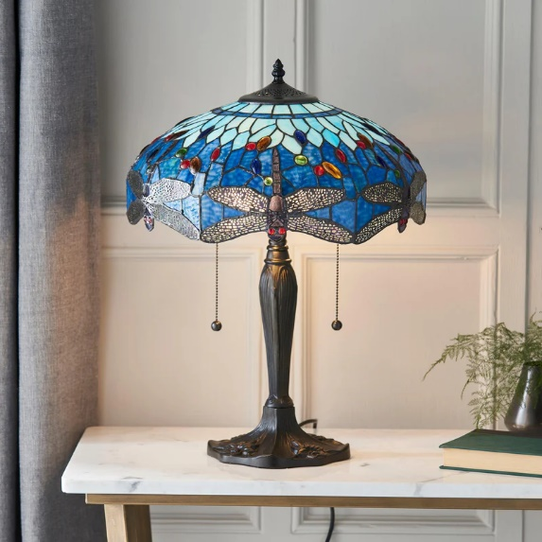
The process for making these is largely the same as the original methods but with new modern skills, such as electronic tools to cut and finish the glass. Even the way glass is created has been updated and made more efficient. A newer technique of using copper foil instead of lead came in around late 19th century first used by Louis Tiffany.

Figure 2 Blue Dragonfly Tiffany Table Lamp
Using copper foil allowed for a higher level of production of commodity items intended for decoration and to show status. Such items are “capable of satisfying human wants” (Marx (1930 [1867]). People can show off having an expensive lamp or genuine stained-glass window in the home to show their wealth and taste.
The skill and time required in traditional stained glass making often makes it too expensive for the average consumer, making demand lower. For stained glass artists to thrive in modern times, they need to develop their techniques to make crafts that are in demand and affordable. They need to ‘carve out a new path for the medium, which had been dominated by religious subjects for decades’ (Cheney 2016). Developing traditional techniques to create a new technique requires a different type of skill, as thorough knowledge of the technique is needed.
Returning to the Tiffany lamp, creating the look of lead panels by using the traditional techniques required but without the traditional materials is skill itself. Copper foil is cheaper therefore more convenient for hobby crafters as well as mass production. The flexibility and size of the materials allows for more intricate designs than the traditional led. Creating an alternative method required a lot of skill and knowledge in resistant materials and how they can be applied to stained glass making.

In contemporary art, there are newer developments in traditional skills. Juliet Forrest is a British stained-glass artist who applied a unique skill to her work using frit. She mainly works with stained-glass panel pieces that incorporate frit, which is roughly cut-glass powder that melts and binds with the glass when fired at high temperatures or can create texture on the glass when fired at lower temperatures. This skill allows her to create unique pieces of work. She also combines this with painting directory onto the glass, which allows for a lot of intricate detail to be incorporated. Her work can sell for around £2,250.50. Forrest describes her work as ‘luxury craft’, but she has a varied price range and creates affordable pieces such as prints of her glass work in the form of greeting cards at £10. With a background in landscape painting, Forrest started working with glass as a hobby but expanded her skills by creating these new techniques to be able to be a competitor in the art market.
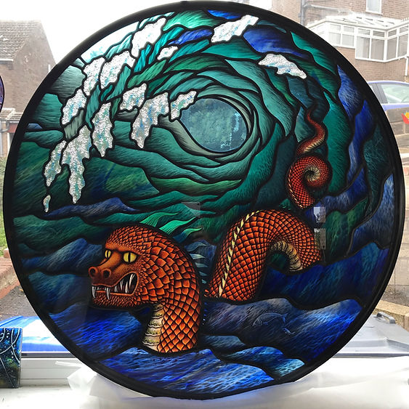
Figure 3 Sea Serpent and Wave
This piece ‘Sea serpent and wave’ was a commission piece for a kitchen and inspired by the existing shoal of glass fish surrounding the window. Forrest made the piece combining fused glass with English antique glass and layering them in several segments. These were painted using traditional glass painting, staining and enamelling. The sea serpent is inspired from Norse mythology –Jormungandr, which means god of war. The word comes from jormun, meaning huge and superhuman and gandr meaning elongated. The serpent dominates for forefront of the piece, with a large wave behind it. According to the myth, the serpent is said to be able to circle the Earth from it head to its tail, which could be symbolic of the circle of life. The circle looks to be an important theme within the piece as it appears within the wave above. The colour choice of the serpent could be to represent its danger (Albers 2013).
The first process of making fused glass by using Frit – crushed fusible glass- allows a singular piece of glass to having varied colours in an intentional and controlled way. It can add depth and texture to the piece. This is done by applying frit to the glass and fusing in the kiln, her skill of this allows her to understand how the frit will react to different types of glass, temperatures and time. Traditional glass painting is a difficult skill to master with each stroke having to be meaningful and precise as it is not possible to go over strokes without removing previously laid down paint. The technique to glass painting has not changed over time.
Copper and silver staining can be done once the paint has been fired as it is fired at a lower temperature. Silver stain must be fired at around 1022F/550C to 1040F/560C, which is 212F/100C lower than the temperature needed for paint firing. This means that if fired together, the silver stain will be overfired, creating a cloudy bubbling effect on the surface (Francis, 2016). The same with applies to enamels, so it is important to use a different process to avoid the bubbling affect. This is done by using the stained glass panel process using lead which is then moulded around the cut pieces of glass. It is then soldered together, cemented and blackened. The blackening process can be forced using grate polish or over time the lead reacts with the air and darkens. Designing the panel itself is a skill, to plan the idea and be able to achieve a complicated design like this involves a lot of artistic creativity and ingenuity. All of this is put together using the stained glass panel process using lead which are moulded around the cut pieces of glass. Then soldered together, cemented and blackened. The blackening process can be forced using grate polish or over time the lead reacts with the air and darkens. Designing the panel itself is a skill, to plan the idea and be able to achieve a complicated design like this involves a lot of artistic integrity.
There are a lot of artistic and technical skills required in making an art piece like the works of Juliet Forrest. For quick sales items that can be sold on platforms such as Etsy or craft stalls, there are additional skill sets required. To make work stand out from the crowd, there are many websites which give long lists on easy and quick crafts that can sell. The skills needed in a business prospective are important and vital for the business to flourish. There needs to be a developmental strategy within the business to react and meet changing customer needs. One example of this is ShepherdCraftStudio on Etsy (ShepherdCraftStudio, 2024). She has a 4.8 average rating review, which is partly due to her speedy replies, quick delivery time and satisfactory products. She is noted as a star seller on Esty for consistently earning 5 start reviews. This shows that communication with customers and good business acumen are important skills for her success. She sells a range of ceramic items ranging from decorations to trinket bowls. Nothing on her site is more expensive than £22 meaning she is a very affordable maker. She mainly makes items that feature ‘cutesy’ animals. These items tend to sell well as pet owners and animal lovers can relate them. Her site currently is filled with Christmas ornament boxes, meaning her products are relevant for the season, giving the customer what they want. This is also an important skill as it requires knowing the market segment and meeting demands.

The quality of what the creator is making is important as being able to give the customer the best product possible is paramount, for their reputation and for customer satisfaction. Ensuring quality over quantity is fore mount i.e. if you make 20 but badly made ceramic jugs the consumer will be unhappy with their purchase, and it will give your company a bad reputation meaning your revenue will decrease. Not only from sales but from time, materials and from loss of products that aren’t being bought. However, of the quality of these ceramic jugs was very good their more likely to sell, meaning more word of mouth equalling a better reputation. This furthers to increased revenue and it even means the price of the product can be increased over time as the consumer knows it of good make.

Being consistent with your marketing and branding will make it easier for customers to understand what you're trying to sell. Engaging with customers on social media is important being an active creator means you're always staying relevant and reminding people of your products. Ensuring high-quality material is being created such as photos or posts means customers can easily access and view your work. ‘Audio helps bring out emotions in viewers, which can lead to greater engagement and increased loyalty among customers’ (Callpage Team, 2023). Creating videos of your work is a newer but very important aspect if marketing now. With many big brands getting involved with reels or mainly TikTok is an easy and relatively low-cost way to advertise the products.

The online aspect of social media is important for sales where customers may not have known about the company if they hadn’t come along to a craft fair. However, being able to network within the craft world allows makers to further themselves with opportunities in a physical sense. Talking to other creators at events such as craft fairs is important to find out about other fairs/ markets, ideas and techniques can be picked up from advice or knowledge from other makers. And building strong relationships with customers will help promote loyalty and trust. So, networking at craft fairs and markets is really important as it encourages word of mouth marketing which will further strengthen the reputation. Also listening to feedback from customers to how to improve the products and how the maker presents themselves is also important. A friendly and knowledgeful person is likely to attract customers and the customers are the main focus. Incorporating the desire of the customer is useful for customer satisfaction. For example, seasons such as, Christmas Halloween and Easter. People are mainly looking for gifts around this time or something festive to decorate the house and will items normally sell fairly easily/quickly.

Although the craft world is overall seen as a welcoming and friendly it can be ‘extremely subjective; what one person believes to be great art, another deems terrible’ (Noonan, 2011). Often more serious artists can look down on and be snobby towards quick craft items. Some deem craft as not real art. I see both points, as its quick and some skills are relatively easy compared to spending hours on a very intricate painting or sculpture. But there is still a certain artistic skill that goes towards these craft items. The makers having the freedom and diversity of what they create is what art is indented to do. Art is quite subjective and there needs to be differentiating levels of sales.

Craft is closely linked to the word hobby and is hard to separate the two from each other. Where some have it as a full-time occupation others have it a weekend job. That is the freedom with it. But also, limitation quick sales normally mean cheaper prices. May be hard to progress to having it as a full time by limitations i.e. pottery- kiln, clay, bills. The word craft lost its sort of power behind it and started getting looked down on as it was associated with cheap local fairs e.c.t. ‘Art differs from craft based on convention and our preconceptions. Art stands above craft as belonging to the mind of aesthetes. Craft is less precious and touched’ (Proactive Creative, 2022). Craft is important as this how each person can individually express themselves no matter on their ability or social standing.

Quick sales an advantage for small businesses to increase the revenue. This allows them to grow their business and cover the current expenses. The more money they have means the more ability they have to create and bring other ideas and to the business. Quicker sales mean it's easier to attract new customers and building a customer base through consistent sales. This means they can expand the reach of their products to further customer markets. No matter at what level the art/ craft is being made they both require a certain amount of skill and artistic fluidity. Skill in stained glass means learning practical making techniques and designing. Skills also in the form of the patience and resilience to get the work done and put in long hours. Skill is also out of box thinking and perseverance to further knowledge in the skill to advance techniques. Lastly skill is the sales and business to price, market and sell the work.

Overtime the technique for stained glass has had limited changes but how it is used has dramatically. From stained glass being a serious profession with guilds to anyone being able to create pieces. The skill has been repurposed to commission work. Stained glass is not solely for monasteries and churches it can now be bought as a commodity.

References
Albers, J. (2013). Interaction of Color: 50th Anniversary Edition. United Kingdom: Yale University Press.
Cartwright, M. (2018) “Medieval guilds,” World History Encyclopedia [Preprint]. Available at: https://www.worldhistory.org/Medieval_Guilds/ (Accessed: December 8, 2024).
Callpage Team. (2023, March 9). How to Attract Customers: 13 Ways to Build a Brand People Love. Retrieved from Callpage: https://www.callpage.io/blog/posts/how-to-attract-customers
Cheney, L. D. G. (2016). Radiance and Symbolism in Modern Stained Glass: European and American Innovations and Aesthetic Interrelations in Material Culture. United Kingdom: Cambridge Scholars Publishing. (Accessed: December 12, 2024)

Corbett, S.P. (2017) How to be a Craftivist, London: Unbound
Forrest, J. (n.d.). Sea Serpent and Wave. Retrieved from Juliet Forrest Glass: https://www.julietforrest.com/sea-serpent-and-wave
Francis, M. (2016, august 1). Stain Glass With Silver Nitrate. Retrieved from Everything Stained Glass: https://everythingstainedglass.com/stain-glass
Great East Window. (2018). Retrieved from York Minster: https://yorkminster.org/discover/conservation/great-east-window/
Marx, K. (1930 [1867]), Capital Volume 1. (Translated by Paul, E & Paul, C.) London: J.M. Dent
Medieval History. (2017, may 25). Retrieved from World History US: https://worldhistory.us/medieval-history/the-use-of-stained-glass-in-medieval-times.php
Noonan, C. (2011, September 11). Artistic snobbery – Is there such a thing. Retrieved from A Younger Theatre: https://www.ayoungertheatre.com/artistic-snobbery-is-there-such-a-thing/
Proactive Creative. (2022, May 11). Art Vs. Craft Debate: An In-depth Exploration. Retrieved from Proactive Creative: https://proactivecreative.com/difference-between-art-and-craft/
ShepherdCraftStudio. (2024, December 2). Retrieved from Etsy: https://www.etsy.com/uk/shop/ShepherdCraftStudio?ref=nla_listing_details&sort_order=price_desc
Sheriff stained glass specialists. (2017, march 15). How Stained Glass is Used to Tell Stories. Retrieved from lead windows: https://www.lead-windows.co.uk/news/how-stained-glass-is-used-to-tell-stories#:~:text=Stained%20glass%20windows%20are%20one%20of%20society%E2%80%99s%20most,still%20used%20today%20in%20churches%20across%20the%20world.

Figure List
Figure 1 St Cuthbert Window, York minster. Retrieved from: https://yorkminster.org/discover/conservation/. Accessed: December 8, 2024
Figure 2 Blue Dragonfly Tiffany Table Lamp, Tiffany Lighting Direct. Retrieved from: https://www.tiffanylightingdirect.co.uk/products/blue-dragonlfy-large-tiffany-lamp. Accessed: December 8, 2024
Figure 3 Sea Serpent and Wave, Juliet Forrest. Retrieved from: https://www.julietforrest.com/. Accessed: December 8, 2024

