Waste and Resource Management Report

Title- Marine Litter: Problems & Recommendations

By Connor Yates, 1705314

Word Count- 3298

Abstract
Plastic is entering the Earth’s waters and areas are being affected significantly from the damage that they are causing. This report will try to analyse what are the effects of these plastics being there and how they affect marine life; however, it will not just look at what has happened and what the futures problems may lay in wait, it will also show some recommendations and show a way of how humans can deal/are dealing with these issues.

Introduction
The need for plastic has seen a dramatic increase since it was first produced. Geyer et al (2017) estimated that 8300 million metric tons (Mt) of virgin plastic has been produced and in 2015 the amount of waste that had been created was 6300 Mt. Of which, most of this waste would have ended up in landfills or the environment that surrounds us. That is a huge amount of plastic entering our environment.
The first documented signs of plastics entering into the marine environment was when plastic pellets had been ingested by Prions in 1966 (Harper & Fowler 1987). However, times have changed but there are still plastics littering the water.
Resources suggest that Marine litter is an ever-increasing concern and is a difficult area to try and overcome. Protecting Marine life has become a main priority within the environmental world, which has been recently noted within the UN Summit in Bali early this year. It proposed a War on Ocean plastics with their clean seas proposal (Anonymous, 2017). Therefore, with all the advancements the world has made, marine litter is a topic that is still currently debated.

Discussion
Marine litter is a problem, it effects the environment, has negative effects on the economy regarding clean-up operations, the decrease in tourism and it can even cause harm to human health (UNEP, 2009). If these negatives to plastics being in the waters have been stressed at a global level in 2009, why is there still reports stating that plastics have made their way to the shoreline of the Antarctic, which has also been outlined by Louisa Casson (2017) by saying that the ‘Pacific and the Arctic are becoming dumping grounds for plastic’.
In 2009, UNEP went on further to describe the reason why they believe countries can get away with this behaviour, which may be the reason why an increased amount of plastic is making its way into seas and oceans. They believed that there is a lack of strategy between countries, of whom, may not be bothered leading to a deficiency in implementation and enforcement by these governments (UNEP, 2009).
Therefore, if it is believed to be a ‘deficiency in implementation and enforcement’ as UNEP (2009) pointed out, this could be a huge explanation to why plastics are making their way into the Oceans and Seas. Without proper enforcement and guidance, there is going to be no drive or effort to make sure we reduce the amount of plastic harming not only our marine life, but ourselves and the Earth.

The Plastic Journey
Plastic can resist water, resist high temperatures, it has a low cost and easy to make (de costa et al.,2016), which makes it a prime material to use by companies. Having a resistance to water and high temperatures, it could travel vast distances (Liboiron, M et al., 2013).
In 2012, a Typhoon knocked 7 containers off the ship and 150 tonnes of plastic pellets or nurdles had entered into the water (LEE, A. et al., 2014). The decision to start the clean-up was made two years after the incident (Lee, A. et al., 2014). Two years for that plastic to be transported via wind, water or animal. It was proactive for the company who created this problem to be sanctioned and ordered to pay a large sum, nevertheless, the amount of damage that this had on the environment is detrimental.
Alex Brietler, (2007) stated that nurdles drift with the current and are only stopped if they are eaten by fish, which will undoubtedly transport this pellet from one place to another and possibly to the plate of a human.

Therefore, the decision a few years later for the clean-up operation would have been a little too late to try and remediate the damage, many of the pellets would have been transported via sea or fish. The damage that this would cause to the environment is unthinkable, acknowledging the fact that we need to reduce the amount of plastics entering into our waterways and even washing up on our shores.

See below (Fig 1) a set of distribution maps that were created to reveal 3 categories of litter found on the local beaches.

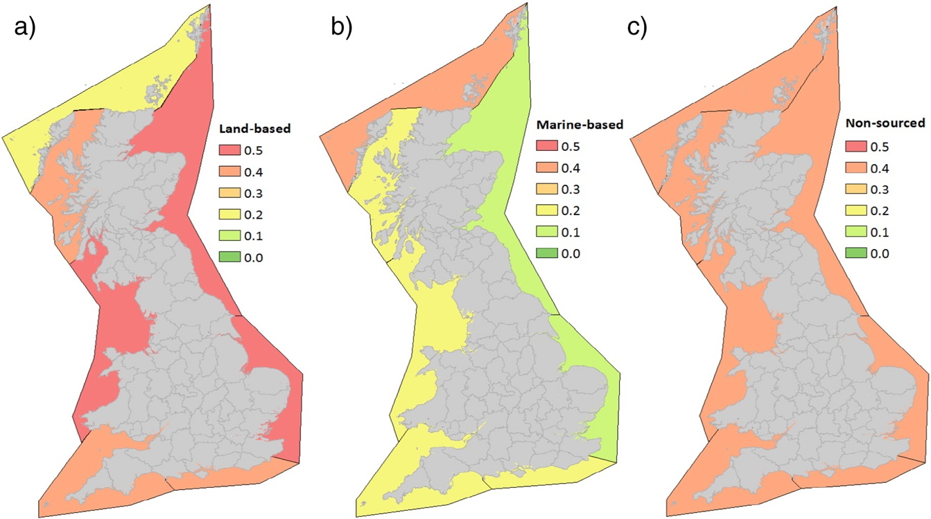

(Fig.1) Distribution maps of 3 categories of marine litter that comes from the land. (Nelms, S, 2017)

As you can see, (Fig.1) stipulates that a lot of land based materials enter the water, this may be because many big cities litter the coastline of the United Kingdom and a high population means more litter (McCormick, 2015). As we have come to understand throughout history, cities were built near the coast so that they could import and export goods and have various other benefits, although, it is now becoming a burden on the environment.

It has come to light that the reasons given above are now having an adverse effect on the environment. With the increase in demand for newer plastic materials there has been a new threat created, a threat that is becoming harder to eradicate from the water and that is micro plastics - a material that is less than 5mm in size (Martin et al., 2017).
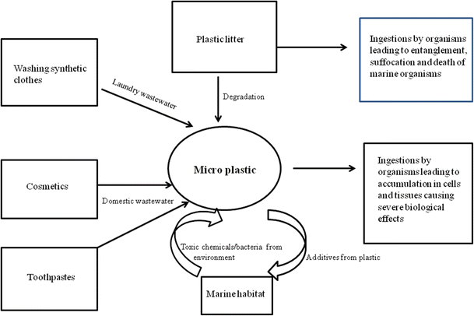

(Fig.2) A micro route to the sea (Sharma & Chaterjee 2017).

Often, plastics break down through a variety of different ways, including oxidization and photo degradation (Ryan et al., 2009, Andrady 2003). Although, plastics have been moulded into different items, they degrade the same way and they are reduced to micro plastics. As you can see from (Fig.2), domestic plastics are contributing to the continued micro plastic problem. The picture notes that plastics are getting into the water through the means of wastewater. Once it is turned into a micro plastic, it is then creating havoc for marine life by way of ingesting the item, which can lead to a build-up, slowly killing the animal because it leaves them with less space for food.
If you can imagine then the amount of homes throughout the UK, let alone the World, that have several items in each of those three categories, adding plastic to the water, it’s astronomical. However, the need to look better and the need to be clean obviously outweighs the value of Wildlife.
For example, cosmetics. Cosmetic products have a huge market and consumer base. One such micro plastic is Microbeads. Microbeads are polyethylene and polypropylene particles (Sharma & Chatterjee, 2017), that can be used in facial products for the use of removing dead skin cells, dirt and bacteria away from your face.
Imogen Napper noted that 80 facial scrubs in the UK still used plastic material in their facial products (Wells, 2015). Although, many countries have started to understand the harm that plastic materials, such as microbeads can have on the environment. For instance, Sweden and Canada have proposed an all-out ban on the use of Microbeads in products (Sharma & Chatterjee, 2017). The harm it causes has now finally been recognized by the UK Government and now a ban has come into effect (Gov.uk, 2018). However, there are plenty of harmful plastics out there entering our waters that are going unnoticed such as synthetic fibres.
It has been identified that a mere piece of clothing can produce a staggering 1900 fibres per wash (Browne et al., 2011, Pirc et al., 2016). All these fibres entering the wastewater stream unmonitored fuelling the notion of what UNEP stated in 2009. People put several pieces of clothing in a washing machine, therefore, a huge amount of unmonitored micro plastics are entering the waters through washing our clothes.
Pirc et al. (2016) conducted an assessment with a blanket weighing 350g, which was washed on average of four times a year and they also assessed a fleece jacket weighing 500g, which was washed 8 times a year.
The results showed that the blanket released 4.5mg’s of fibres and 6.5mg for the fleece (Pirc et al,.2016). It was calculated that 70mg of fibres were released into the water from just one person’s wash (Pirc et al., 2016). Many pile clothes into the washing machine, unaware of what is being added to the water.
Pirc et al (2016) further went on to mention that Slovakia with its 2 million plus inhabitants produce on average a staggering 144kg a year. Imagine 70 million inhabitants, that would be 5.04 tonnes of micro plastics a year entering our wastewater streams based on these findings. Although, the findings were resigned to the fact that wastewater treatments would manage to treat this, it was an area that they believed was a source that should be deemed an issue and something should be done about it (Pirc et al., 2016).
If that is true, why are there no major signposts from governments to demand companies to reduce the amount of clothing made from synthetic materials as it has been shown that Wastewater plants reliability to treat all wastewater can be low, allowing pollutants to escape the net (Marzec et al., 2017).
Therefore, plastics need to be monitored more intently as there are still routes that allow plastic to enter the water. Not only that, these plastics make up parts of floating landfills that contain bottles, packaging, a place which micro plastics are now calling home. There are whole swells of water that are covered with plastic, namely Gyres. It has been reported that there are Gyres in the North and South Atlantic, South Indian, North and South Pacific Oceans (Sharma & Chatterjee, 2017). Patches of water which will undoubtedly endanger wildlife.

Landfills of the water
There are plastic landfills within our waters, areas that harbour danger for creatures and wildlife suggesting that this is going unnoticed. It does beg the question how are these areas being created, why there are no operations being undertaken to remove them from the water. Could it be that there is a huge amount of rubbish that gets disposed of incorrectly or ships losing their cargo (Sigler 2014).
It has been noted that there have been several areas of concern within the Northern and Southern Hemisphere, areas that have been called Gyres, some twice as big as Texas (Sigler 2014). Areas which have been created through a combination of oceanic and atmospheric force which binds litter, plastic, seaweed together and then reside in certain parts of the Ocean (NOAA 2013).
On their voyage around the Pacific, the National Oceanic Atmospheric Administration (NOAA) discovered that there were two huge areas of marine litter within the Pacific Ocean, one on the East and one on the West.

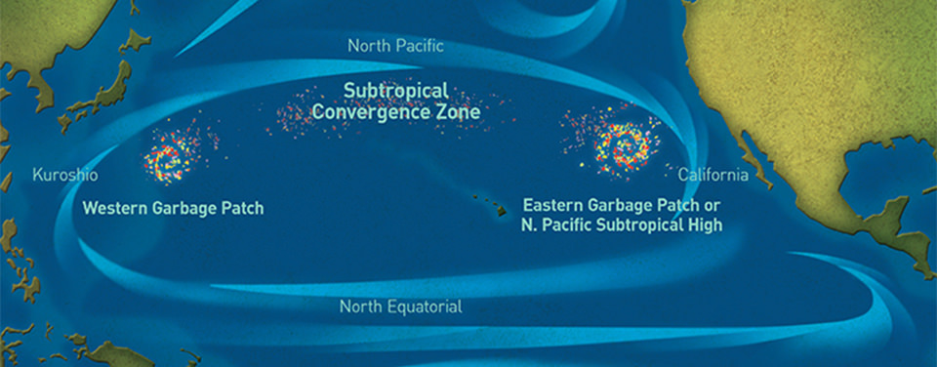
(Fig 3.) The Garbage patches of the pacific, (NOAA, 2013)

As you can see in (Fig.3) these areas have been created due to plastic finding its way into the more calmer waters of these areas (NOAA, 2013), which as you can see in the (Fig.3), the areas are larger in width than Japan.
This is just one area of many that has been created through improper disposal and lack of policing. The Mediterranean Sea is a vast expanse of water that is surrounded by many coasts. It has been used by many ships for import and export of goods, however, this area has also been infiltrated by anthropogenic waste
In the study undertaken by Cozar et al. (2015) to see how much plastic was in the Mediterranean Sea, five different types of plastics had been found within their results including pellets and film. Cozar et al. (2015) goes on to note that of all sites studied, plastic material ranged from 22 to 1934 g km squared, of which, 92% of the sites showed high concentrations of plastic material within them and it was then calculated that the average concentration was 423g per km squared, or 243,853 items per km squared.
Although the area is not on the grand scale of an Ocean, to still have 92% of the sites containing large proportions of plastic particles (Cozar et al., 2015) is a frightening site. Especially if this body of water contains 4%-18% of all water species (Bianchi & Morri, 2000, Cozar et al., 2015) that could be effected by this material and may possibly die out. So, in terms of the world population, that would be between 304 million and 1.37 billion people, so near the number of inhabitants of American and China (Worldometers, 2017). If this amount of people could potentially be affected by a pollutant, then there would be more action from the World Leaders and something would be done about it, so why are we not taking an action to save our water species.
These are just two examples of where marine plastics reside. Plastics in the sea are pretty much everywhere, the Sea Education Association have been finding plastic particles in the North Atlantic Sea since 1986 (Van Franeker & Law, 2015). Many plastics inhabit seas globally and there is a higher concentration where industry is built near the coastline (Li et al., 2016). These areas are not going to go away, they are here to stay and they are embedding themselves within our waters, that can be problematic for the wildlife and in the long run and eventually be problematic for us.

More plastic, more problems?
So, with all this plastic in the sea, is it a problem. These Gyres are still out there and they have been notified to all, so is it a major problem?
Corals are one of many organisms that can suffer the side effects of ingesting plastic particles. Corals ingest phytoplankton which has had its membrane breached by these micro plastics, causing the energy that they give other species to be reduced (Sharma & Chatterjee, 2017). Once this Plankton has been ingested by the coral it cannot be digested as normal and directly effects their health (Sharma & Chatterjee, 2017).
Micro plastics are a harmful particle to Coral reefs, which are areas that are the most biologically diverse (Praveeena et al., 2012). If this continues to happen then the coral reefs will slowly die and that will mean that species within that ecosystem will become extinct and it will surely have a negative effect on the food chain.
Moreover, it has been showcased that 48-cetacean species have also suffered from ingesting these micro plastics such as whales and dolphins (Li et al., 2016), with what micro plastics can do to the animal’s body, it presents a new hazard (Li et al., 2016).
A study conducted by De Stephanis et al (2013) examined a sperm whale found dead near Granada, Spain. The results showed that the whale had died from a gastric rupture attributed to impact from debris. On further inspection, they managed to retrieve several pieces of plastic that had been ingested. De Stephanis et al. (2013) had noted that there had been an increase in plastics used for Greenhouses within that area, of which, some materials were found within the whale. Therefore, anthropogenic waste could be the reason why this animal died, a species that is protected (De Stephanis et al., 2013).
Not only are solid plastics a problem to wildlife, the build-up of micro plastics has the potential to cause harm to the human health (Sharma & Chatterjee, 2017). There have been fish collected from fish markets that have contained micro plastics, a staple food for island communities such as Iceland and Faroe Islands, which consume on average 92 kg and 87.3kg of sea fish per capita and it has been known that older predator species may contain more contaminants than what is recommended as a safe level for consumption (Lusher et al., 2017).
Moreover, Bivalves have been known to harbour disease such as Cholera and Hepatitis (Boero, 2016), diseases which can have huge implications on human health. Therefore, this would be a significant problem that marine plastic would have caused. So, what that needs be done to stop our marine wildlife dying and creating a domino effect that could possibly effect human health along the way.

Recommendations.
Governments should introduce policies that take a Zero tolerance approach to marine litter (Sharma & Chatterjee, 2017) and to remediate the waters of all these plastics and try to reduce the amount that enters the water, make water treatments plants more aware of what is entering them and make the owners aware that plastics are still entering the water stream.
There should be a tax put on companies that use plastic packaging and follow the way of the supermarket Iceland and try to implement a policy to eradicate plastic packaging from their products (BBC News, 2018).
Put more emphasis on clean-up operations and possibly endorse small and large companies. There have been innovative products that have been produced such as the Marine debris clean-up equipment, which is a piece of equipment that could reduce the amount of fishing gear, bottles and other solid materials that are clustered within our waters (DESMI, unknown date), or even put faith in the Ocean Clean-up project that effectively states that it could reduce 50% of the Great Pacific Garbage patch in 5 years (The Ocean Clean up, 2017).
Also, a recommendation that must be stressed is the improved participation for data collection from all. Most sources stipulate that there is little to no data being supplied to help research. O’hanlon et al. (2017) conducted a study about seabirds in the north Atlantic Sea. They recorded that 74% of the Seabirds they examined for plastic ingestion, had ingested plastic. However, it was noted that there is a disproportionate amount of studies conducted by countries, of which, a large amount of them were collected before the 21st century (O’hanlon et al., 2017).

O’hanlon et al. (2017) further goes on to recommend that studies should report the size of the plastic detected so that others are able to compare and there needs to be a coordinated and collaborative effort when collecting data. Although they are recommending this for Seabirds, this could be said for most collections of a variety of species with emphasis being put on the collaboration from governments, with researchers, agents and using methods such as lavage or necropsy (O’hanlon et al., 2017) being used more to further understand the damage and protect the Earth.

Conclusion
To conclude, plastics are not only harmful to the wildlife and the ecosystem, they are also harmful to humans. Although there are strategies already in place and schemes outlined for the future, the timeline is long and it will take extreme immediate action to remediate what humans have done to the Earth. The rise in consumerism and the demand for plastic products has left marine life in danger as wildlife are unable to distinguish from what is food and what is plastic.
There is a need for Governments to take control of this hectic problem, for the sake of species protection and human health, otherwise this will spiral to a point where there will be no return. Moreover, it has been shown there is not enough effort put in to help with this problem. The data is either old or non-consistent leading to individual cases, data that can-not be used to help future projects. There needs to be a push toward products that are innovative and there needs to be more money invested in future projects to gain that data that can be useful and aid in the fight against marine litter. Humans created this problem, it is only fair that humans resolve it.

References

Andrady A. L. (ed.) 2003 Plastics and the environment. New York: Wiley.
Anonymous2017, Feb 23. UN Declares War on Ocean Plastic. Targeted News Service.
BBC News, Jan 2018, ‘Iceland Supermarket chain claims to be plastic free by 2023’, Available online: http://www.bbc.co.uk/news/business-42692642, Accessed on [21/01/18]
Bianchi CN, Morri C. 2000 ‘Marine biodiversity of the Mediterranean Sea: situation, problems and prospects for future research.’ Mar Pollut Bull. ; 40(5): 367–376
BREITLER, A., 2007, Feb 19. Officials trying to keep tiny pellets out of waterways: Plastic makes up 60% to 80% of ocean trash. McClatchy - Tribune Business News, 1.

BOERO, F., 2016. MARINE BIODIVERSITY AND ECOSYSTEM FUNCTIONING: THE PILLARS OF GOOD ENVIRONMENTAL STATUS. Biologia Marina Mediterranea, 23(1), pp. 50-57.

Browne, Mark Anthony, Crump, Phillip, Niven, Stewart J., Teuten, Emma, Tonkin, Andrew, Galloway, Tamara, and Thompson, Richard, 2011, Accumulation of Microplastic on Shorelines Woldwide: Sources and Sinks, Environmental Science & Technology 2011 45 (21), 9175-9179, DOI: 10.1021/es201811s

Casson, L. 2017. ‘How does plastic end up in the ocean?’ Available online: https://www.greenpeace.org.uk/plastic-end-ocean/ (21/01/18)
CÓZAR, A., SANZ-MARTÍN, M., MARTÍ, E., GONZÁLEZ-GORDILLO, J.I., UBEDA, B., GÁLVEZ, J.Á., IRIGOIEN, X. and DUARTE, C.M., 2015. Plastic Accumulation in the Mediterranean Sea. PLoS One, 10(4),.

De Stephanis, R., Gimenez, J., Carpinelli, E., Gutierrez-Exposito, C., & Canadas, A. (2013). As main meal for sperm whales: Plastics debris. Marine Pollution Bulletin, 69, 206–214

Desmi, Unknown date, Marine Debris Equipment, Available online: https://www.desmi.com/desmi-products/marine-and-aquatic-debris-clean-up-equipment.aspx, Accessed on [21/01/18]

Geyer R, Jambeck JR, Law KL, (2017) Production, use, and fate of all plastics ever made. Sci Adv 3:e1700782

Gov.uk, 2018, ‘World-leading microbeads ban takes effect’, Available online: https://www.gov.uk/government/news/world-leading-microbeads-ban-takes-effect, [Accessed on 21/01/18]

Harper, P.C. and Fowler, J.A., 1987. Plastic pellets in New Zealand storm-killed prions (Pachyptila spp.).

LEE, A. and CHI-FAI, C., 2014, Apr 09. Compensation deal struck for clean-up of plastic pellets spilled in typhoon. South China Morning Post. ISSN 10216731.

LI, W, TSE, H, & FOK, L 2016, ‘Plastic waste in the marine environment: A review of sources, occurrence and effects’ Science of the Total Environment, 566, PP. 33-349, GreenFile, EBSCO host.

LIBOIRON, M., 2013. Redefining pollution: Plastics in the wild, New York University.
LUSHER, A., HOLLMAN, P. and MENDOZA-HILL, J., 2017. Microplastics in fisheries and aquaculture: Status of knowledge on their occurrence and implications for aquatic organisms and food safety. FAO Fisheries and Aquaculture Technical Paper, (615), pp. I,III,IV,V,X,XI,XV,XVI,XVII,1-7,9-35,37-53,55-65,67-69,71-73,75-83,85-123,125-126.

MARTIN, J., LUSHER, A., THOMPSON, R.C. and MORLEY, A., 2017. The Deposition and Accumulation of Microplastics in Marine Sediments and Bottom Water from the Irish Continental Shelf. Scientific Reports (Nature Publisher Group), 7, pp. 1-9.

MARZEC, M., 2017. Reliability of removal of selected pollutants in different technological solutions of household wastewater treatment plants. Journal of Water and Land Development, 35(1), pp. 141-148.

MCCORMICK, A.R., 2015. Anthropogenic litter and microplastic in urban streams: Abundance, source, and fate, Loyola University Chicago.

Nelms, S, Coombes, C, Foster, L, Galloway, T, Godley, B, Lindeque, P, & Witt, M 2017, 'Marine anthropogenic litter on British beaches: A 10-year nationwide assessment using citizen science data', Science Of The Total Environment, 579, pp. 1399-1409, GreenFILE, EBSCOhost, viewed 31 December 2017.

NOAA, 2013, Ocean facts, ‘What is the Great Pacific Garbage Patch’, Available online: https://oceanservice.noaa.gov/facts/garbagepatch.html. [Accessed 11/01/18]

NOAA, 2013, Office of Response and Restoration, ‘Where Are the Pacific Garbage Patches?’ Available online: https://response.restoration.noaa.gov/about/media/where-are-pacific-garbage-patches.html, [Accessed on 11/01/18]
O'hanlon, N, James, N, Masden, E, & Bond, A 2017, 'Seabirds and marine plastic debris in the northeastern Atlantic: A synthesis and recommendations for monitoring and research', Environmental Pollution, 231, pp. 1291-1301, GreenFILE, EBSCOhost, viewed 22 January 2018.
PRAVEENA, S.M., SIRAJ, S.S. and ARIS, A.Z., 2012. Coral reefs studies and threats in Malaysia: a mini review. Reviews in Environmental Science and Biotechnology, 11(1), pp. 27-39

PIRC, U., VIDMAR, M., MOZER, A. and KRZAN, A., 2016. Emissions of microplastic fibers from microfiber fleece during domestic washing. Environmental science and pollution research international, 23(21), pp. 22206-22211.

Ryan, Peter .G, Moore, Charles J, van Franeker, Jan A, Coleen L. MoloneyPhil. Trans. R. 2009 Monitoring the abundance of plastic debris in the marine
Sharma, S. & Chatterjee, S. Environ Sci Pollut Res (2017) 24: 21530. https://doi-org.ezproxy.uwtsd.ac.uk/10.1007/s11356-017-9910-8

SIGLER, M., 2014. The Effects of Plastic Pollution on Aquatic Wildlife: Current Situations and Future Solutions. Water, Air and Soil Pollution, 225(11), pp. 1-9.

The Ocean Clean-Up, 2017, The Ocean Clean-up Project, Available online: https://www.theoceancleanup.com, Accessed on [21/01/18].

UNEP (2009) Marine Litter: A Global Challenge. Nairobi.
Van Franeker, J, & Law, K 2015, 'Seabirds, gyres and global trends in plastic pollution', Environmental Pollution, 203, pp. 89-96, GreenFILE, EBSCOhost, viewed 21 January 2018.

WELLS, D., 2015, Aug 27. Cosmetics and cleaning products 'polluting seas with microplastics'. The Western Morning News, 3.

Worldometers, 2017, ‘Countries in the world by population (2017)’, Elaboration of ata by United Nations, Department of Economic and Social affairs, Population Division. World Population Prospets: The Revision. Available online: http://www.worldometers.info/world-population/population-by-country/. [Accessed: 21/01/18]

