

Programme: MSc Software Engineering and AI
Module: Artificial Intelligence
Module code: ACCA7026
Lecturer: Dr Mohamed Bennasar

Student ID：2106260
Student Name：Hairong Lyu

Study of the handwritten digital recognition system based on KNN, SVM and neural network model
- Introduction
With the development and application of artificial intelligence technology, handwritten digital recognition technology is applied to data collection to realize the data screening of artificial intelligence. Handwritten digital recognition is a branch of optical character recognition technology. Due to its influence by different national backgrounds, personal writing habits and other factors, offline handwritten digital recognition is still an important problem in the field of pattern recognition[1].

Yang Jiping [1] restored the creation process of MNIST dataset through opponent writing image processing. After the basic pre-process steps such as image standardization and "smooth denoising", the classical algorithms such as KNN and SVM and PCA-KNN and PCA-SVM optimization models were adopted to realize the offline handwritten digital recognition of Arabic digits from the three modules of handwritten digital image preprocessing, single recognition algorithm model and PCA "dimension reduction" optimization. Zhang Yining[2], et al., studied the application of KNN algorithm in handwritten digital recognition technology from the aspects of computing process, image processing and data processing. On the basis of KNN algorithm, they proposed the design scheme of Python library call, and studied the program design code of Classify() function and img2vector function. Zhong lehai[3], et al, used 13-point grid features to extract MNIST dataset, and BP neural network acted as a classifier with a 79.5% classification accuracy. Cun [4], et al., improved the structure and weight constraints of BP neural networks to test the USPS handwritten digital dataset and can achieve a recognition rate of 81.6%. A multilayer BP neural network based on backpropagation training in MATLAB was identified at 91.6%, as implemented by Wellner[5] et al. Based on the existing neural network, Yu Wensheng [6] et al, improved the error backpropagation neural network excitation algorithm, using the new activation function, optimizing the update of the parameters, taking the cross-entropy function and citing the Batch Norm algorithm.

In recent years, scholars at home and abroad have applied this idea to handwritten number classification, which not only solves the tedious steps of manual feature extraction and the inertial thinking of excessively relying on prior knowledge, but also can remove most redundant and irrelevant data with the help of traditional classifiers to improve the classification accuracy and prediction time of handwritten numbers.In this paper, the handwritten Arabic numbers in the MNIAT dataset are selected as objects, and the KNN and SVM classical algorithms are used to realize digital identification with the neural network model, and compare the classification effect of each algorithm by modifying the reference.

- Methodology
2.1 K-Nearest Neighbor ( KNN)
The k-nearest neighbor classifier, also known as the KNN algorithm (K Nearest Neighbors Algorithm), identifies the k nearest neighbors to be identified from the training set, and then determines which samples to be identified according to the categories to which the k nearest neighbors belong.

2.1.1 Development status of KNN algorithm
Originally proposed by Cover and Hart in 1968, the KNN is a theoretically more well-established classification algorithm.This is an algorithm based on template matching ideas, though simple, effective and still used today.

However, k nearest neighbor method because the calculation is quite large, so quite time-consuming, Ko and Seo proposed an algorithm TCFP (text categorization using feature projection), try to use the feature projection method to reduce the classification of the system, and improve the system performance, the experimental results show that its classification effect is similar to k nearest neighbor method, but its operation time is only one-tenth of the k nearest neighbor operation time.

In addition, the KNN optimization scheme also has kd-tree and BFPTR, et al.

The kd tree (K-dimension tree) is a tree data structure that stores instance points in a k-dimensional space for rapid retrieval.The kd tree is a binary tree representing a division of the k-dimensional space, and constructing the kd tree is equivalent to constantly codividing the K-dimensional space with a superplane perpendicular to the coordinate axis, forming a series of K-dimensional superrectangular regions.Each junction of the kd tree corresponds to a k-dimensional superrectangular region.Using the kd tree saves the search of most data points, thus reducing the computational amount of the search.

In KNN, we aim to find elements with large K or small K. In fact, there is a better algorithm called BFPTR algorithm, also known as median median algorithm. Its worst time complexity is O (n), which is proposed by Blum, Floyd, Pratt, Tarjan and Rivest.The idea of this algorithm is to modify the principal element selection method of the fast selection algorithm to improve the time complexity in the worst case.

2.1.2 KNN principle
Distance metric, selection of k value and classification decision rules are the three basic elements of the k nearest neighbor algorithm.

Based on the selected distance metrics (for example, Manhattan distance or Euclidean distance, Minkowski Minkowski), you can calculate the distance between the test sample and each instance point in the training set, select the k nearest neighbor points according to the value of k, and finally classify the test instances according to the classification decision rule.

2.1.3 KNN algorithm steps
1) Calculate the distance between the test data and each training data;
2) Sort according to the increasing relationship of distance;
3) Select the K points with the minimum distance;
4) Determine the frequency of the category where the first K points are located;
5) Returns the most frequent category in the first K points as the predictive classification of the test data.
To sum up, KNN is to calculate the distance between the test data and each training data, remove the labels of the nearest K training data, and the largest number of them is used as the prediction label for the test data.

2.2 Support Vector Machine (SVM)
2.2.1 Principle of the SVM algorithm
The SVM transforms this process into an optimization problem by learning samples to find a classification into an interval boundary. It is well known that the classification interval is determined by the small number of samples nearest the classification decision boundary, and than these samples farther from the classification decision boundary, will not affect the optimal weight vector, these very special samples, known as "support vector", is that they support the linear classifier in the sense of the maximum classification interval. This is why this algorithm is called a support vector machine (SVM).

2.2.2 Advantages and disadvantages of SVM
merit:
- With strict mathematical theory support, and strong interpretability, we do not rely on statistical methods, thus simplifying the usual classification and regression problems;
- Be able to identify the key samples critical to the task (i. e., support vector);
- After using nuclear techniques, nonlinear classification and regression tasks can be handled;
4. The final decision function is determined by only a few support vectors, and the computational complexity depends on the number of support vectors, but not the dimension of the sample space, which in a sense avoids the "dimensional disaster".
shortcoming:
1. Long training time.When the SMO algorithm is applied, the time complexity of selecting two parameters is O (N²), where N is the number of training samples;
2. When the nuclear technique is adopted, if the spatial complexity is required to store the nuclear matrix, it is O (N²);
3. When the model predicts, the prediction time is proportional to the number of support vectors.Predictive computational complexity is higher when the number of support vectors is large.
Therefore, SVM is currently only suitable for small-batch sample tasks, and cannot adapt to millions or even hundreds of millions of samples.

2.2.3 SVM algorithm steps
1. Read the data set;
2. Data format conversion;
3. Train the SVM classifier;
4. Test set classification;
5. Calculate the classification accuracy.

2.3 neural network
2.2.1 Neural network-related knowledge[7]
Artificial neural network: Artificial neural network has the characteristics of strong anti-interference, high fault tolerance, parallel distributed processing, self-organization learning. After several decades of development, its theory has achieved extensive success in many research fields, such as pattern recognition, automatic control, signal processing, and assisted decision-making. Here, it is emphasized that the artificial neural network is like the "heart" of artificial intelligence, driving the normal operation and work of AI-related technologies.

Neuronal model: Neuronal model is the basic model in a neural network. A single neurons can receive information from other neurons in the network. If the information exceeds the threshold, this neuron is activated and then sends information to other neurons.

Activation function: that is, the operation function executed on the corresponding neurons of the artificial neural network is an important part of the artificial neural network, which is of great significance to improve the convergence speed and identification accuracy of the artificial neural network. Its main function is to map the sample data from the input end to the output end.

Gradient descent: Gradient descent is an iterative method that can be used to solve both linear and nonlinear problems. The standard gradient descent algorithm for the randomized initialization of the research subjects can be used in the field of deep structural neural network learning, but the experimental results show that the learning performance is not good.Common training and learning algorithms have full-batch gradient descent, stochastic small-batch gradient descent, and stochastic gradient descent.The purpose is to correctly adjust the weight vector and calculate a gradient for each weight, so as to strengthen the learning ability of the network and minimize the error mean, which can improve the convergence rate of the network to some extent. Gradient descent is one of the most commonly used methods when solving the model parameters of machine learning-correlated algorithms, the unconstrained optimization problem.

2.2.2 Neural network algorithm steps
1. Data reading;
2. Data normalization;
3. Train the model, including forward propagation, backpropagation, and parameter update;
4. Test the classification dataset;
5. Assess the classification accuracy.
- Experimental preparation
3.1 Data Source
The dataset used in this paper is the MNIST dataset (the modified National Institute of Standards and Technology database). The MNIST file is 55.7MB and contains a total of 70000 handwritten digital images (60000 data for the training set and 10000 data for the test set). The experimental operation environment is: MATLAB version is R2021a version, and the experimental computer is Windows10 system.
- Results and discussion
4.1 results and evaluation of KNN algorithm
Figure 1 shows the running results of the KNN algorithm, in which the peripheral 10 adjacent samples represent the classification, with an accuracy of 96.70%. When the number of samples K is changed to 5, the accuracy reaches 96.87% (see Figure 2 for results). When the sample number is changed near K to 3, the accuracy reaches 97.06% (see Figure 3 for the results).
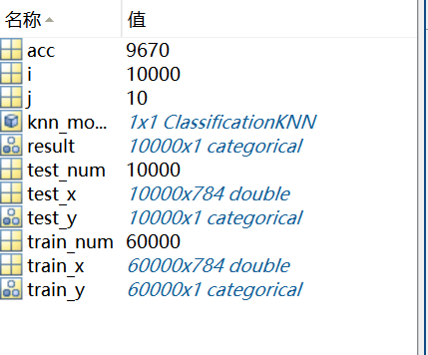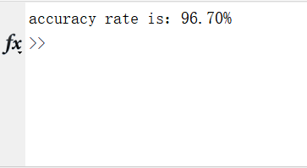
Fig1. Operating parameters and accuracy of KNN (K=10)
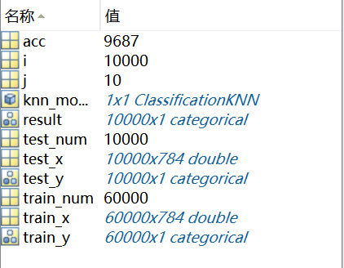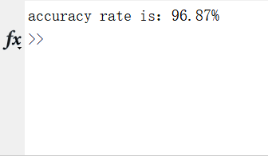
Fig2. Operating parameters and accuracy of KNN (K=5)
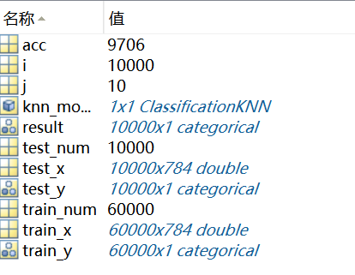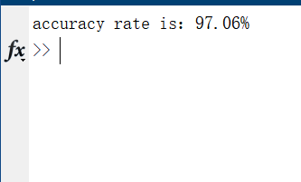
Fig3. Operating parameters and accuracy of KNN (K=3)
After simple comparison, the smaller the K value, the higher the accuracy. For this phenomenon, choosing a smaller K value is predicted, the "learning" approximation error will decrease, and only the training instance closer or similar to the input instance will work on the prediction results. Meanwhile, the estimation error of "learning" will increase, in other words, decreasing K value means that the overall model becomes complex and prone to overfitting.

4.2 results and evaluation of SVM algorithm
Figure 4 shows the classification results of the MNIST dataset by the SVM algorithm, in which the linear kernel function is used, and the accuracy rate can reach 93.63%, the model training time is 1122.57s, and the test set classification time is 3.88s. By contrast, when the kernel function is used to classify with the RBF function, the accuracy rate reaches 11.35%, the model training time is 2722.82s, and the test set classification time is 1422.38s (see Figure 5 for the running results).
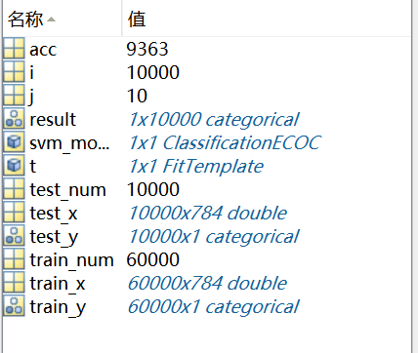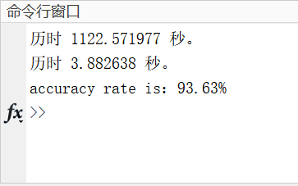
Fig 4. SVM operating parameters and accuracy (kernel function is linear)
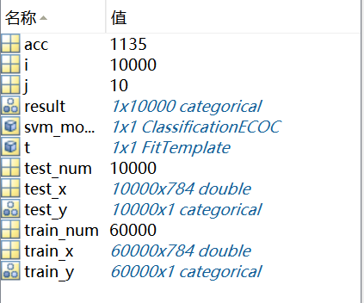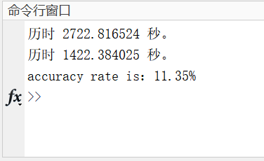
Fig 5. SVM operating parameters and accuracy (kernel function is RBF)
Through running practice, it is clear that the linear kernel function performs well, and the SVM algorithm selecting the RBF kernel function runs longer than the linear kernel function, and the test set classification time is longer. According to this phenomenon, we can find that RBF kernel function is slower than linear kernel function, because the feature space to input space is the same in kernel linear function, with few parameters and fast speed; Gaussian radial basis function is a localized kernel function, which can map a sample to a higher dimension space to solve a dual problem, the calculation speed is slow and easy to overfit when the parameters are not selected.

In this experiment, the RBF kernel function runs very poorly, and after multiple experiments, this dataset classification is not suitable for using the Gaussian radial basis function.

4.3 results and evaluation of the neural network model
Figure 6 shows the neural network operation parameters and the results. It is seen that the neural network model was trained for 6.26s and test time is 0.12s, with an error rate of 5.31%.
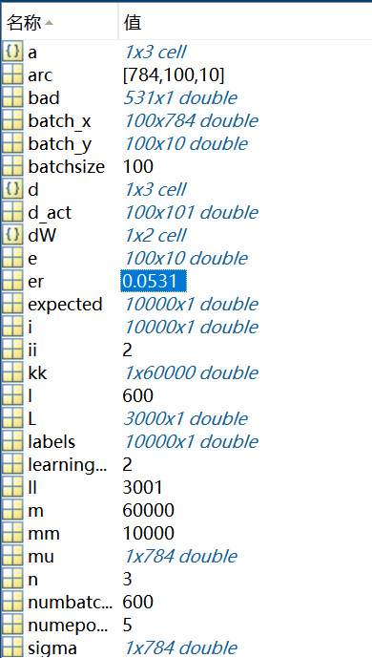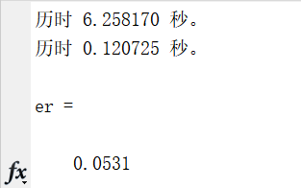
Fig 6. Operation parameters and accuracy of the neural network model
After many actual runs, the classification accuracy of the neural network model was found to be almost maintained at near 94.7%, which was not particularly good. For the reason of low accuracy, the neural network model is not particularly high because due to the local optimal solution found through its own learning way.

4.4 Comparison of the results
Overall, the neural network runs the fastest, but the median accuracy is 2.36% lower than KNN and 1.07% higher than SVM; KNN algorithm is 3.43% higher than SVM and shorter operation time. Overall comparison, the operation speed ranking is: neural network>KNN>SVM; accuracy rate ranking: KNN>neural network>SVM; comprehensive operation speed and accuracy, the neural network model has the best operation effect, KNN second, SVM is the worst.

- Conclusion
- In the KNN algorithm, the smaller the K value, the higher the accuracy of the classification, but there is a risk of overfitting.
- The RBF kernel function in the SVM algorithm is not suitable to classify the MNIST dataset, and the linear kernel function operation performs well.
- In terms of comprehensive operation speed and accuracy, the neural network model works the best, followed by KNN, and the worst SVM.

Reference:
- Yang Jiping. Study on handwritten digit identification based on the principal component dimensionality reduction model [J]. Network Security Technology and Applications, 2021 (03): 31-32.
- Zhang Yining, Chen Haiyan, Chang Ying, Zhang Jingfeng. Based on KNN algorithm [J]. Computer Programming Skills and Maintenance, 2021 (11): 123-124 + 132.
- Zhong Lehai, Hu Wei. A new feature extraction method in Handwritten digital recognition system [J]. Journal of Sichuan University (Natural Science Edition), 2007 (05): 1000-1004.
- Cun Y L, Boser B, Denker J, et al. Handwritten digit recognition with a backpropogation network[J]. Advances in Neural Information Processing Systems, 1990.
- Wellner M , Luan J , Sylvester C . RECOGNITION OF HANDWRITTEN DIGITS, 2002 1 Recognition of Handwritten Digits using a Neural Network. 2009.
- Yu Wensheng, Zhang Xuanxiong. Improved error backpropagation method for neural network opponent write digital recognition [J]. Electronic Design Engineering, 2021,29(23):20-24.DOI:10.14022/j.issn1674-6236.2021.23.005.
- Wang Yun. A Digital Recognition Inquiry Based on the BP Neural Network [J]. Computer Programming Tips & Maintenance, 2021(06): 127-128.

Appendix
Appendix 1：Dataset download address
https://pan.baidu.com/s/19YPUe9S9xnztg9JGnoXxqw

Appendix 2：the KNN code
%knn.m
clc
clear all

%% read dataset
load mnist_uint8;
train_x = double(train_x) / 255;
test_x = double(test_x) / 255;
train_y = double(train_y);
test_y = double(test_y);
train_num = 60000;
test_num = 10000;

%% data format transformation
for i=1:train_num
for j=1:10
if train_y(i,j)~=(0)
train_y(i)= j;
end
end
end
train_y=categorical(train_y(:,1));
for i=1:test_num
for j=1:10
if test_y(i,j)~=0
test_y(i)= j;
end
end
end
test_y=categorical(test_y(:,1));

%% Training model
knn_model = fitcknn(train_x,train_y,'NumNeighbors',10); %respectively 10,5,3

%% test model
result = predict(knn_model,test_x);

%% evacuate
acc = 0.;
for i = 1:test_num
if result(i)==test_y(i)
acc = acc+1;
end
end
fprintf('accuracy rate is：%5.2f%%\n',(acc/test_num)*100);

Appendix 3：the SVM code
%SVM.m
clc
clear all

%% read Dataset
load mnist_uint8;
train_x = double(train_x) / 255;
test_x = double(test_x) / 255;
train_y = double(train_y);
test_y = double(test_y);
train_num = 60000;
test_num = 10000;

%% Data format conversion
for i=1:train_num
for j=1:10
if train_y(i,j)~=(0)
train_y(i)= j;
end
end
end
train_y=categorical(train_y(:,1));
for i=1:test_num
for j=1:10
if test_y(i,j)~=0
test_y(i)= j;
end
end
end
test_y=categorical(test_y(:,1));

%% Training model
tic
t = templateSVM('Standardize',true,'KernelFunction','gaussian'); % linear,RBF
svm_model = fitcecoc(train_x,train_y(1:train_num),'Learners',t);
Toc

%% test model
tic
result = predict(svm_model,test_x);
toc
result = result.';

%% evacuate
acc = 0.;
for i = 1:test_num
if result(i)==test_y(i)
acc = acc+1;
end
end
fprintf('accuracy rate is：%5.2f%%\n',(acc/test_num)*100);

Appendix 4：the Neural network model code
clear all;
close all;
clc;

%% read Dataset
load mnist_uint8;
train_x = double(train_x) / 255;
test_x = double(test_x) / 255;
train_y = double(train_y);
test_y = double(test_y);

%% Data normalized
mu=mean(train_x);
sigma=max(std(train_x),eps);
train_x=bsxfun(@minus,train_x,mu);
%mean value was subtracted separately for each sample
train_x=bsxfun(@rdivide,train_x,sigma);
%Divide by the standard deviation, respectively
test_x=bsxfun(@minus,test_x,mu);
test_x=bsxfun(@rdivide,test_x,sigma);

%%
arc = [784 100 10]; %Input 784, hidden layer 100, and output 10
n=numel(arc);
W = cell(1,n-1); % weight matrix
for i=2:n
W{i-1} = (rand(arc(i),arc(i-1)+1)-0.5) * 8 *sqrt(6 / (arc(i)+arc(i-1)));
%100*785，10*101
end

learningRate = 2;
numepochs = 5; %Training 5 times
batchsize = 100; %100 data at a training session

m = size(train_x, 1);
numbatches = m / batchsize;

%% Training model
L = zeros(numepochs*numbatches,1);
ll=1;
tic
for i = 1 : numepochs
kk = randperm(m);
for l = 1 : numbatches
batch_x = train_x(kk((l - 1) * batchsize + 1 : l * batchsize), :);
batch_y = train_y(kk((l - 1) * batchsize + 1 : l * batchsize), :);

%% forward propagation
mm = size(batch_x,1);
x = [ones(mm,1) batch_x];
a{1} = x;
for ii = 2 : n-1
a{ii} = 1.7159*tanh(2/3.*(a{ii - 1} * W{ii - 1}'));
a{ii} = [ones(mm,1) a{ii}];
end

a{n} = 1./(1+exp(-(a{n - 1} * W{n - 1}')));
e = batch_y - a{n};
L(ll) = 1/2 * sum(sum(e.^2)) / mm;
ll=ll+1;

%% counterpropagation
d{n} = -e.*(a{n}.*(1 - a{n}));
for ii = (n - 1) : -1 : 2
d_act = 1.7159 * 2/3 * (1 - 1/(1.7159)^2 * a{ii}.^2);

if ii+1==n
d{ii} = (d{ii + 1} * W{ii}) .* d_act;
else
d{ii} = (d{ii + 1}(:,2:end) * W{ii}).* d_act;
end
end

for ii = 1 : n-1
if ii + 1 == n
dW{ii} = (d{ii + 1}' * a{ii}) / size(d{ii + 1}, 1);
else
dW{ii} = (d{ii + 1}(:,2:end)' * a{ii}) / size(d{ii + 1}, 1);
end
end
%% updated parameter
for ii = 1 : n - 1
W{ii} = W{ii} - learningRate*dW{ii};
end
end
end
toc

%% testing
tic
mm = size(test_x,1);
x = [ones(mm,1) test_x];
a{1} = x;
for ii = 2 : n-1
a{ii} = 1.7159 * tanh( 2/3 .* (a{ii - 1} * W{ii - 1}'));
a{ii} = [ones(mm,1) a{ii}];
end
a{n} = 1./(1+exp(-(a{n - 1} * W{n - 1}')));

[~, i] = max(a{end},[],2);
labels = i;
[~, expected] = max(test_y,[],2);
toc

%% evacuate
bad = find(labels ~= expected);
er = numel(bad) / size(x, 1) %error rate

