Research in Context
Holly Morris-Price
2104336

Question
(Question 5)
From the Lens-Based Image Making research strand lectures, chose a theme, movement, or selection of artists that relate to your practice or interests, and construct a 2,500-word essay. Critically assess primary themes, key writers, and relevant practitioners.
Essay Topic: Aesthetic Photography in Film
In my essay I will be looking at Aesthetic Film Photography and using Aesthetic Theory to show that the aesthetic of film allows narratives to be built off the aura and look of a photo. I’ve come across several photographers who work with or who have explored into black and white film photography and its aesthetic properties. One thing I’ve thought about is why people enjoy the more worn and roughness and if there was any reason behind it. So looking into a film photography aesthetic as a whole I decided to start at why some people enjoyed film over digital, and if there was a theory or a proper answer as to why, and during that initial search I found a theory written by Street Photographer Eric Kim (2017) where they look at a specific question on his blog, that question was: “Why do I prefer the aesthetics of film pictures over digital pictures?”.
When I first read the question my initial thought of why I myself prefer film over digital is because of personal preference, but then I thought again since I put more meaning with my film since its what i enjoy most. The aesthetics of film have much more depth to them, i find whenever i look at black and white film i feel a deeper connection with it and it has an aura that radiates from the image taken from that roll as if the narrative of the photo is bursting out, and besides the way it makes me feel I’m attracted to the imperfections of it, and the mystery of shooting a roll of film, that’s what makes the aesthetic so interesting in my opinion, these rolls of film can come out looking like whatever and they’ll still have a charm to them all, and i think that’s the difference between digital and film photography. One has a cleaner, more organised and a much more contemporary feel to it due to sleek edges, vibrant colours and sharp lines, but at the same time they also feel flat and empty because of these. But with film you don’t have the sleek look to the outcomes and it has a more personal feel to them in my opinion. And that’s why I think I myself prefer film pictures over digital pictures.
Eric Kim’s response and theory from his blog touch upon the rough appearance of film by saying “First, the randomness and gritty texture of film is more aesthetically beautiful than lifeless, RAW or Jpeg images, because everything in nature is rugged, raw, gritty, and textured.” He then continues the theory with explaining why the rugged and worn look is more aesthetically beautiful to the reader by mentioning areas of nature. “For Example, we prefer to look at the jagged edges of rocks, trees, and the texture of fur, grass, and other organic matter...instead of looking at lifeless, inorganic materials such as stainless steel, or plastic.” (Kim, 2017, The Aesthetics of Photography https://erickimphotography.com/blog/2017/08/14/the-aesthetics-of-photography/ ) from these points the theory is, because we look at nature’s rough edges and impurities everyday even in our clothing. One example of how the rough and worn aesthetic playing into clothing is with clothes like ripped jeans, we love the aesthetic of them because of the rundown look to them, just as we like the look of film due to “the randomness and gritty texture” (Kim, 2017, The Aesthetics of Photography, https://erickimphotography.com/blog/2017/08/14/the-aesthetics-of-photography/ ) when shooting it, and arguably that makes the work much more interesting, I personally don’t feel it limits me in any way whenever I use it, if anything I think it allows me to express not only myself but also my practice as a whole, it creates this depth and aura to it that I’d never get if it was done with a digital camera since I feel matching your practice to the medium you use is really important too. Another reason as to why I decide to use film for my practice as I feel it suits the practice of ‘living in the moment’ which is what I enjoy shooting as it shows a side to strangers, family and also friends too, a lot of images that I see on the daily are posed or someone’s been told to ‘act like the camera isn’t there’ and it feels rather fake and not true to themselves in a sense. So I think Eric Kim’s Theory makes some really interesting points and gives a pretty good reasoning as to why people prefer the aesthetic of film pictures rather than digital ones. After looking a bit deeper into the ‘why’ I wanted to check out some photographers who favour black and white film, or some photographers who at least use it as their medium of practice. While I could look at both colour and B&W film i decided just to look at black and white because it’s what I use in my own practice. So after searching for a while I found 3 people who primarily use black and white film and each one of them have a difference in topics and reasons why they use film. The first photographer I wanted to look at and also wanted to explore was Vika Bykovskaya. Her work has this tranquil feel to them, they don’t give off an aura that’s confusing or busy, and it’s got depth in each image you look at.
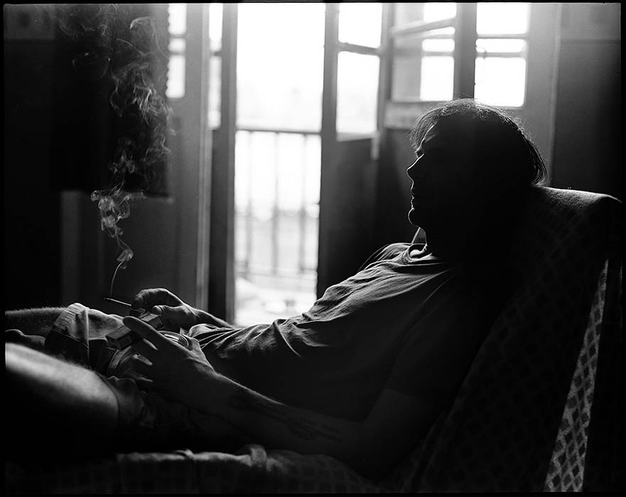

Figure 1

This image by Bykovskaya is an interesting one in my opinion since there’s so much shadow in the foreground rather than the background, in fact the light is solely coming from the top centre of the image, the man in the photo seems to be in his 40s and he’s holding a cigarette in his hand, but his silhouette is partially highlighted but it doesn’t fully light up the face which keeps a sense of anonymity within the image, and the way the image is focused lets us see even more of what is in that foreground, looking closer you can also see he has a tattoo and that the chair he is sat on has a diamond pattern on it. In a small interview done by Lomography, Bykovskaya and 2 other photographers talk about their use of film in their work, and in Bykovskaya’s interview she shares the basis of her photography and working with black and white film.
When I shoot, I mostly focus my attention on the lighting, on the human body, the emotions, on the lines, on the texture of the skin, on contrasts, on my feelings. All this is the basis of my photography. I found it’s much easier to focus on such things with the absence of colour. I’ve never felt that shooting in black and white has ever limited my photography, on the contrary, it makes it possible to give a photograph a secret. (Ellieash, 2019, https://www.lomography.com/magazine/342413-photo-stories-we-met-with-three-photographers-who-favor-black-and-white-film-photography )
I strongly agree with Bykovskaya’s point on the absence of colour, and i think this is also what adds to the aesthetic of film photography. Since the images are black and white, there’s no need to worry about how someone looks essentially, you don’t have to worry about balancing colours since you control the who thing, whether that be during the editing of a photo or if that’s when you’re taking it. You notice way more through a black and white film because i find personally everything stands out much more than it does with colour. She also points out that removing the colour makes it easier in a sense to express something through an image rather than feeling limited to telling a story through a series of images with colour. I also really relate to Bykovskaya and her basis for her work, I also look more to the lighting and contrasts within the frame but a lot of my work is also based of feelings, as I tend to photograph people within the moment, and capturing memories of my own.
So from that same article there was a second photographer that sort of caught my attention and that was Ben Macmaster, after reading the small interview he gave about his work and why he prefers black and white film over colour or digital, he gives a different perspective to the whole aesthetic. Instead of the physical appearance of film, Ben looks at the feeling of the processing of your own film and just the internal side of the aesthetic such as the feeling of producing a print from your film or shooting a roll with your camera and going to develop it, the whole experience is also what makes up part of the aesthetic around film photography. As said by Ben:
I found the whole photographic process, from shooting to developing and printing to be an incredible creative output. I still process and develop myself as it gives me total control over how my film comes out as I can work with the exact developer needed to bring out the contrast that is desired. (Ellieash, 2019, https://www.lomography.com/magazine/342413-photo-stories-we-met-with-three-photographers-who-favor-black-and-white-film-photography )
MacMaster mentions how the process of using film was a ‘creative output’ for him and looking at his Instagram and the photos posted there, the contrasts in his work are really interesting, everything stands out beautifully. His work on Instagram has a lot of horses and cowboys and with each one you look at you can feel the whole atmosphere of the photo bursting out, it’s amazing how it captures all of that in a simple photograph. So going back slightly to ‘why’ people like the aesthetics of film, it’s also because the whole process of it also draws people into it and the style. I know myself that the whole process of shooting and developing is really exciting to me, since you won’t know how your photos will actually turn out till after it’s done.

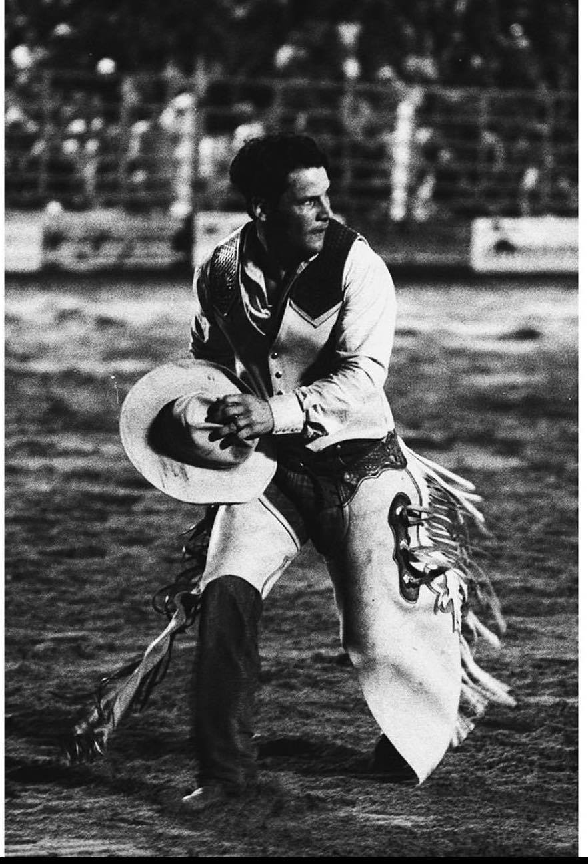

Figure 2
In the small interview with Lomography, MacMaster says this: “A lot of my work involves a sense of timelessness and I believe black and white film encompasses that feeling.” (Ellieash, 2017, https://www.lomography.com/magazine/342413-photo-stories-we-met-with-three-photographers-who-favor-black-and-white-film-photography ) I feel that the photo above really shows off that point of his work, Ben has managed to capture a moment that you can not only see but you can also hear it, it’s a moment in time that’s been preserved within a photograph that’s unique to that moment.
In the photo you can see a man who seems to maybe be in his 30s, and he’s dressed in lots of tasselled clothes resembling something a cowboy would wear, and he’s in a stadium like area with metal fencing behind where there seems to be some crowd stands, although it’s quite unfocused it look like people getting excited or cheering the man on. The ground also appears quite muddy from the lighting in the image. Looking at the image you can almost hear cheering and feel the atmosphere surrounding the image and when it was taken in that moment, and because of the movement in the photo that’s been practically frozen in time it looks like he’s in the process of running from something, from the other images found on his instagram I think that the image was maybe from a bull riding event.
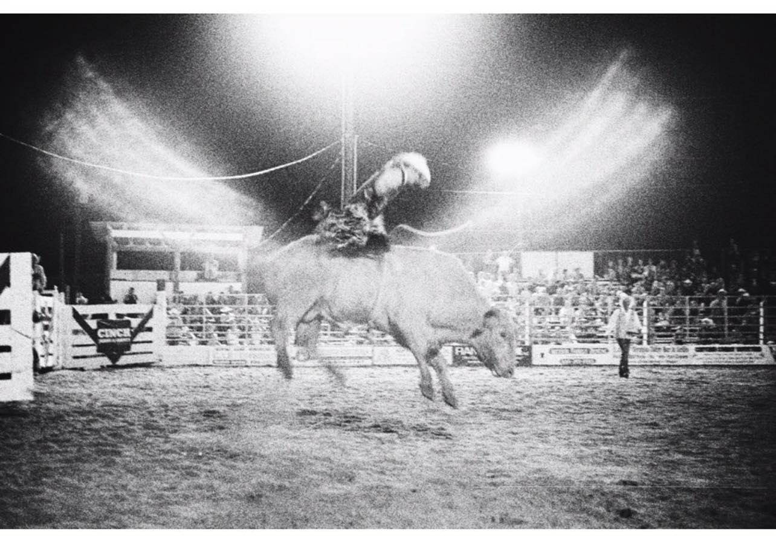

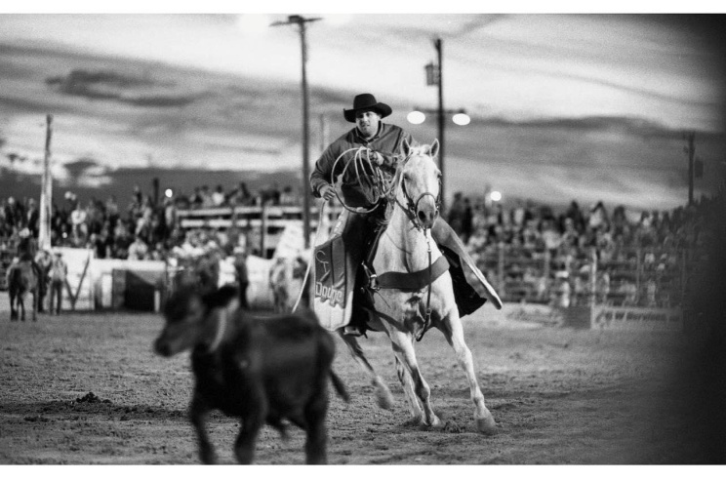

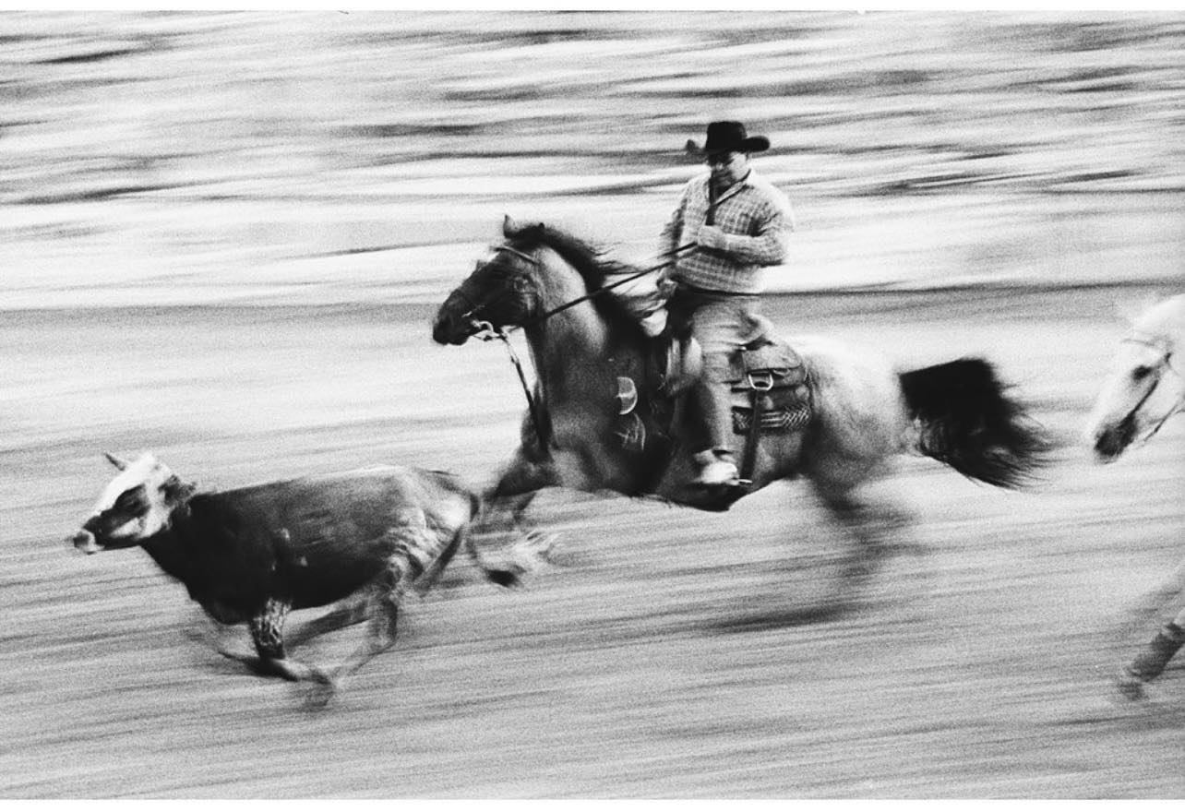

Figures 3,4,5
from the 3 images above they look to be in a very similar area to the original image I picked out, and it’s hard to fully tell but in the first image the person on the bull looks to be the person in the original photo i picked up but it’s hard to truly tell clearly. The first image also looks quite surreal, with what seems to be lights, since the way they are positioned look sort of like wings on the bull, which it’s quite interesting in my opinion. While these don’t exactly have room for a narrative from a glance I’m sure if you were to take the original one you could definitely create a narrative from that image.
For the third photographer I came across their work is much more based on the Aesthetics side since they don’t shoot in film. However their photos look straight out of a movie and create a beautiful setting for a narrative through aesthetic.

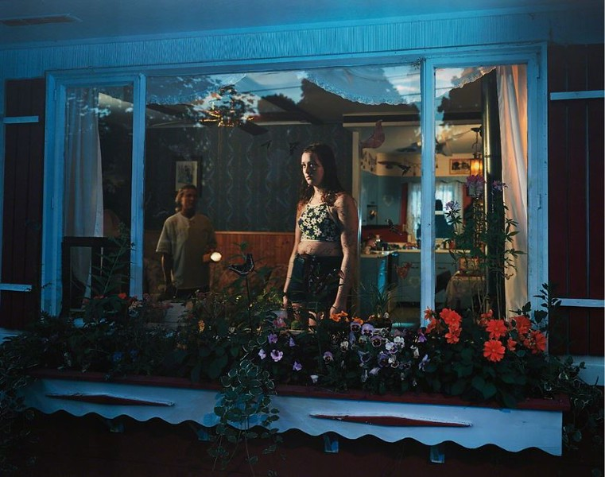
Figure 6
This photographer is Gregory Crewdson. His photographs are absolutely stunning and have an aesthetic to them that is really appealing. Each of his photos is done on sets that look like movie sets, he builds and co-ordinates sets for his photos and they’re amazingly detailed and create an image with so many secrets but also so many narratives. As said on an article about him by Thursd “Gregory Crewdson typically plans each image with meticulous attention to detail, orchestrating light, color, and production design to conjure dreamlike scenes infused with mystery and suspense.” (Thursd., 2022) Crewdson’s work contains that mystery in pretty much every photo you see, it really make you wonder why something is that way or where it’s come from, and it’s amazing how much of an impact his work has on someone just from looking at it.
In the image itself, there are 2 people stood in the window, one seems to be in their 30s and the other one seems to be in their 20s, there are some bright flowers outside the window in a large plant box and you are able to see into the kitchen on the right of the image, the woman that seems to be out of focus is holding a torch and aiming it at the other woman who is blankly staring out the window as if she has seen something or someone out there. The tone of the whole image makes it look rather cold as there are a lot of blue tones within the whites on the outside of the house.
While this image is not in film it still uses aesthetic to draw people in and look at the work carefully, this is also the case with many other photos Crewdson has taken, there’s some images where it seems so surreal you don’t believe that this was actually made on a live set, but they’re so interesting.
I think the overall fondness of film and films aesthetic attractiveness comes from 2 different things, It’s visual appeal, the contrast in each photo shot and how a narrative and how the emotions behind the image comes out to whoever look at the image, but the appeal also comes from processing the film itself, the whole experience when you take the photos to when you develop it yourself, it’s a environment you can control. The feeling of film as a whole makes the aesthetic in my opinion and it’s a beautiful medium to work with as it creates a sense of mystery and wonder due to not being able to see what you’ve got till you develop, it really stops time and projects it more than a digital image does in my own opinion. And i think that’s why there is so much fuss around it.

