Managing the Customer Experience



STUDENT NAME | YORDANKA KANCHEVA
STUDENT NUMBER | 2017633
MODUL CODE AND TITLE | BMSW 5103, UNDERSTANDING AND ENGAGING IN THE CUSTOMER EXPERIENCE
LECTURE NAME | DR. OMEIHE KINGSLEY

EXECUTIVE SUMMARY

This report analyses the customer experience and brand experience in Revolut, a leading financial technology company that has disrupted the traditional banking industry by providing innovative digital banking services. The report explores the different touchpoints and corridors that Revolut has developed to engage with its customers, and how these touchpoints and corridors impact customer relationship management (CRM). The report also discusses the significance of customer touchpoints and customer experience in building long-term relationships with customers and driving business growth.
The report concludes with recommendations for Revolut to further improve its customer experience and CRM strategy, such as enhancing its customer support system, increasing personalization, expanding its product portfolio, and investing in data analytics.
A critical literature review explores two major perspectives on customer experience: the firm's perspective and the co-creation perspective.
The review examines two UK tech companies, Cazoo and Deliveroo, to illustrate how these perspectives are applied in practice.
Overall, this review highlights the importance of adopting both the firm's perspective and the co-creation perspective in designing and managing customer experiences. By leveraging technology and involving customers in the design process, information technology firms can create products and services that are more closely aligned with customer needs and preferences, leading to increased customer satisfaction, loyalty, and positive word-of-mouth recommendations.

Table of Contents

INTRODUCTION 4
PART 1: Examine the customer experience of REVOLUT 5
BACKGROUND INFORMATION of REVOLUT 5
DISCUSSIONS based on the Customer experience journey of Revolut 6
Determination of Customer touch points and Customer corridors in Revolut 6
Significance and appropriateness of Customer Experience and Brand Experience for Revolut 9
How Customer touch points, Customer and Brand Experience affect Customer relationship management (CRM) 10
PART 2: A critical literature review on the customer experience 12
Overview and Discussion of Deliveroo and Cazoo by looking at the Firm's perspective and the Co-Creation perspective 12
CONCLUSION 16
RECOMMENDATIONS 17
LIST OF REFERENCES 18

INTRODUCTION

In today's competitive business environment, companies need to focus on delivering exceptional customer experiences to stand out from the competition (Kumar & Reinartz, 2018). This case study aims to explore the importance of user experience and how they interact with businesses in this journey. This paper will discuss how the implementation of this strategies affects the future of the firms.
The report will analyse Revolut's customer experience by examining customer touchpoints, corridors, and the impact on customer relationship management (CRM).
This document presents an in-depth analysis of the existing research on customer experience and explores two major viewpoints regarding it: the firm's perspective and the co-creation perspective. Additionally, it delves into how comprehending these two outlooks can aid information technology firms in enhancing their customers' experience. To support this, the paper cites examples from Cazoo and Deliveroo, two UK tech firms.

PART 1: Examine the customer experience of REVOLUT

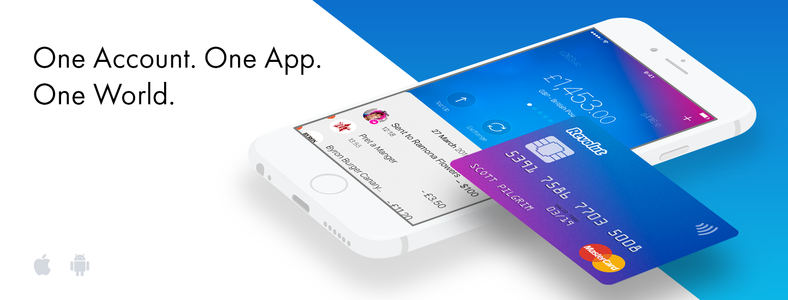Source: Internet

BACKGROUND INFORMATION of REVOLUT

According to the author Pawel Rybacki (’’The Rise of a Digital Bank’’, 2022), Revolut is a digital banking institution based in London that offers its services exclusively online through a mobile application. Provides multi-currency cards (virtual and physical) and personal and business banking solutions like payments, and bank transfers. The platform allows them to exchange currencies as well as transfer at interbank rates, analysis and tracking the use of money in real time. Revolut also offers cryptocurrency exchange, international transfer, investment, and insurance.
"Our mission is to unlock a borderless economy," said Storonsky, co-founder and CEO of Revolut, in May 2022. And this ambition today is becoming a reality. And, according to the same source, Revolut is the most highly valued private company in the UK compared to Barclays Bank.
On the official website of Revolut (https://www.revolut.com/about-revolut/), they introduce themselves as ‘’One app for all things money’’, with over 25 million users, 500 k business users, supported over 200 countries and regions and 29 in-app currencies. What they are aiming for is to build the world's first global financial app.
According to case study of M. Polasik, P. Widavski and A. Lis, Revolut is primarily intended for young customers. Using their smartphones or tablets they are able with just a few clicks to open and set up an account in different currencies and a wide range of financial operations. (Capgemini & Efma, 2020) and all this completely free.

DISCUSSIONS based on the Customer experience journey of Revolut

As a company that markets a product used by a wide customer audience, Revolut has extensive experience from its interaction with consumers. Revolut's customer experience and brand identity are closely intertwined. The company's focus on transparency, low fees, and convenience, combined with its emphasis on personalization and customer-centricity, has helped it build a strong brand identity and a loyal customer base.

Determination of Customer touch points and Customer corridors in Revolut

Any individual contact between a firm and any customer is defined as Touch point (Homburg et al., 2015; Shmitt, 2003).
Customer touchpoints are different channels or points of interaction that customers have with a company. These touchpoints provide opportunities for companies to engage with customers and build relationships (Peelen & Beltman, 2013).
The Customer touch points can also be divided on direct and indirect contacts (Meyer and Schwager, 2007).
Figure 1 (HubSpot, 2023)

Figure 1 illustrates some of the possible touch points for instance: emails, phone calls, meetings, presentations, product catalogues, public reactions, advertisements, social media, company events, product feedback, customer support channels…. (HubSpot, 2023)
Looking into Revolut in the current study case a few numbers of customer touch points are established: a mobile app, website, customer support team, giving information word-of-mouth and physical debit cards. Key touchpoints that ensure a seamless experience for customers are the easy-to-use interface and the instinctive mobile application. The app is easy to navigate, helps customers to use it and understand it smoothly. The website provides with information such as frequently asked questions and educational content.
Revolut customer support team is other important touch point. Although Revolut offers 24/7 support, customers have reported issues when trying to contact with them and their problems are not resolved in a timely manner. This can be a significant frustration for customers, resulting in a negative customer experience.
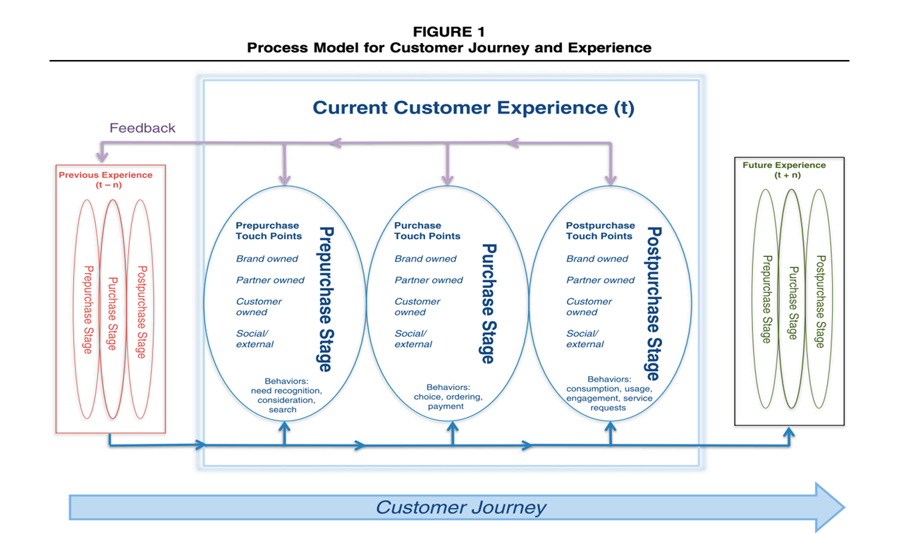
Lemon and Verhoef (2016)
Figure 2
According to Lemon and Verhoef, 2016, vividly illustrated in the above Figure 2 there are three stages in each customer experience and the decisive behaviour in each, including:
- Prepurchase stage-consideration, research
- Purchase stage-choice, ordering, payment
- Post purchase stage-usage, engagement, service
Customer corridors are defined as series of multiple touch points (Dr Kingsley, 2023).
For Revolut, customer corridors include currency exchange, international money transfers and mobile banking. According to Revolut (2023.), their mobile app offers a variety of solutions, such as currency exchange and money transfers at the best rates. Customers can also customize their accounts to suit their individual needs, such as setting daily spending limits or blocking specific types of transactions.
It also advanced security features, such as biometric identification and two-factor authentication, ensure that customers' financial data is protected. Instant notifications for each transaction help customers keep track of their spending and prevent fraudulent activity. These features are essential corridors that provide customers with a sense of security and trust in Revolut's services.

Significance and appropriateness of Customer Experience and Brand Experience for Revolut

Marketing Profs (2019) notes that understanding the difference between customer experience (CX) and Brand experience (BX) is crucial for businesses today.
According to Lemon and Verhoef (2016), The term "Customer experience" refers to a multifaceted idea that covers many aspects, such as a customer's thoughts, emotions, behaviours, perceptions, and interactions with a company's offerings throughout the entire purchasing and utilization journey. It signifies the overall impression that customers hold of a company based on their experiences with it across multiple points of contact (Lemon & Verhoef, 2016).
In the other hand Brafton (2023) defines the Brand experience (BX), as the sum of all interactions a customer has with a brand. BX goes beyond just the tangible items and services provided by a brand. It includes the intangible feelings and mental connections that a customer has with the brand. These emotional and psychological associations can have a significant impact on how a customer perceives and interacts with the brand. This includes everything from brand messaging and advertising to product packaging and design. BX is about creating a holistic customer experience that reflects the brand's values, personality and promise.
The brand experience plays a significant role and facilitates a deeper connection with the users, aiming to inspire them for a better experience (Gavuroa at al., 2018). The positive Brand experience has a great influence on customers to decide to buy more.
Revolut is a fintech company that has become a major disruptor in the financial industry. One of its key strengths is its focus on providing an exceptional customer experience, which has helped it build a strong brand identity. According to Forbes, "Revolut's brand is built on a promise of transparency, low fees, and convenience." (Hyken, 2020). Revolut has achieved this by designing a mobile app that is intuitive and user-friendly, providing fast and reliable customer support, and offering innovative financial solutions.
Revolut's customer experience has also contributed to its brand identity. The company's emphasis on personalization and customer-centricity has helped it build a loyal customer base. Jovanovic (2021) notes that "Revolut's customer experience is based on a human touch and understanding of individual customer needs." This has been achieved through targeted marketing, personalized product recommendations, and customized communication channels.

How Customer touch points, Customer and Brand Experience affect Customer relationship management (CRM)

Customer relationship management (CRM) is a strategy for companies to manage their interactions with customers and improve their satisfaction by focusing on building and maintaining long-term relationships. It involves collecting customer data and using it to develop personalized marketing campaigns, improve service, and tailor products and services to customer needs (Peelen & Beltman, 2013).
By providing positive experiences at every touchpoint, companies can increase customer satisfaction, which in turn can lead to higher customer loyalty and retention (Peelen & Beltman, 2013). In contrast, negative experiences at any touchpoint can lead to customer dissatisfaction and disengagement (Lemon & Verhoef, 2016).
Therefore, companies need to pay close attention to every touchpoint and ensure that customers have a positive experience at each one. This requires an understanding of customer needs and preferences, as well as the ability to personalize interactions and provide prompt and effective issue resolution (Peelen & Beltman, 2013). Companies that prioritize the customer experience across all touchpoints are more likely to achieve their CRM goals and build strong, long-lasting relationships with their customers (Lemon & Verhoef, 2016).
Revolut's focus on providing an exceptional customer experience has helped it build a strong brand identity and a loyal customer base (Jovanovic, 2021). For example, Revolut's mobile app provides a seamless user experience, with features such as instant notifications, real-time exchange rates, and budgeting tools that make it easy for customers to manage their finances (Barnes, 2020).
Revolut's customer corridors include the mobile app, website, social media, and customer support channels, among others (Barnes, 2020). The company's ability to provide a positive experience at each touchpoint has been key to its success. For instance, Revolut's fast and reliable customer support has helped to increase customer satisfaction and retention (Hyken, 2020). The company also offers innovative financial solutions, such as cryptocurrency trading and savings accounts, that cater to the changing needs of its customers (Hyken, 2020).
By prioritizing the customer experience across all touchpoints, Revolut has been able to build strong, long-lasting relationships with its customers, leading to increased loyalty and retention (Jovanovic, 2021). This has helped the company to achieve its CRM goals and become a major disruptor in the financial industry (Barnes, 2020).
These factors contribute to customer satisfaction and loyalty, which are essential components of CRM. However, the limited product offerings, customer support issues, service outages, and lack of physical presence can lead to customer frustration and dissatisfaction.

PART 2: A critical literature review on the customer experience

Customer experience refers to the customers' perceptions and feelings resulting from the interactions with a company's products, services, and channels (Meyer & Schwager, 2007). The customer experience has become a significant aspect of business strategy, and firms use different perspectives to understand and manage it.
Understanding the firm's perspective and the co-creation perspective on customer experience is crucial for information technology firms, as these perspectives provide different approaches to managing customer interactions and shaping customer perceptions. Information technology firms can use both perspectives to design and manage customer experiences effectively.

Overview and Discussion of Deliveroo and Cazoo by looking at the Firm's perspective and the Co-Creation perspective

- The Firm's Perspective (Berry et al, 2002; Stuart and Tax 2004)
The firm's perspective on customer experience focuses on creating a positive impression on customers by meeting their expectations (Gentile et al., 2007). In this view, the firm manages the customer experience by designing and controlling the interactions between the customer and the company (Verhoef et al., 2009).
The Firm’s Perspective is grounded in the belief that businesses can control and shape customer experience by designing and implementing specific strategies, processes, and practices. This perspective emphasizes the role of the organization in delivering a positive customer experience, such as providing high-quality products and services, creating personalized interactions, and ensuring efficient service delivery. One key aspect of this perspective is the use of customer journey mapping to identify touchpoints and pain points in the customer experience and design interventions to improve them (Gentile et al., 2020).

Cazoo is an example of an IT firm that focuses on the firm's perspective of customer experience. Cazoo is a UK-based online used car dealership that aims to revolutionize the way people buy and sell cars. It offers a range of services, including purchasing, financing, and delivery. The company's customer experience strategy is based on online platform, designed to provide a seamless and easy-to-use experience for customers, with clear information and high-quality images of cars (Cazoo, 2023).
Cazoo's approach to customer experience has helped the company to gain a competitive advantage in the online car retailing industry (Whiting et al., 2021). The firm's perspective has enabled Cazoo to control every aspect of the customer journey and provide a consistent and high-quality experience for its customers.

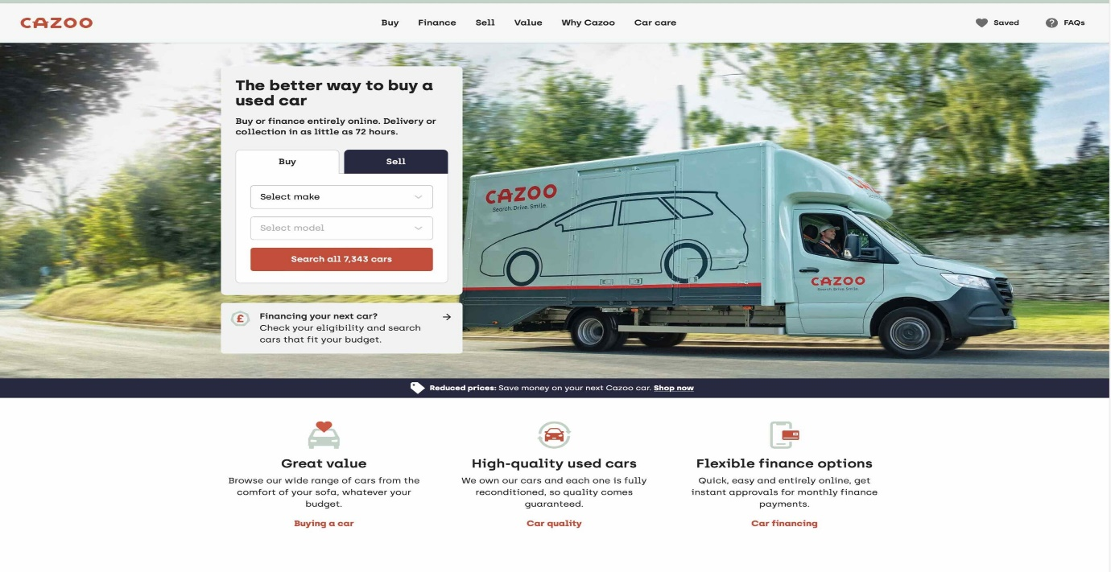
Source: Internet

Cazoo achieves this by offering a wide selection of high-quality cars, providing transparent pricing, and financing options, virtual test drives and delivering cars directly to customers' doorsteps. The company also offers a seven-day money-back guarantee and a comprehensive warranty to reassure customers of their purchase (Cazoo, 2023).

- The Co-creation Perspective (Chandler and Lusch, 2015)
The Co-Creation approach to customer experience highlights the importance of involving customers in the process of designing their own experience. This approach acknowledges that each customer has their own specific requirements, tastes, and anticipations that can't be fully comprehended or satisfied by the organization alone. Therefore, co-creation involves collaborating with customers to co-design and co-deliver the customer experience. Co-creation strategies include involving customers in product and service development, soliciting feedback and suggestions, and creating channels for customer engagement and co-creation (Prahalad and Ramaswamy, 2004). This approach suggests that customers are not passive recipients of a predefined set of experiences but active participants who co-create their experiences with the company. Companies that adopt this perspective view their customers as partners in the design and delivery of products and services.
In the IT industry, this perspective has been adopted by companies like Deliveroo, a food delivery platform that allows customers to order food from local restaurants. Deliveroo is a UK-based and its role connects customers with local restaurants and offers delivery services. Deliveroo’s app provides a range of features that allow customers to customize their orders, track their deliveries, and rate their experiences with the service and the quality of the food (Deliveroo, 2023).

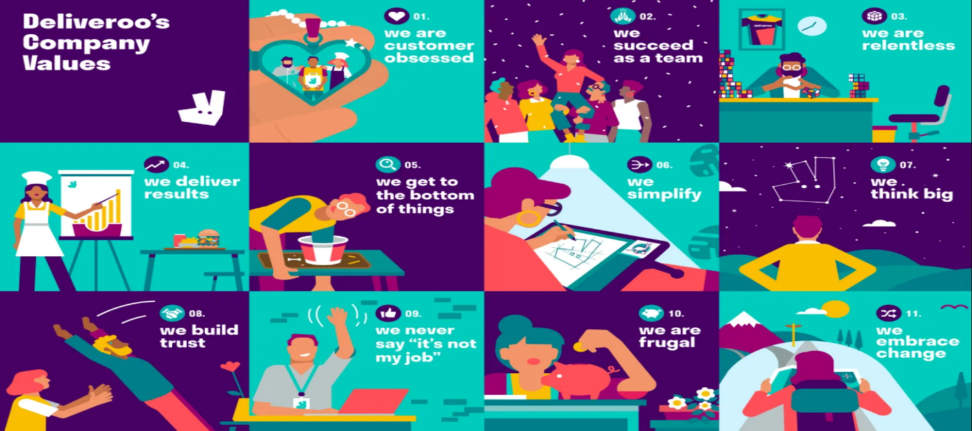
Source: Internet

This feedback is then used to identify areas for improvement and make changes to the service accordingly by optimizing delivery times, improving food quality, and addressing any issues raised by customers. For example, based on customer feedback, Deliveroo introduced a new feature that allows customers to track their delivery in real-time. The company's co-creation strategy involves working closely with restaurants to offer a diverse range of cuisines and menu options that cater to customer preferences and provide feedback and has helped it to create a loyal customer base that values the personalized and flexible experiences that Deliveroo provides and differentiate itself from competitors in the food delivery industry (Liang et al., 2020).
Understanding the Implications for Information Technology Firms
Information Technology (IT) firms can benefit from understanding both the firm's perspective and the co-creation perspective on customer experience. By adopting a firm's perspective, IT firms can focus on delivering high-quality products and services, improving efficiency and convenience, and creating personalized interactions with customers. This can help improve customer loyalty, retention, and advocacy, which can ultimately lead to increased revenue and growth. For example, Cazoo's focus on providing a seamless and hassle-free car buying experience has helped the company grow rapidly since its launch in 2019, with revenues exceeding £150 million in its first year (Cazoo, 2021).
Additionally, information technology firms can use customer data to gain insights into customer behaviour and preferences, which can inform the design and management of customer experiences.

CONCLUSION

In the above discussion it has been established that in-depth study of Customer experience is vital for company management.
As a company that has a strong focus on customer experience and has developed a range of touchpoints to engage with its customer Revolut has effectively leveraged these touchpoints to create a seamless and personalized customer experience that has resulted in high customer satisfaction and loyalty.
Customer relationship management (CRM) is a critical aspect of Revolut's business strategy, and the company has demonstrated its ability to gather customer data, analyse it, and use it to develop personalized marketing campaigns, improve customer service, and tailor products and services to customer needs. The company's approach to CRM has helped it to create loyal customers who are more likely to make repeat purchases, recommend the company to others, and provide feedback that can help the company improve its products and services.
IT firms can benefit from understanding both the firm's perspective and the co-creation perspective on customer experience. The firm's perspective emphasizes the organization's role in delivering a positive customer experience, while the co-creation perspective recognizes the active participation of customers in shaping their own experience. Cazoo and Deliveroo are two UK tech companies that illustrate these two perspectives in their customer experience strategies. Cazoo focuses on providing a seamless and hassle-free car buying experience, while Deliveroo collaborates with restaurants and customers to offer a diverse range of cuisines and menu options.

RECOMMENDATIONS

Based on the analysis of Revolut's customer experience and the identified customer touchpoints and corridors, here are some recommendations that could help improve the customer experience and relationship management:
1. Personalize the customer experience: Revolut could use customer data to personalize their services and offer tailored experiences to individual customers. This could be achieved through targeted marketing, personalized product recommendations, and customized communication channels.
2. Focus on resolving customer issues quickly: Revolut should ensure that they have a responsive and efficient customer support system to handle customer complaints and concerns. This would help in building customer loyalty and trust in the brand (Smith J., 2023).
3. Enhance mobile app functionality: Revolut should continue to invest in its mobile app and ensure that it is user-friendly, intuitive, and packed with features that customers need to manage their finances. This could include improving navigation, adding new features, and enhancing security protocols.
4. Improve transparency and communication: Revolut should strive to provide clear and transparent communication to customers on fees, exchange rates, and other important information related to their financial transactions. This would help in building trust with customers and enhancing their overall experience.
IT firms that prioritize customer experience and adopt a hybrid approach that combines the firm's perspective, and the co-creation perspective can improve customer loyalty, retention, and advocacy, ultimately leading to increased revenue and growth.
IT firms can achieve this by leveraging technology to facilitate customer engagement and co-creation, such as through social media, online surveys, and chatbots.
Additionally, IT firms can benefit from investing in customer journey mapping to identify touchpoints and pain points in the customer experience and design interventions to improve them. This can help ensure that the customer experience is seamless, personalized, and efficient. Finally, IT firms should prioritize customer feedback and use it to continuously improve their customer experience strategy.

LIST OF REFERENCES

Barnes, R. (2020, December 17). How Revolut is changing the game for digital banking. Business Insider. https://www.businessinsider.com/how-revolut-is-changing-the-game-for-digital-banking-2020-12
Berry, L. Carbone, P. and Haeckel, S. H. (2002), (“Understanding Customer Experience Throughout the Customer Journey ...”)
Brafton (n.d.). What is Brand Experience and Why Is It Important? Retrieved from https://www.brafton.com/blog/strategy/brand-experience/
Cazoo. (2021). Cazoo Annual Report 2020. Retrieved from https://cazoo.co.uk/annual-report-2020
Gentile, C., Spiller, N., & Noci, G. (2020). European Management Journal, 38(3), 473-487.
Gupta, S., & Lehmann, D. R. (2005).(“Managing Customers as Investments: The Strategic Value of Customers in ...”) Journal of Consumer Marketing, 22(4), 245-256.
HubSpot. (n.d.). What Are Customer Touchpoints? Retrieved from https://blog.hubspot.com/service/customer-touchpoints
Hyken, S. (2020, August 25). Revolut: The power of a strong customer experience. Forbes. https://www.forbes.com/sites/shephyken/2020/08/25/revolut-the-power-of-a-strong-customer-experience/
Jovanovic, M. (2021, January 12). Revolut's Customer Experience: How to design a mobile banking app that people love. UX Planet. https://uxplanet.org/revoluts-customer-experience-how-to-design-a-mobile-banking-app-that-people-love-7ba3b0e7196a
Lemon, K. N., & Verhoef, P. C. (2016). Understanding customer experience throughout the customer journey. Journal of Marketing, 80(6), 69-96.

Liang, J., Qi, L., & Yang, Z. (2020). The Impact of Customer Participation in Service Co-Creation on Customer Loyalty: The Mediating Role of Customer Experience. Sustainability, 12(3), 1022. https://doi.org/10.3390/su12031022
Marketing Profs. (2019, April 23). Understanding the Difference Between Customer Experience and Brand Experience. Retrieved from https://www.marketingprofs.com/articles/2019/41236/understanding-the-difference-between-customer-experience-and-brand-experience
Meyer, C. and Schwager, A. (2007), “Understanding Customer Experience,” Harvard Business Review, February 1,17–26
Peelen, E., & Beltman, R. (2013). Customer Relationship Management. Pearson Education.
Polasik, M.; Widavski, P.; Lis, A., (2021), ‘’The Digitalization of Financial Markets”, Ch.10-Challenger bank as a new digital form of providing financial services to retail customers in EU Internal Market: The case of REVOLUT’’
Prahalad, C. K., & Ramaswamy, V. (2004). Co-creation experiences: The next practice in value creation. Journal of Interactive Marketing, 18(3), 5-14.
Schmitt, B. H. (2011), “Experience Marketing: Concepts, Frameworks and Consumer Insights,” Foundations and Trends in Marketing, 5 (2), 55–112
Smith, J. (2023). Revolut Customer Experience Analysis: Customer Touchpoints, Corridors, and CRM.
Whiting, R., Jeacle, I., & Harvey, D. (2021). Digital Disruption in the Online Car Retailing Industry. Journal of Accounting and Management Information Systems, 20(1), 90-106.

