2308342 Jamie H-S
Q1
Code:
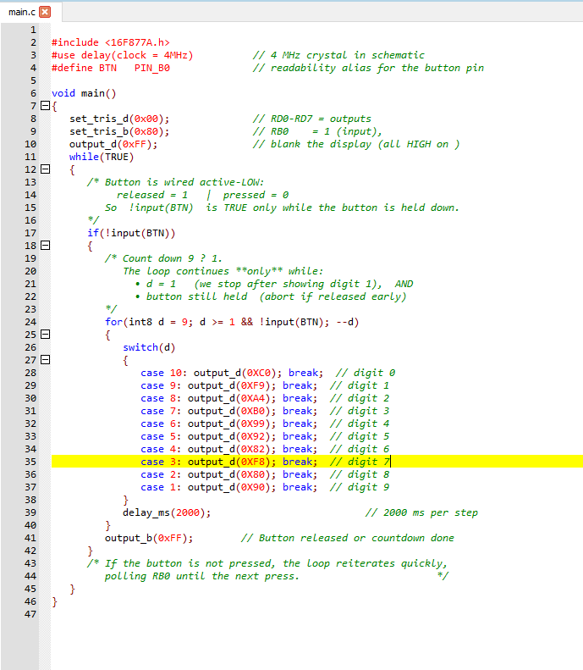

Q1 Schematic

Paused at 0.9s approx
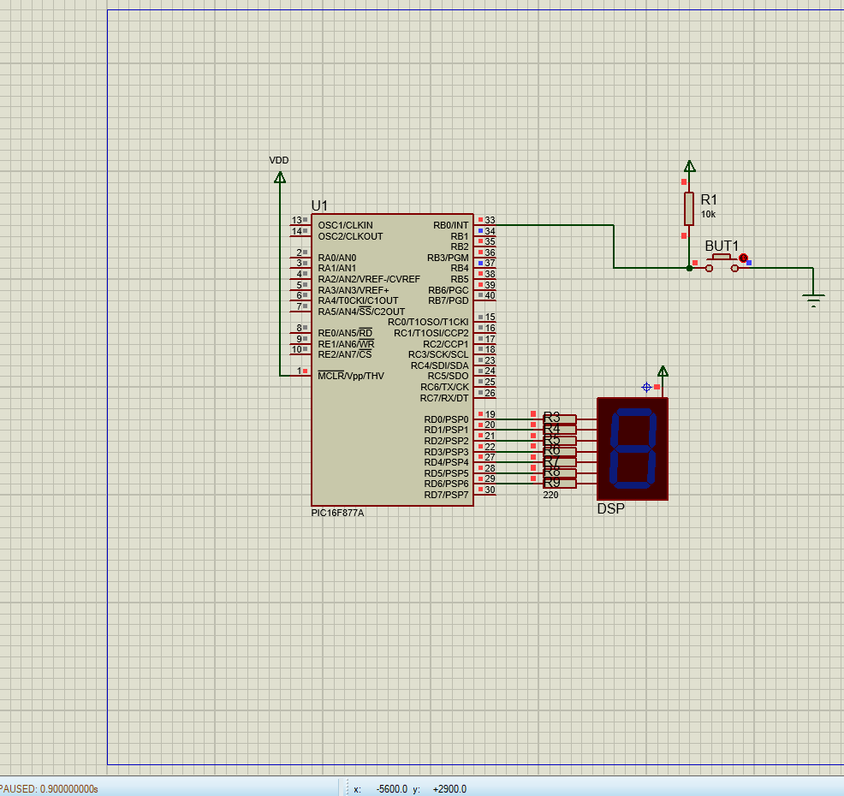

The button was depressed/latched and the seg disp counted up
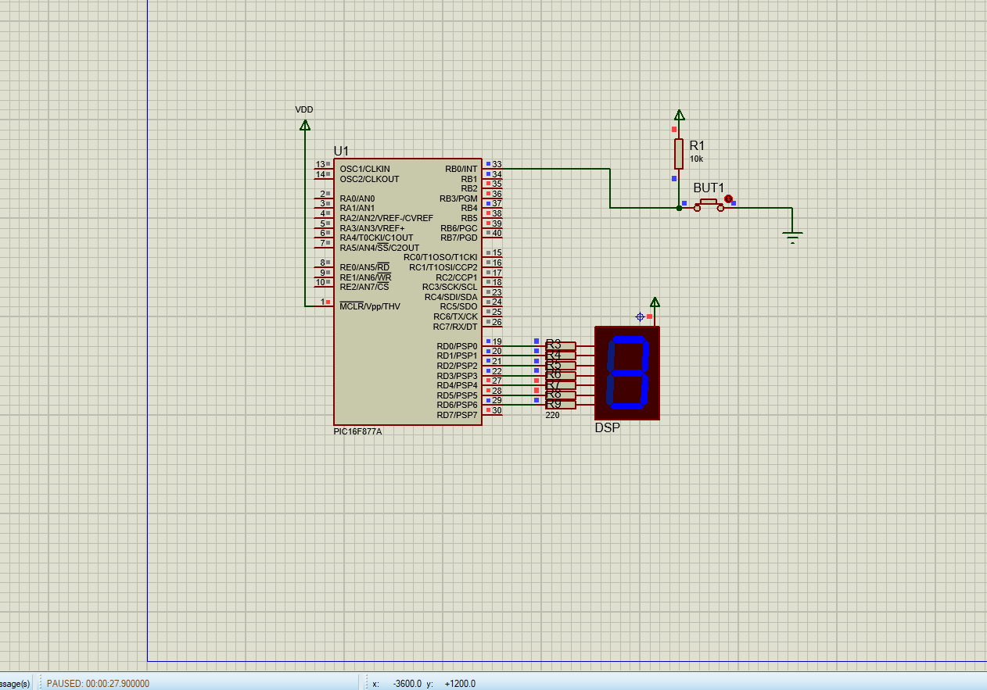

Q2
code
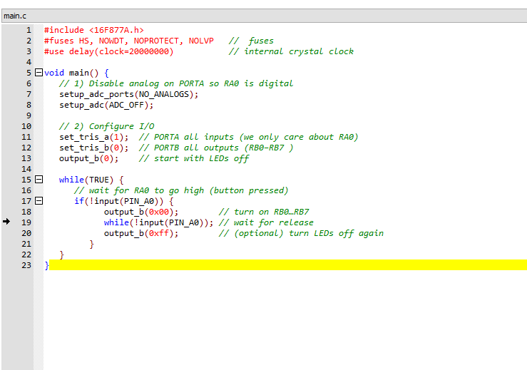

Button not pressed
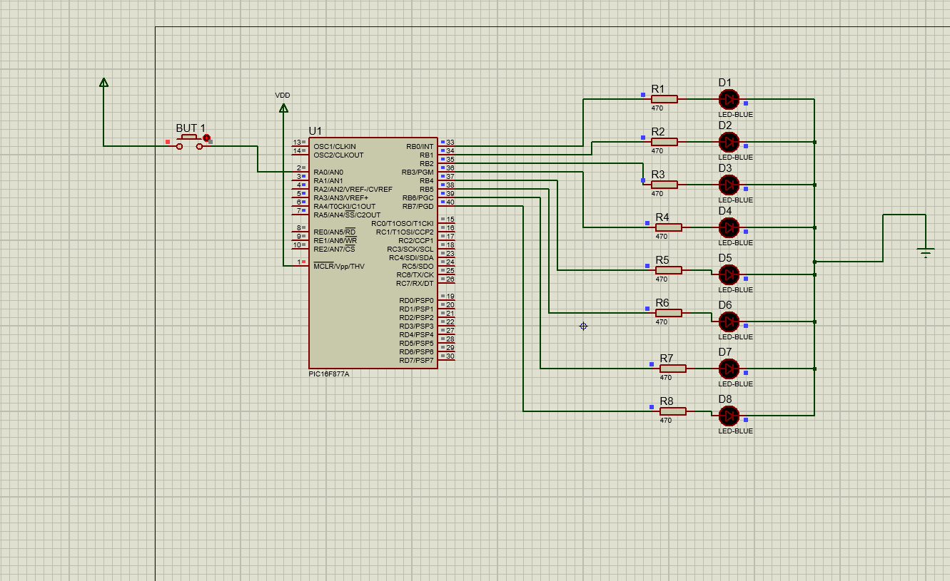

Button Pressed LEDs came on
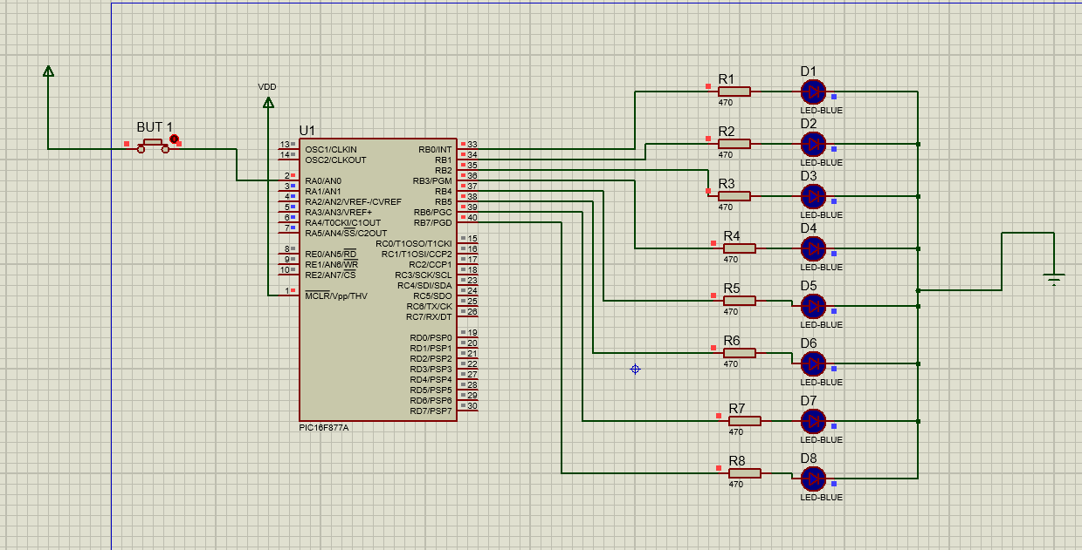

Q3
Circuit with RV2>RV1, so D1 comes on

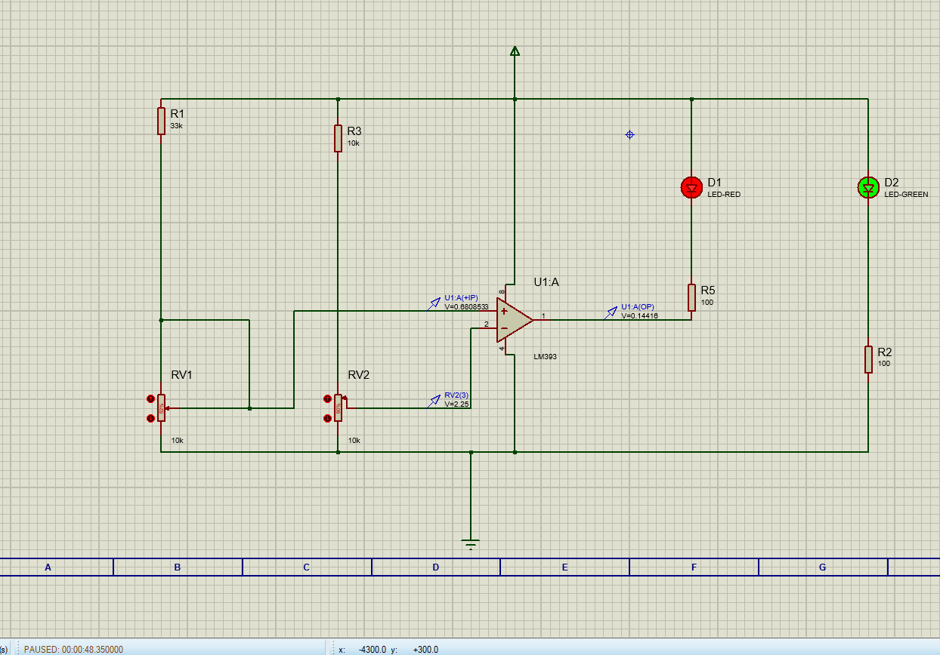

Circuit with RV2<RV1, so D1 turns off
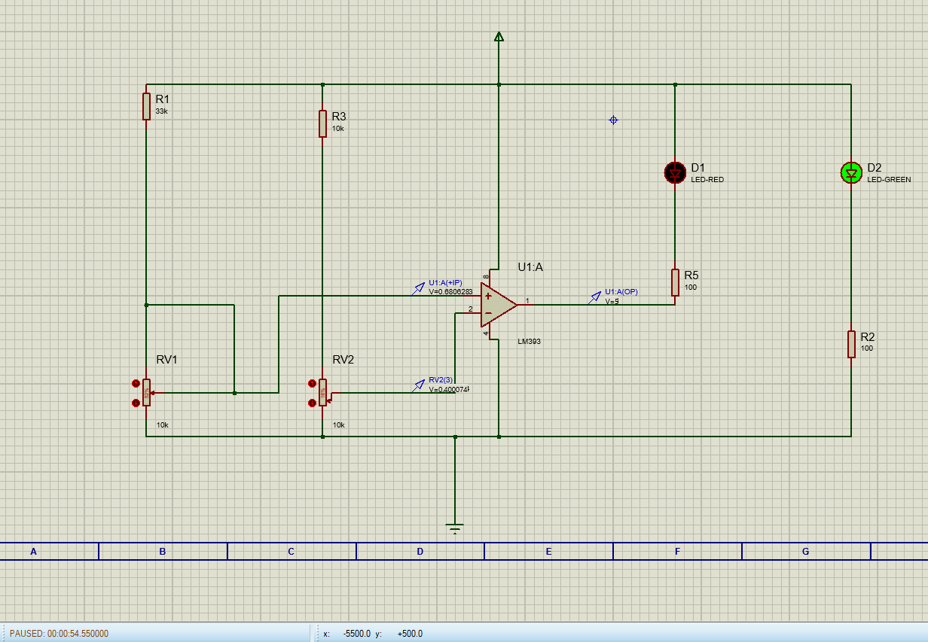

Q4 Buck


