

Critically analysing the effectiveness of police officers mental health training, their response and responsibilities towards incidents involving persons suffering from mental health issues.

Matthew Evans
1816484
BSc (Hons) Professional Policing Practice
November 2021
Word Count 7,522

Acknowledgments
I would like to thank Jane Thomas and my Supervisor, Lewis Tandy, for their time and support throughout the course of the dissertation process. I would also like to thank South Wales Police as my employer for their continued support throughout my 3 year probationary period where I have undertaken this degree.
Finally I would like to thank my family, specifically my Mother, Farther, Sister and particularly my partner Samantha Treadwell for their never-ending kindness and encouragement throughout both College and University. The time and help you all gave to ensure I could succeed is something I will forever be grateful for.

Declarations
Declaration - This work has not previously been accepted in substance for any degree and is not being concurrently submitted in candidature for any degree. Signed: Matthew Evans Date: 29/11/2021
Statement 1 - This dissertation is being submitted in partial fulfilment of the requirements for the degree of BSc.
Signed: Matthew Evans Date: 29/11/2021
Statement 2 - This dissertation is the result of my own independent work/investigation, except where otherwise stated. Other sources are acknowledged by footnotes giving explicit references. A bibliography is appended.
Signed: Matthew Evans Date: 29/11/2021
Statement 3 - I hereby give consent for my dissertation, if accepted, to be available for photocopying and for interlibrary loan, and for the title and summary to be made available to outside organisations.
Signed: Matthew Evans Date: 29/11/2021
Statement 4 - I hereby give consent for my dissertation, if accepted, to be available on the university’s IT system to those who have consent to use the system.
Signed: Matthew Evans Date: 29/11/2021

Abstract
Policing is undergoing enforced diversification, with the growing prevalence of incidents involving mental health, the police now find themselves responding to these incidents more than ever before. This study poses the question of how effective is the training received by officers to deal with these incidents, and could the way they respond to these be improved. The academical and public consensus is that the responsibility to respond to these incidents does not lie with the police, but the health service. There is a substantial gap in the existing literature around the mental health training the police receive and their opinion on the subject as a whole, through the use of surveys this study addresses this. The research has shown that the training the police receive is ineffective, they are not the correct service to respond to mental health incidents and the way they currently respond could be more efficient. With the continual increase in mental health incidents it is recommended that both their training and the way they respond to these incidents is improved.

Table of Contents
Chapter 1 - Introduction 7
1.1 Background 7
1.2 Research Rational 7
1.3 Research Objectives 8
1.4 Structure 8
1.5 Conclusion 9
Chapter 2 - Literature review 10
2.1 Introduction 10
2.2 Police Training 11
2.3 The Correct Service 14
2.4 Alternative Models 15
2.5 Conclusion 17
Chapter 3 - Research Methodology 18
3.1 Introduction 18
3.2 Research Approach 18
3.3 Research Strategy 19
3.4 Survey Distribution 20
3.5 Data Analysis 21
3.6 Limitations 22
3.7 Code of Ethics 22
Chapter 4 - Analysis of results 23
4.1 Introduction 23
4.2 Data Analysis 23
4.3 Demographic and Descriptive Stats 24
4.4 Training Frequency and Effectiveness 24
4.5 What Works 25
4.6 Responsible Service 26
4.7 Mental Health Triage Cars 27
4.8 Other Alternatives 27
4.9 Limitations 28
4.10 Conclusion 28
Chapter 5 - Findings and conclusions 30
5.1 Introduction 30
5.2 Completing Objectives 30
5.3 Limitations 32
5.4 Future Research 32
5.5 Discussion 33
5.6 Recommendations 33
5.7 Conclusion 34
Bibliography 36
Appendix A - Blank Survey Questionnaire 44
Appendix B - Sample of Survey Results 48

Chapter 1 - Introduction

1.1 Background
1 in 6 people will experience a mental health problem weekly, this represents an increase of 20% in the last 2 decades (Mind, 2020). Mental health conditions can have devastating effects on not only the person suffering from the illness but the lives of those around them. The National Health Service (NHS) is predicting an increase of 20% access to mental health services with a 10-30% reduction in capacity in the coming years (NHS, 2020). The ambulance service is also affected by these increases, in 2016/2017 they faced a 23% increase in calls to assist mentally ill patients (Roy, Weyman, Nolan 2020). Similarly the police service are now dealing with more mental health related calls than ever before, in 2008 15% of police incidents involved mental health (Bather, Fitzpatrick and Rutherford, 2008), whilst there was a 28% rise in mental health flagged incidents from 2014-2018 (Jones, 2019). This study will begin to academically evaluate specific aspects of policing and mental health.

1.2 Research Rational
The police have traditionally not been the service who respond to mental health incidents, however due to the growing prevalence of these incidents and other services struggling to meet demand, they now find themselves in a position where they are responding more than ever before. This study is required to critically analyse how the police respond to these incidents, what responsibility they have and are they adequately trained for this. Although there is academic research and reports from official bodies detailing police involvement in mental health incidents, very limited literature exists on the training that police officers receive. To assist the study a research question has been posed;
How effective is the mental health training received by police officers and could the way the police respond to mental health incidents be improved.

1.3 Research Objectives
To enable the research project to be successful and to answer the research question effectively research objectives have been set. These objectives will unambiguously describe what the research is aiming to achieve. The objectives are;
- An analysis of how effective police officers perceive their training to be in regards to mental health.
- To critically analyse if it is the responsibility of the police and are they the correct service to deal with mental health incidents.
- Identify a better working model to ease pressure upon the police and other emergency services responding to mental health incidents.

1.4 Structure
This research project is going to use a mixture of primary and secondary research to answer the research question and achieve successful completion of the research objectives. Chapter two will critically analyse and review the existing literature surrounding the three objectives, this will begin to inform the primary research by highlighting any gaps in the literature allowing the primary research to focus on these areas.
Chapter three will describe the research methods that will be used to conduct the primary research. Chapter four will analyse the results of the primary research as collected by the methods described in chapter three. The data will be presented in the most appropriate format highlighting any themes that may arise.
Finally chapter five will conclude the research project by drawing together key findings, summarising the completion of each objective and answering the research question. Furthermore limitations of the research will be identified and recommendations made based on the academic analysis and evaluation that has taken place.

1.5 Conclusion
This chapter has established and explained the background surrounding mental health and policing. A research question and three objectives have been set that will help guide the research. A clear structure has been set out that has outlined what will be contained within the next chapters as the research project progresses. As earlier described the next chapter will be a critical analysis of the existing literature.

Chapter 2 - Literature review

2.1 Introduction
This literature review aims to critically analyse and carefully review the existing literature surrounding the policing of mental health incidents. Types of literature will include but not be limited to Government reports, books, governing bodies reports, peer reviewed academic journals, organisational guidelines and authorised professional practices. The literature review will seek to test the strength of the existing literature, identifying any weaknesses or gaps that will be addressed later in the study through primary research. Subject area topics will naturally narrow and become more focused on the already defined individual objectives of the research, once more these are;
1) An analysis of how effective police officers perceive their training to be in regards to mental health.
2) To critically analyse if it is the responsibility of the police and are they the correct service to deal with mental health incidents.
3) Identify a better working model to ease pressure upon the police and other emergency services responding to mental health incidents.

These objectives will ultimately inform the answer to the research question, however it is important to note that the overall aim of this literature review is to critically analyse the literature surrounding these objectives, to help identify key findings and any gaps within the literature, thus highlighting the need for further research. The focus will be primarily on mental health incidents within a policing context, however it must be acknowledged that there will be cross overs from other disciplines such as the NHS and ambulance service. It is essential to look at the wider context to gain a broader understanding and demonstrate how research fits within a larger field of study (Fink, 2008).

2.2 Police Training
The type of incidents that the police respond to is rapidly changing, it is estimated that mental health issues now account for 20% of police time (The College of Policing,2015), as such it would be expected that there would be an increase in training to better equip officers to deal with this. The training that the police receive in regards to mental health is paramount to this research however, literature covering this area is scarce. When looking at a national level it is said that “All forces should have policies, partnership protocols and training programmes in accordance with College of Policing standards” (The National Police Chiefs Council, 2020), but under the College Of Policing Authorised Professional Practice there is no mention of any training programs that must be undergone. It is stated that “all officers should receive appropriate training” (College Of Policing, 2016) yet there is no disclosure or inference to what this training should be. Furthermore in 2014 the Crisis Care Concordat was created (Uk Gov, 2014) which devised actions to improve service for those experiencing a mental health emergency, one of these actions was “Improved training and guidance for police officers” (Uk Gov, 2014).Noting the lack of literature and given the time since this concordat was signed there is little to no evidence to suggest that any national policies or programs have been devised to meet this recommendation.
Policing and Mental Health Picking up the Pieces (HMICFRS, 2018) a 59 page document is arguably one of, if not the most important pieces of literature to this research and mental health policing as a whole. Throughout this report references to training are continually made, the tone of which is of damming nature towards the training received by police. Effective training can lead to benefits such as better performance, tactic skills and adaptive expertise (Aguinis and Kraiger, 2008), it can be hardly surprising that Her Majesty’s Inspectorate of Constabulary and Fire and Rescue Services (HMICFRS) places such onus on training when the benefits are clear to see. The Policing and Mental Health Picking up the Pieces report highlights that forces across England and Wales are often devising their own local training programs. Mental health incidents are not local issues, therefore to deliver localised training which will differ from force to force only serves to create disparity in the service provided based on postcode. This is support by Scantlebury et al., (2017) whose study showed no evidence that bespoke one day training had any lasting effects on the number of incidents reported in future. Thomas and Watson (2017) concluded that police officers learn best from hands on experiential learning, whilst they also propose an idea that specialist mental health training should be available for a select group of officers. Applying extra specialised training to a select group of officers is an interesting concept that has seen success across the policing spectrum for varying roles such as firearms and roads policing. However by applying this role to mental health could be seen as the police accepting responsibility for the issue when it is made clear by HMICFRS in the picking up the pieces report (2018) that this is not their responsibility “We have grave concerns about whether the police should be involved in responding to mental health problems to the degree they are” (HMICFRS, 2018 P3).
It is widely acknowledged that the police are not the correct service to respond to mental health emergencies, this is due in part to the lack of training. Policing and mental health picking up the pieces (HMICFRS, 2018) found the police were working beyond their duty and voiced significant concerns over the level of involvement the police have. Furthermore there is also a general lack of understanding by forces about the demand of mental health incidents, this could be leading to significant under-reporting of the incidents (HMICFRS, 2018). This under-reporting could be failing to highlight the need for better training. Comparatively it is interesting to see how the ambulance service manage these incidents and if examples of good practise can be learned from them. However much like the police service the ambulance service are also struggling with the problem, typically persons suffering mental health problems receive worse care than those who experience physical health problems (Edward et al., 2019). In regards to training received and effectiveness in dealing with mental health emergencies, it is argued that paramedics need more undergraduate and in-service education and that limited mental health training is having an adverse effect on their ability to respond to the needs of patients (McCann et al., 2018). Encouragingly positives and learning opportunities can be taken directly from South Central Ambulance Service (2019), their mental health policy sets out important operational guidelines in respect of training, such as ensuring trainers have the right experience and qualifications including a subject matter expert. No guidance of this kind is given by the College Of Policing or any other regulatory body to the training of police in this area. Other studies argue that using the ambulance service for mental health emergencies is a “misuse of the paramedic service” (Ford-Jones, 2017 P1). If this is a view held by many it could begin to blur the lines of responsibility, and who should really take ownership of mental health emergencies.
The Ambulance service are the primary service provider and responder for mental health emergencies, however they are also burdened by a lack of training leading to poor service as highlighted by Edward et al., (2019). Though training provided is inadequate this may not be the sole issue. A major contributing factor may be that neither the police or ambulance service have adapted their process to meet the ever growing demands of mental health emergencies. It is of note that the limitations in the literature around what training both the police and ambulance receive, and the lack of policy available in the public domain could be due to the sensitivity of such information. Given this is it feasible that without enhanced access to non-public documents it will be difficult to draw accurate, academically supported conclusions on the topic. It has been shown that there are gaps in the literature around the mental health training that the police receive, the lack of any guidance or nationally adopted training program for mental health show that further research is needed to highlight if this is an issue for officers. There is no literature available that gathers the opinion of officers on these matters, this is an issue as it does not test the issue from a police perspective.

2.3 The Correct Service
The paradigm is undoubtedly shifting towards the police attending more mental health incidents, from 2015 – 2019 23 police forces recorded an average of a 41% increase in mental health incidents, with one force reporting an astonishing 248% increase (Campbell, 2020). The police do have a responsibility to attend mental health emergencies and have done since 1983 with the introduction of Section 136 of the Mental Health Act (1983). This grants police officers the power to detain and remove a person suffering with a mental disorder in a public place to a place of safety for the purpose of receiving a mental health assessment. This is the sole legislative power that police alone have to deal with mental health issues, so it is unsurprising that given the increase in mental health incidents the use of this power has also increased as illustrated by figure 1.
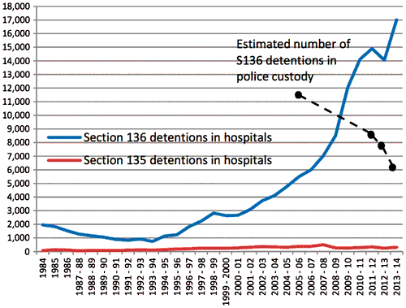
Figure 1. Number of section 135 and section 136 detentions in England and Wales 1984–2014 (Loughran, 2018).
Though the correlation in the use of Section 136 Mental Health Act powers and growing mental health incidents police attend is not surprising, it does further illustrate the depth of the problem being faced by the police. There are concerns over the level of involvement the police have in responding to mental health problems (HMICFRS, 2018), interestingly the same report found that only 2% of the public believed it should be the responsibility of the police, whilst 70% believed it to be the responsibility of the health service. This is further supported by a workshop focus group who said that “police are not medical professionals and that mental health crisis care is a health issue” (Uk Gov, 2014).
The Crisis Care Concordat (Uk Gov, 2014) can be seen as the manual for how emergency services deal with mental health emergencies, it is somewhat dated as it was first commissioned in 2014 and as previously illustrated the size of the problem has grown significantly since then. The document aims to outline how people in mental health crisis are cared for, with emphasis on emergency response care and partnership working. The concordat makes clear that the police “cannot and indeed are not expected to deal with vulnerable groups on their own”, (Uk Gov, 2014) but yet the report throughout is riddled with ambiguity in regards to who’s responsibility it is to respond to these emergencies. The growth of police interventions demonstrates a new challenge for policing, further research will help identify the scale of the problem and look to address how it may be tackled.

2.4 Alternative Models
Partnership working is a key theme throughout many social and healthcare issues, mental health is no different. Tighter working partnerships between health professionals and police will likely improve the care of people in mental health crisis (Rodgers et al., 2019). Mental health emergencies have become wide spread and more common place than ever before and research has highlight that this trend will continue to grow. New trials and programs are being devised to help tackle the issue, many of these involve some form of triage scheme.
Triage schemes consist of a team of mental health specialists who will support the decision of front line officers, this enables them to make better more informed decisions (Avon and Wiltshire Mental Health Partnership NHS Trust, 2021). It is accepted that the purpose of the triage team is to reduce detention by police through section 136 power, thus allowing the person to receive appropriate care from the correct service. Results from early programs such as the Northumberland, Tyne and Wear triage team showed a reduction of 56 % in the use of section 136 powers within the first year (Keown et al., 2016), whilst a 39.5 % reduction was noted by Thames Valley police service (Uk Parliament, 2016). However whilst these schemes boast impressive statistics caution should be taken as many have been implemented without any meaningful investigation into their effectiveness (Puntis, et al., 2018).
Recognised by the College Of Policing and a part of the crime reduction tool box, crisis intervention teams are officers who receive special training to take on the role of “law enforcer and community supporter” (The College of Policing, 2020). The role has been adapted from an American study by Semna Taheri (2014) as such there is no mention of reduction in use of section 136 powers which should be the primary goal for such programs, instead it uses the metrics of arrests and use of force to measure success. The College Of Policing base the crisis intervention team strategy on the study by Semna Taheri (2014), this study by its own admission found that crisis intervention teams had statistically no significant effect on either metric. Furthermore Wood and Berischmitt’s research (2014) found that over an 8 year period in Philadelphia focusing on crisis Intervention teams, there were often “hotspots” of mental health crisis and whilst the intervention team helped to identify these, they had no reduction in their crisis workload, which left officers doubting the long term effectiveness of the program. There is limited literature and no official data outlining the impact that crisis intervention teams have had within the UK, thus making it difficult to draw conclusions on the effectiveness they have, but American literature and studies have shown crisis intervention teams are far from effective.
A strong example of effective collaborative working can be seen in mental health triage cars. These are a form of street triage which contain a police officer, and a mental health nurse (Horspool. Et al., 2016). Each professional performs their own role bringing specialist knowledge to this, it also seamlessly brings services together at the first point of contact. In Leicestershire this has yielded a reduction of 33% in use of the section 136 powers by police (Uk Gov, 2021), this in part is due to having a mental health professional to advise and offer better more appropriate clinical solutions. Interestingly paramedics have no power to detain patients using the Mental Health Act under any circumstances (Putman, 2019) it could be inferred that the police are only present for their detention powers. If this power was extended to paramedics this could then become a healthcare lead program and thus the police could be removed. Interestingly The London ambulance service (2020) commissioned a study where the police were removed, this study paired a paramedic with a mental health professional in a specialist mental health response role, removing the police from the equation. The program was so successful that it was recommended it should receive funding and become an ongoing service (The London Ambulance Service, 2020).

2.5 Conclusion
There is no doubt and the literature shows that the police service have become an essential part to responding to mental health emergencies, it has also highlighted gaps in the literature. One area where there is a clear gap in the literature is around the training that the police receive to deal with mental health incidents. This study will seek to address this gap by gathering the opinions of police officers on their mental health training. Furthermore the study will aim to identify if any of the other models discussed such as mental health triage cars are viable to ease pressure on officers, whilst also gathering their opinions on the alternative models. Key themes highlighted in this literature review suggest that the ambulance and health service are the correct agencies to deal with mental health incidents, however the strength of these findings and themes will need to be tested with primary research.

Chapter 3 - Research Methodology

3.1 Introduction
The previous chapter in this study has begun to answer objectives two and three by critically analysing key literature from academical sources and official bodies. It has also highlighted a gap in the literature leading to the requirement of primary research to achieve objective one. This chapter will set out the methodology for the primary research that will be conducted.

3.2 Research Approach
Research is not simply gathering information, it is about answering unanswered questions or creating those that do not exist (Goddard and Melville, 1996), and in this instance the unanswered question being posed is the research question “How effective is the mental health training received by police officers and could the way the police respond to mental health incidents be improved”. If Research is a systematic process of collecting, analysing, and interpreting information (Leedy and Ormrod, 2010) then methodology is the strategy followed to conduct research and to identify the methods to be used (Alharahsheh, 2020).Though this study has multiple objectives the research conducted will be primarily aimed at answering objective one “An analysis of how effective police officers perceive their training to be in regards to mental health.” there will however be overlaps into the other objectives. Whilst all objectives are equally important to the overall study, it has been highlighted in the literature review that there is not a wealth of reliable literature relating to this area, thus identifying a clear need for primary research to be conducted into objective one.

3.3 Research Strategy
The research is going to be conducted using a modern mixed methods approach as defined by Shorten and Smith (2017, P74) “Mixed methods is a research approach whereby researchers collect and analyse both quantitative and qualitative data within the same study”. This will be done through a survey answered by active serving front line police officers defined by (Her Majesty's Inspectorate of Constabulary and Fire and Rescue Services, 2018) as “neighbourhood policing, response policing and criminal investigations”. When considering what research philosophy to use mixed methods has been chosen because amongst other things it will allow for both open and closed questions to be asked, allowing both quantitative and qualitative data to be collected in a single survey. A statistical analysis will be important to answer closed questions such as “how frequently do you receive training or refresher training” these types of questions will make up the quantitative element of the research. Consideration has been given to creating a purely quantitative research however, key to this research is how officers perceive their training, and as stated by Rahman (2016) quantitative only research this would fail to ascertain deeper underlying explanations. Interestingly Rahman (2016) goes on to compare quantitative research to being a snapshot of a phenomenon measuring the variables only at that moment rather than obtaining a deeper understanding. In the wider context of this study it is important to analyse mental health training as this impacts service delivery as a whole. To be able to answer the research question with any meaningfulness the deeper understanding Rahman talks about will be required, Furthermore Busetto et al (2020, P1) states “Some research questions cannot be answered using only quantitative methods” thus demonstrating the requirement for qualitative research.
When looking at the topic being researched and the research question, as previously stated it is a new area with little existing research. With this in mind Clarke and Jack (1998) describe qualitative research as being useful for investigating new, complex or unexplored areas, all of which apply to this research question. As such if qualitative research can be incorporated to achieve a mixed methodology the deeper understanding Rahman previously described can be achieved. Surveys can often be overlooked as qualitative research however Ponto (2016) states that they are viable. The structure and questions asked within the survey will need to be open, this will allow the participants the opportunity to expand their answers and provide meaningful in-depth insights into the questions being asked. Part of this research is aimed at informing future practise and “identifying a better working model” as per objective 3. Qualitative research as highlighted by Rich and Ginsburg (1999) allows data to be collected in a more natural state which in turn means fewer limitations on translating the findings into real life applications. This will be hugely beneficial to the study as a whole if the research can be used seamlessly to benefit real life applications, particularly at a later stage in the study where recommendations will be made. Further benefits of mixed methodology will include comprehensive data which reflects the participants view grounded in their experiences (Wisdomand Creswell, 2012), this is particularly important as it will provide a more complete view of the training than either quantitative and qualitative research singularly.

3.4 Survey Distribution
The survey is going to be electronically distributed to active serving frontline police officers. Consideration was given to allowing all attested police officers the opportunity to take part in the survey, however officers who are not frontline may have limited, old or second hand experience. This could jeopardise the legitimacy of the answers, ultimately leading to the results not being reflective of the officers who are primarily dealing with the mental health incidents. In contrast by surveying active frontline officers, the responses will be reflective of the current climate of policing. The surveys will be anonymous and confidential, this is important due to the sensitive nature of policing. An acceptable amount of responses will be in the region of 20-30 though this is low for a survey due to time constraints this will be a reasonable goal. When considering how to receive accurate and truthful responses the question of anonymity was posed, Campbell and Waters (1990) found no evidence that anonymity improved the quantity of responses. However Fuller (1974) conducted a survey of navy personal, here it was discovered that pro-navy responses were more common amongst those not granted anonymity in the survey. To gain the best results officer’s responses will need to be as truthful as possible, with Fullers evidence it is shown that providing anonymity will yield better results.

3.5 Data Analysis
Data collected will need to be collated, analysed and suitably formatted. As the research will be mixed methods there will be different methods used to analyse and evaluate each type of data. The quantitative data will be suitable to be converted into percentage figures and can be used in graphs or tables to better illustrate the findings that text alone. A qualitative content analysis will be conducted on qualitative data, this will aim to identify patterns within individual answers that can be used to highlight areas of concern or good working practice relating to the questioned topic. When looking broadly across multiple qualitative questions in the survey thematic analysis can take place to identify any themes that are emerging, as stated by Clarke and Braun (2016) thematic analysis will help to identify patterns in lived experience and seek to understand what participants think and feel. Qualitative data analysis can be time consuming and as earlier stated this could be a limitation, however with a realistic goal of 20-30 surveys there will be enough answers to identify patterns and themes whilst allowing sufficient time to finish the whole study.

3.6 Limitations
It is worth noting that there will be limitations to the research, most glaring will be that it may not be possible to conduct an in-depth qualitative analysis from survey results alone. Consideration has been given to utilising other research methods such as interviews or focus groups which would be a more traditional way to collect qualitative data, however due to time and resource constraints this would not be possible whilst still adopting a mixed methods approach. In maintaining the mixed method approach and allowing quantitative and qualitative data to be collected this will outweigh the benefits of a solely qualitative survey. This limitation could also further impact the validity of the research. Validity can be described as the extent to which a test measures what it claims to measure (Gregory, 1992), As previously mentioned this will be combated through the use of correctly designed open questions. Perreault (1975) highlights that order bias can occur within the survey if questions are set in a specific order, however he does also state that this can be rectified by randomising the questions in the survey. By randomising the survey questions this will further improve validity.

3.7 Code of Ethics
Police officers are bound by strict confidentiality which comes under their code of ethics (The College of Policing, 2014), questions contained in the survey must not encourage answers which may lead to the officers breaching this or any part of the code of ethics. It will be important that no persons will be identifiable from the data or that any information that is sensitive to the police service is revealed. The survey will subject to an ethics form and receive approval before it is distributed.

Chapter 4 - Analysis of results

4.1 Introduction
The previous chapter has outlined the research methodology, this has followed on from the literature review which has highlighted there is a clear gap in the literature around objective one:
- An analysis of how effective police officers perceive their training to be in regards to mental health.
This chapter will present, analyse and interpret the primary research that has been conducted, with the primary goal of answering the above objective using the data gathered from distributed surveys. The research will also seek to utilise the primary research in order to critically analyse the remaining objectives.
- To critically analyse if it is the responsibility of the police and are they the correct service to deal with mental health incidents.
- Identify a better working model to ease pressure upon the police and other emergency services responding to mental health incidents.

4.2 Data Analysis
The raw data that has been collected will need to be analysed, the purpose of this is to bring meaning, structure and order to the data (Anfara et al., 2002) this will allow others to understand it. There will be distinct differences in the types of analysis used for the qualitative and quantitative data, allowing for better interpretation and greater understanding for the reader.

4.3 Demographic and Descriptive Stats
A survey was completed by the target audience as described in the methodology, a blank copy of this questionnaire can be found in Appendix A. This survey was distributed electronically achieving a total of 21 replies. Participants were firstly asked to confirm that they are working as a police constable in either response, criminal investigations department or neighbourhood policing team. This is fundamental to the research because it ensures validity, which is the extent to which the concept is accurately measured and reliability, the consistency of the measurement (Heale and Twycross, 2015). Establishing reliability and validity will ensure the results are accurate (Mohajan, 2017).

4.4 Training Frequency and Effectiveness
When analysing the results it is apparent that there is some disparity in the frequency that training is received, when asked “How frequently do you receive training to deal with mental health related incidents?” 76.2 % of participants reported they have only received one singular training input, 19 % stated that they receive annual training and 4.8% half yearly (see figure 2). These findings show that training is not standardised, furthermore given the research shows a high majority of training is one singular training input, Scantlebury et al’s., (2017) study suggests this is inadequate thus casting doubt on the effectiveness of the training. Moreover this echoes the views of participants who when asked “Do you feel the mental health training you receive is adequate to deal with the incidents you face?” 57.1% strongly disagreed and 38.1% disagreed leaving 4.8% who did agree (see figure 3). Collectively over 95 % of participants do not feel that the training they receive is adequate to deal with the mental health incidents they face. These two findings demonstrate that not only is the training infrequent but also officers believe it to be ineffective.
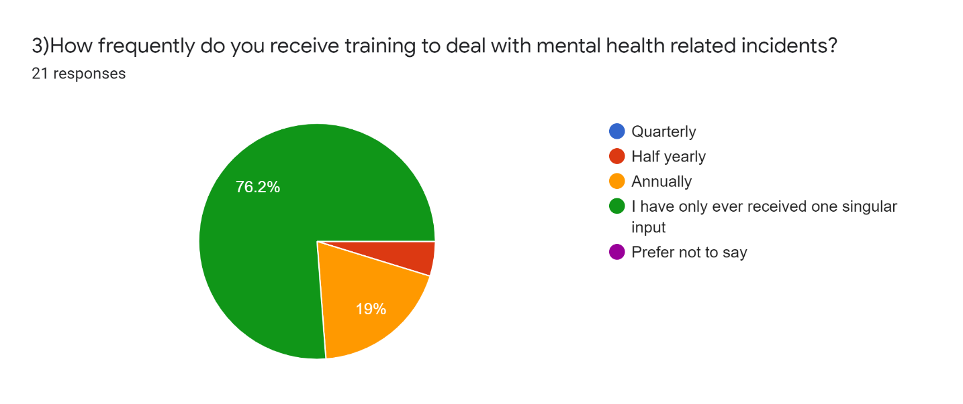
Figure 2
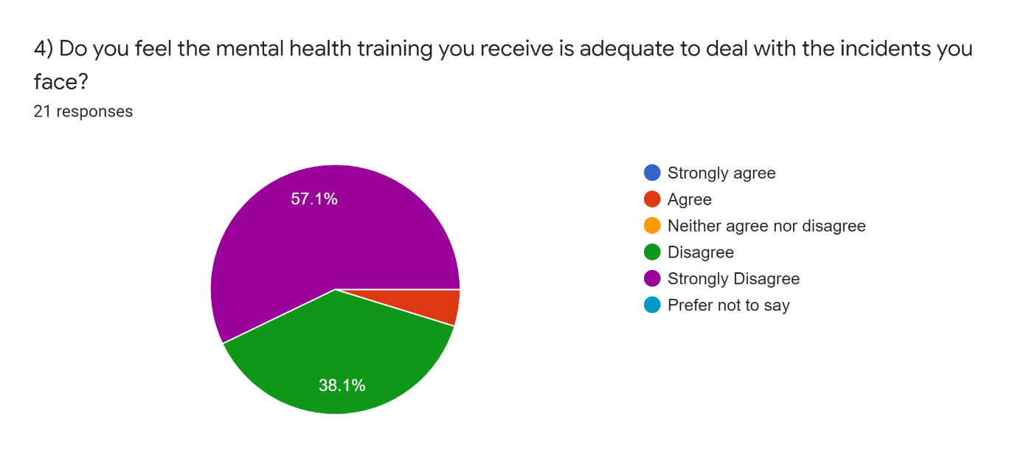Figure 3

4.5 What Works
Participants were asked “Of the mental health training you have received what do you think works well?” one theme that emerged strongly was that officers found their training around tactical communications and simply talking to the person in crisis worked well. Other officers explained that they felt having a good knowledge of their powers and the policies around mental health helped them. Similarly participants were asked “Of the mental health training you have received what do you think doesn’t work so well?” In response participants overwhelmingly stated that they felt training was poor and ineffective, one participant responded “I don’t feel I’ve received any effective training”. Some participants digressed into stating that the police should not be involved with mental health incidents at all.

4.6 Responsible Service
When asked if they believed it to be the responsibility of the police to deal with mental health incidents 95.2% of respondents said it was not, with one believing it is (see figure 4). This aligns with the belief held by the public who when surveyed only 2% believed it should be the responsibility of the police (HMICFRS, 2018). Respondents who answered stating it is not the responsibility of the police were further asked, who’s they believe the responsibility should be. All except one responded by saying it is either the NHS, ambulance, crisis team or health service. Interestingly one person stated they believed there was no correct service as of yet and a new dedicated one should be formed to deal with the incidents.
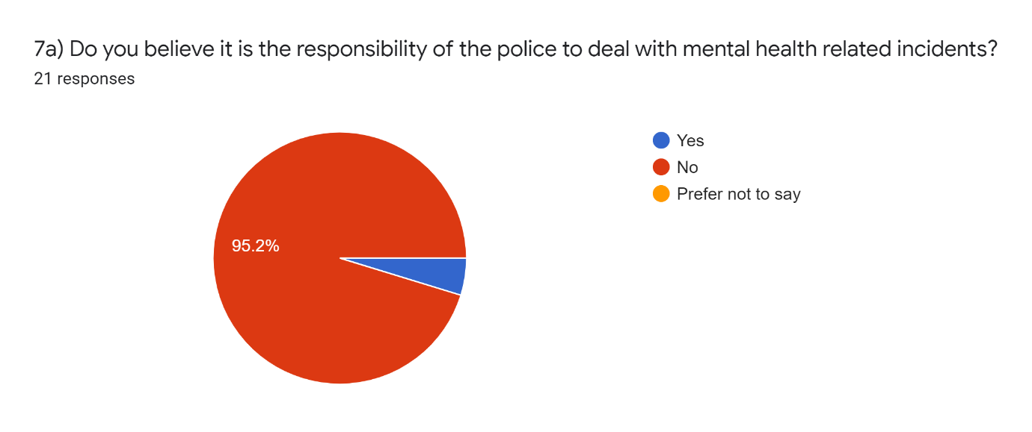
Figure 4

4.7 Mental Health Triage Cars
It has been identified that various police forces such as Leicestershire (UK Gov, 2021) have started to introduce mental health triage cars in an attempt to provide a better service and ease the strain on the police, as such participants were asked if they thought this was a better way to resource mental health incidents. 85.7% answered yes whereas 14.3% answered no (see figure 5). To follow this up participants were then asked why they think that, interestingly all who answered no did so on the basis that they believed this should not fall under the remit of a police officer, with 2 respondents also voicing safety concerns for the single crewed officer. The majority of the 85.7% who supported the idea did so because they believed it would provide a better service and allow persons direct access to mental health professionals.
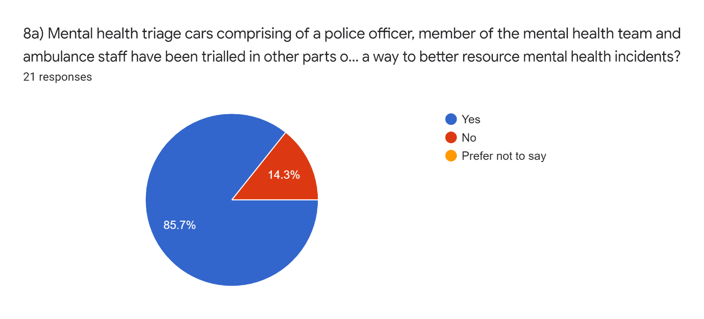
Figure 5

4.8 Other Alternatives
Participants were asked how else they would ease pressure on the police dealing with mental health incidents, two clear themes emerged from this broad question. Firstly participants believed that it should not be resourced by the police and at the first point of contact they should be signposted to the correct service, i.e. the crisis team. The next was that participants believed there should be some form of dedicated responding service which had appropriate powers to detain and if required take the person to a dedicated mental health setting.

4.9 Limitations
In the methodology it was stated that the questions in the survey would be posed in a randomised order to avoid order bias as identified by Perreault (1975). This was not possible as certain questions were related, leading on from one another it would have be illogical to split them up, and this could have potentially confused the participants. It is also accepted that 21 responses is a small sample size and may not be generally reflective of the overall demographic, however the target audience was very specific and the results that were achieved unequivocal.

4.10 Conclusion
The research has primarily set out to achieve objective one and answer the question;
How effective do police officers perceive their training to be in regards to mental health.
This has undoubtedly been achieved there can be no ambiguity within the results, 95% of participants answered stating the training they receive is inadequate to deal with mental health incidents, furthermore the research has begun to highlight a possible cause of this may be due to a lack and infrequency of training. It has been highlighted that the participants strongly believe they are not the correct service to deal with mental health incidents and that this is the responsibility of various aspects of the health service and NHS. Participants on the whole have however shown a willingness, that they are ready to collaborate with other services in order to find a better working model, in particular they were receptive to the idea of a mental health triage car.

Chapter 5 - Findings and conclusions

5.1 Introduction
The previous chapters of this study have introduced the research project, conducted a broad literature review, outlined the methodology adopted within this research and analysed the results of the research. In this section the overall findings of the research will be discussed as well as the findings in relation to each of the set objectives. The chapter will end with a conclusion of the research question;
“How effective is the mental health training received by police officers and could the way the police respond to mental health incidents be improved”

5.2 Completing Objectives
As discussed in this chapter the research objectives will be visited and findings surmised, starting with;
1) An analysis of how effective police officers perceive their training to be in regards to mental health.
This objective was chosen due to the lack of existing literature around the subject, because of this the only feasible way to achieve the objective whilst ensuring reliability and validity was to conduct primary research. The research that was conducted has shown unequivocally that police officers believe the training they receive is inadequate to deal with mental health incidents, furthermore the research had begun to highlight a possible cause of this may be due to a lack and infrequency of training, however further research would be needed to confirm this.
The next objective was;
2) To critically analyse if it is the responsibility of the police and are they the correct service to deal with mental health incidents.
This objective can be seen as twofold. Firstly which service is responsible for mental health emergencies, secondly are the police the correct service to deal with these. Whilst these topics were touched upon using the primary research, it is important to note the answers provided are solely from police officers so are likely to be biased. Because of this inherent bias secondary research must also be accounted for to create a more balanced analysis. The primary research has shown that officers do not believe that they are the correct service to deal with mental health emergencies. This view however is supported by the existing literature from official bodies such as HMICFRS in Policing and Mental Health Picking up the Pieces (2018), Furthermore this report also states it is view held by the public. In summary whilst the police may be able to provide a small level or very niche assistance, they should not be the predominant service to attend mental health incidents. The analysis has shown a clear consensus amongst police officers that they are not the appropriate service to deal with mental health incidents.
The final objective answered within this study was;
3) Identify a better working model to ease pressure upon the police and other emergency services responding to mental health incidents.
This objective was answered again using a mixture of existing and primary research. The existing literature has shown that there are multiple models and schemes being trialled to try and ease pressure on the police and other services, such as crisis intervention teams (The College of Policing, 2020). The mental health triage car stood out amongst the discussed models as the most effective, managing to deliver meaningful results as seen in Leicestershire (UK Gov, 2021). The primary research aimed to gather the views of officers on this model to reinforce its suitability. Over three quarters of officers agreed that this would be a better model, inferring that from a policing perspective the solution may lie in an approach which is specifically tailored to mental health incidents. With all research highlighting the effectiveness of the mental health triage car and it being well received by officers, this would be a better model for responding to mental health emergencies, however it is important to acknowledge this is a singular piece of research and any large scale implementation would require further academic analysis.

5.3 Limitations
Limitations of the study are important for placing research findings in context, they will help interpret the validity and add credibility to the research (Ioannidis,2007). It has already been stated in the previous section, however it is worth reiterating the primary research was conducted on a relatively small sample size and could not be reflective of the wider population. Furthermore the study has achieved all of its objectives, but in doing so has opened more avenues that will need researching. Information about policing in the public domain is generally limited owing to its sensitive nature, especially in the area of training and policy. Therefore it is entirely possible that training, policy or models exist that are not discussed in this study due to them not being publically accessible.

5.4 Future Research
Taking note of the limitations, future research will need to be conducted to establish why police officers believe their mental health training is so poor, once this is understood the issue can begin to be addressed. In respect of the mental health triage car, research where the health service is the primary focus will need to take place in order to identify if the scheme is mutually beneficial, making it worthwhile for all involved. This study has also failed to identify who the most appropriate service is to deal with mental health incidents, if the police were to move away from the forefront of responding to these incidents fertile ground would be created for further academic research in the area.

5.5 Discussion
It is evident from the research that the police are attending more and more mental health emergencies, though it is widely accepted that in doing so they are accepting a role that does not belong to them. Three years has passed since Policing and Mental Health Picking up the Pieces (HMICFRS, 2018) was published, and from the research it is clear that little has changed for the police service who are still burdened with mental health emergencies. Policing and Mental Health Picking up the Pieces (HMICFRS, 2018) raises the further issue of significant under reporting of the problem suggesting the issue is far larger than accepted. In a society where mental health issues are becoming more common the status quo of the police service attending the incidents does not look set to change. Therefore it is imperative that there is an investment in the training of police officers, which would allow them to more effectively deal with the incidents they are facing now more than ever before.

5.6 Recommendations
Recommendations can be made after the research objectives have been investigated, thus these recommendations will be based on the research findings (Abdulai and Owusu-Ansah, 2014). The recommendations will be drawn from the findings of both the primary and secondary research.
When analysing the findings of objective one, it has already been stated that the training police officers receive to deal with mental health incidents is inadequate. Given this the first recommendation made following the research will be;
1) Initial mental health training received by officers should be followed up by an annual refresher, the content of the refresher training should change annually. This will allow for officers to be continually upskilled as part of their continued professional development.
The second recommendation to be made does so following the analysis of objective two, roles and responsibilities of each agency need to be clearly defined and accepted. Though mental health incidents are often dynamic by nature and as such it is impossible to predict every eventuality or outcome, clearly defined roles and responsibilities would allow for a more efficient response by the correct service. Thus recommendation two;
2) A nationally recognised concordat or policy is to be written that will clearly allocate roles and responsibilities for each service from the point of first contact during a mental health incident to the last.
Finally, a more effective response to mental health incidents is required. This was firstly highlighted in chapter two through the existing literature and then further corroborated by the primary research. However whilst further research will be required to validate the model, recommendation three;
3) A mental health triage car should be implemented with its effectiveness being closely monitored, allowing for the results of future research to dictate changes to service or policy.

5.7 Conclusion
To conclude, the study has successfully achieved its objectives and answered the research question. The literature review highlighted a gap in the literature and subsequently when addressing this gap the research discovered that, police officers feel the training they receive to deal with mental health incidents is ineffective. Neither governing bodies, the police nor the public see the responsibility of these incidents as belonging to the police, with most in agreeance the onus of responsibility rests firmly with the health service. Better working models do exist to ease pressure and provide a better service to those who require it, although most are in their infancy, time and further research will be needed to prove their effectiveness.

Bibliography
Abdulai R, Owusu-Ansah A. (2014). Essential Ingredients of a Good Research Proposal for Undergraduate and Postgraduate Students in the Social Sciences. Sage Open. 4 (3), P1-15.
Aguinis, H and Kraiger, K., (2009). Benefits of Training and Development for Individuals and Teams, Organizations, and Society. Annual Review Of Phycology . 60 (1), P451 - 74.
Alharahsheh, H. (2020). A Review of key paradigms: positivism VS interpretivism. Global Academic Journal of Humanities and Social Sciences. 2 (3), P39-43.
Anfara V, Brown K, Mangione T. (2002). Qualitative Analysis on Stage: Making the Research Process More Public. Educational Researcher. 31 (7), P28-38.
Avon and Wiltshire Mental Health Partnership NHS Trust., (2021). Street Triage Service. Available: http://www.awp.nhs.uk/services/community/street-triage-service/. Last accessed 20th July 2021.
Bather A, Fitzpatrick R, Rutherford M. (2008). Briefing 36, The Police and Mental Health. Available: https://www.centreformentalhealth.org.uk/sites/default/files/2018-09/SainsburyCentre_briefing36_police_final_small.pdf. Last accessed 09th May 2021.
Busetto L, Wick W, Gumbinger C. (2020). How to Use and Assess Qualitative Research Methods. Neurological Research and Practice. 14 (2), P1-10.
Campbell M, Waters W. (1990). Does Anonymity Increase Response Rate in Postal Questionnaire Surveys About Sensitive Subjects? A Randomised Trial. British Medical Journal . 44 (1), P75-76.
Campbell, D. (2020). Police 999 Callouts to People Suffering Mental Health Crises Soar. Available: https://www.theguardian.com/society/2020/oct/18/police-999-callouts-to-people-suffering-mental-health-crises-soars. Last accessed 1st July 2021.
Clarke AM, Jack B. (1998). The Benefits Of Using Qualitative Research. Professional Nurse. 12 (13), P845-847.
Clarke V, Braun V. (2017). Thematic analysis. The Journal of Positive Psychology. 12 (3), P297-298.
Duncan E, Best C, Dougall N, Skar S, Evans J, Corfield A, Fitzpatrick D, Goldie I, Maxwell M, Snooks H, Stark C, White C, Wojcik W., (2019). Epidemiology of Emergency Ambulance Service Calls Related to Mental Health Problems and Self Harm: a National Record Linkage Study. Scandinavian Journal of Trauma, Resuscitation and Emergency Medicine. 27 (34).
Edward A, Duncan S, Best C, et al. (2019). Epidemiology of Emergency Ambulance Service Calls Related to Mental Health Problems and Self-harm: A National Record Linkage Study. Scandinavian Journal of Trauma, Resuscitation and Emergency Medicine. 27 (34)
Fink, A., (2014). Conducting Research Literature Reviews: From the Internet to Paper. (4). Thousand Oaks, CA: SAGE.
Ford-Jones, P., (2017). A Critical Analysis of Debates Around Mental Health Calls in the Prehospital Setting. INQUIRY: The Journal of Health Care Organization, Provision, and Financing. 54 (1), P1-5.
Fuller, C. (1976). Effect of Anonymity on Return Rate and Response Bias in a Mail Survey. Journal of Applied Psychology. 59 (3), p292-296.
Goddard W, Melville S (1996). Research Methodology An Introduction. 2nd ed. Lansdowne: Juta. P1-6.
Gregory, R (1992). Psychological Testing: History ,Principles and Applications,. Boston: Allan and Bacon. P117.
Heale R, Twycross A. (2015). Validity and Reliability in Quantitative Studies. Evidence Based Nursing. 18 (3), P66 - 67.
Her Majesty's Government. (2014). Mental Health Crisis Care Concordat Improving Outcomes For People Experiencing Mental Health Crisis. Available: https://s16878.pcdn.co/wp-content/uploads/2014/04/36353_Mental_Health_Crisis_accessible.pdf. Last accessed 11th May 2021.
Her Majesty's Inspectorate of Constabulary and Fire and Rescue Services. (2011). Demanding Times the Front Line and Police Visibility. Available: https://www.justiceinspectorates.gov.uk/hmicfrs/media/demanding-times-062011.pdf. Last accessed 10th May 2021.
Her Majesty's Inspectorate of Constabulary and Fire and Rescue Services. (2018). Policing and Mental Health Picking Up the Pieces. Available: https://www.justiceinspectorates.gov.uk/hmicfrs/wp-content/uploads/policing-and-mental-health-picking-up-the-pieces.pdf. Last accessed 11th Jun 2021.
Horspool K,Drabble S, O'Cathain A. (2016). Implementing Street Triage: a Qualitative Study of Collaboration Between Police and Mental Health Services. BMC Psychiatry. 313 (16), P2-11.
Ioannidis J. (2007). Limitations Are Not Properly Acknowledged In The Scientific Literature. Journal of Clinical Epidemiology. 60 (4), P324 -329.
Ioannidis J. (2007). Limitations Are Not Properly Acknowledged In The Scientific Literature. Journal of Clinical Epidemiology. 60 (4), P324 -329.
Jones, L. (2019). Police 'dealing with more mental health incidents'. Available: https://www.bbc.co.uk/news/uk-49317060. Last accessed 09th May 2021.
Jones, R. (1995). Why do qualitative research?. British Medical Journal. 311 (2), P42.
Keown P, French J, Gibson G, Newton E, Cull S, Brown P, Parry J, Lyons D, Mckinnon I.,(2016). Too Much Detention? Street Triage and Detentions Under Section 136 Mental Health Act in the North-East of England: a Descriptive Study of the Effects of a Street Triage intervention. BMJ Open . 6 (1), p1 - 8 .
Leedy P, Ormrod J. (2010). Practical Research - Planning and Design. 9th ed. Boston: Merrill. P2-10.
London Ambulance service., (2020). Mental Health Joint Response Car Pilot - Evaluation Report. Available: https://aace.org.uk/wp-content/uploads/2020/08/MHJRC-Review-Final-12082020.pdf. Last accessed 22nd July 2021.
Loughran, M., (2018). Detention Under Section 136: Why is it Increasing?. Medicine, Science and the Law. 58 (4), P 268 - 274.
McCann T, Savic M, Ferguson N, Bosley E, Smith K, Roberts L, Emond K, Lubman D., (2018). Paramedics' Perceptions of their Scope of Practice in Caring for Patients with Non-Medical Emergency-Related Mental Health and/or Alcohol and Other Drug Problems: A Qualitative Study. PLoS One.. 13 (12), P1-16.
Mind. (2020). Mental health facts and statistics. Available: https://www.mind.org.uk/information-support/types-of-mental-health-problems/statistics-and-facts-about-mental-health/how-common-are-mental-health-problems/. Last accessed 10th May 2021.
Mohajan, H. (2017). Two Criteria for Good Measurements in Research: Validity and Reliability. Annals of Spiru Haret University. 17 (4), P58 - 82.
Perreault, W. (1975). Controlling Order-Effect Bias. Public Opinion Quarterly. 39 (4), P544 - 551.
Ponto,J. (2015). Understanding and Evaluating Survey Research. Journal of the advanced practitioner in oncology. 6 (2), P168-171.
Puntis S, Perfect D, Kirubarajan A, Bolton S, Davies F, Hayes A, Harriss E, Molodynski A., (2018). A Systematic Review of Co-Responder Models of Police Mental Health ‘Street’ Triage. BMC Psychiatry. 18 (256), P1 - 11.
Putman S. (2019). Mental Health Policy. Available: https://www.scas.nhs.uk/wp-content/uploads/Mental-Health-Policy.pdf. Last accessed 22th July 2021.
Rahman, MS. (2016). The Advantages and Disadvantages of Using Qualitative and Quantitative Approaches and Methods in Language "Testing and Assessment" Research: A Literature Review. Journal of Education and Learning Canadian Center of Science and Education. 6 (1), P102-108.
Rich M, Ginsburg K. (1999). The Reason and Rhyme of Qualitative Research: Why, When, and How to Use Qualitative Methods in the Study of Adolescent Health. Journal of Adolescent Helath. 25 (6), P371 - 378.
Rodgers M, Thomas S, Dalton J, Harden M, Eastwood A., (2019). Police-Related Triage Interventions for Mental Health-Related Incidents: a Rapid Evidence Synthesis. Health Serv Deliv Res. 7 (20).
Roy D, Weyman A, Nolan P. (2020). Self-preservation Comes at a Cost: Why British National Health Service Paramedics Might be Choosing a Healthier, but Poorer, Retirement. Sage Open Med. 8 (1), P1- 8.
Scantlebury A, Fairhurst C, Booth A, McDaid C, Moran N, Parker A, Payne R, Scott W, Torgerson D, Webber M, Hewitt C., (2017). Effectiveness of a Training Program for Police Officers Who Come Into Contact With People With Mental Health Problems: A Pragmatic Randomised Controlled Trial. Plos One. 12 (9)
Shorten A, Smith J. (2017). Mixed Methods Research: Expanding the Evidence Base. Evidence-Based Nursing. 20 (3), P74-75.
South Central Ambulance Service., (2019). Mental Health Policy. Available: https://www.scas.nhs.uk/wp-content/uploads/Mental-Health-Policy.pdf. Last accessed 19th Jun 2021.
Taheri, S. (2014). Do Crisis Intervention Teams Reduce Arrests and Improve Officer Safety? A Systematic Review and Meta-Analysis. Criminal justice policy review. 27 (1), p76 - 96.
The College of Policing (2014). The Code of Ethics. Coventry: College of Policing Limited
The College of Policing. (2015). Estimating Demand on the Police Service. Available: https://paas-s3-broker-prod-lon-6453d964-1d1a-432a-9260-5e0ba7d2fc51.s3.eu-west-2.amazonaws.com/s3fs-public/2021-03/demand-on-policing-report.pdf. Last accessed 16th Nov 2021.
The College of Policing. (2016). Mental Health. Available: https://www.app.college.police.uk/app-content/mental-health/. Last accessed 11th May 2021.
The College of Policing. (2016). Mental Vulnerability and Illness. Available: https://www.app.college.police.uk/app-content/mental-health/mental-vulnerability-and-illness/. Last accessed 26th Sept 2021.
The College of Policing., (2020). Crisis Intervention Teams. Available: https://whatworks.college.police.uk/toolkit/Pages/Intervention.aspx?InterventionID=63. Last accessed 15th July 2021.
The National Health Service. (2020). 2020 Community Mental Health Survey: Statistical Release. Available: https://www.cqc.org.uk/sites/default/files/20201124_cmh20_statisticalrelease.pdf. Last accessed 10th May 2021.
The National Police Chiefs Council., (2020). National Strategy on Policing and Mental Health. Available: https://www.npcc.police.uk/Mental%20Health/Nat%20Strat%20Final%20v2%2026%20Feb%202020.pdf. Last accessed 16th Jun 2021.
Thomas S, Watson A., (2017). A Focus on Mental Health Training for Police. Journal of Criminological Research, Policy and Practice. 3 (2), P93 - 104.
Uk Government., (1983). Mental Health Act. Available: https://www.legislation.gov.uk/ukpga/1983/20/section/136. Last accessed 1st July 2021.
Uk Government., (2014). Mental Health Crisis Care Concordat. Available: https://assets.publishing.service.gov.uk/government/uploads/system/uploads/attachment_data/file/281242/36353_Mental_Health_Crisis_accessible.pdf. Last accessed 20th July 2021.
Uk Government., (2014). Review of the Operation of Sections 135 and 136 of the Mental Health Act 1983. Available: https://assets.publishing.service.gov.uk/government/uploads/system/uploads/attachment_data/file/389202/S135_and_S136_of_the_Mental_Health_Act_-_full_outcome.pdf. Last accessed 01st July 2021.
Uk Government., (2021). Street Triage Pilots. Available: https://www.crisiscareconcordat.org.uk/inspiration/get-inspired-2/. Last accessed 20th July 2021.
Uk Parliament., (2016). Policing and Crime Bill. Available: https://publications.parliament.uk/pa/cm201516/cmpublic/policingandcrime/Memo/PCB06.htm. Last accessed 11th July 2021.
Wisdom J, Creswell J. (2012). Mixed Methods: Integrating Quantitative and Qualitative Data Collection and Analysis While Studying Patient-Centered Medical Home Models. Available: https://pcmh.ahrq.gov/sites/default/files/attachments/MixedMethods_032513comp.pdf. Last accessed 28th August 2021.
Wood J, Beierschmitt L., (2014). Beyond Police Crisis Intervention: Moving “upstream” to Manage Cases and Places of Behavioural Health Vulnerability. International Journal of Law and Psychiatry. 37 (5), P439 - 447.

Appendix A - Blank Survey Questionnaire

Critically analysing the effectiveness of police officers mental health training, their response and responsibilities towards incidents involving persons suffering from mental health issues.

I am PC 6437 Matthew Evans of South Wales Police, currently studying with The University of Wales Trinity St David. I am researching the impact of mental health incidents on frontline policing. This survey will form part of my research.

The survey is completely anonymous. The information you provide will be used to provide insight on how frontline police officers view mental health incidents and the training they receive.

Please do not divulge any sensitive information, e.g. names, DOB of yourselves or subjects. This survey is optional however I would be very grateful for your time and completion of the survey.

You can still submit this survey with the option of skipping any questions that you do not feel comfortable with completing, alternatively if you feel the question is not relevant to you please put “n/a” By completing this survey you are consenting to myself using the information you provide for the purpose of my research. This survey consists of 9 questions and should take no longer than 10 minutes to complete. Thank you for your assistance.

1) Are you a police constable working in either Response, CID, NPT?
Yes
No
Prefer not to say
If you have answered “No” to Q1 then please exit the survey as unfortunately it does not cover your role, thank you for your time however.

2) How long have you been a constable?
0-5 years
6-10 years
11+ years
Prefer not to say
3) How frequently do you receive training to deal with mental health related incidents?
Quarterly
Half yearly
Annually
I have only ever received one singular input
Prefer not to say
4) Do you feel the mental health training you receive is adequate to deal with the incidents you face?
Strongly agree
Agree
Neither agree nor disagree
Strongly disagree
Prefer not to say
5) Of the mental health training you have received what do you think works well?

6) Of the mental health training you have received what do you think doesn’t work so well?

7a) Do you believe it is the responsibility of the police to deal with mental health related incidents?

7b) If no who’s responsibility do you believe it is?

8a) Mental health triage cars comprising of a police officer, member of the mental health team and ambulance staff have been trialled in other parts of the UK, do you think this could be a way to better resource mental health incidents?
Yes
No
Prefer not to say
8b) Why do you think this?

9) How else would you ease pressure on the police dealing with mental health incidents?

Appendix B - Sample of Survey Results

The research utilised a mixed methods research.
Quantitative questions 1, 2, 3, 7A, 8A results are suitable to be displayed using graphs.
A selection of qualitative results will be presented that highlight the themes discussed in the research.

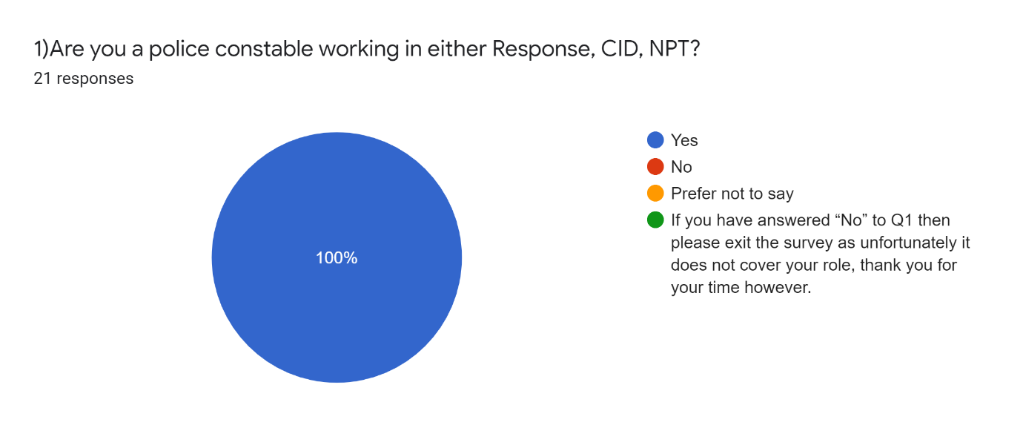
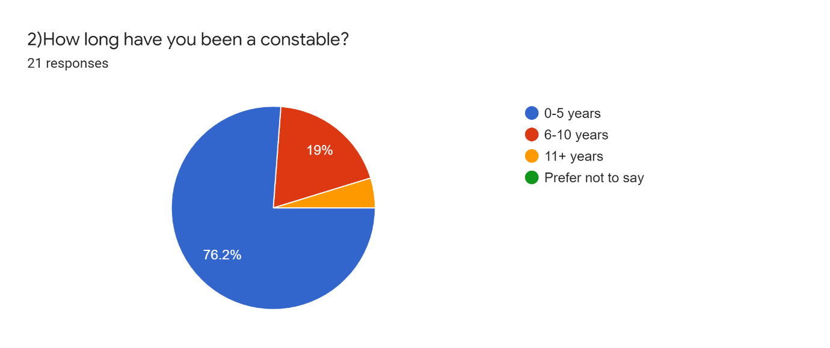
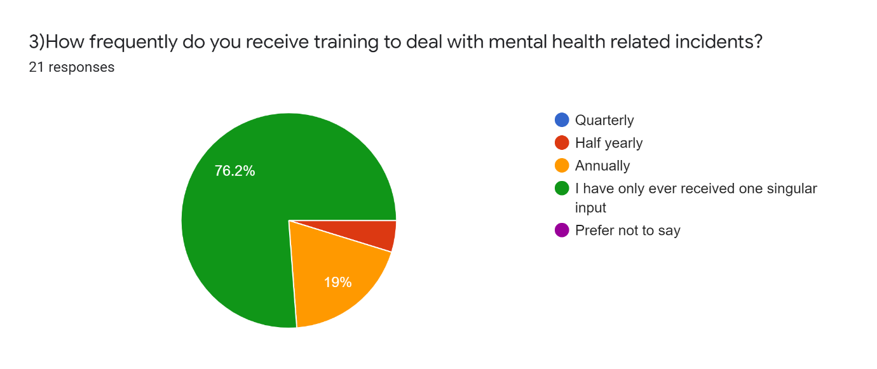
5) Of the mental health training you have received what do you think works well?
- Basic understand of powers available and processes.

- Tactical communication until medical assistance arrives

- Good communication skills and lots of reassurance. Knowledge of support available.

- The mental health training I have received primarily focused on procedural matters - as such, I would say I know the procedure of exercising powers under the Mental Health/Capacity Acts reasonably well.

- Tactical communications and talking to the person as a person

6) Of the mental health training you have received what do you think doesn’t work so well?

- The training received is very poor and basic it requires you to rely on your own experiences rather than training

- The training received is not fit for purpose and does not provide officers with any skills to tackle MH, it relies on the officer using 136 powers which are very limited or talking to the individual/ referring them to other services

- Everything, police officers are not mental health professionals

- I don’t feel I’ve received any effective training

- Not enough training
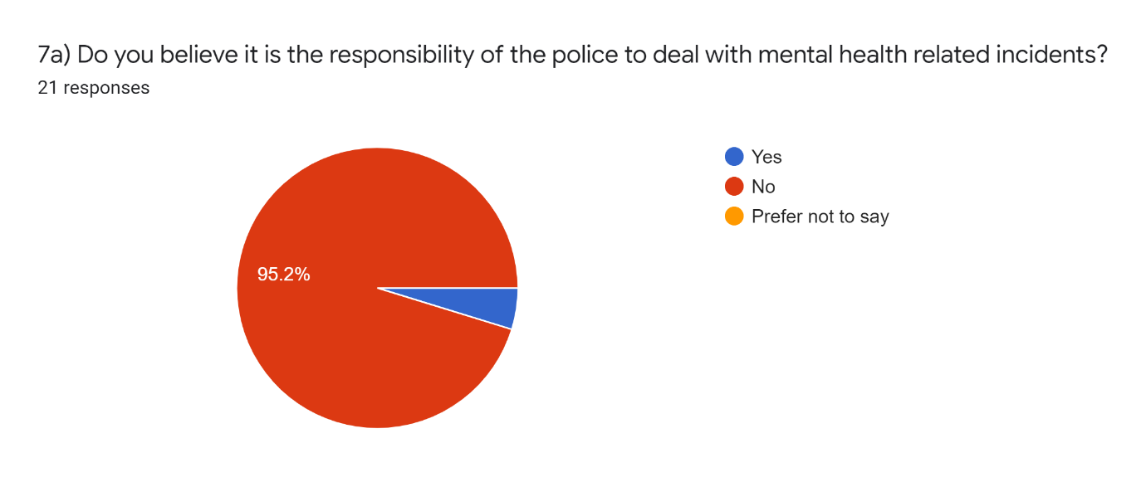
7b) If no who’s responsibility do you believe it is?

- Mental health teams and nhs

- Mental health services, ambulance, nhs

- MH services and NHS as it is a medical issue

- Ambulance service & mental health teams

- I dont think there is a suitable system in place as of yet. Possibly a extra emergency service would be required.
8b) Why do you think this?

- Having a dedicated officer for mental health calls takes that officer away from general policing duties and puts them into a very niche role which us a further abstraction from already-stretched front line teams. Additionally, it results in an officer being single crewed during often volatile and violent individuals, placing the officer in danger.

- There is a massive strain on police for mental health calls at the moment. A huge majority of calls are people suffering with mental health/ambulances not available

- Because Police resources are tied up dealing with MH incidents rather than crime.

- Specialist department would help take demand away for other areas of Policing

- Health take primacy and police present to eliminate threat, risk or harm and utilise powers where appropriate.

9) How else would you ease pressure on the police dealing with mental health incidents?

- Refer them to the correct service at first contact in the PSC. Push back to other services

- Push back to NHS/mental health services

- Mental health ambulances

- Mental health unit to be mobile and suitable to attend calls over Police

- When there is an incident involving MH, just because there is a possible risk to life and limb, shouldn’t mean that it directly comes to the police. There should be a service/contact number or agency that deals with these issues instead of a constable with limited training only trying to relate or compromise for the situation.

