Engine Performance Characteristics

Aeron Tollett
2305464

University of Wales Trinity Saint David
School of Engineering
Motorsport Engineering BEng

12/03/2024

Contents:

- Introduction p3

- Methodology and Equipment

- Results of Test

- Conclusions

You need this 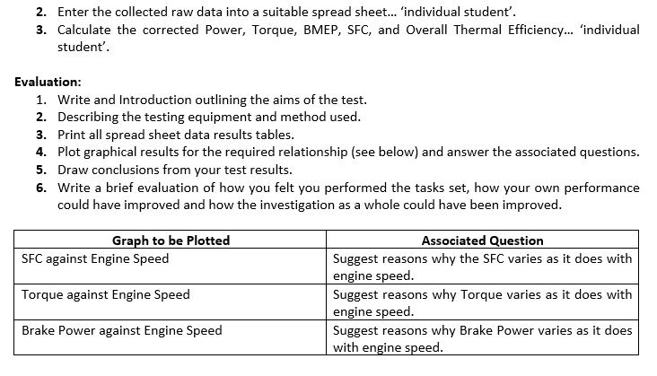

- Introduction:

An engine dynamometer test is usually used to calculate how much power an engine can produce at different engine speeds. It is specifically looking at torque, power, and movement force.
The primary way to assess these figures is by performing a sweep test, which raises the rpm at a constant rate while adjusting the load and measuring the rate of fuel intake. These figures can then be used to calculate the power and torque figures, which is used to visualise vehicle performance.
This practice is common in the automotive industry as a base figure to calculate how efficient their engines and drivetrains are, by comparing the power figure produced at the dynamometer to the power figure produced from a rolling road.
(Lish, 2015)

AIMS
- Find out the engines power and torque to compare by using a dynamometer test
- Test the engine to identify different engine speeds and how horsepower and torque differs and where its maximum output lies.

- Methodology and Equipment

The test used is called a sweep test. This test was chosen because it identifies any abnormal behaviour during different rates of acceleration. This test is where the rpm is steadily increased and the rate of fuel flow into the engine intake was measured, along with the conditions within the test chamber (ambient pressure, ambient temperature, calorific content of the fuel, etc.) and compiled into excel to produce visualised data graphs. From these data categories you can calculate the torque the engine was producing, along with the brake power and corrected power. From this you can calculate the Brake Mean Effective Pressure (BMEP) and the corrected specific fuel consumption (SFC). This gives you all the data required to calculate the energy/hour from both the fuel and the dynamometer, to give a percentage thermal efficiency of the engine. (Go Power Systems, 2021)
The equipment used to achieve all of this was primarily an Eddy-Current W 130 Dynamometer. It is rated to 130kW and 400Nm of torque and has a maximum operating speed of 10,000 rpm.
The engine that was tested on the dynamometer was a D16V3 1.6l inline four taken from a Honda CRX

STEPS TAKEN
- I placed the engine on the dynamometer and began setting up making sure my surroundings were clear and safe to prevent injury.
- I attached various parameter sensors to measure data such as fuel flow, torque and RPM. I double checked my accuracy when placing each sensor to prevent anomalies
- I chose my set engine speed for the dyno test and increased it throughout my data collection.
- I collected each data value and wrote down any anomalies
- I repeated the test once more for further accuracy with my results
- I took this data and created data curves, test my aims to see if the behaviour of the engine was expected, as well as identifying the peak performance.

All parameters such as power and torque data were collected at regular timed intervals and repeated to obtain accurate results. Any anomalies were taken and all data was interpreted into a graph to look at the shape and relationship between parameters.
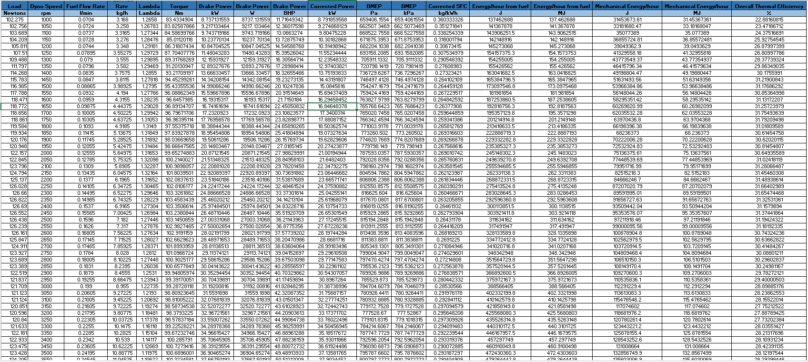

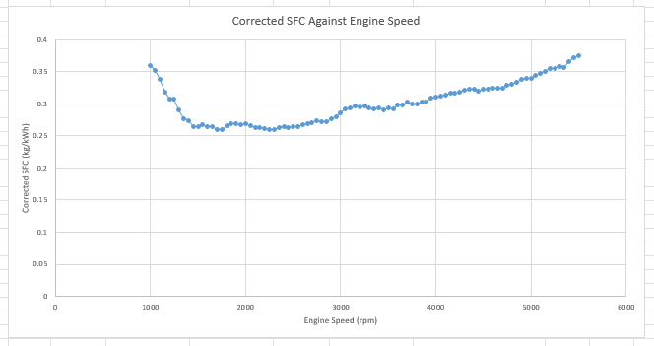

The above graph shows Corrected SFC against Engine speed. We can see the lowest SFC occurs at approximately 2300 rpm, which means at this speed the engine is consuming the least fuel. The SFC increases with engine speed, due to the increased frequency of combustion, which quite simply burns more fuel. The SFC is also higher at the lower engine speeds, because the engine has to fire more to travel a certain distance, therefore increasing the SFC.

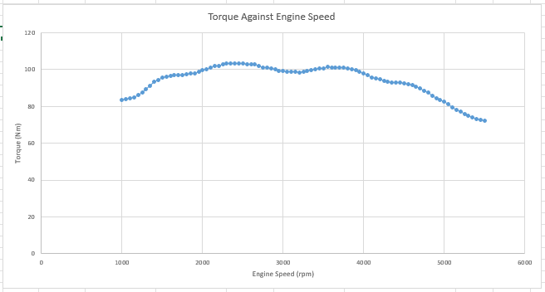

The graph above depicts Torque against Engine speed. The maximum torque is shown to be at roughly 2400 rpm, meaning that this is the engine speed that produces the most torque. At lower engine speeds the torque value tends to be lower because the cylinders inside the engine are firing less frequently, which generates less force at the crankshaft and therefore less torque at the dyno. The graph also shows us that the torque value decreases with higher engine speeds. There are a couple of reasons for this: the first and most likely reason for the lowered torque values is that with increased engine speeds there is less time to intake a sufficient amount of air, which results in incomplete combustion which in turn results in a drop in force on the crankshaft resulting in a loss of torque. The second reason could be that as the engine speed increases, so does stress on the moving parts within the engine, such as the valves and the pistons. This decreases the efficiency of the engine, meaning some torque is lost.

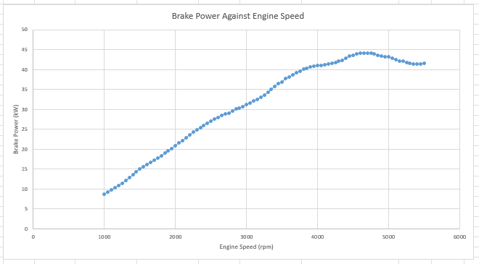

The graph above depicts the Brake Power against Engine speed. We can see a very clear upward trend in this graph, up to a maximum brake power at approximately 4600rpm. Up to the maximum brake power point, brake power is directly proportional to engine speed. This is because the faster the engine goes, the more frequently the cylinders fire, generating more power. The reason why, after the maximum brake power point, the brake power decreases, is due to similar reasons for the drop-off in torque: at high engine speeds, the valves struggle to intake the full amount of air required for complete combustion, resulting in a dirtier and more incomplete combustion which delivers less power to the crankshaft.

Conclusion

To conclude, torque, SFC and brake power are all drastically affected by engine speed. One thing to note, however, is that they all have a “sweet spot” at a certain rpm where the most desirable result can be found. The lowest SFC can be found at 2200 rpm, which is a good fact to know if you want to save fuel while driving this particular engine. The highest torque can be found at 2400 rpm, which would be an ideal engine speed should you need to tow or winch anything. The maximum brake power can be found at 4600 rpm, which would be the ideal engine speed to both accelerate and maintain a high road speed in this specific car. So torque, SFC and brake power can all be optimised through careful control of engine speed.

Overview of performance

I felt that I produced accurate results using correct safety measures and methods.
I preformed best when I made sure to maintain a constant acceleration rate as this provided accurate results and minimised the risk of abnormal engine behaviour.

To improve my results in the future, I would make sure to keep checking that my sensors are accurately placed by using calibrators. To make sure I kept validity, I would repeat this test at least three times and average the results to further improve my conclusions and result accuracy.

As well as this, I would like to improve knowledge and keep an eye on monitoring the condition of the engine. This would give further accurate data and theory behind peak and maximum efficiency.

References

‌
Go Power Systems. (2021). How To Choose A Dyno - Go Power Systems. [online] Available at: https://gopowersystems.com/how-to-choose-a-dyno/#:~:text=An%20acceleration%20or%20sweep%20test,ends%20at%20a%20lower%20speed. [Accessed 18 Jul. 2024].
Lish, T. (2015). What is a Dynamometer and How Does it Work? [online] Setra.com. Available at: https://www.setra.com/blog/test-and-measurement-dynamometer [Accessed 18 Jul. 2024].
‌

