Cloud Engineering Principles and Practice

Abstract
This report evaluates the role that both containerization and serverless computing form the basis of modern cloud-native systems, with a prime position taken by Docker in the packaging and deployment of portable workloads of applications. It starts by reviewing the basics of virtualization, and then describes how Docker images, and volumes together with networking, can be used to create reproducible and scalable web services that can be managed across a clustered infrastructure. At platform layer, the report features load balancing, autoscaling and application gateways that are complementary to spread traffic, scale capacity to demand and implement security and routing policies at the edge.
Based on this, the paper considers the cost and elasticity of cloud use as major factors behind cloud implementation, and compares the economics of container-based clusters to those of the pay-per-invocation serverless systems. Functions-as- a- Service is introduced as the logical choice to serve event-driven and spiky workloads, whereas containers are still beneficial to serve long-running and complex services and multi-cloud portability. The report concludes by describing new trends in hybrid and edge-cloud combining these models, and by gathering experience in practice on how such hybrid designs are actually implemented, which suggests that pragmatic and mixed deployments are the best, and in any case these designs do not fit a single paradigm.
Table of Contents
Abstract 2
1. Introduction 5
2. Cloud Technology: Docker and Containerization 6
2.1 Principles of Virtualization 6
2.2 Principles and Benefits of Containerization 7
2.3 Images and Publishing Images 9
2.4 Container Volumes 11
2.5 Container Networking 12
2.6 Comprehensive Example: Web Server Deployment 13
3. Cloud Computing Concepts 15
3.1 Load Balancing 15
3.2 Scalability 17
3.3 Application Gateways 18
3.4 Complementary Nature of Load Balancing and Scaling 19
4. Main Driving Forces in Cloud Computing Expansion 19
4.1 Cost as a Driving Force 19
4.2 Flexibility as a Driving Force 20
4.3 Serverless Functions (Functions as a Service) 21
4.4 Comparison: Containerization vs Serverless 22
5. Conclusion 23
6. References 25

List of Tables
Table 1: Overview of Key Cloud Technologies 5
Table 2: Types and Advantages of Virtualization 6
Table 3: Containerization vs virtualization 7
Table 4: Differences Between Docker Image and Container 9
Table 5: Types of Docker Image Tags Explained 10
Table 6: Comparing Docker Volume Types and Use Cases 11
Table 7: Network drivers and usage 12
Table 8: Docker Workflow: From Image Creation to Deployment 14
Table 9: Comparison of Layer 4 vs Layer 7 Load Balancing 15
Table 10: Comparison of Horizontal vs Vertical Scaling 17
Table 11: Key Features of Load Balancing Setup 18
Table 12: Comparing Traditional and Cloud Model Costs 19
Table 13: Comparison of Cloud Service Models 20
Table 14: Comparing AWS Lambda and Azure Functions 21
Table 15: Comparing of Containers and. Serverless 23

List of Figures
Figure 1: Containerization vs Virtualization 8
Figure 2: Docker Image Building and Deployment Process 14
Figure 3: Layer 4 and Layer 7 Load Balancing Explained 16

1. Introduction
Cloud computing has not been without its inception in the timesharing systems and the grid systems that transmits the on-demand utility form of computing by giant, virtualised data centres. Providers share resources that are in geographically dispersed locations and open them up as elastic services so that the organisations can be able to scale rapidly and yet they do not have to own and maintain the actual physical equipment [1].
Virtualization abstracts compute, storage and networking to allow many tenants to reasonably share each other on top of infrastructure and enhance utilisation and resiliency. Containerization goes further to envelop applications and dependencies as light weight vehicles which can be moved around and coordinated effectively across environments. Docker has been developed as of now as a standard waych of container running in DevOps pipelines and cloud-native architectures [2].
Such platforms are counting on load balancing to allocate traffic, automated scalability to adjust capacity to demand and to serverless functions to provide fine-grained, event-driven functions to deliver reliable services at scale. The combination of these mechanisms facilitates high availability, cost efficiency and quick innovation in the modern cloud applications [3]. This report thus proposes Docker-based containerization and core platform primitives, load balancing, scalability and application gateways in a representative cloud set up, and evaluates the impact of cost and flexibility serves to propel the uptake of both container-based and serverless execution models, before detailing the future directions.
Table 1: Overview of Key Cloud Technologies
Concept | Brief role in this report
Docker containerization | Applied vehicle in the packaging and run across applications in different environments.
Load balancing | Shares the request of clients between the instances to enhance throughput and resilience.
Scalability | Self-optimizes resources to demand with a low cost.
Serverless functions | Performs event driven functionality with no server control and costs by invocation.

2. Cloud Technology: Docker and Containerization

2.1 Principles of Virtualization
The basic technology involved in it is virtualization which allows numerous, mathematically separate computing environments to access the same physical hardware systems under the illusion that they have their own CPU, memory, storage and networking resources. A hypervisor or software layer interfaces with the server beneath, and it activates access to hardware resources among the virtual machines (VMs) and creates a sharp separation among tenants. Most of the cloud platforms are based on this abstraction, which allows providers to open pooled infrastructure and present it as flexibly on-demand services [4].​
Finally, shared hardware virtualization allows having a large number of VMs with various operating systems on a single physical host, with the hypervisor determining the workload of each VM and safely sharing memory and I/O. This enables providers to consolidate heterogeneous workloads, move and dynamically place VMs, ensure that the utilisation is increased and security boundaries not compromised.​
Types and Advantages of Virtualization
Table 2: Types and Advantages of Virtualization
Type | Description | Typical overhead / notes
Full virtualization | Guest OS that has not been modified is run inside a hardware emulating hypervisor. | Increased overheads; best fit.
Para-virtualization | Guest OS is changed so as to make a direct call to the hypervisor. | Less overhead; requires system modifications.
Hardware-assisted | Hardware virtualization is supported by CPU features (e.g. Intel VT x, AMD V). | Approach native speed; norm in current cloud servers.

Virtualisation can optimise resources and save energy use and cost of capital and operations by the consolidation of a large number of virtual workloads large numbers of physical servers. The high VM isolation is more secure and provides more fault containment, and the capacity to clone, snapshot and migrate VMs provides high flexibility in the deployment and maintenance process to the operator and developers [5].​
Bare-metal and Example comparison
Ordinary lab work assigns one virtualization host to a number of Linux and Windows VMs; each student is in control of his own VM, but a failure or reboot in one of the instances does not impact the other clearly shows that isolation and consolidation can exist on a common hardware. Relative to traditional bare-metal deployment configurations in which the software and solutions of a single application and operating system take up a full server, virtualization creates parting of software and hardware, allowing higher utilisation, faster deployment, and more responsive scaling at the cost of an extra layer of hypervisor and slight increment of the complexity of management and security hardening [6].​

2.2 Principles and Benefits of Containerization
Containerization is another type of application-based virtualization in which the processes are isolated in user-space environments sharing a single host operating system kernel as opposed to traditional VMs which have a complete guest OS on top of a hypervisor. The scheme applies virtualization at OS level by giving different namespaces and cgroups to processes, file system and resources isolation and retains scheduling and device management to the host kernel [7], [8]. The containers provide consequently lighter isolation as well as lower startup overhead and higher consolidation density compared to the hypervisor-based virtual machines.
Containerization vs virtualization
Table 3: Containerization vs virtualization
Aspect | Hypervisor-based virtualization | Containerization (OS-level)
Isolation unit | Full VM with guest OS. | Process-level container sharing host kernel.
Image size | Large (GB, includes OS). | Small (MB, app + libraries).
Startup time | Slower boot of full OS. | Near-instant process start.
Density per host | Lower, due to OS overhead. | Higher, more instances per server.

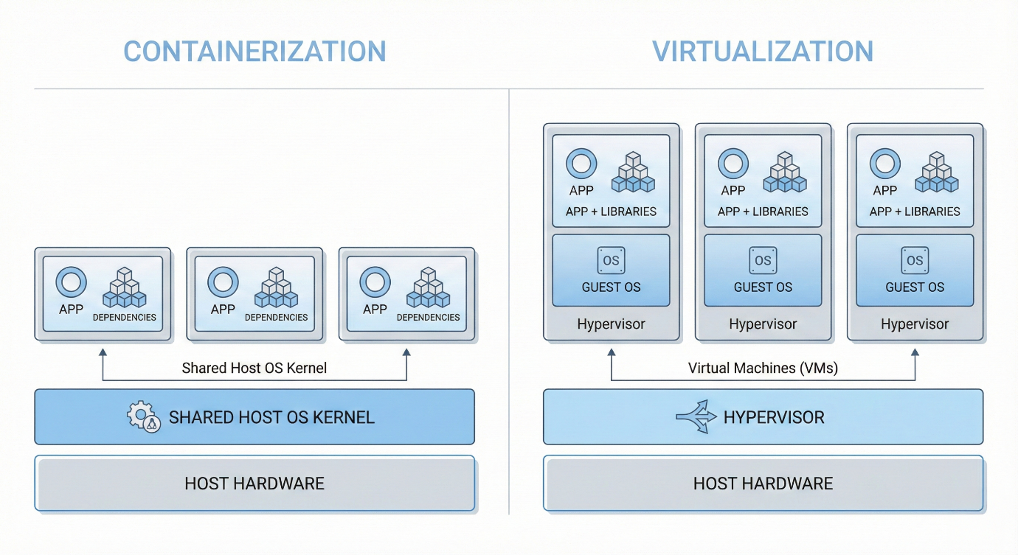
Figure 1: Containerization vs Virtualization
Advantages and Docker framework
Since containers do not provide a complete OS and instead reuse the underlying host kernel, they are resource efficient by being lightweight, and can be densely packed on shared hardware, which is start fast. The same container can be easily transferred between laptops using immutable images and services, which enhances the portability of the image and consistency in behaviour across the delivery pipeline between test environments and production clusters. The properties facilitate rapid deployment, fine-grained scale as well as effective use in cloud native systems [9].
Docker has three primary concepts used to operationalise containerisation: The Docker Engine daemon, a component that handles containers on a host, read only images, which represent the packaged application stacks, and running containers, the stacks made out of those images and which add writeable layers as the containers run. These primitives are then used by orchestrators like Kubernetes to automate the placement, scaling and self-healing of cluster mean workloads across containers.
Illustrative Dockerfile
The following plain Dockerfile contains the statements of how to create an image presented as a sequence of instructions that can be followed up:
- FROM takes a base image (such as a default Linux image having web server).
- COPY creates files of applications into the picture.
- RUN performs build time procedures like installing libraries.
- EXPOSE reports the port that a container will listen on.
- CMD specifies the default start up command, including the installation of the web server.
Example:
FROM nginx:alpine
COPY ./html /usr/share/nginx/html
EXPOSE 80
CMD ["nginx", "-g", "daemon off;"]

Compiled to create this image (such as docker build -t my-nginx .) will result in a portable artifact that can be launched in milliseconds 15 on any compatible host 16 of Docker and will share the same definition definition across development, test and production has been made.

2.3 Images and Publishing Images
Docker images are an immutable template which bundles up an application and its dependencies whereas containers are an instance of an image which contains a writable state. A single image can be deployed repeatedly on multiple hosts with different containers where it will be the same filesystem and configuration that every instance of the image [10].
Images, Containers, and Layers
Table 4: Differences Between Docker Image and Container
Aspect | Docker image | Docker container
Role | Blueprint (read only filesystem). | Started process ran as an image.
Mutability | Impermanent; changed without the help of new image build. | Ephemeral; information located in writible medium or other volumes.
Persistence | Stored in registries versioned. | temporary existence (no exception externalised).

Docker image construction has been done internally as a stack; each command in a Dockerfile (RUN or COPY) can be viewed as creating a new layer; it is also intended to be cached and reused in later invocations when no new instructions have been applied since the last build, thus saving much time and network HGP. This layer/ actually, this layer cache is the key part in any effective CI/CD pipelines since modified instructions only trigger rebuilds of the relying dependent layers.
Tagging and Registries
Tags are used to denote given variants of a given image in a repository, most commonly some pattern, such as name:latest, semantic version names like name:1.2.0, or environment names (such as name:1.2.0-prod). The Docker Hub is a popular public registry, upon which the images are pushed, versioned and shared to facilitate reproducible outfitting and shared effort on shape bands of images.
Table 5: Types of Docker Image Tags Explained
Tag type | Example | Typical use
Floating | myapp:latest | “Current” default image; convenient but less reproducible.
Versioned | myapp:1.2.0 | Exact release; preferred for reliable deployments.
Variant / env | myapp:1.2.0-prod | Configuration or platform-specific variants.

Demonstration: Push to Docker Hub
- Authenticate CLI-wise, docker login with Docker Hub credentials, or other access token; with a successful authentication, the credentials are saved on the device.
- Label the local image in registry/user/repository format e.g. the following docker tag myapp:1.2.0 username/myapp:1.2.0.
- Docker push username/myapp:1.2.0; the client implements any image layers which are not preceding in the repository.
- This check is to verify the push, which involves checking the repository page on Docker Hub, and pulling the image of a different host with docker pull username/myapp:1.2.0.
Registries present a centralised versioning of images, facilitate staff workflows (such as having a number of developers that are using the same base images) and are connected with automated build and deploying networks.

2.4 Container Volumes
Container filesystem is the filesystems of a container are disposable: no data can persist outside a persistent storage volume, even if it is written into it. In workloads like web servers or databases where the state and occurrences must be available longer than a single container, this requires logs and state available both between replicas and lasts long, which prompts the volume features of the Docker engine to provide persistent and shared storage [11].

Docker volume types and Applications
Docker gives three major types of volumes on how to handle data when not in the containers lifecycle.
Table 6: Comparing Docker Volume Types and Use Cases
Volume type | Where data lives | Typical use case
Named volume | Managed in Docker’s storage area. | Persistent app data decoupled from host paths (databases, uploads).
Bind mount | Specific host directory path. | Local development, sharing source code or config files.
tmpfs mount | In-memory on the host. | Sensitive or high-speed temporary data (caches, secrets).

Docker creates and manages named volumes, which can be easily ported across hosts of which the engine is compatible and are also easy to back up or migrate. Bind mounts are presented at a point right between a directory in a host filesystem and the area for iterative development. They are lighter on disk operations, and allow confidential material to last longer on halting resources.
Creating and using volumes
A typical workflow is:
- Volumes set up (so as to store logs or database files) A container with a name (such as docker volume create web-data) is created.
- List a container which is mounting this volume like with -v web-data:/var/log/nginx so that the log files cannot be written to the extraneous layer in the container.
- Create several containers which share the same volume name making them share state or write to the same log directory.
- Examine and administer volumes using such commands as docker volume ls, docker volume inspect web-data, and by starting a temporary utility container (such as an Alpine shell) to access files in the mounted path or handle files in it.
This method offers the continuous storage without depending on any one container, eases the backup plans and allows sharing data between cooperating containers in a controlled manner without getting the demerits of container isolation and portability.

2.5 Container Networking
Container networking refers to the mode of communication between containers, the host and other external networks like the internet. Docker will automatically pin containers to a bridge network on the host and create network namespaces and virtual Ethernet interfaces and iptables rules to isolate traffic and yet will still allow connectivity to be controlled. Making user-defined networks customized network additions will include an embedded DNS to enable containers to communicate with each other by name instead of fixed IP addresses, and this is crucial to having more than one container [12].
Network drivers and usage
Table 7: Network drivers and usage
Driver | Scope / behaviour | Typical use case
bridge | Private virtual network on a single host. | Most standalone containers; simple multi-container apps.
host | Shares host network namespace. | Performance-sensitive services needing host ports.
overlay | Virtual network spanning multiple hosts. | Swarm or clustered deployments across several nodes.
none | No network connectivity. | Strict isolation, custom networking stacks.

Bridge networks use a virtual L2 segment behind NAT which also means that containers get access to external services over the host yet is default isolated against other hosts. Host networking eliminates the namespace barrier with the container suggesting measurement of the IP stack of the host, minimizing overhead at the cost of port insulation. Overlay networks are a type of virtual subnet that are established on top of an underlying infrastructure and are used to route the connections between containers running on multiple machines and are common in clustered and swarm environments.
Designing and utilization of tailor-made networks
One typical structure here is to build a user-defined bridge network (such as docker network create app-net), and to start on it containers associated with it (such as a Web front, and an API service). The containers connect to the network at docker run times on any --network app-net option, and can subsequently connect at docker network connect afterwards, which allows them to communicate using container names that will then be resolved by the built-in docker DNS into container IPs of the container network that the option uses. This facilitates predictable inter-container communication with no need of applying IP manually and separation of application layers on separate virtual networks either to ensure security or to avoid organisational silos.

2.6 Comprehensive Example: Web Server Deployment
A basic web server deployment offers an end-to-end solution that pulls together photos, containers and volumes along with networking and publishing to a registry. It begins by a Dockerfile which describes an image that is a lightweight web server using statical HTML, and this image is run in a container on a network that is user-configurable and that a volume containing the site contents is mounted. and then the image is published to Docker Hub so that the same artifact can be reused in its test and production environment.
A standard Dockerfile of a traditional webpage web server would pick a base image of a minimal webserver, downloads HTML files into a designated folder, records the port it is listening on, and defines what command should be used to run the webserver. Assuming the web server base is FROM, the HTML page component is the COPY element, port 80 flag is the EXPOSE, and the foreground server process is the CMD element which results in a reproducible image when built using the single docker build command.
When the container is run it is added to a container-specific bridge network and a named volume to ensure that the content and logs maintain their existence despite the container lifecycle and to enable other services to locate the web server by its name. After authentication, it can in turn be tagged with a fully qualified name and pushed to the Docker Hub and is now accessible to any authorised host that makes a docker pull and docker run.
Table 8: Docker Workflow: From Image Creation to Deployment
Step | Key concept demonstrated
Write Dockerfile for static web app | Reproducible image definition.
docker build to create image | Immutable, versionable image artifact.
Run with volume and custom network | Persistence and inter-container communication.
Tag and docker push to Docker Hub | Registry-based sharing and reuse across environments.

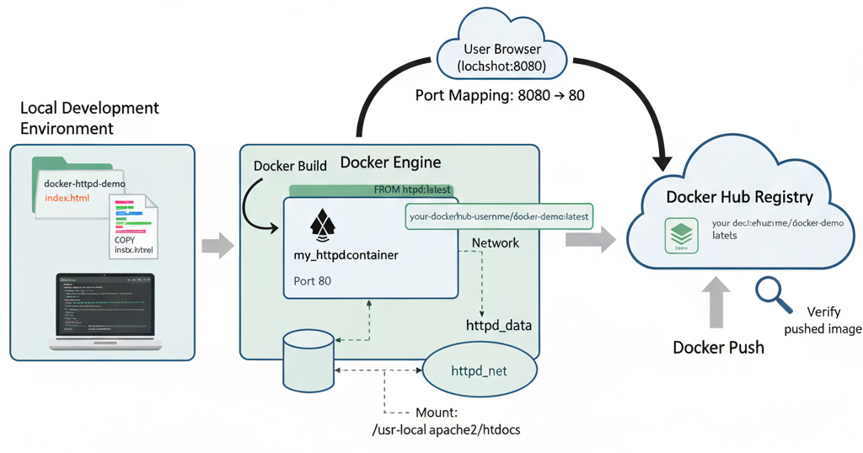
Figure 2: Docker Image Building and Deployment Process

3. Cloud Computing Concepts

3.1 Load Balancing
The load balancing process entails the distribution of the incoming network traffic by multiplying it among a variety of backend instances in such a way that any single node is not overloaded, and response time, availability and fault tolerance in cloud systems are enhanced. A load balancer is in between clients and servers and oversees the wellbeing of the backends and streams every request based on a policing choice to ensure ineffective or sluggish instances are avoided [13].
Types and Algorithms
The routing decisions of layer 4 load balancers are based on transport-layer protocol information like IP address and TCP/UDP port and traffic is treated as opaque bytes streams. Encoder layer 7 load balancers function on the application layer (such as HTTP/Https) and permit routing on URLs, headers or cookies enabling sophisticated content-based policies. Examples of common scheduling algorithms are:
- Round-robin: Round-robin generates an even distribution of requests amongst the instances in a round-robin fashion.
- Least connections: new requests are sent to the least connected instance, which aids in the occurrence where the request duration is variable.
- IP hash: This is a hash of client IP deterministically hashes a user to one backend, and is useful when one simple type of session stickiness like affinity at-rpc.
Table 9: Comparison of Layer 4 vs Layer 7 Load Balancing
Dimension | Layer 4 load balancing | Layer 7 load balancing
Decision basis | IP/port, TCP/UDP metadata. | HTTP path, headers, cookies, hostnames.
Visibility | No insight into content. | Full application-level awareness.
Typical usage | Generic TCP services, legacy protocols. | Web APIs, microservices, multi-tenant web apps.

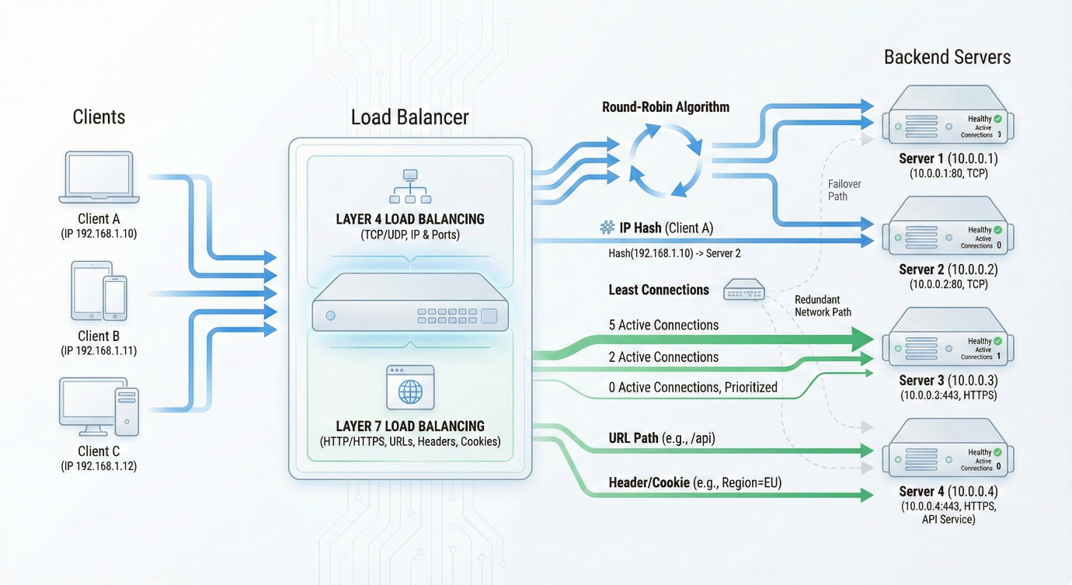
Figure 3: Layer 4 and Layer 7 Load Balancing Explained

E.g. AWS Application Load Balancer
During a standard deployment of a cloud, client access to a DNS endpoint is exposed by an Application Load Balancer (ALB) that widely distributes HTTP(S) traffic across targets (in multiple availability zones) and periodically checks the health of each target to ensure that unhealthy instances are not rotated until they are brought online again. It uses high-level configuration information such as listeners (ports and protocols), rules (path/host-based routing), and target groups (sets of EC2 instances or containers) instead of low-level information of the actual network configuration of each individual node. This architecture supports graceful failover and high availability and optimises the utilisation of resources, by directing traffic to instances that are healthy and loaded appropriately, and are a part of the group [14]. Practical applications may be the process of load balancing requests in stateless web servers behind an API, issuing URL paths to discrete microservices, or haphazard microservice traffic between service versions on a blue-green deployment or a canary deployment.

3.2 Scalability
Scalability in cloud systems is the ability to scale computing resources either upward or downward in order to keep applications running at the necessary performance as workload fluctuates but without over-provisioning and unwarranted expense. With current-day platforms, this is realized by having a mix of both horizontal and vertical scaling, orchestrated by independent policies on autoscaling, which responds to metrics like CPU, memory or custom application indicators [15].
Scaling Concepts
Horizontal scaling will either add or remove instances (e.g., VMs or containers), but vertical scaling will add or take away resources (CPU and RAM) on existing instances. Horizontal techniques are more likely to provide superior fault tolerance and fine-grained elasticity, whereas cold-start overhead and management complexity can be encountered and vertical scaling is easier and less limited by the capacity of a node.
Table 10: Comparison of Horizontal vs Vertical Scaling
Aspect | Horizontal scaling | Vertical scaling
Mechanism | Add/remove instances. | Resize instance resources (CPU/RAM).
Fault tolerance | Higher (more redundant nodes). | Lower (node is a larger single failure domain).
Practical limit | Often many nodes. | Bounded by largest machine type.

Autoscaling and Policies
The auto scaling services check measurements and spawn or dismiss resources automatically to offer elasticity. Reactive triggers are usually average CPU utilisation, memory pressure or request rate, but complex setups use custom metrics or predictive models in order to predict load [16].
In cloud environments, instances are placed in logical units of autoscaling, called either Auto Scaling groups or similar constructs that are characterized by a minimum, target and maximum capacity and policies that control the manner and timing of scale. Most styles of policy include a target-tracking (have a metric that approaches a target value); step scaling (apply larger steps when the metrics do not meet the target); and scheduled scaling (scale capacity at known peaks and off-peaks). Scale-out policies create instances as demanded passes scale-out test values and scale-in eliminates instances as the demand passes scale-in tests in reverse plus with cool down and minimum capacity to help avoid thrashing.
Elasticity and cost
Elasticity is the nature of closely comparable resources given to the prevailing demand with time, as a way of enhancing quality of service and limited cost. Through integration of conservatism of minimum capacity and autoscaling limits and cost-conscious policies, operators may maintain performance within service level targets but only incur expense on resource usage that is absolutely necessary in the diurnal and seasonal pattern of workload.

3.3 Application Gateways
Application gateways are specialised Layer 7 reverse proxies, which are placed on the edge of an application, ending client connections and inspecting HTTP(S) traffic and redirecting requests to the relevant backend services according to application-level policies. They are a centralized point of interest, in terms of security, routing and observability and a controlled choke point, between a public internet and internal loads [17].
Table 11: Key Features of Load Balancing Setup
Aspect | Description
L7 load balancing | URL-based routes instead of IP and port-based routes.
SSL termination | Unloads TLS handshake and decryption will be performed on the gateway, and makes it easier to backend configuration.
WAF integration | Maps web application firewall regulations to process undesirable requests via apps.
Path/host routing | Maps/api/static/ or any other hostname to specific pools of backing end.
Backend pools | Backup and health-check server groups or containers.

On an AWS-style deployment, an application load-balancer introduces HTTPS listeners, where TLS is terminated, host and path based conditions are assessed, and requests are sent to target groups based on the instances or containers that make the backend, where unhealthy making requests cannot be rotated out on a periodic basis as a result of health checks. Security: Viewing and covering internal addresses, standardising TLS policy at the edge, and deploying a configured WAF are better to ensure security against various typical web attacks such as injection and cross-site scripting any time traffic enters the application layer.

3.4 Complementary Nature of Load Balancing and Scaling
A load balancing and scaling create a feedback-driven control loop in cloud architectures load balancer redistributes incoming traffic across instances, and the autoscaler changes the quantity of instances so that each instance adheres to desired utilisation and latency constraints. The exported metrics on both the load balancer and backends (request rate, error rate and CPU load) propose the decision to scale-out and scale-in to ensure that the load distribution (traffic) and the capacity available (capacity turned up and down) are monitored to meet availability, performance, and cost-effectively over time.

4. Main Driving Forces in Cloud Computing Expansion

4.1 Cost as a Driving Force
One of the motivational factors that drive cloud adoption is cost, as it changes IT expenditure on large and rigid capital expenditures into small and operating utilization expenditures. Organisations are no longer buying and depreciating servers, storage, and networking devices but rather renting resources through cloud offerings on a pay-as-you-use or reserved basis where they only pay the amount of resources they use [18].
CapEx vs OpEx and Pricing
Table 12: Comparing Traditional and Cloud Model Costs
Dimension | Traditional on-prem (CapEx-heavy) | Cloud model (OpEx-oriented)
Upfront investment | Large hardware and data centre build-out. | Minimal; resources provisioned on demand.
Cost flexibility | Fixed, long depreciation cycles. | Variable, usage-based billing.
Capacity planning | Over-provision for peaks. | Scale with demand via autoscaling.

The economies of scale experienced by cloud providers are seen under huge shared infrastructures and this ensures that the unit costs of compute, storage and networking is reduced and this enables cloud providers to provide competitive prices that cannot be achieved by single enterprises with private deployment. There is also a reduction in operational expenses, since managing lifecycle of hardware, power, cooling as well as a good part of platform maintenance is assumed by the provider which in most cases removes the need of huge on-site operations teams [19].
The most prominent optimisation techniques include autoscaling (the quantity of instances is modified in response to the workload demand) and right-sizing (the instance types and reservations are chosen in accordance with the patterns of long-term utilisation). The combination enables organisations to prevent endemic over-provisioning but the performance stays bundled, enhances the total cost of ownership in migrated workloads and cloud-native workloads.

4.2 Flexibility as a Driving Force
The key justification why organisations undertake cloud computing is due to its flexibility whereby it provides a globally dispersed resource, fast provisioning, an extensive selection of service models which can be aggregated and adapted to fit business requirements as they required. Operators have data centres in numerous geographic locations, allowing applications to be started nearer to the users to minimize latency and address data-residency policies, and new capacity can be implemented in minutes, as opposed to weeks or months [20].
Cloud systems Cloud solutions are specifically technology-agnostic, making virtualised compute, storage and networking accessible via APIs to ensure that customers can deploy heterogeneous operating systems, frameworks and databases on the same infrastructure. There are several different types of service offerings- Infrastructure as a Service (IaaS), Platform as a Service (PaaS) and Software as a Service (SaaS) which enables organisations to select between how much of the stack they have control over and how much service is fully controlled.
Table 13: Comparison of Cloud Service Models
Service model | Customer focus | Flexibility characteristics
IaaS | Virtual machines, storage, networks. | High control over stack; can lift-and-shift or re-architect gradually.
PaaS | Application runtime and services. | Faster development; abstracts OS and middleware management.
SaaS | Complete applications. | Immediate functionality; minimal deployment effort for business teams.

This composition enables experimentation and innovation: with community teaming it is possible to spin impromptu environments environmentally support either pilots or A/B tests, scaling winning services to global proportions and terminating failures with situational insignificance, enhancing business flexibility and time to get to market over centralized on-premise facilities.

4.3 Serverless Functions (Functions as a Service)
Serverless computing is a cloud architecture where developers deploy executable code as stateless functions that can be run as events, the provider manages the overall provisioning, scaling and maintenance of an underlying set of infrastructure. Functions of this type are deployed on demand as Function-as-a-Service (FaaS) systems, like AWS Lambda, and Azure Functions, and they are approximately auto-scaled horizontally and de-scaled when idle [21], [22].
Major FaaS platforms
Table 14: Comparing AWS Lambda and Azure Functions
Aspect | AWS Lambda | Azure Functions
Triggers | API Gateway, queues, object storage, schedules. | HTTP endpoints, queues, Event Grid, timers, storage.
Scaling | Per-request, down to zero when idle. | Event-driven, elastic, down to zero on consumption plans.
Pricing unit | Requests and execution time. | Executions and resource-seconds.
Typical languages | Python, Node.js, Java, etc. | .NET, Java, Node.js, Python, etc.

The main features are event-driven execution (e.g. HTTP calls, queue messages, file uploads), automatic scaling to zero instances (usually, no events arrive at all) and pay-per-invocation pricing (users are billed based on the number of requests and compute time instead of reserved servers). The platform obscures server administration activities (e.g. operating system patches and capacity planning), and promotes stateless function design, where state is stored in external data stores, object stores or queues [23].
Common examples are lightweight HTTP APIs, event driven files processing pipelines, event driven stream processing, scheduled batches executing jobs and event driven integrations among SaaS services. Typical serverless architecture patterns are combining a set of functions behind an API gateway, processing functions through interconnected queues to be decoupled, or responding to events in parallel by spreading them across a set of functions to be highly elastic.

The pluses are that it will be fine-grained, it has less operational load, and it is economical to operate spiky or unpredictable workloads as idle time is not billed mostly. Limitations can consist of cold-start latency in cases where functions have not recently been executed, execution time and resource bounds, issues with the highly stateful or long-lived workload, or increased features of provider executability and provider- event system features.

4.4 Comparison: Containerization vs Serverless
Both containerization and serverless package up application logic into secluded calculation units yet have important dissimilarities in terms of cost model, flexibility and responsibility in operation. Container workloads are typically continuously provisioned, either VMs or nodes, and as a result organisations pay per lifetime of the provisioned instance, even during idle time, which is favourable in the case of bursty, or low duty cycle, workloads [24]. Container clusters on given instances that are either reserved or have a discount might be cheaper and predictable at sustained high utilisation compared to large scale deployments of serverless infrastructure whose per-request charges increase linearly with traffic.
On flexibility, the containers enable complete control over the runtime, OS libraries and system tools and standard image formats enable the identical container to operate with multiple orchestrators and cloud providers. Serverless services have a reduced selection of runtime, are capped in terms of memory and execution time, and have a close relationship with provider event sources and management APIs, which raise the danger of vendor lock in despite the emergence of multi-cloud serverless platforms. However, containers are managed by orchestration platforms like Kubernetes, to schedule, do network, scale and update, which add complexity to operations, but serverless most performance issues are obscured, and cold-start latency and less transparent performance optimization.
Table 15: Comparing of Containers and. Serverless
Dimension | Containers | Serverless (FaaS)
Cost model | Pay for allocated nodes/VMs, even when idle. | Pay per invocation and duration; scales to zero when idle.
Performance profile | Stable, no cold starts; you size clusters. | Cold starts can add latency on infrequent paths.
Flexibility | Full control over OS, runtime, dependencies. | Restricted runtimes, resource/time limits.
Portability | OCI images portable across environments. | Stronger coupling to provider events and APIs.
Ops complexity | Requires cluster/mesh, monitoring, upgrades. | Minimal server management; focus on function code.
Best suited for | Long-running services, complex stacks, steady traffic. | Event-driven tasks, sporadic workloads, glue code and pipelines.

Practically, a lot of cloud-native architectures use a combination of the two: core microservices in containers are controlled and portable to be scalable and event-driven workflows are handled by serverless functions as this optimises the cost and agility.

5. Conclusion
Containerization having Docker as the default runtime and container format has become a fundamental part of cloud-native engineering as it allows the consistent and portable deployment of stacks of complexity applications over heterogeneous infrastructure. Integrating with load balancing, autoscaling, and application gateways, container platforms provide scalable, resilient services that keep their applications and services available and performing at peak under changeable load distribution as well as centralise security and traffic control at the application-edge.
Cost and flexibility are the two primary factors that have influenced this change: containers enable organisations to optimise the long-running workloads and maintain cross provider portability, and serverless functions are providing the manors of finely-grained, event-driven execution and near-frictionless scaling with sporadic tasks and integration logic. New developments around hybrid and edge between service architectures are unifying these models, where long-lived services and latency-sensitive functions or bursty, and much closer to end users, are implemented in containers.
In practice, it is demonstrated by the most successful designs always being habakkuk hybrids: strategically scoped container clusters to which auto-scale and load balancing are applied, selectively enhanced with serverless functionality when these are distinctly able to make operations simpler, more cost efficient, or allow rapid experimentation without proving harder to monitor or control.

6. References
[1] Chinazor Prisca Amajuoyi, Luther Kington Nwobodo, and Mayokun Daniel Adegbola, “Transforming business scalability and operational flexibility with advanced cloud computing technologies,” Comput. Sci. IT Res. J., vol. 5, no. 6, pp. 1469–1487, June 2024, doi: 10.51594/csitrj.v5i6.1248.
[2] P. Muzumdar, A. Bhosale, G. P. Basyal, and G. Kurian, “Navigating the Docker Ecosystem: A Comprehensive Taxonomy and Survey,” Asian J. Res. Comput. Sci., vol. 17, no. 1, pp. 42–61, Jan. 2024, doi: 10.9734/ajrcos/2024/v17i1411.
[3] A. Maciá-Lillo, H. Mora, A. Jimeno-Morenilla, N. E. García-D’Urso, and J. Azorín-López, “AI edge cloud service provisioning for knowledge management smart applications,” Sci. Rep., vol. 15, no. 1, p. 32246, Sept. 2025, doi: 10.1038/s41598-025-14429-7.
[4] L. F. Bittencourt and E. R. M. Madeira, “HCOC: a cost optimization algorithm for workflow scheduling in hybrid clouds,” J. Internet Serv. Appl., vol. 2, no. 3, pp. 207–227, Dec. 2011, doi: 10.1007/s13174-011-0032-0.
[5] P. T. Endo, M. Rodrigues, G. E. Gonçalves, J. Kelner, D. H. Sadok, and C. Curescu, “High availability in clouds: systematic review and research challenges,” J. Cloud Comput., vol. 5, no. 1, p. 16, Dec. 2016, doi: 10.1186/s13677-016-0066-8.
[6] K. S. Ketha, G. Song, and T. Zhu, “Analysis of Security in OS-Level Virtualization,” 2025, arXiv. doi: 10.48550/ARXIV.2501.01334.
[7] J. P. Martin, A. Kandasamy, and K. Chandrasekaran, “Exploring the support for high performance applications in the container runtime environment,” Hum.-Centric Comput. Inf. Sci., vol. 8, no. 1, p. 1, Dec. 2018, doi: 10.1186/s13673-017-0124-3.
[8] A. Segalini, “Beyond virtual machine migration for resources optimization in highly consolidated data centers,” Nov. 2021. [Online]. Available: https://theses.hal.science/tel-03651853
[9] Oyekunle Claudius Oyeniran, Oluwole Temidayo Modupe, Aanuoluwapo Ayodeji Otitoola, Oluwatosin Oluwatimileyin Abiona, Adebunmi Okechukwu Adewusi, and Oluwatayo Jacob Oladapo, “A comprehensive review of leveraging cloud-native technologies for scalability and resilience in software development,” Int. J. Sci. Res. Arch., vol. 11, no. 2, pp. 330–337, Mar. 2024, doi: 10.30574/ijsra.2024.11.2.0432.
[10] N. Sharma, “Containerization of Web Application using Docker,” Int. J. Res. Appl. Sci. Eng. Technol., vol. 9, no. VI, pp. 701–705, June 2021, doi: 10.22214/ijraset.2021.35152.
[11] D. Neri, “Analysing and Deploying (Micro)service-Based Applications,” in Advances in Service-Oriented and Cloud Computing, vol. 1115, M. Fazio and W. Zimmermann, Eds., in Communications in Computer and Information Science, vol. 1115. , Cham: Springer International Publishing, 2020, pp. 166–173. doi: 10.1007/978-3-030-63161-1_14.
[12] D. Perri, M. Simonetti, S. Tasso, F. Ragni, and O. Gervasi, “Implementing a Scalable and Elastic Computing Environment Based on Cloud Containers,” in Computational Science and Its Applications – ICCSA 2021, vol. 12949, O. Gervasi, B. Murgante, S. Misra, C. Garau, I. Blečić, D. Taniar, B. O. Apduhan, A. M. A. C. Rocha, E. Tarantino, and C. M. Torre, Eds., in Lecture Notes in Computer Science, vol. 12949. , Cham: Springer International Publishing, 2021, pp. 676–689. doi: 10.1007/978-3-030-86653-2_49.
[13] R. R. Dornala, “Ensemble Security and Multi-Cloud Load Balancing for Data in Edge-based Computing Applications,” Int. J. Adv. Comput. Sci. Appl., vol. 14, no. 8, 2023, doi: 10.14569/IJACSA.2023.0140802.
[14] P. Somasekaram, R. Calinescu, and R. Buyya, “High-availability clusters: A taxonomy, survey, and future directions,” J. Syst. Softw., vol. 187, p. 111208, May 2022, doi: 10.1016/j.jss.2021.111208.
[15] D. Zou et al., “OptScaler: A Collaborative Framework for Robust Autoscaling in the Cloud,” 2023, doi: 10.48550/ARXIV.2311.12864.
[16] A. Bento, F. Araujo, and R. Barbosa, “Cost-Availability Aware Scaling: Towards Optimal Scaling of Cloud Services,” J. Grid Comput., vol. 21, no. 4, p. 80, Dec. 2023, doi: 10.1007/s10723-023-09718-2.
[17] M. A. Khatun, S. F. Memon, C. Eising, and L. L. Dhirani, “Machine Learning for Healthcare-IoT Security: A Review and Risk Mitigation,” IEEE Access, vol. 11, pp. 145869–145896, 2023, doi: 10.1109/ACCESS.2023.3346320.
[18] S. Deochake, “Cloud Cost Optimization: A Comprehensive Review of Strategies and Case Studies,” SSRN Electron. J., 2023, doi: 10.2139/ssrn.4519171.
[19] H. Vo Van, M. Abu Afifa, N. Nguyen, and D. V. Bui, “Cloud accounting: a systematic literature review,” Glob. Knowl. Mem. Commun., Jan. 2025, doi: 10.1108/GKMC-04-2024-0246.
[20] L. M. Contreras, J. Baliosian, P. Martinez-Julia, and J. Serrat, “Computing at the Edge: But, what Edge?,” in NOMS 2020 - 2020 IEEE/IFIP Network Operations and Management Symposium, Budapest, Hungary: IEEE, Apr. 2020, pp. 1–9. doi: 10.1109/NOMS47738.2020.9110342.
[21] J. Long, H.-Y. Tai, S.-T. Hsieh, and M. J. Yuan, “A Lightweight Design for Serverless Function as a Service,” IEEE Softw., vol. 38, no. 1, pp. 75–80, Jan. 2021, doi: 10.1109/MS.2020.3028991.
[22] V. Yussupov, J. Soldani, U. Breitenbücher, A. Brogi, and F. Leymann, “FaaSten your decisions: A classification framework and technology review of function-as-a-Service platforms,” J. Syst. Softw., vol. 175, p. 110906, May 2021, doi: 10.1016/j.jss.2021.110906.
[23] A. Joosen et al., “How Does It Function? Characterizing Long-term Trends in Production Serverless Workloads,” in Proceedings of the 2023 ACM Symposium on Cloud Computing, Santa Cruz CA USA: ACM, Oct. 2023, pp. 443–458. doi: 10.1145/3620678.3624783.
[24] Y. Zhang, T. Zhang, G. Zhang, and H.-A. Jacobsen, “Lifting the Fog of Uncertainties: Dynamic Resource Orchestration for the Containerized Cloud,” 2023, arXiv. doi: 10.48550/ARXIV.2309.16962.

