Student Name: Melissa Dunnion
Student Number: 2309623
Module Code: LCLM5003
Module: Project Management
A project portfolio.

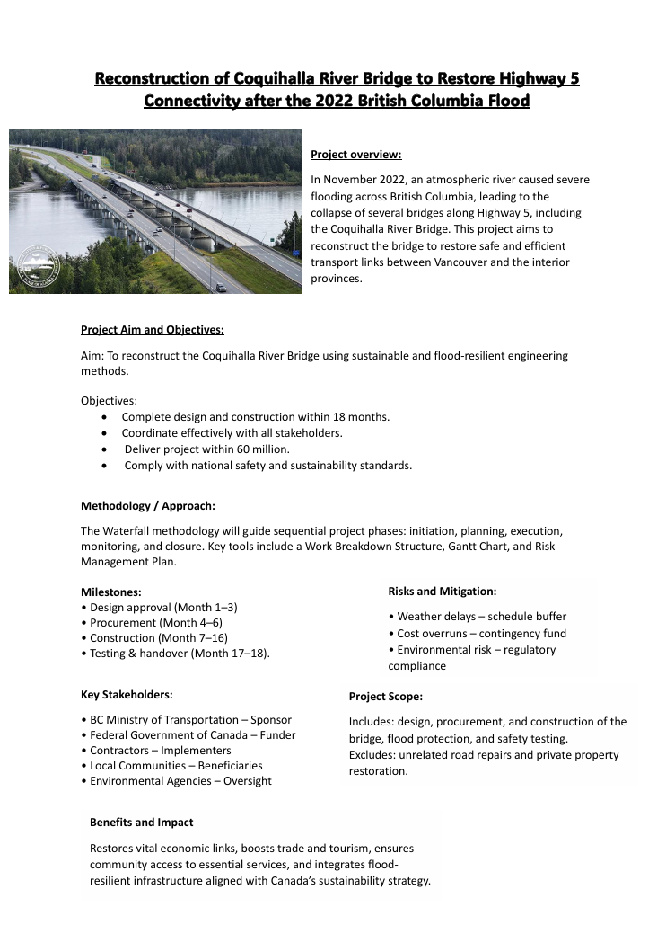

Part B – Reflection on Feedback
Reconstruction of Coquihalla River Bridge to Restore Highway 5 Connectivity after the 2022 British Columbia Flood
During the Week 6 poster presentation, I received valuable feedback from both my tutor and peers regarding the clarity, depth, and professional presentation of my project proposal. The overall response was positive, highlighting the poster’s clear structure, visual appeal, and logical flow of information. However, several areas for improvement were identified, particularly in the depth of stakeholder analysis, detail in risk assessment, and referencing style. Reflecting on this feedback has helped me to critically evaluate my approach and plan how to enhance the final project management plan.
One strength identified was the clarity of the project aim and objectives. My peers commented that the objectives were realistic and measurable, demonstrating a clear understanding of project scope and purpose. The tutor also commended the professional layout and concise language, which effectively communicated complex project ideas within a limited space. This feedback confirmed that my efforts to maintain visual balance and concise text were successful in making the proposal engaging and accessible to a non-specialist audience.
However, the tutor suggested expanding on the stakeholder engagement strategy. Although the poster identified key stakeholders such as the British Columbia Ministry of Transportation and local communities, it did not explain how communication and collaboration would be maintained throughout the project lifecycle. In response, I plan to include a detailed stakeholder management matrix in the final report, outlining each stakeholder’s influence, interest, and preferred communication method. This will strengthen the practical application of stakeholder theory (Freeman, 1984) and demonstrate proactive engagement and accountability.
Another area of improvement involved the risk analysis section. My peers noted that while the poster identified key risks—such as weather delays and cost overruns—the mitigation strategies could have been elaborated further. For instance, contingency planning and environmental management could be explained in relation to the PMBOK Guide’s risk management framework (PMI, 2021). In my final submission, I will therefore include a comprehensive risk register detailing probability, impact, ownership, and mitigation actions. This will evidence my understanding of structured risk management processes.
Additionally, feedback suggested that the poster could have included more quantitative data, such as estimated timelines and cost breakdowns, to demonstrate feasibility. To address this, I will include a detailed Gantt chart and resource allocation plan in the final project management plan. These visual tools will illustrate project sequencing, dependencies, and resource efficiency.
Finally, the tutor reminded me to ensure accurate Harvard referencing and consistent formatting across all sections. I will review and update my reference list, ensuring all sources are credible and cited correctly. This will enhance the academic quality and professionalism of the final submission.
Overall, the feedback session has been a valuable learning experience that improved both my project proposal and understanding of project management practice. It highlighted the importance of critical reflection, stakeholder engagement, and evidence-based planning.

Part C – Project Management Plan
Introduction
In November 2022, unprecedented flooding across British Columbia caused widespread infrastructure damage, including the collapse of the Coquihalla River Bridge on Highway 5. This disruption significantly affected regional mobility, supply chains, and community access, demonstrating the vulnerability of critical transport networks to extreme weather events.
The Coquihalla River Bridge Reconstruction Project aims to restore this essential route by delivering a modern, flood-resilient bridge that complies with Canadian engineering, environmental, and safety standards. This Project Management Plan (PMP) outlines the structured approach for delivering the project within an 18-month timeframe and a £60 million budget.
The plan draws on recognised project management frameworks, including the PMBOK Guide (PMI, 2021) and PRINCE2 principles, to ensure clear governance, effective risk management, and robust stakeholder engagement. A Waterfall methodology is adopted to support sequential planning and control across the phases of design, procurement, construction, and handover.
Overall, this PMP provides the strategic foundation for delivering a sustainable, technically sound, and socially beneficial infrastructure project that enhances regional connectivity and long-term climate resilience.
Project Description
The Coquihalla River Bridge Reconstruction Project addresses the urgent need to restore Highway 5 after the 2022 floods severely damaged key transport infrastructure in British Columbia. The failure of the original bridge disrupted freight movement, commuter travel, and emergency access, highlighting the importance of rebuilding a safer and more resilient structure.
The project aims to design and construct a modern, flood-resistant bridge that can withstand future extreme weather conditions and support long-term regional mobility. Funded jointly by the BC Ministry of Transportation and Infrastructure Canada, the reconstruction will be delivered within an 18-month schedule and a budget equivalent to £60 million.
The project includes feasibility assessments, environmental approvals, detailed engineering design, procurement of contractors and materials, full bridge construction, quality testing, and final handover. A Waterfall project management approach will be used to ensure each stage is completed sequentially with strict quality and regulatory controls.
Once delivered, the new bridge will restore a critical transport corridor, strengthen economic recovery, and enhance the overall resilience of British Columbia’s infrastructure network.
Project Scope
The Coquihalla River Bridge Reconstruction Project includes all activities required to design, build, and certify a new, flood-resilient bridge on Highway 5. The scope focuses on delivering a safe, durable structure within the agreed 18-month timeframe and £60 million budget.
3.1 In Scope
- Feasibility studies and environmental assessments
- Detailed engineering design and material specification
- Procurement of contractors, equipment, and sustainable materials
- Construction of foundations, bridge structure, and drainage systems
- Quality assurance testing, inspections, and certification
- Stakeholder communication and environmental monitoring
3.2 Out of Scope
- Post-completion maintenance and future repairs
- Road upgrades beyond the immediate bridge area
- Non-essential landscaping or beautification works
3.3 Deliverables
- Approved design package and project plans
- Fully constructed, certified bridge
- Final handover documentation and project closure report
This defined scope ensures the project remains focused, cost-effective, and compliant with regulatory and safety standards.
Work Breakdown Structure (WBS)
The Work Breakdown Structure outlines the major phases and tasks required to deliver the bridge reconstruction. It provides a clear hierarchy of work packages to support planning, scheduling, and monitoring.
WBS Summary
WBS Code | Task / Phase | Main Outputs
1.0 Initiation | Site assessment, feasibility study, environmental approval | Feasibility report, permits
2.0 Planning | Engineering design, procurement planning, risk and quality planning | Approved designs and plans
3.0 Execution | Construction of foundations, superstructure, drainage and road alignment | Completed bridge structure
4.0 Monitoring & Control | Inspections, progress reviews, cost and risk control | Quality reports and updates
5.0 Closure | Final testing, certification, documentation and handover | Handover report and sign-off
This WBS ensures that all core project activities are clearly defined and can be managed in a controlled, sequential manner.

Quad Chart
Objectives
- Rebuild the Coquihalla River Bridge using a resilient, flood-proof design.
- Restore full Highway 5 connectivity within 18 months.
- Deliver the project within the approved £60 million budget.
- Ensure compliance with safety, engineering, and environmental standards.
Timeline / Key Milestones
- Jan–Mar 2026: Feasibility, site surveys, environmental approvals
- Apr–Jun 2026: Detailed design, procurement, contractor selection
- Jul 2026–Apr 2027: Construction of foundations, structure, and drainage
- May–Jun 2027: Testing, certification, and final handover
Major Risks & Mitigation
- Weather delays: Build flexibility into the schedule
- Cost pressures: Use contingency and regular financial audits
- Environmental risks: Continuous monitoring and compliance checks
- Labour shortages: Early hiring and subcontractor agreements
Expected Benefits
- Restored regional mobility and supply chain reliability
- Improved safety and climate resilience
- Support for local economic recovery
- Long-term reduction in flood-related disruption
Gantt Chart
Project Phase | Start | End | Duration | Key Output
Initiation | Jan 2026 | Mar 2026 | 3 months | Feasibility + approvals
Planning & Design | Apr 2026 | Jun 2026 | 3 months | Final design + procurement
Construction | Jul 2026 | Apr 2027 | 10 months | Completed bridge structure
Testing & Handover | May 2027 | Jun 2027 | 2 months | Certification + opening
This mirrors a standard Waterfall approach and clearly shows the critical path:
Initiation → Design → Construction → Testing.

Stakeholders’ Involvement
Effective stakeholder engagement is essential to the success of any large-scale infrastructure project. The Coquihalla River Bridge Reconstruction Project involves multiple stakeholder groups, each with distinct interests, levels of influence, and communication needs. Ensuring clear, consistent, and transparent communication will build trust, reduce resistance, and enhance collaboration across all project stages.
This section identifies key stakeholders, analyses their level of influence and interest, and outlines strategies to maintain their engagement in accordance with PMBOK (2021) stakeholder management principles and Freeman’s Stakeholder Theory (1984).
7.1 Identification of Key Stakeholders
Stakeholder Group | Role / Interest | Influence Level | Engagement Strategy
British Columbia Ministry of Transportation and Infrastructure (MOTI) | Project sponsor and funder; responsible for regulatory oversight, budget allocation, and project approval. | Very High | Frequent progress reporting, milestone presentations, and risk updates.
Federal Government of Canada – Infrastructure Canada | Provides federal funding and ensures compliance with national climate adaptation and safety standards. | High | Formal reports and quarterly reviews; alignment with federal sustainability policies.
Project Management Team | Responsible for planning, execution, and monitoring of the project. | High | Daily coordination meetings and performance evaluations.
Construction Contractors and Engineers | Deliver design, materials, and construction in compliance with safety and environmental regulations. | High | Site meetings, safety briefings, and progress monitoring.
Local Communities (Hope and Fraser Valley residents) | Affected by construction impacts and beneficiaries of improved transport access. | Medium | Public consultations, newsletters, and online updates.
Environmental Agencies (e.g., Fisheries and Oceans Canada, BC Environmental Assessment Office) | Ensure ecological protection of river systems and habitat during construction. | High | Environmental audits, site inspections, and compliance reports.
Emergency Services and Logistics Companies | Depend on restored transportation for emergency and commercial operations. | Medium | Stakeholder meetings and feedback surveys.
Media and Public Interest Groups | Influence public perception and transparency. | Medium | Press releases and progress announcements.

7.2 Stakeholder Power–Interest Grid
To prioritise communication and engagement efforts, stakeholders can be mapped using a Power–Interest Grid, as shown below:
Category | Description | Stakeholders | Engagement Approach
High Power / High Interest | Directly control or fund the project and expect detailed updates. | MOTI, Federal Government, Project Manager, Lead Contractors | Manage closely through regular meetings, performance reports, and decision briefings.
High Power / Low Interest | Have influence but limited daily involvement. | Environmental regulators, local authorities | Keep satisfied through periodic updates and compliance assurance.
Low Power / High Interest | Affected but not decision-makers. | Local residents, community organisations, emergency services | Keep informed through newsletters, public forums, and community liaison officers.
Low Power / Low Interest | Indirectly affected; require minimal contact. | General public, media | Monitor through press releases and general updates.

7.3 Stakeholder Communication Plan
A structured communication plan will ensure timely, accurate, and transparent information sharing across all levels.
Stakeholder | Communication Method | Frequency | Responsible Party
MOTI (Sponsor) | Project status meetings and reports | Monthly | Project Manager
Federal Infrastructure Canada | Progress and compliance reports | Quarterly | Project Director
Construction Contractors | Site meetings, task briefings | Weekly | Site Manager
Local Communities | Community forums, email bulletins | Bi-monthly | Community Liaison Officer
Environmental Agencies | Compliance reports, audits | Bi-monthly or as required | Environmental Manager
Internal Project Team | Coordination meetings, dashboards | Daily | Project Manager
Media/Public | Press releases and official updates | At key milestones | Communications Officer

7.4 Engagement Tools and Techniques
The following tools will be applied to facilitate effective stakeholder engagement:
- RACI Matrix (Responsible, Accountable, Consulted, Informed): to define stakeholder roles and responsibilities at each phase.
- Stakeholder Register: maintained and updated throughout the project to record stakeholder details, interests, and communication preferences.
- Feedback Mechanisms: such as surveys, public meetings, and online feedback portals to assess satisfaction and concerns.
- Conflict Resolution Protocol: structured process for addressing disputes between stakeholders through mediation and documented action plans.
- Information Management System: centralised digital platform for document sharing, progress tracking, and communication logs.
7.5 Importance of Stakeholder Engagement
Strong stakeholder engagement:
- Reduces resistance by addressing community and environmental concerns early.
- Enhances collaboration and alignment between federal and provincial authorities.
- Builds transparency, strengthening public trust in government-led reconstruction projects.
- Improves decision-making, as stakeholder feedback informs risk mitigation and resource allocation.
According to Bourne (2015), effective stakeholder management not only improves project outcomes but also safeguards the project’s reputation, funding continuity, and social licence to operate.
Allocation of Resources
The project requires a mix of human, financial, and material resources to support safe and timely delivery.
Human Resources
A team of engineers, project managers, surveyors, safety officers, and skilled labourers will be allocated. Responsibilities will be clarified through a RACI matrix to ensure accountability.
Financial Resources
The project budget is set at £60 million, which covers design, construction, materials, labour, equipment, environmental monitoring, and a contingency allowance.
Material & Technical Resources
Resources include sustainable construction materials, heavy machinery, surveying tools, and digital project management systems such as BIM and MS Project for scheduling and monitoring.
Regular tracking and cost-control processes will ensure resource use remains efficient and within budget.
Risk Analysis
The project faces several risks related to environment, finance, workforce, and safety. A risk register will be maintained throughout the project lifecycle.
Key Risks and Mitigation
Risk | Impact | Mitigation
Severe weather delays | High | Flexible scheduling and protective measures
Cost increases | High | Contingency allocation and cost monitoring
Environmental non-compliance | Medium | Early engagement and routine audits
Labour shortages | Medium | Early recruitment and contractor agreements
Safety incidents | High | Strict adherence to safety protocols
Risks will be reviewed regularly, with updates shared through monthly reports and escalated to senior management where required.
Conclusion
The Coquihalla River Bridge Reconstruction Project represents a critical infrastructure initiative designed to restore transportation connectivity and economic stability following the devastating 2022 floods in British Columbia. Guided by PMBOK (2021) and PRINCE2 principles, this Project Management Plan has outlined a structured, evidence-based approach to deliver the project within 18 months and under a CAD 60 million budget.
The plan establishes a clear project scope, a detailed Work Breakdown Structure, and an integrated schedule through the Gantt and Quad Charts, ensuring all phases — from initiation to closure — are systematically executed. Strong emphasis is placed on stakeholder engagement, ensuring cooperation between government bodies, contractors, and local communities. Effective resource allocation and risk management strategies further ensure that the project remains financially viable and environmentally sustainable.
By incorporating sustainable materials, robust design standards, and proactive risk mitigation, the reconstructed Coquihalla River Bridge will not only restore Highway 5 connectivity but also enhance climate resilience, public safety, and long-term socio-economic benefits for British Columbia. This project exemplifies modern, responsible infrastructure development — balancing engineering excellence with environmental and social responsibility.
References
Bourne, L. (2015) Stakeholder Relationship Management: A Maturity Model for Organisational Implementation. 2nd ed. Farnham: Gower Publishing.
Freeman, R.E. (1984) Strategic Management: A Stakeholder Approach. Boston: Pitman.
Government of British Columbia (2023) Highway 5 Flood Recovery Program Update. Victoria: Ministry of Transportation and Infrastructure.
Silvius, A.J.G. and Schipper, R.P.J. (2014) Sustainability in Project Management. Farnham: Gower Publishing.
UN (2022) Sustainable Development Goal 9: Industry, Innovation and Infrastructure. Available at: https://sdgs.un.org/goals/goal9 (Accessed: 3 November 2025).
Canadian Environmental Assessment Agency (2022) Environmental Assessment Process under the Canadian Environmental Assessment Act. Ottawa: CEAA.
CSA Group (2021) Canadian Standards for Bridge Design (CSA S6-19). Toronto: CSA Group.

