MANAGING PROJECT IN ORGANISATION
Elisabeta Alexandra Badea (2011897)
the green escape Romania, Brasov
the green escape
ALEXANDRA-ELISABETA BADEA 2011897
LEADERSHIP AND MANAGEMENT LEVEL 5
LONDON CAMPUS GROUP 2
LECTURER: Rexon Nting

TABLE OF CONTENT

THE GREEN ESCAPE

The purpose of the project is to deliver quality and sustainable services and give the customers the faculties they craving. In the same time the goal of this project is to reshape the customer experience on the hospitality sector and to open a unique concept of hotel, based on the customer’s experience connecting with the nature.

PROJECT OVERVIEW
(demands, potential and opportunities)

Romania is a beautiful country. Plenty of traditions, great food and amazing country side . Romania is placed on the north of Balkan Peninsula and it is circled by the Carpathian Mountains, also has a border on the Black Sea. Romania has endless highlights and endless natural beauties. The country has temperate-continental climate, which means hot summers and long cold winters. Although the Carpathian Mountains stretches on 7 countries, Romania has 51% of the mountain range. Romanian mountains are the last true wilderness of Europe. They represent about 65% of Europe’s remaining primeval forests: home of brown bears, wolves and lynx. Romania is rich in lakes, mountains, castles, pagane caves and all sorts of amazing natural monuments. Romania has full potential. However, the tourism only contributes 2-3% to the national GDP in the last 19 years. Because of the mismanagement and the lack of interest shown by the government and for the first time in 41 years, Romania disappears from World Travel Market- London.
While other countries have plans and use tourism to recover post-covid “damages”, Romania government has no short or long term plans to when it comes to tourism. No strategies, no investment, no interests in the sector. Moreover Romania has not got a tourism minister since 2009. The government merged the tourism minister with the ministry of regional development and housing. Since then, tourism it is only scriptic in Romania, and even Romanians are going abroad for holidays due to the lack of facilities.

OBJECTIVES

- Open a green power hotel on the mountain side, promoting the natural wellbeing
Moving to green energy, rather the traditional side the project is beneficial for the owner as well as environment and the rest of the stakeholders.
- Have all-inclusive facilities.
Have spa facilities and meditation rooms Offer customers thematic nights about history of the region ,Have a guide for organised walks and mountain trails, camp fire, Entertainment and recreation for all ages, Family friendly, Regular events
- Adhering to EU standards
Targeting local and abroad tourism we need to align with the European Union standars in hospitality .
- Sustainability and integrity of the business
Use the full potential on the mountains side to roll the business 12 months. Business growth without compromising the integrity of the business. Advanced technology within the hotel to facilitate the customers’ needs and also to promote their safety. Promote Romania culture, tradition food and music and tourist attractions nearby.

PROJECT SCOPE

Goals: to build a green all inclusive hotel aligning with Eu hospitality sector
Potential Challenges: Economical, Political, external, environmental-(Climate and Climate calamities), Human Resources, social, technologies ,legal, work force, locals, local authorities, activists
Resources: a capital of £475.000 and sponsors
Millstone schedule: 09.01.2022-17.03.2023
Stakeholders: sponsors, suppliers, customers, workforce, local authorities

EXCLUSION FROM THE SCOPE
The project has all documentations in place when it comes to planning, executing and delivery. However, during the last part of the project other additional costs and implications may arise. Such as: training Human Resources, marketing professionals-if any failure with the existing marketing strategy team, breakages. Etc.

DELIVERABLES

PHASE 1- AUTHORISATION
DATE | TASK | TASK DESCRIPTION | RESPONSABILITY | COMMENTS/  TICK COMPLETITION
1.11.2021 | THE QUALITY OF THE LAND | DO MEASUREMENT, SEE THE QUALITY AND POTENTIAL OF THE AREA | PROJECT MANAGEMENT COORDINATOR  INGINEER
1.11.2021 |  | CHECK FIRE AND EARTQUICK PROTECTION, WATER AVAILABILITY, NEIBORHOOD | PROJECT MANAGEMENT  SPECIALISTS
2.11.2021 | COUNCIL COLABORATION | INFORM COUNCIL OF THE POSIBILITTY OF BUILDING THE HOTEL AND OBTAIN INFORMATION | PROJECT MANAGEMENT AND THE ADMIN
5.11.2021-  7.11.2021 | BUY THE LAND | FINANCIAL TRANSACTIONS AND PAPER WORK | PROJECT MANAGEMNT  ACCOUNTATN
5.11.2021 | COUNCIL | SEE COUNCIL TO START THE PROCESS OF OBTAINING THE PERMITTS | PROJECT MANAGER, ADMIN
6.11.2021-15.11.2021 | PERMITS | BETWEEN THIS DATES, CHECK THE PROGRESS OF PERMITS | PROJECT MANAGER
16.11.2021-1.01.2022 | HR | AFTER OBTAINING THE PERMITS, RECRUIT A TEAM FOR THE PROJECT EXECUTION | PROJECT MANAGER  HR OFFICER

Phase 2. Landscaping
DATE | TASK | TASK DESCRIPTION | RESPONSIBILITY | COMMENTS/  TICK COMPLETITION
10.01.2022-  12.01.2022 | Cleaning and grubbing the land | Any trees or other objects on the land must be removed | Construction  Team B
9.01.2022-  09.01.2022 | Promote the hotel on the market | Install the posters around the working area  Open a website | Marketing team
11.01.2022.  11.01.2022 | Aerate the soil | Poking holes into the ground to provide the soil with good air circulation water and nutrient consumptions | Constructions team B
11.01.2022-  12.01.2022 | Buy seeds and trees  Plant seeds and trees | 11.01- Buy seeds  12.01- plant seeds | Construction team B | The seeds must be planted within 1M on the right and left of the land
11.01.2022-  12.01.2022 | Instal the irrigation system for the plants | Assess the area and install the system | Construction  team B
11.01.2022 | Anchor the trees and mulch around them | Plant the trees | Construction  Team B | Plant trees 2M apart on the right and left of the land
12.01.2022-  13.01.2022 | Clean the area | Leave the area clean for Constrictions team A to start the hotel foundation | Construction  team B | Compete a detailed report of the activities undertaken on period 9-13.01.2022  Any loss or remaining must be reported.  Hand over invoices of the services provided/materials.

PHASE 3. CONSTRUCTIONS
DATE | TASK | TASK DESCRIPTION | RESPONSIBILITY | TICK COMPLETITION/  COMMENTS
14.01.2022-  28.01.2022 | Lay the foundation | Dig the whole, framing foundation, filling foundation | Construction team A
28.01.2022-  28.07.2022 | Build the  Walls, ceiling and roof | Frame the walls, fill the walls with bricks, the ceiling build and move to roof | Construction team A
1.08.2022-  1.09.2022 | Install and interior interior plumbing |  | Construction team A
1.9.2022-  15.10.2022 | Install exterior electrical work |  | Construction team A
1.08.2022-  9.08.2022 | Fix the doors and windows |  | Construction team A
1.09.2022-  17.10.2022 | Install the interior electric work- |  | Construction team A
2.09.2022-  2.11.2022 | Install the flooring |  | Construction team A
2.09.2022-  2.10.2022 | Instal the interior doors and fixture |  | Construction team B
1.08.2022-  15.11.2022 | Paint the interior and exterior of the building |  | Construction teamA
2.10.2022-  5.01.2023 | Install the water and heating systems | Radiators, Air conditioner | Construction team B
5.01.2023 | Instal and test the technologies systems | Internet  Cctv  Television | Construction team B

PHASE 4. GREEN POWER
15.01.2022-  25.01.2022 | Install the hydropower system source | Install the main system | Specialist
20.09.2022-  25.11.2022 | Install the interior energy works | The inside technology for the hydropower system | Specialist  Construction team A
25.11.2022-  20.12.2022 | Evaluate the work | Auditing | Specialists  Project manager
20.12.2022-  31.01.2022 | Check the utility and performance of the hydropower system | See the capacity of the system and possible errors | Specialist
23.12.2022 | Hand over the polices procedure of the system | Any documentation of the systems | Trainings requirement for the systems
23.12.2022 | Hand over the risk management of the system | Any manuals, possible incidents related | The specialist  The project manager
2.01.2023 | Hand over cost benefit plan | A speculation of the money saving and investing | The specials, accountant,  The project manager
 | Regularly reviewing | Auditing | Specialist  Project manager

PROJECT CLOSURE

DATE TASK TASK DESCRIPTION RESPONSIBILITY COMMENTS
15.12.2022-  2.01.2023 | Project file | necessary information about the construction as well as all technical specifications and equipment manuals, that must be delivered to the owner. | Specialist  Project manager
5.01.2023-  10.03.2023 | Completing the construction | all parts of the hotel (e.g. rooms, lobby, kitchen, reception, IT, etc.) are being furnished with all the required equipment | Construction and specialists | Staff at this time should be given the necessary time, to familiarize themselves with the property prior to opening. A very good tactic is that of soft opening.
10.03.2023- | Design work and install | The last details and touches must be completed today | Design team  Construction teams  Project manager
10.03.2023-  17.03.2023 | Overall review | Auditing | Project manager  HR  Specialists
18.03.2023-  14.03.2023 | Controlled visitors | Have visitors invited to see how the project would run | Project Manager
1.03.2021  10.3.2023 | Documentation check and storing |  | HR  Financial
17.03.2023 | Grand opening

GANNT CHART

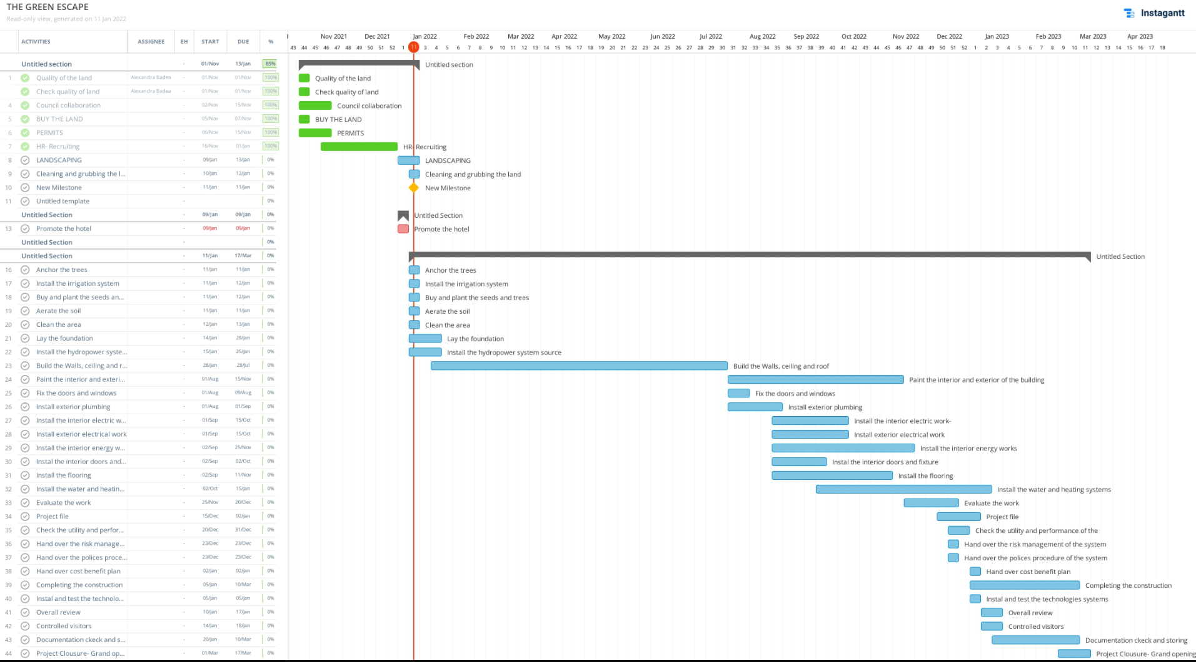

CONSTRAINTS

The project constrains are based on 3 factors:
- Quality
- Cost
- Time

The project will be executed considering the factors mentioned above, however things can go as not planned and we can loose or compromise one of the factors, which, ultimately, affects the scop.
The constraints will be assessed, managed, control and reviewed during the execution.
The prime of the constraints is the quality. Having given the utility of the project, the Health and Safety of the customers and staff must be primordial and there must be no tolerance towards the quality of products, staff selecting and constrictions execution.
The project execution must followed as per engineering plans only, any changes or risk arisen along the way must be communicated and discussed with the appropriate stakeholder. Service quality consists of three dimensions: physical facilities, staff, and materials. It also divided into two aspects: functional quality and technical quality. A similar approach argued that service quality includes three dimensions: functional quality, environment, and technical quality. Another approach confirmed that service quality has five dimensions namely: assurance, reliability, empathy, tangibility and responsiveness.

SPECULATIONS

The project is designed to be unique, to stand out from the crowd and to obtain competitive advance. Analysis conducted in order to identify and plan the project has shown that building a green hotel is beneficial for the business owner as well as the others.
Trends shows that the hotel has full potential to function for the whole year, the majority of the mouths is snowing and there many activities for the summer to explore. Trends shows that there are not many all-inclusive hotels in the targeted area also Green Power Businesses are not a thing yet in Romania. I believe that the “connect with the nature and future hotel” will attract the customers and with a good market strategy, European tourists will show interests in this businessThe community will eventually be happy using green power and preserving natural resources.Romania has great experts and engineering in the constructions sector, therefore workforce should not be a problem.
The hotel will be ready in 2 years.

SUSTENABILITY

Business case

The project is designed to be unique, to stand out from the crowd and to obtain competitive advantage. Analysis conducted in order to identify and plan the project has shown that building a green hotel is beneficial for the owner as well as environment and the rest of the stakeholders. An analysis of the financial side of other hotels in the industry using green power shown that it can be cost effective and increases the profits. Also other project can be derivate, for example attracting additional funds from the government to reward your efforts and supporting your project, by trying to keep to environment safe and preserve the natural resources. Be a leader om the market in respect of sustainability project/business and enhance your brand market value. The business will have the goodwill of the company. The stakeholders can appreciate that you are not only doing business but you are preoccupied about the environment as well. Performance of the project executions will be will be executed and reviewed using different tools and methodologies such as Gant charts, stakeholders analysis tools, SMART tools, Monte Carlo. The project efficiency is measured using the iron triangle( time, cost, quality). Audits and Appraisals will be used to monitor the work performance and area of improvements of the employee as well as their development and moving forward of the project. The overall project purpose is to create a brand, maximise profit and innovate the hospitality sector.

ALTERNATIVES
Rolling such a complex project, although there are risk monitoring and controlling procedures in place, due to any reason, the executions of the project should fail, there are alternatives such us: selling the project, obtain more sponsors, retake the project and use the land for other purposes, selling the project and the land. If any conflicts in respect of the project mission and vision, as a project manager I would prefer to sell project, allowing the stakeholders to remain, if the project is not aligning with my mission, vision and my beliefs.

COST AND TIMESCALE

The cost of the overall bussiness is 1.398.000.
The project owner investition- ownership of the land and permits, assessment+ £400.000
The rest of the project is based on the sponsorship that has 40% of the company share.

Task | Cost invested | Timescale
Phase 1 | £200.000 | 1.11.2021-1.01.2022
Phase 2 | £3.000 | 01.01.2022-10.01.2022
Phase 3 | £425.000 | 14.01.2022-15.03.2023
Phase 4 | £850.000 | 15.01.2022-23.12.2022
Phase 5 | £120.000 | 15.12.2022-17.03.2023
Total | 1.398.000

RISK MANAGEMENT

The risk of the business are many, according to the complexity of the project. However, the risk are expected risks and there is a plan to manage and control those risk factors, therefore, no harm should be cause to the project. The plan will be regularly reviewed and updated in order to monitor and control the risks.

STAKEHOLDERS COMMUNICATION PLAN ANALYSYS

HUMAN RESOUCES

Romanian is well known for their expertise in engineering. The human resources will be recruit exclusively from Romania. The project does not include the recruiting of the staff hotel or training for them.

The team is based on:

The Project Owner is Alexandra Badea (coordinator). The team contains 9 departments- strategic, tactical and operational. Every department have more team members lead by the head of their department.

COVID-19

Covid-19 risk assessment
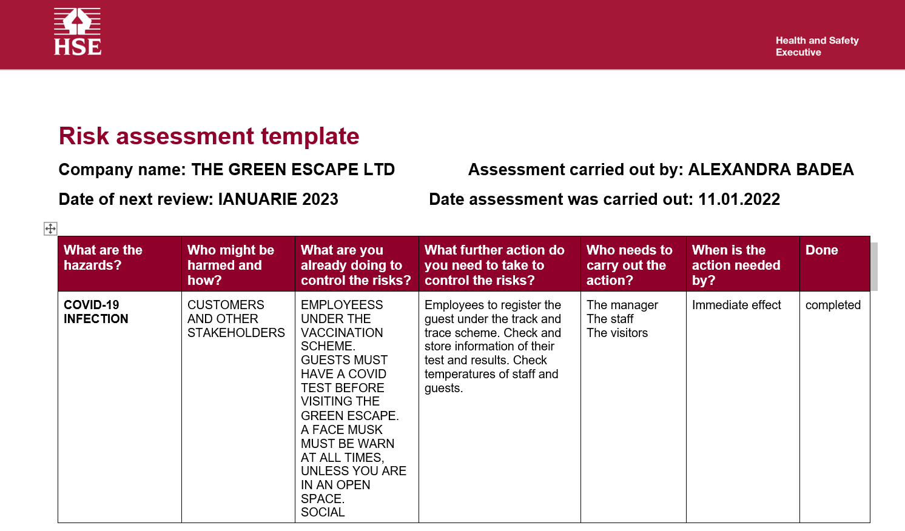

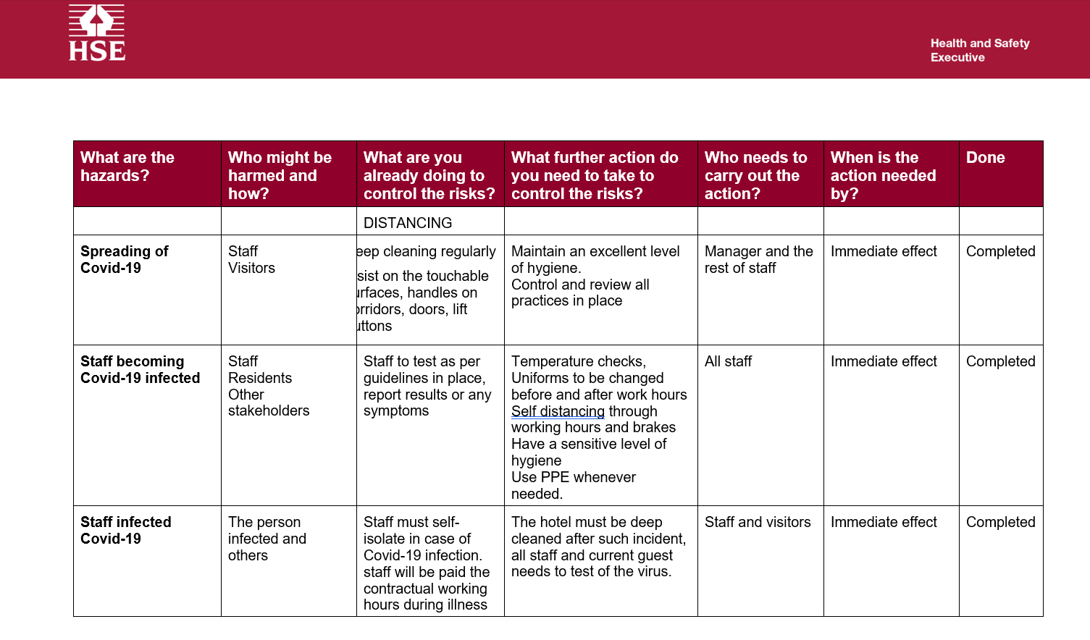

The hospitality suffered a lot during Covid pandemic. Now, that everything is easing up, people are ready to start traveling again. Although, there are relaxations in place traveling abroad will be hard still, therefore The Green Escape, uses the full potential of the mountainside to attract customers. Green Escape offers the customers high quality standards, all inclusive packages and many other benefits while keeping everyone safe.

Contents
THE GREEN ESCAPE 2
PROJECT OVERVIEW 2
OBJECTIVES 2
PROJECT SCOPE 3
EXCLUSION FROM THE SCOPE 3
DELIVERABLES 3
GANNT CHART 9
CONSTRAINTS 10
SPECULATIONS 10
Business case 11
ALTERNATIVES 11
COST AND TIMESCALE 11
RISK MANAGEMENT 12
STAKEHOLDERS COMMUNICATION PLAN ANALYSYS 14
HUMAN RESOUCES 15
COVID-19 16
TASK 2- PROJECT PRESENTATION 18

TASK 2- PROJECT PRESENTATION
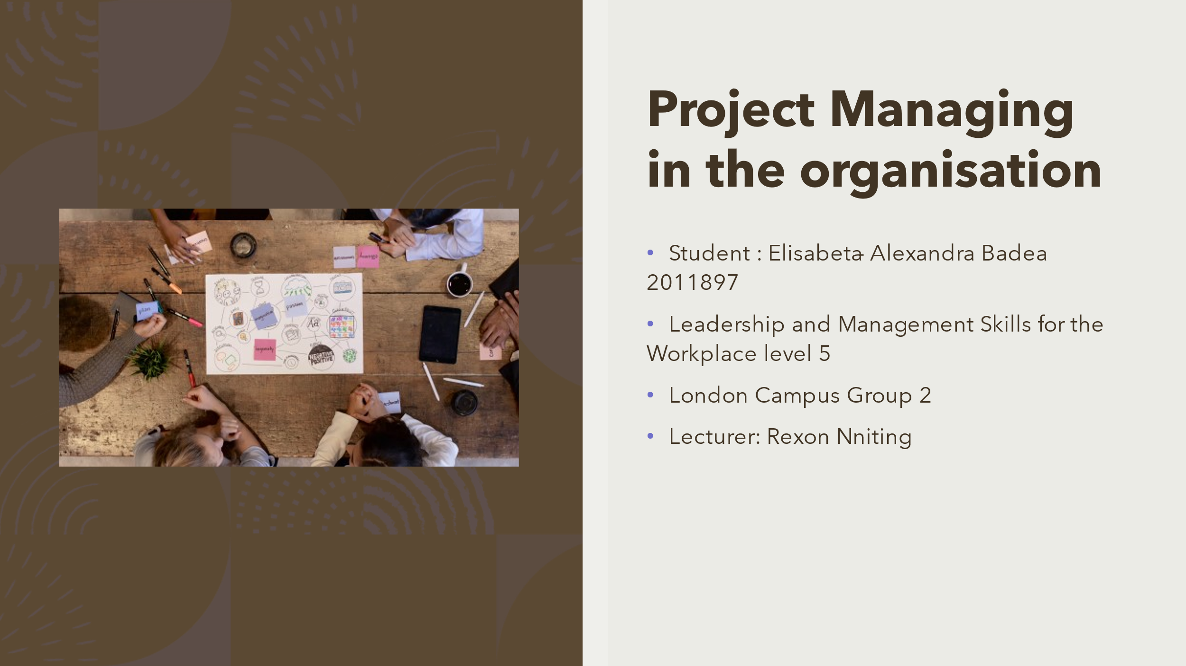

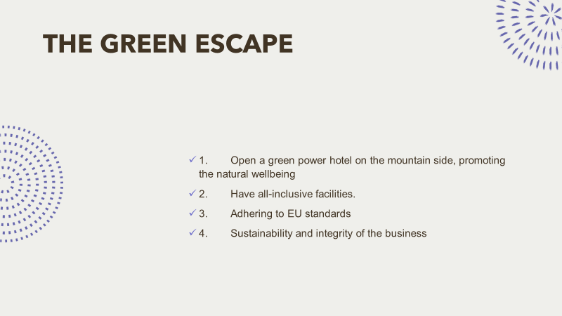

Note: The purpose of the project is to deliver quality and sustainable services and give the customers the faculties they craving. In the same time the goal of this project is to reshape the customer experience on the hospitality sector and to open a unique concept of hotel, based on the customer’s experience connecting with the nature.

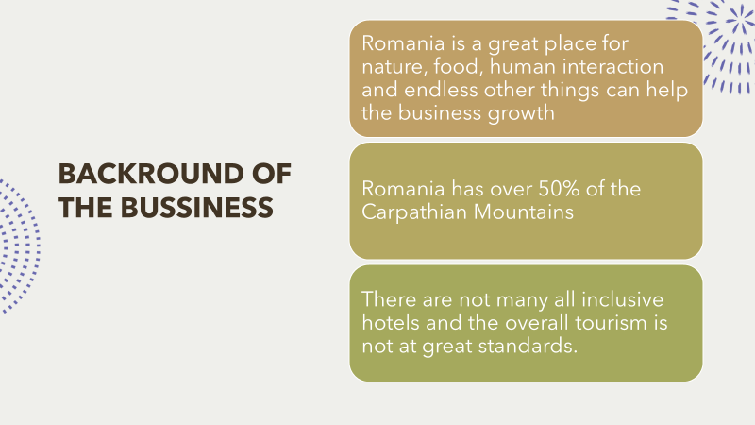

Note: Use the full potential on the mountains side to roll the business 12 months. Business growth without compromising the integrity of the business. Advanced technology within the hotel to facilitate the customers’ needs and also to promote their safety. Promote Romania culture, tradition food and music and tourist attractions nearby.

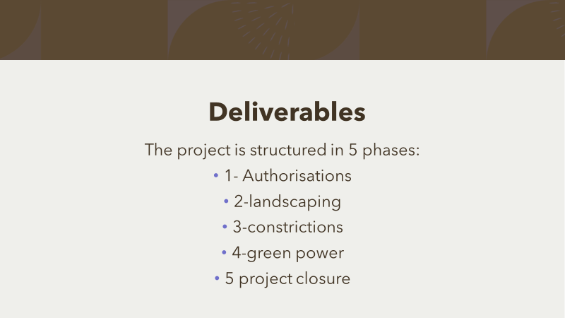
Phase 1 £200.000 1.11.2021-1.01.2022
Phase 2 £3.000 01.01.2022-10.01.2022
Phase 3 £425.000 14.01.2022-15.03.2023
Phase 4 £850.000 15.01.2022-23.12.2022
Phase 5 £120.000 15.12.2022-17.03.2023
Total 1.398.000

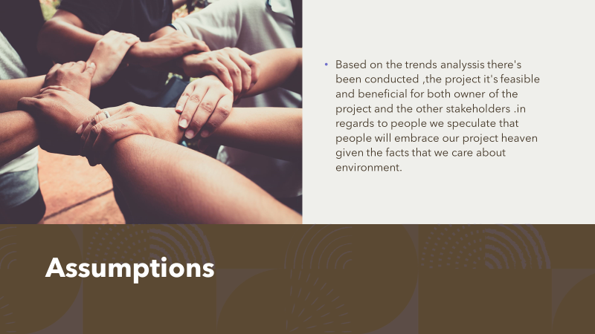

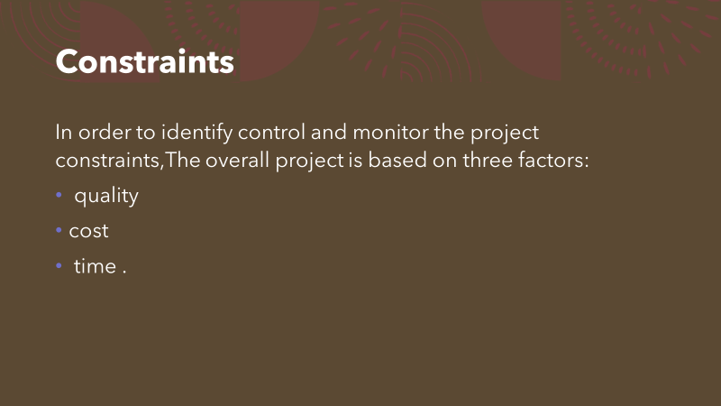

Note:The constraints will be assessed, managed, control and reviewed during the execution.
The prime of the constraints is the quality. Having given the utility of the project, the Health and Safety of the customers and staff must be primordial and there must be no tolerance towards the quality of products, staff selecting and constrictions execution.

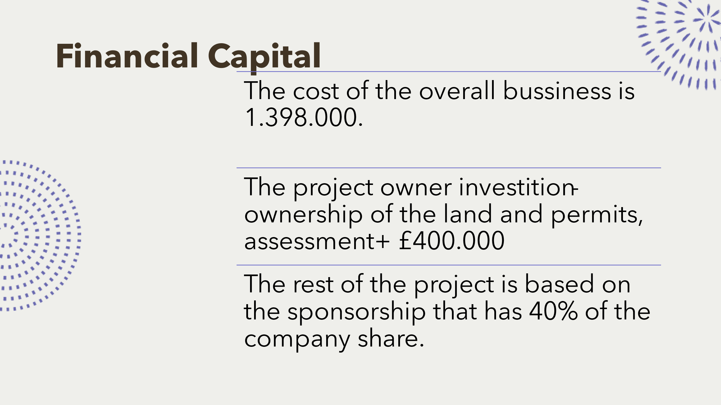

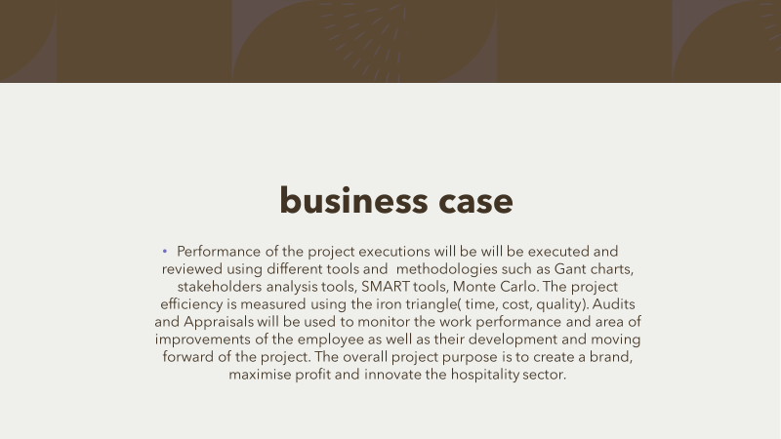

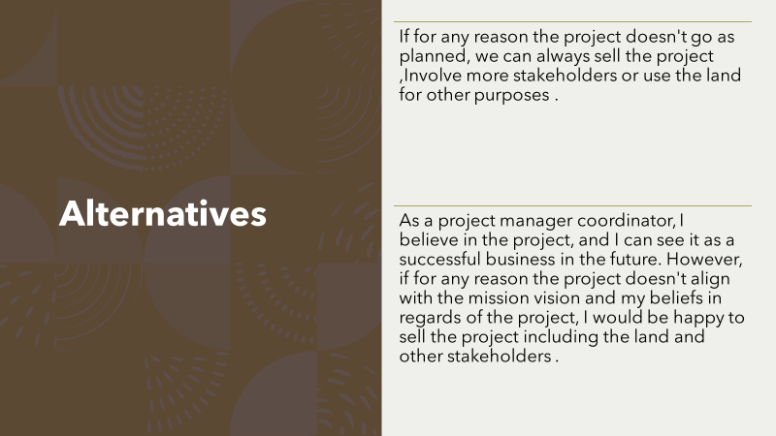
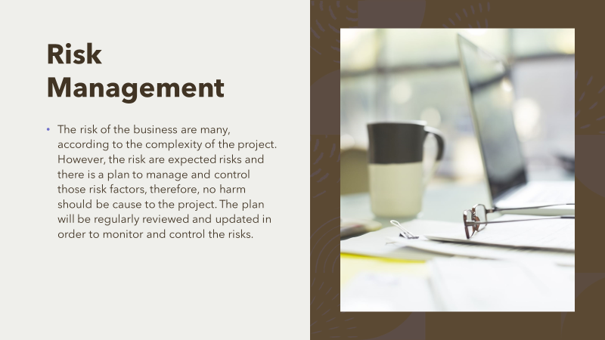
Note: Potential Challenges: Economical, Political, external, environmental-(Climate and Climate calamities), Human Resources, social, technologies ,legal, work force, locals, local authorities, activists

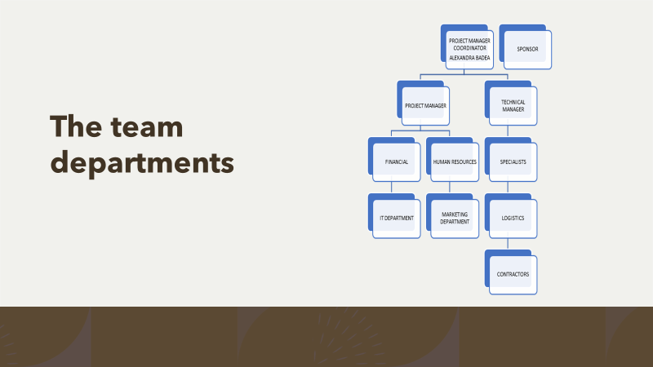
Note: Romanian is well known for their expertise in engineering. The human resources will be recruit exclusively from Romania. The project does not include the recruiting of the staff hotel or training for them.

