

Building a training data generator for poker hand classification.

by
Jennifer Ada

Supervisor: Dr Tim Bashford
Second Marker:

Project submitted as part of the requirements for the award of BSc (Hons) Software Engineering

April 2018
DECLARATION

I, Jennifer Ada declare that I am the sole author of this Project; that all references cited have been consulted; that I have conducted all work of which this is a record, and that the finished work lies within the prescribed word limits.

This work has not previously been accepted as part of any other degree submission.

Signed : .............................................

Date : ...............................................

FORM OF CONSENT

I Jennifer Ada hereby consent that my Project, submitted in candidature for the B.Sc.(Hons) Software Engineering degree, if successful, may be made available for inter-library loan or photocopying (subject to the law of copyright), and that the title and abstract may be made available to outside organisations.

Signed : .............................................

Date : ...............................................

Abstract

A summary of the methods used.
The project was managed through feature prioritisation adapted from Feature Driven Development (FDD) for single person use[1]. Development was iterative aiming to prototype features separately as components which are then integrated into the core framework after static analysis and unit testing which were applied to those facets that were deemed of high enough risk.
The TensorFlow[2] machine learning framework was used to design the target neural network allowing a layer of abstraction which allowed faster iteration because of its modularity. Research should be reproducible as possible, and frameworks reduce the need to replicate code. Therefore, TensorFlow was chosen as an answer to these requirements.
Python was used to develop the rules-based classifier and the data generator due to it being the language used to manage nodes in TensorFlow and for its inherent modularity which complemented the iterative prototyping. Special thanks must be given to Donald “Paddy” McCarthy on Rosetta Code[3] who provided the starting point for much of the classification algorithms used.

A summary of the major findings and/or deliverables.
After evaluating an example[4] classifier it was concluded that due to the probabilistic nature of the existing datasets, it was necessary to produce a data generator with equally proportionate samples of each rank of hand to ensure that the data did not cause a classifier to over-train[5]. This is because hand values are tied to the probability of that hand appearing in the UCI dataset[6]. Therefore, to mitigate the small sample of high value hand labels in the dataset (I.e. Straight Flush), the generator would produce equal samples of each set of values.
In developing the data generator, the Straight Flush hands were being generated slower than the other hands by a significant margin (3-4 hours for 1000 samples) because of the brute-force algorithm. The generator functions were benchmarked for time and the hypothesis was confirmed.
It was concluded that although parallelisation in theory will improve performance of dataset generation, it was not proven because time benchmarking data proved insufficient. As a side-effect of developing a data generator, it was concluded that a rules-based classifier can achieve 100% accuracy as a result, this rules-based classifier may be used as a pre-processor for the neural network with the intention that this will reduce training time and resources while costing accuracy or flexibility.

A statement of conclusions and recommendations.
It is speculated that a parallelised data generator will be proven to perform faster when adequate time benchmarking is found. The UCI data and data generated from this project should be compared on separate classifiers and their accuracy compared.
The rules-based classifier using McCarthy’s algorithms may be used as a pre-processor for a neural network. This could be compared with a network without a pre-processor and the two compared to see whether the pre-processor will reduce training time and resources while reducing accuracy of the neural network.
Contents
Abstract 4
A summary of the methods used. 4
A summary of the major findings and/or deliverables. 4
A statement of conclusions and recommendations. 4
Chapter 1: Introduction 1
Aims 2
Objectives 3
Structure 4
Chapter 2: Research & Review of Literature 5
Carnegie Mellon University 6
Counterfactual Regret Minimization 6
University of Alberta 7
Loki’s Architecture 8
DeepStack 9
University of Columbia 10
Google 13
AdanaBTU 14
Card Tables, Hand and Game Data, and Self Play 15
UCI Dataset sample and keys. 16
Theoretical Limitations for Benchmarking 17
Moore’s Law 17
Amdahl's Law 17
Gustafson-Barsis’s Law 17
Sun & Ni’s Law 17
Frameworks 18
Chapter 3: Research and Development Methodology 19
Research Methodology 19
Research Overview 19
Development Methodology 23
Software 24
Hardware 24
Materials and Tools 24
Chapter 4: Design and Implementation 25
Chapter 5: Evaluation 29
Conclusions drawn from data. 31
Which objectives were met. 32
Which aims were met. 32
What would be done differently next time. 32
Chapter 6: Conclusions and Recommendations 33
Chapter 7: Reflection 34
References 35
Appendices 37
Action research framework. 37

Figure 1 MNIST Input (Number is the digit ‘1’) without label. 1
Figure 2 UCI Data Archive poker hand Input with rank label. 1
Figure 3 Use Case UML diagram illustrating that training requires more operations than testing. 2
Figure 4 Dependency resolved and prioritised objectives. 3
Figure 5 High-level overview of Action Research stages[8]. 4
Figure 6 Comparison of most relevant Poker AI. 5
Figure 7 Loki's architecture[10]. 8
Figure 8 DeepStack architecture overview. 9
Figure 9 Filters that Poker-CNN learned from playing video poker[12]. 10
Figure 10 Unpadded hand classifier for Four of a Kind (2’s) and a 5 of Diamonds. input based on Unified Representation[12]. 11
Figure 11 URP encoding key. 11
Figure 12 URP encoding index. 11
Figure 13 Rank encoding. 12
Figure 14 MNIST Capsule Network. The capsules have lower capsules nested inside. 13
Figure 15 Instances of hand combinations in UCI training data. 14
Figure 16 Percentage of hand combination instances in UCI training data. 14
Figure 17 UCI dataset sample. 16
Figure 18 UCI dataset suit key. 16
Figure 19 UCI dataset face key. 16
Figure 20 UCI dataset label key. 16
Figure 21 Research Design 21
Figure 22 Benchmarking of 4 multi-processes proved inconclusive. 22
Figure 23 Output of Static Analysis tool, Pylint. 24
Figure 24 Final design iteration context for classifier. 26
Figure 25 Class design for system. 26
Figure 26 Feature List prioritised by MSCW analysis. 27
Figure 27 Activity diagram of classifier. 28
Figure 28 Probability of hands being drawn[6]. 29
Figure 29 Total time for four samples to be generated. 30
Figure 30 1000 time samples for each generator function summarised by fastest and slowest functions. 30
Figure 31 Line-by-line benchmarks parallelised code proved inconclusive. 31
Figure 32 The program started more processes than there were cores on the processor. 31

Chapter 1: Introduction
The MNIST[7] dataset is a commonly used database of images of handwritten numbers paired with labels describing which number each image represents, which is used to train and test artificial neural networks (ANN) to classify handwritten numbers.
$\left[\begin{matrix}0 & 0 & 0 & 0 & 0 & 0 & 0 & 0 & 0 & 0 & 0 & 0 & 0 & 0 \\ 0 & 0 & 0 & 0 & 0 & 0 & 0 & 0 & 0 & 0 & 0 & 0 & 0 & 0 \\ 0 & 0 & 0 & 0 & 0 & 0 & .6 & .8 & 0 & 0 & 0 & 0 & 0 & 0 \\ 0 & 0 & 0 & 0 & 0 & 0 & .7 & 1 & 0 & 0 & 0 & 0 & 0 & 0 \\ 0 & 0 & 0 & 0 & 0 & 0 & .7 & 1 & 0 & 0 & 0 & 0 & 0 & 0 \\ 0 & 0 & 0 & 0 & 0 & 0 & .5 & 1 & .4 & 0 & 0 & 0 & 0 & 0 \\ 0 & 0 & 0 & 0 & 0 & 0 & 0 & 1 & .4 & 0 & 0 & 0 & 0 & 0 \\ 0 & 0 & 0 & 0 & 0 & 0 & 0 & 1 & .4 & 0 & 0 & 0 & 0 & 0 \\ 0 & 0 & 0 & 0 & 0 & 0 & 0 & 1 & .7 & 0 & 0 & 0 & 0 & 0 \\ 0 & 0 & 0 & 0 & 0 & 0 & 0 & 1 & 1 & 0 & 0 & 0 & 0 & 0 \\ 0 & 0 & 0 & 0 & 0 & 0 & 0 & .9 & 1 & .1 & 0 & 0 & 0 & 0 \\ 0 & 0 & 0 & 0 & 0 & 0 & 0 & .3 & 1 & .1 & 0 & 0 & 0 & 0 \\ 0 & 0 & 0 & 0 & 0 & 0 & 0 & 0 & 0 & 0 & 0 & 0 & 0 & 0 \\ 0 & 0 & 0 & 0 & 0 & 0 & 0 & 0 & 0 & 0 & 0 & 0 & 0 & 0\end{matrix}\right]$
Figure 1 MNIST Input (Number is the digit ‘1’) without label.
Poker hand value classification as a part of hand evaluation, shares many of the same characteristics as handwritten digit classification and has its own datasets for training such as UCI’s Poker Hand Data Set[6].
$\left[\begin{matrix}1 & 10 & 1 & 11 & 1 & 13 & 1 & 12 & 1 & 1 & 9\end{matrix}\right]$
Figure 2 UCI Data Archive poker hand Input with rank label.
Although they are similar, there are differences between handwritten digit and hand value classification in terms of the input, function and output. Poker hand classification[4] takes more than one input such as five tuples to represent the cards in a hand and produce as output the value of the hand so that a proportional bet can be made, or the correct action taken by a different module. This contrasts with MNIST where the input is an image or 2D array of pixel data and the output are the label that the program has decided matches the image.

Aims
The overall aim of the project is to answer the question “Can an artificial neural network be trained to play poker or solve other imperfect information scenarios, and can the AI and associated research be reproduced accessibly?”
Here, accessibility can be divided in to two coupled factors, performance and cost. Performance can be further subdivided into training performance and testing performance each of which has its own requirements and parameters. Reductions in cost can involve an opportunity cost in terms of performance.
In testing, the worst-case scenario is that the software is eventually tested using a human element and so requires real-time response time (See Figure 1). The worst case-scenario is that the software cannot respond in real-time and therefore the testing use case would by necessity look more like the training use case as there is no human element, this would mean that the software could be left for months to train without human input as it no longer meets those requirements.
To ensure that the software and associated research is accessible, the hardware required, and intellectual overhead also needs to be inexpensive to reproduce. However, if performance is sacrificed to a certain opportunity cost then these two factors can be at odds with each other. Therefore, benchmarking of the software is necessary, to gauge how much performance can be sacrificed and still be satisfactory.

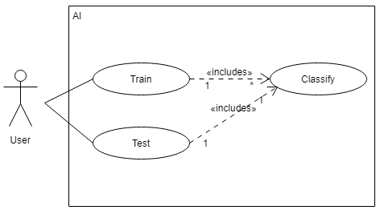
Figure 3 Use Case UML diagram illustrating that training requires more operations than testing.

Objectives
The order of objectives is based on classification of priority of features and dependency resolution. The priority layer has no dependencies whereas the next layers depend on the layers that came before.
The first deliverable is a suitable dataset for training and testing the proposed classifier. Existing sets will be surveyed, and a data generator may be designed and built in this phase. The requirement will be informed by the dependencies of both TensorFlow’s CNN architecture and the Unified Representation for Poker Games (URP) from Columbia University.
Secondary is to design a classifier that functions similarly to MNIST classifiers as this will provide the foundation for learning TensorFlow. This model will be refined with previous research into Poker AI and will be targeted towards development with TensorFlow in python. This will comprise the second deliverable. This will be accompanied by the third deliverable which is the design of benchmarking experiments to measure time taken on different platforms to compare and analyse which platforms are viable for researching the minimum specifications needed to run the classifier.
The last two deliverables will be, the development of a classifier and benchmark data collected and analysed to find the minimum specifications needed to run the software.
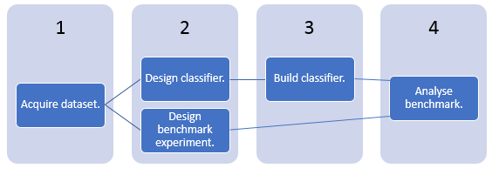
Figure 4 Dependency resolved and prioritised objectives.

Structure
The overall project structure is informed by action research[8]:

.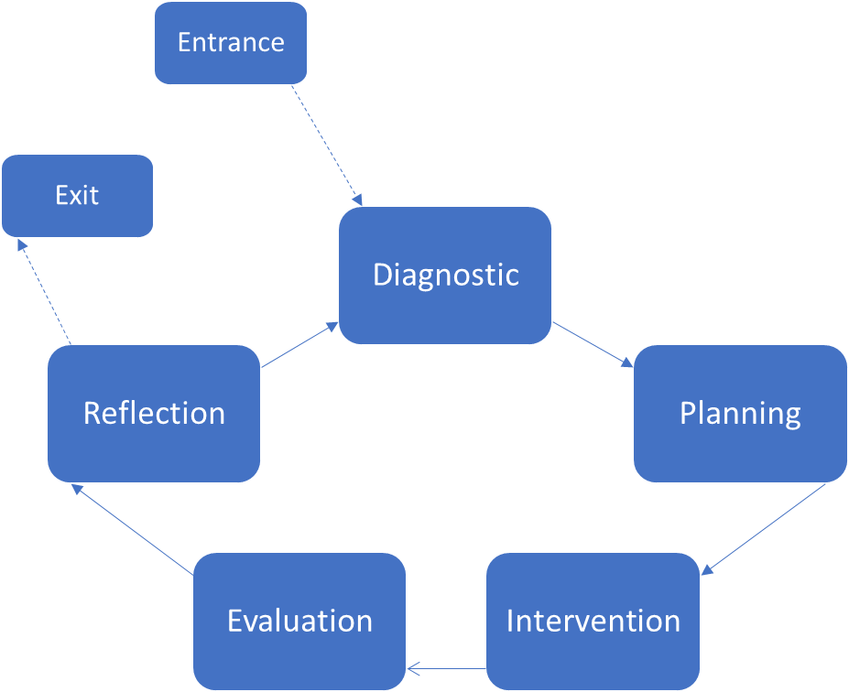
Figure 5 High-level overview of Action Research stages[8].

In the following chapters, the state of the art and historically significant or seminal research will be evaluated to answer questions to the problem. This ensures that potential pitfalls are avoided. Further research, design and development of the project will be described and finally the project will be evaluated, and conclusions and recommendations for future work and personal improvement will be extrapolated.

Chapter 2: Research & Review of Literature
Poker AI has seen progress thanks to the University of Alberta’s DeepStack, Carnegie Melon University’s Libratus, Columbia University’s Poker-CNN and all the other submissions to the Annual Computer Poker Competition at either the AAAI Conference, or the International Joint Conference on Artificial Intelligence.
The stereotypical artificial neural network is either a multi-layer perceptron or a convolutional network. In poker they are used to learn the game by adjusting the likelihood that they will produce an output depending on how fit that output was when given the same or similar input previously and generalise what it has learned to improve the strategy the next time it plays poker.
A perceptron is also referred to as an artificial neuron, single layer perceptron and feedforward neural network (FF). Fundamentally it is a function which receives inputs and applies weights to them. The sum of these are then passed to a function which produces output. An FF is usually trained using back-propagation a type of supervised learning that compares the output to the best-case answer and then adjusts the weights of the model from output through to input so that they either match or are closer.
Recent advances in the field include Counterfactual Regret Minimization (CFR), an algorithm from game theory for solving imperfect information games and neural networks either in tandem with CFR as in DeepStack, or separately with an aim to generalise the application over several games as seen in Poker-CNN without and Libratus with CFR.
Name | Origin | Function | Paradigm
Libratus[9] | CMU | Two-player / heads-up No-limit Hold’em | Counterfactual Regret Minimization (CFR)
Loki-2[10] | UoA: Loki-1 | Multiplayer Limit Hold’em | Formula based strategy (FBS)
DeepStack[11] | UoA | Two-player / heads-up No-Limit Hold’em | CFR / Feed-forward network (FFN)
Poker-CNN[12] | UoC | Video Poker, Multiplayer No-limit Hold’em, Multiplayer Triple Draw | Data-driven Convolutional Neural Network (CNN)
MATLAB ANN’s[4] | AdanaBTU | Hand Strength Classification | FFN
Figure 6 Comparison of most relevant Poker AI.

Carnegie Mellon University
Carnegie Mellon University’s two most significant Poker AI projects are Claudico[11] and its successor Libratus. Claudico was beaten by a group of four professional poker players in a test of 20,000 hands per player over 13 days but in 2017 Libratus beat professional players in a test of 120,000 hands over 20 days.
Claudico, like many poker AI had odd bet sizing at times. There are many variables that can be speculated upon to explain this such as lack of emotion, context (robots don’t need money to pay rent so financial loss has less meaning), etc. Investigation of these factors could lead to further research.
Libratus was powered by the Pittsburgh Super Computer, ~7,250 times faster than an “average laptop” which is significantly larger than the hardware that Polaris (See University of Alberta.) which did use a laptop a decade previously.
Libratus did not reuse Claudico's code, Libratus does not have a fixed strategy but relies on an algorithm that computes the strategy. Players were able to notice Libratus changing its strategy each day as it would analyse its own play at night and correct mistakes.

Counterfactual Regret Minimization
Hart and Mas-Colell[13] discovered a technique in game theory called regret matching. An equilibrium in the play state is reached by players by remembering regrets for past decisions. By remembering whether they regret a past decision, they can make future decisions based on how much they regret that decision on average. This has parallels to backpropagation in feed forward neural networks where generally each node in a layer has its weight adjusted depending on the accuracy of the networks prediction during training.
Counterfactual regret minimization lead to the counterfactual regret minimization algorithm which has appeared in the annual computer poker competitions and many of the AI examined in this paper however, [12] argues that there are several drawbacks to CFR where CNN may be better suited to the task. It is not easy or straightforward to generalize these works to other poker variations because the rules may be different this parallels the problems of overtraining in artificial neural networks.
More complex poker games such as No-limit Hold’em have a larger search space than heads-up limit Texas Hold’em, operating on each game state to find the best responses for those games becomes more difficult because the number of states is several orders of magnitudes larger because of the increased amount of actions to choose from thanks to betting granularity.
Assuming none of the game-state information is ignored it may not be practical to use abstraction to lower the amount of states used in the CFR algorithm. This will also impact the difficulty in finding a Nash equilibrium solution because traversing the amount of game states is computationally expensive. Projects such as Libratus or DeepStack which use CFR attempt to solve these problems by abstracting some of the state and harnessing large computing resources for training, they do not play against multiple opponents at a table they do play No-limit Hold’em. It has been concluded that a CNN would be more suited to the project requirements.

University of Alberta
The University of Alberta are arguably the most prolific poker AI research university with bots including Loki and Poki, PsOpti and Sparbot[14], Vexbot, Hyperborean and Polaris[15], Cepheus and also DeepStack.
Loki is based on a Master of Science thesis by Denis Richard Prapp, granted in 1998 “Dealing With Imperfect Information In Poker”[10]. Of note is the emphasis on solving imperfect knowledge problems with multiple competing agents using AI.
The multiple competing agent problem is of significance because much of popular imperfect information problems in the problem domain of poker only model a single competing agent such as DeepStack which uses an artificial neural network and Libratus which doesn’t.
In 2007 the University of Alberta debuted Polaris in a heads-up match against a competent poker player (which it lost, although it was close). In 2008 Polaris competed against six human players in an informal test during the Gaming Life Expo and achieved three wins, two losses and one tie.
Polaris is a composite program which consists of multiple bots working together. The program contains multiple fixed strategies and chooses between them during a match. Loki works on a similar principle where parts of its functionality are separated into modules. What is most significant about Polaris is that it can be run using a MacBook Pro as opposed to resource intensive Libratus / DeepStack. Also, of note is that Polaris only plays two-player heads-up No-Limit Hold’em.
Unlike Loki and Libratus, Cepheus and its successor DeepStack employ neural networks to play Limit Hold’em. Cepheus managed to solve Limit Hold’em in 2015. It managed to do this by playing itself for two months and this strategy of self-play is significant because training against human opponents costs a significant amount of time. The big difference between Claudico and Cepheus[11] is that Claudico plays No-Limit Hold’em, which is much harder to master.
Limit Hold’em is the largest imperfect information game to be essentially solved. Regardless Cepheus has a firm grip on Limit Hold’em, the No-Limit version remains unsolved and some scientists believe it may be that way for years to come because of the unpredictable nature of the game.
A 2017 study included dozens of participants, 44,000 hands of poker and lead to DeepStack becoming a winning poker player with no training from expert poker players. Like Cepheus, DeepStack also used self-play to train itself and built on the work of Cepheus. DeepStack employs deep neural networks to emulate human intuition and learn “on the go”. Again, DeepStack only played heads-up No-Limit Hold’em so it played only one opponent in each game and is harder than the Limited game that Cepheus essentially solved.

Loki’s Architecture
At a high-level Loki is comprised of three modules as demonstrated in the Figure below, Loki's architecture [6]. These allow for parts of the project to be developed in isolation as they are decoupled by interfaces.
In hand evaluation, the weights from opponent modelling and data about the game state are taken. Values are generated which roughly correspond to the probability of holding the strongest hand. It is a weighted enumeration system where the multiplayer hand evaluation is a field array computed by combining the weight arrays of all active players. This could be simplified to omit opponent modelling in an early iteration and would then function as a classifier. This is a priority module to implement.
The opponent modelling module translates the betting history of the opponent into information about betting behaviour and possible hands held and the betting strategy module takes the values generated by hand evaluation, the opponent models, and the game state and determines determine the best action.
By delegating opponent modelling until a future iteration and resolving remaining dependencies, hand evaluation is the only viable module to implement first. Betting strategy will be implemented after hand evaluation is finished. Once both modules are integrated, opponent modelling will be developed and integrated into the other two modules.
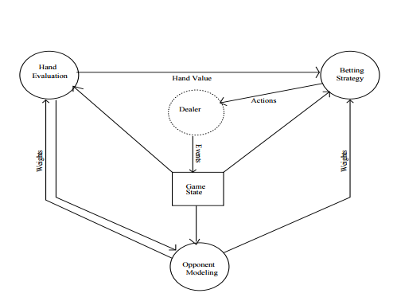
Figure 7 Loki's architecture[10].

DeepStack
DeepStack plays poker with a seven layer feedforward network. At 500 nodes in each layer for a total of 3500 nodes, it is possible to see why DeepStack is so computationally expensive. There are two inputs which are the pot size as a fraction of the players’ total and an encoding of the players’ ranges as a function of the public cards. The ranges are encoded by clustering hands into buckets of 1000. The output of the network are counterfactual values for each player, interpreted as fractions of the pot size.
The network consists of three separate networks like Loki. An auxiliary network solves the game before any cards are dealt to speed up early game performance. The first main network deals with the flop or first three cards and the second handles the fourth card dealt. These networks operate inside an outer network that ensures the counterfactual values to satisfy the zero-sum property from game theory.
Trained is achieved by generating random pot sizes and cards which are solved to produce training examples. The turn network was trained with 10 million poker turns and the flop was trained with 1 million turns. The target counterfactual values for each training game were generated by solving the game with players’ actions restricted to fold, call, a pot-sized bet, and an all-in bet using a depth-limited solving procedure and a trained turn network.
DeepStack itself requires far too many computational resources for the requirements of this project to emulate. A Leduc[16] version of DeepStack has been implemented in lua which could be ported to TensorFlow in python. Leduc is significant because it is a simplified version of poker. This would save time and other resources when it comes time to train and run the neural network but could make it unsuitable to test in real poker games.
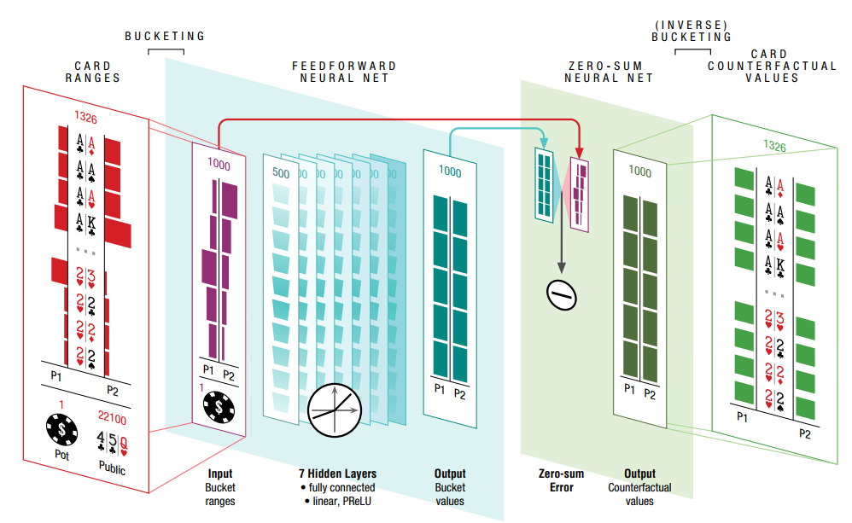
Figure 8 DeepStack architecture overview.

University of Columbia
Poker-CNN is a project developed by researchers at Columbia University, it takes a data-driven approach to using a Convolutional Neural Network (CNN). The CNN can play multiple types of Poker games by using techniques from image recognition such as MNIST neural networks to learn patterns from the input. Poker-CNN simulates poker hands via monte-carlo simulation. This method was deemed too complex for the requirements of the project, so an alternate source was necessary, but Poker-CNN was still relevant to the data specification.

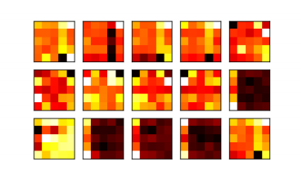
Figure 9 Filters that Poker-CNN learned from playing video poker[12].
As the research focuses on a data-driven approach, a Unified Representation for Poker Games (URP) was also created which uses a 3D tensor which forms the specification for the output of the data generator in this project.
Just as the UCI dataset has four values for suits and 13 for ranks, each card in the URP is a 13 X 4 sparse binary matrix which is padded to 17 X 17 for operations on the data. A tensor of 5 of these matrices forms a hand and the sum of the hands is also included.
Therefore, each card in a dataset generator designed in this project will use encoding compatible with URP. It is most likely that this will entail collapsing the 13X4 2D array into a single integer which represents a unique value in the array.

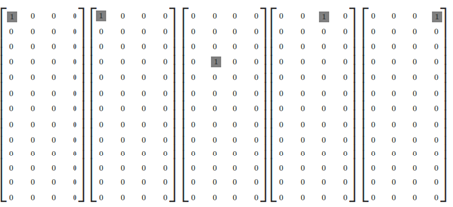
Figure 10 Unpadded hand classifier for Four of a Kind (2’s) and a 5 of Diamonds. input based on Unified Representation[12].

'2H' | '2D' | '2C' | '2S'
'3H' | '3D' | '3C' | '3S'
'4H' | '4D' | '4C' | '4S'
'5H' | '5D' | '5C' | '5S'
'6H' | '6D' | '6C' | '6S'
'7H' | '7D' | '7C' | '7S'
'8H' | '8D' | '8C' | '8S'
'9H' | '9D' | '9C' | '9S'
'10H' | '10D' | '10C' | '10S'
'jH' | 'jD' | 'jC' | 'jS'
'qH' | 'qD' | 'qC' | 'qS'
'kH' | 'kD' | 'kC' | 'kS'
'aH' | 'aD' | 'aC' | 'aS'
Figure 11 URP encoding key.

0 | 1 | 2 | 3
4 | 5 | 6 | 7
8 | 9 | 10 | 11
12 | 13 | 14 | 15
16 | 17 | 18 | 19
20 | 21 | 22 | 23
24 | 25 | 26 | 27
28 | 29 | 30 | 31
32 | 33 | 34 | 35
36 | 37 | 38 | 39
40 | 41 | 42 | 43
44 | 45 | 46 | 47
48 | 49 | 50 | 51
Figure 12 URP encoding index.

With compatible encoding, the dataset would consist of rows of 6 integers. The first five would be integers representing cards encoded in the above fashion and the final integer would be the label of the hand:
High-card | 0
One-pair | 1
Two-pair | 2
Three-of-a-kind | 3
Straight | 4
Flush | 5
Full-house | 6
Four-of-a-kind | 7
Straight-flush | 8
Figure 13 Rank encoding.
For TensorFlow poker games this involves encoding a one hot 2D array of rank and suit for each card represented. This has parallels but is not the same as the state of the art in image recognition architecture, which is Capsule Networks.

Google
Capsule Networks were introduced by Geoffrey Hinton in 2017. They comprise of layers within layers as opposed to linear layers found in CNN. As capsules become more nested they capture more specific details of the input. Active capsules at a lower layer make predictions of the presence of details for capsules above them. When multiple predictions agree, a higher-level capsule becomes active indicating the possibility of a higher-level detail.
Capsules have proven to perform well on MNIST tests, in some cases better than CNN. Although this work is concerned primarily with vision (MNIST), it could be argued that problems of vision have common ground with imperfect information games through pattern classification and the encapsulation approach could have applications to multi-step-multi-agent problems.
This argument may be proven by DeepStack which purports that deep neural networks can solve both games and image recognition problems although it should be noted it uses a feed forward network and CFR, not Capsule Networks. This could indicate that the next evolution of Poker-CNN is a capsule network as it’s pattern recognition and unified representation for poker games works in a similar fashion to MNIST heuristics while acting as an extension of the CNN paradigm.
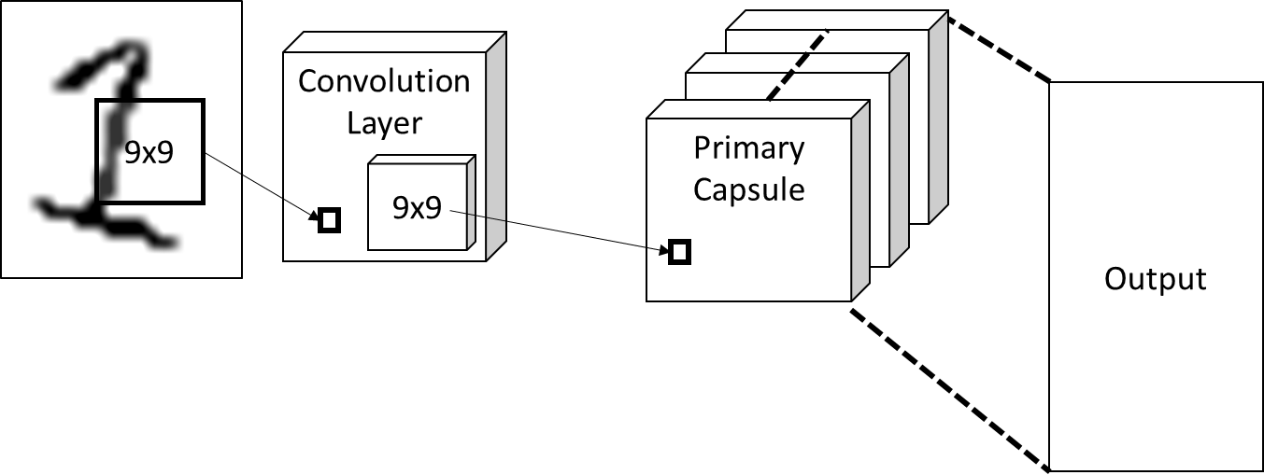
Figure 14 MNIST Capsule Network. The capsules have lower capsules nested inside.

AdanaBTU
Adana BTU in Turkey[4] used the UCI data archive [6] to classify poker hands by strength using MATLAB’s Neural Networks Toolbox. Using resilient back-propagation with 50 nodes yielded accuracy of roughly 92%. One risk of the UCI data archive is that of One-Sided Sampling [5] which could explain why 92% was the upper limit. If the UCI machine learning database’s Poker Hand Training Dataset is analysed (See Figures below) the reason that it risks One-Sided Sampling is clear:
Hand Combination | Instances | Percentage of Total
Nothing in hand | 12493 | 49.95201919
One pair | 10599 | 42.37904838
Two pairs | 1206 | 4.822071172
Three of a kind | 513 | 2.051179528
Straight | 93 | 0.3718512595
Flush | 54 | 0.2159136345
Full house | 36 | 0.143942423
Four of a kind | 6 | 0.02399040384
Straight flush | 5 | 0.0199920032
Royal flush | 5 | 0.0199920032
Figure 15 Instances of hand combinations in UCI training data.

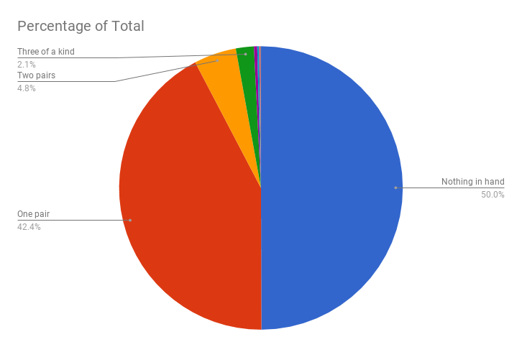
Figure 16 Percentage of hand combination instances in UCI training data.

As illustrated in the Figures above, over 92% of the data comprises two out of ten possible combinations with the next largest combination comprising less than 5%. This could indicate that there is at least a correlation between accuracy and sample size although an experiment would need to be undergone to check causation. This risk may be mitigated with equal sample sizes for each rank.

Card Tables, Hand and Game Data, and Self Play
There are various other approaches to training classifiers in terms of data. At poker AI’s core is the capacity to evaluate the value of the game state. Fundamentally because this is a game there are rules. Card value can be derived from these rules and commonly is coded by a table such as one-hot encoding where each possible pair of cards of rank and suit are encoded in a 2D array.
Again, these rules and the probability of the hands appearing can be used to create a value table and with some explicit exceptions comprise the cornerstone of hand evaluation for a poker AI. When creating an AI to solve an imperfect information problem it is necessary to identify what the rules of the system are to at least inform the inputs and to identify those probabilities either through training or through a table.
In contrast or to enhance the training in tandem previously collected data on games such as on IRC. In “Using Artifical Neural Networks to Model Opponents in Texas Hold’em”[17] modelling was done with data collected from games played over internet relay chat (IRC) to simulate online learning. Accuracy was measured by predicting the most recent actions.
Alternative to training with data or as an extra layer to encapsulate the above is the use of evolution as a heuristic and have the artificial neural network play itself, potentially playing against previous versions of itself. This can be extended further so that generations of neural networks are mated with each other to produce offspring. The risk with all these approaches and neural networks in general is overtraining and overspecialisation which was one of the criticisms of the backpropagation technique.
“Deep Reinforcement Learning from Self-Play in Imperfect Information Games” by Johannes Heinrich and David Silver[18] discusses how when NFSP is used in a Leduc simulation, neural fictitious self-play was able to approach Nash equilibrium.
NFSP was able to approach:
“the performance of state-of-the-art, superhuman algorithms based on significant domain expertise.”
Neural Fictitious Self-Play is comprised of two networks. The first uses reinforcement learning based on experience playing other agents which allows it to approximate
“best response to the historical behaviour of other agents.”
The second is trained based on the agents own behaviour. The agent combines a mixture of both its average strategy and best response strategy. An alternative is also discussed called DQN or Deep Q Network in full which is part of the DeepMind project and also uses a deep convolutional network architecture[19].

UCI Dataset sample and keys.
S1 | C1 | S2 | C2 | S3 | C3 | S4 | C4 | S5 | C5 | Label
1 | 10 | 1 | 11 | 1 | 13 | 1 | 12 | 1 | 1 | 9
2 | 11 | 2 | 13 | 2 | 10 | 2 | 12 | 2 | 1 | 9
3 | 12 | 3 | 11 | 3 | 13 | 3 | 10 | 3 | 1 | 9
4 | 10 | 4 | 11 | 4 | 1 | 4 | 13 | 4 | 12 | 9
4 | 1 | 4 | 13 | 4 | 12 | 4 | 11 | 4 | 10 | 9
1 | 2 | 1 | 4 | 1 | 5 | 1 | 3 | 1 | 6 | 8
1 | 9 | 1 | 12 | 1 | 10 | 1 | 11 | 1 | 13 | 8
2 | 1 | 2 | 2 | 2 | 3 | 2 | 4 | 2 | 5 | 8
3 | 5 | 3 | 6 | 3 | 9 | 3 | 7 | 3 | 8 | 8
4 | 1 | 4 | 4 | 4 | 2 | 4 | 3 | 4 | 5 | 8
Figure 17 UCI dataset sample.

S# | Suit
1 | Hearts
2 | Spades
3 | Diamonds
4 | Clubs
Figure 18 UCI dataset suit key.

C# | Face
1 | Ace
2 | 2
3 | 3
4 | 4
5 | 5
6 | 6
7 | 7
8 | 8
9 | 9
10 | 10
11 | Jack
12 | Queen
13 | King
Figure 19 UCI dataset face key.
Label # | Rank
0 | Nothing in hand.
1 | One pair.
2 | Two pairs.
3 | Three of a kind.
4 | Straight.
5 | Flush.
6 | Full house.
7 | Four of a kind.
8 | Straight flush.
9 | Royal flush.
Figure 20 UCI dataset label key.

Theoretical Limitations for Benchmarking
There are various laws which impose physical limits on the resources that are available to the model. These limitations inform requirements for establishing some performance benchmark in TensorFlow as some Poker solving AI has operated on laptops whereas others have been trained in large data centres. Training iterates over a larger amount of data like batch processing, so it is that feature which will be most computationally expensive as a worst-case reference for performance requirements.

Moore’s Law
It has been popularly believed that the density of transistors will double every two years to eighteen months. The current state of the art is pursuing multiple processor cores to accommodate the increased density of transistors [20]. To maximise efficiency, these cores need to be utilised concurrently otherwise cores are wasted. This also applies to general purpose computing on Graphics Processing Units (GPGPU / GPU / Graphics cards). Both of which can be benchmarked independently and in concert.

Amdahl's Law
The time it takes for a fixed size program being run serially divided by the time taken to run in parallel can vary depending on which parts are parallelised.[21] That is if large parts of the neural network can be parallelised, although constrained by the parts that can’t, there can be a performance boost via parallelisation. This necessitates measuring the time it takes for different features of the system to execute.

Gustafson-Barsis’s Law
In contrast to Amdahl’s Law, the time taken is fixed and it is the amount of parallelised work (scalability) that can be done in that time that is the concern.[22] So in the past a neural network may be limited to a certain number of inputs by current technology. In the future with more advanced technology that same network would not perform quicker, it would usually take more inputs instead. Time measurements may provide insight into parallelisation effects on performance but proving Amdahl or G-Bs laws is beyond the scope of the project.

Sun & Ni’s Law
Whereas Gustafson is concerned with time constraints and Amdahl was concerned with problem size constraints, Sun and Ni is concerned with memory capacity[23]. Memory capacity and the data flow bottlenecks between processor and memory are a real concern as they affect processing performance. This is the final factor that may need to be considered when benchmarking the systems.

Frameworks
There are advantages and disadvantages to using off the shelf software such as coding frameworks. The purpose of this dissertation is to optimise the performance of artificial neural networks, so the main prerequisite of any framework will be the ability to be optimised.
A survey on ANN frameworks was conducted as recently as 2016[24]. TensorFlow was identified as a viable framework among others. TensorFlow was selected for this dissertation as facilities are pre-prepared for TensorFlow development.
The academic library shows research in Microprocessors and Microsystems Journal[25] as the most recent work in “parallelized” and “tensorflow” and confirms TensorFlow as a viable framework for neural networks. Node-level parallelisation for deep neural networks with conditional independent graph[25] mentions techniques compatible with TensorFlow’s inherent optimisation which may be compatible with card game NN.
Toolkits and Libraries for Deep Learning[26] further corroborates that TensorFlow has good performance which is necessary for optimisation benchmarking and supports multiple GPU’s and CPU’s which will be necessary for implementing pure GPU implementations and pure CPU implementations for benchmark comparison.
DeepStack uses Torch7 a LuaJIT scripting language that interfaces with C. [11] Although other strong candidates exist for developing poker AI, TensorFlow has been selected because of its accessibility and compatibility.

Chapter 3: Research and Development Methodology

Research Methodology

Research Overview
The requirements for the research come from several problems that need to be solved during the development of the deliverables covered in the second half of this chapter.
Action Research has precedent in the field of Software Engineering as far back as 1993 and a general framework has been devised for the implementation of Action Research in Software Engineering tasks[27][8] which is used in this report. Action Research was chosen as the most suitable overall research methodology because the planning, design, development and testing of software is the overall focus of the project.
The question to be answered is “can the AI and associated research be reproduced accessibly?” To determine whether the project provided deliverables accessibly, data analysis and reflection will be necessary making Action Research a suitable choice. One factor which will be omitted and may risk incompatibility is that Action Research is often done in the context of a group of people not an individual. Hopefully the individual aspect will not jeopardise the methodology as it is the analysis and reflection aspects which are most relevant.
Before any action in the research is employed, a literature review will be undertaken. A hypothesis of the solution to the problem will be formed and evaluated against the literature. The best-case scenario is that quantitative data from multiple sources can be found and triangulated which answer the problem. If so, the research can end, and the solution tested in practice by implementing the solution in a development setting and critically evaluating its relevance to the solution of the problem. This could be activities such as creating software to generate data to feed to a neural network and its costs and benefits such as how much time was invested or what problems the solution mitigated.
Where quantitative measurements are necessary to answer a problem, an experiment will be designed and executed. An example in the project is measuring the time taken to generate High Rank Datasets. These are comprised of automated benchmarks.

Research Philosophy
The research philosophy was chosen in the context of the needs of software engineering in general and the accessibility requirements for the project:
- Any method must not be so prohibitively expensive that it cannot be reproduced by all researchers.
- Data is collected through reproducible actions which inform software engineering decisions during development of deliverables.
The positivist and deductive philosophy of the methodology acknowledges that solo-programming and research has its dangers of bias and that although research will attempt to be quantitative, ultimately at times inferences must be made which are qualitative. Frameworks for experimental research naturally lend themselves to these requirements as like templates they are reproducible and reusable.

Data Collection
Two different approaches to time measurement were used for different benchmarks.
The default_timer module from timeit was used where large batches of operations needed to be measured and concurrency was not a concern. This was used to get 1000 hand generation time measurement samples for of each rank. This method writes to file and so is convenient for batches of samples. However, it does not record timestamps, only the amount of time it takes for the code to run.
- def b_high(max):
- i = 0
- file = open("high_card_times.csv", "a")
- while i < max:
- start = timer()
- CSVWrite.get_hand_of_rank(RANKS[0])
- end = timer()
- file.write("%s," % (end - start))
- i += 1
- file.close()
The line_profiler[28] is a module for profiling code by line and was used to measure smaller samples of operations it was used to roughly verify the accuracy of the timeit method. Functions are tagged with “@profile” to profile them in the command line.
- import line_profiler
- import atexit
- import multiprocessing
- import benchmark
- profile = line_profiler.LineProfiler()
- atexit.register(profile.print_stats)

- def worker_sflush():
- """worker function"""
- print()
- benchmark.b_sflush(1)
- return
- @profile
- def parallel():
- jobs = []
- for i in range(4):
- p = multiprocessing.Process(target=worker_sflush)
- jobs.append(p)
- p.start()
- if __name__ == '__main__':
- parallel()

Figure 21 Research Design

Research Deliverables
After literature review the architecture for the target neural network was chosen. Like Loki an architecture most like TensorFlow’s framework, modular parts based on hand evaluation, opponent modelling and betting strategy functionality was theorised to be compatible with iterative prototyping.
The system architecture was modelled. During modelling, opponent modelling was discarded, and on evaluation and reflection, the strategy layer was left to be designed at a later iteration. Hand evaluation was concluded to be the first module of the architecture to be implemented as it deals with the fundamental input which is hand classification by rank of hand.
After a second literature review, a convolutional neural network based on Poker-CNN was regarded as the best model for classification because of the ability to detect patterns like MNIST and its potential to be extended to capsule networks which could provide enhanced pattern detection capabilities. TensorFlow also supports CNN.
A suitable data source was needed to replace Poker-CNN’s monte-carlo simulated hands as this method was deemed too complex. A third literature review was undertaken, and UCI was identified as a possible source for a dataset. After evaluating Adana-BTU’s classifier it was concluded that it was necessary to produce a data generator to ensure that the classifier did not over train and protect other researchers from overtraining. This is because hand values are tied to the probability of that hand appearing. Therefore, to mitigate the small sample of high value hand labels in the dataset (I.e. Straight Flush), the generator would produce equal samples of each set of values.
A CSV data generator was designed and built in python targeted at Poker-CNN’s unified poker representation which could be successfully loaded into TensorFlow. In reflection and evaluation, the Straight Flush cards were concluded as being generated slower than the other cards by a significant margin (3-4 hours for 1000 samples) which would affect usability.
As an experiment, the generator functions were benchmarked for time and the hypothesis was confirmed. As a further experiment a parallelised version was tested but time benchmarking data proved insufficient because it lacked granularity, so it was difficult to measure when processes started and ended.
As a side-effect of exploratory research into data generation, a rules-based classifier was constructed in python using McCarthy’s algorithms as this achieves 100% accuracy which is superior to what is expected from a classifier built with an artificial neural network. As a result, this rules-based classifier may be used as a pre-processor for the neural network with the intention that this will reduce training time and resources while costing accuracy or flexibility.
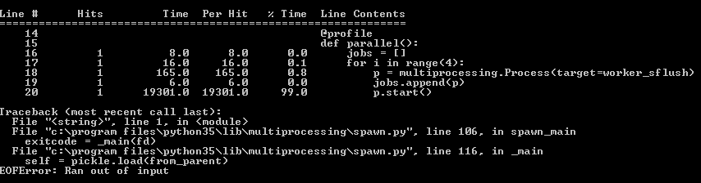
Figure 22 Benchmarking of 4 multi-processes proved inconclusive.

Development Methodology
Requirements for this project include support for a single developer as opposed to larger teams which methodologies are usually targeted towards. The international standard ISO/IEC 12207 provides a framework for evaluating software methodologies. This was considered too complex for the needs of the project, so suitable development methodologies
Nystrom designed Agile Solo [1], a software process model for solo-programmers that concluded that for solo programmers it is best to adapt a methodology to the requirements of the project. After evaluating its use, it was decided a solo-programmer methodology would be adapted from feature driven development.
Feature Driven Development (FDD) is part of the Agile paradigm of development ethos. It mirrors the design of the research methodology significantly reducing complexity of the project at the risk of mixing up research and development methodology. FDD places an emphasis on unit testing. Unit testing was switched out of the methodology and replaced with iterative prototyping of modules and unit testing relegated to features that were high risk.
FDD-Solo Is built from the following practices:
- Development of Overall Model:
  - Cognitive walkthrough.
  - UML Modelling: Use-case.
  - UML Modelling: Class.
- Building Feature List:
  - <action> <object><result> principle.
- Plan by Feature:
  - MSCW Analysis.
- Design by Feature:
  - UML Modelling: Sequence.
- Build by Feature:
  - Prototypes built in modules and integrated.
  - Unit Testing.
  - Static Analysis
No single satisfactory method had been found during literature review although elements of other methods were desirable. It was concluded that the design of a new methodology was necessary. By tailoring the method to the projects needs it should better support the project than a more generic method.
Except for this project, the specific FDD derived method has never been tested and this introduces an element of risk. Consequently, reusing elements from other methods at the very least guarantees that some of the methods have been proven to work or have been used before, mitigating some of that risk. Although prototyping components in isolation as opposed to test driven development increases flexibility but introduces more risk of the code not being test-worthy, although components will not go from prototype to integration until they are functional.

Software
Anaconda will be used to provide an execution environment for the python and TensorFlow code on a Windows 8.1 Operating System. The project also requires several command line tools for python, Pylint[29] for static analysis, and line_profiler / kernprof[28] for benchmarking. These are free to use and are readily available and so are ideal for this project.

Hardware
A standard laptop will be used as the initial target for development. It has 8 GB of RAM and an AMD A10-7300 processor which is an ULV (Ultra Low Voltage) quad-core processor with an integrated AMD Radeon R6 GPU with 6 compute cores, 2 of which are deactivated. For the purposes of initial research only the CPU cores and RAM are relevant. GPU benchmarking being left until the neural network is completed. This meets the same requirements as the software.

Materials and Tools
Python allows static analysis of code relatively easily with a single command line tool called Pylint. This provides a 10.00 out of 10.00 rating metric for adhesion to parts of the Python Enhancement Proposals such as the PEP 8 style guide for python code. This provides coding conventions which conform to the standard library in python. This also involves PEP 257 which is concerned with Docstring Conventions which are used to provide help text for modules and functions amongst other elements.
It is easy and fast to iterate with the tool and is more efficient than a manual code review as the automation makes it objective and exhaustive. It was especially useful for identifying unused module imports, ensuring that constants and variables were appropriately labelled, and that functions and modules were documented and commented correctly.
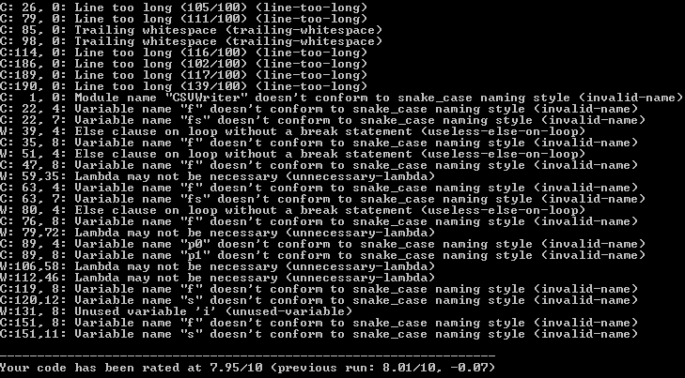
Figure 23 Output of Static Analysis tool, Pylint.
The command line tool line_profiler or kernprof[28] and the default_timer module from timeit is used for benchmarking. Python also includes the unittest library which makes unit testing of features quick and iterative as a framework is provided for unit testing without installing additional resources.

Chapter 4: Design and Implementation
A cognitive walkthrough of the neural network was undertaken to identify use-cases and capture activities. The use-cases were modelled using UML Use-case. A class diagram capturing the objects in the use-cases was modelled with UML. A feature list was built using an “<action> <object> <result>” syntax adapted from feature driven development.
The project was initially planned by feature using MSCW analysis. As each feature was built, a sequence diagram was modelled in UML. This feature was then developed iteratively by prototyping the functionality as a separate module to be integrated into the whole. Static analysis was used to enforce coding standards.
The CSVWrite and CSVRead modules allow data to be generated and written to file, and read from file into TensorFlow respectively. In CSVWrite, calling get_hand_of_rank(rank): with one of the following options will produce a sample of the correct hand type.
Possible arguments:
- straightflush
- fourofakind
- fullhouse
- flush
- straight
- threeofakind
- twopair
- onepair
- highcard
demonstration.py can be run from the command line to generate equal sample sizes of each rank. By default it will produce batches of 4 samples, this can be adjusted by altering the constant BATCH_SIZE. Running benchmark.py will automatically log the time taken for each of the 9000 samples generated and write each time to a CSV file for the samples rank.
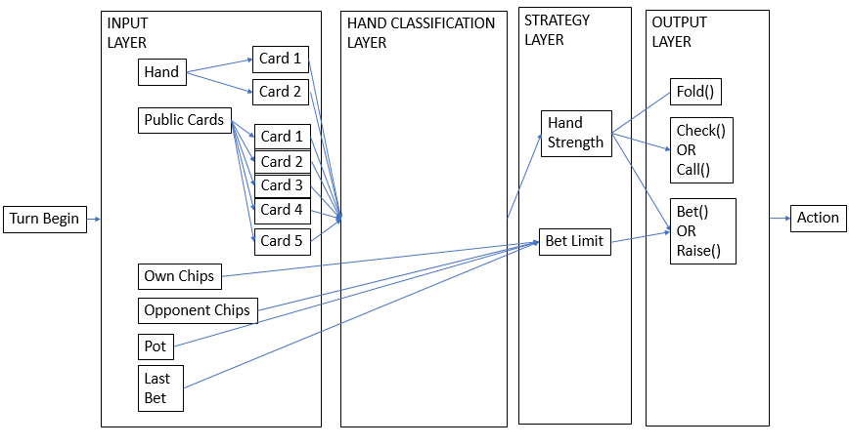
Figure 24 Final design iteration context for classifier.

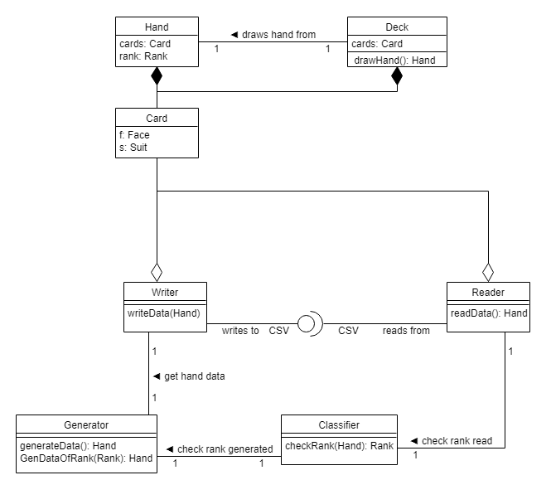
Figure 25 Class design for system.

MUST | <Write> | <Hand and Rank> | <CSV>
 | <Read> | <CSV> | <Hand and Rank>
 | <Generate> | <Hand> | <Random Hand>
SHOULD | <Classify> | <Hand> | <Rank>
COULD | <Generate> | <Hand> | <Hand of Rank>
 | <Benchmark> | <Code> | <Times>
 | <Parallelise> | <Code> | <Optimisation>
Figure 26 Feature List prioritised by MSCW analysis.
The Convolutional Neural Network for classifying the data from the generator specification from Poker-CNN’s Unified Representation for Poker Game’s, is designed with TensorFlow as a target platform as it provides a framework for neural network layers.
The model architecture for the CNN devised for TensorFlow and the consumer of the data generated is based on three components. Convolutional layers, pooling layers and full connected layers. The CNN applies these as a series of filters to the data to learn high-level features which can be used for pattern recognition and classification. The tf.layers module in TensorFlow contains methods to create each of the three types of layers.
A Convolutional Neural Network is used to extract features. The convolutional layers take samples from the data. For each sample, the layer performs operations to produce a single value to represent the information in the sample such as patterns. Nonlinearities are added to the output of the convolution to avoid training difficulties.
The pooling layers down-sample the data extracted by convolutional layers to reduce the dimensionality of the feature map to decrease processing time. They only keep the maximum value, discarding the other.
The dense layers perform classification on the features down-sampled by the pooling layers. In a dense layer, every node in the layer is connected to every node in the preceding layer.
The final dense layer in a CNN contains a single node for each target class in the model. It uses a function to generate a value between 0-1 for each node, all of which must sum together to 1. These values represent measurements of how likely the input falls into each target class.

The model to classify hand ranks in the poker datasets may use the following CNN architecture. After each individual card in the hand is read from the CSV file into its respective 4 x 13 matrix the matrix is padded to 17 x 17. This helps the convolution and max pooling nodes perform operations on the matrices[12]. In convolutional layer 1, 3x3 filters are applied to the matrices(extracting 3x3 matrices for adjacency patterns) with a ReLU (Rectified Linear Unit) activation function. Pooling layer 1 performs max pooling with a 2x2 filter and stride of 2 (which specifies that pooled regions do not overlap).
Convolutional layer 2 comprises of another series of 3x3 filters, with ReLU and pooling layer 2 is the same as pooling layer 1. It may be possible to drop the second convolutional and pooling layers. Dense layer 1 consists of 1024 neurons with dropout regularization rate of 0.4 (probability of 0.4 that any given element will be dropped during training) and dense layer 2 is the logits or output layer which consists of 9 neurons, one for each hand rank target class (0-8) ( Straight Flush, Four of a Kind, Full House, Flush, Straight, Three of a Kind, Two Pair, One Pair, High Card)

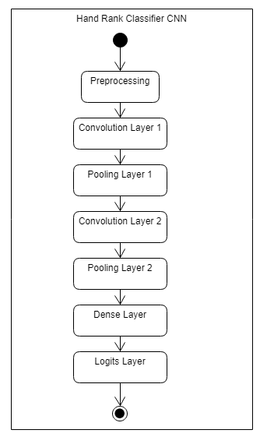
Figure 27 Activity diagram of classifier.

Chapter 5: Evaluation
During development the speed at which Royal Flush hands are generated felt significantly higher than other hand types. This was hypothesised to be due to the way that hands are generated. The algorithm uses a brute force approach it draws a hand from a deck and if it is not a valid hand of the target rank (e.g. Royal Flush) it discards the hand and draws a new hand from a new deck until it finds the correct ranked hand. Big O measures the limiting behaviour of a function and in this case the limiting behaviour is the probability of a certain hand being drawn.

Poker Hand | # of hands | Proportion of total # of hands | # of poker hands | Probability of drawing hand %
Royal Flush | 4 | 0.00000154 | 480 | 0.000153908
Straight Flush | 36 | 0.00001385 | 4320 | 0.001385169
Four of a kind | 624 | 0.0002401 | 74880 | 0.024009604
Full house | 3744 | 0.00144058 | 449280 | 0.144057623
Flush | 5108 | 0.0019654 | 612960 | 0.196540155
Straight | 10200 | 0.00392464 | 1224000 | 0.392464678
Three of a kind | 54912 | 0.02112845 | 6589440 | 2.112845138
Two pairs | 123552 | 0.04753902 | 14826240 | 4.753901561
One pair | 1098240 | 0.42256903 | 131788800 | 42.25690276
Nothing | 1302540 | 0.50117739 | 156304800 | 50.1177394
Total | 2598960 | 1.0 | 311875200
Figure 28 Probability of hands being drawn[6].

An initial benchmark of four samples appeared to indicate that the limiting behaviour is the probability of a certain hand being drawn.

Function | Total (s)
b_high | 0.00262146
b_pair | 0.00587737
b_2pair | 0.0297011
b_3kind | 0.0733929
b_straight | 0.460952
b_flush | 1.44967
b_full_house | 0.690471
b_4kind | 2.94553
b_sflush | 103.388
Figure 29 Total time for four samples to be generated.
Roughly 1000 samples were generated and benchmarked to validate the initial hypothesis.
 | Straight Flush (Seconds) | High Card (Seconds)
Largest value in Batch 1 | 324.2262 | 0.001387135
Largest value in Batch 1 | 80.70618 | 0.001200312
Largest value in Batch 1 | 60.4747 | 0.001842314
Largest value in Batch 1 | 59.34799 | 0.001567479
Smallest value in Batch 1 | 0.076061 | 0.000122569
Smallest value in Batch 1 | 0.059754 | 0.000101511
Smallest value in Batch 1 | 0.131379 | 0.000100971
Smallest value in Batch 1 | 0.027454 | 0.00010961
Average value in Batch 1 | 16.60548 | 0.000285814
Average value in Batch 2 | 11.22539 | 0.000270206
Average value in Batch 3 | 11.1925 | 0.000259257
Average value in Batch 4 | 9.944892 | 0.000263304
Largest value in all batches | 324.2262 | 0.001842314
Smallest value in all batches | 0.027454 | 0.000100971
Average value in all batches | 12.24207 | 0.000269645
Sum of Batch 1 | 4234.397 | 0.072882622
Sum of Batch 2 | 2862.475 | 0.068902641
Sum of Batch 3 | 2854.088 | 0.066110553
Sum of Batch 4 | 2436.499 | 0.0671424
Size of Batch 1 | 255 | 255
Size of Batch 2 | 255 | 255
Size of Batch 3 | 255 | 255
Size of Batch 4 | 245 | 255

Figure 30 1000 time samples for each generator function summarised by fastest and slowest functions.

Although it was confirmed that multiprocessing increased the speed with which batches were generated, an adequate benchmarking technique for parallelised code was not found.
Function | Total (s)
parallel() | 0.0105269
jobs = [] | 0.00000432
for i in range(4): | 0.00000864
p = multiprocessing.Process(target=worker_sflush) | 0.00000000
jobs.append(p) | 0.00000324
p.start() | 0.01042159
Figure 31 Line-by-line benchmarks parallelised code proved inconclusive.
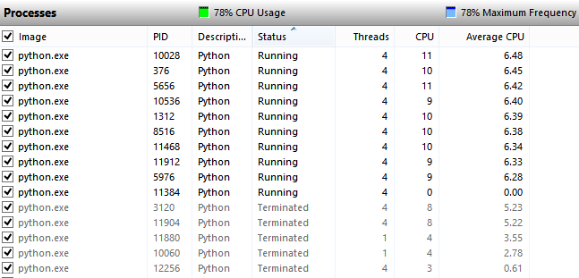
Figure 32 The program started more processes than there were cores on the processor.

Conclusions drawn from data.
Because the data is generated by brute force The Straight Flush generation algorithm is less performant than the other algorithms as there are more incorrect hands that are drawn from a deck that must be discarded because the hand is not a Straight Flush. This should be the target of future optimisations. It is proposed that the two benchmarks are compared before considering a more optimal solution than brute force.
A pre-processing step was not initially considered during classification. Many of the poker bots encountered in the literature use either a hybrid system or use a rules-based approach. Many of the same and other bots also use some form of pre-processing on the data before a neural network is fed it.

Which objectives were met.
Even though the order of objectives was managed with feature driven development, there was some inertia to pivoting on features. The first deliverable is a suitable dataset for training the proposed CNN. This was achieved satisfactorily. Existing sets were surveyed and deemed inadequate or too expensive. A data generator was created, and this led to a rules-based classifier in contrast to the Artificial Neural Network classifier that was anticipated. This will be used in the pre-processing phase of the network and other functionality and data generators will be evaluated in the future to shrink the neural network with the aim of reducing training time and increasing performance. With some processing, the data generated can be used to adhere to the Unified Representation for Poker Games (URP).
The benchmarking experiments were designed to measure time taken on a laptop which was deemed adequately cheap, but this was not compared with other platforms as a caveat. These benchmarks function as the baseline for the minimum specifications needed to run the classifier, but depending on implementation, the eventual neural network may require more hardware most likely in the training phase.

Which aims were met.
By designing and building a program that produces poker hand data in a CSV format both cheaply and efficiently, that the aim of making research in the imperfect information field more accessible has been achieved. It provides datasets where the distribution of ranks of hands in the dataset is equally distributed. It is hypothesised that this will mitigate dangers of overtraining present in the UCI machine learning database where ranks are proportionally represented in the dataset based on their probability of occurring. In terms of rules-based classification this dataset does not pose any danger but in a neural network this could lead to over or under training which would be hard to detect at accuracy levels of even 92% using the UCI dataset.

What would be done differently next time.
It was initially assumed that the AI would train by playing another AI however this would have expanded the scope of the project. After a time, investment into researching this avenue in the literature review it was deemed that the functionality of the current data generator was sufficient. This pushed back the priority of later features and meant that the neural network was not implemented in this phase of the project and as a result the neural network is the focus of the next phase and will integrate the hand classification code as a pre-processor.

Chapter 6: Conclusions and Recommendations
A data generator has been built which with some modifications should generate any combination of samples sizes of different ranks of hands. Once a neural network classifier has been constructed equal sample sizes of different ranks should be compared against UCI’s dataset to see which one is more suitable for training.
The neural network remains to be implemented although the design is finalised, and a rules-based classifier has been developed in its place. It was not expected that the data generator implementation would take up a sufficient amount of time so that the neural network development would be delegated. Prior to starting the project, a rules-based classifier was not considered part of the scope. However, it achieves 100% accuracy and requires no training. The neural network may comprise a far smaller part of the functionality of the system than was assumed.

Chapter 7: Reflection
Not all Aims were achieved as described. Although an accurate classifier has been built during the process of building a data generator, the neural network classifier remains unimplemented.
Problem were pre-empted with risk analysis by prioritising aims and dependencies and through literature review to identify those which needed to be implemented first. An alternate implementation of some of the Aims provided most of the functionality of the original aim while changing the way it was implemented.
Initial resistance to an alternate implementation could be due to sunken cost fallacy. Pivoting quicker could have saved time. In addition, unit testing was begun after many prototypes had already been built and integrated this lead to less verification and validation.
It has been concluded that a simpler project management methodology may be more suitable for solo development projects, Python is a suitable language for component-based prototyping and unit tests should be undertaken more thoroughly.
Personally, the project increased confidence and competence in undertaking a large body of research and development and has fostered a continuing interest in machine learning.

References
[1] A. Nystrom, “Agile Solo Defining and Evaluating an Agile Software Development Process for a Single Software Developer,” Chalmers University of Technology, University of Gothenburg, 2011.
[2] M. Abadi et al., “TensorFlow: Large-Scale Machine Learning on Heterogeneous Distributed Systems.”
[3] D. McCarthy, “Rosetta Code Poker hand analyser: Python,” 2018. [Online]. Available: https://rosettacode.org/wiki/Poker_hand_analyser#Python. [Accessed: 22-Apr-2018].
[4] G. Dişken, A. Bilim, and T. Üniversitesi, “PREDICTING POKER HAND’S STRENGTH WITH ARTIFICIAL NEURAL NETWORKS.”
[5] M. Kubat and S. Matwin, “Addressing the Curse of Imbalanced Training Sets: One-Sided Selection,” Ottawa, 1997.
[6] D. Dua and E. Karra Taniskidou, “UCI Machine Learning Repository,” University of California, School of Information and Computer Science., 2017. [Online]. Available: http://archive.ics.uci.edu/ml.
[7] T. E. Potok et al., “A Study of Complex Deep Learning Networks on High Performance, Neuromorphic, and Quantum Computers,” 2017.
[8] P. S. Medeiros, S. Guilherme, and H. Travassos, “Action Research Can Swing the Balance in Experimental Software Engineering,” Rio de Janeiro, 2009.
[9] N. Brown and T. Sandholm, “Libratus: The Superhuman AI for No-Limit Poker (Demonstration),” 2017.
[10] D. R. Papp, “Title of Thesis: Dealing with Imperfect Information in Poker,” University of Alberta, 1998.
[11] M. Moravčík et al., “DeepStack: Expert-Level Artificial Intelligence in Heads-Up No-Limit Poker,” 2017.
[12] N. Yakovenko, L. Cao, C. Raffel, and J. Fan, “Poker-CNN: A Pattern Learning Strategy for Making Draws and Bets in Poker Games,” Proc. 30th Conf. Artif. Intell. (AAAI 2016), 2016.
[13] Mas-Colell and Hart, An Introduction to Counterfactual Regret Minimization. 2000.
[14] J. Rubin and I. Watson, “Similarity-Based Retrieval and Solution Re-use Policies in the Game of Texas Hold’em.”
[15] M. Bowling et al., “A Demonstration of the Polaris Poker System.”
[16] F. Southey et al., “Bayes’ Bluff: Opponent Modelling in Poker.”
[17] A. Davidson, “Using Artifical Neural Networks to Model Opponents in Texas Hold’em,” 1999.
[18] J. Heinrich and D. Silver, “Deep Reinforcement Learning from Self-Play in Imperfect-Information Games.”
[19] V. Mnih et al., “Human-level control through deep reinforcement learning,” Nature, vol. 518, 2015.
[20] G. E. Moore, “Cramming more components onto integrated circuits.,” Electronics, vol. 38, no. 8, 1965.
[21] G. M. Amdahl, “Validity of the single processor approach to achieving large scale computing capabilities,” in AFIPS spring joint computer conference, 1967.
[22] J. L. Gustafson and J. L., “Reevaluating Amdahl’s law,” Commun. ACM, vol. 31, no. 5, pp. 532–533, May 1988.
[23] X. H. Sun and Y. Chen, “Reevaluating Amdahl’s law in the multicore era,” J. Parallel Distrib. Comput., vol. 70, no. 2, pp. 183–188, 2010.
[24] P. R. Alencar David and D. R. Cowan David, “A Survey on Domain-Specific Languages for Machine Learning in Big Data Ivens Portugal.”
[25] “M2DC – Modular Microserver DataCentre with heterogeneous hardware,” Microprocess. Microsyst., vol. 52, pp. 117–130, Jul. 2017.
[26] B. J. Erickson, P. Korfiatis, Z. Akkus, T. Kline, and K. Philbrick, “Toolkits and Libraries for Deep Learning,” 2017.
[27] P. S. Medeiros, D. Santos, and G. H. Travassos, “Action Research Use in Software Engineering: an Initial Survey.”
[28] “line_profiler and kernprof,” 2018. [Online]. Available: https://github.com/rkern/line_profiler/blob/master/README.rst. [Accessed: 13-Apr-2018].
[29] “Pylint - code analysis for Python.” [Online]. Available: https://www.pylint.org/. [Accessed: 23-Apr-2018].

Appendices

Action research framework.
- Diagnosis
  - Problem Description
  - Project Context
  - Research Theme
- Planning
  - Literature Survey
    - Initial Study
  - Action Focus
    - Objectives
    - Research Questions
    - Expected Outcomes
  - Hypotheses
  - Operational Definitions
    - Techniques
    - Tools
    - Instruments
    - Study Design
- Actions
- Evaluation and Analysis
- Reflections and Learning
  - Learning
  - Reflections

Systems and software engineering – Software life cycle processes.

