
Data Manipulation
Assignment 2
Statistical Programming – ADDB5021
Lucy Boyt - 2308345

Contents
Visualisations: 2
Challenges and Things Learned: 6
Improvements for Future Work 7
Generative AI 7
References and Technical Resources 8

This assignment required the manipulation, analysis and visualisation of an air quality dataset using R. The approach taken focused on writing clear, reusable functions and selecting visualisation techniques that best communicated the structure and behaviour of the data whilst remaining accessible to end-users.

Visualisations:
The variation of nitrogen oxides as nitrogen dioxide over time was visualised using a line plot (Figure 1). This approach is well-suited to time-series data, clearly displaying fluctuations, longer-term trends and anomalous peaks within the selected period. To reduce short-term variability and visual noise, the data was restricted to readings taken at noon on the first of each month (Figure 2). The x-axis scale is adjusted using controlled date breaks and labels were rotated to improve readability over longer time spans (Figure 3).
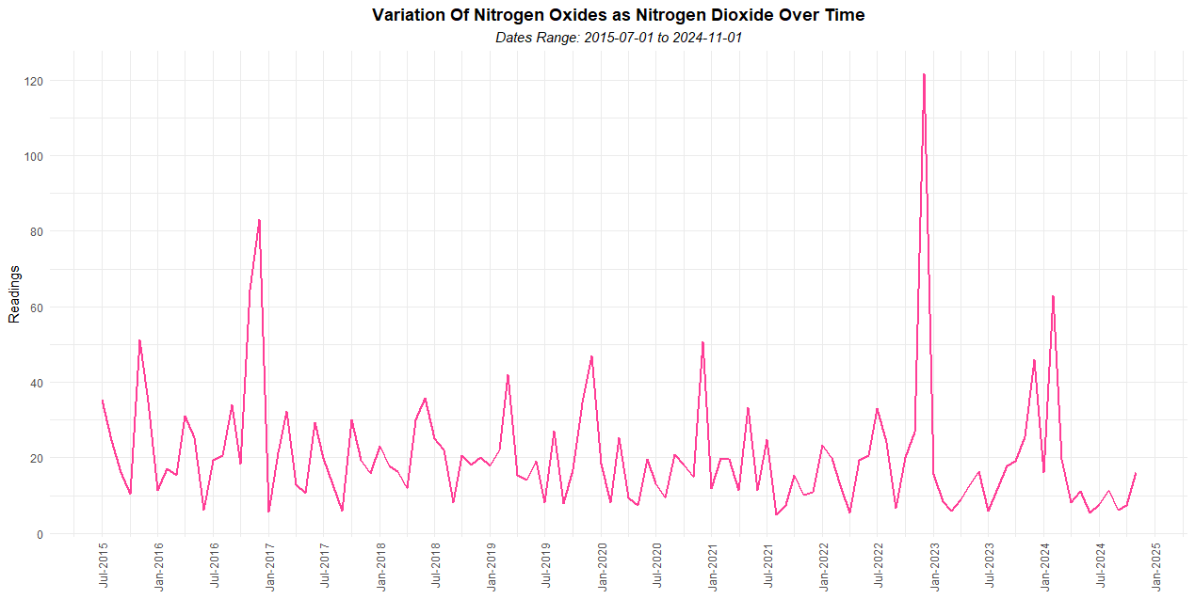
Figure 1 – Variation of Nox as NO2

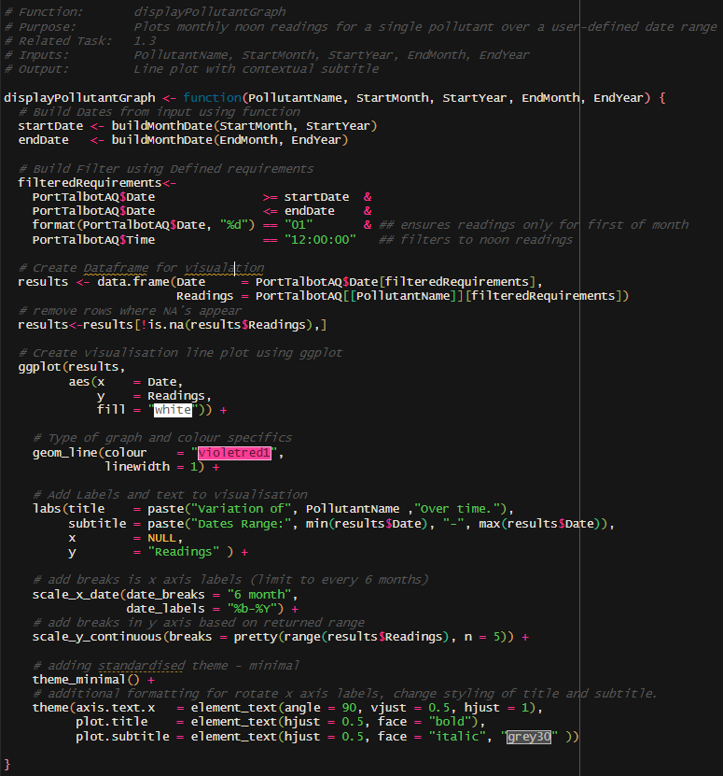
Figure 2 – Filter – Noon and first of the month
Figure 3 - Script detailing additional layers implemented to adjust axis scale and formatting
When exploring the variation in pollutant levels over ten years, a multi-line plot was initially considered; however, overlapping lines and differing pollutant magnitudes resulted in a cluttered and difficult-to-interpret visualisation. This led to the selection of a heatmap as a more effective alternative (Figure 4). This approach improves readability by separating each pollutant into horizontal bands, allowing patterns to be compared both individually and across pollutants without overplotting. Values were scaled within each pollutant to prevent variables with larger magnitudes from dominating the visualisation, ensuring variation could be compared effectively (Figure 5).
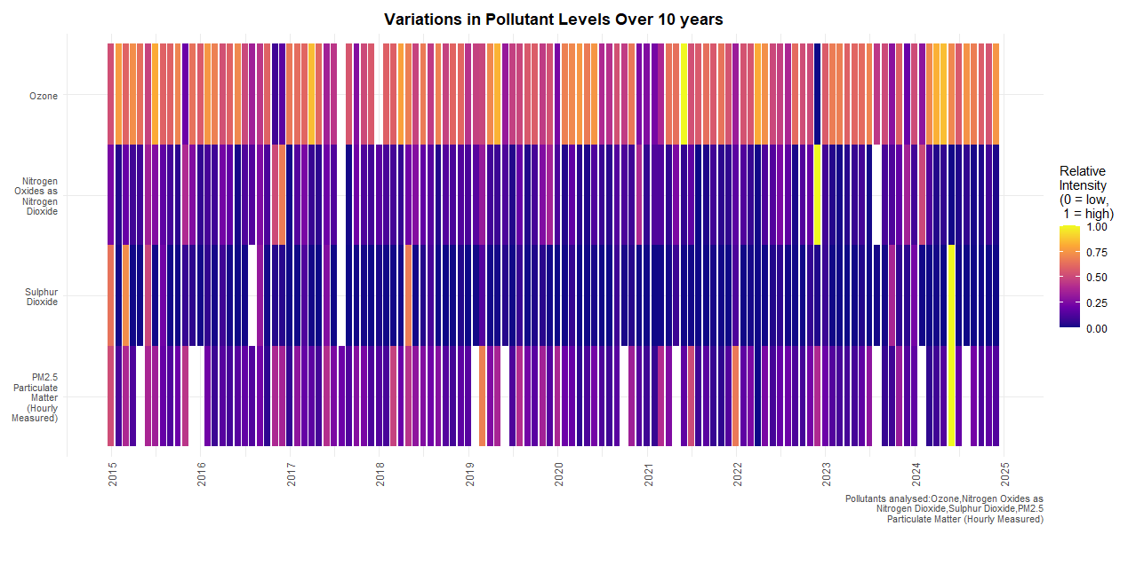
Figure 4 – Variations in pollutant levels
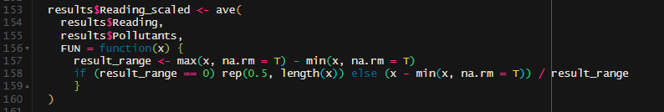
Figure 5 – Scaling script.
The relationship between ozone and nitrogen dioxide was explored using a scatter plot (Figure 6). The visualisation allows the overall structure of the relationship to be assessed across the full dataset. Adding a fitted linear regression line provides a clear visual indication of the direction and strength of the association, supporting interpretation of the Pearson correlation coefficient. Transparency was applied to reduce overplotting caused by the sample size, and annotation of the regression equation, correlation value and sample size links the visual output to the statistical result (Figure 7).

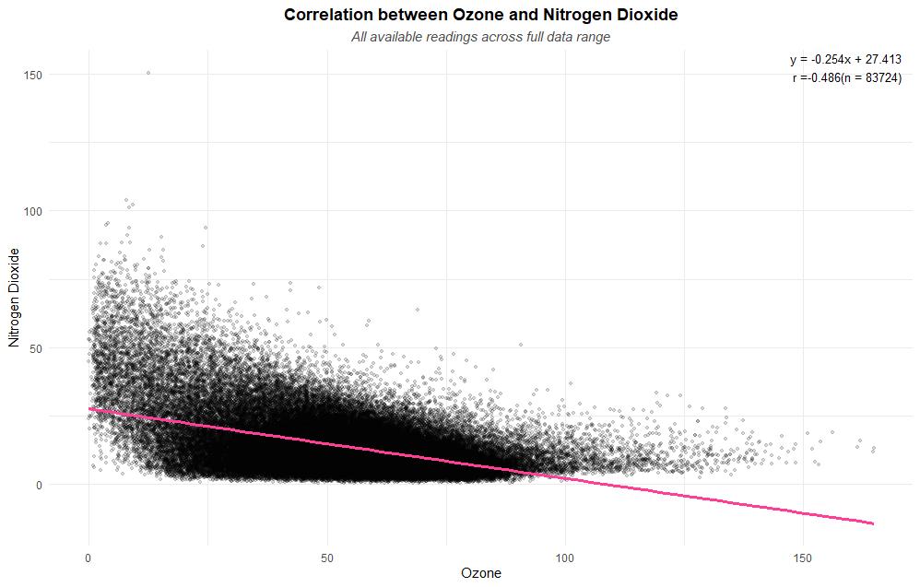
Figure 6 – Correlation between O3 and NO2
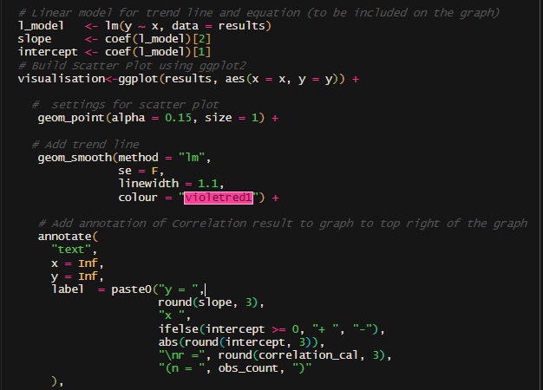
Figure 7 – Script: Linear regression, annotation and transparency formatting.
Ozone levels under different wind speed conditions were compared using a boxplot, which is effective for examining the central tendency between groups. Using jittered points alongside the box plot provided additional insight into data density without overwhelming the visualisation. This allowed distributional differences to be assessed before and alongside the formal t-test.
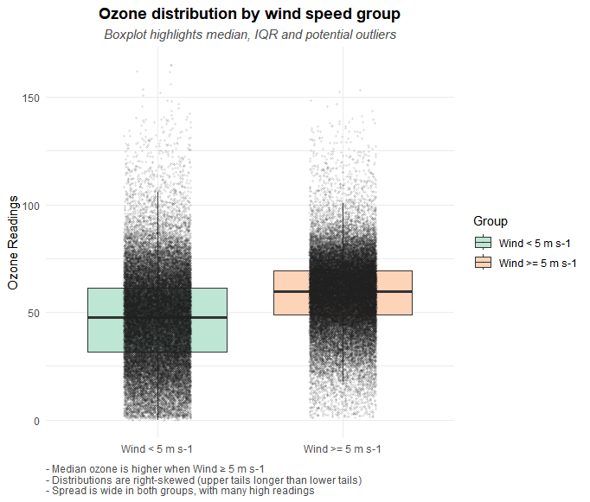
Figure 8 – Ozone Distribution

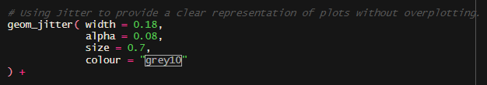
Figure 9 – Jitter Script

While the selected visualisations are effective in communicating patterns within the data, each approach has trade-offs. For example, the heatmap provides a clear high-level comparison across multiple pollutants, which limits precise quantitative interpretation. Similarly, while transparency and jitter improve the readability of dense plots, they require careful tuning to avoid obscuring underlying distributions. On reflection, these trade-offs reinforce the importance of selecting visualisation methods that balance clarity, accuracy and analytical intent, particularly when it comes to presenting complex data to non-technical audiences.

Challenges and Things Learned:
The process reinforced the importance of data transformation and preparation before analysis, particularly when working with large, real-world datasets. An initial challenge involved selecting appropriate external packages. The assignment required plenty of debugging, particularly in handling NA values that generated warnings in the dataframe. The use of dplyr functions such as glimpse() also proved useful for efficiently inspecting and understanding the structure of a large dataset.
Learning to use ggplot2 involved an initial learning curve; however, understanding its layered structure enabled more effective visualisation choices, such as replacing a visually cluttered multi-line plot with a heatmap to improve interpretability. For distributional analysis, the Shapiro-Wilk test was not appropriate due to the sample size, so interpretation relied on visual inspection and the interquartile range, which was a new technique for me when assessing spread and potential outliers.

Improvements for Future Work
An area for future improvement would be further abstraction of metadata, such as pollutant measurement units, into a separate structure to reduce redundancy and improve clarity within the main data set. Visualisations could also be enhanced by dynamically assigning axis labels and annotations based on this metadata.
While ggplot2 was used successfully to generate visualisations, further improvements could be made in terms of font handling, as warnings were encountered due to differences between operating systems. With more time, this would improve portability and ensure consistent visual presentation across environments.
Overall, the assignment strengthened my understanding of statistical programming by combining data manipulation, visual exploration and formal analysis within a single workflow. It highlighted the importance of selecting appropriate tools and visualisation techniques to ensure results are both accurate and clearly communicated.

References and Technical Resources
[1] H. Wickham, ggplot2: Elegant Graphics for Data Analysis. New York, NY, USA: Springer, 2016.
[2] H. Wickham, M. Averick, J. Bryan, et al., “Welcome to the tidyverse,” Journal of Open Source Software, vol. 4, no. 43, p. 1686, 2019.
[3] N. Matloff, The Art of R Programming: A Tour of Statistical Software Design. San Francisco, CA, USA: No Starch Press, 2011.
[4] T. C. Urdan, Statistics in Plain English, 4th ed. New York, NY, USA: Routledge, 2017.
[5] H. Wickham, “ggplot2 documentation,” https://ggplot2.tidyverse.org/, accessed Dec. 23, 2025.
[6] Stack Overflow, “Remove all of x-axis labels in ggplot,” https://stackoverflow.com/questions/35090883/remove-all-of-x-axis-labels-in-ggplot, accessed Dec. 23, 2025.
[7] DataVizPyr, “Remove axis tick and axis text with ggplot2 in R,” https://datavizpyr.com/remove-axis-tick-and-axis-text-with-ggplot2-in-r/, accessed Dec. 23, 2025.
[8] H. Wickham, “aes_colour_fill_alpha,” https://ggplot2.tidyverse.org/reference/aes_colour_fill_alpha.html, accessed Jan. 6, 2026.
[9] DataVizPyr, “Rotate x-axis text labels in ggplot2,” https://datavizpyr.com/rotate-x-axis-text-labels-in-ggplot2/, accessed Jan. 6, 2026.
[10] Puget Sound Regional Council, “Using fonts in ggplot2,” https://psrc.github.io/intro-ggplot2/content/using_fonts.html, accessed Jan. 6, 2026.
[11] H. Wickham, “scale_manual,” https://ggplot2.tidyverse.org/reference/scale_manual.html, accessed Jan. 6, 2026.
[12] H. Wickham, “scale_brewer,” https://ggplot2.tidyverse.org/reference/scale_brewer.html, accessed Jan. 6, 2026.
[13] H. Wickham, “Brewer scales,” https://ggplot2-book.org/scales-colour#brewer-scales, accessed Jan. 6, 2026.
[14] R Graph Gallery, “ggplot2 color,” https://r-graph-gallery.com/ggplot2-color.html, accessed Jan. 10, 2026.
[15] DataNovia, “ggplot title, subtitle and caption,” https://www.datanovia.com/en/blog/ggplot-title-subtitle-and-caption/, accessed Jan. 11, 2026.

Generative AI
Generative AI (ChatGPT) was used as a support tool during the completion of this assignment. Its use was limited to checking the script against the assignment brief to ensure all required elements were addressed and supported structured note-taking for Task 2. This allowed greater focus on the coding and analytical aspects of the assignment.

