
Developing Relationship and Workplace Achievement
BMSK5002 – Brynach Heffernan

Introduction
In this essay I will be critically evaluating three development vehicles available to an organisation.
There are various development vehicles in an organisation to help boost the performance of employees. These development vehicles play an important role in an organisation as it encourages everyone to work harder to achieve their goals.
Below I have stated three development vehicles of an organisation and how they help increase efficiency.
Motivation
The idea of motivation is to encourage the individuals to meet their goal.
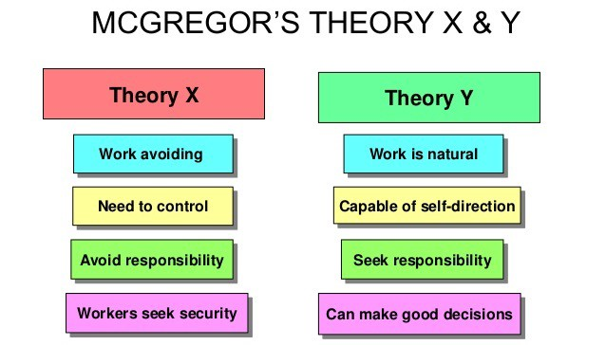
According to McGregor’s theory X and theory Y, theory X is demotivated employees, they are motivated by fear such as losing their jobs because of lack of responsibilities and productivity. Theory Y is self-motivated employees, they are motivated by set individual goals and want to contribute towards the organisation’s success.

If a manager believes that the team members dislike or they do not have motivation towards their work they will use an authoritarian style of management. This approach is very useful and usually involves micromanaging people's tasks to ensure that it gets done properly. McGregor called this Theory X.
On the other side, if a manager believes that team members take pride in their work and see it as a challenge, then they will more likely adopt a participative management style. Managers who use this approach trust their people to take responsibility and ownership of their work and do it effectively by themselves without micromanaging people. McGregor called this Theory Y. (Mind Tools content team, 2019)
Motivation is very essential in a workplace it increases level of productivity, when individual have the urge and willingness to meet their deadlines for each and every task. Motivated employees can make an impact on stakeholders. With the content of job satisfaction can maximise the number of candidates applying for this particular job role.

“Content theories of motivation attempts to explain those specific things that actually motivate the individual at work. These theories are concerned with identifying people’s needs and their relative strengths, and the goals the pursue in order to satisfy their needs.” (Mullins, L.J, Christy, G. 2016 p-228).
According to Ibis Hotel they motivate their employees by offering them meal on duty so that individuals do not have to spend money on food while they work there. After a certain period of time individuals can look forward to their entitlement of 28 days paid holiday including public holidays. The Ibis Hotel offers their employees a company discount card which includes a variety of other benefits. Ibis Hotel also stated that their employees are friendly and it’s a fun place to work so that individuals can adapt themselves quickly to the environment. They also have an excellent career development opportunity. This helps motivate the employees working for Ibis hotel and in return increases work efficiency and productivity. (IBIS Styles London Excel, 2019).
Engagement
The Concept of Engagement in a workplace means employees are focused and have the determination to succeed. It is important that the employees are engaged to their tasks or job role because it will increase productivity. Some times employees can not engage with their tasks due to a personal, physical and behavioural issue. In that case McGregor theory X can be applied, where we have to apply micromanaging people and can give the employees some extra training if required. A manager should set up realistic targets for employees to achieve, if the target is too high then the employees can get distracted and be disengaged from the task or job role. By implementing some incentives and changing some of the training methods it can help engage and involve them towards the organisation.
All Admiral Employees get a share scheme after one year of service. The free shares are allocated twice a year in March and September and each year they have a total value of up to £3,600. Employees can then sell their shares after three years of receiving them. (Admiral, 2019).
The meaning of individual engagement is ambiguous towards their job role among both academic and physical who uses their expertise discussions with clients. It shows that the term is used at different occasions to refer to psychological states, traits, and behaviours as well as their experiences and outcomes. (Schneider, 2015)

Training
Training is one of the extremely important key elements for an organisation. Because without training the employees, as a manager or an employer will not be able to implement the organisational values across to the employees and introduce the job role. Training is also important when there are changes to the organisations values or when introducing any new systems to the employees. Training can be an expensive investment for an organisation. During the training period the manager can assess their employee’s ability and contributions towards the organisation.
Hilton employees are trained to an extreme high level of standard. They believe that employing the right candidate for the job role will uphold their brand. To maintain the high level of customer service successfully, the individuals must maintain their attitude, behavioural skills and organisational values. Before applying for a job at the Hilton each and every candidate must have the following:
- Previous experience in customer service
- Excellent communication skills
- Have the pledge to deliver an outstanding high level of customer service
- Have the capability to work under pressure
(Hilton, 2019).
Organisational training is to attract, retain and motivate the employees. Training prepares employee to use new knowledge, skills and abilities to a better organisational mission, vision and values. (learning, 2016)

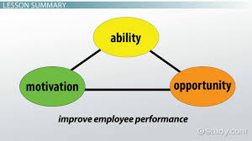
According to the AMO theory. It suggests that there are three independent key components that outline employee ability and contribution to the success of the organisation. organisational interests are best served by a system that attends to the employees Ability, Motivation, and Opportunity. (Tomas, J.M & Marin-Garcia, J.A. 2016, p-1040).

Task 2
The individual plays a very critical role in the operating of the organisation. Individuals contribute in the organisation when they are going to achieve something out of it. For example, the desire for rewards in cash or generous, reputation, the desire to show the skills already developed etc represent some of the motives of the individuals in contributing in an organisation. Individuals tend to recognise themselves with the organisation in which they contribute. There is a close relationship amongst individual’s intentions and their bonding with the organisation. (sociology guide, 2018)
In the workplace employees who have the urge, willingness and self-motivation and contribute to the organisation’s success. Every individual is different and they have their own ways of contributing.
Below I will be critically assessing motivation at my workplace Killay Spice Indian restaurant.
Motivation
At Killay Spice motivation is a very essential key to success and very competitive because this is a customer service sector. The management of Killay Spice is considered to be one of the best motivated organisation in the Indian restaurant industry by offering their employees a weekly incentive and rewards after a twelve months completion review, also any gratuities from the customers all belongs to the employees. Killay spice encourage individuals to succeed in their job role and be promoted to a higher post so that individuals can be more productive. Killay Spice always make sure that all employees are comfortable and safe at workplace. One of their policy is that all tasks or job role are crystal clear so that employees do not have any confusions about their task. Every six months Killay Spice holds a raffle draw with several different prizes for the employees which gives them a chance to win and refresh their mind from the work environment.
Flexibility: Killay Spice allows their employees to contribute a week off their time to concentrate on a task of their choice. This allows the individuals to understand and discover the different sectors at workplace and can help to improve customer service with new thoughts. The working hours are also flexible in case of any emergencies.
Free advantages: Killay Spice offer their employees with additional benefits that motivates staff and keeps them joyful at work. Free staff taxi, gym membership and providing additional training are part of the benefits that employees get while working there.
Safety and Happiness: Every four months Killay Spice carry out an additional safety checks at work to satisfy their employees that they are in a safe work environment. A liability insurance is put in place so that in case of an unfortunate circumstance everyone is covered. Killay Spice values their employees time and effort, any overtime contribution by individuals will be paid time and a half.

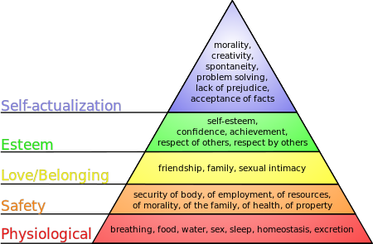
Abraham Maslow developed a theory that recommends and explains how individuals are motivated and satisfied with five basic requirements. These requirements are organised in a hierarchy. According to Abraham Maslow hierarchy, where lower needs takes importance and must be completed before any others are triggered. Once the first one is achieved, then to move up one by one to the top. (Robert Tanner, 2019).
According to Abraham Maslow theory there are different levels of motivation all down to the individuals needs. Killay Spice offer to provide extra training and support and an opportunity to be promoted to a higher post. Any gratuities are shared amongst the employees and bonuses is subject to individual performance. Killay Spice also allows employees to have a week off from their schedule to contribute towards a different department so that individual do not feel reserved and get new thoughts and ideas to improve customer service. In case of any emergencies time off from work can be taken.
However not all employees are motivated in the same way. In killay spice every individual has different needs and requirements and not everyone is motivated with incentives and rewards some people prefer to have an encouraging workplace where managers are delegating tasks equally and inspiring them to work harder as well as appreciating them when doing so, this helps motivate the individuals as well as the whole team which in return makes the workplace cultivating and optimistic for everyone. The culture of the workplace is lenient where all employees have freedom to understand the job properly which makes them more responsible.
In comparison with Killay Spice Dragon Hotel has been motivating their staff differently which led to them being more successful.
According to Indeed one of the employees working at Dragon hotel stated that staff and management are friendly and always encourage and motivate each other to reach their goals. (indeed, 2017).
According to TripAdvisor a review left by one of their customers stated that the management at Killay Spice need to maintain their time properly and encourage and motivate their employees to provide a better customer service. Also, they should allow time slots between their customers reservations and not to over booked the restaurant. (TripAdvisor, 2018).

Engagement
Individual engagement is an important vehicle for Killay Spice because employee’s engagement is key to their customer service. The management of Killay Spice always try to keep their employees engaged with their tasks or job roll by making the working environment optimistic as well as maintaining a high standard of professionalism. Employee engagement is based on how an individual consider their job role and how much they are committed for an organisation’s goals, values and have the urge to contribute to organisational success with the intelligence of their own well-being.
“This is about how we create the conditions in which employees offer more of their capability and potential”. (MacLeod, D. 2018)
Killay Spice consider individual engagement as a two-way commitment where communication amongst an organisation and its employees is essential, it is based on faith and integrity. It also can increase organisational success as well as individual performance, productivity and job satisfaction.
William Kahn in his 1990 study, ‘Psychological Conditions of Personal Engagement and Disengagement at Work’, has built on the theories of Frederick Herzberg and Ryan & Deci. Kahn’s main purpose was to build on these theories however he conducted his own study by perceiving and analysing the behaviours at workplace.
William Kahn’s theory stated that employee’s engagement is divided into three psychological condition which are:
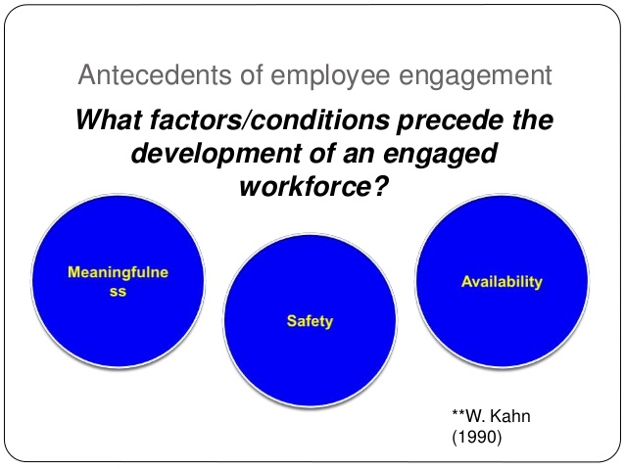
- Meaningfulness: Killay Spice believes that If an employee finds the work significant to permit themselves to engage with the work and the organisation.
- Safety: if an employee feels safe to come to work without a possibility of risking themselves to adverse consequences.
- Availability: if an employee feels emotionally and physically engaged at their work at this specific time.
(Young, J. 2018)

According to William Kahn’s theory In Killay Spice employees are approached as true partners including them in all decision-making processes and when taking certain decisions when changing roles, responsibilities and work relations. The manager in Killay Spice makes the working environment safe for all the employees as well as giving them the freedom of putting their views and opinions forward which are taken into consideration when making a decision.
Training
Training is a vital key element for Killay Spice. The concept of training is taken seriously to consideration and Killay Spice train their employees to the high levels of standard. It is not necessary to have previous experience due to all employees start from the scratch. Every individual is different that is why Killay Spice offer varieties of different method of training such as hands-on. The idea of hands-on is to let the individuals explore the workplace environment, learn as they work and pick up every tips and tricks of the trade. By doing that individuals can introduce themselves to other employees and the customers. This can make them feel comfortable in the work environment. Killay Spice believes that by using Hands-on method it can minimize the level of conflict in an organisation and judge their employee’s ability as well as individual’s level of team playing skills.
“Hands-on training skips the conceptual and dives right into the practical, allowing trainees to quickly get their hands on whatever they’re learning. This approach is widely preferred by employees, 52% of adults say the best way to learn is through active participation. On top of being well-received by trainees, hands-on learning also has several other advantages. It’s often a quicker process because you dive in on day one. It can also boost knowledge recollection; long days in a training lecture may leave some trainees fried, but hands-on training requires focus, which can improve information retention”. (6 Popular Employee Training Methods, 2019)
However, compared with Killay Spice Dragon hotel is more established. The reason being is they require minimum of two years previous skills and experience in hotels from their employees and have good reference from the previous employer. Dragon hotel believes that by doing this they are not putting their customers or their reputation at risk. Also, by having the previous employers reference they can analyse the individual’s performance as well as any behavioural issues. (The Dragon Hotel Swansea, 2019).
Although Killay Spice uses the method Hands-on by having previous skills and experience they will not put their reputation at risk. It can also take long time to train inexperience individuals.

Task 3
Personal Development Plan
Personal development plan is a method to reflect on individuals progress categorising the importance of the improvement where required. It also allows the individuals to investigate different types of resources and where to seek help when needed. Individuals can also make some plans and implement changes or take actions in the required areas. (University of Leicester, 2019).
Objectives | Measures | Priority | Support & Development  Internal External |  | Review Dates | Other Comments
Improve on customer service | Focus on customers experience all time they in the premises and look for touch points. | High | Training, support and development | Join online courses to improve on customer service | 3 months | Being polite, having an optimistic friendly environment while attending customer with a positive attitude.
Improve management skills | Maintaining time management, develop a good understanding with employees | Medium | Schedule for day to day duties, brief on every start of the shift. | Setting up early to improve time management and become more productive | 1 month | Prioritising tasks according to their importance, allocating tasks equally amongst employees will help to increase productivity
Problem solving and decision-making skills | Analysing the main issues that are affecting the circumstances | High | Implementing a strategy to solve the problem and offer a solution | Analysing the problem by breaking it down into parts, Writing it down. | 3 months | Analysing the problem in small sections helps to find the solution. Listing solutions helps to come up with the best one.
Self - Awareness | Reflecting back on the day helps realise the strong points and the flaws. | Low | Feedback and suggestions from peers. | Taking psychometric tests to assess levels of self-awareness | Review at the following appraisal | Stepping out of comfort zone and trying out new experiences will help create awareness of responding in different ways.

The personal development plan above states how a manager in a restaurant should perform to be more productive for an organisation.
The first objective is to improve customer service. Customer service is a key element for an organisation no matter if it is a big or a small organisation. Providing a good customer service will increase customer loyalty to the business this will allow customers to spend more. It can also generate the word-of-mouth which is a free advertisement and it can help build up business reputation. (Business.gov.au, 2019).
The second objective is to improve management skills. Management is a very important part for any organisation. Without any management a restaurant cannot operate properly. The restaurant manager will decide when to implement or change any rules and regulations. A good manager will ensure that the establishment is running successfully and implement all the organisational values across to the employees and maximize productivity. (Sandy, 2014).
The third objective is to improve problem solving and decision making. These are important in a restaurant business because as a manager they have to have the knowledge and understanding of the concept of problem solving and decision making and stay calm. First, they have to identify the type of the problem, research for alternatives and think over the alternatives to make the right choice then implement and make decision for the problem. (BC Campus, 2019).
The fourth objective is to improve self-awareness. Self-awareness is an important aspect as it helps reflect on the actions and to find out the strengths and weaknesses. It allows individuals to look back and compare any mistakes committed previously to ensure that it doesn’t happen again. In the food industry it is important for a manager to be able to manage their staff and also reflect back on their actions to make them aware of their mistakes. Feedbacks and suggestions from colleagues in the workplace formally or informally help to increase self-awareness. (Tjan, A. K. 2015).

References
6 Popular Employee Training Methods. (2019). wyzowl. [Online]
Available at: https://www.wyzowl.com/employee-training-methods/
[Accessed 03 04 2019].
Admiral. (2019). Seven key facts about the Admiral Share Scheme. [Online]
Available at: https://admiraljobs.co.uk/inside-admiral/post/51/Seven-key-facts-about-the-Admiral-Share-Scheme
BC Campus. (2019). Effective Problem Solving and Decision Making. [Online]
Available at: https://opentextbc.ca/workinginfoodserviceindustry/chapter/effective-problem-solving-and-decision-making/
[Accessed 04 04 2019].
Business.gov.au. (2019). Customers. [Online]
Available at: https://www.business.gov.au/people/customers
[Accessed 04 04 2019].
Gregg learning. (2016). Youtube/Introduction to Employee Training and Development. [Online]
Available at: https://www.youtube.com/watch?v=CLm-UaRAwtE
[Accessed 28 03 2019].
Hilton. (2019). Assistant Front Office Manager Job Summary. [Online]
Available at: https://jobs.hilton.com/job/Assistant-Front-Office-Manager/J3S1TK79PQPHNJ80ZXB
[Accessed 04 04 2019].
IBIS Styles London Excel. (2019). IBIS Styles London. [Online]
Available at: https://www.google.co.uk/search?ei=SFWlXMitEdeBjLsPlryY2AQ&q=ibis+styles+career&oq=ibis+styles+career&gs_l=psy-ab.3..0j0i22i30l2j0i22i10i30j0i22i30l2.8505.12388..13928...0.0..0.111.539.6j1......0....1..gws-wiz.......0i71j0i67.1ip7A5OSfd4&ibp=htl;jobs&sa=X
[Accessed 04 04 2019].
Indeed. (2017). Dragon hotel. [Online]
Available at: https://www.indeed.co.uk/cmp/Dragon-Hotel/reviews?fcountry=GB&floc=Swansea
[Accessed 03 04 2019].
MacLeod, D. (2018). Engaging For Success. [Online]
Available at: https://engageforsuccess.org/our-founders
[Accessed 02 04 2019].
Mind Tools content team. (2019). Theory X and Theory Y. [Online]
Available at: https://www.mindtools.com/pages/article/newLDR_74.htm
Mullins, L. J. &. Christy, G. (2016). Management and Organisational Behaviour. 11th ed. Harlow: Pearsons Education Limited, pp-228.

Robert Tanner, M. (2019). Motivation – Applying Maslow’s Hierarchy of Needs Theory. [Online]
Available at: https://managementisajourney.com/motivation-applying-maslows-hierarchy-of-needs-theory/
[Accessed 02 04 2019].
Sandy. (2014). Managers Play A Crucial Role In The Success Of A Restaurant. [Online]
Available at: http://www.cooking-culinary-arts-schools.org/2014/04/03/hospitality-programs/restaurant-management/managers-play-a-crucial-role-in-the-success-of-a-restaurant.asp
[Accessed 04 04 2019].
Schneider, William H. Macey and Benjamin (2015). The Meaning of Employee Engagement. Industrial and Organizational Psychology, pp. 3-30.
Sociology guide. (2018). roles of individual in organisation. [Online]
Available at: http://www.sociologyguide.com/organization-and-individual/role-of-individual-in-organizations.php
[Accessed 01 04 2019].
The Dragon Hotel Swansea. (2019). The Dragon hotel swansea jobs. [Online]
Available at: https://www.google.co.uk/search?q=The+Dragon+Hotel&ibp=htl;jobs#fpstate=tldetail&htidocid=ZCigQz3CF6lLN3RwAAAAAA%3D%3D&htivrt=jobs
[Accessed 03 04 2019].
Tjan, A. K. (2015). Harvard Business Review: 5 Ways to Become More Self-Aware. [Online]
Available at: https://hbr.org/2015/02/5-ways-to-become-more-self-aware
[Accessed 04 04 2019].
Tomas, J. A. & Marin-Garcia, J. M. (2016). Deconstructing AMO framework: A systematic review. OmniaScience, 12(4), pp. 1040.
TripAdvisor. (2018). Killay Spice. [Online]
Available at: https://www.tripadvisor.co.uk/Restaurant_Review-g186466-d9609871-Reviews-or10-Killay_Spice-Swansea_Swansea_County_South_Wales_Wales.html#REVIEWS
[Accessed 04 04 2019].
University of Leicester. (2019). Personal Development Planning. [Online]
Available at: https://www2.le.ac.uk/offices/ld/personal-development-planning-pdp
[Accessed 04 04 2019].
Young, J. (2018). Heroes of Employee Engagement: No.9 William Kahn. [Online]
Available at: https://peakon.com/blog/future-work/william-kahn-employee-engagement/
[Accessed 02 04 2019].

