

FAKE NEWS DETECTION IN ELECTIONS – ANALYZING TWITTER DATA DURING UK ELECTIONS

Program : MSC Software Engineering and AI
Student ID : 2418717
Student Name : FORUM NITINKUMAR PASTAGIA
Module Code : ACFA7003
Module : Master Project
Lecturer : Nouh Elmitwally

TABLE OF CONTENTS

INTRODUCTION 3
Overview of the problem area 3
Importance of the project 3
LITERATURE REVIEW 3
Related Work 3
Comparison and justification of Different Approaches 4
Comparison table 4
RATIONALE AND RESEARCH GAP 5
PROBLEM STATEMENT 5
RESEARCH AIM AND OBJECTIVES 6
Research Aim 6
Objectives 6
SCOPE AND LIMITATIONS 6
METHODOLOGY 6
Description of the System Architecture 7
Flowchart Diagram 8
Data Collection Method 8
EXPECTED OUTCOMES & IMPACT 9
PROJECT TIMELINE 9
REFERENCES 10

INTRODUCTION

Overview of the problem area
The spread of fake news has led to social media, particularly in Twitter, being a major source of threat in matters of democratic integrity. The presence of fake news in the electoral campaigns may depict the voters in a negative light, spoil the overall opinion and publicity, and undermine the faith in the institution of democracy itself. Consequently, it is important to devise a uniform method of identifying and labeling such disinformation to ensure that the outcome of elections would remain unaffected. Twitter has become an essential source of political conversation, in which the communication can be distributed at an extremely fast rate, and cannot just bolster genuine information, but it can also discourage and create information.
The study will also seek to develop a powerful model of how to detect and estimate counterfeit news on Twitter in regards to elections in the UK. The research will enlighten the policy makers, the social media service providers, as well as voters, on how misinformation can be minimized and the factual dissemination of the political communication propagated.

Importance of the project
The project is substantial because it will serve to ensure the integrity of the democratic count on the basis of the elections by establishing the final system through which the fake news on Twitter during UK elections is noted and scrutinized. The study will be advantageous as it will identify linguistic, behavioral, and sentimental aspects distinguishing fake news from authentic news through a small number of available tools. Awareness of such trends will assist the policymakers, the social sites, and the voters in order to prevent the false information. The results will be utilized to make evidence-based decisions and provide the methodological foundation of upcoming research that will deal with any military misinformation in the future, and even make democracy more transparent and feature responsible digital communication practices.

LITERATURE REVIEW

Related Work
Social Media and Political Communication
Politics has found its way to social media, and this is where politics has greatly described its political communication with references made to the formation of electoral outcomes. In particular, Twitter makes it possible to distribute information fast and contribute to spreading of misinformation due to its viral nature. According to specialists, Twitter political rhetoric does not merely respond to the mood of citizens but can even control the latter [1]. This is not a newly recorded phenomenon when it comes to the power that social media wield over the electorate.
Fake News Detection Techniques
False news recognition has developed very much in the research where computer techniques are on the forefront. The TEG language cues are based on their application to the NLP solutions (mood, semantics, and syntax), which contribute to the differentiation between fake news and authentic news [5]. Classical machine learning methods, such as random forests and support vector machines (SVMs), and the deep learning approach, such as LSTMs, have been applied in categorization.
Misinformation during Elections
Other electoral instances have offered circumstances of misinformation, highlighting factors in gameplay. It found that the spread of fake news reached new heights in the 2016 US presidential election, and the same is witnessed in European and Asian elections [4]. Although the research on the influence of misinformation in the political conversation in Britain has provided evidence to the effect, not many studies combine the tools of NLP, machine learning, and social network analysis in a unified system.

Comparison and justification of Different Approaches
The existing studies of fake news detection have pursued alternative methods. Azer et al. (2021) put particular emphasis on the area of social media and political communication, concerning analytical implications of Twitter on voter behavior, yet failed to deploy automated fake news detection. Tsai (2023) used the method of NLP with a focus on mood, semantics, and syntax to classify content, but he focused exclusively on all features of the text, without paying attention to networks or behavior. Sharma et al. (2022) consider the problem of misinformation in elections with the help of case studies, without predictive modeling or computing methods involved. The proposed project uses NLP and machine learning in addition to deep learning (LSTM, transformer models) and network-based features to fill these gaps, creating a predictive framework that is robust. .

Comparison table
Study / Author | Focus / Approach | Techniques Used | Limitations / Gaps | How Your Study Differs / Adds Value
Azer et al., 2021 | Social media and political communication | Analysis of Twitter’s influence on voter behavior | Focused on public sentiment; no automated fake news detection | Combines social behavior analysis with NLP and ML for systematic fake news detection
Tsai, 2023 | Fake news detection using NLP | Mood, semantics, syntax analysis for classification | Limited to textual analysis; no network-based features | Incorporates linguistic, behavioral, sentiment, and network features using ML and deep learning models
Sharma et al., 2022 | Misinformation in elections (US & global) | Case studies of misinformation spread | Lacked real-time or predictive modeling; no integration of NLP & ML | Develops a predictive framework integrating NLP, ML, deep learning, and network analysis for UK election data

RATIONALE AND RESEARCH GAP
The existing literature has demonstrated several gaps, which have been UK-based analysis, application of multilingual election discourse, and lingering difficulties in granting real-time turnover. With these gap areas identified, the proposed study aims to come up with a common framework that integrates NLP, machine learning, as well as network-based techniques in the detection and analysis of fake news in the UK election cycles.

PROBLEM STATEMENT
False news circulation on social media and Twitter in particular has been mentioned as a massive threat to democracy. In the case of the UK election, people can use fake news to argue in a deceiving manner to the voters, form a psychological view of the people, and create a lack of trust in the democratic structures [11]. Having a method to determine and define this disinformation will be key to having its influence on the integrity of votes.

RESEARCH AIM AND OBJECTIVES

Research Aim
The study aims to develop a framework using NLP, Machine Learning, and Deep Learning to extract linguistic, behavioral, and sentiment features, classify fake news on Twitter during the UK 2019 election, and critically reflect on misinformation detection challenges.

Objectives
- To identify and categorize the types of misinformation most prevalent on Twitter during the UK elections.
- To extract and analyze linguistic, behavioral, and sentiment features from tweets and determine their effectiveness in predicting fake news.
- To develop and evaluate Machine Learning and Deep Learning models (such as, Random Forest, SVM, LSTM, BERT) for accurate classification of fake news tweets.
- To examine how misinformation patterns vary across different electoral contexts and reflect on challenges and implications for detection and mitigation strategies.

SCOPE AND LIMITATIONS
This study works with the Twitter data related to the UK elections in 2019 and specifically the General Election. It reviews political content and points of engagement, such as likes, retweets, replies, and credibility of the accounts, to fully identify fake news promotion [7]. In order to ensure consistency under the NLP process, non-English tweets will be filtered or translated.
However, the study has many limitations. To begin with, the data available is only among published UK General Election Electioneering tours of 2019 on Twitter, which may not necessarily reflect all the conversations and personal experiences. Also, it can be a limitation on the language diversity, which can compromise the integrity of linguistic peculiarities.

METHODOLOGY
System Development Approach
In this research, an iterative approach based on agile principles in the construction and testing of the fake news detector framework will be followed. Data preprocessing cycle, feature extraction cycle, machine learning, deep machine learning model development, and evaluation processes will be performed iteratively [8]. The cycle would consist of testing, verification, and model optimization at each stage, thus allowing changes to be adaptively applied according to the viewed outcomes.
Tools & Technologies
It will be based on Python as the programming language, exploiting NLP tasks with libraries like NLTK, SpaCy, and TextBlob and machine learning algorithms like Random Forest and SVM through scikit-learn. Models based on deep learning, such as LSTM or transformer-based networks (BERT), will be implemented with the help of Tensorflow and PyTorch [6]. NumPy and pandas will be utilized to process and analyze data and Matplotlib and Seaborn will be utilized to visualize data. The data will be handled through CSV, making handling and replication easy.
Requirements Analysis
Functional Requirements: Tweets will be preprocessed (tokenization, lemmatization, cleaning), linguistic, behavioral, and sentiment features will be extracted, and ML (Random Forest, SVM) and deep learning (LSTM, BERT) communication models will be implemented to classify fake news, and interaction patterns of the network will be integrated [9]. Accuracy, precision, recall, F1-score, and ROC-AUC will be used to evaluate the model with the results presented in an aggregated, anonymized format.
Non-Functional Requirements: The system shall provide high performance, precision, reproducibility, scaled, as well as maintainability [12]. Ethical obedience and privacy of the user are imperative. Outputs created must be understandable and practical, and assist stakeholders in making decisions and counter misinformation on Twitter.
System Architecture

Description of the System Architecture
The suggested system adheres to a recursive pipeline of the list of fake news in Twitter. Raw tweets are gathered together and preprocessed (removal of stop-words, tokenization, and lemmatization) [10]. Displayed languages, behaviour, emotions are mined and incorporated into the ML and deep learning algorithms (Random Forest, SVM, LSTM, BERT). The output labels tweets as fake and real. Prediction is improved with network-based capabilities and user interaction measures.

Flowchart Diagram
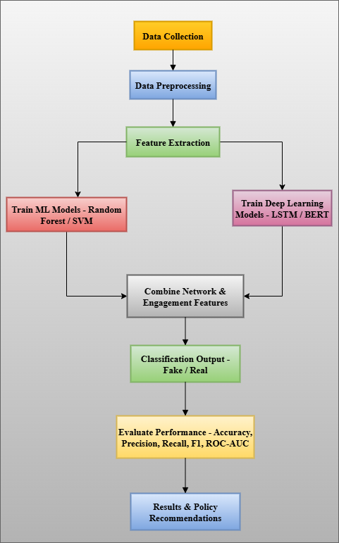
Figure 1: Fake News Detection System Architecture
(Source: Draw.io)

Data Collection Method
The secondary data collection of the study will rely on the dataset of 2019_all twitter data.csv (Source: https://www.kaggle.com/datasets/albrace/twitter-data), which includes tweets about the UK elections. Some of the important fields are tweet content, engagement (likes, retweets, replies), user metadata (followers, verified), and quotation or mentioning a tweet.
In this work, a quantitative and computational research design is embraced in order to identify and examine the phenomenon of fake news on Twitter during the UK 2019 General Election. The classification of tweets will be based on a combination of NLP and ML methods, determining whether they are fake or real [2].

EXPECTED OUTCOMES & IMPACT
This study predicts outcomes from analyzing fake news dissemination on Twitter during the UK 2019 elections by different techniques. The information available in the dataset will consist of textual materials, measures of user engagement, and the credibility of the personal account. NLP will also be used to extract the linguistic characteristics of tweets (sentiment polarity, lexical selection, syntactic structures) to feed the machine learning classifiers. Additionally, deep learning models such as LSTM and transformer-based architectures (BERT) will be applied to capture contextual and sequential patterns in tweets, enhancing fake news classification performance.
These features will be processed into the ML models whose outputs will be used to categorize tweets as fake or real news with the support of random forest and Support Vector Machine (SVM). The model performance evaluation will be user-based on the accuracy, precision, recall, and the F1-score.

PROJECT TIMELINE
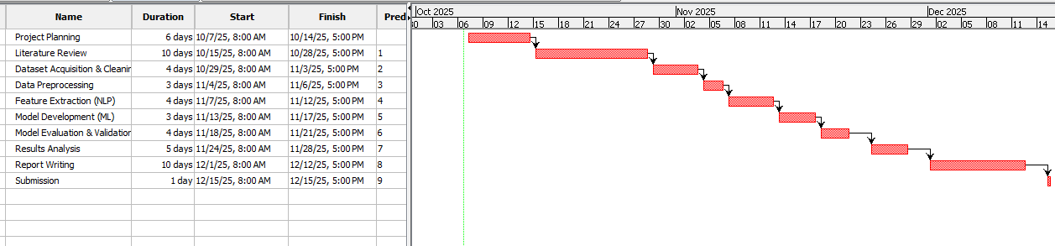
Figure 2: Gantt chart
(Source: Projectile)

REFERENCES
[1] Azer, M., Taha, M., Zayed, H.H. and Gadallah, M., 2021. Credibility detection on twitter news using machine learning approach. International Journal of Intelligent Systems and Applications, 10(3), p.1.
[2] Bashaddadh, O., Omar, N., Mohd, M. and Khalid, M.N.A., 2025. Machine Learning and Deep Learning Approaches for Fake News Detection: A Systematic Review of Techniques, Challenges, and Advancements. IEEE Access.
[3] Khanam, Z., Alwasel, B.N., Sirafi, H. and Rashid, M., 2021, March. Fake news detection using machine learning approaches. In IOP conference series: materials science and engineering (Vol. 1099, No. 1, p. 012040). IOP Publishing.
[4] Sharma, S., Saraswat, M. and Dubey, A.K., 2022. Fake news detection on Twitter. International Journal of Web Information Systems, 18(5/6), pp.388-412.
[5] Tsai, C.M., 2023. Stylometric fake news detection based on natural language processing using named entity recognition: In-domain and cross-domain analysis. Electronics, 12(17), p.3676.
[6] Alshuwaier, F.A. and Alsulaiman, F.A., 2025. Fake News Detection Using Machine Learning and Deep Learning Algorithms: A Comprehensive Review and Future Perspectives. Computers, 14(9), p.394.
[7] Yakkundi, S., Patil, R., Sangani, S., Goudar, R.H., Goudar, S.I. and Qazi, A., 2025. Exploring machine learning for fake news detection: techniques, tools, challenges, and future research directions. Discover Applied Sciences, 7(8), p.873.
[8] E. Almandouh, M., Alrahmawy, M.F., Eisa, M., Elhoseny, M. and Tolba, A.S., 2024. Ensemble based high performance deep learning models for fake news detection. Scientific Reports, 14(1), p.26591.
[9] Albtoush, E.S., Gan, K.H. and Alrababa, S.A.A., 2025. Fake news detection: state-of-the-art review and advances with attention to Arabic language aspects. PeerJ Computer Science, 11, p.e2693.
[10] Hamed, S.K., Ab Aziz, M.J. and Yaakub, M.R., 2023. Fake news detection model on social media by leveraging sentiment analysis of news content and emotion analysis of users’ comments. Sensors, 23(4), p.1748.
[11] kcl.ac.uk, 2024. How is 'fake news' affecting the UK General Election and can anything be done about it?. Accessed From: https://www.kcl.ac.uk/how-is-fake-news-affecting-the-uk-general-election-and-can-anything-be-done-about-it [Accessed On: 08-10-2025].
[12] Alonso, M.A., Vilares, D., Gómez-Rodríguez, C. and Vilares, J., 2021. Sentiment analysis for fake news detection. Electronics, 10(11), p.1348.

