
CONINENTALhotel budget planner
Module: financial management for the Hotel Industry (BMIH5007).
Lecturer: Dale Clarke.
Student: Mukhlishah Raja (2020782).



Executive Summary

This report has calculated a budget plan for the continental hotel in London for January 2022 to December 2023. The report has detailed the budgeted income and expenditure for The Continental Hotel from January 2022 to December 2023, it has also shown the net monthly income/expenditure alongside the opening and closing balance on the hotels bank balance. This report has detail the zero-base budgeting techniques to implement budgeting approach for the future. This report will focus on 3 sections which are:
- Traditional based budget and zero-base budget
- How zero-based budget can be implemented, and the process used
- Supporting budget control via sustainability.

The Continental hotel is based in London and is a small hotel with only 15-rooms. This hotel charges £250 per night, per room. According to the gat away lounge (2021) the average price for a 5-star hotel room in London is between £250-£350 per night.
A brief look into both traditional budgeting as well as zero-based budgeting; understanding that traditional based budgeting is prepared based on the previous year's data as a base and zero-based budgeting is based on zero as a base. Traditional budgeting requires less justification to zero-based budgeting as it is assumed there is no previous data to go by. As zero-based budgeting is based on zero it requires more deep analysis and complex calculations.
Sustainability was further investigated to investigate if sustainability can be of support to budget controls. It is understood that sustainability according to is meeting the present needs and requirements without harming or compromising on future generations in the process to fulfil present requirements. The report found that sustainability impacts customers and sustainability can be a massive asset to the hotel industry as Budgeting control can support sustainability as innovative strategies can be utilised to ensure more sustainability measures, this works well with marketing as people like to feel good about helping the environment, this also helps the business as less use of water by encouraging customers to re-use towels will save the company on costs.
The continental hotel can easily improve sustainability with slight changes:
- Limit water waste by encouraging customers to reuse.
- Use cleaning supplies more friendly to the environment like steam cleaning
- Make eco-friendly adaptation to hotel facilities
- Reduce plastic usage
- Recycle where possible

Table of Contents
Executive Summary 1
Introduction 4
Budgeting: Traditional based budgeting vs zero-based budgeting. 4
The Continental Hotel Budget planner: 4
Financial Analysis 5
Financial Analysis Trends 5
Conclusion (average of 10% of word count) 6
Bibliography 7

I tried updating the contents page but it would allow me to adjust or change it nor update it?

Introduction

This report will detail the budgeted income and expenditure for The Continental Hotel from January 2022 to December 2023, it will also show the net monthly income/expenditure alongside the opening and closing balance on the hotels bank balance. This report will detail the zero-base budgeting techniques to implement budgeting approach for the future. This report will focus on 3 sections which are:
- Traditional based budget and zero-base budget
- How zero-based budget can be implemented, and the process used
- Supporting budget control via sustainability.

The Continental hotel is based in London and is a small hotel with only 15-rooms. This hotel charges £250 per night, per room. According to the gat away lounge (2021) the average price for a 5-star hotel room in London is between £250-£350 per night.

The Continental Hotel Budget planner:

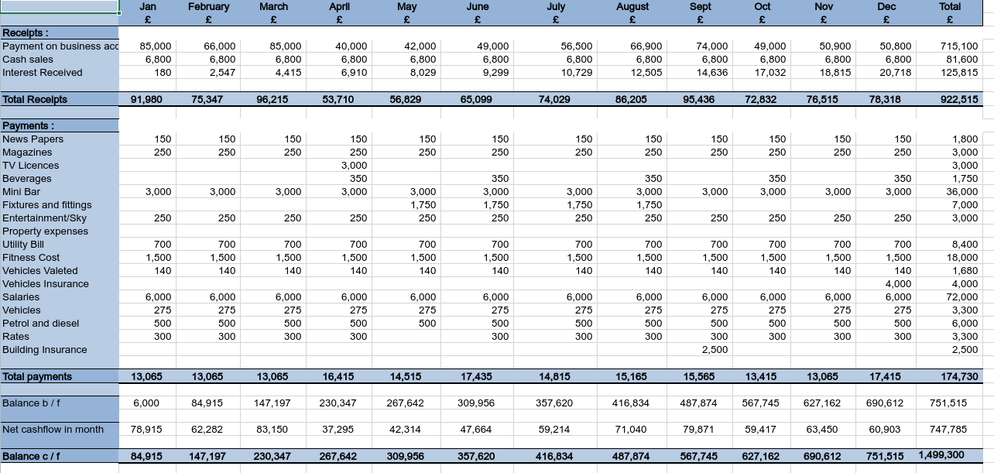
Word excel has been used to Prepare the budget planner for the hotel for the forthcoming year. This shows the budgeted income and expenditure clearly categorized, It also clearly show the net monthly income/expenditure and the opening and closing balance on the hotels bank balance. This has been worked out to the nearest pound. This report has assumed that four weeks in a calendar month.

Budgeting: Traditional based budgeting vs zero-based budgeting.

According to accounting tools (2022) the budget is a set of financial plans that describe businesses assumed future. A budget is used as guide using actual operating results. the budget plan is used for funding as a plan for future operations.

Traditional based budgeting:
This method of budgeting is used with the previous year's budget as a base with adjustments made around environmental and market requirements with consumer requirements considered. The previous year's costs and revenues are to be considered the main factors in traditional based budgeting. The advantages and disadvantages for this method is (e-finance management, 2022):
The advantages of traditional based budgeting are:
- Implementation
- Stability
- Decentralisation
- Consolidation
- Easy to prepare
The disadvantages of traditional budgeting are:
- Fixed and rigid
- Less motivation and creativity
- Excessive reliance
- Inflation
- No priority for resource allocation.

Zero-based budgeting:
Zero-based budgeting which is also known as ZBB is a method used where all expenses are justified. The ZBB starts from a zero base, every finance is analysed within the organisation for costs and requirements, budgets are then facilitated around requirements for the upcoming period. The buget disregards whether the budget is higher or lower than the previous ones (Kagan,2022).
Prasanna (2022) details the advantages and disadvantages of zero-based budgeting as follows:
The advantages of ZBB:
- Justify all expenses
- Expenses kept in check
- Promotes optimisation within management
- Promotes transparency
- Promotes strategical growth
The disadvantages of ZBB:
- Time consuming
- Might harm company in long run
- Risk or manipulations
- Risk of fraud
- Risk of non-factual data used

According to e-finance management (2022) traditional based budgeting is prepared based on the previous year's data as a base and zero-based budgeting is based on zero as a base. Traditional budgeting requires less justification to zero-based budgeting as it is assumed there is no previous data to go by. As zero-based budgeting is based on zero it requires more deep analysis and complex calculations.

The process of zero-based budgeting and implementation

The zero-based budget process n 5 steps according to chegg.com (2022):
- Identifying the decision factors, this can be identified by categorising activities which are meaningful.
- Using the identified decision factors in the zero-based budgeting process a decision package is to be created, this is done by creating smaller segments or decision packages whilst keeping the company's objectives in mind.
- Rate the decision packages in order of importance: management should ensure accuracy of each decision package cost before ranking importance order.
- Available resources and funds should be allocated, the more important or significant factors get more funding.
- Finally, the last step is to control and monitor the performance in the decisions made, this can help management understand specifics in each department.

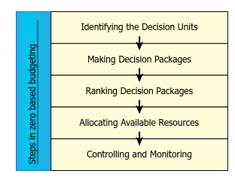

According to Ueland (2020) the process of Zero-based Budgeting is broken down into a similar 5 level process of objective, visibility, template, choices, and control like the diagram below:
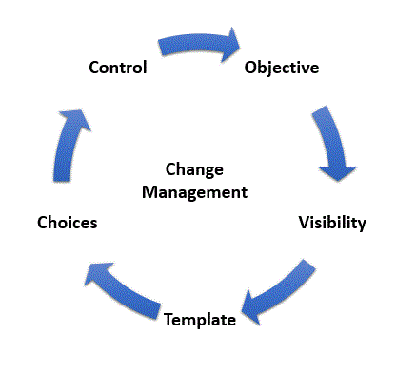

Can budgeting control and support sustainability?

Sustainability according to Mcgil (2022) is meeting the present needs and requirements without harming or compromising on future generations in the process to fulfil present requirements.

There are 3 types of sustainability which are:
- Social equity
- Environmental protection
- Economic viability

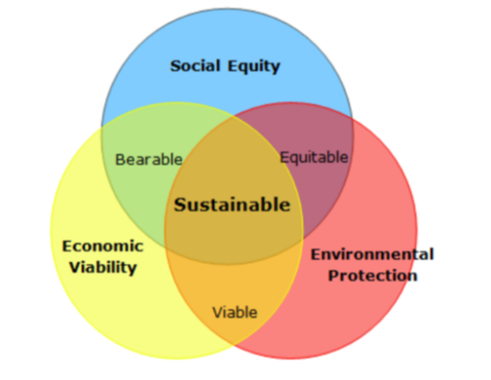(Future learns, 2022).

- Social sustainability focuses on reducing impact on humans, this includes eliminating abuse like child labour, encouraging fair trade. This is the hardest sustainability to define according to Kvallsbris (2020).
- Environmntal sustainability focuses on minimising environmental impact on the planet by reducing greenhouse gas emissions, minimising pollution, and global warming. This is the most focussed sustainability (Evans, 2020).
- Economical sustainability is the ability to support itself financially without impacting the social, cultural, and environmental aspects of a community (University of Mary Washington, 2022).

Sustainability supports finances by (Accounting for sustainability, 2022):
- cost cutting: by creating a sustainable business can reduce the overall business expenditures. For example, using less water will cute water charges
- Efficiencies: less use of recourses like water cuts washing times if customers are encouraged to re-use towels.
- Reduce environmental damages causes by pollution which will reduce insurance claims
- New opportunities
- Innovations in business practises may encourage more employment

Budgeting control can support sustainability as innovative strategies can be utilised to ensure more sustainability measures; this works well with marketing as people like to feel good about helping the environment (world happiness report, 2020).

The continental hotel can easily improve sustainability with slight changes (Just means, 2019):
- Limit water waste by encouraging customers to reuse beddings and towels causing less washing which will result in less chemical use as well as water use.
- Use cleaning supplies more friendly to the environment like steam cleaning which will save on replacing chemicals cleaners
- Make eco-friendly adaptation to hotel facilities
- Reduce plastic usage
- Recycle where possible

Conclusion.

This report has calculated a budget plan for the continental hotel in London for January 2022 to December 2023. A brief look into both traditional budgeting as well as zero-based budgeting; understanding that traditional based budgeting is prepared based on the previous year's data as a base and zero-based budgeting is based on zero as a base. Traditional budgeting requires less justification to zero-based budgeting as it is assumed there is no previous data to go by. As zero-based budgeting is based on zero it requires more deep analysis and complex calculations.
Sustainability was further investigated to investigate if sustainability can be of support to budget controls. It is understood that sustainability according to is meeting the present needs and requirements without harming or compromising on future generations in the process to fulfil present requirements. The report found that sustainability impacts customers and sustainability can be a massive asset to the hotel industry as Budgeting control can support sustainability as innovative strategies can be utilised to ensure more sustainability measures, this works well with marketing as people like to feel good about helping the environment, this also helps the business as less use of water by encouraging customers to re-use towels will save the company on costs.

Bibliography

Accounting sustainability. (2022). Why sustainability and finances. Available at: https://www.accountingforsustainability.org/en/about-us/why-sustainability.html (Accessed: 12 July 2022).

Accounting tools. (2022). Budget definition. Available at: https://www.accountingtools.com/articles/budget-1(Accessed: 1 July 2022).

Accounting tools. (2022). Budget definition. Available at: https://www.accountingtools.com/articles/budget-1(Accessed: 1 July 2022).

e-finance management. (2022). Traditional budgeting. Available at: https://efinancemanagement.com/budgeting/traditional-budgeting (Accessed: 4 July 2022)

e-finance management. (2022). Zero Based Vs. Traditional Budgeting. Available at: https://efinancemanagement.com/budgeting/zero-based/zero-based-vs-traditional-budgeting (Accessed: 4 July 2022).

Evans, M. (2002). What is environmental sustainability? Available at: https://www.thebalancesmb.com/what-is-sustainability-3157876 (Accessed: 11 July 2022).

Future learns. (2022). The three pillars of sustainability. Available at: https://www.futurelearn.com/info/courses/sustainability-society-and-you/0/steps/4618 (Accessed: 10 July 2022).

Just means. (2019). INGERSOLL RAND SHOWS HOW MAKING ONE SMALL CHANGE LIKE USING CANVAS SHOPPING BAGS OR ADJUSTING THERMOSTATS CAN HAVE BIG IMPACT ON ENVIRONMENT. Available at: http://www.justmeans.com/article/ingersoll-rand-shows-how-making-one-small-change-like-using-canvas-shopping-bags-or (Accessed: 10 July 2022).

Kagan, J. (2022). Zero based budgeting. Available at: https://www.investopedia.com/terms/z/zbb.asp (Accessed: 10 July 2022).

Kvallsbris. (2020). Measuring sustainability. Available at: https://www.kvallsbris.co.uk/sustainabilityblog-1/2020/7/17/measuring-sustainability-and-the-challenges-in-doing-so (Accessed: 11 July 2022).

Kvallsbris. (2020). Measuring sustainability. Available at: https://www.kvallsbris.co.uk/sustainabilityblog-1/2020/7/17/measuring-sustainability-and-the-challenges-in-doing-so (Accessed: 12 July 2022).

Mcgil. (2022). What is sustainability. Available at: https://www.mcgill.ca/sustainability/files/sustainability/what-is-sustainability.pdf (Accessed: 10 July 2022).

Prasanna. (2022). Zero-based budgeting advantages and disadvantages. Available at: https://www.aplustopper.com/zero-based-budgeting-advantages-and-disadvantages/ (Accessed: 10 July 2022).

The getaway lounges. (2021). How much do hotels in London cost. Available at: https://thegetawaylounge.co.uk/blog/how-much-do-hotels-in-london-cost (Accessed: 1 July 2022).

Ueland, J. (2020). Zero-based budgeting implemented an overview. Available at: https://fpa-trends.com/article/zero-based-budgeting-implementation-overview (Accessed 10 July 2022).

Ueland, J. (2020). Zero-based budgeting implemented an overview. Available at: https://fpa-trends.com/article/zero-based-budgeting-implementation-overview (Accessed 13 July 2022).

University of Mary Washington. (2022). Economic sustainability. Available at: https://sustainability.umw.edu/areas-of-sustainability/economic-sustainability/ (Accessed: 11 July 2022).

World happiness report. (2020). Sustainability makes people happier. Available at: https://worldhappiness.report/news/sustainability-makes-people-happier-research-finds/ (Accessed: 10 July 2022).

