Research and case scenario in Data and Security Compliance
Nicholas Gelstharp (2211042)
Data Security and Compliance
7/8/24

Contents

Task 1 – Research in Data Security and Compliance 0
Introduction 0
Legislation 0
Security Frameworks – ISO/IEC 27000 & NIST 2
Conclusion 4
Task 2 – Case Scenario 0
Organisational chart 0
Policies and Procedures 1
Data Protection Compliance 2
Security Standards 3
Contingencies Planning 4
Governance and Strategic Planning for Security 5
Risk Management 5
References 6

Task 1 – Research in Data Security and Compliance

Introduction

Today most of the modern world rely on computerised systems to operate whether it is an excel spreadsheet to store records of stock, or comprehensive relational databases with customer records that are accessed through the cloud, the use of digital data is ubiquitous. Governments across the world hold records some of which, if compromised, could cause national security emergencies. With the data so valuable both competing governments and hackers are constantly trying to access confidential information for sale. For this reason, data security is vital for organisations and governments. Failure to create an environment that protects, detects, reacts and safeguards IT systems and infrastructure can have financial and legal consequences. An example of this is the Equifax breach of 2017
“This incident affected 148 million Americans – 56% of adult Americans. Almost all of them had their names, date of birth and Social Security numbers compromised….The main reason the breach occurred is that Equifax did not patch vulnerable software that it was repeatedly told was vulnerable”.
[1]
This is just one of a number of example of data breaches. The image below is a visualisation of a number of other breaches where the larger the circle the more information has been compromised within each category

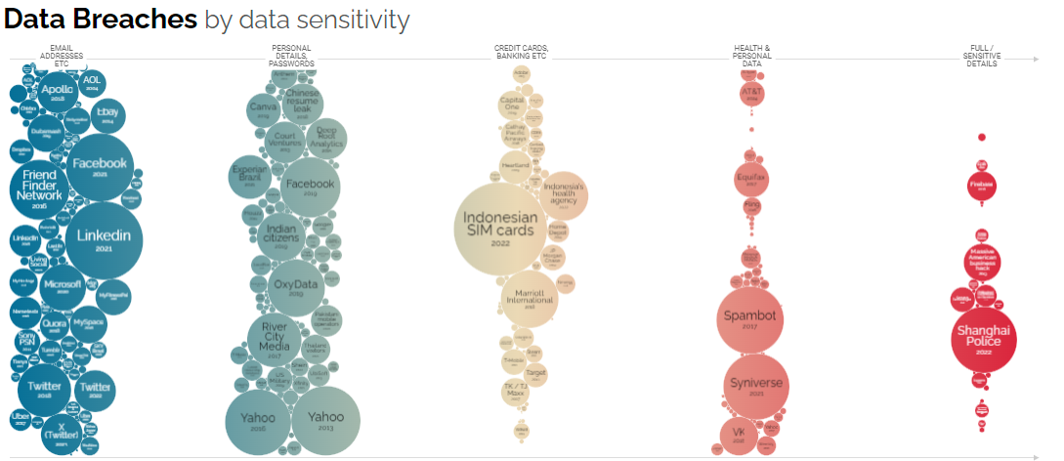
[2].
With such a pressing need for data security this paper will research what laws are in place within the UK and Europe that all persons responsible for data must consider. It will then look at the frameworks that are in place that help organisations and government departments to be able to cope with these threats and how effective these frameworks are in achieving that goal. This paper will research ISO/IEC 27000 and also the NIST security framework for this reason.

Legislation

The main piece of legislation within the UK would be the Data Protection Act [3]. This piece of legislation applies to anyone that is responsible for data within the UK and it is the Uk’s implementation of the General Data Protections Regulation (GDPR). It’s key principles are that data (information) must be
- Used in a way that is fair, lawful and transparent
- Used for specific, explicit purposes
- Used in a way that is adequate, relevant and limited to only what is necessary
- Data is kept accurate and up to date
- Data is not kept for longer than is required
- Data is handled in a way that ensured appropriate security, including protection against unlawful or unauthorised processing, access, loss, destruction or damage occurs.
These points have a significant impact on the IT systems being designed and used across the UK. It ensures that for example if you give your personal information to an online retailer, they cannot use that data for any other purpose than what you signed up for. A very recent example of this is where users of Meta (Facebook) were going to have their data fed into a generative AI model which was being developed by the company. This was stopped by the ICO (Information Commissioners Office) under the data protection act as this would contradict this piece of legislation [4].
This legislation also requires that data is handles with appropriate security. This means that any organisation that deals with security must have appropriately trained staff and software that can meet this requirement, and this also includes physical security. An example of this is where Skipton Financial Services breached the data protection act when a laptop was lost that contained 14,000 records of personal information. The breach was issued as there was insufficient encryption in place to protect the records that were held on the device. The device was actually being used by a contractor and not a permanent member of staff, but this shows that the law applies to anyone working for or on behalf of the organisation that owns the data [5].
This legislation has a massive influence on both why modern organisations and government departments are required to have comprehensive data security measures in place to mitigate the potential of any legal repercussion and the financial implications that these could incur as shown in the graphic below

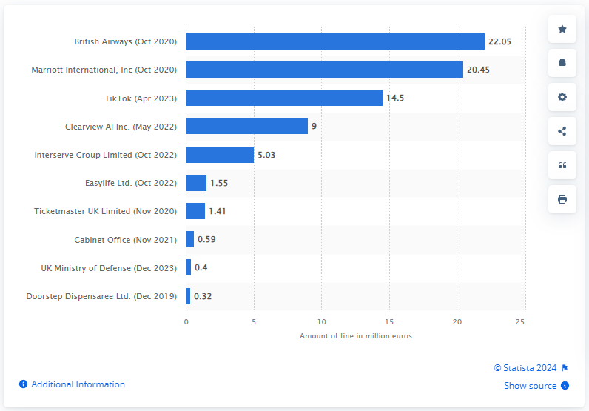
[6]. These potential outcomes could bankrupt a business or cause irreparable damage to reputation of the organisation resulting in potential further losses from sponsorships or loss of revenue from custom that it may have otherwise expected.
One of the primary reasons that IT systems are ubiquitous for businesses are that technological progressions have allowed organisations to operate across the world relatively easily. However, this also means that organisations are required to comply with local legislation to the country that information is being submitted to and, if the data is collected in the UK or EU there are requirements that any offshoring of data to a country outside of the EU comes with legal ramifications.
Under currently legislation the term adequacy is used, which means that the recipient country must have an adequate set of data protection legislation, systems, practices or processes in order for the allowance of data offshoring to be considered compliant. The UK is considered adequate under EU law as a place to offshore data, however this is not true across all nations [7]. Where this is difficult to manage is in the emergence of cloud based storage where large providers can have clusters across the world. Research into this issue shows that recently Microsoft have advised the Scottish Government that there is no guarantee that its data stored on cloud services remain within its territory [8]. The government in New Zealand are also facing similar challenges as a data breach in the US has compromised some 180 New Zealand public agencies after they invested $1 billion a year in this area [9].
The national cyber security centre have issued 14 cloud principles that should be taken into account when looking into using a cloud based provider [10] which should be considered by UK government and any organisation that is thinking about migrating to a cloud based service. And although these are principles, they are not defined in law and should a cloud provider not comply with local laws, GDPR or Data Protection act for the UK the owner of the data will still be liable to legal action as previously noted.

Security Frameworks – ISO/IEC 27000 & NIST

To help government agencies and organisations of all sizes to both comply legislatively within the UK and more broadly across the Europe there are a few different Security Frameworks that help users understand what they need to do and why. One of those frameworks is ISO/IEC 27000. This framework is made up of the following elements
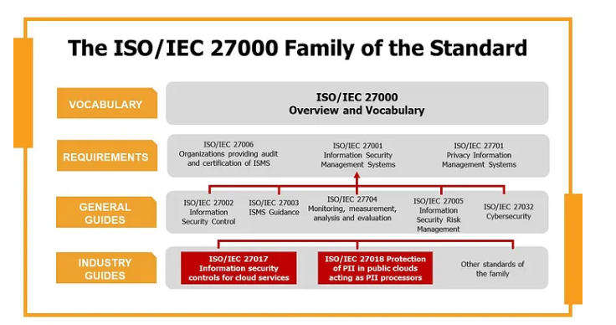
[11].
ISO/IEC 27001 is “the world’s best-known standard for information security management systems (ISMS) and their requirements. Additional best practice in data protection and cyber resilience are covered by more than a dozen standards in the ISO/IEC 27000 family. Together, they enable organisations of all sectors and sizes to manage the security of assets such as financial information, intellectual property, employee data and information entrusted by third parties” [12].
The main practical element of this framework is ISO/IEC 27001 the latest version of which was published in 2022 and is the only certifiable element of the framework. The framework is based on a plan, do, check, act model made up from the following elements
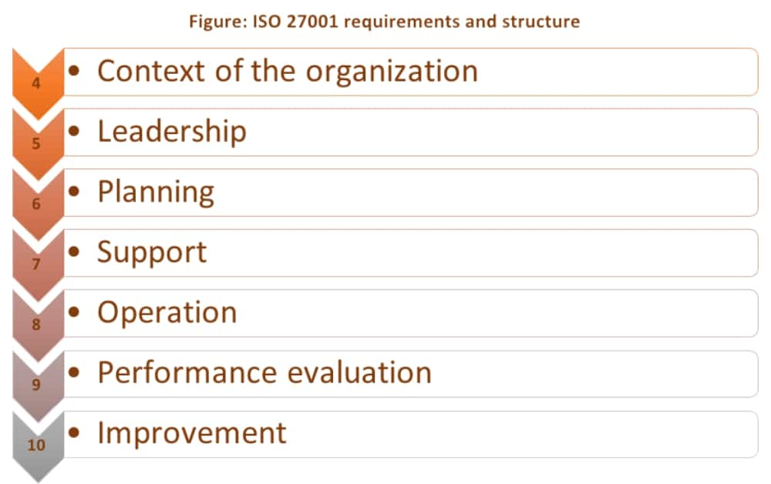
[13]

The focus is entirely on ISMS (Information Security Management Systems) and it has been specifically designed to comply with GDPR and Data Protection legislation. Each section of the above diagram illustrates an area in which an organisation must show compliance in order to achieve certification. The context of the organisation is needed so that the full scope of the systems can be documented. Within the leadership section there is a requirement to document how leadership will support the standard and their commitment to do so continually. The planning section focuses on risks, how they are assessed, identified and documented. The support section related to the available resources that the organisation puts in place to raise awareness and communicate with staff as anyone with access to the system could potentially post a security risk. The operation section deals with the measure that are implemented to ensure appropriate planning and controls exist and are followed by the organisation. Performance evaluation relates to how the ISMS is monitored and how analysis of the monitoring is performed and evaluated. The whole cycle is then repeated in the improvement section on a continual basis through regular reviews [14].
Further to this there are 14 domains of ISO which have been outlined within their annexes. These are
- Information Security Policies – ensuring that policies exist and align with security practices
- Organisation of Information Security – This covers topics including the assignment of information security roles and also things like working from home or working remotely
- Human Resource Security – This is focussed entirely on ensuring that anyone that works with or for the organisation has a sound understanding of their responsibilities in relation to information security
- Asset Management – Ensuring that information is available to identify assets, who has them, where they are located and when the time comes that they are disposed of responsibly
- Access Control – This is making sure that only people that need access to information have it.
- Cryptography – This is making sure that information that this is applied appropriately.
- Physical and environmental security – As mentioned previously physical security is just as important as digital and this element ensured that this is appropriately considered.
- Operational Security – This is checking that the organisation has the right amount of defence to reduce the risk of infection or data loss
- Communication Security – This is in place to address the policies, technologies and strategies in place for communicating information across the internal network of the organisation
- System acquisition, development and maintenance – this annex details how an organisation should have information security at its heart when going through the lifecycle of software
- Suppler relations – Ensuring that the appropriate contractual arrangements and checks are in place when working with suppliers
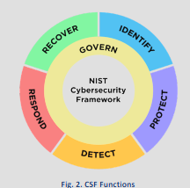
- Information security incident management – This determines the steps taken over business continuity and how the organisation will deal with incidents.
- Information security aspects of business continuity – Ensuring that the business addresses information security in business continuity plans.
- Compliance – This annex related to applicable laws, regulations and helps the organisation with understanding what is required of them and why.
[15].
The ISO 27001 is clearly a comprehensive framework that aims to safeguards information whilst complying with relevant legislation. Certification means that the organisations are likely to be compliant and it also minimises the risks of client data being lost. However, it is not a guarantee that compliance will be achieved with legislation. The framework itself was last updated in 2022 and in the time since it was released technologies have advanced at a significant rate. In order to keep up the framework would need to be revised regularly. However, the framework is already very complex and regular revisions would mean that it would be very difficult to maintain pace. Another, negative of this framework would be the cost. There is a cost to certification, and then a requirement to keep recertifying and go through audits which will cost time for the staff used by the organisation. The complexity of the framework means that smaller organisations where there may be only a handful of people may struggle to comply, especially if they cannot support teams of people to deal with each element as would be the case in larger or government organisation.
Another example of a security network is the NIST Cybersecurity Framework which
“…provides guidance to industry, government agencies, and other organizations to manage cybersecurity risks. It offers a taxonomy oh high-level cybersecurity outcomes that can be used by any organization – regardless of its size, sector, or maturity – to better understand, assess, prioritize, and communicate its cybersecurity efforts”
[16].
The CSF (Cybersecurity Framework) is made up from 5 core functions as shown in figure 2 [17]. With each of these core functions there are subcategories that in place to give detailed instruction on what organisations should cover within each section. Unlike ISO/IEC 27000, the NIST CSF is not specifically about the protection of information systems. Instead, the framework focuses on how an organisation manages risk related more broadly to its Cybersecurity. As this framework is based around US legislation it also does not change to meet the requirements of GDPR.

Conclusion
In conclusion, the research shows that there have been a significant amount of data breeches across many of the worlds leading organisations, despite their investment in security technologies. For this reason and the legislation researched, information security is absolutely mandatory. Security frameworks such as ISO/IEC provide excellent direction to organisations across the world on how to minimise the risks associated with keeping data digitally and organisations can use these standards even if they do not require certification. The NIST framework is a good example of this. This framework is less comprehensive and less specific to the protection of data, however it is easier to understand and apply for smaller organisations that may not have a specific cyber security department dedicated to its implementation. In conclusion though, most organisations will employ multiple frameworks depending on size and nature. The ISO/IEC 27001 is specifically designed around UK and EU legislation and as such is gold standard within that region. Though most smaller organisations may look at the principles of NIST and employ those as a start before growing and progressing to ISO/IEC 27001. Both in combination would provide organisations and their customers with the knowledge that their business is less likely to be victim to attack, and data less likely to be stolen. However, it is key to note that there are no frameworks or technologies that guarantee either compliance with legislation or safety from attach, they will merely lessen the associated risk. In order to continue to keep the risk low, an organisations security must be ever reviewed and evolving to ensure that compliance with legislation and new risks are identified and actions taken even if a security framework does not specify it, as the frameworks will not change as quickly as the technological or political landscape.

Task 2 – Case Scenario

Within this report I will outline the new information security unit that will serve the DVLA. This report will detail how the organisation will need to change in order to facilitate this new unit as well as what its function will be and the impacts of its creation on the wider business.

Organisational chart

At the highest level this is the organisational chart of the business. Note that the newly formed information security team sits above all other departments and reports directly to the CTO. The reason for this is that the team need to be independent so that they are not influenced by the politics of other departments and are not caught up in any potential conflicts of interest that might occur. The second reason to place them above the other departments within the organisational chart would be that this would give them the authority to enact any policies that are put in place to protect the organisations information.
The team would need to include many different elements within it, as information security should not be a response, it should be an ongoing considerations especially for departments that are responsible for software development that will process customer information which in this case belongs to the UK public. For this reason below is the organisational chart that would exist within the new Information security team

This team structure is designed to ensure that the business have information security in consideration at all points. The technical architecture team would ensure that the tech used is compliant with information security policies and principles. The technical product management team will work with the teams building software to ensure that information security is properly implemented and tested. The legislative compliance department will be responsible for ensuring that the business are aware of any existing and new legislation as they come into practice. They will then work with the business to ensure compliance. Risk and audit will be responsible for ensuring risks are properly mitigated and deal with the risk appetite of the organisation. The cyber security team will work on the proactive defence of the organisations IT systems to protect the data. They would implement security frameworks and seek the required certification. The Ethical Hacking department will perform penetration testing on the systems to try and find holes in security that can then be patched. Through this team and organisational structure the organisation will thoroughly deal with information security at all levels.

Policies and Procedures

The policies and procedures that would be implemented by this new would include:
- Physical Security Policies – All machines used by the organisation must be asset tagged, with the ability to remotely disable the machine if required. All lost equipment must be reported as soon as it is noticed and regular asset discovery checks should be in place. Only authorised personnel that have gone through the required background checks should be allowed to use DVLA systems. This will also cover who has access to which parts of the buildings owned, for example office staff would not need to have access to any server rooms and not all staff will need direct access to this area either.
- Access Policy – There must be robust user access controls in place that ensures that only staff that need to have access to a system or information have it. For example the DVLA controls millions of drivers and vehicle records and only staff that directly need access to them should have it. Every system should have a user access document that shows who has access and why. There should be robust procedures in place that remove users as they move job role/department or leave the organisation. User access logs should be in place to show what has been accessed, by whom and when. Training should be given to all staff to inform that any unauthorised access, can result in termination of employment and legal action.
- Data Policy – This policy should be in place to demonstrate the organisations commitment to ensuring that data is handled in accordance with the Data Protection Act and GDPR. This will what information will be kept and why. How long it will be kept for. What the purpose of this information is and how to deal with freedom of information requests in relation to the information that is held. It will also specify procedures on how data should be handled and how the consent of the people that gave the data will be captured.
- Business continuity policy - This policy will deal with how the business will respond to incidents of all varieties. Who should be informed, and what actions should be taken to secure information if required.
- Passwords and encryption policy – This policy will deal with what is password protected, where information can be stored and how this information should be encrypted. The procedures that underpin this will include things like automated requirements for staff to update passwords.
- Remote working policy – This policy will detail who is allowed to work remotely and the technology that must be in place to allow this to happen safely i.e. vpn. This will detail how remote access is managed and monitored. It will also detail systems that need to be put in place to identify anyone trying to access the system that is not recognised.
- 3rd Party Policies – This related to the requirements that 3rd parties would need to comply with in order to work with the organisation. For example, information cannot be passed to a 3rd party where that data will be sent outside of UK and EU territorial boundaries without assurances. It will also detail requirements such as only working with ISO 270001 accredited organisations or other such technical requirements that will ensure that the information that a 3rd part would have access to is not compromised and also will still stay in compliance with all of the relevant legislation.
- Risk and Audit policy – This policy will detail the security frameworks that must be complied with including the requirements for any certification that must be maintained and who would be responsible for this (Cyber Security department). This will also detail the audit requirement for both internal and external audits to take place regularly by the risk and audit team.

Data Protection Compliance

Data protection compliance is critical to the DVLA. The organisational structures and the policies that have been detailed are designed to ensure that compliance is achieved. The legislative team within the new information security team exist to solely ensure that all legislation is complied with, and the organisation is aware of any new legislation that is in the process of being released.

The risk and audit team also play a key role in ensuring that compliance is achieved as the implementation of the policies by the teams across the organisation must be regularly audited to ensure that compliance is in place. These audits must be performed internally as well as externally as the internal audits should ensure that when external audits take place that the desired results are more likely to be achieved.
Training will be given to all staff to be aware of all the policies mentioned in detail, this will form part of a corporate induction that will require a signature from every member of staff that goes through this. This will be followed by annual refresher training that is delivered through digital platforms and is tail ended with an assessment that will test each staff member on their knowledge of these policies and how they can be and should be being applied. This will also apply to 3rd parties such as contractors that will have access to the systems as anyone that physically or digitally has access to the organisations IT systems could be a potential risk.

Security Standards

It would be my recommendation to follow the ISO/IEC 27000 framework within the DVLA, with the risk and audit team within the information security team responsible for ensuring that the requirements for this certification are followed. The DVLA is large enough that it is able to support a dedicated team to ensuring that the standards are employed across the 14 domains. The benefits of the implementation of this standard are primarily that it will significantly lesson the risk of a data breach occurring. With the scale and complexity of the DVLA I also feel that ITIL framework should be followed
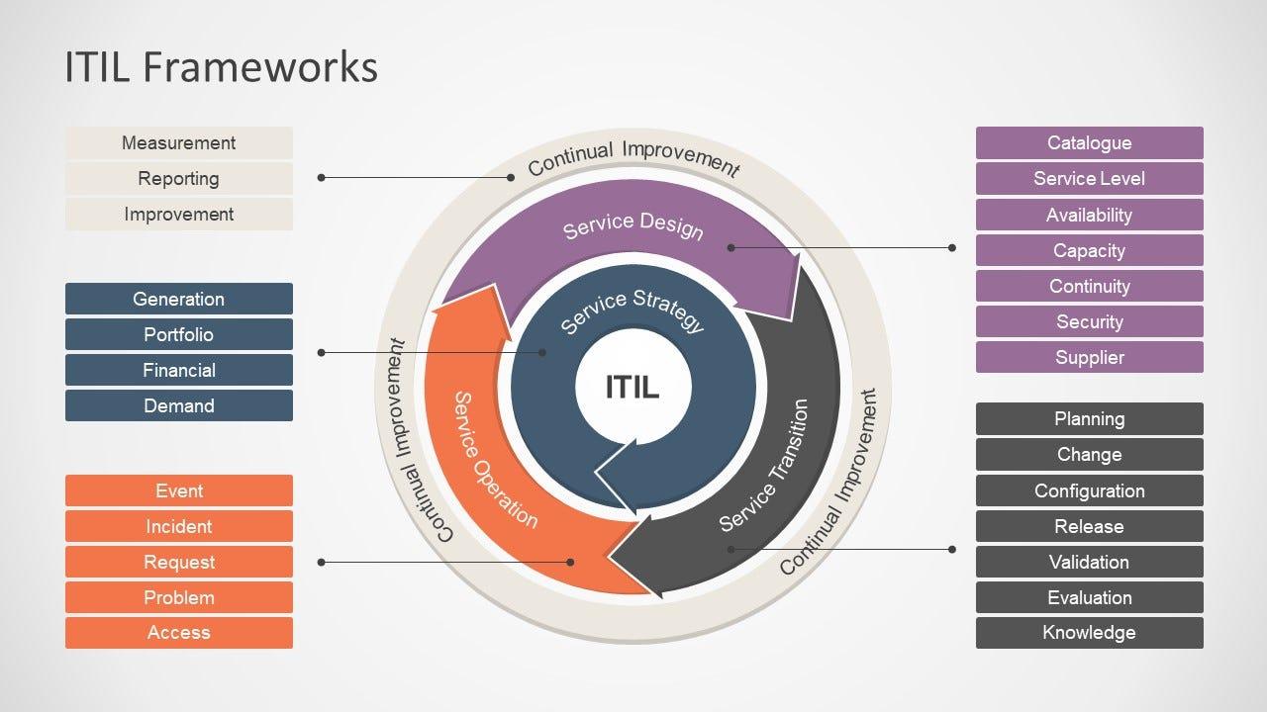

[18]. This framework is designed to ensure that the services provided by DVLA follow a lifecycle that will incorporate regular audit and review. This will enhance security, transparency and also through continual improvement ensure that patching of software and vulnerabilities are documented and implemented. This will in turn increase the security of the information that is held on DVLA systems.
A further security framework that should be followed would be the Cyber Essentials and Cyber Security Plus frameworks. These government backed frameworks provide guidance, training and support for organisations to minimise the threats presented in Cyber Security. Certification should be sought to ensure that compliance [19].
All National Cyber Security Centre guidance should also be regularly reviewed and followed which includes the NIST security framework. The NCSC resources regularly post updated information on potential vulnerabilities that have been identified through its partner network which includes all of the major organisations across the world as well as their governments. An example of this is a post about how China state-sponsored cyber attackers have new and evolving techniques that are being deployed [20]. Through regular review and subscription to the website these issues can be highlighted outside of any of the formal procedures. This can then ensure that the organisation is up to date and will also ensure that the organisation is not waiting on a framework review before implementation of any actions that could prevent a potential breach.
The NIST certification for the organisation will check that the policies and procedures that have been recommended within this report are being properly implemented. They also have many training courses such as CCP which will benefit the cyber Security professionals within the organisation as this will ensure they their training and awareness has reached the levels that should be expected of them.

Contingencies Planning

The business continuity team should be responsible for ensuring that as many different scenarios are considered and planned for. For example they will need to ensure that there is planning in place for a power outage as well as the threat of a data breach. The business continuity team are responsible for ensuring that any risks identified are accompanied by business recovery strategies that will minimize operational impact and protect data integrity.
They will also be responsible for identifying the disaster recovery teams, that would deal with the situation depending on the situations that have presented themselves. Within this training should be given to those teams on the recovery strategies that have been decided to ensure that should the situation actually happen everyone within the disaster recovery team can act as quickly as possible to implement the required strategy.
Communication plans should be created for each scenario, especially as any loss of data for the DVLA would be related to the general public. The Information Commissioners Office (ICO) may also have to be informed, and the timings and content of the breach would need to be detailed. Although this is not a technical role, it is equally essential because if an announcement was released that highlighted a security issue that had not been resolved, it could lead to further attacks and a further loss of data.
Business continuity should also ensure that there are UPS’s available so that systems can run in a power outage, and that appropriate backups are performed and can be called upon if required. They should also coordinate test runs of an event to evaluate the effectiveness of the teams involved.
All of this should be reviewed regularly to ensure that the contingency planning that is in place is appropriate and doesn’t become outdated as new technologies are used within the business. For this reason they will need to work closely with the risk and audit team as new risks are identified.

Governance and Strategic Planning for Security

All major decisions should seek sponsorship from specifically appointed individuals from across the business and ultimately the strategic plan should be signed off at an executive level to ensure that the information security team are aligned with the objectives of the organisation. The CTO and the Chief Risk Officer should act as two central points of governance as they will have the oversight of all of the strategic planning for the entire organisation and understand how information systems are being utilised and how that could change going forwards. The Head of Cyber Security may also be involved to ensure that each element is planned for securely and in line with the requirements of the recommended certification and legislation that impact the organisation.
There is also likely to be a requirement for a member of the newly created team to sit on any boards within the DVLA that approve new work streams. This will ensure that there is a level of strategic planning at all levels of the business for the security of information and will also ensure that no wasted time and money is spent by the organisation in progressing developments which are later shut down due to information security concerns.

Risk Management

The risk and audit team will within the new organisation chart will be responsible for risks. They will be responsible for working with other teams across the organisation to allow for risks to be identified, sponsored, tracked and ultimately resolved where possible. They will have a keen understanding of the risk appetite for the organisation and also be able to advise from an information security perspective whether or not the risks that are being considered are breaking legislative or certification compliance. This will help ensure that information security and integrity are at the heart of the organisation at all levels.

References

[1] | R. Sloan and R. Warner, Why Don't We Defend Better, 1st Edition ed., Boca Raton, 2109.
[2] | D. McCandless, T. Evans and P. Barton, “Data Breaches by data sensitivity,” Information is beutiful, 15 Jan 2024. [Online]. Available: https://informationisbeautiful.net/visualizations/worlds-biggest-data-breaches-hacks/. [Accessed 8 July 2024].
[3] | UK Government, “Data Protection,” Gov.uk, [Online]. Available: https://www.gov.uk/data-protection#:~:text=Under%20the%20Data%20Protection%20Act,access%20personal%20data. [Accessed 8 July 2024].
[4] | ICO, “Statement in response to Meta's plans to train gernerative AI with user data,” ico, 14th June 2024. [Online]. Available: https://ico.org.uk/about-the-ico/media-centre/news-and-blogs/2024/06/statement-in-response-to-metas-plans-to-train-generative-ai-with-user-data/. [Accessed 8th July 2024].
[5] | “Finance advisory firm breaches Data Protection Act,” Computer Fraud & Security, vol. 2008, no. 4, p. 4.
[6] | statista, “Largest fines issued for General Data Protection Regulation (GDPR) violations in the United Kingdom (UK) as of April 2024(in million euros),” statista, April 2024. [Online]. Available: https://www.statista.com/statistics/1385746/largest-fines-issued-gdpr-uk/. [Accessed 8th July 2024].
[7] | ICO, “Adequacy,” ico, [Online]. Available: https://ico.org.uk/for-organisations/data-protection-and-the-eu/data-protection-and-the-eu-in-detail/adequacy/. [Accessed 8th July 2024].
[8] | C. Donnelly, “UK government’s M365 use under scrutiny after Microsoft’s ‘no guarantee of sovereignty’ disclosure,” ComputerWeekly.com, 24th June 2024. [Online]. Available: https://www.computerweekly.com/news/366589468/UK-governments-M365-use-under-scrutiny-after-Microsofts-no-guarantee-of-sovereignty-disclosure. [Accessed 8th July 2024].
[9] | P. Pennington, “Growing government reliance on offshore cloud services has security experts worried,” 16th August 2023. [Online]. Available: https://www.rnz.co.nz/news/national/495883/growing-government-reliance-on-offshore-cloud-services-has-security-experts-worried. [Accessed 8th July 2024].
[10] | NCSC, “Cloud Security Guidance,” NCSC, [Online]. Available: https://www.ncsc.gov.uk/collection/cloud/the-cloud-security-principles. [Accessed 8th July 2024].
[11] | CFE Certification, “The ISO/IEC 27000 Family of Standards,” Medium, 16th Feb 2021. [Online]. Available: https://cfecertification.medium.com/the-iso-iec-27000-family-of-standards-2f04697f2e82. [Accessed 8th July 2024].
[12] | ISO, “Information Security Management,” ISO, [Online]. Available: https://www.iso.org/standard/iso-iec-27000-family. [Accessed 8th July 2024].
[13] | D. Kosutic, “What is ISO 27001? A quick and easy explanation,” Advisera, [Online]. Available: https://advisera.com/27001academy/what-is-iso-27001/. [Accessed 8th July 2024].
[14] | V. Mohan, “ISO 27001 Requirements – A Comprehensive List,” Sprinto, 29 January 2024. [Online]. Available: https://sprinto.com/blog/iso-27001-requirements/#:~:text=ISO%2027001%20requirements-,What%20are%20the%20ISO%2027001%20requirements%3F,risk%20assessment%2C%20and%20risk%20management.. [Accessed 8th July 2024].
[15] | Citation Certification, “Citation Group,” Citation Group, 28th December 2023. [Online]. Available: https://citationgroup.com.au/resources/what-are-the-14-domains-of-iso-27001/. [Accessed 8th July 2024].
[16] | NIST, “The NIST Cybersecurity Framework (CSF) 2.0,” National Institute of Standards and Technology U.S. Department of Commerce, 2024, pp. 2-3.
[17] | NIST, “The NIST Cybersecurity Framework (CSF) 2.0,” National Institute of Standards and Technology U.S. Department of Commerce, 2024, p. 5.

