
menu engineering – farm to fork restaurant
BMIH4002 - Food & Beverage Operations


TUTOR : FFION CUMBERPATCH
STUDENT : ELENA-GABRIELA DAVID 2212249
WORD COUNT: 431
Restaurant Concept
The "Farm to Fork" concept is a holistic eating experience that seeks to supply a connection in between the plate, and the land in an advanced setup. The main theme of our dining establishment is the emphasis on locally-sourced organic, and seasonal components. We aim to showcase the abundant authentic, as well as varied flavours of Britain consequently advertising neighbourhood farmers, as well as providers while likewise minimising our carbon impact. This method reflects the growing worldwide fad towards sustainability, as well as much healthier consuming selections.
Our target audience is broad yet distinct. We accommodate those who prioritise top quality, and sustainability over rate. These consist of health-conscious people households, green consumers and young professionals that value locally sourced, fresh food and also are ready to pay a price for an unique dining experience.
Our menu is curated with a focus on fresh natural components that show the seasonal produce readily available in the UK. Each meal is an event of British food with a modern twist and also we give a selection of alternatives for all programs - beginners, keys, treats, as well as beverages. The intent is to satisfy different tastes, preferences, as well as nutritional needs.
The starters, such as, the Farmhouse Soup and also Grilled Asparagus offer a light yet tasty starting to the dish heating up the taste for the main course. The mains consisting of the Organic Chicken and Leek Pie and Pan-Seared Sea Bass are timeless recipes presented with our signature touch. We've picked these dishes since they recognise favourites that reverberate with a broad audience yet we're raising them with the quality of our components, and also the ability of our preparation.
The treat area includes British classics like Rhubarb, and also Apple Crumble, and also Strawberry, as well as Elderflower Pavlova. These were selected to offer a pleasant ending that complements the preceding programmes, and also continues the theme of locally sourced seasonal ingredients. Our drink selection is a mix of organic wines craft beers, and rejuvenating juices intending to satisfy different choices while aligning with our dining establishment's idea.
Our prices is competitive considering the high quality of active ingredients and the total eating experience we provide. It's made to attract our target market that value the provenance, as well as top quality of their food over low-cost deals, and also convenience food.
In summary the "Farm to Fork" concept is a celebration of nature's bounty accepting the splendour of in your area sourced ingredients while accommodating a target market that values wellness sustainability, as well as exceptional culinary experiences.

Menu Design
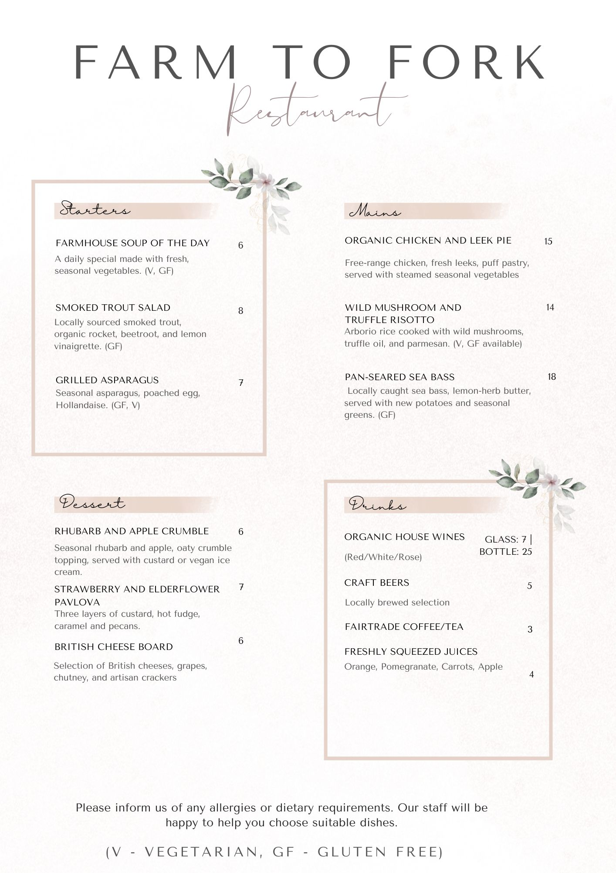

References
Innovations, A. (n.d.) Benefits of Eating Locally Sourced, Sustainable Foods - ADEC ESG [Online]. Benefits of Eating Locally Sourced, Sustaina | ADEC ESG. Available: https://www.adecesg.com/resources/blog/benefits-of-eating-locally-sourced-sustainable-foods/. [Accessed 04 June 2023]
Organic food sales revenue in the UK 1999-2020 | Statista. (n.d.) [Online]. Statista. Available: https://www.statista.com/statistics/282379/organic-food-and-drink-sales-in-the-united-kingdom-uk-since-1999/. [Accessed 04 June 2023]
Top Restaurant Industry Trends in 2023 | Square. (2023) [Online]. Square. Available: https://squareup.com/gb/en/townsquare/restaurant-trends. [Accessed 04 June 2023]
6 Restaurant pricing strategies that actually work | TableCheck Blog. (n.d.) [Online]. 6 Restaurant pricing strategies that actually work | TableCheck Blog. Available: https://www.tablecheck.com/en/blog/6-restaurant-pricing-strategies-to-maximize-profits/. [Accessed 04 June 2023]
How to Create a Restaurant Dinner Menu. (n.d.) [Online]. Small Business - Chron.com. Available: https://smallbusiness.chron.com/create-restaurant-dinner-menu-15677.html. [Accessed 04 June 2023]
Top 10 Traditional British Foods | British Study Centres. (2019) [Online]. BSC (EN). Available: https://www.british-study.com/en/blog/traditional-british-foods. [Accessed 04 June 2023]
Larson, S. (2022) What Is a Holistic Diet? [Online]. Escoffier. Available: https://www.escoffier.edu/blog/sustainability/what-is-a-holistic-diet/. [Accessed 04 June 2023]
Restaurant Menu Pricing. (2022) [Online]. WebstaurantStore. Available: https://www.webstaurantstore.com/article/129/restaurant-menu-pricing.html. [Accessed 04 June 2023]
How to Price A Menu: Price Formula for Bars and Restaurants. (n.d.) [Online]. How to Price A Menu: Price Formula for Bars and Restaurants. Available: https://home.binwise.com/blog/how-to-price-a-menu. [Accessed 04 June 2023]
Should You Choose Locally Sourced Food for Your Restaurant?. (n.d.) [Online]. WebstaurantStore. Available: https://www.webstaurantstore.com/blog/1588/local-sourcing-for-seasonal-menus.html. [Accessed 04 June 2023]

