3/24/2025
University of Wales Trinity Saint David
London campus
Module Name: Scripting and Programming Concepts
Module Code: ACCA 5036

Student Name: Mohammad Sufyan Khan
Student ID: 2412986

Lecturer’s Name: Koushik Modak

SPC Assignment on
Student Equipment Booking System
Code Link: https://github.com/MK9726/2412986-Assessment-1-Scripting-and-Programming-Concepts.git

Table of Contents
Introduction 2
Main Body 2
1. Analysis 2
2. Software Design and Development 4
Design: 4
Implementation Decisions 6
Source Code 7
4. Evaluation 13
Conclusion 14
References 14

Introduction
Bright Minds Academy is a private tuition centre and they need us to create a program to manage how they book the classroom equipment, at the moment it’s a messy system on paper so a lot of things get forgotten or misplaced and the aim of the program I am going to make is to prevent something like that from happening. they need to be able to add and remove equipment, manage what is booked and see who has booked what equipment and where it has been booked for this is so they can manage everything with less errors.

Main Body
- Analysis
The system I am creating needs to be able to properly add bookings to a system with the ability to track what equipment has already been booked, for how long and by who to prevent double bookings. It needs to be easy to use as the previous system was just a paper booking sheet and it needs to be able to take over that, things to consider are also older staff who will need to be able to get used to a new system and also needs to be simple enough for them to be able to adapt to. The system will provide a few functions which will benefit the needs of the business.

Functional Requirements
- Add new equipment: The staff should be able to add and remove new equipment whenever possible to keep up with the new and old equipment they have available
- Record bookings: The staff should be able to make new bookings, remove old bookings and assign bookings to whichever member of staff or whichever student has borrowed the equipment.
- View booking records: The staff should be able to see who has booked what, for how long so that they can prevent double bookings and keep an eye on who has what to prevent missing items.
- Simple Search: There needs to be a simple search option which lets staff search by either name or equipment to see who has booked what
- Low-Booking Alerts: A notification needs to show up when a piece of equipment has been booked and not been returned or if too many pieces of equipment have been booked. There should also be a notification when equipment to book is running out so a collection can be made.
- User-Friendly Interface: The interface needs to be user friendly in a way where it’s easy to use for people who are not as computer literate as the rest of the staff team especially where they are moving from paper to a whole new computer system.
- Scalability: The system needs to be built in a way where without having to create a whole new system it can be updated to update/remove certain functions

Non-Functional Requirements
In addition to functionality, the system must meet several quality criteria:
- Reliability: The system needs to be reliable as it will be the only system in use to keep everything accurate and be able to see where the equipment is.
- Performance: The program needs to be lightweight so that it can run properly and effectively on the machines at the tutoring centre, if the program is too heavy it could take too long to open or use which can cause issues with the booking side.
- Security: The program needs to be secure so that it cannot be altered, this is so that people can not just change the bookings or equipment list to take whatever they want. There will also be personal data with needs to be handled properly.
- Accessibility: The program needs to be available to all staff, and it needs to be simple enough to use with clear instructions so users who are not as technically capable can still use it.

2. Software Design and Development
In this section of the report, you will document the design and development of the software. Your submission should include:
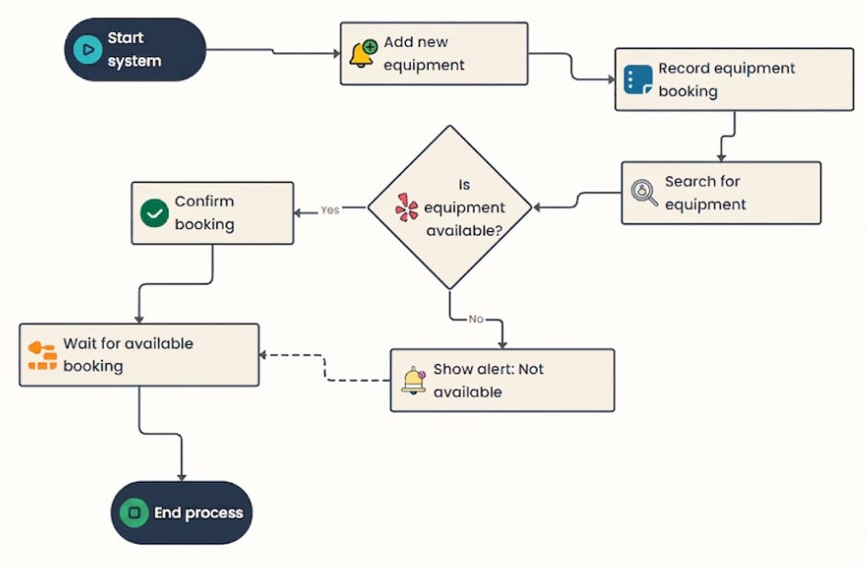
Design: Represent the algorithm of your solutions as follows: •

Pseudo-code:
START
equipment_list = []
bookings_list = []
FUNCTION clear_screen:
print blank lines
FUNCTION check_overdue:
FOR each booking:
IF active AND time has passed end time:
mark as Expired
FUNCTION get_time_label(seconds):
RETURN duration as "Xh Ym"
FUNCTION time_options:
RETURN list of duration choices
FUNCTION add_equipment:
ask for equipment name
IF blank, "back", or already exists: go back
ELSE: add to equipment_list
FUNCTION delete_equipment:
IF list empty: go back
show list, ask user to pick
IF equipment has active booking: refuse
ELSE: delete it
FUNCTION add_booking:
IF no equipment: go back
ask for equipment, student name, and duration
save booking with start/end time and status = Active
FUNCTION list_bookings:
IF none: go back
show each booking with time remaining or EXPIRED

FUNCTION overdue_bookings:
show only Expired bookings
UNCTION delete_booking:
show all bookings, ask user to pick one
delete it
FUNCTION search_bookings:
ask for name or equipment
show any matching bookings
FUNCTION main:
LOOP:
show menu
IF any overdue: show warning
run chosen option (1-8)
IF 8: print "Goodbye" and EXIT
RUN main

Implementation Decisions
- Data Structures: I used two data structures for this program one is the “equipment_list” which basically stores the name of all the equipment but as text string, I used this because it is have for adding and removing items because it stays in an order that is easier for staff and it also lets them pick things using numbers.
Another one is “bookings” which is a list of dictionaries and one booking has all the information about it together things like the student name, equipment name how long it was booked for etc.
- Programming Constructs: I wrote each feature as its own function like the add booking, search bookings, and delete equipment functions. This was because doing this kept everything organised and if there were any errors it’d be easier to change them without breaking multiple functions.
- Python Modules and Libraries: I used two modules which were “time” and “datetime”. Time was used to count the seconds to add a times for a booking which I added as a timer so once a booking is made the timer starts either for 30 minutes, 1 hour, 1 hour and 30 minutes or 2 hours depending on the option chosen. Time is also used to check for overdue bookings. I used this because it’s built into python as a function already and it is easier to track the starting and ending of a timer in a program.
- I also used “datetime” for the add booking which gives the time in the format that can be read. It converts the time into string e.g. 11:11:11 which goes into the booking and is shown to the staff members when they search up a booking. I used both time and datetime because if I had only used time, it would have given me 30 minutes as 1800 seconds, datetime is the reason it gives me a 30:00:00 timer.

Source Code
•Please use some screenshots of your codes to explain them further.
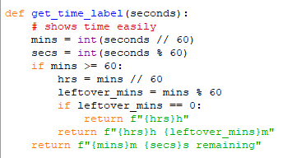
In relation to the above, if you see the time for 30 minutes for example is 30 * 60 this would normally show 180 seconds but because of the get time label as shown above this is now split into HH:MM:SS of a maximum time of 2 hours and minimum of 30 minutes.
This section makes the time clearer because it splits it into HH:MM:SS making the time look more like a digital clock e.g it would show 3m 00s instead of 180 seconds.
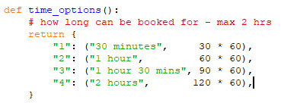

This section is to add the equipment it shows the user in a clear and easy way how they can add a piece of equipment to the system e.g Laptop 1, Tablet 1 etc.
It also checks for duplicates to prevent double bookings of the equipment to make it easier to manage.
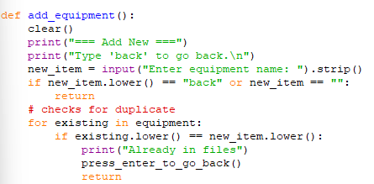

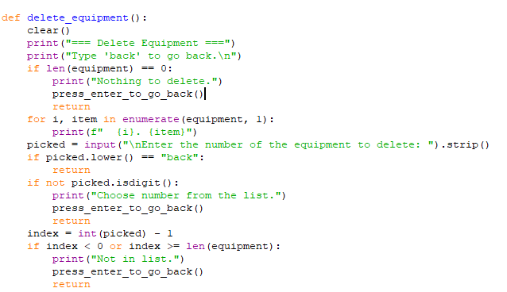
This part is to delete equipment that has been added this is in case something has been added by accident and also warns the user if they try to delete something has not even been added by saying “can’t delete”

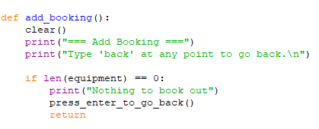
This part is to delete equipment that has been added this is in case something has been added by accident and also warns the user if they try to delete something has not even been added by saying “can’t delete”

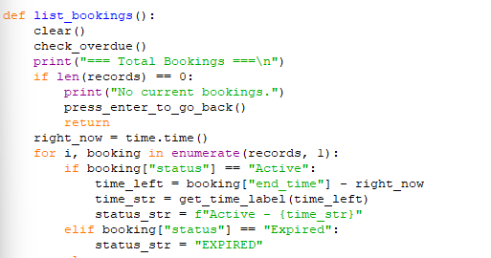
The section here lists the bookings, it shows the item that was booked, who it was booked by, how long it was booked for, when it was booked, if it’s active or inactive and if it is active and for how long

This part is for the overdue bookings, the clear and check_overdue sections clear the screen and check to see if any of the bookings made have expired or not, the next part checks the records and shows the ones listed as “expired”.
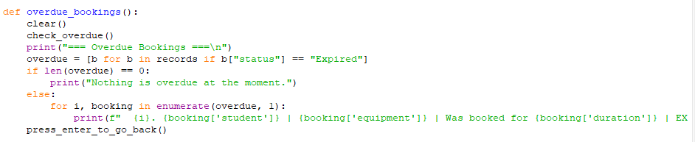

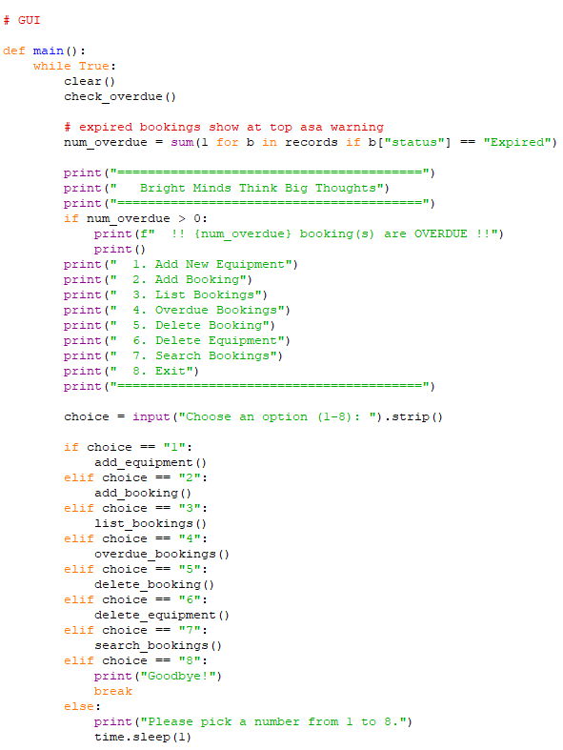
This part is for the overdue bookings, the clear and check_overdue sections clear the screen and check to see if any of the bookings made have expired or not, the next part checks the records and shows the ones listed as “expired”.

3. Testing and Debugging Report
a) Program testing is important to the SDLC because it helps ensure that the code is functioning properly and meets the needs of the intended client. Being able to test the code saves cost because you catch mistakes during the coding phase still and not after you have given it to the client. It also lets you test to prevent too many bugs and reduces the chances of the client complaining after the code is completing which makes it easier to fix. [1]
b) Syntax errors are errors that happen when the code you are writing doesn’t follow the rules of the language, it’s kind of like making grammar mistakes, common ways these happen are if you misspell a word or use the incorrect symbol for the code and it could cause something to not run correctly or at all. To prevent this from happening you could use a code editor that has syntax highlighting so as you’re writing the code the editor will highlight any errors so you can fix them as you go along. You can fix these by checking the error message shown in your editor and also review the code by checking for common mistakes that are usually made you could also use the debugging tool in the editor to help you with this [2]
Another error type is the logic error; this is when the code doesn’t run the way it’s expected to however they are harder to find than syntax errors because there is no error message or anything like that it simply just does not run correctly. They are mainly because of issues with the design of the code that is written, the code needs to follow a logical sequence if it does not that is where a logical error occurs. To avoid this, you need to find common patterns where you think the logical error would occur and just take extra caution when writing those sections of the code. [3] [4]
c) 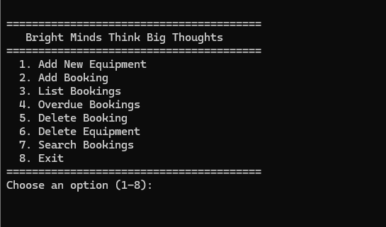
This is showing the program open and working

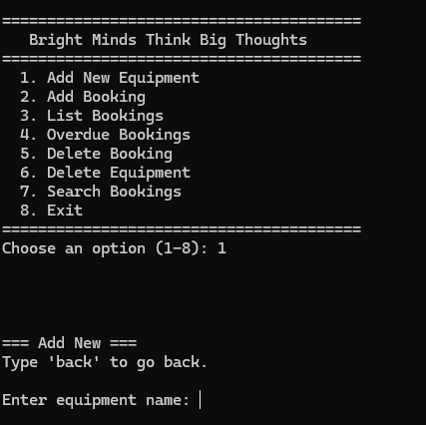
I have selected option 1 and it has prompted me to add a piece of equipment.
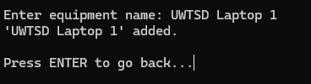
I have added a piece of equipment named “UWTSD Laptop 1” and it has notified me that it was added and has prompted to go back to the main menu.
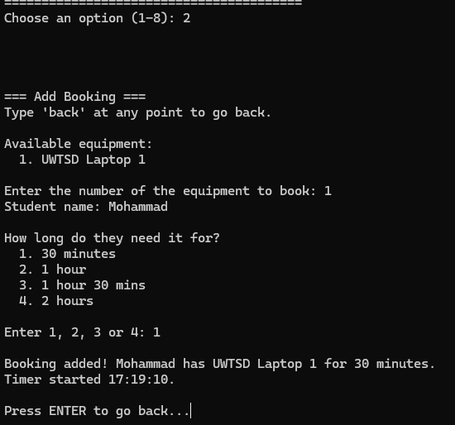
Here I have picked option 2 to add the booking, it has asked me what I would like to book, my name and how long to book for from the 4 options provided then it has confirmed my booking at the end.
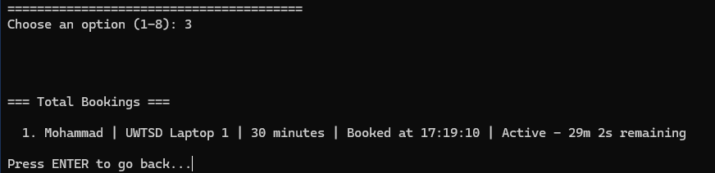
Option 3 is showing my active booking with the time I booked it and how long is left.
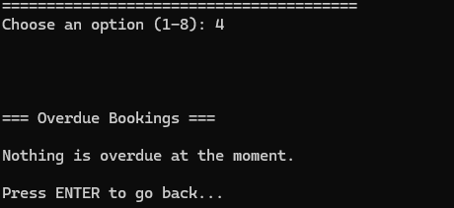
Option 4 is showing that there are no overdue bookings as per last screenshot the booking is still active.

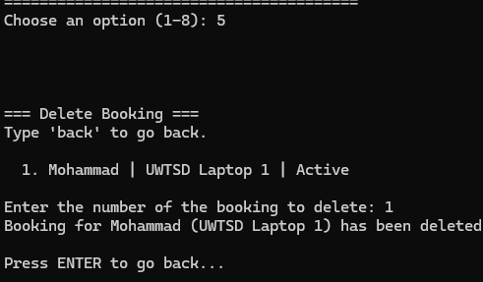
Option 5 has shown my booking to be deleted.
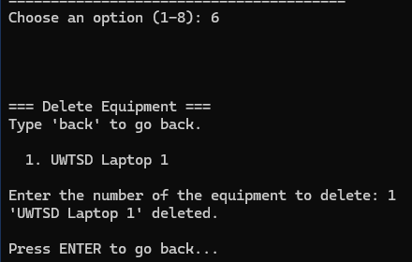
Option 6 has deleted my piece of equipment.

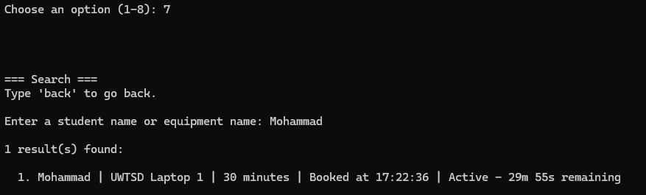
Option 7 has shown my booking as active; it let me search with either student name or equipment name. and Option 8 closes the program completely to the desktop.

4. Evaluation

• Challenges Faced: one of the main challenges I faced was getting the time and datetime functions to work properly, I needed a lot of guidance for this. Another issue I faced was the bookings, I am able to make double bookings, and I couldn’t figure out how to fix it so it still lets the user make double bookings for the same piece of equipment and with the same student’s name I couldn’t figure out how to fix this. I think this is something I need to work on more and apply to future projects.

• Future Improvements: Some improvements I can think of are fixing the double booking feature and maybe add a better GUI and the add a way to store the data that is entered so there is a log of all the bookings this is so they can export the logs in case they ever need to go through to find out who has borrowed something or to find any missing equipment etc. I would also like to potentially add permanent users and have a login bases system for it.

• Self-Reflections: Throughout this I learned (very harshly) even small mistakes can cause my code not to run, many times I misspelled a few functions, and it took me forever to figure out what was wrong and fix it to make it so that my program was able to run. I also realised even for something simple like a bookings program it actually takes a lot of time, effort and attention to properly complete a program.

Conclusion
In conclusion the program I have created for the Bright Minds tutoring centre I feel meets the requirements however I still think some functions can be made better to be suited more to the security side of things.
During the coding phase I faced a lot of issues with getting the times to appear correctly until I found the datetime function. It did take time to figure out and implement correctly but it worked out in the end.
Overall, I think I gained some valuable skills from this assignment mainly trying to solve a real-world problem and the attention to detail and I think with more work the program could be a lot better.

References

[1] | IEEE Computer Society, “The Importance of Software Testing,” [Online]. Available: https://www.computer.org/resources/importance-of-software-testing#fundamentals. [Accessed 20 04 2026].
[2] | geeksforgeeks, “What is a Syntax Error and How to Solve it?,” 12 04 2024. [Online]. Available: https://www.geeksforgeeks.org/c/what-is-a-syntax-error-and-how-to-solve-it/. [Accessed 21 04 2026].
[3] | “What Is A Logic Error, And How Is It Related To Coding?,” maxtrain, 29 02 2024. [Online]. Available: https://maxtrain.com/2024/02/29/what-is-a-logic-error-and-how-is-it-related-to-coding/. [Accessed 20 04 2026].
[4] | BBC, “Writing error-free code,” BBC, [Online]. Available: https://www.bbc.co.uk/bitesize/guides/zcjfyrd/revision/4. [Accessed 20 04 2026].

