Portfolio HPAR5012 Caleb Rees
For this portfolio I am choosing to submit a reflective journal of my research and activities related to experimental archaeology. This portfolio represents my research journey into historical food technology and the social implications of the food practices in different contexts within modern historical period. Included are reports of my own experimental archaeology projects which include baking hardtack a biscuit without any moisture used for sea voyages of all type in this portfolio it will also include this reflective journal spans the whole of the module and mentions every piece of research that was done in order to come to these conclusions and reflection my experiences with the module and the work and research it presented me with.the span of time that I intend to cover is the mid-eighteenth century all the way to the mid nineteenth century touching upon sailing in the eighteenth century and the Napoleonic was and heavily focusing on the mid-nineteenth century and the industrial revolution as well as world war one and two.
Something that was pointed out to me by my lecturer Quentin pointed out to me is that I need to focus on that idea of how food made people feel and I honestly didn’t go into too much detail during my presentation which I honestly did terribly in and it ended with my confidence shot in a lot of ways. Although as with everything life must go onwards. So, after dealing with things that was happening in my life at the time I got to work with rewriting some of this diary if not all. This diary I think morphed and changed as it went on, as most diaries tend to as they, in my opinion, don’t have a real point to them and is more a documentation in thoughts and ideas of the journey a person took to get the final results of a piece of art or other such works. So that means the biggest question that I had to ask myself was “how was this diary going to look” how this piece was going to read or how was it going to look visually and as much as I am an artst and I pride myself on my creativity and my artistic ability could not think of how I wanted to structure this. My conclusion was to right this in a more personal format because in my mother’s own words “what is more personal than food.
Part of this diary, by the fact that it is a piece of academic writing has to be formal and include citations and facts about this project that I am doing which I fully intend to do. But I think it is a good idea to talk about how my ideas came together in this less information-based way and to get an idea of the emotion behind the food that I decide to write about.my biggest inspiration came from quite an unexpected place. The piece of text I am referring to is by Angus Darlymple-Smith and Ewout Frankema. These two writers and academics together published “Slave ship provisioning in the long 18th century. A boost to West African commercial agriculture?” which, although is a lengthy title it does what it says on the tin and talks bout, in detail, what the provisions were on the slave ships. The book goes into explicit detail of the crewman’s meals as well as the captains meal which is generally bread (hardtack), meat, bacon, blue and green peas, salted fish, rice ,sweet as well as rapeseed oil(Dalrymple-smith and Frankema, 2017) this is a standard meal but will vary due to circumstance and other factors but this meal is a fine thing for a sailor to eat and be fed and healthy. This however doesn’t really happen to the slaves that were kidnapped and sold onto these ships bound for plantations. Slaves were not meant to eat well and in fact their diets seem to continue to greatly emphasize that these people are no longer considered humans and thus must be put down and lowered through their diet. Although there is a need to feed people what they need due to their very nature of sailing and its inherit need for rationing means that these slaves were never going to get a vast banquet even if they were allowed to exist on the level of the other crew men but they are fed gruel and other unpleasant meals in order to grind their will down in order to make these slaves more subservient(Dalrymple-smith and Frankema, 2017).

Although originally, I wanted to be more formal in my writing and present findings in a more controlled manor I can to the realisation that I simply can’t do that with my project. The topic I chose to study is food and that by its nature simply cannot be informal as food is so intrinsic to the human experience though, while true it is possible to lost recipes and reviews in more a more formal manor the goal of this project is not to find recipes from the past but to document how the past relationship with food differs today. An example I prefer to use is work man’s food, which would be food that is not usually made for taste and is instead made for energy and refuelling purposes(Haber, 2010).
A good example of workman’s food is food such as baked beans which was popularly used during the industrial revolution. for factory workers to eat at home after a long and hard day’s work or even a breakfast that will start the day(The Eighteenth-Century English Diet and Economic Change - ProQuest, no date). Energy consumption is important in any time but there was a primary focus on the modern period. I wanted to look at how food consumption changed compared to now and the meaning behind the food we make and the best way I figured that I would do that is by looking at the food of the working class and what came about as due to needs and due to poverty or due to other factors such as class or even food availability. Interestingly food availability in the late eighteenth and early nineteenth century although food was no longer scarce as the industrial revolution allowed for increased yield. The common and the poorest economic group could still not afford food(Gazeley and Newell, 2015) in order to meet their dietary needs.

The main idea I had for this project was to make hard tack which was ,and still is, a biscuit that is basically devoid of moisture and any other ingredients(Haber, 2010) . the food is a simple recipe which just generally consists of two cups flower to one cup of water and mixed into a dough and a small amount of salt but generally this as long as the biscuits are as the dough is a solid and dry as you can reasonably make it you have got the dough that you need. Next the dough must be cut up into small squares or generally any shape you desire and then must be then slowly baked at a low temperature for around 7 hours(O’Hagan, 2024) the biscuit that you get from this process is indescribably dense and was not meant to be good just meant to be pure carbohydrates and energy. To be perfectly honest I found that the process of making them was interesting. I distinctly remember the odd smell of what I can only describe as burning but the hardtack was bot burning at all in fact it was baking quite well but I guess there was something happening to it that gave them this odd smell. I can only imagine the smell of making this in bulk like they used o during the world wars and throughout the eighteen hundreds (Esq, 1875)
The real interesting thing about hardtack, or what I found to be the most interesting at least, is the odd culture that appeared around this food. The ships biscuit was dense is a way that is difficult to put to words you could smack it on a table and the table is more likely to break. It is hyperbole like that , that shows you the culture around this odd piece of food that was so prevalent in the working class, sailors, and soldiers(Haber, 2010). During the first world war hardtack was given out to soldiers as basic rations but due to the density of this meal it was known to break and shatter the teeth of those who ate it. Due to that it made for a poor meal unless they used their water, or if they are lucky, coffee or some other hot drink (Walbert, 2009)+. The mass production of food was something that needed to be a priority as there is no military that will win anything on an empty stomach. Hardtack fits that criterion perfectly it ended up feeding 3.5 million active service members which translates to around one billion rations produced by during World War two (Walbert, 2009). Another interesting part about hardtack is that due to the density it would be used as a tablet to write letters on and actually get sent to people as paper was a scarce luxury that not many could afford(O’Hagan, 2024). This use for hardtack gained a reputation
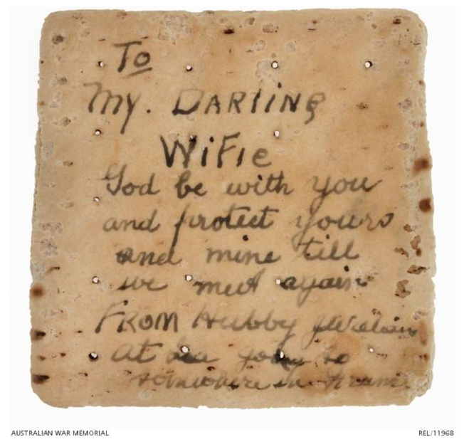
figure 1/Hardtack inscribed by Sgt. James William in 1917. Source: Australian War Memorial, REL/11968.
It is also worth mentioning that hardtack last more or less forever as there are examples of there being examples of this ships bread lasting well over 100 years and even is still now edible with even comments like “Army biscuits were notoriously tough” a quote made by Nick Fletcher, head of Military Heraldry and Technology at AWM(Ewbank, 500) even comparing them to clay tablets. Eating these dense types of bread is a trial in itself as first you have to soak the bread in to a liquid or grate the bread into a soup so that there would not be any chance of someone breaking their teeth in on the hardtack in fact there used to be an old joke between soldiers that they should eat the bread with bullets in order to eat something softer(O’Hagan, 2024). Hardtack is still used today because as mentioned it still is used today due to its high concentration of carbohydrates, the breads low weight and its low material cost and the ability to make large batches relatively fast as it only takes a small amount of dough, water and salt in order to make 10 or even 20 biscuits ready for consumption. Figure 2’s example of hardtack and gravy is technically more modern, but I feel its important to show that this food is still being used in the modern day and actually helps people a great deal when out hiking in any conditions whether that is a say trip or even camping out while hiking.
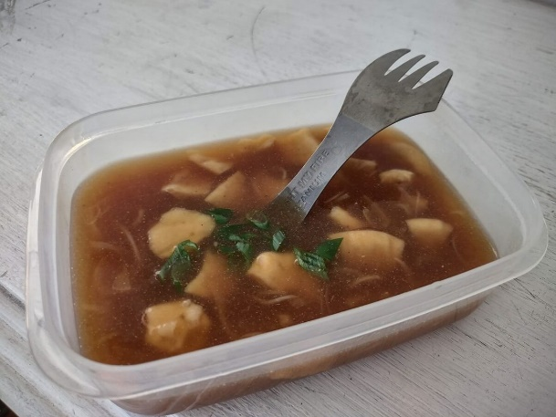.
figure 2/ trail meal hard tack in gravy/Hiking Food/ June 28 2022

A diary needs to explain what someone went through in the day but there is many and the day I baked the hardtack was eventful. I wont recap the entire day because honestly not all of it was important. I went to the shops and hung out with my friend that was all that happened in the day, but it was in the night and when I decided to make these dry biscuits. Making it was uneventful as I made the dough and cut it up as I described earlier and put it in the oven on low temperature, as I said the temperature was on low and it would be going for a long time, seven hours in fact. It was in those seven hours that was the major events of the day as in that time there was a storm that battered my home and ended up taking out the power lines for a few hours and letting my biscuits take a break from being cooked for an hour, which worked to my benefit in the end but I had a major panic attack over. I remember panicking so much that it would ruin the biscuit and I would have to start over the 7 hour process that, at this point I was more than 4 hours in that the smell of the biscuits which as I said, is something that I cannot describe pulled me deeper in to this spiral that lead me into the corner of my room. But then more than one hour later the power turned back on, and the biscuits then continued to cook until one is when they finished cooking through and extracting as much water and moisture as possible.
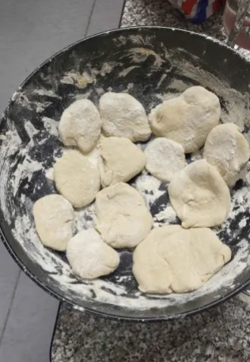
figure 3/the dough being set out/caleb rees/2024/Lampeter
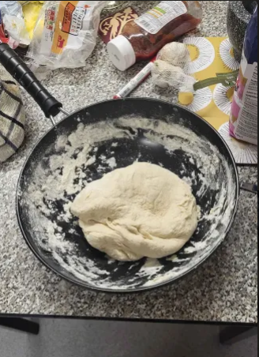
figure 4/the dough before the oven/caleb rees/2024/Lampeter
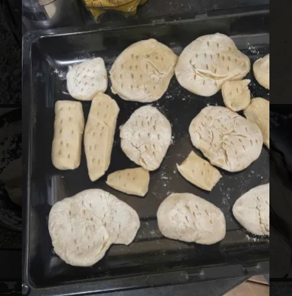
Once I had made the biscuits, I ended up going down a rabbit hole of these survival/rationing types of food and found out some very interesting things about many cultures and what they all individually eat in order to survive harsh journeys or even harsh winters. And one that I came across that made me particularly interested was pemmican. Pemmican was what made trade in native America possible as it was a food packed with so much protein and energy that it could keep someone going for as long as their bodies could hold out(Ngapo et al., 2021). Pemmican Is normally completely made from a bison, with no part of the bison being wasted as pemican is cooked inside the bison skin and the fat and meat is held together in a frozen bar, which coincidentally resembles a breakfast cereal bar that you get in the supermarkets. These meals can be eaten frozen or cooked it depends on the circumstance that you have to eat them in. what this entry into my diary is trying to say is that there are other such foods that merit study and viewership as pemmican, like many other types of food of their nature, allowed the economy and trade to flow. Without these foods being rationed out then the world as we know it would not be as vast, and the archaeological record would not be nearly as full as it is now. How many places would be undiscovered? Unexcavated? Undocumented? Although I will be the first person to say that pushing a machine like the economy is not without its moral and ethical faults, as I mentioned in the moments about the slave trade(Dalrymple-smith and Frankema, 2017) it still merits notoriety that these meals are what kept our world moving in the way it has for so long.
figure 5/ halfway complete biscuits/caleb rees/2024/Lampeter
The presentation that I ended up handing in was a failure and sitting here now the day after I ended up giving the presentation I can feel that I have a failed it. Despite the proverbial gut punch to my confidence, I know that I have to pick myself back up, to be honest the one thing it feels that I know how to do is pick myself back up. But I though it would be worth reflecting on where I actually went wrong as there are many ways it went wrong, and it honestly feels like I just did not have a grasp on exactly what I needed to do to complete that task. I don’t believe that I was taught poorly, and I certainly don’t believe that its anyone else’s fault I feel like I just ended up getting something wrong that dominoed in to and entire. I feel that my presentation was aesthetically good and that my delivery was good as I have found that I am fine with speaking in large crowds and even to smaller ones, oddly enough it is one on one conversations that I struggle with the most. but it is in the content and the reading that I simply did not do or did not find applicable to the power point presentation that I was tasked with. My presentation was more about experimental archaeology and not what I wanted to do and honestly, I have to agree with that sentiment. I find that I really have no aim with what I am doing and feel that I need to push myself further and find out what about these historical foods that I made.

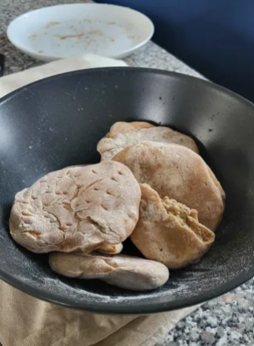
figure 6/finished product/ caleb rees/2024/Lampeter
Figure 5 here shows the completed product of the ships biscuit that I ended up making from my project and intend to hand in as soon as the submission point opens, which is sufficient to say erratic. But the food itself is devoid of moisture and is incredibly dense, so much so that the biscuit is significantly lighter than it reasonably seems to be. The biscuit is dense and honestly you could use it to hammer in nails and hold your walls together. Hyperbole aside the biscuits last a long time and the only thing that can really spoil them is weevils and other bugs making their home in the bread however it is still actually edible and in fact has been eaten like that many during the 18th century during long voyages(O’Hagan, no date)

My lecturer ended up putting things correct for me in the end as I realised a lot of things about what my project is and how I can hopefully save this metaphorical sinking ship. I realised that there was a key factor in what I am talking about in this journal that, for some unknown reason I never considered. The feeling that this food evoked in sailors, soldiers and the modern world. And although I may rewrite a large portion of this journal because if this, I may end up with significantly more material to write with. The conditions that the sailors worked in and how that translated to food that made storing light and hearty meals mandatory(Dalrymple-smith and Frankema, 2017). Then it interested me further how the unstable economy of world war one and two made it how cheap and easy meals were what he military needed to stay strong, although it is worth mentioning that any military would realistically value this such as the heavily studied Napoleonic wars and their scarce food supplies(Gates, 2011). Or the modern uses in the hiking and outdoor camping community which is still incredibly active and uses many of the food and energy storing techniques that have been used for hundreds of years.
Interestingly die to a logistical error there has been a significant extension on the project which thankfully does give me more time to work on my research but also enjoy the coming holidays with my family. Although working is the priority I will let myself have some fun as I think anyone who is able to celebrate the holidays should celebrate whatever holiday they choose too.so what did I learn during my time off ad away from university? Well aside from how different Christmas as an adult is to that of a child. I learnt more about where I went wrong in my work as my lecturer sent me back my marks for my power point presentation that I did the previous month and I realised that I had failed the assignment which was not a surprise in fact it was expected but seeing that I now have concrete feedback to work off od I think I can now actually beginning to work on the issues that I fell into before in the power point presentation. My first real failure was, as I said a lack of direction in the aim of my project. So, I decided to find that aim. The aim that I decided was what does certain diets or food say about history and what it can say about the needs of the group that it feeds. My second pitfall was my lack of readings which I hopefully have fixed in my re writes and continued reading of the topics around this

This diary has been an eventful experience and one that is filled with what I believe to be an authentic experience in the effects of food and how it can impact those in the direst of situations. It is my belief that the food meant for soldiers and sailors being so compact and storable is a testament to what people are capable of and that fact that the food that I have discussed has been used, studies and utilised in so many different ways further show how ingenuity shows to be a soldier’s best friend. For example, the letters that was used to carve in hardtack as seen in figure one. But there are also downsides as there are examples of bugs living in hardtack that you still have to eat (O’Hagan, 2024). So, it seems that hardtack is being used throughput history, but it is even used in the modern day in hiking and camping as a trail food that will give people the energy, they need in order to persevere through the trial that they put themselves through or even surviving the ordeal that is sailing. It seems that hardtack can persevere through any manner of trials, and I hope that, through this diary that I have done the same.

Bibliography
Walbert, D. (2009). Food For Fighters. 1-2.

Dalrymple-smith, A. and Frankema, E. (2017) ‘Slave ship provisioning in the long 18th century. A boost to West African commercial agriculture?’, European Review of Economic History, 21(2), pp. 185–235. Available at: https://doi.org/10.1093/ereh/hex002.
Esq, W.E.S. (1875) ‘Preservation of Biscuit and other Farinaceous Articles of Diet from Weevil, Maggots, and other Insects in H.M. Navy’, Royal United Services Institution. Journal [Preprint]. Available at: https://doi.org/10.1080/03071847509415780.
Ewbank, A. (500) Australian Soldiers Used to Write Letters Home on Crackers, Atlas Obscura. Available at: http://www.atlasobscura.com/articles/australian-soldiers-hardtack-letters (Accessed: 20 January 2025).
Gates, D. (2011) The Napoleonic Wars 1803-1815. Random House.
Gazeley, I. and Newell, A. (2015) ‘Urban working-class food consumption and nutrition in Britain in 1904’, The Economic History Review, 68(1), pp. 101–122. Available at: https://doi.org/10.1111/ehr.12065.
Haber, B. (2010) From Hardtack to Homefries: An Uncommon History of American Cooks and Meals. Simon and Schuster.
Ngapo, T.M. et al. (2021) ‘Pemmican, an endurance food: Past and present’, Meat Science, 178, p. 108526. Available at: https://doi.org/10.1016/j.meatsci.2021.108526.
O’Hagan, L.A. (no date) ‘The semiotic remediation of hardtack biscuits during World War One’, Visual Studies, pp. 1–16. Available at: https://doi.org/10.1080/1472586X.2024.2347512.
The Eighteenth-Century English Diet and Economic Change - ProQuest (no date). Available at: https://www.proquest.com/openview/b03634264f5981f6c8e423a2b0b60443/1?pq-origsite=gscholar&cbl=1819326 (Accessed: 19 January 2025).
figure 1/Hardtack inscribed by Sgt. James William in 1917. Source: Australian War Memorial, REL/11968.
figure 2/ trail meal hard tack in gravy/Hiking Food/ June 28 2022
figure 3/the dough being set out/caleb rees/2024/Lampeter

figure 4/the dough before the oven/caleb rees/2024/Lampeter

figure 5/ halfway complete biscuits/caleb rees/2024/Lampeter
figure 6/finished product/ caleb rees/2024/Lampeter

