

Organisational Culture
Individual Report: LCLM5005

Student Name: Rio-Raquel Ramsey

Student Number: 2416415

Lecturer: Ramseses Manalang

Table of Contents

Introduction 3
Organisational Culture of John Lewis 4
How Organisational Culture Shapes Structure and Decision Making…………………….5 Organisational Culture Theories………………………………………………………………6
Handy's 4 types of culture……………………………………………………………………...7
Figure 1…………………………………………………………………………………………7.1
The cultural web.………………………………………………………………………………..8
Figure 2…………………………………………………………………………………………...9
Organisational Culture and Adaptation to the External Environment of John Lewis Partnership..………………………………………………………………………………..10/11
Evaluation of the impact of Organisational Culture on Performance 12 Conclusion……………………………………………………………………………………...13
References………………………………………………………………………………………14

INTRODUCTION

This report examines the organisational culture of John Lewis Partnership (JLP), one of the UK’s most recognised and trusted retailers on the high street, ranking in the top 10 in the retail sector (Retail Sector, 2024). John Lewis is renowned for an employee-owned structure, with 69,000 employees known as partners. (John Lewis Plc,2026)
This report analyses how organisational culture within John Lewis shapes its structure, decision-making process, and its ability to adapt to external pressures.

Organisational culture is vital in how modern organisations run, influencing decision-making, behaviour and performance. According to Mullings and Christy (2016), organisational culture is described as “How things are done around here”.
It examines its impact on employee attitudes, organisational structure and strategic choices. (Statista Research Department, 2025)

Organisational Culture of John Lewis Partnership

For nearly a century, John Lewis has held partners at the very heart of how the company is run and its organisational culture; they believe it's not just work or a job, but who they are. They're more than just employees; they are partners.
John Lewis Partnership is the largest employee-owned business in the UK, originally founded as an industrial democracy experiment by the company's founder, John Spedan Lewis. Its culture nurtures shared responsibilities, mutual respect and collective end goals. It has a major sense of inclusivity within its community and draws strength from all its partners, who are seen as special individuals.
Customer service is another vital factor in John Lewis' organisational culture, because partners rather than stakeholders own it; they pride themselves on what matters-the customers. Partners are trained to maintain a high standard of professionalism and customer satisfaction.
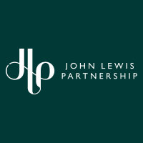



How Culture Shapes Structure and Decision Making

Because the business's ownership structure is built around partners being able to voice their ideas, share responsibility, and act fairly, these core cultural values shape how teams are assembled and how major business decisions are made.
The culture of partnership is reflected in the organisation's structure: while most retailers use a top-down hierarchy, John Lewis employs a more democratic model. Because employees are classed as partners, they have a genuine stake in the business, which directly influences decision-making processes and leadership styles, fostering a participative environment.

Organisational Culture theory – Handy: 4 types of culture (2020) and The cultural web (1992).

This report will present two theories: Charles Handy’s cultural types and the cultural web by Johnson and Scholes. Both models will be applied to John Lewis to illustrate how its shared values, traditions, and behaviours shape its organisational practices, such as its democratic structure and emphasis on shared responsibility.
Within Handy’s theory, 4 types of organisational culture are identified: Power, Role, Task, and Person.

Power: Fast decisions, Strong direction, few formal rules
Role: Structure, rules, clearly defined roles
Task Culture: Flexible, project-based, collaboration is key, expertise is valued
Person Culture: The individual is the Centre; the organisation exists to support them
According to (business.com,2026) Handy based it on Greek gods:
Power Culture is based on Zeus: Top-down, power and influence
Role Culture is based on Apollo: Bureaucratic, strict procedure
Task culture is based on Athena: Small team focused on results and solution-oriented, flexibility and adaptability
Person Culture is based on Dionysius: Individual-focused, prioritising the betterment of their people, and relying on self-motivation. JPS uses a blend of Role and person culture, which is unusual but works with the employee-owned structure. This combination also highlights a structured yet people-centred approach that supports fairness, motivation, and community.

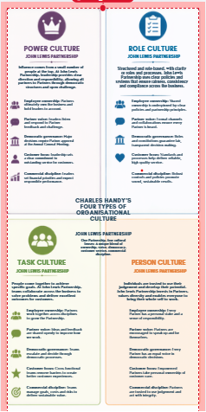
Figure 1. Handy's 4 types of culture

The cultural web (Johnson and Scholes., 1992)

The cultural web is broken down using 6 cultural groups:
Stories and Myths: Past and present events that are discussed within and outside the company; shared partnership, high-end customer service, and fairness; this cements the idea that their employees matter as much as customers, with customers coming first.
Rituals and Routines: How events that matter and how said events are handled. E.g., training courses, Friday drinks, recruitment and selection processes. These daily routines remind partners of values and responsibility.
Symbols: Introducing the term “partner” instead of “employee” can be seen as a strong symbol of unity, equality, and shared ownership and values.
Power Structure: Partners can elect leaders and representatives who provide fairness and transparency. This is shown in the cultural belief of distributed and shared responsibility.
Organisational Structure: The way the organisation is being run, how things are being managed, determined and distributed, which supports a democratic structure reflecting the partnership model.
Control Systems: monitoring processes that reflect what the organisation prioritises, such as teamwork, high-end customer service and customer and partner satisfaction.

Both Handy's theory and the cultural web provide insight into JLP culture, representing it as people-focused, ethical, and collective.

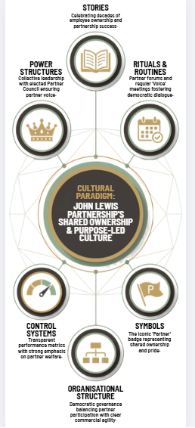
Figure 2. Cultural web
Organisational Culture and adaptation to the external environment of John Lewis Partnership PESTEL (1967, Aguilar)

Political: JLP's culture of unity, fairness, and transparency helps mitigate political pressures and ensures responsible practices. For example, when new laws or regulations emerge, partners are informed and involved in decision-making, exemplifying how the organisation's culture facilitates compliance and adaptation to external political changes.
Economical: Because partners have a personal stake, they are more willing to support cost-saving measures and implement new working practices to ensure high-end service standards are maintained, even when budgets are tight. Clear and open communication reduces anxiety and builds trust; this, in turn, supports effective navigation through economic changes more than competitors with different or weaker cultures.
Social: Trends such as diversity and ethical consumerism highly influence JLP. The organisation's culture already reflects social values such as inclusivity, high-end customer service, and fairness, because partners are trained to value, respect, and empathise with customers, which can lead to more personalised service that meets rising expectations, making it easy to adapt to social changes both within the workforce and the customer base.
Technology: Tech is one of the main external pressures, especially as the world has started to shift to online shopping and going digital; partners being encouraged to be involved and share not just ideas but also feedback can help adapt to new digital tools, upgrade operating systems and improve online services. This aligns with the inclusive open decision-making culture and long-term goals.
Environmental: Environmental pressures, such as climate change, tend to influence customer/stakeholder behaviour. JLP’s culture has consistently shown shared responsibility, inclusivity and long-term thinking that includes reducing waste, ethical sourcing, and actively finding ways to save energy, making it smoother to adapt to environmentally friendly practices, which again align with JLP values.(Gregory et al., 2009)
Legal: Retail organisations must comply with laws and regulations related to employment, consumer rights, health and safety, and data protection. Partners understand the importance of ensuring the rules are followed and high standards are maintained, with JLP culture reflecting ethical behaviour. This makes it easier to uphold legal compliance, and with open, clear communication that explains legal changes, changes can be consistently reviewed. (Solo, 2025)

Using JLP with the PESTEL framework shows how culture helps keep the business consistent and adaptable despite external environmental changes. Due to the organisation's culture being built on partnership, shared responsibility, and overall fairness, it can respond to and adapt to Political, economic, Social, Technological, Environmental, and Legal pressures without compromising its identity whilst also moving with the times. JLP’s values act as an anchor, guiding how the company responds to new laws and regulations, budget challenges, or changing sustainability demands; this demonstrates a strong cultural foundation that helps the organisation maintain trust, make fair, insightful decisions, and stay resilient.

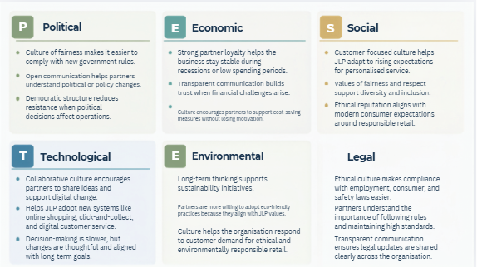
Figure 3. PESTEL Framework

Evaluation of the impact of organisational Culture on performance

The organisational culture of JLP has a large Impact on how well the organisation performs. Because the company is built on shared ownership and fairness, these cultural values mould everything from workforce motivation to customer service. The impact can be reflected in both positive and challenging ways. (Gregory et al., 2009)

One of the largest positive impacts is workforce motivation. Because they are classed as partners rather than “just employees”, partners feel personally connected to the business as co-owners. This sense of ownership motivates them to work at their best, deliver high-end service, and take pride in their roles. A motivated workplace tends to create a better customer experience, which in turn strengthens JLP’s reputation and helps boost sales. The culture also promotes teamwork, unity, and support, which reduces conflict and anxiety and creates a non-toxic, stable environment.
Customer service is also a big strength, with JLP known for high-quality, high-end service; this reputation stems from JLP’s culture. Partners are trained to empathise and treat customers with respect, patience and care. This is then followed by loyalty, repeat purchases and a positive brand representation. While the retail market can be quite competitive, this strong cultural commitment to high-end service and partners gives JLP a significant advantage over rivals that are typically price- and speed-focused.
JLP’s culture supports long-term stability through its values, ethical behaviour, fairness, and open communication. The organisation tends to adopt a long-term approach to protect its future rather than make snap decisions for short-term returns. This builds trust with various stakeholders, including customers, suppliers, and partners.
Partners often show commitment, unity and strength, keeping the organisation on a steady path during difficult periods.
Although there are positives, the culture can present some challenges. The retail industry is fast-moving, and competitors often make rapid changes to pricing, technology, and strategy. The democratic decision-making model can be seen as positive for partner involvement but can also slow down the organisation's quick reaction. JLP’s approach means collective decision-making creates delays, which in turn reduce agility and make it harder to compete with faster retailers.
Costs and budgets can be another challenge; the partnership model offers benefits such as bonuses, training, discounts, and well-being support packages. These benefits are costly to maintain, especially during periods of low sales. However, this may raise workforce morale; it can also strain budget resources and hinder investment in other areas, such as expansion.
And lastly, high expectations for a high-end service and certain behaviours create pressure for the partners, especially to continuously maintain these standards at all times, which can lead to anxiety, stress, and rapid burnout. If not monitored, this can affect performance and reputation. Overall, the culture maintains a strong and mostly positive impact on performance. It shows customer loyalty, ethical behaviours, long-term stability, and motivation. Decision making can be slow, causing delays, whilst costs can also increase. The main challenge for John Lewis Partnership is ensuring there is a balance between its cultural values with staying relevant and competive in a rapidly changing environment.

Conclusion

John Lewis Partnership’s organisational culture plays a vital role in how the business runs and how it reacts to the pressures of a rapidly changing retail environment. Its partnership model creates a workplace built on shared ownership, fairness and collective responsibility; these values shape both everyday behaviour and long-term strategic decisions. Throughout this report, it has become clear that culture is not merely an internal element but a core factor influencing structure, performance, and decision-making.

The culture encourages open communication, democratic engagement, fairness and a strong sense of belonging amongst the partners. This has a direct impact on customer service, employee motivation, and the organisation's reputation for ethical behaviour. The culture also reflects stability during difficult periods of uncertainty, even when facing economic pressures, technological change, or differences in customer expectations.JLP's values drive how the organisation adapts and maintains consistency.
The culture also presents challenges, such as decision-making delays, which can lead to delays; the cost of maintaining partner benefits can limit budget resources. The above factors highlight the need to balance maintaining the strengths of the partnership model while making sure the organisation stays competitive in a fast-moving industry.
In conclusion, John Lewis Partnership's culture is one of its prized assets; it fosters resilience, strengthens relationships with customers and partners, and provides not only an identity but also a sense of community. This cultural foundation has been laid for the organisation and will remain crucial to its ability to adapt to change and maintain long-term success.

References

Statista Research Department (2025) John Lewis Partnership – statistics & facts. Published by Statista Research Department, 17 December 2025. Available at: https://www.statista.com/topics/8716/john-lewis-partnership (Accessed: August 2026)

Solo, A. (2025) Essential legal considerations for employers: A guide to employment law compliance. Sprintlaw UK. Published 16 July 2025. Available at: https://sprintlaw.co.uk/articles/essential-legal-considerations-for-employers-a-guide-to-employment-law-compliance/ (Accessed: 10 August 2026).

Aguilar, F. J. (1967) Scanning the business environment. New York: Macmillan.

Gregory, A., Lumpkin, G. T. and Brigham, K. H. (2009) Organisational performance: The role of strategic orientation and environmental context. Journal of Business Research, 62(6), pp. 673–679.

Mullins, L. J. and Christy, G. (2016) Management and Organisational Behaviour. 11th edn. Harlow: Pearson

Johnson, G. and Scholes, K. (1992) Exploring Corporate Strategy. London: Prentice Hall.

Handy, C. (2020) Understanding Organisations. 5th edn. London: Penguin Books.

Figure 1: Canva, 2026

Figure 2: canva, 2026

John Lewis Partnership (2026) Annual Report and Accounts 2026. London: John Lewis Partnership.

Retail (2026) Retail Industry Report 2026. London: Retail.

