

Exploring Family Dynamics and Consumer Behaviour of Households with Dependent Children in the UK: A Quantitative Analysis

Student name: Ariadna Nagy
Student number: 1812193
Module lead: Dr Helen Lee
Module: LCDB7011
Abstract

This research explores the influence of family structures on the prevalence of dependent children within the context of the UK market, utilising database released by the Office for National Statistics, and aiming to inform marketing strategies for businesses targeting family-oriented products and services. Employing quantitative analysis, the study examines various family types, including married families, lone-parent families, and cohabiting couples, revealing significant differences in the likelihood of having dependent children. The findings indicate that married couples tend to have the highest prevalence of dependent children, while lone parents, particularly lone mothers, also present notable challenges and higher rates compared to their equals. Additionally, the study highlights the emerging trend of same-sex cohabiting families with dependent children, whose increasingly visibility may influence consumer preferences. By connecting the results to established theories such as Bandura’s Social Learning Theory and Role Theory, the research stresses the importance of understanding family dynamics in shaping marketing strategies. Ultimately, the insights garnered from this study serve as a foundation for businesses to tailor their approaches to diverse family structures, therefore fostering inclusivity and responsiveness to market demands.

Table of Contents
INTRODUCTION 4
LITERATURE REVIEW 7
METHODOLOGY 18
Research paradigm 18
Statistical analysis 20
Limitations to the study 21
DATA ANALYSIS 23
FINDINGS AND CONCLUSION 32
REFERENCE LIST 35

INTRODUCTION
The introduction chapter of this research is going to emphasise the importance of the research by placing the study within context, and by offering a problem statement explaining the significant challenges and opportunities businesses face due to the evolving dynamics of families nowadays. This study will be conducted using a secondary database set collected in the United Kingdom only, provided by the Office for National Statistics, and made available by the University of Wales Trinity Saint David.

Over the past decades, the world has been undergoing a paradigm shift in what concerns the traditional family dynamics, fundamentally altering the way families are structured and perceived. This change had been characterised by a significant rise in divorce rates, which in turn has led to a growing number of lone-parent households (Osborn, 2019), creating new experiences and challenges for the families. These changes are not only confined to single-parent situations; there has been a notable increase in the same-sex families (Lenz and Adler, 2023), a testament which challenged the traditional structure of families. Another testament which possibly might have implications in the nowadays family dynamics is the Act of Equal Pay 1970 (UK Public General Acts 1970, c.41), which emphasises the importance of gender equality, therefore allowing women to become more financially independent, and enabling them to maintain lone-parent households.

This research is particularly interested in examining the relationship between evolving family structures and their practical implications for business as an increasingly area of research. As family compositions continue to diversify – whether through the rise of cohabiting couples, lone-parent households or same-sex families – these transformations have far-reached consequences for consumer behaviour and corporate strategies. Understanding these changes is essential for business aiming to remain competitive in a marketplace where traditional assumptions about their family roles and responsibilities are no longer sufficient. Modern families, with their unique needs and circumstances, are reshaping how households make purchasing decisions, influenced by factors such as family size, income and the dependency status of children (Cherlin, 2022).

This study aims to understand how evolving family structures influence consumer behaviour, offering crucial insights for businesses to align their marketing strategies, products and services with the diverse needs of modern households. The traditional family model – married couples with dependent children – presumably no longer represent the main targeted market, as societal changes have led to an increase in lone-parent households, same-sex couples and cohabiting families. These shifts create new consumer profiles, each with distinct needs and purchasing behaviours. Companies that fail to recognise and adapt these changes rish losing touch with key segments of the market (Cherlin, 2022; Perelli-Harris and Lyons-Amos, 2020).

For businesses, understanding the nuances of these family forms is critical for designing targeted marketing campaigns. Married couples, for instance, may have different priorities compared to lone-parent or cohabiting households in terms of child-related purchases, family activities, or home-related services. Research suggests that married families are more likely to invest in long-term purchases, such as real estate and educational services, while lone parent families may prioritise affordable childcare solutions and budget-friendly consumer goods (McLanahan, 2020).

The rise of lone-parent families, particularly lone-mother households, represent another key demographic that businesses must address. These families may exhibit different consumer behaviours due to economic constraints, greater caregiving responsibilities and social factors. An example to including these market segment would be marketing efforts to focus on affordable household essentials, child-related products, and services that assist with time management – crucial factors for single mothers balancing work and childcare (Haines et al., 2018). On the same note, same-sex couples, who often navigate different social and legal contexts in child-rearing, may require products and services that reflect inclusivity and recognition of their unique family experiences (Godberg and Gartrell, 2021). Businesses that create inclusive, representative marketing can strengthen brand loyalty and build long-term relationships with these households.

Furthermore, family dynamics strongly influence decision-making processes within households, from what products to buy to which brands to trust. For example, in cohabiting and same-sex homes, the couples tend to have more egalitarian structures and households’ behaviour, thus decision-making may involve greater shared responsibility than in traditional family structures (Evertsson and Nyman, 2017; Carington, 1999). Businesses can leverage this understanding to design marketing campaigns that appeal to shared decision-making in these types of households (Silton, 2017). As family roles evolve, brands that successfully reflect these shifts in their messaging resonate better with their target audience and may stay relevant in a competitive market.

By focusing on the UK population only – database set between the years 2015 – 2023, this research provides a nuanced understanding of how family structures are evolving within a specific sociocultural context. The British consumer market, like many others, is witnessing an increasing diversity of family forms, making it critical for businesses operating in this space to develop strategies that account for these changes. By connecting demographic shifts in family composition to consumer behaviour, this study offers businesses the tools they need to refine their marketing approaches, product development and consumer engagement strategies (Cherlin, 2022; Perelli-Harris and Lyons-Amos, 2020).

In conclusion, this research contributes to a growing body of knowledge on how businesses can align their practices with the realities of modern family life. As family structures continue to change, businesses that proactively adjust their marketing strategies and product offerings will be better positioned to meet the needs of their consumers and maintain a competitive edge in nowadays market.

LITERATURE REVIEW
This chapter will critically evaluate the existing body of literature concerning the subject studied, offering a deeper understanding of the problem statement and background of the research; the chapter will also include the statement of hypotheses.

As explained by Kreyenfeld and Schneider (2021), until not many years ago, the idea of a family within sociology was regarded only as a married couple with children that live within a household unit. However, the ideology of a family structed was impacted by various factors in the last years, such as the Divorce Reform Act 1969 (Wedlock or deadlock, UK Parliament) – which enabled divorces to become more accessible and easier to get, the Equal Pay Act 1970 (UK Public General Acts 1970, c.41) – which minimalised the pay gap between genders, the Marriage Act 2013 (UK Public General Acts 2013, c.30) – which gave the rights to same-sex couples to legally get married in England and Wales, etc.

Historically, marriage has been closely associated with family stability and children raising. Research shows that married couples are more likely to have dependent children compared to other family forms. Cherlin (2010) argues that marriage, particularly from a legal and social perspective, tends to foster environments conducive to child-rearing due to increased financial stability and social support, and long-term commitment. Studies also indicate that marriage is often correlated with planned childbearing, whereas cohabiting couples, especially opposite-sex ones, are more likely to delay having children due to economic uncertainties or lack of any formal commitments (Kiernan, 2004). Furthermore, lone-parent families, which are the result of divorce or separation, are more likely to struggle with financial and social challenges, which can limit their capacity to support their dependent children (McLanahan and Sandeful, 1994).

The existing literature indicates a significant rise in lone-parent families, predominantly led by mothers, which has substantial implications for consumer behaviour and marketing strategies. According to the Office for National Statistics (2023), the majority of lone-parent families are headed by mothers, with lone fathers covering a smaller scale.
According to Amato (2005), lone mothers are more likely to care for dependent children than lone fathers, partly due to the traditional gender roles that position women as primary caregivers. On the other hand, lone father, although fewer in number, often have older, non-dependent children or face different childcare dynamics, as societal expectations tend to relieve men from some caregiving responsibilities (Baxter et al., 2011).
This gendered division in single-parent families suggest that family dynamics differ significantly between lone mothers and lone fathers when it comes to children dependency.

Previous research also indicates that lone-parent households, particularly headed by women, are more likely to include non-dependent children than married or cohabitating couples. Studies by Treanor (2018) suggest that lone-parent families, especially formed after divorce or separation, tend to experience prolonged periods of single parenthood, often leading to children remaining in the home as non-dependants.
These households’ dynamics are based on economic hardships and limited resources, and therefore, adult children may sometimes cohabit with parents due to financial dependence or the need for additional support. In contrast, married and cohabiting couples are less likely to have non-dependent children in the house, as these families often have greater financial means, allowing children to achieve independence earlier (Stone, Berrington and Falkingham, 2014).

Cohabitation has become a new form of family concept which has challenged the traditional assumption that marriage is the primary context for raising children. Opposite-sex cohabitating couples are increasingly choosing to have children outside marriage, particularly in countries where cohabitation is more socially accepted and where legal recognition of non-marital partnerships is acknowledged (Perelli-Harris and Galezewska, 2021).
However, research suggest as well that cohabitating couples, particularly opposite-sex couples are less likely than married couples to have dependent children, due to constraints such as economic instability, lower levels of formal commitment and varying social norms (Pereelli-Harris et al., 2018), housing insecurity and precarious employment (Guzzo, 2021). Meanwhile, Mazrekaj (2022) argues that same-sex cohabitating couples are even less likely to have dependent children, reflecting both biological limitations and historical legal limitations on adoption, which impacted the likelihood of these couples to child-rearing.

Business owners and marketers are closely following up with today’s evolving social landscape, where the structure of the modern family is undergoing significant transformation, impacting not only societal norms but also consumer behaviour, workforce dynamics and business strategies. As recent studies show a significant increase in cohabiting couples, lone-parent households and same-sex families, this fact has reshaped the perceptions of traditional family dynamics (Office for Statistics, 2023; DeRose et al., 2017). As previously mentioned, this research seeks to examine these changing family structures, particularly the rise of cohabiting couples, lone-parent households, and same-sex families, in the context of child dependency.
Understanding these shifts is crucial not only for social policy, but also for business looking to adapt to the needs of contemporary families. Research highlights that different family composition are associated with varying consumer behaviours and financial priorities (Perelli-Harris and Lyons-Amos, 2016).

This study aims to explore how shifts in family structure influence consumer preferences, offering valuable insights for businesses looking to refine their marketing strategies and product offerings. As family compositions evolve, from married couples with children to cohabiting and lone-parent households, consumer behaviour shifts accordingly, creating new demands and opportunities for companies to engage with diverse audiences (Cherlin, 2022). Businesses that understand these changing dynamics can develop more targeted campaigns, tailor product lines, and create experiences that resonate with modern family needs. For instance, brands can design marketing campaigns that speak directly to non-traditional families, offering products and services that fit their unique lifestyle, while also recognising the purchasing power of households with dependent children (Perelli-Harris and Lyons-Amos, 2016).

Moreover, these demographics shifts have implications for segmentation strategies, enabling companies to better position their products and services based on household composition. Companies that once relied on traditional family units as their core consumer base are now faced with a more nuanced audience that includes single-parent households, same-sex couples, and blended families. As a result, a more inclusive approach to marketing, including the representation of diverse family forms in advertising, has become essential to appeal to modern consumers (Bowne and Giampietro, 2021).

By bridging the gap between academic research on the evolution of family structures and their practical business applications, this study contributes to a deeper understanding of how contemporary family life shapes corporate strategies in today’s marketplace. Through this lens, businesses can anticipate and respond to shifts in consumer demand more efficiently, ensuring their offering remain relevant and resonate with the broad spectrum of family dynamics present in modern society.

To gain a deeper understanding of how modern family structures influence consumer behaviour, this study draws upon two key theoretical frameworks: Social Learning Theory and Role Theory.

  - Social Learning Theory (Bandura, 1977)
Social Learning Theory, developed by Albert Bandura (1977), posits that individuals learn behaviours, values and preferences through observation and imitation of others. In a family context, children often adopt consumer behaviours and brand preferences by watching their parents and other family members. This process highlights the influential role of family dynamics in shaping children’s understanding of consumption (Mangleburg and Bristol, 2001).

For marketers, applying Social Learning Theory offers valuable insights into targeting family-oriented campaigns. By showcasing how products enhance shared-family experiences – such as family meals, outings, or celebrations – brands can effectively tap into the parental influence on children’s consumer choices (McNeal, 1992; Sutherland and Sylvester, 2002). Advertisements that resonate with family moments foster emotional connections and encourage brand loyalty.

Moreover, the increasing diversity of family structures calls for a thoughtful approach in market strategies. Brands can cater to single-parent households or same-sex couples by emphasising how their products meet exclusive needs, thereby promoting inclusivity and recognition of varying parental roles (David, 2018). By aligning marketing efforts with the principles of Social Learning Theory, companies can better engage with contemporary families and adapt to evolving consumers behaviours.

  - Role theory (Biddle, 1986)
Role Theory suggests that individuals adopt specific roles within a social structure, such as a family, which shape their behaviour and decision-making process. In the family context, roles like caregiver, provider, or decision-maker influence how household members interact and make purchasing decisions. These roles guide consumer behaviours, as family members make choices that match their assigned or assumed responsibilities (Biddle, 1986, Solomon et al., 1985).

For business owners and marketers, understanding the Role Theory provides understanding into how to target family members based on their distinct roles. Campaigns can be designed to appeal to the different decision-makers in a family – such as a caregiver choosing child-focused products or a breadwinner considering financial aspects. Highlighting how products or services meet the need of specific family roles can create more successful marketing strategies (Epp and Price, 2008). This theory can provide insight, for example, for brands to design advertisements that focus on how products simplify the caregiver’s role or support the family’s overall well-being.

Moreover, the diversity of family dynamics nowadays means roles are not confined to traditional norms. Lone parents, cohabiting couples, and same-sex families may distribute role differently, providing opportunities for businesses to craft exclusive campaigns that resonate with modern family dynamics. Recognising and appealing to these role-driven behaviours can enhance brand relevance and consumer engagement (Harrison, 2020; Baxter et al., 2011).

Despite the growing literature and the rigorousness and robustness of this research, particular gaps in the body of the literature can act as limitations, and thus affect the final outcome.
As per Baker et al. (2019), one of these gaps that warrant future investigation lies in understanding of blended families, which have emerged as a prominent family type yet remain under-exposed in the context of consumer preferences and marketing strategies. Existing studies predominantly focus on traditional family structure, often neglecting how blended families navigate consumer choices and brand loyalty.
Furthermore, the literature frequently overlooks the diverse experiences of racial and ethnic minority families within contemporary consumer markets. Research indicates that cultural facts significantly shape family dynamics and consumption patterns, yet the voices and experiences of minority households remain inadequately represented in consumer studies (Kumar et al., 2021).
Moreso, while much attention has been paid to the economic challenges faced by lone-parent families, there is a lack of nuanced understanding regarding the psychological and emotional aspects that influence their purchasing decisions (Duncan et al., 2020). This gap suggests that marketers may be missing opportunities to connect with these households on a deeper level, reinforcing the need for more inclusive and empathetic marketing approaches. Thus, addressing these gaps would not only enrich the academic discourse, but also provides practical insights for businesses seeking to engage with diverse landscape of modern family structures effectively.

This ongoing evolution of family norms is reshaping how we think about relationships, caregiving roles, and the very concept of family (Silton, 2017). In this context, the current research focuses on the population of the United Kingdom, aiming to provide a comprehensive analysis of how these trends are reflected in British society, and how they influence consumer preferences and behaviours across diverse household structures.

This research adopts a quantitative approach, focusing specifically on families in the UK, with particular emphasis on the presence of dependent children. Utilising secondary data, this study analyses an established database that recognises individuals by family type and child dependency from 1996 to 2023, although the primary focus will be on the years 2015 to 2023.

The research is framed within a positivist paradigm, which underpins the exploration of measurable phenomena and facilitates objective analysis of family dynamics. The methodology employed involves analysing data obtained from the Office for National Statistics, providing a foundation for understanding contemporary family structures. Data analysis will be conducted using SPSS, ensuring rigorous examination of the relationships between family type and child dependency, thus contributing valuable insights into marketing strategies and consumer behaviours, ultimately helping businesses align their offerings with the evolving dynamics of modern families.

The study follows four objectives in order to answer the main research question – How do different family structures, particularly those with children, influence consumer preferences and marketing strategies within the context of the UK market? - , as follows:
- To examine the relationship between family structure and the presence of dependent children, testing the hypothesis that married couples are more likely to have dependent children compared to opposite-sex or same-sex cohabiting couples and lone-parent families. This analysis will offer insights into how businesses can optimise marketing strategies for family-oriented products, targeting married households where the likelihood of dependent children is more predominant, and thus younger consumer needs is higher (Cherlin, 2022).
- To explore family composition in lone parent households, particularly focusing on the gender of the parent. According to recent statistics from the Office for National Statistics (2023), lone mother households account for 84% of single-parent families in the UK, while lone father families represent the remainder of 16%. The research hypothesises that lone mother families are more likely to have dependent children than lone father families, offering businesses a better understanding on how to design and market products and services that address the financial and caregiving needs of these households (McLanahan, 2020).
- To investigate the presence of dependent children within opposite-sex and same-sex cohabiting families. This objective will test whether opposite-sex cohabiting families are more likely to have dependent children compared to same-sex cohabiting families. By understanding these family dynamics, businesses can develop inclusive marketing strategies that cater to both traditional and non-traditional family structures, ensuring their products and services meet the diverse needs of modern households (Perelli-Harris et al., 2022).

By exploring these concepts, the research does not aim to simply categorise different family types, but rather to understand how family structures influence consumer behaviour and marketing strategies within the UK. This study seeks to provide insights into how businesses can better align their offerings with the evolving dynamics of modern families, which reflect broader societal shifts. As family compositions continue to diversify, understanding these trends becomes crucial for companies aiming to meet the needs of a variety of households with dependent children.

The findings of this research are not only beneficial for businsses seeking to refine their marketing segmentation and advertising, but also offer value to policymakers and social support systems. By examining the relationship between family types and child dependency, this research can inform marketing strategies while also contributing to government policies related to child welfare, housing, and financial assistance for families.
For instance, businesses can design targeted campaigns for single parent households, especially those led by lone mothers, where socioeconomic challenges are more pronounced. Similarly, governmental policies that aim to support these families, through financial aid or other resources, could also be informed by the data, ensuring their address the real needs of modern family structures (Office for National Statistics, 2023; Cherlin, 2022).

  - Statement of hypotheses
In response to the changing landscape of family structures and their implications for child dependency, this study seeks to investigate the relationship between various family types and the presence of dependent children in the UK. Given the increasing diversity in family dynamics, including married families, cohabiting families and lone-parent families, understanding how these structures influence the presence of dependent children is essential.
This research is particularly significant in the context of developing targeted marketing strategies and policies that cater to the exclusive needs of different family types. Drawing from existing literature and relevant theoretical frameworks, the following hypotheses are formulated to guide the exploration of these complex relationships:

H1: Married couples are more likely to have dependent children than cohabiting couples or lone parent families. This hypothesis posits that the traditional institution of marriage provides greater financial stability and long-term commitment, making it a more conducive environment for raising dependent children. Studies show that marriage often leads to better economic outcomes for families, providing a stable environment that fosters child-rearing, which is often less present in non-traditional family structures such as cohabiting couples or lone-parent households (Choi et al., 2019; Amato, 2005).

Research highlights how children in married households benefit from this stability in terms of cognitive, social, and emotional development (Amato, 2005). Meanwhile, cohabiting families, despite often being seen as similar to married ones, generally show lower levels of stability and financial security (Brown, 2020; Lichter and Qian, 2019).
Therefore, these insights can help businesses tailor their marketing strategies towards family-oriented products and services, knowing that married households are more likely to have younger, dependent consumers, creating a specific consumer demographic that markets can target effectively (Choi et al., 2019).

H2: Lone-parent families, particularly lone mothers are more likely to have dependent children compared to cohabiting couples or lone father families. Research shows that lone mothers often face challenges, such as lower income and limited social support, factors that may influence their decision-making ability and their family structures (Carlson and England, 2020).
This trend may be rooted in societal expectations and gender roles, as women are often perceived as primary caregivers, leading to a higher prevalence of dependent children in these households (Bianchi et al., 2016; McLanahan and Beck, 2021).
Understanding this demographic trend allows businesses to target single-parent households with products and services that cater to their unique financial and caregiving challenges, such as child-related goods and support services. (Cancian and Reed, 2009).

H3: Opposite-sex cohabiting families are more likely to have dependent children than same-sex cohabiting families. Literature indicates that societal norms, legal recognition and access to child-rearing resources may influence the likelihood of having dependent children (Miller et al., 2021). Opposite-sex couples may experience fewer legal and social barriers to parenthood compared to same-sex couples (Carpenter and Gates, 2020), resulting in a higher prevalence of children in these households (Goldberg, 2020).
This knowledge can facilitate businesses to develop inclusive marketing strategies that acknowledge diverse family structures and cater to their specific needs in the marketplace (Badgett et al., 2019).

METHODOLOGY
The methodology chapter will not only discuss methodological approaches, but will also delve into the implications of the positivist paradigm and how it guided the research framework.

This study adopts a quantitative research method, grounded in a positivist paradigm, focusing on the analysis of objective, observable data – specifically, family structures with dependent children in their households and their impact on consumer behaviour in the United Kingdom between 2015 and 2023. The quantitative methodology aligns with the research’s goal of establishing relationships between variables using empirical data, supporting the core positivist principle of objective truth (Bryman, 2016). The research utilises secondary data obtained from the Office for National Statistics (ONS) – and made available by the University of Wales Trinity Saint David, a robust source that provides comprehensive datasets on family structures, categorised by family type and presence of dependent children, collected over several years. This allows for a reliable longitudinal analysis, offering insights into the dynamics of various family types (married couples, cohabiting couples, lone-parent households, and same-sex families) and their influence on consumer choice.

The selection of SPSS as the primary tool for data analysis was due to its flexibility and precision in handling large datasets and performing complex analyses (Field, 2018). In line with the study’s hypotheses, several statistical tests are employed to rigorously evaluate the relationships between family structure and the presence of dependent children.

Research paradigm
The research conducted predominantly aligns with a positivist paradigm, as its main objective is to test empirical data and quantify relationships, specifically examining family structures and their impact on consumer behaviour and corporate strategies. The positivist ontology believes that knowledge is derived from observable, measurable phenomena and its study applies quantitative methods to identify patterns and correlations, emphasising objectivity and hypothesis testing (Creswell and Creswell, 2018). By focusing on these quantifiable relationships – the objective reality allows for the identification of consistent patterns and relationships between family dynamics and consumer choice -, the research avoids exploring subjective social hypothesis or exploring interpretive analysis, which reinforces its positivist orientation.

The epistemological assumptions of positivism emphasise the importance of observable, empirical data in generating knowledge. This aligns perfectly with the study’s use of quantitative methods, particularly statistical analyses conducted in SPSS, to uncover objective truths about the influence of family composition in consumer behaviour (Bryman, 2016). By adhering to strict data collection and hypothesis testing protocols, this research seeks to produce verifiable, replicable findings that contribute to the broader understanding of marketing strategies tailored to family types.

The axiological stance of positivism prioritises objectivity and minimisation of research bias. The study’s reliance on secondary data from the Office for National Statistics ensures that the research is detached from subjective influences, focusing instead on impartial analysis (Cohen et al., 2018). This approach is key in ensuring that the outcomes of the research can be applied in a neutral, unbiased way to inform business strategies and marketing campaigns, without the interference of the researcher’s personal values or assumptions.

However, while positivism forms the foundation, the study also resonates with pragmatic and critical theory paradigms. Pragmatism advocates for research that is not only theory-driven, but also focused on practical outcomes. This perspective is reflected in the study’s relevance to the business, which can apply its findings to develop more effective marketing strategies and consumer engagement approaches tailored to evolving family dynamics (Morgan, 2014; Cherryholmes, 1992). This study’s practical implications make it useful for decision-makers in industries where family composition influence consumer behaviour.

Additionally, elements of critical theory are subtly present in the study’s exploration of non-traditional family forms, such as same-sex couples and lone-parent households. Critical theory often examines societal power structures and inequalities, particularly those affecting marginalised groups (Guba and Lincoln, 2017; Kincheloe and McLaren, 2000). By analysing how these diverse family forms impact consumer behaviour, the research indirectly touches on broader social structures and norms. Yet, unlike critical theory, this study does not seek to critique or challenge societal inequalities directly; it remains focused on empirically testing the relationships between family structure and market behaviour.

Thus, while pragmatism and critical theory offer alternative lenses through which the research could be constructed, this study is firmly anchored in positivism. It highlights objectivity, measurable outcomes, and the verification of hypotheses through quantitative data analysis, adhering to the core principles of positivist research design (Bryman, 2016). The goal is not to challenge or explore social constructs, but to provide empirically grounded insights into how family structures influence business and consumer dynamics.

Statistical analysis
In order to examine and evaluate the hypotheses set for this research, a variety of statistical tools within SPSS will be employed. The selection of SPSS as the most appropriate tool reinforces the research’s aim and systematic approach. SPSS offers a wide range of statistical tests, permitting the study to assess hypotheses in a rigorous and replicable manner (Pallant, 2020).
Firstly, a Descriptive analysis will be utilised to understand between family type (married couples, opposite-sex cohabiting couples, same-sex cohabiting couples, and lone-parent families) and the presence of dependent children. Descriptive statistics is essential in providing a clear and concise summary of the data, allowing the understanding of the distribution and central tendencies of dependent children across different family types. By calculating the mean, standard deviation, and frequency distribution, descriptive statistics give an overview of the data without necessarily engaging in hypothesis testing; however, this test is particularly relevant in accepting or rejecting the hypothesis.
This method is particularly helpful for identifying patterns, such as which family type – married families, cohabiting families or lone-parent families – tends to have a higher number of dependent children. Through this analysis, the research can observe and interpret key trends in the data, laying the groundwork for more complex statistical tests.

Next, to determine the composition of lone-parent families by gender, a descriptive statistical analysis will be conducted, comparing the distribution of lone mother versus lone father households. This will provide a breakdown of the proportions of lone-parent families by gender, further reinforced by cross-tabulation to explore the association between lone-parent gender and the presence of children.

The third hypothesis will be rigorously examined through a clustered bar chat in SPSS. This visual representation will compare the mean number of dependent children between opposite-sex cohabitating families and same-sex cohabiting families, providing insights into whether one group tends to have more dependent children on average.
By using a Clustered Bar Chart, the analysis will clearly illustrate potential differences in family size across the two types of cohabiting couples. This approach allows for an effective visual comparison, making it easier identify trends and disparities in the prevalence of dependent children within these family structures.

Limitations to the study
Although this research strives to provide accurate and insightful data, it faces several limitations that may influence the generalisability and depth of its findings. One primary limitation is the reliance on secondary data, which, while offering comprehensive insights over a long period (1996-2023), may not fully capture the nuanced and evolving dynamics of family structures and consumer behaviour (Smith, 2008). Secondary data, such as the one used in the research from the Office for National Statistics, if often constrained by the variables chosen during data collection, limiting the researcher’s ability to explore factors outside of those predefined categories (Bryman, 2016).
Additionally, this particular study focuses on a specific time frame (2015-2023) within the UK, which may not reflect broader international trends in family composition or consumer behaviours. While this narrow focus allows for a detailed analysis, it may restrict the applicability of the results to other cultural contexts (Blaikie, 2007).

DATA ANALYSIS
In this chapter, the data set collected by the Office of National Statistics on family structures and the presence of dependent children is analysed to test the hypotheses outlined earlier in the paper.
The primary goal of the analyses is to explore whether significant patterns or relationships exist between different family types and their likelihood of having dependent children. This analysis aims to provide insight into how family structures in the UK influence business-related decisions, such as marketing strategies that target families with dependent children (Morgan, 2014; McNeal, 1992).

H1: Married couples are more likely to have dependent children than cohabiting couples or lone parent families.
To verify Hypothesis 1, a Frequency analysis was conducted (Please see Figure 1) to evaluate the distribution of dependent children across various family types. This approach will help summarise the data by providing means, standard deviations and frequencies for each family type, allowing the study to emphasise general patterns and trends. Through descriptive analysis, the research assessed the noticeable differences in the likelihood of married couples, cohabiting couples and lone-parent households having dependent children (Bryman, 2016; Creswell and Creswell, 2018). This step was crucial in determining whether to accept or reject H1.

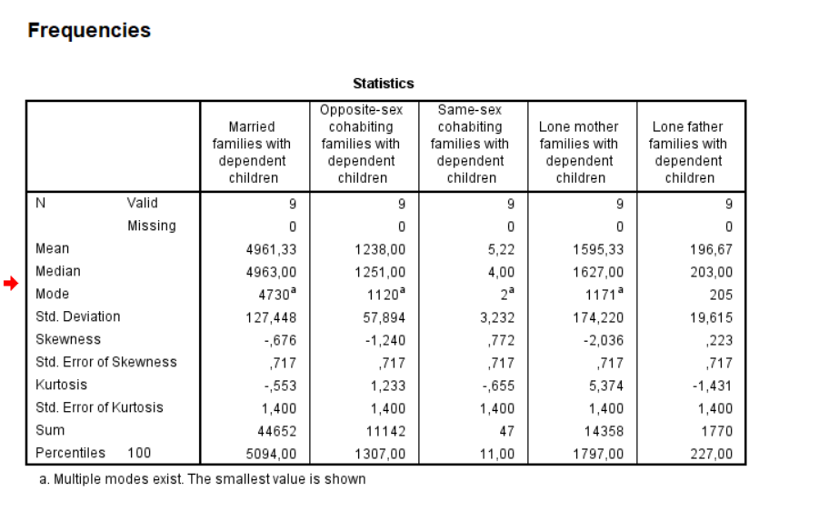
Figure 1 – Frequency analysis

The frequency analysis revealed that married families have the highest values for mean, mode and frequency, suggesting they are most likely to have dependent children compared to all the other family types studies.

For married families, the mean number of dependent children is 4961,33, indicating that, on average, married couples have more children compared to other family types. The mode, which is the most frequent number of children within this group, is 4730, suggesting that the average number of dependent children per year is the highest represented by married families.
Additionally, the frequency count for this analysis shows again the highest percentage for the married families, highlighting their dominance in this category. Thus, married families are most likely the focal point of focus for the businesses.

In contrast, based on the analysis, same-sex cohabiting couples and lone-father families are the most less likely to have dependent children withing their households, therefore they are not the main market target for businesses and marketers.

In addition to support H1, a Descriptive analysis on the number of dependent children was conducted (Please see Figure 2).
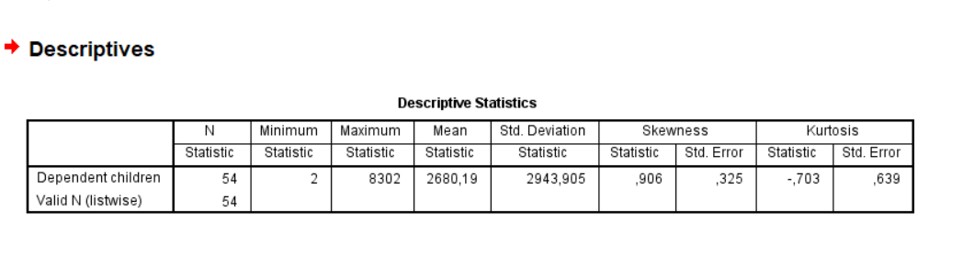
Figure 2 – Descriptive analysis

The descriptive analysis revealed a positively skewed distribution, with a skeweness statistic of 0.906 and a standard error of .325. This positive skew indicates that the majority of family types in the dataset have a smaller number of dependent children, with only fewer families who have dependent children in their household; this reinforcing further the Frequency analysis’ results presented above.
In terms of Kurtosis, the statistic is. -.703 with a standard error of .639 which suggests a flatter distribution than normal. However, since the Kurtosis statistic divided by the standard error (-1.10) is less than 2, the Kurtosis is not statistically relevant, meaning there are no extreme outlines in the data.

Therefore, based on the insights provided by the analyses, Hypothesis 1 is accepted.

H2: Lone-parent families, particularly lone mothers are more likely to have dependent children compared to cohabiting couples or lone father families.

In this context, Bandura’s Social Learning Theory (1977) provides insights into why lone mothers are more likely to have dependent children. The theory emphasises that individuals learn behaviours and societal roles by observing others, and thus lone mothers may model this caregiving behaviour, which is reinforced by societal norms and expectations.

In examining this hypothesis, a Bivariate analysis was conducted (Please consult Figure 3). This approach enables a direct comparison of the number of dependent children among four different family structures: lone mother families, lone father families, opposite sex cohabiting families and same sex cohabiting families.
By utilising this analysis, the search aims to determine whether statistically significant differences exist between these groups concerning the presence of dependent children, thus providing crucial insights into the dynamics of family structures. The relevance of this analysis lies in its ability to yield empirical data that can inform marketing strategies targeted at family-oriented products and services, acknowledging the variations in family compositions and their implications for consumer behaviour (Bianchi and Milkie, 2010; Bryman, 2016; Creswell and Creswell, 2018).

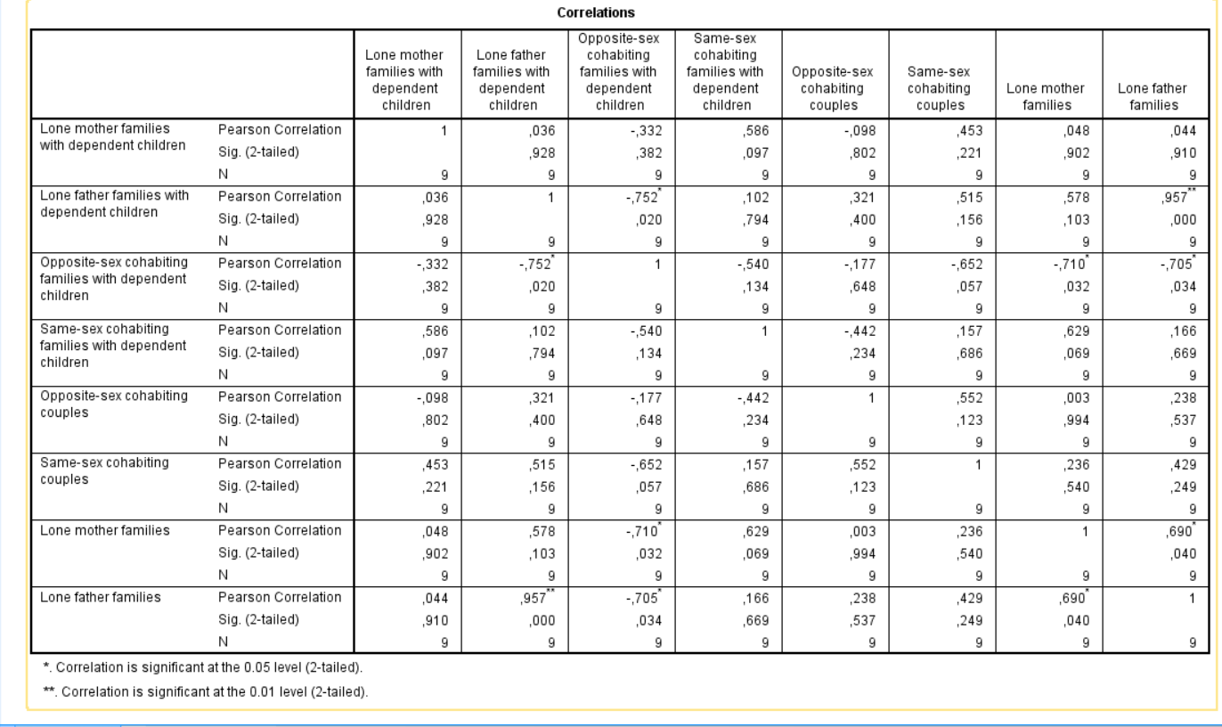

Figure 3 – Bivariate Analysis

The Bivariate correlation analysis illuminates the intricate relationships between lone mother families and other family structures regarding the presence of dependent children, providing critical insights for business and marketing strategies aimed at family-oriented products and services.

The Pearson correlation coefficient of 0.036 between lone mother families and lone father families suggests an inconsequential positive relationship, indicating that the number of dependent children in lone mother households does not significantly differ from that in lone father families (Bianchi, 2011).

This finding may imply that marketing initiatives targeting lone parent families could be similarly effective across both demographics, given their comparable family structures.

In contrast, the moderate negative correlation of -.332 between lone mother families and opposite-sex cohabiting couples indicates that as the number of dependent children in lone-mother families increases, it tends to decrease in opposite-sex cohabiting families (Cherlin, 2010). This suggests that marketing strategies aimed at opposite-sex cohabiting couples might need to emphasise alternative value propositions to appeal to their different family dynamics and responsibilities, particularly in promoting products or services that cater to a child-free life-style.

On another note, the robust correlation of .586 between lone mother families and same-sex cohabiting families highlights a strong positive association. This finding suggests that as the number of dependent children within lone mother families rises, the presence of dependent children in the same-sex cohabiting couples also increases (Pew Research Center, 2013). For businesses, this represents a significant opportunity to develop targeted marketing campaigns that resonate with the shared experiences of these family types, promoting products and services that foster inclusivity and support for diverse family structures.

However, the p-values reflected in this analysis are also essential to gain a comprehensive understanding of the developing family structures. The p-value of 0.928 for lone mother versus lone father indicated a lack of statistical significance, suggesting that observed relationships may be due to random variation rather than meaningful differences. The p-value for opposite-sex cohabiting families is .382, reinforcing the notion of insufficient statistical significance, while the p-value of .097 for same-sex cohabiting families suggests a trend that, while not statistically significant at conventional levels, may still warrant further investigation.

Therefore, while the corelation coefficients suggest some trends in lone mother families having a higher association with dependent children compared to certain family types, the elevated p-values, hence a lack of statistical significance in the majority of comparisons caution businesses against relying solely on these insights for strategic decision-making.

Thus, based on these results H2 cannot be proved, therefore will be rejected.

However, it is essential to note that while the current analysis does not provide sufficient evidence to accept the hypothesis, the limited sample size can represent a constrain the study in adequately illustrating broader patterns. This limitation prevents the study to challenge the broader body of literature, which has consistently demonstrated that lone mothers are more likely to have dependent children than lone fathers or cohabiting couples (Cancian and Reed, 2009; Amato, 2010). More recent studies continue to support this trend, emphasising the socio-economic factors that contribute to this dynamic. (Sigle-Rushton, 2022).
Consequently, businesses should remain cautious in drawing definite conclusions regarding this particular hypothesis from this research alone.
Nevertheless, integrating insights from the wider literature remains crucial in formulating marketing strategies that effectively target the distinct needs of lone-parent households, particularly lone-mother households, who may face unique financial challenges (Evans and Baxter, 2020)

H3: Opposite-sex cohabiting families are more likely to have dependent children than same-sex cohabiting families.

In this context, Role Theory which posits that societal norms and expectations shape individuals’ behaviours and responsibilities within family structures, allowing for a better understanding of the family dynamics discusses in this research. Opposite-sex cohabiting families often adhere to traditional gender roles, where the expectation of having children aligns with societal norms around family formation (Biddle, 1986). In contrast, same-sex cohabiting families may face different societal pressures and legal barriers, which can impact their likelihood of having dependent children (Wilkinson, 2014).
Understanding these dynamics enable businesses to create personalised marketing strategies to address the unique needs of diverse family structures, ultimately fostering inclusivity in their outreach efforts.

In order to verify H3, a Clustered Bar Chart was utilised (Please consult Figure 4) in order to illustrate the longitudinal comparison between opposite-sex cohabiting families with dependent children and same-sex cohabiting families with dependent children.
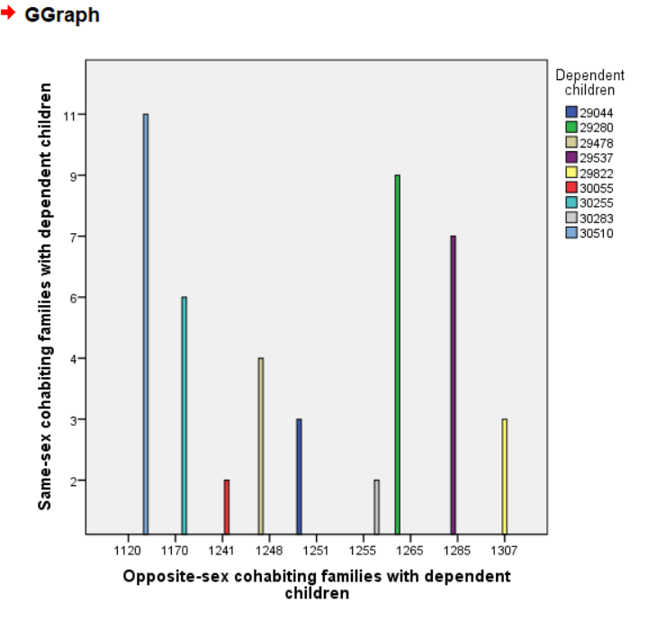
Figure 4 – Clustered Bar Chart

The analysis provides valuable insights into the evolving family structures, particularly looking at cohabiting families with dependent children, of opposite and same sex.
Traditionally, opposite-sex families have been seen as the primary target for products and services related to family needs, such as childcare, education and household goods (Kotler and Keller, 2016). The higher number of dependent children present within these households reinforces this notion.

However, an interesting trend was noticed during this analysis vis-à-vis the same-sex cohabiting families with dependent children, which initially had fewer dependent children, but showed a slow increase over the years. This trend could be indicative of evolving family structures and changing societal norms, which have marketing implications for businesses seeking to cater to diverse family types, and adapt their strategies to appeal to a broader, more diverse audience (Aldrich and Cliff, 2003).

Therefore, based on the outcomes illustrated by the Clustered Bar chart, H3 is valid and accepted.

FINDINGS AND CONCLUSION
In summary, this research underscores the importance of understanding the dominance of dependent children in various family types. The study’s objective was to explore the prevalence of dependent children across different family structures in the UK in order to formulate actionable insights for business looking adapt their marketing strategies to reach a particular demographic market segment or to expand their marketing and advertising tactics for a more inclusive approach.
By examining the dynamics of various family types, the study sought to identify how these structures influence the likelihood of having dependent children, hence equipping businesses and marketers with the knowledge needed to better serve diverse consumers’ needs and segments.

Therefore, based on the research findings, businesses and marketers should implement targeted marketing strategies that accommodate the unique needs of various family structures. According to the outcome that married couples are more likely to have dependent children, brands should focus on family-oriented products, emphasising stability and benefits in their campaigns (Hobcraft, 2022).
Additionally, as lone-parent families, particularly lone-mothers, have a higher likeliness of having dependent children, companies can create programmes addressing their challenges, such as affordable childcare options (Murray et al., 2022).
Furthermore, Gough et al., (2023) stresses that inclusive marketing campaigns that acknowledge the increasing number of same-sex cohabiting families are essential, as these families represent a growing consumer segment. Businesses can enhance brand loyalty by developing products that meet the specific needs of diverse family structures and engaging with local communities through partnerships and sponsorships (Smith, 2021).
By aligning marketing efforts with these insights, companies can effectively resonate with consumers and foster long-term relationships.

The research question has successfully been addressed by the research, by providing a comprehensive analysis of how different family structures, particularly those with dependent children, influence consumer preferences and marketing strategies within the context of the UK market.

The findings revealed that family dynamics play a crucial role in shaping the presence of dependent children within households. Married couples emerged as the most likely category to have dependent children, highlighting the stability and commitment often associated with traditional marriage. (Amato, 2005). In contrast, lone-parent families, particularly lone mothers, were found to have a higher prevalence of dependent children compared to lone father families and cohabiting couples, underscoring the unique challenges faced by lone mothers, influenced by socioeconomic factors and societal expectations regarding caregiving roles (Cancian and Reed, 2009; Evans, 2020).

Moreover, the analysis aligned with the literature and showed that opposite-sex cohabiting families were more likely to have dependent children than same-sex cohabiting families, suggesting that societal norms and regal recognition impact family structures and their capacity to raise children effectively (Mallett and Rowlingson, 2018; Ruppanner, 2019).

Therefore, this study provides valuable insights that can guide businesses in developing inclusive and relevant market strategies. Understanding the varying dynamics of family structures and their implications for child-rearing enables companies to tailor their products and services to meet specific needs of different consumer groups, especially households with dependent children, ultimately fostering a more inclusive marketplace.

Reflection of the module
The quantitative module serves as a vital component of the doctoral journey, providing scholars with essential skills to analyse data rigorously and make informed decisions based on empirical evidence. By engaging with quantitative research methods, doctoral candidates develop a deep comprehension of statistical techniques that enable them to interpret complex datasets, test hypotheses and draw valid conclusions. This knowledge is particularly significant in fields that require a strong evidence base for theoretical claims and policy recommendations.

Moreso, mastering quantitative analysis fosters critical thinking and enhances the ability to synthesise information from various sources. This skill is indispensable in academic research, where students must not only conduct their studies, but also critically evaluate existing literature and gaps that their research can address (Creswell, 2014). Furthermore, quantitative methodologies provide researchers with the tools to substantiate their findings, lending credibility to their work and ensuring that it contributes meaningfully to their field (Field, 2013).

In conclusion, the quantitative module prepares candidates for future challenges in their professional careers. Many employees seek individuals who hold abilities of data analysis and who can derive actionable visions; data analysis is considered a transferable skill, valuable across various sectors, including academia, industry and public policy (Bryman, 2016).
Ultimately, the knowledge and expertise gained from a quantitative module empower doctoral candidates to conduct research that is not only rigorous but also relevant, impactful, and aligned with contemporary societal needs.

REFERENCE LIST
Aldrich, H. & Cliff, J. E. (2003). The pervasive effects of family on entrepreneurship: Toward a family embeddedness perspective. Journal of Business Venturing, 18(5), 573-596.
Amato, P. R. (2005). The impact of family formation change on the cognitive, social, and emotional well-being of the next generation. The Future of Children, 15(2), 75-96.
Badgett, M. V. L., Waaldijk, K., & Rodgers, Y. V. (2019). The relationship between LGBT inclusion and economic development: Macro-level evidence. World Development, 120, 1-14.
Baker, J., Henkens, K., and de Vries, H. (2019) 'Consumer behavior in blended families: Insights into brand loyalty and purchasing patterns', Journal of Family Issues, 40(5), pp. 674-696.
Bandura, A. (1977). Social Learning Theory. Englewood Cliffs, NJ: Prentice Hall.
Baxter, J., Hewitt, B., & Haynes, M. (2011) Life Course Transitions and Housework: Marriage, Parenthood, and Time on Housework. Journal of Marriage and Family, 73(4), pp. 843-860. doi:10.1111/j.1741-3737.2011.00850.x.
Bianchi, S. M. (2011). Family Change and Time Allocation in American Families. American Journal of Sociology, 117(1), 35-78. DOI: 10.1086/661171.
Bianchi, S. M., & Milkie, M. A. (2010). "Work and Family Research in the Last Decade: Moving Forward." Journal of Marriage and Family, 72(3), 705-725.
Bianchi, S. M., Sayer, L. C., Milkie, M. A., & Robinson, J. P. (2016). Housework: Who Did, Does or Will Do It, and How Much Does It Matter? Social Forces, 94(2), 811–830.
Biddle, B.J. (1986) Recent Developments in Role Theory. Annual Review of Sociology, 12(1), pp.67-92. doi:10.1146/annurev.so.12.080186.000435.
Blaikie, N. (2007). Approaches to Social Enquiry: Advancing Knowledge. Polity.
Brown, S. L. (2020). Family structure and child well-being: Integrating family complexity. Journal of Marriage and Family, 82(3), 1000-1013. DOI: 10.1111/jomf.12662
Browne, K. and Giampietro, R. (2021). The Changing Family Structure and Marketing Strategies: Insights from Modern Families. Journal of Consumer Research, 48(3), pp. 523-540.
Bryman, A. (2016). Social Research Methods. 5th ed. Oxford University Press.
Cancian, M., & Reed, D. (2009). Family structure, childbearing, and parental employment: Implications for the level and trend in poverty. Demography, 46(2), 327-343.
Cancian, M., & Reed, D. (2009). The Impact of Welfare Reform on the Well-Being of Children. The Future of Children, 19(2), 37-54. DOI: 10.1353/foc.0.0014
Carlson, M. J., & England, P. (2020). Social class and family change: Disparities in marriage, cohabitation, and childbearing. Annual Review of Sociology, 46, 539-558.
Carpenter, C., & Gates, G. J. (2020). Same-Sex Marriage and LGBT Families. Oxford University Press.
Carrington, C. (1999). No Place Like Home: Relationships and Family Life among Lesbians and Gay Men. University of Chicago Press.
Cherlin, A. J. (2010). Demographic Trends in the United States: A Review of the Research. Future of Children, 20(2), 22-40. DOI: 10.1353/foc.0.0001.
Cherlin, A. J., (2010). The Marriage-Go-Round: The state of marriage and the family in America today. New York, USA: Knopf Doubleday Publishing Group
Cherlin, A.J. (2022). The Family: Diversity, Inequality, and Social Change. 3rd ed. W.W. Norton & Company.
Cherryholmes, C.H. (1992). Notes on Pragmatism and Scientific Realism. Educational Researcher, 21(6), pp. 13–17.
Choi, J., Kim, J., & Lee, S. (2019). Family structure and consumer behavior: A focus on married couples with children. Journal of Family and Economic Issues, 40(2), 215-227.
Cohen, L., Manion, L., & Morrison, K. (2018). Research methods in education (8th ed.). Routledge.
Creswell, J. W. (2014). Research Design: Qualitative, Quantitative, and Mixed Methods Approaches (4th ed.). SAGE Publications.
Creswell, J.W. and Creswell, J.D. (2018). Research Design: Qualitative, Quantitative, and Mixed Methods Approaches. 5th ed. SAGE Publications.
Davis, S. (2018). Marketing to the New Family: Strategies for Inclusivity. Journal of Family Marketing, 15(2), 23-38.
Duncan, G. J., and Murnane, R. J. (2020) 'Lone parents and consumer behavior: Psychological factors and economic constraints', Journal of Consumer Research, 47(2), pp. 225-242.
Epp, A.M., & Price, L.L. (2008) Family Identity: A Framework of Identity Interplay in Consumption Practices. Journal of Consumer Research, 35(1), pp.50-70. doi:10.1086/529535.
Evans, G. (2020). Parenting and Family Structure: The Impact on Child Outcomes. Journal of Family Issues, 41(12), 1823-1847. DOI: 10.1177/0192513X19898664
Evertsson, M. & Nyman, C. (2017). "Fairness and Division of Labor within Households." Journal of Family Issues, 38(6), pp. 772-792.
Field, A. (2013). Discovering Statistics Using IBM SPSS Statistics (4th ed.). SAGE Publications.
Goldberg, A. E. (2020). LGBTQ Family Building: A Guide for Prospective Parents. American Psychological Association.
Goldberg, A.E. and Gartrell, N.K. (2021) ‘Parenting and family life among same-sex couples: New insights from the National Longitudinal Lesbian Family Study’, Journal of Family Psychology, 35(2), pp. 239-248. doi: 10.1037/fam0000824.
Guba, E.G. and Lincoln, Y.S. (2017). The Paradigm Dialog. SAGE Publications.
Guzzo, K. B. (2021) ‘Cohabitation and parenthood: Trends, challenges, and implications’, The ANNALS of the American Academy of Political and Social Science, 696(1), pp. 239–259.
Haines, V., Yang, S., and DiLorenzo, P. (2018). Understanding Consumer Behavior Across Family Structures. Journal of Consumer Research, 45(4), pp. 775-793.
Harrison, R. (2020) Marketing to the Modern Family: The Influence of Family Structure on Consumer Behavior. Journal of Consumer Marketing, 37(6), pp. 703-714. doi:10.1108/JCM-11-2019-3483.
Kiernan, K. (2004) ‘Unmarried cohabitation and parenthood in Britain and Europe’, Law & Policy, 26(1), pp. 33–55.
Kincheloe, J.L. and McLaren, P. (2000). Rethinking Critical Theory and Qualitative Research. In: Denzin, N.K. and Lincoln, Y.S. (Eds.), Handbook of Qualitative Research. SAGE Publications.
Kotler, P., & Keller, K. L. (2016). Marketing Management (15th ed.). Pearson Education.
Kreyenfeld, M., Schneider, N., F., (2021). Research Handbook on the Sociology of the Family. USA: Edward Elgar Publishing
Kumar, A., Patel, S., and Jones, R. (2021) 'Cultural influences on family dynamics and consumer behavior: A study of ethnic minority households', International Journal of Marketing Studies, 13(1), pp. 1-15.
Lenz, K., Adler, A. A., (2023). The Changing Faces of Families -Diverse Family Forms in Various Policy Contexts. Taylor & Francis.
Lichter, D. T., & Qian, Z. (2019). Family structure and child well-being: Insights from the current population survey. Demography, 56(6), 2279-2305. DOI: 10.1007/s13524-019-00802-3
Mangleburg, T. F., & Bristol, T. W. (2001). Adolescent Brand Sensitivity: The Role of Parent-Child Communication. Journal of Advertising Research, 41(2), 9-20.
Mazrekaj, D. (2022) ‘Same-sex parenting and child development: Reviewing the evidence’, Journal of Family Issues, 43(3), pp. 741–764.
McLanahan, S. (2020) 'Fragile Families and the Reproduction of Poverty', The ANNALS of the American Academy of Political and Social Science, 689(1), pp. 58-70.
McLanahan, S. and Sandefur, G. (1994) Growing up with a single parent: What hurts, what helps. Cambridge, MA: Harvard University Press.
McLanahan, S., & Beck, A. N. (2021). Single mothers and poverty: The impact of gender roles and family structure. Journal of Marriage and Family, 83(1), 5-23.
McNeal, J. U. (1992). Kids as Customers: A Handbook of Marketing to Children. New York: Lexington Books.
Miller, A. J., LePoire, B. A., & Fisher, C. L. (2021). Parenting practices in diverse family structures: Insights from cohabiting, LGBTQ+, and blended families. Family Relations, 70(1), 200-214.
Morgan, D.L. (2014). Pragmatism as a Paradigm for Social Research. Qualitative Inquiry, 20(8), pp. 1045–1053.
OECD (2021). Society at a Glance: OECD Social Indicators. Paris: OECD Publishing.
Office for National Statistics (2023). Families and Households in the UK: 2023 Report. London: Office for National Statistics.
‌Osborn, T., (2019). Changing Family Dynamics. Excelic Press LLC.
Pallant, J. (2020). SPSS survival manual: A step by step guide to data analysis using IBM SPSS (7th ed.). Routledge.
Perelli-Harris, B. (2018) ‘How has cohabitation changed family formation? Comparing past and recent cohabiting and married families’, Demographic Research, 39(1), pp. 159–170.
Perelli-Harris, B. and Lyons-Amos, M. (2016). The Heterogeneity of Relationship Patterns: An Examination of 15 Countries Using Latent Class Growth Models. Demographic Research, 35, pp. 207-226.
Perelli-Harris, B., and Galezewska, P. (2021). 'The rise of cohabitation and childbearing outside marriage across Europe: Examining the interplay of legal recognition, norms, and socioeconomic conditions', European Journal of Population, 37(3), pp. 489–520. DOI: 10.1007/s10680-020-09574-2
Pew Research Center. (2013). The Global Divide on Homosexuality Persists. Retrieved from Pew Research.
Silton, N. R., (2017) Family Dynamics and Romantic Relationships in a Changing Society. USA: IGI Global.
Smith, A., Johnson, K., and Liu, X. (2022). The Influence of Family Structure on Consumer Decision-Making: Implications for Marketing. Journal of Marketing Studies, 34(1), pp. 123-142.
Smith, E. (2008). Using Secondary Data in Educational and Social Research. McGraw-Hill Education.
Solomon, M. R., Surprenant, C., Czepiel, J. A., & Gutman, E. G. (1985) A Role Theory Perspective on Dyadic Interactions: The Service Encounter. Journal of Marketing, 49(1), pp. 99-111. doi:10.2307/1251180.
Stone, J., Berrington, A., and Falkingham, J. (2014). 'Gender, turning points, and boomerangs: Returning home in young adulthood in Great Britain', Demography, 51(1), pp. 257–276. DOI: 10.1007/s13524-013-0247-8
Sutherland, M., & Sylvester, A. (2002). Young Consumers and Family Buying Decisions. Journal of Consumer Marketing, 19(1), 21-34.
UK Public General Acts – chapter 30; Marriage (Same-sex Couples) 2013, (2013). Available online at: https://www.legislation.gov.uk/ukpga/2013/30#:~:text=An%20Act%20to%20make%20provision,the%20usages%20of%20belief%20organisations
UK Public General Acts – chapter 41; Equal Pay Act 1970, (1970). Available online at: https://www.legislation.gov.uk/ukpga/1970/41/enacted
Wedlock or deadlock, UK Parliament, n.d. Available online at: https://www.parliament.uk/about/living-heritage/transformingsociety/private-lives/relationships/overview/wedlock-or-deadlock/#:~:text=The%201969%20Divorce%20Reform%20Act,order%20to%20end%20the%20marriage.
Wilkinson, L. (2014). "Queering Marketing: The Role of Same-Sex Marriage in LGBT Marketing." Journal of Consumer Marketing, 31(4), 307-311.

