Managing Engineering Projects

Title: Assignment 1

Author: David Whitmore
Email: David.Whitmore@vale.com
Number: 01792 841331
Address:
Vale Europe Limited,
Clydach Refinery,
Clydach,
Swansea,
SA6 5QR

Contents
Executive Summary
Introduction
Project Governance
Managing Structure
Corporate Board
Steering Committee
Communication Strategy
Project Team
Roles and Responsibilities
Project Stages and Risk Management
Project Initiators / Drivers
FEL1 - Concept
FEL2 - Feasibility
FEL3 - Detailed Design
Execution
Close Out
Risk Management
Conclusion
References
Appendices

Executive Summary
The production process at the car assembly plant "Company X" has been reviewed and recommendations put forward to improve its efficiency. The current process produces cars in batches of the same model and colour and incurs set up delays when changing between batches. In recent times the demand for a generic specification has decreased with customers now wanting a larger variety of models, colours and accessories to choose from. To help ensure they can meet this customer demand, Company X has decided to automate their process by investing heavily in robotic technology allowing different spec cars to be produced on demand at any time. Company X has engaged Project Consultants D. Whitmore Ltd to produce a high-level report detailing the process used to execute the project.

Introduction
Capital projects are usually identified by organisations due to their complexities and strategic importance and as such will have a large impact on the organisation. To ensure the successful execution of the project a comprehensive and effective management structure is critical. This report will detail the structure and governance of the project while providing project management and planning methodologies for the required stages of the project journey.

Project Governance
Management Structure
Governance over the Capital Investment portfolio is exercised at Corporate level while governance over an individual project is exercised by the projects Steering Committee which is appointed at a local level.

Corporate Board
The Corporate board must have enough information to satisfy them of the projects worth and convince them of the projects teams ability to execute within the specified parameters. They are also responsible for processing capital project authorisation and performing portfolio optimization and levelling.

Steering Committee
The project Steering Committee will be appointed as early in the process as possible. It is usually made up of the key stakeholders and department heads. Its function is primarily to provide senior level guidance and support, removing roadblocks and ensuring the project deliverables are on target in terms of delivery, cost, quality and value. When required they make the final executive decisions and arbitration.
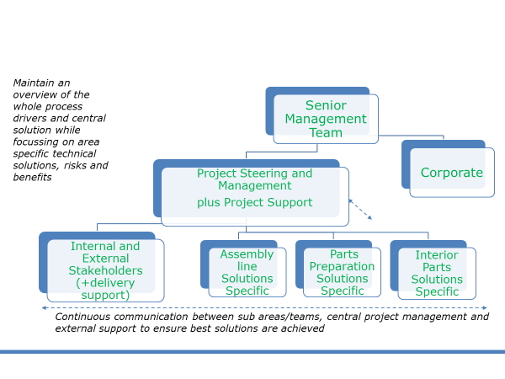Fig 1. Company Structure

Communication Strategy
The communication needs of the project are often misunderstood and underestimated. The process to prepare a communication plan as part of the project execution strategy will assist in developing an understanding of the needs of different groups associated with the project.
Any written documents (emails, memorandum, etc.):
- Limit emails to the appropriate persons, ensuring a copy the Project manager and Project Coordinator.
- Always use the project reference number e.g. ‘1234’ at the start of the document reference subject/title.

Any verbal communication:
- Always inform by email the Project Manager and the Project Coordinator of any relevant outcome (e.g. actions, important information, etc.) of the verbal communication. The Project Manager and the Project Coordinator will decide if they feel that the information needs to be recorded and distributed to the Project Team members.
- All Project Meetings will be documented, and the minutes distributed to all the Project Team.
Communication with the Project Steering:
- The Project Manager and the Project Coordinator will regularly inform the Project Steering members of the progress of the project.
Use of a common folder
- A Project Folder will be created on Company X server with a copy held by D Whitmore; the 2 will not be linked for safety reasons.
- Any files to be incorporated in the Project Folder will be done by D Whitmore
The Steering Group, Project Team and Project support members will have read access only to avoid discrepancy between information

Project Team
Roles and Responsibilities
The below are a typical list of stakeholders involved in the capital project process.

Project Sponsor
This is usually the Plant Manager or Process Owner who has identified a requirement and who will define objectives and justification for the project request

Project Manager
Mission: The project manager facilitates the project. They assemble the project team, develop the project plan and manage the project deliverables on time, within budget to the full satisfaction of the customer.
Responsibility: To lead the project team in the day to day running of the project ensure the project plan is adhered to while resolving any conflicts or issues. Ensure budgetary requirements are met and produce and present progress reports to the project steering committee.

Project Controller
Mission: The Project Controller is responsible for accurate and transparent financial management of the project, in compliance with the organisations financial rules and local regulations.
Responsibility: Monitor the financial status of the project in terms of Forecast and actual spend. Produce financial reports for review by the project manager and finance. Liaises with other team members to evaluate potential issues and develop a subsequent mitigation plan.

Project Scheduler
Mission: The Project Scheduler is responsible to optimize the project schedule to deliver the project as early as possible, to reduce the related risks and costs and to optimize the allocation of resources.
Responsibility: To integrate all activities derived from the project scope into the overall project schedule, to determine the critical path and to optimize it based upon the availability of resources to freeze the schedule baseline.

They keep the schedule updated by constantly monitoring progress versus schedule
baseline while anticipating all events (risks or opportunities) that may have an impact on schedule. Prepares progress reports for team members, project manager and stakeholders.

Project Quality Manager
Mission: The Project Quality Manager (PQM) ensures compliance with the quality standards along the whole project duration. S/he is charge of Quality Audit and quality control for the full project scope. S/he reports to the project manager on the status and effectiveness of the Project Management System.
Responsibility: Interpret and communicate the customers quality requirements to the project team. To coordinate the implementation of the project quality plan and associated procedures.

Project Procurement Manager
Mission: The Project Procurement Manager (PPM) has the mission to nominate the most suitable suppliers based on equipment strategy, geographical area and technical suitability, as well as award & manage contracts ensuring that the contractors meet their obligations on time, costs and quality.
Responsibility: Manage and coordinate all sourcing, tendering and complex procurement and logistic processes.

Stakeholder / Team Member
Members or representatives from interested departments to ensure all viewpoints are appreciated. Stakeholders can include members from the sponsors business unit, plant operations, R&D, Maintenance, Health Safety Environment and Technical. They bring valuable and sometimes conflicting viewpoints that help ensure informed decisions and ultimately project success.

Project Support
An external resource that assist the Project team. They can be an individual engineer or consultancy company who are brought on board for their expertise in a required discipline.

5.0 Project Stages and Risk Management
There are many definitions and models pertaining to the stages of a project or the Project Life Cycle (PLC) as it is commonly referred to, however the generic 5 stage framework (Aaltonen & Kujala, 2010) still remains the favoured for many with Turner (2009, p.10) stating “there is a growing agreement” around a PLC model comprising five distinct stages: (1) concept, (2) feasibility, (3) design, (4) execute, and (5) close. Others have built on this with recent researchers including specific steps for operation and disposal (Alexander et al, 2019) with elements of risk allocation sharing (Carbonara & Pellegrino, 2018) and the measurement of success (Liu et al, 2018)
Although the PLC appears a simple portrayal of the project journey from concept through to completion, it is also a managerial framework that defines the work criteria and management tools to be used during each stage (Hodgson, 2002).
Project Initiators / Drivers
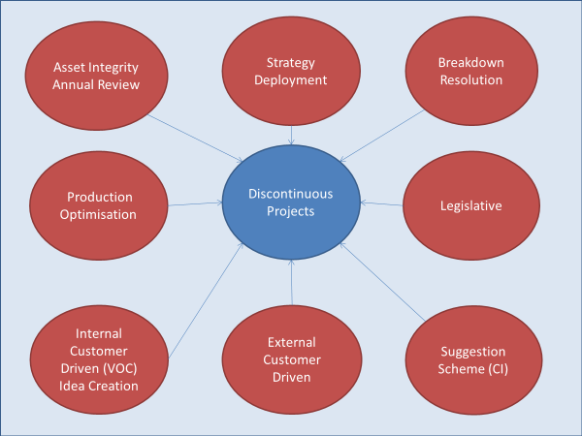
Fig 2. Project Drivers
In the case of "Company X" the primary project driver is an external customer demand which has consequently led to a revised production strategy.

The proposed project and risk management structure for this project is detailed below in the form of the Front-End Loading (FEL) framework which is a consistent series of activities at the front 3 stages of:
- Concept / FEL1 - Prepare the business case,
- Feasibility / FEL2 - Assess risk and opportunity to ensure the "best fit project solution" is selected.
- Design - Detailed Design / FEL3 - Plan the project in full detail.

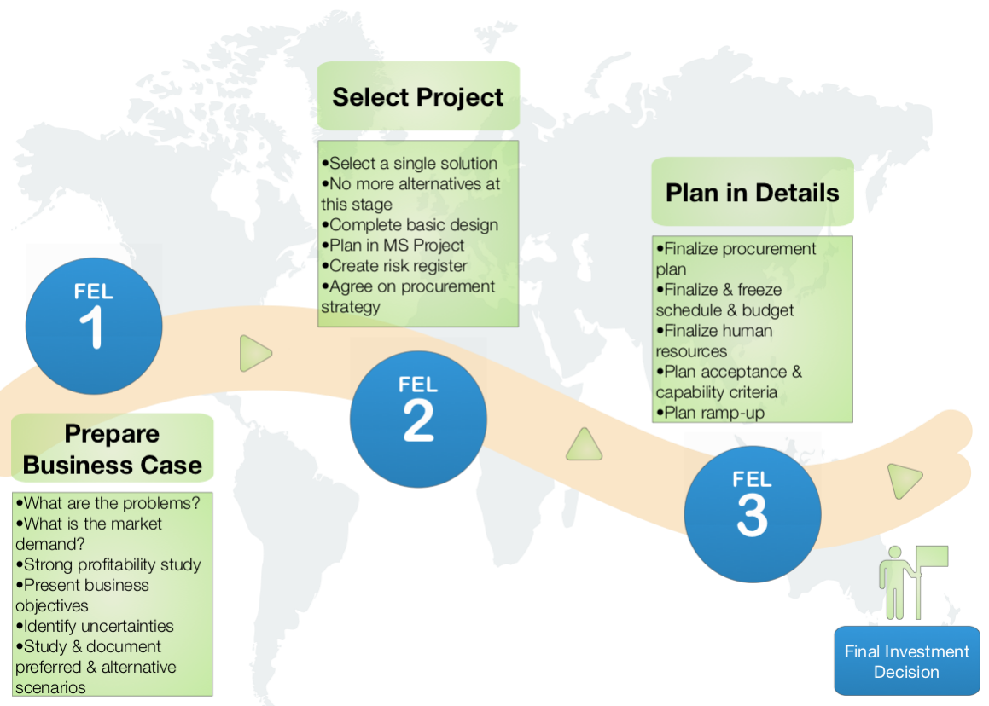
Fig 3. FEL Development Phases

To deliver the project’s investment objectives, a phases & gates system is adopted. It
structures the development of projects before investment decision is taken.

FEL1 -Concept
- Defining the Opportunity or problem
- Assembling the Steering Committee.
- Prepare Business case
- Identify alternatives - Business and Technical
- Identify Business risk / showstoppers
- Identify the stakeholders
- High level budget estimate - including 50% contingency
- Develop project Charter (see appendix 1)
FEL2 - Feasibility
- Feasibility studies
- Front End Engineering Designs (FEED)
- Develop detailed scope
- Preliminary designs - Civil, mechanical, electrical, structural, process
- Preliminary layouts
- Selecting the appropriate technology
- Assess project alternatives;
- Create major equipment list
- Develop equipment specifications
- Selecting project Envelope
- Create master schedule with high level critical path
- Budget estimate - including 30% contingency
- Assemble project team
- Update Project Charter

FEL3 - Detailed Design
- Detailed Design packages - Civil, mechanical, electrical, structural, process.
- Detailed drawings - P&ID's, Isometrics, General design
- Procurement Plan
- Tender Packages
- Supplier Proposals
- Resource loaded Schedule - Critical path and milestones identified
- Detailed Cost - 10% Contingency
- Detailed Risk Register
- Commissioning plan
- EH&S plan
- CDM /F10 Submission
- Update Project Charter

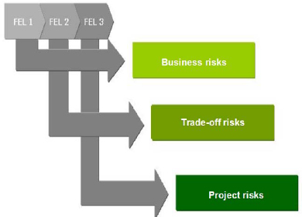
Fig 4. FEL Risk profile

Execution Phase
The Execution Phase is predominantly the longest phase of the project management lifecycle as it requires the most resources and outputs. It is here that the intended plant, machinery, product or service is delivered to the customer for approval. The Project Management Body of Knowledge (PMBOK, 2008) states – "The Executing Process Group consists of those processes performed to complete the work defined in the project management plan to satisfy the project specifications." It is the critical stage that ensures your plan and schedules are executed with clinical precision and minimal deviation (Fortune & White, 2006). Key activities include:
- Assemble Team and review execution plan
- Procure Equipment, services and materials
- Hold Kick off meetings
- Compile documentation - Risk Assessments, Method Statements, Lifting Plans, Permits
- Inductions and competency checks
- Site Management and Delivery - Work segregation, Unloading activities, temporary works, Equipment Installation
- Give recognition and rewards to team members and keep them motivated.

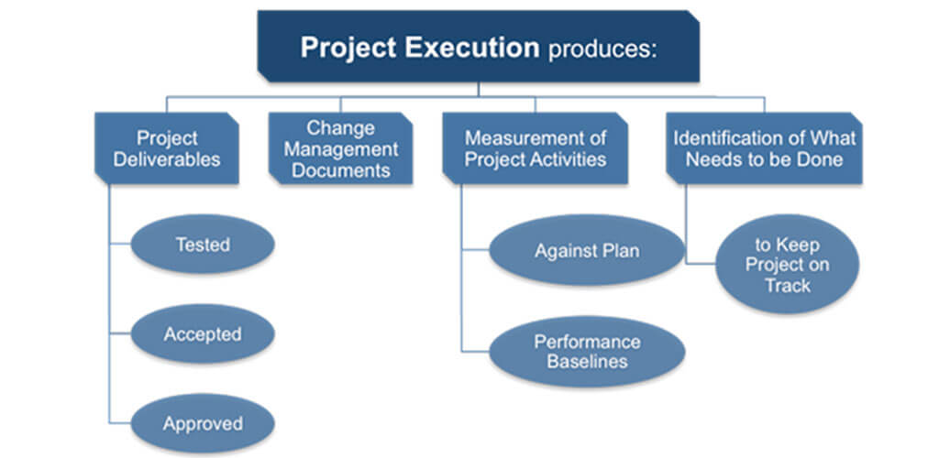
Fig 5. Project execution chart

Close Out Phase
During this phase of the project, all aspects of the project must be finalised and meet the satisfaction of the customer. This phase can often be approached with less focus than previous phases and members may drift from the team before completion putting the overall success of the project at risk (Cooke-Davies, 2002). It is important that the below activities are treated as individual work packages and treated as an extension of the previous phase.
- Complete operations planning
- Commissioning
- Perform operator training
- Create Assets in CMMS
- Submit drawings to drawing office
- Create standard work procedures (SWP)
- Submit recommended spares into system
- Create Planned Preventative Maintenance (PPM) tasks
- Evaluate project
- Post project assessment - Knowledge gained & lessons learned
- Celebrate success.
- Continued improvement and development.
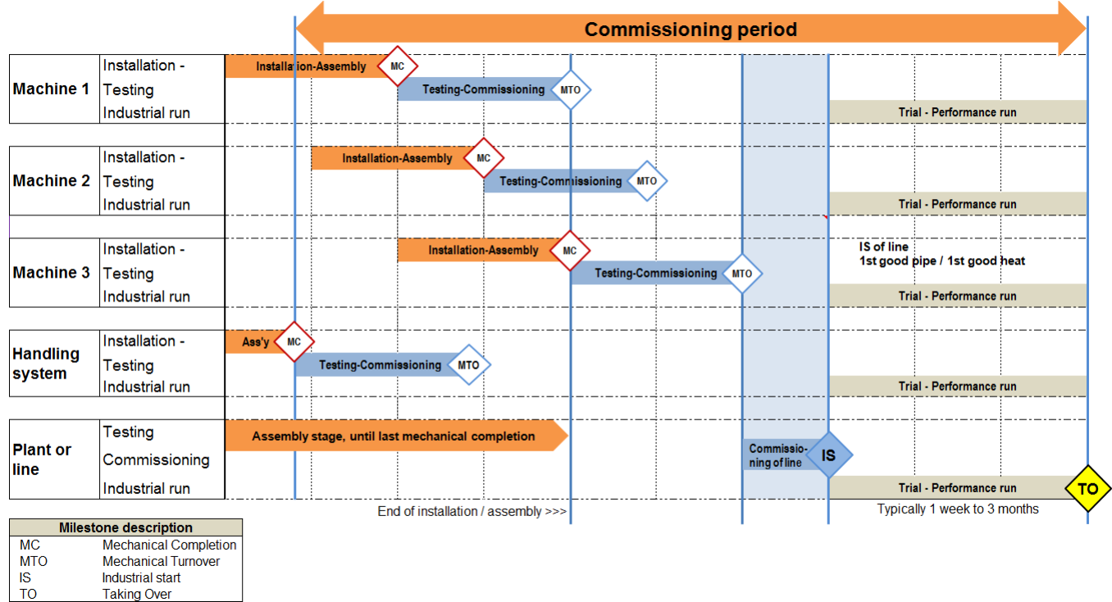
Fig 6. Typical Commissioning Plan

The Risk Management Process
The Association for Project Management (APM) Project Risk Analysis and Management Guide defines project risk as an “uncertain event or set of circumstances that, should it occur, will influence the achievement of one or more of the project’s objectives.” (APM, 2004, p. 17). When assessing risk at the outset of a project it is important to capture both the potential threats and opportunities as this will help develop a more robust and comprehensive project scope with a proposed quantitative impact on the cost and the schedule. Using the below identification categories, the information can be recorded and monitored in a risk and opportunity register (see Appendix 1) throughout PLC.

RISK Categories
1 | Low or Acceptable Risk
2 | Some Business Risk or Inefficiency but is plausibly not going to threaten the business/project significantly
3 | Significant Risk that could plausibly impact the project and Refinery operations

OPPORTUNITY Categories
A | Large prize, low resources (financial & manpower) to implement
B | Large prize but either high cost and/or high manpower to implement  OR… Smaller prize but low resources (financial & manpower) to implement
C | Smaller prize, but either high cost and/or high manpower to implement

The effective approach identifies:
1. The key risks and how to reduce their impact and/or their probability to occur, and;
2. The key opportunities and how to increase their benefit and/or increase their probability to materialize.
The use of check-lists (see Appendix 2) to help identify risks & opportunities, is particularly effective. To ensure continual improvement, return of experience between projects is an essential part of the process.

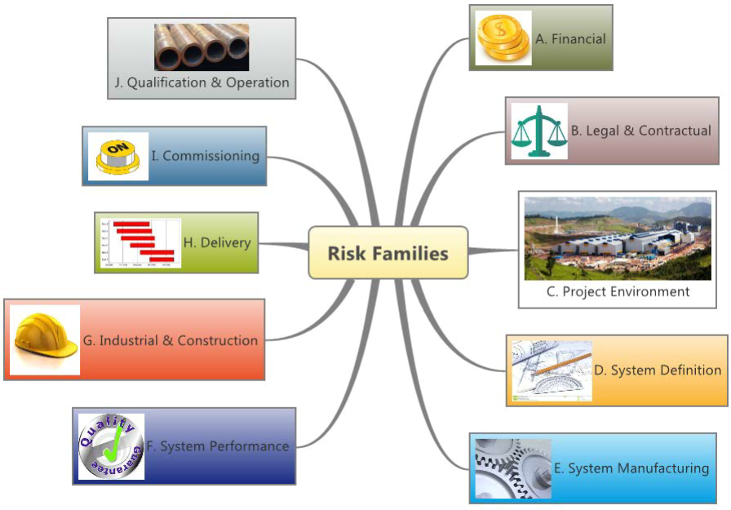
Fig 6. Risk Origins

Conclusion
A project can vary in type, size, complexity and industry therefore no one model, or methodology will be a best fit for all. There are so many variables and considerations from differing areas such as planning and scheduling, resourcing, costing, procurement, design, legislation and so on, that it would be easy to either get caught up or miss out on the detail. The framework proposed, if followed and implemented correctly is designed and proven to increase the likelihood of the project being executed successfully. It ensures a detailed understanding of the project requirements is developed and communicated with key personnel who can then systematically work through the project cycle to ultimately ensure the project satisfies the customer needs within the specified time and budgetary constraints.

8.0 References
Aaltonen, K., Kujala, J. (2010). A project lifecycle perspective on stakeholder influence strategies in global projects. Scandinavian Journal of Management, 26(4), 381–39.
Alderman, N., Ivory, C., McLoughlin, I., Thwaites, A., Vaughan, R. (2014). Managing complex projects: Networks, knowledge and integration. New York, NY: Routledge.
Alexander, J. (2015). Understanding why complex projects overrun: Developing a framework for identifying and managing risks (Unpublished PhD thesis). Curtin Business School, Curtin University, Perth, Western Australia.
Alexander, J., Ackermann, F., & Love, P. E. D. (2019). Taking a Holistic Exploration of the Project Life Cycle in Public–Private Partnerships. Project Management Journal, 50(6), 673–685. https://doi-org.ezproxy.uwtsd.ac.uk/10.1177/8756972819848226
Association for Project Management. (2004). Project risk analysis and management guide. High Wycombe, UK: APM Publishing Limited.
Biesenthal, C., Clegg, S., Mahalingam, A., Sankaran, S. (2018). Applying institutional theories to managing megaprojects. International Journal of Project Management, 36(1), 43–54.
Bower, D.C. and Finegan, A.D. (2009), “New approaches in project performance evaluation techniques”, Int. J. Managing Projects in Business, Vol. 2 No. 3
British Standards Institute. (2010). Project management: Principles and guidelines for the management of projects. London, UK: BSI.
Cable, D. M., Judge, T. A. (2003). Managers’ upward influence tactic strategies: The role of manager personality and supervisor leadership style. Journal of Organizational Behavior, 24(2), 197–214
Carbonara, N., & Pellegrino, R. (2018). Revenue guarantee in public-private partnerships: A win-win model. Construction Management and Economics, 36(10), 584–598. doi:10.1080/ 01446193.2018.1467028
Cooke-Davies, T. (2002). The “real” success factors on projects. International Journal of Project Management, 20, 185–190.
Fortune, J., & White, D. (2006). Framing of project critical success factors by a systems model. International Journal of Project Management.
Gil, N. A. (2015). Sustaining highly-fragile collaborations: A study of planning mega infrastructure projects in the UK. Retrieved from https://ssrn.com/abstract=2557370
Hodgson, D. (2002). Disciplining the professional: The case of project management. Journal of Management Studies, 39(6), 803–821.
Jugdev, K., & Müller, R. (2005). A retrospective look at our evolving understanding of project success. Project Management Journal.
Liu, H. J., Love, P. E. D., Smith, J., Irani, Z., Hajli, N., Sing, M. C. P. (2018). From design to operations: A process management life-cycle performance measurement system for public-private-partnerships. Production Planning & Control, 29(1), 68–83.
Mahalingam, A., Levitt, R. E. (2005). Understanding and mitigating challenges on global projects: The role of the freelance expatriate (pp. 1–11). San Diego, CA: In Construction Research Congress 2005: Broadening Perspectives.
Marshall, N. (2006). Understanding power in project settings. In Hodgson, D., Cicmil, S. (Eds.), Making projects critical (pp. 207–231). Basingstoke, England: Palgrave.
Mengel T. (2006) Project management ethics: responsibility, values and ethics in project environments. In: Dinsmore P, editor. The AMA handbook of project management. New York: American Management Association.
Meredith, J. R., Mantel, S. J. (2010). Project management: A managerial approach. Hoboken, NJ: Wiley.
Murphy, A. and Ledwith, A. (2007), “Project management tools and techniques in high-technology SMEs”, Management Research News, Vol. 30 No. 2
Ninan, J., Mahalingam, A., & Clegg, S. (2019). External Stakeholder Management Strategies and Resources in Megaprojects: An Organizational Power Perspective. Project Management Journal, 50(6), 625–640. https://doi-org.ezproxy.uwtsd.ac.uk/10.1177/8756972819847045
Pinto, J. K., & Slevin, D. P. (1988b). Critical success factors across the project life cycle. Project Management Journal, 19(3)
Project Management Institute. (2007). Practice standard for project configuration management. Newtown Square, PA: Project Management Institute.

Project Management Institute. (2008). A guide to the project management body of knowledge (PMBOK® Guide) (4th ed.). Newtown Square, PA: Project Management Institute.
Regan, M., Love, P. E. D., Jim, J. (2015). Public infrastructure procurement: A review of adversarial and non-adversarial contracting methods. Journal of Public Procurement, 15(4), 405–438
Rosacker, K.M. and Olson, D.L. (2008), “Public sector information system critical success factors”, Transforming Government: People, Process and Policy, Vol. 2 No. 1
Thomas, J., Mullaly, M., 2009. Guest editorial: explorations of value: perspective on the value of Project Management. Project Management Journal 40
Turner, J.R., 2009. The Handbook of Project-based Management, third ed. McGraw-Hill Publishing, Glasgow.
Vasconcelos, I. M. M. & Moraes, P. P. (2010). Structuring a PMO with the help of front-end loading and the PMBOK® guide. Paper presented at PMI® Global Congress 2010—EMEA, Milan, Italy. Newtown Square, PA: Project Management Institute
Winch, G. M. (2014). Three domains of project organising. International Journal of Project Management, 32(5), 721–731.

Appendicies
Appendix 1 - Sample Risk and Opportunity Register

Appendix 2 - Risk Checklist

Title: Production Automisation |  | Project No. 1234
Engineer: D. Whitmore |  | Date: 10/12/19

Project Manager/Engineer to Assemble team to agree pages 1-15 of this document.

Project Manager/Engineer to complete pages 1-15 prior to agreement

Team to consist of representatives, as required, from SHE (including compliance), Sponsor, Production Area Engineer, Engineering Systems, CIE, HR and Technical.

CAPITAL/NEW WORK/PLANT ALTERATIONS - BUDGET ESTIMATE 20%

BUDGET ESTIMATE items included in cost below
QUANTITY | DESCRIPTION | COST
1

1

Prepared By: | Total Cost:

HEALTH, SAFETY, ENVIRONMENTAL AND COMPLIANCE SECTION
WITHIN THE CATEGORIES LISTED BELOW, DOES THE PROPOSAL ALTER, CHANGE OR IMPACT UPON ANY OF THE FOLLOWING ELEMENTS? | YES  OR  NO | WHAT PROBLEMS ARE CREATED AFFECTING PLANT OR PERSONNEL SAFETY?  RECOMMENDED ACTION?
COMAH
1. Does the modification involve a change in the Quantity of a Dangerous substance?
2. Does the modification involve a change of phase of a Dangerous substance?
3. Does the modification involve the introduction of a new Dangerous substance?
4. Does the modification involve a new process?
5. Does the modification involve significant changes to the storage facilities?
6. Does the modification involve a change from automatic to a manual control system in Safety critical Plant?
7. Will there be changes to the mode of delivery or transport of Dangerous substances?
8. Will there be changes to the design or location of Occupied buildings?
9. Will there be a significant change to the original design parameters such as process operating conditions or practices, changed throughput, design life extensions or removal of safety critical plant?
10. Does change affect or is it related to a COMAH critical asset WSE?
11. Will any changes affect or create systems that fall under the critical flange procedure?
If any of the above questions produce a YES answer, then please convene a meeting between the Engineering Manager and the Process Safety Supervisor.

WITHIN THE CATEGORIES LISTED BELOW, DOES THE PROPOSAL ALTER, CHANGE OR IMPACT UPON ANY OF THE FOLLOWING ELEMENTS? |  |  | YES  OR  NO | IF YES, WHAT IS THE  RECOMMENDED ACTION?
SUSTAINABILITY
1. Introduce new, or alter existing, release of emissions to air or water (drains)?
2. Introduce new or alter facilities incorporated for treating emissions, wastes, etc? E.g. Local Exhaust Ventilation (LEV), drainage, process waste?
If LEV is included convene a meeting with the Hygienist in SHE
3. Require application for Environment Agency consent or environmental permit variation under Environmental Permitting Regs 2010?
4. Involve any excavation work?

- Please give estimated volumes of material to be excavated.
- What is the intended disposal route for excavated material?
- All excavated material is considered contaminated, therefore worst case samples of excavated material must be tested to determine its waste characteristics (WAC test).
- Any excavated material must be stored in an approved area and remediation costs factored into project budgets?
5. Require disposal of packaging waste, scrap metal, redundant equipment etc?
6. Introduce new or alter existing hazardous waste for external disposal?
ENERGY EFFICIENCY

1. Will the equipment/process increase the Refinery’s energy consumption? If “yes” approximate quantity and report to Energy Superintendent?
2. Is the most appropriate energy source being used (natural gas, electric, steam etc.)
3. Has the most energy efficient equipment been specified?
4. Ensure, if possible, equipment is specified from the enhanced capital allowance scheme and all details are forwarded to accounts?
If any of the above questions produce a YES answer, then please convene a meeting between the Engineering Manager and the Sustainability Supervisor to ensure that BAT (Best available techniques) is complied with.

HAZOP STUDY
1. Introduce new or revision to HAZOP Study
(See Safety Instrumented Systems Question 3)

If New HAZOP Study is NOT Required, please state why?

ENGINEERING SECTION
WITHIN THE CATEGORIES LISTED BELOW, DOES THE PROPOSAL ALTER, CHANGE OR IMPACT UPON ANY OF THE FOLLOWING ELEMENTS? | YES  OR  NO | WHAT PROBLEMS ARE CREATED AFFECTING PLANT OR PERSONNEL SAFETY?  RECOMMENDED ACTION?
PROJECT INFORMATION

1. Does the project require a Story board erected on the site of the Project?
It is incumbent on the Project Engineer to follow up and discuss the Engineering Design with the plant Superintendent and Operators, as required, for improvement Opportunities.

If any of the above questions produces a YES answer, then please convene a meeting between the Engineering Manager, Sponsor and Plant Superintendent.
CONSTRUCTION DESIGN and MANAGEMENT

1. Is the work to be performed defined as ‘construction work’ in the CDM regulations 2015?
2. If YES, will the project Last more than 30 days and have more than 20 workers working simultaneously at any one point
OR, will the project involve more than 500 man days?
3. If YES, then the Project Engineer must submit notification to the HSE using form F10.
All projects must maintain documentation to satisfy the General Principles of Prevention as in L153. If you are in any doubt about the CDM regulations, convene a meeting between the Engineering Manager and the local CDM experts (Mechanical Engineer).

WITHIN THE CATEGORIES LISTED BELOW, DOES THE PROPOSAL ALTER, CHANGE OR IMPACT UPON ANY OF THE FOLLOWING ELEMENTS? | YES  OR  NO | WHAT PROBLEMS ARE CREATED AFFECTING PLANT OR PERSONNEL SAFETY?
RELIEF AND BLOWDOWN
1. Introduce or alter any potential cause of over/under pressuring the system or part of it?
2. Introduce or alter any potential cause of higher or lower temperature in the system or part of it?
3. Introduce a risk of creating a vacuum in the system or part of it?
4. In any way affect equipment already installed for the purpose of preventing or minimising over or under pressure?
AREA CLASSIFICATION (DSEAR 2002)
1. If any plant is to be modified, extensively refurbished or new plant added then will the DSEAR regulations apply?
2. Introduce or alter the location of potential leaks of flammable material?
3. Alter the chemical composition or the physical properties of the process material?
4. Introduce new or alter existing electrical equipment?
5. Is the work area currently zoned?
6. Will the zoning of the area need to be re-assessed prior to specifying equipment?
7. Will all equipment mechanical and electrical be specified for the required zone and marked accordingly?
8. Will the DSEAR risk assessments be revised and updated prior to commissioning?

WITHIN THE CATEGORIES LISTED BELOW, DOES THE PROPOSAL ALTER, CHANGE OR IMPACT UPON ANY OF THE FOLLOWING ELEMENTS? | YES  OR  NO | WHAT PROBLEMS ARE CREATED AFFECTING PLANT OR PERSONNEL SAFETY?

SAFETY INSTRUMENTED SYSTEMS
1. Does the project involve any modification to any safety-instrumented system (SIS), i.e. hard-wired trip, sensor (e.g. transmitter), logic solver or final element (valve)?
2. Will the change affect the basic process control system (BPCS), e.g. the DCS or I/A. If so, the impact on the SIS must be properly considered, reviewed and approved prior to making the change?
3. Or following process hazard assessment (e.g. HAZOP) it is recognised that there is a requirement identified for (or change to the) risk reduction by a safety function? For example, a new alarm is required or there is a change that affects the alarm circuit in some way?
SOFTWARE
1. Will the modification involve software change or the installation of new software?
2. Will a programme of software testing and commissioning be set up prior to final commissioning?
PROJECT SITE SUPERVISION
1. With the agreement of the relevant area personnel state who will be the person responsible to act as permit signatory?
2. State the arrangements for supervision of the work on site?
If the answer is yes to any of the above the project is classified as Functional Safety and a Safety Authority must be appointed (i.e. Electrical/Instrument Manager or Superintendent, Compliance)

WITHIN THE CATEGORIES LISTED BELOW, DOES THE PROPOSAL ALTER, CHANGE OR IMPACT UPON ANY OF THE FOLLOWING ELEMENTS? | YES  OR  NO | WHAT PROBLEMS ARE CREATED AFFECTING PLANT OR PERSONNEL SAFETY?

OPERATION AND DESIGN
1. Require consideration of relevant Codes of Practice and Specifications? List all Major Relevant regulations and standards consulted?
2. Affect the process or equipment upstream or downstream of the change?
3. Affect safe access for personnel and equipment, safe places of work and safe layout? (Ladders – working platforms, walkways, etc.)
4. Require the Creation and /or the alteration of existing Assets in SAP? Require the Creation and /or revision of equipment inspection frequencies – Maintenance Plans?
5. Affect any existing trip or alarm system or require additional trip or alarm protection?
6. Affect the reaction stability or controllability of the process?

7. Affect existing operation or maintenance procedures or require new procedures? (Isolation for mechanical/electrical).
8. Alter the composition of, or means of disposal of, effluent?
9. Alter the fall, elevation or drainage of roadways, pathways or hard standings that may give rise to ponding water?

WITHIN THE CATEGORIES LISTED BELOW, DOES THE PROPOSAL ALTER, CHANGE OR IMPACT UPON ANY OF THE FOLLOWING ELEMENTS? | YES  OR  NO | WHAT PROBLEMS ARE CREATED AFFECTING PLANT OR PERSONNEL SAFETY?

PIPEWORK
1. Introduce or alter any potential cause of failure of pipe work/supports/bellows/valves/ship plates/bursting disks/filters, etc?
2 Introduce any equipment that needs to be included in the prevention or monitoring of corrosion within pipework or steelwork system?
3. Have any new isolation points been introduced to existing systems or has a new system that includes isolations been introduced?
4. If yes, then has the Safe Isolation of Plant Policy been considered?
CIVILS STRUCTURE
1. Introduce or alter any potential loads on or strength of foundations/structures/vessels/materials of construction?
ENGINEERING HARDWARE

1. Introduce change to or require new P&ID’s/Wiring Diagrams/Plant Layouts or any other drawings?

TRAINING OPERATING MANUAL

1. Introduce change to or require:

New Commissioning Procedures

Normal Operating Procedures
(including MTS and SWP)

Emergency Shut-Down Procedures

Refinery Emergency Plan

WITHIN THE CATEGORIES LISTED BELOW, DOES THE PROPOSAL ALTER, CHANGE OR IMPACT UPON ANY OF THE FOLLOWING ELEMENTS? | YES  OR  NO | WHAT PROBLEMS ARE CREATED AFFECTING PLANT OR PERSONNEL SAFETY?
Machinery Directive 98/37/EC

1. Will the machinery to be supplied require CE certification?

2. Who is responsible for supplying the CE certification?

3. Will the equipment be supplied with a certificate of incorporation or conformity from the supplier?

4. Will the machinery be in compliance with the following directives:
Electromagnetic Compatibility Directive 92/31/EEC
Low Voltage Directive 73/23/EEC

WITHIN THE CATEGORIES LISTED BELOW, DOES THE PROPOSAL ALTER, CHANGE OR IMPACT UPON ANY OF THE FOLLOWING ELEMENTS? | YES  OR  NO | WHAT PROBLEMS ARE CREATED AFFECTING PLANT OR PERSONNEL SAFETY?

SAFETY EQUIPMENT
1. Require the provision of additional safety equipment upon completion to run the new system?
2. Affect existing safety equipment?
3. Fire protection/fighting equipment upon completion to run the new system?
4. Require the addition or modification to escape routes?

HR SECTION
WITHIN THE CATEGORIES LISTED BELOW, DOES THE PROPOSAL ALTER, CHANGE OR IMPACT UPON ANY OF THE FOLLOWING ELEMENTS? | YES  OR  NO |  | WHAT PROBLEMS ARE CREATED AFFECTING PLANT OR PERSONNEL SAFETY?

ERGONOMICS
1. Introduce or alter any potential working positions of people?
2. Layout and positioning of controls and instruments?
3. Position of plant and equipment?
TRAINING
1. Will a programme for operator training be set up prior to commissioning?

2. Will a programme for mechanical/electrical/instrument technicians be set up prior to commissioning?
3. Will changes or new MTS, SWP or related procedures be required?
ORGANISATIONAL CHANGE
1. Will the project introduce an organisational change?

2. Will the project require the creation or reduction of jobs?
If the answer is yes to any of the above, then a Management of Organisational Change (MoOC) must be initiated by the Project Sponsor

DOCUMENTATION | REQUIRED |  | COMPLETE
DOCUMENTATION | YES | NO | YES | NO
GENERAL
Completion Certificate | MANDATORY
Hydrostatic Test Certificate
Loop Testing
Calibration Tests
Test Certificates
Electrical Testing/Running
Dry Running
Equipment Spares
Equipment List
SAFETY

Safety Equipment
Fire Equipment
Environmental Monitoring
Health Surveillance
Material Safety Data Sheets
TRAINING
Operating and Maintenance
Manuals
Training Register
OPERATIONS
Start Up Procedures
Operating Procedures
MTS Manuals up to date
SWP Created/updated
Commissioning Plan | MANDATORY

DOCUMENTATION | REQUIRED |  | COMPLETE
DOCUMENTATION | YES | NO | YES | NO
DRAWINGS
P.I.D.’s | MANDATORY
Civil
Building/Structure
Mechanical Plant Layout
Mechanical Detail Drawings
Electrical
Instrumentation
Copy of Drawing Request Form
ENGINEERING DOCUMENTATION
Installation Method Statements

Risk Assessments

Vendors Manuals
CE Certification

DSEAR (2002) Certification
Quality Assurance Documentation
Assets Created/Updated in SAP
Maintenance Plans Created/Updated in SAP
HAZOP study and action plan

Final Copy of Software |  | N
Functional Safety Plan |  | N
CDM Pre Construction Phase Plan | Y
CDM Health and Safety Plan | Y
Once the all the above documentation is complete at the end of the Project then the Project Manager and Sponsor to sign that all documentation is in place

Signed: PROJECT MANAGER Date

Acceptance: SPONSOR Date:

APPROVALS (to be signed following agreement meeting)

APPROVED BY SPONSOR: Signature:
APPROVED BY SHE: Signature:
APPROVED BY AREA ENGINEER: Signature:
APPROVED BY CIE: Signature:
APPROVED BY HR: Signature:
APPROVED BY TECHNICAL: Signature:
APPROVED BY ENG SYSTEMS: Signature:

ENGINEERING MANAGERS COMMENTS:

APPROVED BY ENGINEERING MANAGER: Signature:

